Returns to technical education: a longitudinal and cross-sectional study of Brazil, 2007 to 2018

Bruno de Oliveira Cruz[1] Luiz Rubens Câmara de Araújo[2]

Thiago Mendes Rosa[3]

2021-07-13

# Abstract

We estimate the return to technical education in Brazil between 2007 and 2018. A rich administrative record of formal labor market (RAIS) allows us to construct a panel of all formal workers in 2007, following them until 2018. Identification of workers was based on National Catalog of Technical Occupations. Also, we use the two waves (2007 and 2014) of National Household Survey (PNAD), about technical education, to further investigate. Results suggests a positive and significant wage premium – between 21.3% and 24.9% in favor of workers in technical occupation/with technical education, controlling for other available observable variables (schooling, age, firm size, economic sector and job spell). Even restricting our sample to young workers (18 years-old) having high school diploma in the beginning of period – profile required for a technical occupation – the positive and significant wage premium remains, but in a lower magnitude (between 5.8% and 7.8%). However, cross-section data suggest no wage premium for the young generation of 2014 and, hence, cohorts are affected distinctly by technical education. Taking into consideration the benefits found, technical education seems to be cost-effective if it costs up to R$ 8,595.10 monthly (at a 6% annual interest rate).

**Keywords:** Technical Education, RAIS and PNAD

**JEL:** J24, J08 and I26

# Introduction

School-to-work is one of the main policy makers’ challenges in many countries, including Brazil[4]. The National Household Survey (PNAD)[5] shows, for example, that unemployment rate was 10.95% in Brazil in 2014, for young people aged 18 to 24 (while the general rate was 6.25), so these juveniles were an important part of all unemployed individuals in Brazil. Moreover, estimates shows that 23.5% of this public were neither in school nor holding down a job (among them, unemployed people are included[6]). The absence of job or any kind of occupation can potentially be a source of various social problems, like poverty and incidence of crime. At the same time, there is a growing effort by local government to increase vocational training and technical education opportunity to this population.

On the other hand, 83% of above 25 years-old had, at most, high school degree (about eleven years of schooling). People with primary education (about eight years of schooling) were 10%, while people with primary incomplete were 32% and no educated were 12%[7]. Thus, there still a huge part of the working age population with low qualification and, therefore, potential low job placement. In this scenario, technical education is often an alternative to enhance labor market opportunities for youth, decreasing unemployment and providing a source of income (Frigotto 2005). Hence, identify the return to technical education on earnings is important to answer the following question: are there any gains to young people, regarding wages or professional careers, if they have a technical education certificate?

Using a panel with all Brazilian formal workers, registered in Annual Relation of Social Information (RAIS)[8], from 2007 to 2018, we estimate the effect of occupations related to technical education on wages in formal labor market. Our database covers all registered workers, using occupational information based on Brazilian Classification of Occupations (CBO), a codification organized by IBGE, to identify technical workers. Previous studies using panel data are scarce, especially about technical education. Regarding Brazilian literature, we find papers using cross-sectional databases, mainly focused on the 2007 National Household

Survey, when a special supplement about professional qualification was applied[9]. Nevertheless, longitudinal studies, in general, can control efficiently non-observable effects (constant in time), which may affect econometric studies, a feature absent cross section databases (Stevens, Kurlaender, and Grosz 2019). However, due to structure of our data, with an invariant characteristic in time, we are not able to estimate the effects of technical education by fixed-effects. To overcome this issue, we rely on random-effects, with several alternative estimation by complex random-effect-within-between (REBW) of matching data. Hence, this paper contributes to improve the debate about the relationship between education and wages, specifically technical qualification. Recent Brazilian high school reform, carried out in 2017, praises the importance of this debate. We also use PNAD 2007 and 2014 waves about technical education to assess the consistency of our estimates with an alternative database, taking into consideration the selection to labor market.

Our panel estimates shows that workers who were in occupations related to technical education in 2007 had a positive and significant wage difference, between 21.3% and 24.9%, when compared to other workers, controlling for several characteristics (e.g. schooling, tenure, sex and age). When we focus on a more specific group, young with 18 years-old (and hence with no past wage trends), who had only high school in the beginning, we find a positive and significant wage difference, but in a lower magnitude – between 5.8% and 7.8%. Results are robust to matching data and random effects within-between estimates. The cross-section results point to same direction, although the effect seems to fade away, with no effect for the young generation of 2014, suggesting the importance in reassessing the effects over time and generations. Heterogeneous effects suggests that industry workers benefit more from technical education than the general workers (only in cross-sectional data). A cost-benefit analysis estimates the maximum value could be spent, given some interest rates, to cover the costs with technical education. Results suggest, given an ideal cost (estimated by Araújo et al. (2016)), the benefits would cover between 13.6 times and 5.2 times of high school costs, or between 10.5 times and 4 times of the technical education costs (depending on rate of return considered).

This paper is organized as follows. Section two presents a brief review of technical education and previous papers’ estimation of its returns. The next one brings methodological aspects, including data sources and its manipulation. Fourth section presents the main results, while the last concludes with remarks.

# Importance of education, technical education and its impacts on labor markets

In a wider perspective, correlation between education and economic development exists for a long time (Hanushek et al. 2008), gathered under human capital theory, which has been an important research area backing to the middle of XX century (Becker 1962). Since then, many studies flourished trying to estimate returns to education investments (Psacharopoulos 1994), where income equation, based on wages, is a common tool (Mincer 1974). Among schooling types, or phases, technical education is the one conceived to improve school-to-work transition.

An important characteristic of technical education in Brazil is its narrow connection with high school, being, at same time, integrated or consecutive, with a recognized certificate[10]. In the first kind of technical education, students are enrolled in two courses, high school and technical education, and take parallel classes. In the second type, students are enrolled only in one course, taking classes simultaneously. Finally, after concluding high school, they can enroll in an isolated technical course, which requires high school certification. One of the most important features of technical education is its association with basic education, giving a wider qualification to future workers, since it demands a range of previous abilities from students. In opposition, professional qualification is usually simpler and shorter, needing, in general, no specific background knowledge (Alves and Santos Vieira 2009). Frigotto (2005) points to the necessity of educated citizens with critical thinking, able not just to execute technical tasks, but capable to exercise citizenship, only possible through high quality basic education. Also, general education may help people adapt or acquire new skills due to changes in industry, a common scenario with technological changes.

Association between basic education, i.e. conclusion of all three levels of education[11], and technical education was not always prevalent in Brazil. The Decree-Law 2,208/1997[12] separated technical education from regular high school, stopping its federal expansion, dissociating these two type of teaching. This rule changed in July 2004, with Decree-Law 5,154/2004[13]. Today, Brazil lives a new phase in this area, when Provisional Measure 746/2016[14], implemented High School Reorganization, later converted in law[15], which makes high school more flexible, establishing also common topics to be covered in all Brazilian schools. All these changes aim to help school-to-work transition, increase high-school graduation and improve quality of education. It is important to point out that, in 2014, 98.7% of children aged 7 to 14 were in school in Brazil, lowering to 84.3% for adolescents aged 15 to 17 and only 48.5% of people aged 18[16]. So, while the *ensino fundamental* (7 to 14 years) could be considered universalized, the *ensino médio* (15 to 17) was still behind, with around 15% of young out of school.

In line with school-to-work discussion, Corseuil, Foguel, and Gonzaga (2019) evaluate the Brazilian Apprenticeship program[17], which subsidies firms to hire and train young, finding positive effects in the chances to hold a formal job five years after the program, also finding a positive effect in acquiring higher levels of formal education. Endogeneity was dealt with the age rules to participate in the program and the year of its implementation. To answer the same question, Fersterer, Pischke, and Winter-Ebmer (2008), using failed firms, found positive effect of training on employment, with results being similar between OLS and instrumental variables estimation. Despite technical education is not necessarily like an apprenticeship program, with on the job learning regularly, its concept is connected by the school-to-work transition purpose, making these results relevant to our discussion.

An important aspect of formal education curriculum is the academic versus technical track in the end of basic education. Some countries tend to put some emphasis to academic track, aiming to provide more general skills and, also, to open a door to higher education. In this line, family decision plays a central role, where expected return to the academic track, when compared to the technical education, is relevant in decision making (see Biavaschi et al. (2012) and Kahyarara and Teal (2008)). Sometimes people simply do not know the real return to technical education and prefer to enroll their children to academic path, the “safer choice,” making this an informational issue. Indeed, Psacharopoulos (1994) reports that rates of returns (ROR) of general education are higher than technical education, especially due to the later be more expensive (in unitary costs) than the former. However, Bennell (1996) points out that costs of general education might be different in developing countries, and, hence, the higher ROR of general education must be taken with caution due to countries heterogeneity. Meer (2007) brings this discussion showing that, for United State, the path chosen by students of technical education would not be higher if they have chosen differently, suggesting that the alternative path is not necessarily better. On the other hand, Krafft (2018), using longitudinal men sibling’s information for Egypt (15-34 years), shows that returns to formal vocational secondary education are not different for those without formal education, and, in fact, there are substantial returns to vocational skills acquired outside school. So, the academic versus technical education debate (and even outside school skills acquisition) seems to be still open. There are relevant country idiosyncrasies, which makes our study important to bring new evidence to discussion. Despite of this, the technical education framework in Brazil has a close relationship with formal education, which approximate paths of academic and technical education.

The path difference between academic and technical education can be related not only to outcomes in the labor market, but also to level of education. In this sense, Dougherty (2018), taking advantage of oversubscription, shows that CTE programs increase the probability of high school graduation on-time, with higher effects for low-income students. This is an important aspect for countries where high school dropout is relatively high and the quality of education is low, which is the case of Brazil as mentioned before (see Leon and Menezes-Filho (2002) and Neri (2015) for a discussion about school dropout in Brazil). Bishop and Mane (2004), using USA data, also suggest positive impacts when technical courses track are offered in high school on: attendance, graduation, even higher levels of education, and labor market outcomes. All of them with positive rates of return considering the costs. Still according to Bishop and Mane (2004), students who spent about 1/6 of their time dedicated to occupational courses in high school had, at least, 12% higher wages after school, and about 8% seven year later, controlling for previous ability and family background. Grubb (1996) shows similar evidences, suggesting that two years of qualification programs can improve students’ economic status, while short-term programs of qualification have lower results, recommending, therefore, unification of professional training and educational programs. So, not only labor market outcomes may be improved, but also the education level, suggesting a double benefit of technical education.

A common discussion regarding job market and education is signaling (introduced by Spence 1978). Due to job market imperfect information, more educated people (with higher levels of education or some training), who have a certificate, give a signal to the market that they have higher abilities, and, hence, are more productive, regardless of the quality of education received. In this discussion, Carruthers and Sanford (2018) show that people with a certificate from Tennessee Colleges of Applied Technology had higher quarterly earnings than non-completers, who, in their turn, earn higher earnings than matched non-students. So, it seems that technical education indeed provides skills that are useful in labor activities. Also, there are important heterogeneous effects, with stronger returns for health associated courses and improvement in mobility between industries. Similarly, Stevens, Kurlaender, and Grosz (2019), using a fixed-effect and individual-specific trends, show positive effects from

California community colleges career and technical education concluders, ranging from 14 to 45 percent, also with higher returns to healthcare sector programs.

Another relevant aspect is the heterogeneous effects of technical education, not only due to course type. Sakellariou (2003) shows that, while formal education offer higher returns to males, the scenario is the opposite for females. Also, the social return reported to vocational secondary education exceeds the academic by 10%. Once technical education has a variety of courses, and some of them are traditionally gender related, this kind of heterogeneous effects analysis is important.

Regarding short training programs, while distinct of technical education, they also have relevance in this discussion due to their similar aims. Attanasio, Kugler, and Meghir (2011), using a randomized setup, show that this type of initiative has high rates of return in terms of earnings (19.6%) and employment in the short-run (over the year after course conclusion), for women. In the long run, the follow-up of the same study (Attanasio et al. 2017), and with a larger sample, shows that the results are persistent and positive for men. The analysis took into consideration the formal job market, finding about 12% higher earnings overall which gives an economical status to the program. In a different analysis, Brunello, Comi, and Sonedda (2012) use regional variation in Italian training subsidies to show a positive effect in monthly earnings, with different results by firm size (higher for smaller firms). Greenberg, Michalopoulos, and Robins (2003), Heckman and Smith (2004), Card, Kluve, and Weber (2010), Card, Kluve, and Weber (2018) and Vooren et al. (2019) survey several studies relating training policies to labor outcomes, like wages or finding a job. In sum, they conclude that exists a significant middle/long term effects on earnings for workers with some professional/technical qualification.

In Brazilian literature, the main focus is on a special supplement of 2007 Brazilian Household Survey (PNAD)[18], dedicated to this topic. Results, in general, show a positive and significant effect of technical/professional qualification on wages, between 12% and 14% (Vasconcellos, Lima, and Menezes-Filho 2010). Barros et al. (2011) compares people between 25 and 65 year-old in *Espírito Santo*[19] to other people with same age in Southeast Region, finding 11% higher wages for workers who had technical certificate. Aguas (2014), also using 2007 PNAD, estimates returns to technical qualification by three approaches: OLS, treatment effect and propensity score. She finds a positive and significant wage premium, between 21% and 24%, for technical education certificate holders. Regarding longitudinal data, Oliveira and Rios-Neto (2007) analyze the impact of National Plan for Professional Qualificatio[20] held in Belo Holizonte between 1996 and 2000, using a CEDEPLAR/UFMG’s[21] database, finding a reduction of unemployment spell. Reis (2015), using Monthly Employment Survey (PME)[22], from January, 2006 to December, 2012, finds a positive impact of technical education in wages per hour (8%).

Thus, literature about relationship between technical education and outcomes in labor market is not exhaustive in Brazil. We find only two papers using longitudinal databases to evaluate this effect, none of them using the RAIS database, a rich administrative register with detailed information of formal workers. We also update PNAD results with 2014 wave of the same topic, hoping to provide a wider evidence regarding technical education in Brazil. So, with a longitudinal and two cross-sectional databases, we hope to update estimates and give a wide perspective regarding technical education in Brazil.

# Database description and methodological aspects

In this section we will present the two databases (RAIS and PNAD) and the estimation strategy for each one.

# Annual Relation of Social Information (RAIS)

RAIS is an administrative database organized by Ministry of Economy, which contains personal information of all Brazilian workers in formal labor market. Every firm that had a relationship with a worker during the year are obligated to inform the Ministry this relationship.

We cover the 2007 to 2018 period, considering only workers who was still working in the company at the end of the reference year (last day)[23]. Also, we filter workers who had contracts with, at least, 10 hours of working time and a hourly wage above the federal minimum[24]. Also, we restrict data to people with at least 18 years, the minimum age for a full-time job, excluding those under apprenticeship contract.

To construct our panel, we created a unique key to identify workers every year. We joined first and last names with all personal identification numbers (PIS, CTPS and CPF), using 2007 as base year. This procedure was necessary due to changes in CPF or PIS in the subsequent years, due to error or real changes[25]. Thus, with this unique key, we could ensure that we find the exact same workers in the following years. When a worker had two or more jobs, we kept only the one with higher wage. Therefore, based on this unique key constructed for all workers in Brazil in 2007, we followed them during the next years until 2018. We use national database to consider possible migration of workers between municipalities.

We define technical occupation, the treatment, as follows: we match all CBOs[26] with National Catalog of Technical Courses (CNCT[27]), finding every worker in this condition in 2007 RAIS. Considering that high school in mandatory for those who have technical education, we identify workers who had, at least, this schooling degree or incomplete higher education. Thus, all workers with compatible schooling and in technical related occupation were considered as potentially workers with a technical certification.

Currently, Brazilian technical education has 227 courses with 800, 1,000 or 1,200 hours class load, divided in 13 groups/axes (Environment and Wealth; Industry processes and control; Education and Social Development; Business and management; Information and communication; Infrastructure; Military; Food production; Cultural production and design; Industrial production; Natural resources; Safety; and Tourism and leisure) [28]. National Catalog brings expected profile for all professionals formed by the courses, minimum required infrastructure, job field, related norms and laws, certification possibilities, further qualifications path and formation integration, and, associated CBOs.

We focus on workers in occupations related to these courses holding high school or incomplete higher school degree, since college concluders have a superior degree of education, with different competences. All other works were grouped as “outside technical occupation” (controls). We follow these two groups, starting in 2007, until 2018, and, using this panel, we hope capture differences in the two groups’ trajectory, in a more efficient way than using cross-section data. Once we are interest in a time-invariant characteristic (workers who started the period in technical education), it is not possible to estimate parameters with a fixed-effect model. So, we use a random effect model with some alternative specification to deal with possible endogeneity. However, even in a scenario where fixed-effect approach were possible, if the wage tendency of technical and non-technical job holders were different, the estimator would not be able to give the real effect of treatment. To deal with it, in an alternative estimation, we keep only people with 18 years-old in 2007, with no experience in the formal labor market. By doing this, we assure that all of them have the same initial wage tendency (starting from zero). As a robustness exercise, we also match treated and control to create a more homogeneous group.

So, equation 1 refers to the standard model to be estimated.

(1)

where is the log of hourly wages and are regressors.

As said before, it is usual to treat in panel analysis (Baltagi 2008), a fixed-effect context, where the time-invariant parameter of unobservable characteristics (*µi*) vanishes with a demeaned data (within estimator) or with first-difference (FD) estimator. However, pursuing this path, all the other time-invariant characteristics, like gender and our variable of interest, vanishes as well. To overcome this, with the random-effect strategy, a *“quasi-demeaned”* model is defined in equation 2 (Croissant and Millo 2008).

(2)

where = , and are time means of and . When = 1 we have

the fixed-effect estimator, while when = 0 we simply have a pooled OLS.

In the robustness section, we estimate a complex random effect within-between model

(REWB) following Bell, Fairbrother, and Jones (2019), that incorporate within and between effects, allowing us to estimate time-invariant parameters (equation 3).

(3)

where is the demeaned within predictor of time-variant variables, is the coefficient within, is the coefficient between and and are the coefficients and time-invariant variables, respectively.

We also introduce a market control to consider eventual spillover effects of technical education (Ferracci, Jolivet, and Berg 2014). Every year, municipality and axis is considered a market, with the share of technical workers over the total workers. Equation 4 shows the controls, where is the share in year *y*, municipality *m* and axis *a*, are the technical job holders and are all the workers.

(4)

Table 1 shows the variables we will use and their description[29]. All characteristics listed are controls usually found in wage equations.

**Table 1:** RAIS Variables: description by type

|  |  |  |
| --- | --- | --- |
| Type | Variable | Description |
| Panel IDs | Worker information | name, Social Security Number (PIS/NIS) and Personal Identification number (CPF) |
| Year | The year of information, from 2007 to 2018 |
| Outcome | Hourly wage | Average of hourly real wage in the year |
| Treatment | Technical CBO | Brazilian Occupational Classification (CBO) codes used to identify technical education related jobs |
| Controls | Age | On December 31st, and its quadratic to capture non-linearities |
| Gender | Male or female |
| Schooling | Two dummies: high school or higher education |
| Tenure | Length, in year, working in the current job, and its quadratic to capture non-linearities |
| Firm size | A dummy for big companies (above 500 employees) |
| Occupation | Dummies for the ten groups of Brazilian Occupational Classification (CBO) codes |
| Industry | A dummy for the Industry sector, based on National Classification of Economic Activities (CNAE) |
| Commerce | A dummy for the Commerce activity, based on National Classification of |
|  | Economic Activities (CNAE) |
| Public Sector | A dummy for the Public sector, based on Legal Nature of the firm |
| GDP PP | Gross Domestic Product per person in the municipality |
| PBF PP | Annual transfers per person from Bolsa-família Program (PBF) |
| BPC PP | Annual transfers per person from Benefício de prestação Continuada (BPC) |
| Metropolitan Area | A dummy for municipalities inside a Metropolitan Areas |
| Distance | Distance, in km, to the state capital |
| FIT | A dummy for municipalities with Federal Insitute of Technology in the year (taken from Higher Education Census). |
| Axis | Share of workers in a given market. The market is a year, a municipality and one of the thirteen technological axes. |

Source: RAIS, INEP and IBGE

The entire database has 294.7 million observations, which brings a computational limitation to the analyzes[30]. To overcome this situation, we take about 1.4% random sample of 2007 workers and follow them in the subsequent years, resulting in 3.97 million observations[31]. Table 2 shows these figures.

**Table 2:** RAIS – total observations, sample and share of Technical CBO, 2007-2018

|  |  |  |  |  |
| --- | --- | --- | --- | --- |
| Year | Observations | Sample | % sample | % Tech CBO |
| 2007 | 35,996,861 | 502,061 | 1.39 | 5.2 |
| 2008 | 28,511,965 | 272,393 | 0.96 | 5.4 |
| 2009 | 26,855,478 | 374,185 | 1.39 | 5.5 |
| 2010 | 26,208,774 | 357,283 | 1.36 | 5.6 |
| 2011 | 25,370,347 | 353,519 | 1.39 | 5.6 |
| 2012 | 24,538,620 | 341,963 | 1.39 | 5.6 |
| 2013 | 23,732,256 | 329,943 | 1.39 | 5.7 |
| 2014 | 22,936,243 | 318,885 | 1.39 | 5.7 |
| 2015 | 21,711,226 | 301,382 | 1.39 | 5.8 |
| 2016 | 20,444,715 | 283,311 | 1.39 | 5.8 |
| 2017 | 19,553,765 | 270,904 | 1.39 | 5.8 |
| 2018 | 18,848,543 | 261,709 | 1.39 | 5.8 |

Source: RAIS

We see that, except for the first two years (2007 to 2008), we lose, on average, less than one million observations over the years. It is likely that, due to the 2008 global crisis, a huge portion of workers lost their formal jobs and never returned. In our sample, we see a reversion of the crisis from 2008 to 2009; the share of workers with technical CBO starts with 5.2% of total, rising to 5.8% in the last period. So, overall, the share of technical occupations is low in Brazil.

## Brazilian National Household Survey (PNAD)

The PNAD is a yearly investigation of labor force characteristics. It is undertaken by IBGE since 1967 and, in some years, the survey has special supplements to investigate other matters (Travassos, Viacava, and Laguardia 2008). Since 2004, PNAD is representative to the whole country[32] and, regarding technical education, PNAD had two special questionnaires: in 2007 and 2014.

As a household survey, we have information about the workers’ family, which gives us the opportunity to take into consideration a wider range of characteristics, including some of the determinants for participation in labor market. On the other hand, we do not have a panel structure to handle the time component, which makes both analyses complementary. Table 3 shows the variables we use to estimate the returns, considering also the selection into labor market.

**Table 3:** PNAD Variables: description by type

|  |  |  |
| --- | --- | --- |
| Type | Variable | Description |
| Outcome | Occupational status* | Dummy indicating if the person worked in the week of reference |
| Hourly wage | Hourly real wage in the previous month |
| Treatment | Technical school | Dummy for people with technical education |
| Controls | Age* | In the survey’s reference date |
| Gender* | Male or female |
| Black* | Dummy for blacks |
| Schooling* | Two dummies: high school or higher education |
| Tenure | Length, in year, working in the current job |
| Occupation | Brazilian Occupational Classification (CBO) groups |
| Urban* | Dummy for urban areas |
| MR* | Dummy for if the municipality is in a Metropolitan Areas |
| UF* | Dummy for 26 states and the Federal District (minus the reference) |
| RP* | Dummy for the reference person in the family |
| School attendance* | Dummy for people still studying (any level of education) |
| Children u14* | Number of people under or with 14 years-old in the family |
| Children o14* | Number of people over 14 years-old in the family |
| Married Couple* | Dummy for families with married couples |
| Household income* | Household income without the personal income (if she have income) |
| Public sector | A dummy for public sector jobs |
| Industry | A dummy for Industry sector |
| Commerce | A dummy for Commerce activity |
| Formal job | A dummy for formal jobs |

Source: RAIS

Obs.: * Variables present in selection equation.

In 2007, the sample size was 399,964, while in 2014 the sample was 362,627, both representative to the entire country. The results here take into consideration the complex survey design of PNAD (see Silva, Pessoa, and Lila 2002), and Table 4 shows the big figures for both years.

**Table 4:** PNAD 2007 and 2014 – population over 18 years by technical education status and total population

|  |  |  |  |  |  |
| --- | --- | --- | --- | --- | --- |
| Variable | 2007 | |  | 2014 | |
| N | % |  | N | % |
| People with Technical Education | 7,451,167 | 5.7 |  | 8,606,057 | 5.8 |
| People without Technical Education | 123,797,241 | 94.3 |  | 140,089,887 | 94.2 |
| Total of people 18 years-old and above | 131,248,408 | 69.1 |  | 148,695,945 | 73.2 |
| Total of population | 189,955,482 | 100.0 |  | 203,190,817 | 100.0 |

Source: IBGE/PNAD

Brazil had almost 190 million people in 2007, increasing this figure in 13 million by 2014. The share of people with or above 18 years-old is increasing, while the share of those with technical education remained steady, around 5.8%. These figures are in accordance with RAIS figures, suggesting that both analyses will have similar target groups.

To contextualize the overall situation of labor market in Brazil, Table 5 shows the unemployment numbers of 2007 and 2014.

**Table 5:** PNAD 2007 and 2014 – unemployment for population over 18 years by technical education status

|  |  |  |  |  |  |
| --- | --- | --- | --- | --- | --- |
| Variable | 2007 | |  | 2014 | |
| N | % |  | N | % |
| Unemployed (18 and above) | 6,928,989 | 7.45 |  | 6,410,849 | 6.25 |
| Unemployed (18 years) | 464,625 | 21.06 |  | 471,476 | 22.96 |
| Unemployed with Tech (18 years and above) | 458,885 | 7.07 |  | 474,176 | 6.57 |
| Unemployed with Tech (18 years) | 14,82 | 28.64 |  | 26,328 | 26.24 |

Source: IBGE/PNAD

Overall, we see that the unemployment rate of young people is about three times of general’s population in 2007 and a little higher in 2014. While for all population the unemployment rate is similar between people with or without technical education, for young with 18 years-old, the rate is higher for the technical group (which can be related to the “lock-in” effects, where people engaged in qualification may suffer a lower job opportunity in the short run; see Card, Kluve, and Weber (2010) and Card, Kluve, and Weber (2018) for a discussion).

# Results

In this section, we present first results of longitudinal study (from RAIS database), both for the unrestricted and filtered only to young with 18 years-old in 2007. Then, we present results for the two waves of PNAD (2007 and 2014), also for the unfiltered and filtered data. Next, we present some heterogeneous effects, followed by alternative estimates as a robustness exercise. Finally, we present a benefit versus costs analysis to bring the social return to discussion.

## Longitudinal analysis: technical education returns from 2007 to 2018

Figure 1 shows the changes of the two groups’ characteristics, technical workers and others.

**Figure 1:** Descriptive for all workers, 2007 to 2018

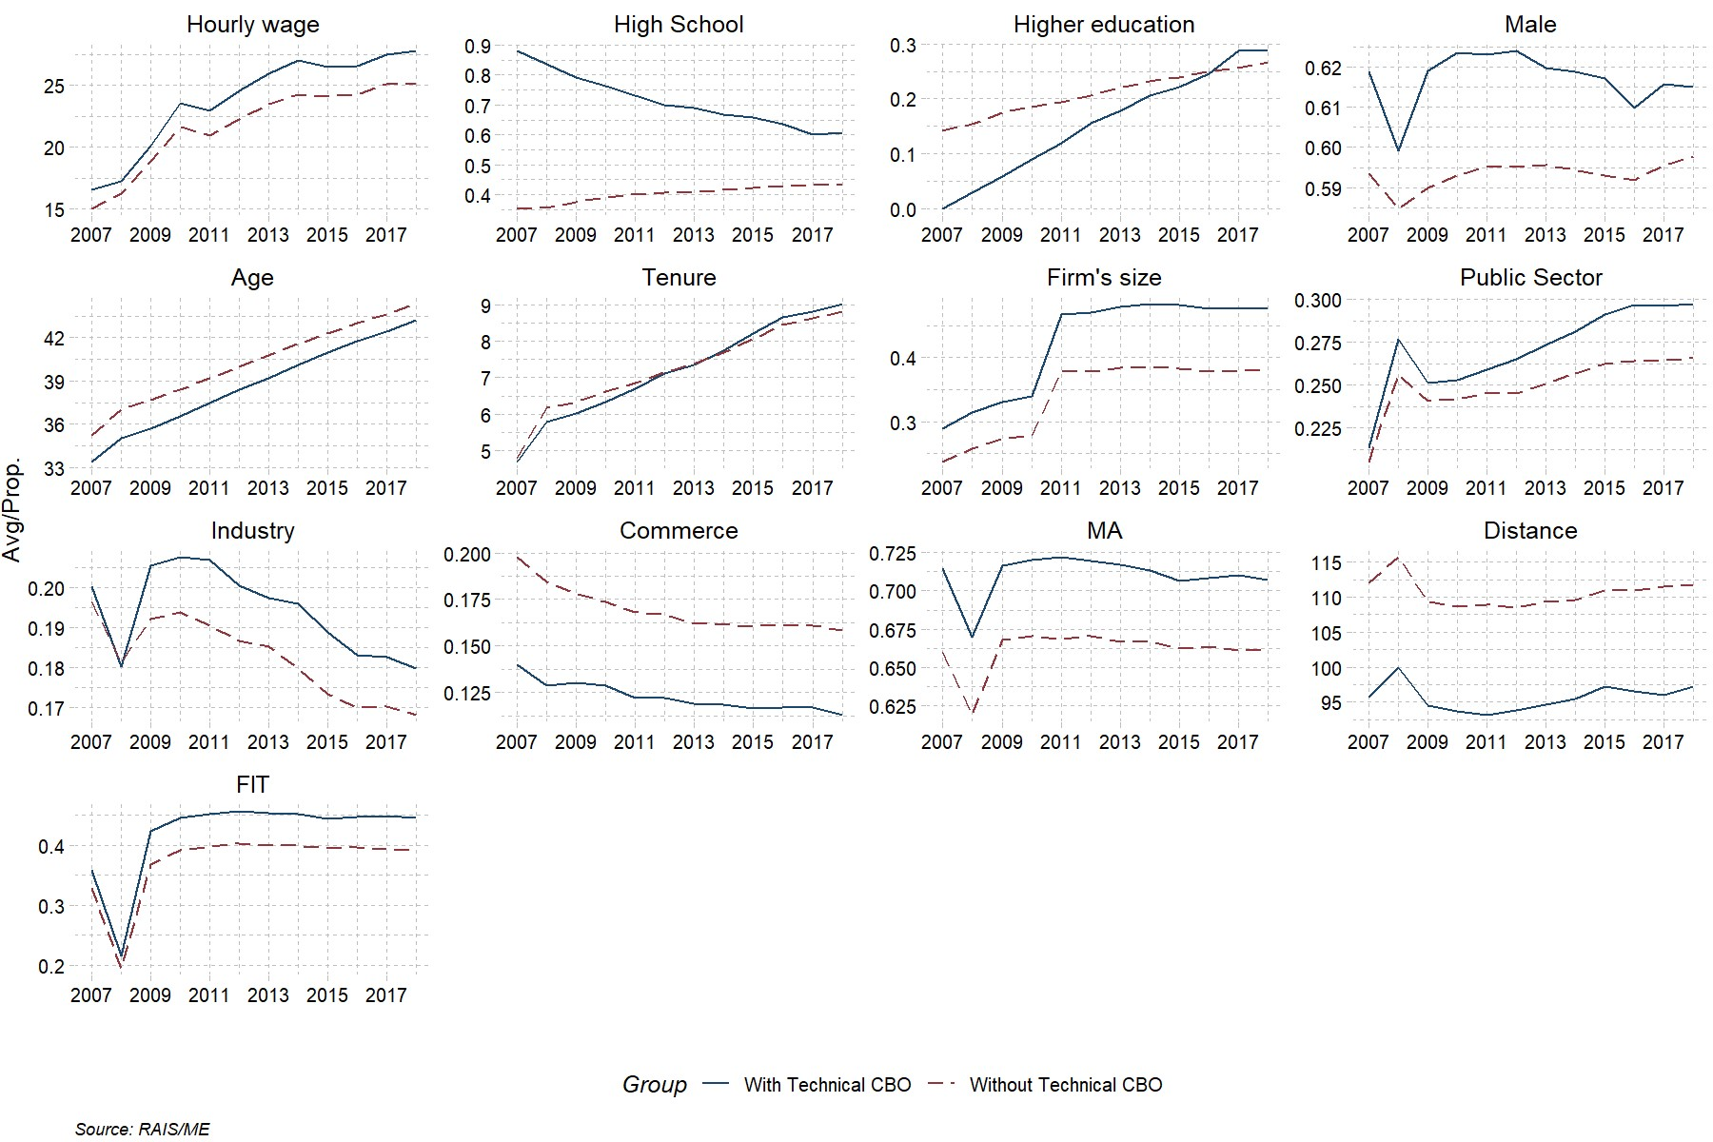

We notice that none of technical worker, by definition, had complete higher education in 2007. During the years, we find a qualification raise with the gap between two groups shortening. By the end of the period (2016 onward), technical workers are the majority with higher education. This result suggest that technical education is not the end of qualification for those workers, but the beginning of a higher education (which is in accordance with Bishop and Mane (2004) and Corseuil, Foguel, and Gonzaga (2019) findings). This raise in education can be related to lifelong learning discussion, where Purcell, Wilton, and Elias (2007) discuss about mature graduates and their difficulties in labor market, while Jenkins et al. (2003) conduction a longitudinal study of UK, with positive effects on wages[33]. Technical workers are a little younger, more male, work more in big companies, in the public sector and in industry (after 2009), but less in Commerce. While tenure is almost the same for both groups, location of jobs is quite different: technical workers are closer to the state capital, in Metropolitan Areas (MA) and in municipalities with Federal Institutes of Technology (FIT). Figures 3, 4 and 5 (in Appendix) show descriptive by CBO, Axis and CNAE, respectively.

Response variable is natural logarithm of real hourly wage. To calculate this variable we transform weekly hired hours into monthly hours, since wages are informed in month base[34]. Ratio between wage and hours worked was adjusted by consumer price index, taking as reference December of 2020[35].

We estimate our results with random effects[36], with Swamy and Arora (1972) parameter transformation.

Table 6 shows results for wage gains, considering all workers.

**Table 6:** Random effect estimation results for all workers, 2007 to 2018

|  |  |  |  |  |
| --- | --- | --- | --- | --- |
| Term | Estimate | Std. Error | T | p-value |
| Intercept | 0.699 | 0.005 | 133.930 | 0.000 |
| Age | 0.063 | 0.000 | 370.402 | 0.000 |
| Age2 | -0.001 | 0.000 | -290.848 | 0.000 |
| Tenure | 0.018 | 0.000 | 215.653 | 0.000 |
| Tenure2 | 0.000 | 0.000 | -51.170 | 0.000 |
| Axis 1 | 0.145 | 0.018 | 8.278 | 0.000 |
| Axis 2 | 0.700 | 0.028 | 25.283 | 0.000 |
| Axis 3 | 0.390 | 0.123 | 3.162 | 0.002 |
| Axis 4 | 1.502 | 0.023 | 66.378 | 0.000 |
| Axis 5 | 0.024 | 0.012 | 2.091 | 0.037 |
| Axis 6 | 2.840 | 0.058 | 49.336 | 0.000 |
| Axis 7 | 0.110 | 0.018 | 6.129 | 0.000 |
| Axis 8 | -0.372 | 0.129 | -2.879 | 0.004 |
| Axis 9 | 7.995 | 0.137 | 58.457 | 0.000 |
| Axis 10 | -0.081 | 0.041 | -1.954 | 0.051 |
| Axis 11 | -0.177 | 0.084 | -2.106 | 0.035 |
| Axis 12 | 18.449 | 0.185 | 99.524 | 0.000 |
| Axis 13 | 0.978 | 0.108 | 9.055 | 0.000 |
| Firm's size | 0.076 | 0.001 | 139.584 | 0.000 |
| Public Sector | 0.135 | 0.001 | 129.543 | 0.000 |
| CBO1 | -0.026 | 0.004 | -7.205 | 0.000 |
| CBO2 | -0.030 | 0.004 | -8.141 | 0.000 |
| CBO3 | -0.161 | 0.004 | -44.547 | 0.000 |
| CBO4 | -0.246 | 0.004 | -68.869 | 0.000 |
| CBO5 | -0.325 | 0.004 | -90.219 | 0.000 |
| CBO6 | -0.368 | 0.004 | -93.469 | 0.000 |
| CBO7 | -0.274 | 0.004 | -75.575 | 0.000 |
| CBO8 | -0.247 | 0.004 | -65.509 | 0.000 |
| CBO9 | -0.266 | 0.004 | -69.868 | 0.000 |
| Industry | 0.064 | 0.001 | 81.404 | 0.000 |
| Commerce | -0.035 | 0.001 | -49.248 | 0.000 |
| GDP PP | 0.002 | 0.000 | 135.609 | 0.000 |
| PBF | 0.000 | 0.000 | 38.457 | 0.000 |
| BPC | 0.000 | 0.000 | 129.789 | 0.000 |
| MA | 0.036 | 0.001 | 36.209 | 0.000 |
| Distance | 0.000 | 0.000 | -49.691 | 0.000 |
| FIT | 0.046 | 0.001 | 73.483 | 0.000 |
| High School | 0.022 | 0.001 | 43.702 | 0.000 |
| Higher education | 0.224 | 0.001 | 283.299 | 0.000 |
| Male | 0.178 | 0.001 | 124.209 | 0.000 |
| Technical CBO | 0.193 | 0.003 | 61.687 | 0.000 |

Source: RAIS/ME

Obs.: R2-Adj: 0.36; F = 1,977,380; DF1: 41; DF2: 3,967,497.

The return estimated is 21.3%[37], which is very similar to the effects reported in Brazilian literature (Barros et al. 2011; Oliveira and Rios-Neto 2007; Vasconcellos, Lima, and MenezesFilho 2010; Aguas 2014). Among the other characteristics contributing to higher wages, higher education and male are the most relevant. It is also interesting to notice that market variables (share of Axis workers in the total) are important in all the cases. Inside Ferracci, Jolivet, and Berg (2014) spill-over effects of treatment discussion, these results suggest this effect is, in general, positive for wages. So, the expect result of higher shares of technical education in a market (and, hence, the competition) meaning lower wages is not prevalent. It might be the case that there is still room to increase technical jobs in Brazilian formal labor market (in other words, participation of technical jobs is low in market).

Despite the panel structure gives a temporal analysis, it might be the case that past tendency of wages is not the same for both groups. To address this limitation, we now look only to young with 18 years-old and high school in 2007. With this filter, we are dealing with people with no experience in formal (full time) job and, hence, no past wage trends[38] (Figure

2).

**Figure 2:** Descriptive of young 18 years-old, 2007 to 2018

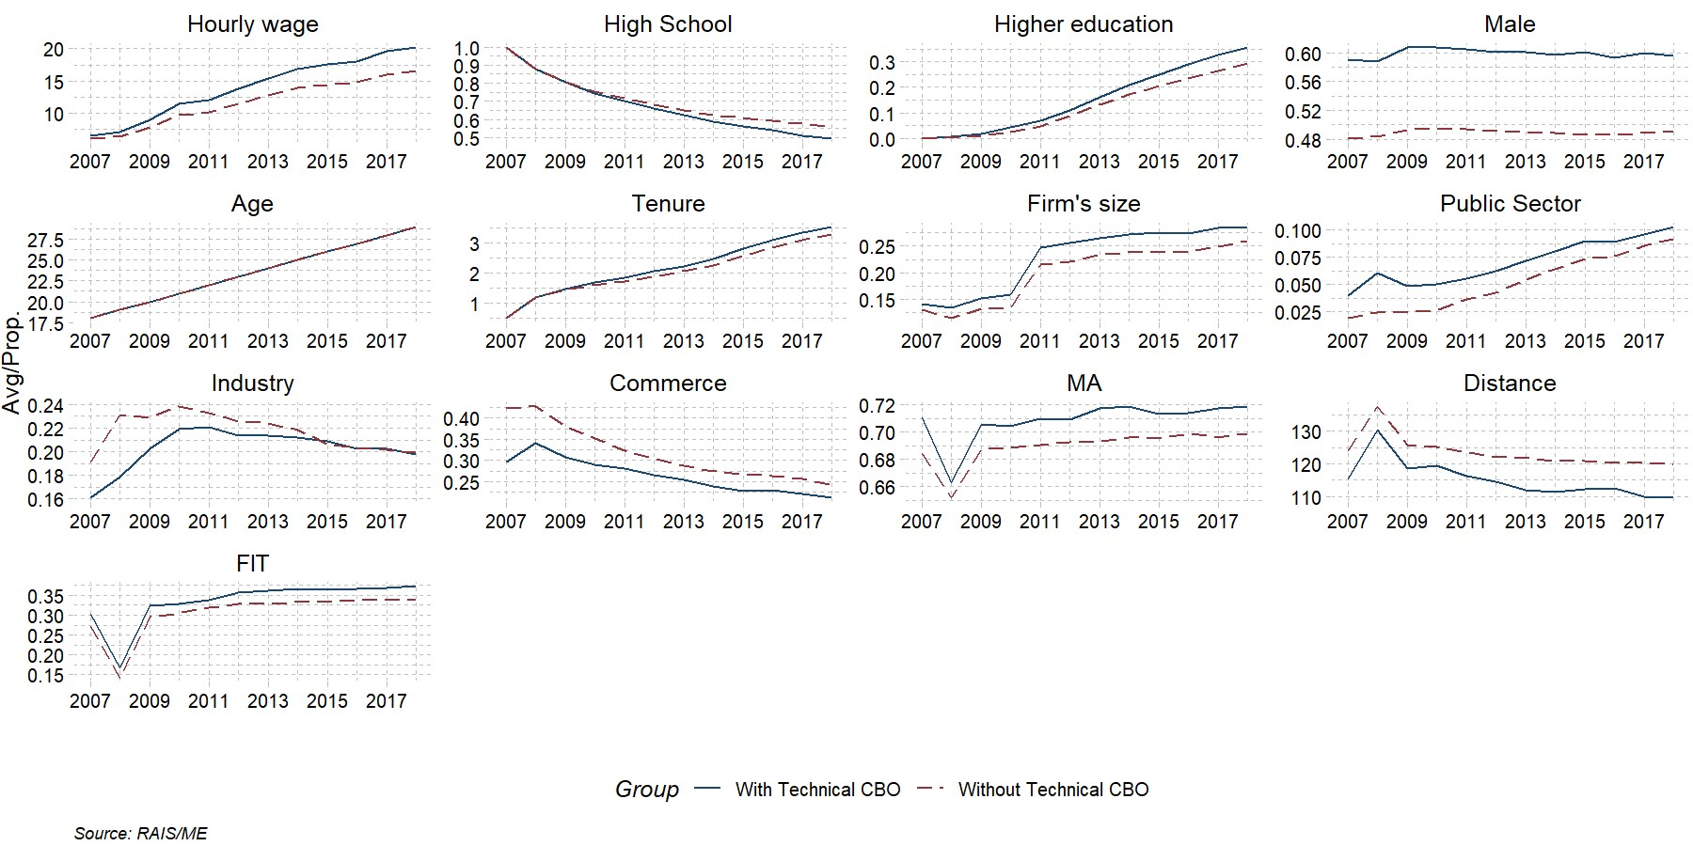

Trends show remarkably similar characteristics in the beginning of the period: almost the same hourly wage, and, by definition, schooling, age and tenure. We still have some difference in formal labor market entrance between groups, where young technical workers are more in public sector and less in Industry and Commerce. It is interesting to notice that the gap in industrial sector is shortened, and, by the end of the period, figures are virtually the same. Like unfiltered database, technical workers are closer to state capital, live more in Metropolitan Areas (MA) and in municipalities with FIT. Table 7 shows the estimation for youth.

**Table 7:** Random effect estimation results for young with 18 years-old in 2007, 2007 to 2018

|  |  |  |  |  |
| --- | --- | --- | --- | --- |
| Term | Estimate | Std. Error | t | p-value |
| Intercept | -1.840 | 0.014 | -135.342 | 0.000 |
| Age | 0.303 | 0.001 | 273.121 | 0.000 |
| Age2 | -0.005 | 0.000 | -221.638 | 0.000 |
| Tenure | 0.037 | 0.000 | 111.082 | 0.000 |
| Tenure2 | -0.002 | 0.000 | -43.109 | 0.000 |
| Axis 1 | -1.076 | 0.036 | -29.888 | 0.000 |
| Axis 2 | 0.705 | 0.047 | 15.163 | 0.000 |
| Axis 3 | 1.665 | 0.218 | 7.622 | 0.000 |
| Axis 4 | 1.170 | 0.039 | 30.046 | 0.000 |
| Axis 5 | 0.256 | 0.027 | 9.644 | 0.000 |
| Axis 6 | 1.881 | 0.100 | 18.896 | 0.000 |
| Axis 7 | 0.019 | 0.037 | 0.517 | 0.605 |
| Axis 8 | 1.611 | 0.201 | 8.001 | 0.000 |
| Axis 9 | 3.608 | 0.209 | 17.305 | 0.000 |
| Axis 10 | 0.975 | 0.076 | 12.808 | 0.000 |
| Axis 11 | -1.038 | 0.156 | -6.658 | 0.000 |
| Axis 12 | 6.468 | 0.341 | 18.965 | 0.000 |
| Axis 13 | 0.449 | 0.168 | 2.671 | 0.008 |
| Firm's size | 0.095 | 0.001 | 108.587 | 0.000 |
| Public Sector | 0.171 | 0.002 | 93.424 | 0.000 |
| CBO1 | -0.143 | 0.005 | -26.338 | 0.000 |
| CBO2 | -0.127 | 0.005 | -23.642 | 0.000 |
| CBO3 | -0.261 | 0.005 | -49.193 | 0.000 |
| CBO4 | -0.365 | 0.005 | -69.225 | 0.000 |
| CBO5 | -0.353 | 0.005 | -66.719 | 0.000 |
| CBO6 | -0.349 | 0.006 | -55.373 | 0.000 |
| CBO7 | -0.343 | 0.005 | -64.231 | 0.000 |
| CBO8 | -0.310 | 0.006 | -55.778 | 0.000 |
| CBO9 | -0.286 | 0.006 | -50.651 | 0.000 |
| Industry | 0.066 | 0.001 | 64.272 | 0.000 |
| Commerce | -0.007 | 0.001 | -8.422 | 0.000 |
| GDP PP | 0.001 | 0.000 | 45.564 | 0.000 |
| PBF | -0.001 | 0.000 | -44.374 | 0.000 |
| BPC | 0.000 | 0.000 | -3.134 | 0.002 |
| MA | 0.027 | 0.001 | 20.546 | 0.000 |
| Distance | 0.000 | 0.000 | -28.840 | 0.000 |
| FIT | 0.039 | 0.001 | 37.370 | 0.000 |
| Higher education | 0.227 | 0.001 | 204.875 | 0.000 |
| Male | 0.100 | 0.001 | 75.359 | 0.000 |
| Technical CBO | 0.056 | 0.003 | 20.850 | 0.000 |

Source: RAIS/ME

Obs.: R2-Adj: 0.57; F = 1,605,544; DF1: 40; DF2: 1,308,728.

When we focus on the restrict data base, i.e. young (aged 18), with high school degree, and who were in technical occupation in the beginning of the period (2007), wage premium still positive, but in a much lower magnitude, 5.8%. Results concerning other characteristics suggests that higher education is the most important, followed by holding a job in public sector. These workers are in a privileged position, once the initial wage premium is large for young people in public sector *vis-à-vis* private sector, with, in general, well defined career progression. The job market variables still have, in general, positive effects, suggesting the same spillover effect observed for the unfiltered data.

So far, when we analyze all workers, we find effects of technical jobs compatible with those estimated before in Brazil. However, when we target the analysis on young workers, with no experience in formal labor market, an important part of the effect vanishes, suggesting that estimations without taking into consideration the trend of earnings may be misleading. Also, it seems to exist an important generation difference in technical education returns, with disadvantage to the most recent cohorts.

## Cross-section analysis: technical education returns in 2007 and 2014

We start the analysis showing the descriptive statistics for the two waves of survey, along with a mean difference t-test between groups (Table 8).

**Table 8:** Descriptive statistics and mean difference test, 2007 and 2014

|  |  |  |  |  |  |  |  |
| --- | --- | --- | --- | --- | --- | --- | --- |
|  | 2007 | | |  | 2014 | | |
| Variable | Tech No | Tech | P.value |  | Tech No | Tech | P.value |
| Formal Job (%) | 40.7 | 23.2 | 0.000 |  | 41.0 | 26.4 | 0.000 |
| Married Couple (%) | 74.2 | 73.4 | 0.066 |  | 72.8 | 71.6 | 0.013 |
| Commerce (%) | 13.7 | 11.6 | 0.000 |  | 12.5 | 11.6 | 0.004 |
| High School (%) | 65.2 | 21.2 | 0.000 |  | 60.6 | 25.7 | 0.000 |
| Higher Education (%) | 20.2 | 7.3 | 0.000 |  | 24.7 | 10.9 | 0.000 |
| Children over 14 | 1.4 | 1.5 | 0.000 |  | 1.1 | 1.1 | 0.001 |
| Children under 14 | 1.3 | 1.6 | 0.000 |  | 0.9 | 1.0 | 0.000 |
| Student (%) | 13.9 | 9.9 | 0.000 |  | 11.6 | 7.8 | 0.000 |
| Public Sector (%) | 13.1 | 4.0 | 0.000 |  | 10.5 | 4.2 | 0.000 |
| Age | 36.7 | 41.3 | 0.000 |  | 39.6 | 43.4 | 0.000 |
| Industry (%) | 14.0 | 9.6 | 0.000 |  | 12.7 | 8.0 | 0.000 |
| Male (%) | 47.8 | 47.7 | 0.936 |  | 50.7 | 47.3 | 0.000 |
| Black (%) | 37.1 | 48.8 | 0.000 |  | 42.2 | 53.2 | 0.000 |
| Ref. Person (%) | 42.5 | 43.0 | 0.306 |  | 47.2 | 45.0 | 0.000 |
| Household Income (WPI) | 2,024.9 | 1,372.3 | 0.000 |  | 3,223.7 | 2,356.8 | 0.000 |
| MR (%) | 41.2 | 31.8 | 0.000 |  | 40.4 | 31.3 | 0.000 |
| Hourly wage | 41.0 | 22.2 | 0.000 |  | 78.9 | 48.0 | 0.000 |
| Tenure (%) | 690.1 | 811.3 | 0.000 |  | 774.4 | 843.9 | 0.000 |
| N# household members | 3.6 | 3.9 | 0.000 |  | 3.3 | 3.5 | 0.000 |
| Urban (%) | 96.2 | 83.7 | 0.000 |  | 96.0 | 85.3 | 0.000 |

Source: PNAD/IBGE

In 2007, except for male, reference person and families with married couple, the two groups are different. By 2014, differences are present in all variables. So, profiles are statistically different, especially in hourly wage differences.

Once we have a potential selection problem, we run a first stage to create an Inverse Mills Ratio (IMR), following the seminal Heckman (1977) paper. Table 9 presents this first stage results.

**Table 9:** First stage regression – probit on occupation status, 2007 and 2014

|  |  |  |  |  |  |
| --- | --- | --- | --- | --- | --- |
| Variable | 2007 | |  | 2014 | |
| Estimate | SD. Error |  | Estimate | SD. Error |
| Intercept | -0.996*** | 0.043 |  | -1.276*** | 0.046 |
| Age | 0.089*** | 0.002 |  | 0.100*** | 0.002 |
| Age2 | -0.001*** | 0.000 |  | -0.001*** | 0.000 |
| High School | 0.269*** | 0.009 |  | 0.249*** | 0.008 |
| Higher Education | 0.788*** | 0.018 |  | 0.719*** | 0.014 |
| Male | 0.661*** | 0.008 |  | 0.693*** | 0.008 |
| Black | -0.008 | 0.007 |  | -0.010 | 0.007 |
| Married Couple | 0.094*** | 0.008 |  | 0.065*** | 0.008 |
| Urban | -0.450*** | 0.019 |  | -0.306*** | 0.017 |
| MR | -0.040*** | 0.010 |  | 0.022** | 0.010 |
| Ref. Person | 0.382*** | 0.009 |  | 0.259*** | 0.008 |
| Children under 14 | -0.001 | 0.002 |  | -0.003 | 0.003 |
| Children over 14 | 0.009*** | 0.003 |  | 0.004 | 0.003 |
| Student | -0.009 | 0.012 |  | -0.060*** | 0.014 |
| Household Income (WPI) | 0.000*** | 0.000 |  | 0.000*** | 0.000 |
| N# household members | -0.007** | 0.002 |  | -0.015*** | 0.003 |

Source: PNAD/IBGE

Obs.: significance level (* = at 10%; ** = at 5%; *** = at 1%)

As expected, age contributes positively (at decreasing rates) in job status, as well education (mainly higher education), gender (for males), families with married couples, the position in household (reference person), have older children and higher household income not considering the personal one (but not in a big magnitude). All positive estimates are consistent in the two years, except for children (no longer significant). Regarding the negative influence, we have urban and Metropolitan Areas and the number of household members in 2007. In 2014, Metropolitan Area changes its sign while be a student now lowers the chance to also have a job. It is interesting to notice that neither blacks nor young children have significant effects on occupational status. Overall, we suspect that it is likely that the IMR will be relevant in the wage equation, presented in Table 10.

**Table 10:** Wage equation for all workers, 2007 and 2014

|  |  |  |  |  |  |
| --- | --- | --- | --- | --- | --- |
| Variable | 2007 | |  | 2014 | |
| Estimate | SD. Error |  | Estimate | SD. Error |
| Intercept | 1.727*** | 0.057 |  | 2.417*** | 0.058 |
| Technical Education | 0.133*** | 0.008 |  | 0.112*** | 0.008 |
| Age | 0.044*** | 0.002 |  | 0.047*** | 0.002 |
| Age2 | 0.000*** | 0.000 |  | -0.001*** | 0.000 |
| High School | 0.208*** | 0.006 |  | 0.180*** | 0.006 |
| Higher Education | 0.824*** | 0.014 |  | 0.753*** | 0.014 |
| Male | 0.347*** | 0.011 |  | 0.393*** | 0.011 |
| Black | -0.141*** | 0.005 |  | -0.116*** | 0.004 |
| Tenure | 0.020*** | 0.001 |  | 0.017*** | 0.001 |
| Tenure2 | 0.000*** | 0.000 |  | 0.000*** | 0.000 |
| Urban | 0.104*** | 0.014 |  | 0.085*** | 0.011 |
| MR | 0.140*** | 0.009 |  | 0.145*** | 0.008 |
| CBO1 | 0.234*** | 0.025 |  | 0.058** | 0.023 |
| CBO2 | 0.020 | 0.024 |  | -0.117*** | 0.021 |
| CBO3 | -0.084*** | 0.023 |  | -0.234*** | 0.021 |
| CBO4 | -0.369*** | 0.023 |  | -0.509*** | 0.021 |
| CBO5 | -0.556*** | 0.023 |  | -0.622*** | 0.020 |
| CBO6 | -0.808*** | 0.028 |  | -0.911*** | 0.024 |
| CBO7 | -0.504*** | 0.023 |  | -0.525*** | 0.020 |
| CBO8 | -0.514*** | 0.025 |  | -0.572*** | 0.024 |
| CBO9 | -0.432*** | 0.025 |  | -0.473*** | 0.023 |
| Public Sector | 0.248*** | 0.009 |  | 0.209*** | 0.009 |
| Industry | -0.014* | 0.008 |  | -0.092*** | 0.007 |
| Commerce | -0.008 | 0.006 |  | -0.072*** | 0.006 |
| Formal Job | 0.121*** | 0.006 |  | 0.065*** | 0.005 |
| IMR | 0.238*** | 0.028 |  | 0.404*** | 0.030 |

Source: PNAD/IBGE

Obs.: significance level (* = at 10%; ** = at 5%; *** = at 1%)

Indeed, in both years, we see that IMR enters with positive and significant sign. Also, we see that the effect of technical education is 14.3% in 2007 and 11.8% in 2014, both lower than the return estimate in panel analysis (which can be related to selection correction). So, even when selection is taken into consideration, return remain positive and compatible with Brazilian literature Oliveira and Rios-Neto (2007).

Although we have results compatible between panel and cross-section data for the unfiltered database, it could not be true when we look just for young with 18 years-old in the start point. Since we do not have a panel structure, but we have the age, we run an additional regression for people aged 25, in order to compare the situation of generation, that were 18 in 2007, seven years later (Table 11).

**Table 11:** Wage equation for people with 18 years-old (2007 and 2014) and for people aged

25 in 2014

|  |  |  |  |  |  |  |  |  |
| --- | --- | --- | --- | --- | --- | --- | --- | --- |
| Variable | 2007 | |  | 2014 | |  | 2014/25 years | |
| Estimate | SD. Error |  | Estimate | SD. Error |  | Estimate | SD. Error |
| Intercept | 1.391*** | 0.228 |  | 2.688*** | 0.327 |  | 3.118*** | 0.136 |
| Technical Education | 0.249*** | 0.064 |  | -0.068 | 0.060 |  | 0.097** | 0.038 |
| Male | 0.290** | 0.106 |  | 0.170 | 0.133 |  | 0.320*** | 0.052 |
| Black | -0.064* | 0.034 |  | -0.052 | 0.032 |  | -0.084*** | 0.023 |
| Tenure | 0.034 | 0.023 |  | 0.029 | 0.026 |  | 0.044*** | 0.009 |
| Tenure2 | -0.004 | 0.003 |  | -0.013** | 0.004 |  | -0.005*** | 0.001 |
| Urban | -0.070 | 0.094 |  | -0.073 | 0.105 |  | 0.105** | 0.043 |
| MR | 0.110** | 0.040 |  | 0.012 | 0.041 |  | 0.073** | 0.026 |
| CBO1 | 0.830*** | 0.220 |  | 0.037 | 0.233 |  | 0.101 | 0.098 |
| CBO2 | 0.568*** | 0.169 |  | 0.106 | 0.196 |  | 0.024 | 0.088 |
| CBO3 | 0.716*** | 0.144 |  | 0.299 | 0.208 |  | -0.061 | 0.085 |
| CBO4 | 0.445*** | 0.132 |  | -0.065 | 0.185 |  | -0.327*** | 0.082 |
| CBO5 | 0.270** | 0.137 |  | -0.151 | 0.188 |  | -0.438*** | 0.082 |
| CBO6 | 0.326** | 0.163 |  | -0.241 | 0.219 |  | -0.633*** | 0.096 |
| CBO7 | 0.410** | 0.135 |  | -0.075 | 0.192 |  | -0.349*** | 0.082 |
| CBO8 | 0.461** | 0.145 |  | -0.200 | 0.209 |  | -0.410*** | 0.109 |
| CBO9 | 0.188 | 0.158 |  | -0.135 | 0.208 |  | -0.343*** | 0.094 |
| Public Sector | 0.050 | 0.108 |  | -0.075 | 0.113 |  | 0.191*** | 0.054 |
| Industry | -0.055 | 0.040 |  | -0.037 | 0.054 |  | -0.050 | 0.033 |
| Commerce | 0.004 | 0.041 |  | -0.083** | 0.036 |  | -0.069** | 0.026 |
| Formal Job | 0.163*** | 0.034 |  | 0.100** | 0.037 |  | 0.072** | 0.025 |
| IMR | 0.609** | 0.295 |  | 0.367 | 0.366 |  | 0.364** | 0.139 |

Source: PNAD/IBGE

Obs.: significance level (* = at 10%; ** = at 5%; *** = at 1%)

While we see a huge effect for youth in 2007, 28.2%, roughly the double of the full sample, the effect in 2014 is not different from zero (with a negative coefficient). When we look to results for people aged 25 in 2014, we see that positive effect is much lower, 10.2%, a little more than one third of the 2007’s effect. If we admit that, in general, the sample of two years are comparable (same generation looked in two times), effect is decreasing in time. Comparing with longitudinal results, with a lower positive effect for young generation of 2007 until 2018, it suggests that effects may have decreased over the years. It is important to keep in mind that 2014 was the beginning of a severe recession that afflicted Brazil in 2015 and 2016[39], so the adverse labor market may explain, in parts, the absence of effect observed. In this context, the so called “scarring effects” might be relevant, since the relationship between youth unemployment and permanent wage/job losses are reported in literature (Gregg and

Tominey 2005; Schmillen and Umkehrer 2017). In a context of recession, which is the case of

Brazil in the late of 2014, scarring effect may be boosted (Eliason and Storrie 2006; Ouyang

2009). According to Gangl (2006), labor network protection plays a crucial role to alleviate this situation, even more because repeated unemployment exposure increases losses.

Hence, it is important to keep in mind that returns to technical education is neither constant over time nor is the same for different generations. It is necessary to update estimates when new data is available in order to assess if the conclusion remains or has changed.

## Heterogeneous effects

It is common that treatment effects differ for subgroups of population from average effects. We have some features regarding technical education that should give different effects, mainly related to the type of activity. First, the public sector has an important role in the Brazilian labor market, with important wage premium that attracts workers (see Belluzo,

Anuatti-Neto, and Pazello (2005); Holanda Barbosa and Holanda Barbosa Filho (2012); Holanda (2009); Souza and Medeiros (2013) for a discussion). Second, technical education has several activities usually related more to industrial jobs than the other sectors of economy. In order to investigate these possibilities, we rerun the results with three filters: only to private sector, only to industrial sector and only to commerce activity (results in Table 12 both for longitudinal and cross-section data).

**Table 12:** Heterogeneous effects of Technical CBO/Education on Private Sector, Industry and Commerce. All workers and young (18 years-old)

|  |  |  |  |  |  |  |  |
| --- | --- | --- | --- | --- | --- | --- | --- |
| Group | Longitudinal | |  | Cross-section | | | |
| Full | Young |  | Full 2007 | Young 2007 | Full 2014 | Young 2014 |
| Private | 0.146*** | 0.048*** |  | 0.152*** | 0.206*** | 0.121*** | -0.024 |
| (0.002) | (0.002) |  | (0.009) | (0.060) | (0.009) | (0.058) |
| Industry | 0.152*** | 0.068*** |  | 0.228*** | 0.362*** | 0.212*** | 0.092 |
| (0.003) | (0.003) |  | (0.019) | (0.082) | (0.020) | (0.119) |
| Commerce | 0.118*** | 0.029*** |  | 0.120*** | 0.221* | 0.091*** | 0.107 |
| (0.003) | (0.003) |  | (0.019) | (0.124) | (0.019) | (0.068) |

Source: RAIS and PNAD/IBGE

Obs.1: significance level (* = at 10%; ** = at 5%; *** = at 1%)

Obs.2: SE in parenthesis

For all workers and in longitudinal data, estimates are, in general, similar among sectors. When we consider only private sector, difference from general return is 5.7 p.p, when we consider industry, difference is 4.9 p.p. and for commerce, difference is 8.8 p.p. suggesting the highest difference for last sector. When we look to young with 18 years-old in 2007, we see that differences for private, industry and commerce are 0.8 p.p, -1.2 p.p and 2.9 p.p respectively, a lower difference than for unfiltered data.

Looking now to cross-section data, we observe that wage premium is higher for industry, both for all workers and for young, with 11.4 p.p. difference (25.6% return) and 15.3 p.p. difference (43.6% return) in 2007, respectively. In 2014, return to industry is also higher than to general estimate, but only for all workers (lower than 2007), with 11.8 p.p. difference (23.6% return). For young with 18 years-old, effects remain no significant, suggesting a different picture among generations.

Thus, technical education seems to enjoy higher returns from industry in a given year

(when cross sectional data is considered), but not in the longitudinal context. Regarding the higher returns for industry, it is natural result if we think these activities as more technological than others, like commerce. These heterogeneous effects are in line with results reported by Carruthers and Sanford (2018) and Stevens, Kurlaender, and Grosz (2019).

## Robustness tests

Despite all richness and sample size of our data, there might remain some selection into technical education not fully controlled. So, to deal with this issue, we match people with technical occupation to the rest of the database in the ratio of two to one. We use the nearest neighbor match, with a *logit* distance (propensity score)[40], considering all variables used in wage regression. Also, we increase the number of observations, both to unfiltered and filtered data (using 2007 data as reference, 5% for the former and 20% for the latter) and, alternatively, we restrict our data only to people who appears in all the years (i.e., we have 12 observations, from 2007 to 2018, to all sample), constructing a balanced panel. Descriptive are in Figures 6 and 7 (longitudinal data) and Tables 17 and 18 (cross-section data) in Appendix, while results are in Table 13.

**Table 13:** Matching results for longitudinal and cross-section database. All workers and young (18 years-old)

|  |  |  |  |  |
| --- | --- | --- | --- | --- |
| Database | Estimate | SE | t | P-value |
| RAIS - all workers | 0.223 | 0.002 | 114.6 | 0.000 |
| RAIS - all workers (balanced) | 0.224 | 0.002 | 123.8 | 0.000 |
| RAIS - Young (18 years-old) | 0.075 | 0.002 | 36.6 | 0.000 |
| PNAD 2007 - all workers | 0.128 | 0.009 | 14.7 | 0.000 |
| PNAD 2007 - Young (18 years-old) | 0.230 | 0.082 | 2.8 | 0.006 |
| PNAD 2014 - all workers | 0.122 | 0.009 | 13.0 | 0.000 |
| PNAD 2014 - Young (18 years-old) | -0.081 | 0.066 | -1.2 | 0.225 |

Source: RAIS/ME and PNAD/IBGE

Obs.: SE = Standard Error

We observe that conclusions remain quite the same. Results seems to be robust both for longitudinal and cross-sectional data, offering, virtually, no changes in conclusion made in previous sections.

To investigate furthermore, Table 14 presents estimates for the random effects withinbetween model for all workers. Due to computational limitation, associated with the necessity of a more parsimonious specification (Bell, Fairbrother, and Jones 2019), we restrict estimation to the matched data and with fewer covariates (omitting the quadratic of age and tenure, industry and commerce dummies, CBO, axes, BPC, MA and distance). We looked to keep all variables with a closer relationship to workers characteristics, focusing in dropping environmental variables.

**Table 14:** Random-effects-between-within for all workers, 2007 to 2018

|  |  |  |  |  |
| --- | --- | --- | --- | --- |
| Variable | Estimate | SE | t | P value |
| Intercept | 1.468 | 0.008 | 194.2 | 0.000 |
| Year | 0.041 | 0.001 | 54.2 | 0.000 |
| Age Bw | 0.006 | 0.000 | 38.0 | 0.000 |
| Age Wi | -0.008 | 0.001 | -9.5 | 0.000 |
| Tenure Bw | 0.038 | 0.000 | 154.3 | 0.000 |
| Tenure Wi | 0.005 | 0.000 | 23.3 | 0.000 |
| FIT Bw | -0.017 | 0.003 | -5.5 | 0.000 |
| FIT Wi | 0.041 | 0.002 | 26.7 | 0.000 |
| Public sector Bw | -0.034 | 0.005 | -7.3 | 0.000 |
| Public sector Wi | 0.117 | 0.004 | 32.4 | 0.000 |
| Firms' size Bw | 0.246 | 0.004 | 60.1 | 0.000 |
| Firms' size Wi | 0.058 | 0.002 | 37.0 | 0.000 |
| GDP pp Bw | 0.006 | 0.000 | 68.7 | 0.000 |
| GDP pp Wi | 0.003 | 0.000 | 55.0 | 0.000 |
| PBF Wi | -0.002 | 0.000 | -62.4 | 0.000 |
| PBF Bw | 0.001 | 0.000 | 38.5 | 0.000 |
| Higher education Bw | 0.853 | 0.008 | 112.9 | 0.000 |
| Higher education Wi | 0.094 | 0.002 | 40.1 | 0.000 |
| High school Bw | -0.011 | 0.004 | -2.6 | 0.008 |
| High school Wi | -0.016 | 0.002 | -9.7 | 0.000 |
| Male | 0.259 | 0.003 | 90.8 | 0.000 |
| Technical CBO | 0.211 | 0.003 | 74.4 | 0.000 |

Source: RAIS/ME

Obs.1: SE = Standard Error; Bw = Between; Wi = Within.

Obs.2: N: 1,068,146; n: 129,754; Marg. R2: 0.43; Cond. R2: 0.95.

Once again, estimates are very closer to our standard model. Here, return to technical occupation is 23.5%, which is 2.2 p.p. higher than standard estimates, and -1.4 p.p. lower than matched database estimates. Since this model allows us to distinguish within (individual related) from between coefficient (time related), we observe that the former class is more important for FIT and public sector, while the latter class is more relevant to age, tenure, firm’s size and higher education. Table 15 presents the same results for young workers (18 years-old in 2007).

**Table 15:** Random-effects-between-within for young workers (18 years-old in 2007), 2007 to

2018

|  |  |  |  |  |
| --- | --- | --- | --- | --- |
| Variable | Estimate | SE | t | P value |
| Intercept | 1.351 | 0.018 | 75.4 | 0.000 |
| Year | 0.067 | 0.001 | 127.4 | 0.000 |
| Age Bw | 0.009 | 0.001 | 10.1 | 0.000 |
| Tenure Bw | 0.048 | 0.001 | 37.1 | 0.000 |
| Tenure Wi | 0.009 | 0.001 | 14.7 | 0.000 |
| FIT Bw | 0.021 | 0.004 | 5.7 | 0.000 |
| FIT Wi | 0.044 | 0.003 | 12.9 | 0.000 |
| Public sector Bw | 0.042 | 0.009 | 4.7 | 0.000 |
| Public sector Wi | 0.184 | 0.008 | 22.2 | 0.000 |
| Firms' size Bw | 0.172 | 0.006 | 30.9 | 0.000 |
| Firms' size Wi | 0.079 | 0.003 | 24.0 | 0.000 |
| GDP pp Bw | 0.003 | 0.000 | 37.7 | 0.000 |
| GDP pp Wi | 0.002 | 0.000 | 26.8 | 0.000 |
| PBF Wi | -0.002 | 0.000 | -31.6 | 0.000 |
| PBF Bw | 0.000 | 0.000 | 7.6 | 0.000 |
| Higher education Bw | 0.472 | 0.008 | 56.4 | 0.000 |
| Higher education Wi | 0.132 | 0.005 | 28.4 | 0.000 |
| Male | 0.097 | 0.003 | 32.5 | 0.000 |
| Technical CBO | 0.072 | 0.003 | 23.3 | 0.000 |

Source: RAIS/ME

Obs.1: SE = Standard Error; Bw = Between; Wi = Within. Age whithin was dropped due to lack of variance.

Obs.2: N: 230,638; n: 34,806; Marg. R2: 0.42; Cond. R2: 0.89

Like the unfiltered data, estimates are very closer to the standard model. The return to technical occupation estimated by REWB is 7.5%, which is 1.7 p.p. higher than the standard estimates, and -0.3 p.p. lower than match estimates. Conclusions regarding the between and within parameters are quite the same.

In sum, we observe that our estimates are very robust to alternative models (standard random effects, with or without matched data, and the within-between version of random effects), all of them suggesting the same pattern for technical education returns. For all workers, returns are higher (between 21.3% and 24.9%) than for young workers (between

5.8% and 7.8%), suggesting differences by generation.

## Cost and benefit analysis

As said before, technical education, usually, has a lower Rate of Return (ROR) due to its higher unit costs (Psacharopoulos 1994). Thus, a natural question is if returns estimated here are enough to face costs of technical education. Unfortunately, we are not able to estimate all costs related to this type of education[41], but we try to give some figures, helping the debate about ROR.

First, we will make some assumptions: (i) the average effect estimate with matching database in the 12 years of our panel will be the same for, at least, 35 years of the labor life;

(ii) we take three interest rates to bring the flow of benefits to present values (6%, 12% and 18%); (iii) we assume, during this period, that people will work the same average weekly number of hours. Taking the current Brazilian inflation target (3.75% in 2021 down to 3.25% in 2023), even with its 1.5% tolerance, the rates chosen are compatible with real positive rates of return. Finally, assuming that technical education usually demands 18 months, we estimate the maximum monthly amount someone could expend to reach the rates of return suggested (Table 16).

**Table 16:** Cost and benefit analysis of technical education returns according to longitudinal matching database

|  |  |  |  |  |
| --- | --- | --- | --- | --- |
| Estimate | Effect per hour | Return in PV | Cost per month | Rate |
|  |  | 154,712 | 8,595 | 6% |
| All workers | 5.01 | 87,241 | 4,847 | 12% |
|  |  | 59,103 | 3,283 | 18% |
|  |  | 38,832 | 2,157 | 6% |
| Young 18 years-old | 1.22 | 21,897 | 1,217 | 12% |
|  |  | 14,834 | 824 | 18% |

Source: RAIS/ME

Obs.1: Number of weekly hours worked are 40.8 and 42.2 for all workers and young, respectively.

Obs.2: We consider 4.35 weeks in a month and 35 years of work.

Obs.3: Costs considering 18 months of a standard technical course.

Obs.4: Estimates from standard random effects with matched data.

The National Education’s Plan[42] established minimum parameters for educational quality and Araújo et al. (2016) estimated the costs by educational phase. The yearly cost per student estimated in 2015, for high school and technical education, was R$ 6,111.16 and R$ 7,944.50 (which gives in Dec/2020 figures R$ 7,562.93 and R$ 9,831.80, respectively). So, the return estimated here covers between 13.6 times and 5.2 times of high school costs, or between 10.5 times and 4 times of technical education costs (depending on rate of return considered). Nonetheless, high school is mandatory to all young Brazilian, so if we consider only the difference between the ideal cost of high school and technical education, R$ 2,268.87, return would be even higher. It is important to remember that ideal cost is not the actual amount spent by the government, so returns are enough to cover the current costs.

However, if we consider the effect just for young workers, returns covers between 3.4 times and 1.3 times the high school costs, and between 2.6 times and 1.01 times technical education costs. It is important to remember that we are not considering the possibility of economies of scale, like when student takes, at the same time, high school and technical education. Also, we are not able to assess any externality, positive or negative, that may alter results. Even though, our results are important to bring to debate the limits until the technical education might be economic and offering update estimates to young interested in pursuit this path.

# Conclusions and remarks

We update estimate of technical education on wages using longitudinal and cross-section data. We were able to consider time dimension with RAIS data, while deal with the selection into labor market with PNAD data. As proxy for technical education (in panel data), we consider people who, in 2007, was holding a job related to technical course, according to National Catalog of Technical Courses, and had high school diploma or incomplete college. Our results suggest a positive and significant wage difference in favor of technical workers. Wages premium, between 21.3% and 24.9% for all workers, and between 5.8% and 7.8% for young workers, indicate that technical education offers, in short or in long run, a good job opportunity. Cross-section analysis confirms such numbers, although not for the young generation in 2014, suggesting that generations may be affected differently over the years.

The magnitude of estimates is consistent with previous works about this issue Oliveira and Rios-Neto (2007).

For students who are finishing academic life and looking for a quick entry into labor market, technical education and, therefore, a technical education, could be an interesting alternative to improve school-to-work transition. Also, the positive effect found here could encourage students to pursuit the technical education path. For Brazil, with only less than 6% of its adults with technical education, public policies towards strengthening qualification of work force may enhance average schooling of labor force, increasing, simultaneously, wage opportunities.

# References

Aguas, Marina Ferreira Fortes. 2014. “Ensaios Sobre a Educação Profissional e Os Rendimentos Do Trabalho: Uma análise Para o Brasil.” PhD thesis.

Alves, Edgard Luiz Gutierrez, and Carlos Alberto dos Santos Vieira. 2009. “Qualificação Profissional: Uma Proposta de Política pública.” *Planejamento e Políticas públicas*, no.

12. [https://www.ipea.gov.br/ppp/index.php/PPP/article/view/143.](https://www.ipea.gov.br/ppp/index.php/PPP/article/view/143)

Araújo, Herton Ellery, Camillo de Moraes Bassi, Ana Luiza Machado de Codes, and Ana Paula Barbosa Meira. 2016. “Quanto Custa o Plano Nacional de Educação?: Uma Estimativa Orientada Pelo Custo Aluno Qualidade (CAQ).” [https://www.ipea.gov.br/po rtal/index.php?option=com_content&view=article&id=28785.](https://www.ipea.gov.br/portal/index.php?option=com_content&view=article&id=28785)

Attanasio, Orazio, Arlen Guarín, Carlos Medina, and Costas Meghir. 2017. “Vocational Training for Disadvantaged Youth in Colombia: A Long-Term Follow-up.” *American Economic Journal: Applied Economics* 9 (2): 131–43.

Attanasio, Orazio, Adriana Kugler, and Costas Meghir. 2011. “Subsidizing Vocational Training for Disadvantaged Youth in Colombia: Evidence from a Randomized Trial.” *American Economic Journal: Applied Economics* 3 (3): 188–220.

Baltagi, Badi. 2008. *Econometric Analysis of Panel Data*. John Wiley & Sons.

Barros, Ricardo, Samuel Franco, Diana Grosner, Rosane Mendonça, and Andrezza Rosalém. 2011. “Educação técnica e Distribuição de Renda No Espírito Santo.” *Revista Brasileira de Monitoramento e Avaliação*, no. 1: 104–35.

Becker, Gary S. 1962. “Investment in Human Capital: A Theoretical Analysis.” *The Journal of Political Economy*, 9–49. [http://www.jstor.org/stable/1829103.](http://www.jstor.org/stable/1829103)

Bell, Andrew, Malcolm Fairbrother, and Kelvyn Jones. 2019. “Fixed and Random Effects Models: Making an Informed Choice.” *Quality & Quantity* 53 (2): 1051–74.

Belluzo, Walter, Francisco Anuatti-Neto, and Elaine T. Pazello. 2005. “Distribuição de Salários e o Diferencial Público-Privado No Brasil” 4 (59): 511–53. [http://www.scielo.br/ pdf/rbe/v59n4/a01v59n4.pdf.](http://www.scielo.br/pdf/rbe/v59n4/a01v59n4.pdf)

Bennell, Paul. 1996. “General Versus Vocational Secondary Education in Developing

Countries: A Review of the Rates of Return Evidence.” *The Journal of Development Studies* 33 (2): 230–47.

Biavaschi, Costanza, Werner Eichhorst, Corrado Giulietti, Michael Jan Kendzia, Alexander

Muravyev, Janneke Pieters, Núria Rodríguez-Planas, Ricarda Schmidl, and Klaus F. Zimmermann. 2012. “Youth Unemployment and Vocational Training.”

Bishop, John H., and Ferran Mane. 2004. “The Impacts of Career-Technical Education on High School Labor Market Success.” *Economics of Education Review* 23 (4): 381–402.

Brunello, Giorgio, Simona Lorena Comi, and Daniela Sonedda. 2012. “Training Subsidies and the Wage Returns to Continuing Vocational Training: Evidence from Italian Regions.” *Labour Economics* 19 (3): 361–72.

Card, David, Jochen Kluve, and Andrea Weber. 2010. “Active Labour Market Policy Evaluations: A Meta-Analysis.” *The Economic Journal* 120 (548).

———. 2018. “What Works? A Meta Analysis of Recent Active Labor Market Program Evaluations.” *Journal of the European Economic Association* 16 (3): 894–931.

Carruthers, Celeste K., and Thomas Sanford. 2018. “Way Station or Launching Pad?

Unpacking the Returns to Adult Technical Education.” *Journal of Public Economics* 165: 146–59.

Corseuil, Carlos Henrique, Miguel N. Foguel, and Gustavo Gonzaga. 2019. “Apprenticeship as a Stepping Stone to Better Jobs: Evidence from Brazilian Matched Employer-Employee Data.” *Labour Economics* 57: 177–94.

Croissant, Yves, and Giovanni Millo. 2008. “Panel Data Econometrics in R: The Plm Package.” *Journal of Statistical Software* 27 (2).

Dougherty, Shaun M. 2018. “The Effect of Career and Technical Education on Human

Capital Accumulation: Causal Evidence from Massachusetts.” *Education Finance and Policy* 13 (2): 119–48.

Eliason, Marcus, and Donald Storrie. 2006. “Lasting or Latent Scars? Swedish Evidence on the Long-Term Effects of Job Displacement.” *Journal of Labor Economics* 24 (4): 831–56.

Ferracci, Marc, Grégory Jolivet, and Gerard J. van den Berg. 2014. “Evidence of Treatment Spillovers Within Markets.” *Review of Economics and Statistics* 96 (5): 812–23.

Fersterer, Josef, Jörn-Steffen Pischke, and Rudolf Winter-Ebmer. 2008. “Returns to Apprenticeship Training in Austria: Evidence from Failed Firms.” *Scandinavian Journal of Economics* 110 (4): 733–53.

Frigotto, Gaudêncio. 2005. “Concepções e Mudanças No Mundo Do Trabalho e o Ensino médio.” *Ensino médio Integrado: Concepção e Contradições. São Paulo: Cortez*, 57–82.

Gangl, Markus. 2006. “Scar Effects of Unemployment: An Assessment of Institutional Complementarities.” *American Sociological Review* 71 (6): 986–1013.

Greenberg, David H., Charles Michalopoulos, and Philip K. Robins. 2003. “A Meta-Analysis of Government-Sponsored Training Programs.” *ILR Review* 57 (1): 31–53.

Greene, William H. 2003. *Econometric Analysis*. Pearson Education India.

Gregg, Paul, and Emma Tominey. 2005. “The Wage Scar from Male Youth Unemployment.” *Labour Economics* 12 (4): 487–509.

Grubb, W. Norton. 1996. *Working in the Middle: Strengthening Education and Training for the Mid-Skilled Labor Force.* ERIC.

Hanushek, Eric A., Ludger Woessmann, Eliot A. Jamison, and Dean T. Jamison. 2008.

“Education and Economic Growth.” *Education Next* 8 (2).

Heckman, James J. 1977. *Sample Selection Bias as a Specification Error (with an Application to the Estimation of Labor Supply Functions)*. National Bureau of Economic Research Cambridge, Mass., USA. [http://www.nber.org/papers/w0172.](http://www.nber.org/papers/w0172)

Heckman, James J., and Jeffrey A. Smith. 2004. “The Determinants of Participation in a

Social Program: Evidence from a Prototypical Job Training Program.” *Journal of Labor Economics* 22 (2): 243–98.

Ho, Daniel, Kosuke Imai, Gary King, Elizabeth Stuart, and Alex Whitworth. 2018. *Package ‘MatchIt’*. Version.

Holanda, Ana Luiza Neves. 2009. “Diferencial de Salários Entre Os Setores público e Privado: Uma Resenha Da Literatura” 1457 (IPEA). [http://www.ipea.gov.br/portal/images/storie s/PDFs/TDs/td_1457.pdf.](http://www.ipea.gov.br/portal/images/stories/PDFs/TDs/td_1457.pdf)

Holanda Barbosa, Ana Luiza Neves, and Fernando Holanda Barbosa Filho. 2012. “Diferencial de Salários Entre Os Setores público e Privado No Brasil: Um Modelo de Escolha Endógena,” no. IPEA. [http://www.en.ipea.gov.br/agencia/images/stories/PDFs/TDs/t d_1713.pdf.](http://www.en.ipea.gov.br/agencia/images/stories/PDFs/TDs/td_1713.pdf)

Jenkins, Andrew, Anna Vignoles, Alison Wolf, and Fernando Galindo-Rueda. 2003. “The

Determinants and Labour Market Effects of Lifelong Learning.” *Applied Economics* 35

(16): 1711–21.

Kahyarara, Godius, and Francis Teal. 2008. “The Returns to Vocational Training and Academic Education: Evidence from Tanzania.” *World Development* 36 (11): 2223–42.

Krafft, Caroline. 2018. “Is School the Best Route to Skills? Returns to Vocational School and Vocational Skills in Egypt.” *The Journal of Development Studies* 54 (7): 1100–1120.

Leon, Fernanda Leite Lopez de, and Naércio Aquino Menezes-Filho. 2002. “Reprovação, Avanço e Evasão Escolar No Brasil.” *Pesquisa e Planejamento Econômico (PPE) - Artigos*. [http://repositorio.ipea.gov.br/handle/11058/4286.](http://repositorio.ipea.gov.br/handle/11058/4286)

Meer, Jonathan. 2007. “Evidence on the Returns to Secondary Vocational Education.” *Economics of Education Review* 26 (5): 559–73.

Mincer, Jacob A. 1974. “Schooling and Earnings.” In *Schooling, Experience, and Earnings*, 41–63. NBER. [http://www.nber.org/chapters/c1765.pdf.](http://www.nber.org/chapters/c1765.pdf)

Neri, Marcelo. 2015. “Motivos Da Evasão Escolar.” *Pesquisa Todos Pela Educação*. [https: //www.cps.fgv.br/ibrecps/rede/finais/Etapa3-Pesq_MotivacoesEscolares_sumario_pri ncipal_anexo-Andre_FIM.pdf.](https://www.cps.fgv.br/ibrecps/rede/finais/Etapa3-Pesq_MotivacoesEscolares_sumario_principal_anexo-Andre_FIM.pdf)

Oliveira, Ana Maria Hermeto Camilo de, and Eduardo Luiz Gonçalves Rios-Neto. 2007. “Uma Avaliação Experimental Dos Impactos Da Política de Qualificação Profissional No Brasil.” *Revista Brasileira de Economia* 61 (3): 353–78.

Ouyang, Min. 2009. “The Scarring Effect of Recessions.” *Journal of Monetary Economics* 56

(2): 184–99.

Psacharopoulos, George. 1994. “Returns to Investment in Education: A Global Update.” *World Development* 22 (9): 1325–43.

Purcell, Kate, Nick Wilton, and Peter Elias. 2007. “Hard Lessons for Lifelong Learners? Age and Experience in the Graduate Labour Market.” *Higher Education Quarterly* 61 (1): 57–82.

Reis, Mauricio. 2015. “Vocational Training and Labor Market Outcomes in Brazil.” *The BE Journal of Economic Analysis & Policy* 15 (1): 377–405.

Sakellariou, Chris. 2003. “Rates of Return to Investments in Formal and Technical/Vocational Education in Singapore.” *Education Economics* 11 (1): 73–87.

Schmillen, Achim, and Matthias Umkehrer. 2017. “The Scars of Youth: Effects of Early-

Career Unemployment on Future Unemployment Experience.” *International Labour Review* 156 (3-4): 465–94.

Silva, Pedro L. N., Djalma Galvão Carneiro Pessoa, and Maurício Franca Lila. 2002. “Análise

Estatística de Dados Da PNAD: Incorporando a Estrutura Do Plano Amostral.” *Ciência & Saúde Coletiva* 7 (4): 659–70. [http://www.scielo.br/pdf/csc/v7n4/14597.](http://www.scielo.br/pdf/csc/v7n4/14597)

Souza, Pedro, and Marcelo Medeiros. 2013. “Diferencial Salarial Público-Privado e Desigualdade de Renda Per Capita No Brasil” 43: 5–28. [http://www.scielo.br/pdf/ee/v43n1/a01 v43n1.pdf.](http://www.scielo.br/pdf/ee/v43n1/a01v43n1.pdf)

Spence, Michael. 1978. “Job Market Signaling.” In *Uncertainty in Economics*, 281–306.

Elsevier.

Stevens, Ann Huff, Michal Kurlaender, and Michel Grosz. 2019. “Career Technical Education and Labor Market Outcomes Evidence from California Community Colleges.” *Journal of Human Resources* 54 (4): 986–1036.

Swamy, PAVB, and Swarnjit S. Arora. 1972. “The Exact Finite Sample Properties of the Estimators of Coefficients in the Error Components Regression Models.” *Econometrica:*

*Journal of the Econometric Society*, 261–75.

Travassos, Claudia, Francisco Viacava, and Josué Laguardia. 2008. “Os Suplementos Saúde

Na Pesquisa Nacional Por Amostra de Domicílios (PNAD) No Brasil.” *Revista Brasileira de Epidemiologia* 11: 98–112.

Vasconcellos, Lígia, Fernanda Costa Lima, and N. Menezes-Filho. 2010. “Avaliação Econômica Do Ensino Médio Profissional.” *Fundação Itaú Social, Brasilia*.

Vooren, Melvin, Carla Haelermans, Wim Groot, and Henriëtte Maassen van den Brink.

2019. “The Effectiveness of Active Labor Market Policies: A Meta-Analysis.” *Journal of Economic Surveys* 33 (1): 125–49.

Wooldridge, Jeffrey M. 2010. *Econometric Analysis of Cross Section and Panel Data*. MIT press.

# Appendix

**Figure 3:** Descriptive for all workers by CBO, 2007 to 2018

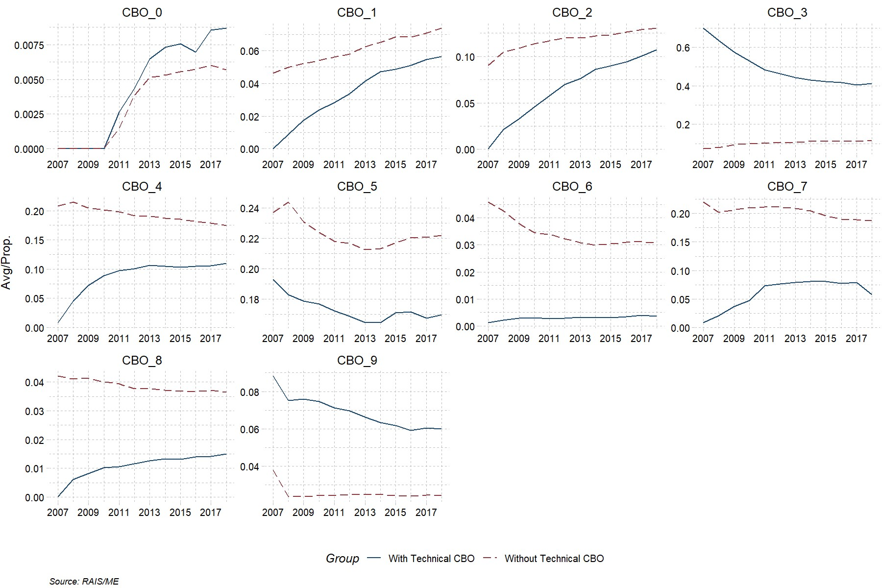

**Figure 4:** Descriptive for all workers by Axis, 2007 to 2018

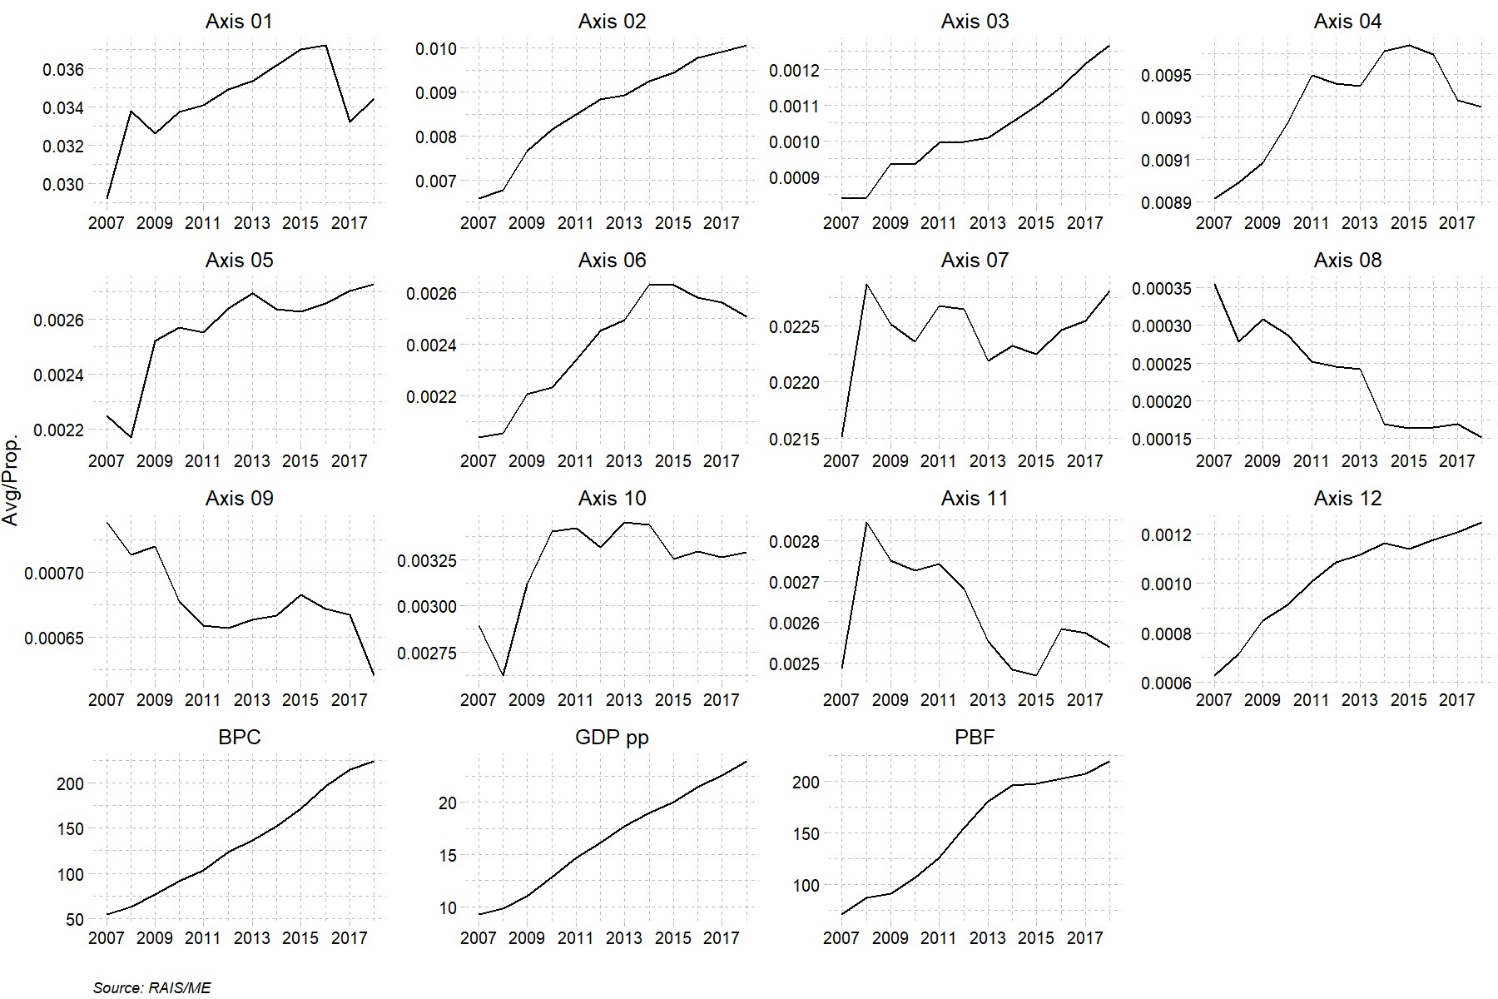

**Figure 5:** Descriptive for all workers by CNAE, 2007 to 2018

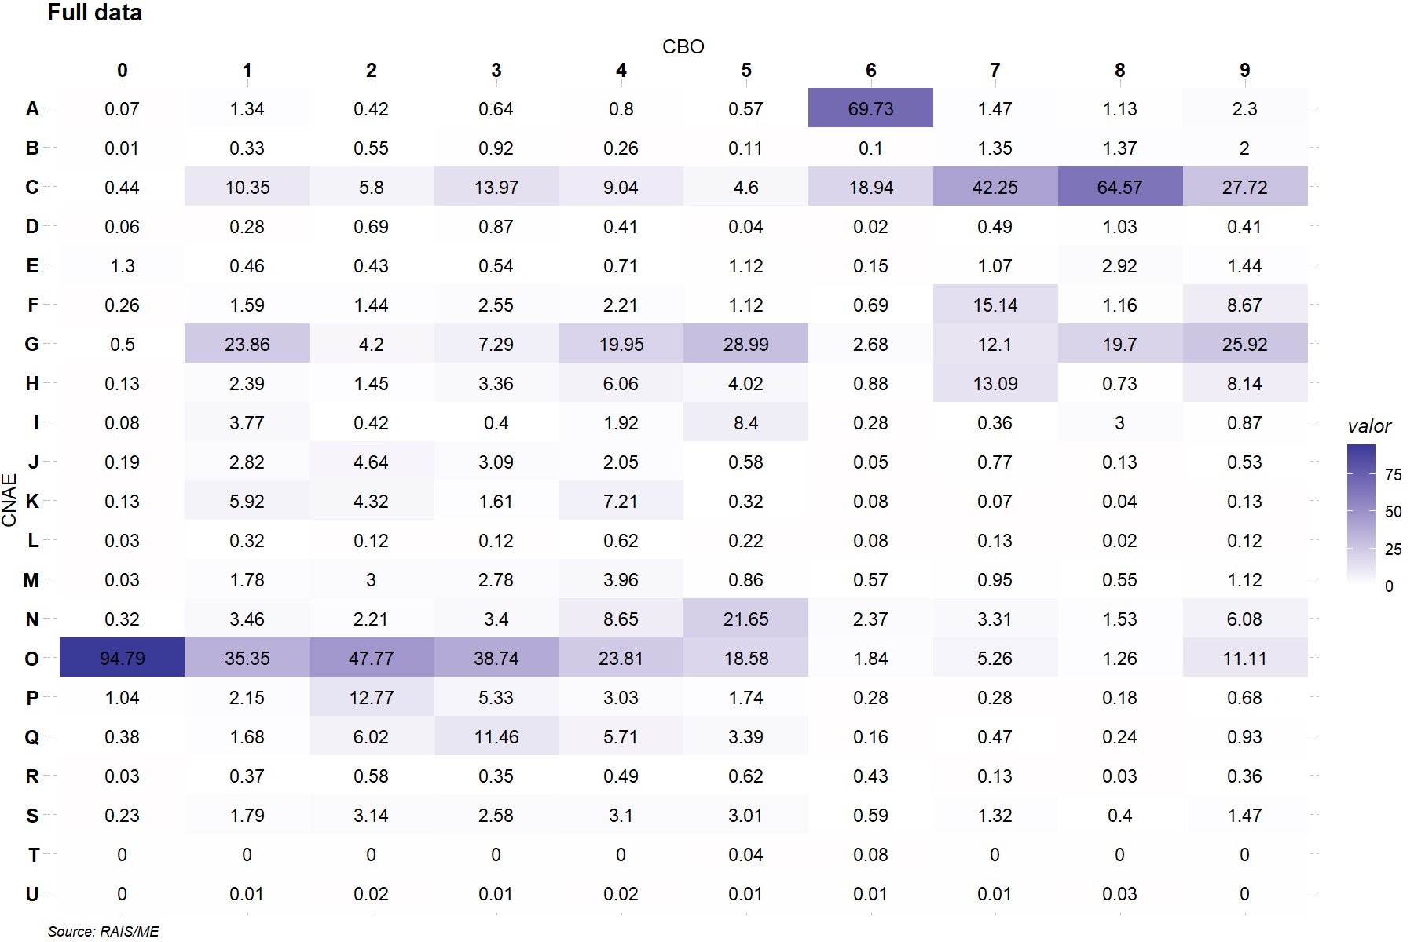

**Figure 6:** Descriptive for all workers for matching database, 2007 to 2018

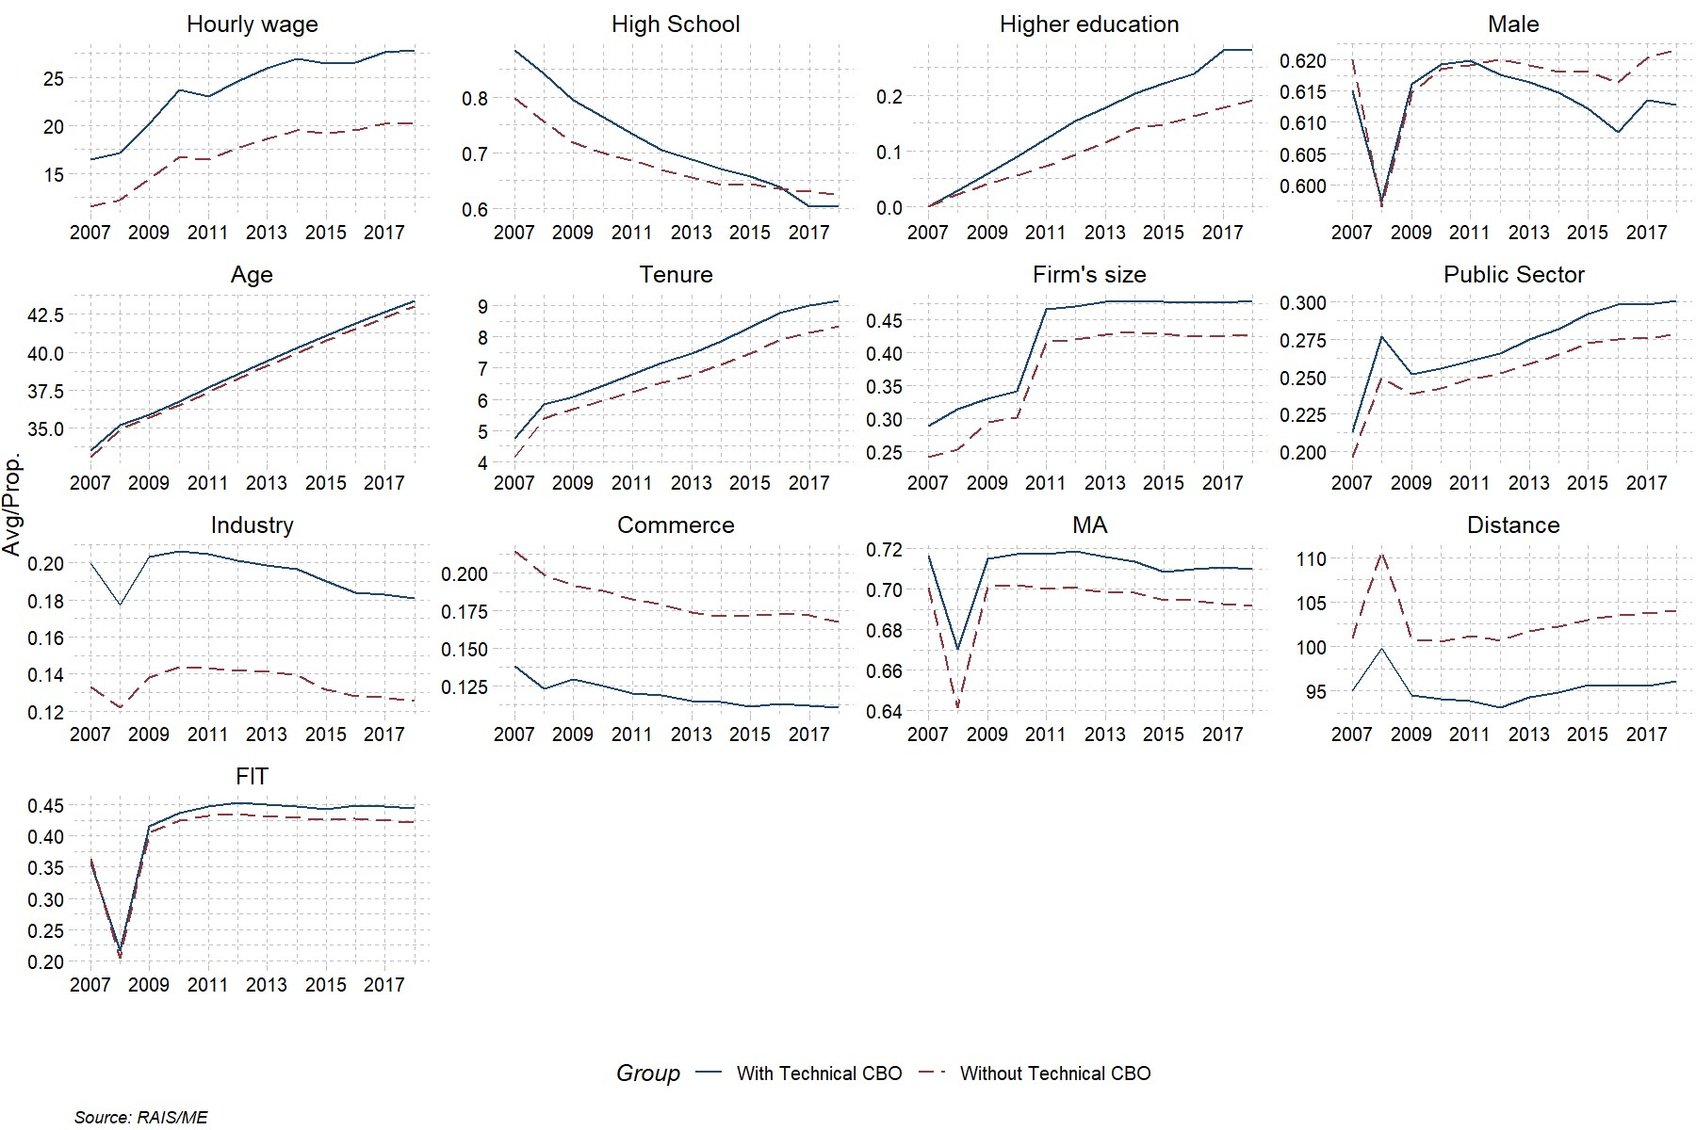

**Figure 7:** Descriptive for young workers for matching database, 2007 to 2018

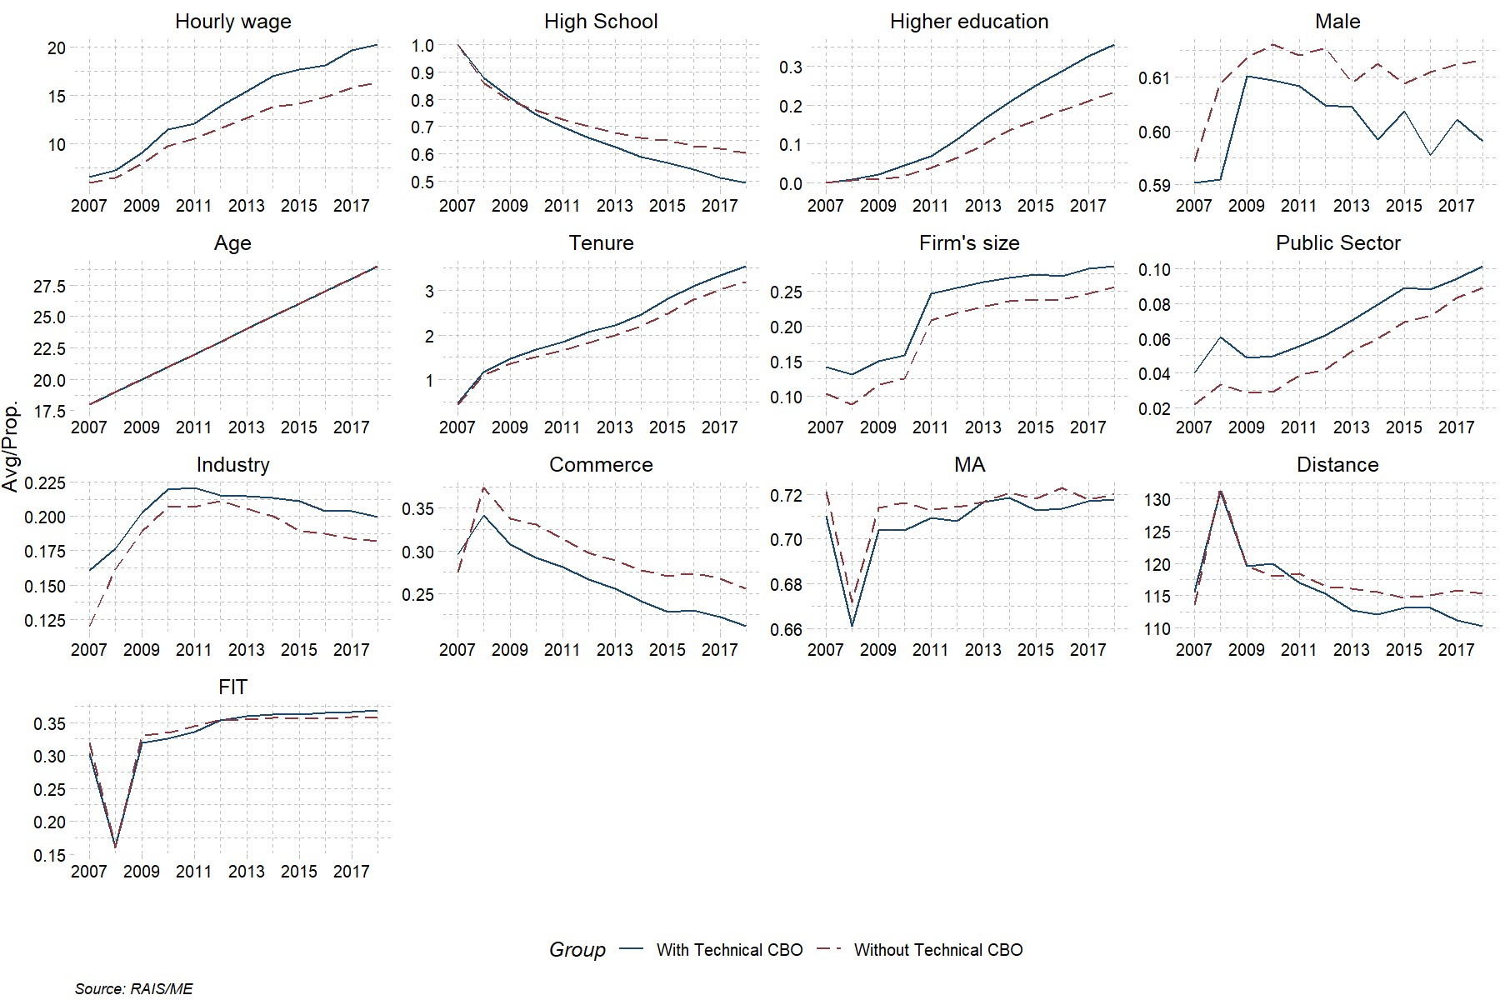

**Table 17:** Descriptive statistics and mean difference test for matching data (all workers), 2007 and 2014

|  |  |  |  |  |  |  |  |
| --- | --- | --- | --- | --- | --- | --- | --- |
| Variable | 2007 | | |  | 2014 | | |
| Tech | No Tech | P.value |  | Tech | No Tech | P.value |
| Formal Job (%) | 40.8 | 27.0 | 0.000 |  | 41.2 | 31.1 | 0.000 |
| Married Couple (%) | 74.5 | 72.9 | 0.001 |  | 72.8 | 71.5 | 0.007 |
| Commerce (%) | 13.7 | 13.1 | 0.064 |  | 12.7 | 13.0 | 0.506 |
| High School (%) | 65.3 | 31.1 | 0.000 |  | 60.8 | 35.0 | 0.000 |
| Higher Education (%) | 19.8 | 11.2 | 0.000 |  | 24.4 | 15.9 | 0.000 |
| Children over 14 | 1.4 | 1.6 | 0.000 |  | 1.1 | 1.2 | 0.000 |
| Children under 14 | 1.3 | 1.5 | 0.000 |  | 0.9 | 1.0 | 0.000 |
| Student (%) | 14.3 | 11.2 | 0.000 |  | 11.6 | 8.9 | 0.000 |
| Public Sector (%) | 13.1 | 5.3 | 0.000 |  | 10.6 | 5.3 | 0.000 |
| Age | 36.6 | 40.4 | 0.000 |  | 39.5 | 42.4 | 0.000 |
| Industry (%) | 14.2 | 10.4 | 0.000 |  | 12.6 | 9.0 | 0.000 |
| Male (%) | 48.0 | 46.7 | 0.023 |  | 50.4 | 46.7 | 0.000 |
| Black (%) | 37.2 | 43.9 | 0.000 |  | 42.1 | 48.0 | 0.000 |
| Ref. Person (%) | 41.9 | 40.7 | 0.029 |  | 46.1 | 42.7 | 0.000 |
| Household Income (WPI) | 2,065.0 | 1,706.8 | 0.000 |  | 3,303.4 | 2,843.7 | 0.000 |
| MR (%) | 39.7 | 36.4 | 0.000 |  | 40.2 | 39.0 | 0.107 |
| Hourly wage | 39.8 | 27.5 | 0.000 |  | 120.1 | 87.6 | 0.000 |
| Tenure (%) | 692.0 | 746.8 | 0.000 |  | 767.7 | 770.0 | 0.837 |
| N# household members | 3.6 | 3.8 | 0.000 |  | 3.3 | 3.4 | 0.000 |
| Urban (%) | 96.6 | 91.5 | 0.000 |  | 96.5 | 93.2 | 0.000 |

Source: PNAD/IBGE

**Table 18:** Descriptive statistics and mean difference test for matching data (18 young),

2007 and 2014

|  |  |  |  |  |  |  |  |
| --- | --- | --- | --- | --- | --- | --- | --- |
| Variable | 2007 | | |  | 2014 | | |
| Tech | No Tech | P.value |  | Tech | No Tech | P.value |
| Formal Job (%) | 38.1 | 16.5 | 0.009 |  | 29.5 | 26.3 | 0.480 |
| Married Couple (%) | 70.7 | 70.3 | 0.968 |  | 75.4 | 74.4 | 0.809 |
| Commerce (%) | 11.1 | 12.5 | 0.766 |  | 14.0 | 14.3 | 0.919 |
| High School (%) | 97.4 | 31.2 | 0.000 |  | 90.9 | 84.2 | 0.019 |
| Higher Education (%) | 0.0 | 0.0 |  |  | 0.0 | 0.0 |  |
| Children over 14 | 2.1 | 2.2 | 0.707 |  | 1.9 | 1.9 | 0.627 |
| Children under 14 | 1.1 | 1.6 | 0.068 |  | 1.0 | 1.0 | 0.577 |
| Student (%) | 20.3 | 53.2 | 0.000 |  | 31.7 | 27.6 | 0.361 |
| Public Sector (%) | 0.0 | 0.2 | 0.044 |  | 0.2 | 0.0 | 0.318 |
| Age | 18.0 | 18.0 | 0.961 |  | 18.0 | 18.0 | 0.665 |
| Industry (%) | 8.4 | 8.6 | 0.954 |  | 6.4 | 9.8 | 0.208 |
| Male (%) | 59.8 | 51.6 | 0.305 |  | 48.3 | 52.4 | 0.438 |
| Black (%) | 42.8 | 48.4 | 0.485 |  | 47.4 | 50.9 | 0.471 |
| Ref. Person (%) | 3.0 | 2.7 | 0.918 |  | 2.1 | 2.9 | 0.596 |
| Household Income (WPI) | 1,958.3 | 1,811.2 | 0.621 |  | 3,273.3 | 3,087.0 | 0.493 |
| MR (%) | 32.4 | 34.8 | 0.742 |  | 33.1 | 35.8 | 0.543 |
| Hourly wage | 13.2 | 9.5 | 0.020 |  | 32.9 | 38.3 | 0.263 |
| Tenure (%) | 91.3 | 143.5 | 0.154 |  | 58.2 | 107.4 | 0.007 |
| N# household members | 4.3 | 4.6 | 0.215 |  | 4.1 | 4.1 | 0.975 |
| Urban (%) | 97.9 | 86.4 | 0.000 |  | 92.2 | 89.6 | 0.318 |

Source: PNAD/IBGE

1. IPEA, bruno.cruz@ipea.gov.br
2. CODEPLAN, luiz.araujo@codeplan.df.gov.br
3. Universidade de Brasília, thiagomendesrosa@outlook.com
4. Ryan (2001) compares countries from Europe and United States in school-to-work transition and several public policies undertaken to improve youth labor Market insertion. In 2019, the Provisional Measure 905 aimed to improve job insertion of young aged 18 to 29, but is no longer active. Available in: <http://www.planalto.gov.br/ccivil_03/_ato2019-2022/2019/Mpv/mpv905.htm>
5. Survey carried out by *Insituto Brasileiro de Geografia e Estatística – IBGE*.
6. People who is looking for a job
7. This means that 54% of people would need, necessarily, increase their schooling level in order to be able to get a technical certificate (plus 4% with incomplete high school).
8. RAIS is a mandatory administrative database. All formal companies in Brazil must inform Ministry of Economy all active employees and/or who was an employee, but left the company during the year.
9. Panel starts in 2007 in order to compare our results with literature
10. Also known as Training and Vocational Education and Training (TVET) or Career and Technical Education (CTE), these terms are interchangeable here, meaning the same type of education. Short term vocational training, or professional qualification, on the other hand, does not have, in general, a formal time schedule neither demands a basic educational background. In addition, government authorization is not required to offer this type of qualification. Thus, professional qualification and technical education are conceptually different, with distinct objectives in Brazil and will be distinguished when necessary.
11. Today, there are three levels of basic education in Brazil. For children under 5 years, called *Educação Infantil*; for children aged 6 to 14, called *Ensino fundamental*; and for 15 to 17, called *Ensino Médio*. These three levels are mandatory to all children/adolescents. They are equivalent, respectively, to preschool and kindergarten, elementary and middle school and high school in countries like United States.
12. Available in: <http://www.planalto.gov.br/ccivil_03/decreto/d2208.htm>
13. Available in: <http://www.planalto.gov.br/ccivil_03/_ato2004-2006/2004/decreto/d5154.htm>
14. Available in: <http://www.planalto.gov.br/ccivil_03/_ato2015-2018/2016/mpv/mpv746.htm>
15. Law 13,415/2017, available in: <http://www.planalto.gov.br/ccivil_03/_ato2015-2018/2017/lei/l13415.htm>
16. According to PNAD/IBGE.
17. Programa Jovem Aprendiz.
18. *Pesquisa Nacional por Amostra de Domicílios* from Brazilian Institute of Statistics and Geography (IBGE).
19. One of 26 Brazilian States.
20. PLANFOR – *Programa Nacional de Qualificação Técnica*.
21. Federal University of Minas Gerais.
22. *Pesquisa Mensal de Emprego*, a survey from IBGE.
23. Information related to defense activity (CNAE 8422-1) was excluded, since all army servants are registered
24. Companies are in charge to provide information, so incorrect report, although rare, is a possibility.
25. Also, these are marginal occurrences.
26. Brazilian Classification of Occupation.
27. This national catalog is currently in third edition, available in: http://portal.mec.gov.br/index.php?option=com_docman&view=download&alias=41271-cnct-3-edicao-pdf&category_slug=maio-2016-pdf&Itemid=30192.
28. The codes for each axis in regressions is 1 to 13 in this same order.
29. PBF is one of the biggest conditional cash transfer program in the world. The target are families under the extreme poverty and poverty lines (in 2020, families earning up to R$ 89 by person, or U$ 17, by month are considered extremely poor, while families above that amount and up to R$ 178, or U$ 34, are considered poor), focused one children. As counterpart, school attendance and vaccination are required. PBF reaches around 14 million families in Brazil in 2021. On the other hand, BPC is a program for elderly and handicapped. The poor population in this profile (people aged 65 or over and all handicapped) are eligible for a minimum wage paycheck (R$ 1.100, or U$ 212, in 2021).
30. In RAIS, one person may have as many entries as jobs she has. Hence, the information is about *job*, not person. If a person has more than one job in a year, we keep the one with higher wage.
31. Considering computer memory constraints, this figure was the maximum value that made this analysis feasible.
32. Before 2004, in the North, only urban areas were in the sample. The other areas of the country were fully representative.
33. A wider discussion regarding lifelong learning can be found in UNESCO Institute for Lifelong Learning [(https://uil.unesco.org/)](https://uil.unesco.org/). In 2017, this subject was present a special report in The Economist: [https: //www.economist.com/special-report/2017-01-14.](https://www.economist.com/special-report/2017-01-14)
34. We consider 4.35 weeks per month.
35. IPCA, calculated by IBGE
36. More information about random effects are available in Greene (2003), Wooldridge (2010), Baltagi (2008) and Croissant and Millo (2008)
37. Due to log transformation, the actual effect is *eβ−* 1.
38. By definition, they have the very same past wage history, i.e. no formal wage in a full time job before 2007.
39. In 2014, the GDP growth was only 0.5%, and, in the next two years, it felt -3.3% and -3.5%. The unemployment rate rose from 6.5% in the last quarter of 2014 to 12% in the same period of 2016, according to PNADC/IBGE.
40. Matching are conduct with “MatchIt” R package (Ho et al. 2018).
41. Brazil has public and private schools offering technical education. In public system, we may have schools maintained by municipal, states or federal governments, with several transfers between them. Also, some schools offer academic and technical courses, making hard to distinguish the costs.
42. *Plano Nacional de Educação*, available in: [http://www.planalto.gov.br/ccivil_03/_ato2011-2014/2014/ lei/l13005.htm](http://www.planalto.gov.br/ccivil_03/_ato2011-2014/2014/lei/l13005.htm)