**Module 1 Assignment**

***Given the provided data, what are three conclusions that we can draw about crowdfunding campaigns?***

The most widely applicable conclusion from this data is that projects the set lower initial funding goals had a higher chance of success. If a project does not meet their initial goal in crowdfunding, they don’t receive any of the funds. You need to at least meet the initial goal to continue your project, and you will not lose funds if you go above your target. In Figure 1 you can observe the highest success rate between $ 15,000 and $ 30,000. If a project demands a high initial capital, crowdfunding may not be the best option. With this in mind, it would be prudent to recommend a modest goal to start with crowdfunding. The recommendation for an initial funding goal would be between $ 15,000 and $ 30,000 based on this collected data.

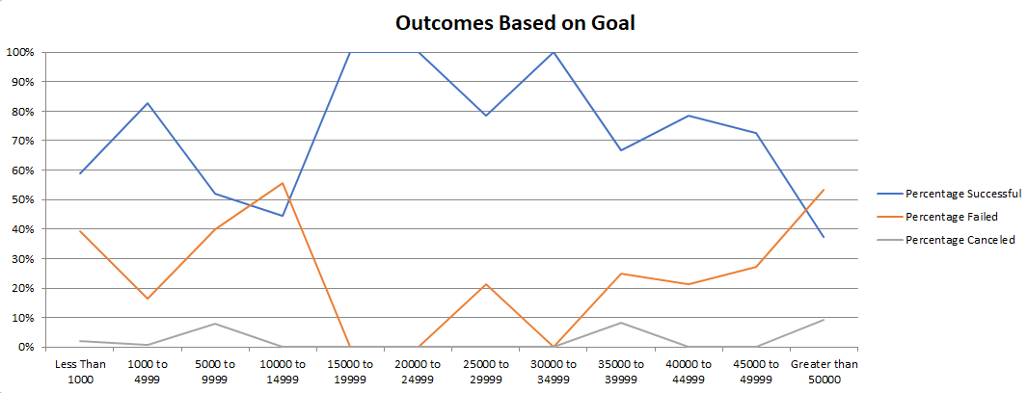

**Figure 1** – Success rate versus grouped funding goals

This dataset has projects from the year 2010 to 2020, in which all the years are fairly evenly populated with data, except for the year 2020.

The most populated categories were theater by far, followed by film & video and music which are very similar in counts. The lowest was Journalism at 4 projects, and

***What are some limitations of this dataset?***

A significant limitation with this dataset is that the source is not known, so no recommendations can be made about which crowdfunding platform to choose. Further research and more data collection would be needed to recommend a certain platform, or whether certain categories are more popular with one or the other.

It is worth noting that this dataset is mostly populated with projects from the United States. Kickstarter and Indiegogo tell us that their platform can be used internationally, so anyone can contribute from anywhere in the world. A project may have received their funds in a specific currency, but the location of the backers in not provided in this data. I would hesitate to draw conclusions regarding a certain category’s success based on country.

The projects are organized in this data are organized by a parent and sub category, but specific details about them are not available. Strategies such as providing incentives to people becoming backers are not known, which would have a reasonable impact on the likelihood of a project reaching its goal.

This leads to a similar issue with the recommendation of setting a lower initial goal to improve success. In this case, success is determining by a funding goal, not by profit or project success. For instance, a successful project could spend all their funds on delivering their product and have zero profit, but will still be considered a success by meeting their initial goal.

The information in this dataset is over a 10 year period, it might be more accurate to take a 5 year trend instead to get more recent trends and data.

***What are some other possible tables and/or graphs that we could create, and what additional value would they provide?***

A table could be made showing the outcome per year, to see how many projects are in this dataset every year. It’s fairly evenly distributed but barely any in 2020. One reason could be that the data was stopped being collected around then.

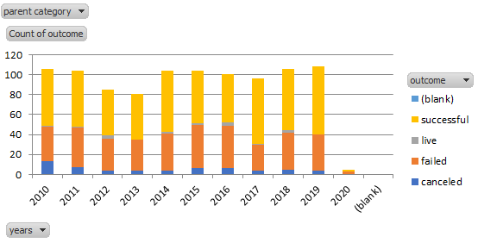

You could compare the number of projects in each category over time, in order to assess the popularity of each category over time. This might help identify a more popular topic to start a project on.

You could also analyze the success rate versus the average donation. That’s something that could be hard to influence in practice, but something simple like rewarding backers who donate over a certain amount could work. If it suggests that a higher amount of lower donations is more success, try to get your crowdfund to reach more people.