

**ADDIS ABABA UNIVERSITY**

ADDIS ABABA INSTITUTE OF TECHNOLOGY

**CENTER OF INFORMATION TECHNOLOGY AND**

**SCIENTIFIC COMPUTING**

DEPARTMENT OF SOFTWARE ENGINEERING

Fundamental of web and development

**Title**: lecture one based assignment

**Assignment number**:1

**Name**: Kidus Yohannes

**ID**: ATR/7242/11

**Section**:2

Submitted To: Mr. Fitsum Alemu

February 2020

**1.1 The History of Internet**

The Internet started in the 1960s as a way for government researchers to share information. Computers in the '60s were large and immobile and in order to make use of information stored in any one computer, one had to either travel to the site of the computer or have magnetic computer tapes sent through the conventional postal system.

Another catalyst in the formation of the Internet was the heating up of the Cold War. The Soviet Union's launch of the Sputnik satellite spurred the U.S. Defense Department to consider ways information could still be disseminated even after a nuclear attack. This eventually led to the formation of the ARPANET (Advanced Research Projects Agency Network), the network that ultimately evolved into what we now know as the Internet. ARPANET was a great success but membership was limited to certain academic and research organizations who had contracts with the Defense Department. In response to this, other networks were created to provide information sharing.

January 1, 1983 is considered the official birthday of the Internet. Prior to this, the various computer networks did not have a standard way to communicate with each other. A new communications protocol was established called Transfer Control Protocol/Internetwork Protocol (TCP/IP). This allowed different kinds of computers on different networks to "talk" to each other. ARPANET and the Defense Data Network officially changed to the TCP/IP standard on January 1, 1983, hence the birth of the Internet. All networks could now be connected by a universal language.

**1.2 Evolution of internet**

The Internet started in the 1960s as a way for government researchers to share information. Computers in the '60s were large and immobile and in order to make use of information stored in any one computer, one had to either travel to the site of the computer or have magnetic computer tapes sent through the conventional postal system.

Another catalyst in the formation of the Internet was the heating up of the Cold War. The Soviet Union's launch of the Sputnik satellite spurred the U.S. Defense Department to consider ways information could still be disseminated even after a nuclear attack. This eventually led to the formation of the ARPANET (Advanced Research Projects Agency Network), the network that ultimately evolved into what we now know as the Internet. ARPANET was a great success but membership was limited to certain academic and research organizations who had contracts with the Defense Department. In response to this, other networks were created to provide information sharing.

January 1, 1983 is considered the official birthday of the Internet. Prior to this, the various computer networks did not have a standard way to communicate with each other. A new communications protocol was established called Transfer Control Protocol/Internetwork Protocol (TCP/IP). This allowed different kinds of computers on different networks to "talk" to each other. ARPANET and the Defense Data Network officially changed to the TCP/IP standard on January 1, 1983, hence the birth of the Internet. All networks could now be connected by a universal language.

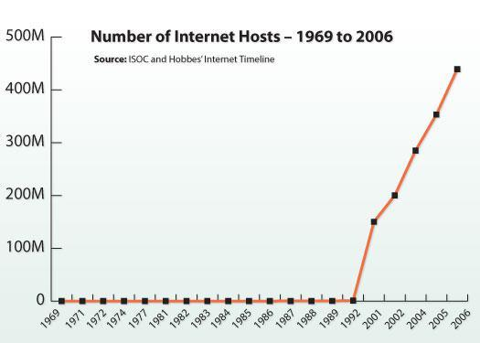

3.1 News website

The news website is basically an online portal for News channel. They offer latest news headlines on Electronic format. You get all latest updates and notification on your device. There is various News portal present now a day.

List of news websites:

* New York Times ([link](http://www.nytimes.com/))
* CNN ([link](http://www.cnn.com/))
* Yahoo news([link](http://news.yahoo.com/))
* Washington post([link](http://www.washingtonpost.com/))
* Fox news([link](http://www.foxnews.com/))

3.2 Informational website

An informational website is a site with a purpose to provide detailed information about a specific topic, such as science, economics, movies, etc.

List of informational websites:

* Wikipedia([link](http://www.wikipedia.org/))
* Dotdash([link](https://www.dotdash.com/))
* Guinnessworldrecords([link](http://www.guinnessworldrecords.com/))
* WHO([link](http://www.who.int/))
* Refdesk.com([link](http://www.refdesk.com/))

3.3 Business (Marketing) website

A business website is any kind of website that represents your business. Even small local businesses need a simple online presence to be taken seriously in today’s world.

Business website is any website that’s devoted to representing a specific business. It should be branded like the business (the same logo and positioning) and communicate the types of products and/or services the business offers.

List of Business (Marketing) websites:

* Amazon([link](http://www.amazon.com/))
* Alibaba ([link](http://www.alibaba.com/))
* Walmart([link](https://www.walmart.com/))
* eBay([link](http://www.ebay.com/))
* Newegg([link](http://www.newegg.com/))

## 3.4 Educational Website

The websites of educational institutions and those offering online courses fall into the category of educational websites. These websites have the primary goal of either providing educational materials to visitors, or providing information on an educational institution to them.

List of Educational Websites:

* W3 school([link](https://www.w3schools.com/))
* EdX([link](https://www.edx.org/))
* Khan Academy([link](https://www.khanacademy.org/))
* WikiHow([link](https://www.wikihow.com/))
* Codecademy([link](https://www.codecademy.com/))

3.5 Entertainment website

They are aimed at entertaining people, both by providing music, video clips or online games.

These websites seem to be colourful and fun to look at, which makes sense considering the nature of their content.

List of Entertainment websites:

### Channel 4([link](https://www.channel4.com/))

* Netflix([link](http://www.netflix.com/))
* IMDb([link](http://www.imdb.com/))
* TMZ([link](http://www.tmz.com/))
* Spotify([link](http://www.spotify.com/))

3.6 Advocacy website

An Advocacy Web Page is one sponsored by an organization attempting to influence public opinion. These web sites usually present views of a particular group or association. Sponsors of advocacy websites include the Democratic National Committee, the Society for the Prevention of Cruelty to Animals, and the Society to Protect Human Rights.

List of Advocacy Website:

* World Advocacy([link](http://www.worldadvocacy.com/))
* Greenpeace([link](http://www.greenpeace.org/))
* Sierra Club ([link](http://www.sierraclub.org/))
* Environmental Defense Action Fund([link](http://www.undoit.org))
* Natural Resources Defense Council ([link](http://www.nrdcwildplaces.org/))

3.7 Blog website

A blog website is a site that is updated with new information on an ongoing basis. It normally consists of a collection of posts. Posts may be short, informal, controversial, or more professional.

List of Blog websites:

* WordPress([link](http://www.wordpress.org/))
* Wix([link](http://www.wix.com/))
* Weebly([link](http://www.weebly.com/))
* Blogger([link](http://www.blogger.com/))
* Tumblr([link](http://www.tumblr.com/))

3.8 wiki website

A wiki is any website where various users are able to collaborate on content and all make their own tweaks and changes as they see fit. There are wikis for fan communities, for business resources, and for collecting valuable information sources.

List of wiki websites:

* Wikipedia([link](https://wikipedia.org/))
* Wiki how([link](https://wikihow.com/))
* World reference([link](https://www.wordreference.com/))
* Stack over flow([link](https://stackoverflow.com/))
* Quora([link](https://www.quora.com/))

3.9 Social Network websites

We all know Facebook and Twitter, but social media sites can take many other forms. These sites are usually created to let people share thoughts, images or ideas, or simply connect with other people in relation to a certain topic.

List of Social Network websites

* Face Book([link](https://www.facebook.com/))
* Twitter([link](http://twitter.com/))
* Skype([link](http://www.skype.com/))
* Tumblr([link](https://www.tumblr.com/))
* QQ([link](http://www.qq.com/))

3.10 Content Aggregator website

A content aggregator is an individual or organization that gathers Web content (and/or sometimes applications) from different online sources for reuse or resale. There are two kinds of content aggregators: (1) those who simply gather material from various sources for their Web sites, and (2) those who gather and distribute content to suit their customer's needs.

List of Content Aggregator websites:

* Alltop([link](https://alltop.com/))
* Popurls([link](http://popurls.com/))
* The Web List([link](http://theweblist.net/))
* Wp News Desk([link](http://wpnewsdesk.com/))
* Blog Engage([link](http://www.blogengage.com/))

3.11 Personal website

A personal website is a group of web pages that someone creates about themselves. It basically contains things that are personal.It is used for personal career marketing (by containing a list of the individual's skills, experience and a CV), social networking with other people with shared interests, or as a space for personal expression.

List of personal websites:

* Nick Jones([link](http://www.narrowdesign.com/))
* Jim Ramsden([link](http://jimramsden.com/))
* Vladimir Strajnic([link](http://www.strajnic.net/))
* Gary Le Masson([link](http://www.garylemasson.com/))
* Juliana Rotich([link](http://julia.na/))

3.12 portal website

Portals are primarily used for internal purposes within businesses, schools, or institutions. These websites often involve a login process, allowing students to access the school website, or granting employees access to their emails, alerts, and files all in one place.

List of portal websites:

* AAiT([link](http://portal.aait.edu.et/))
* Harvard university([link](http://portal.my.harvard.edu/))
* Santander bank([link](https://www.santanderbank.com/))
* York university([link](https://passportyork.yorku.ca/ppylogin/ppylogin))
* Stanford university([link](https://axess.sahr.stanford.edu/))

4.1 Guidelines for evaluating the value of a Web site

There are six Guidelines for evaluating the value of a Web site and they are authority, purpose, coverage, currency, objectivity and accuracy.

4.1.1 AUTHORITY

Authority reveals that the person, institution or agency responsible for a site has the qualifications and knowledge to do so. Evaluating a web site for authority:

* Authorship: It should be clear who developed the site.
* **Contact information** should be clearly provided: e-mail address, snail mail address, phone number, and fax number.
* Credentials: the author should state qualifications, credentials, or personal background that gives them authority to present information.
* Check to see if the site supported by an organization or a commercial body

4.1.2. PURPOSE

The purpose of the information presented in the site should be clear. Some sites are meant to inform, persuade, state an opinion, entertain, or parody something or someone. Evaluating a web site for purpose:

* Does the content support the purpose of the site?
* Is the information geared to a specific audience (students, scholars, general reader)?
* Is the site organized and focused?
* Are the outside links appropriate for the site?
* Does the site evaluate the links?
* Check the domain of the site. The URL may indicate its purpose.

4.1.3. COVERAGE

It is difficult to assess the extent of coverage since depth in a site, through the use of links, can be infinite. One author may claim comprehensive coverage of a topic while another may cover just one aspect of a topic. Evaluating a web site for coverage:

* Does the site claim to be selective or comprehensive?
* Are the topics explored in depth?
* Compare the value of the site’s information compared to other similar sites.
* Do the links go to outside sites rather than its own?
* Does the site provide information with no relevant outside links?

4.1.4 CURRENCY

Currency of the site refers to: 1) how current the information presented is, and 2) how often the site is updated or maintained. It is important to know when a site was created, when it was last updated, and if all of the links are current. Evaluating a web site for currency involves finding the date information was:

* first written
* placed on the web
* last revised

Then ask if:

* Links are up-to-date
* Links provided should be reliable. Dead links or references to sites that have moved are

not useful.

* Information provided so trend related that its usefulness is limited to a certain time

period?

* the site been under construction for some time?

4.1.5 OBJECTIVITY

Objectivity of the site should be clear. Beware of sites that contain bias or do not admit its bias freely. Objective sites present information with a minimum of bias. Evaluating a web site for objectivity:

* Is the information presented with a particular bias?
* Does the information try to sway the audience?
* Does site advertising conflict with the content?
* Is the site trying to explain, inform, persuade, or sell something?

4.16 ACCURACY

There are few standards to verify the accuracy of information on the web. It is the responsibility of the reader to assess the information presented. Evaluating a web site for accuracy:

* Reliability: Is the author affiliated with a known, respectable institution?
* References: do statistics and other factual information receive proper references as to

their origin?

* Does the reading you have already done on the subject make the information seem

accurate?

* Is the information comparable to other sites on the same topic?
* Does the text follow basic rules of grammar, spelling and composition?
* Is a bibliography or reference list included?

4.2 evaluation of websites based on the above guidelines

4.2.1 Ride

[](http://ride8294.com/)

Authority

* The site author is a company named as Hybrid Designs PLC links to a personal website with full ELIGIBILITY AND QUALIFICATION.
* The contact information for ride company is clearly stated as shown below:

Bole, sheger Building office no-706, phone_no 8294.

* Author stated qualifications, credentials, or personal background that gives them authority to present information.

Purpose

* This Web site clearly stated that it’s developed to give information about meter taxi service providing company in Ethiopia called ride. Also this site helps drivers to sign up and start work with company online.

Coverage

* Most of the topics in this site explored in depth for example if we see Drivers sign up it gives full information for prerequisites to sign up.
* Actually, it’s better site when it is compared with other similar sites.
* This site doesn’t provide information for outside links and the links in this site doesn’t go outside.

CURRENCY

* looking at the footer tells us the site was created in 2014, and last updated in Mar 3 2020 so the site information is mostly current.

OBJECTIVITY

* The site trying to explain, inform about there service
* The information’s presented try to attract the audience to Use their service
* The site doesn’t have advertising conflict with the content.

Accuracy

* The site is clearly readable and doesn’t have any spelling and capitalization errors.
* The information in this site is seems to be accurate.

4.2.2 Hulu sport betting

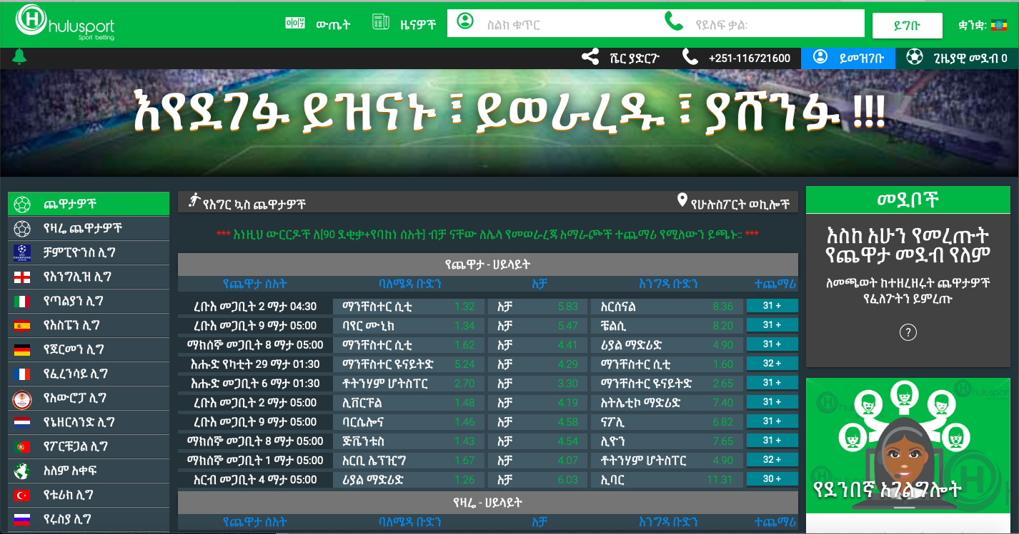

Authority

* The site author is a company named as [Hulegeb Online Solution PLC](http://hulegeb.com) links to a personal website with full ELIGIBILITY AND QUALIFICATION.
* The contact information for Hulu sport is clearly stated as shown below:

Addis Ababa Bole Medhanialem,Beza Building,3rd floor 0118-932131

* Author stated qualifications, credentials, or personal background that gives them authority to present information.

Purpose

* This Web site clearly stated that it’s developed to provide daily odd information of different types of sports in different parts of the world for the games that are held soon. Also allows to bet online by creating account online. IN addition, it allows users to see game result and their bet status online.

Coverage

* Most of the topics in this site explored in depth and it gives full information for prerequisites to sign up.
* Actually, it’s better site when it is compared with other similar sites because it allows users Amharic language as a choice.
* This site doesn’t provide information for outside links and the links in this site doesn’t go outside.

CURRENCY

* looking at the footer tells us the site was created in 2017, and it is updated up-to-date because odds change continuously.

OBJECTIVITY

* The site trying to explain, inform about their service
* The information’s presented try to attract the audience to bet games with their site.
* The site doesn’t have advertising conflict with the content.

Accuracy

* The site is clearly readable and doesn’t have any spelling and capitalization errors.
* The information in this site is seems to be accurate.