

**ADDIS ABABA UNIVERSITY**

ADDIS ABABA INSTITUTE OF TECHNOLOGY

**CENTER OF INFORMATION TECHNOLOGY AND SCIENTIFIC COMPUTING**

DEPARTMENT OF SOFTWARE ENGINEERING

Fundamental of web and development

**Title**: lecture one based assignment

**Assignment number**:1

**Name**: Kidus Yohannes

**ID**: ATR/7242/11

**Section**:2

Submitted To: Mr. Fitsum Alemu

February 2020

1.1 The History of Internet

The Internet started in the 1960s as a way for government researchers to share information. Computers in the '60s were large and immobile and in order to make use of information stored in any one computer, one had to either travel to the site of the computer or have magnetic computer tapes sent through the conventional postal system.

Another catalyst in the formation of the Internet was the heating up of the Cold War. The Soviet Union's launch of the Sputnik satellite spurred the U.S. Defense Department to consider ways information could still be disseminated even after a nuclear attack. This eventually led to the formation of the ARPANET (Advanced Research Projects Agency Network), the network that ultimately evolved into what we now know as the Internet. ARPANET was a great success but membership was limited to certain academic and research organizations who had contracts with the Defense Department. In response to this, other networks were created to provide information sharing.

January 1, 1983 is considered the official birthday of the Internet. Prior to this, the various computer networks did not have a standard way to communicate with each other. A new communications protocol was established called Transfer Control Protocol/Internetwork Protocol (TCP/IP). This allowed different kinds of computers on different networks to "talk" to each other. ARPANET and the Defense Data Network officially changed to the TCP/IP standard on January 1, 1983, hence the birth of the Internet. All networks could now be connected by a universal language.

1.2 Evolution of internet

The Internet started in the 1960s as a way for government researchers to share information. Computers in the '60s were large and immobile and in order to make use of information stored in any one computer, one had to either travel to the site of the computer or have magnetic computer tapes sent through the conventional postal system.

Another catalyst in the formation of the Internet was the heating up of the Cold War. The Soviet Union's launch of the Sputnik satellite spurred the U.S. Defense Department to consider ways information could still be disseminated even after a nuclear attack. This eventually led to the formation of the ARPANET (Advanced Research Projects Agency Network), the network that ultimately evolved into what we now know as the Internet. ARPANET was a great success but membership was limited to certain academic and research organizations who had contracts with the Defense Department. In response to this, other networks were created to provide information sharing.

January 1, 1983 is considered the official birthday of the Internet. Prior to this, the various computer networks did not have a standard way to communicate with each other. A new communications protocol was established called Transfer Control Protocol/Internetwork Protocol (TCP/IP). This allowed different kinds of computers on different networks to "talk" to each other. ARPANET and the Defense Data Network officially changed to the TCP/IP standard on January 1, 1983, hence the birth of the Internet. All networks could now be connected by a universal language.

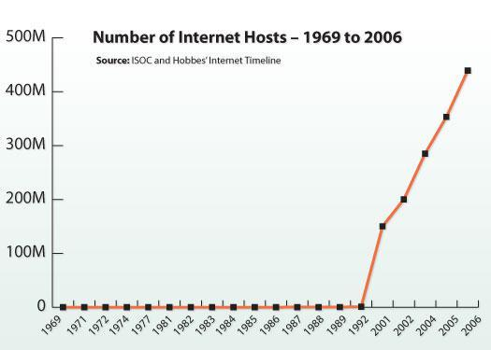

3.1 News website

The news website is basically an online portal for News channel. They offer latest news headlines on Electronic format. You get all latest updates and notification on your device. There is various News portal present now a day.

List of news websites:

* New York Times ([link](http://www.nytimes.com/))
* CNN ([link](http://www.cnn.com/))
* Yahoo news([link](http://news.yahoo.com/))
* Washington post([link](http://www.washingtonpost.com/))
* Fox news([link](http://www.foxnews.com/))

3.2 Informational website

An informational website is a site with a purpose to provide detailed information about a specific topic, such as science, economics, movies, etc.

List of informational websites:

* Wikipedia([link](http://www.wikipedia.org/))
* Dotdash([link](https://www.dotdash.com/))
* Guinnessworldrecords([link](http://www.guinnessworldrecords.com/))
* WHO([link](http://www.who.int/))
* Refdesk.com([link](http://www.refdesk.com/))

3.3 Business (Marketing) website

A business website is any kind of website that represents your business. Even small local businesses need a simple online presence to be taken seriously in today’s world.

Business website is any website that’s devoted to representing a specific business. It should be branded like the business (the same logo and positioning) and communicate the types of products and/or services the business offers.

List of Business (Marketing) websites:

* Amazon([link](http://www.amazon.com/))
* Alibaba ([link](http://www.alibaba.com/))
* Walmart([link](https://www.walmart.com/))
* eBay([link](http://www.ebay.com/))
* Newegg([link](http://www.newegg.com/))