CS 115
LABORATORY 1
READ Carefully, do not skip lines trying to rush it!
Due Date: This laboratory assignment is to be performed(at least started)in class. It can be finished outside the class. It is due on Blackboard on 9/15/15 by 10:00 p.m. MAKE SURE THAT :
- Always create a folder on the Desktop with a name that signifies the assignment (i.e Lab1). You will be saving all your work files in that folder).
- Zip (compress) the files (folder i.e Lab1) and name the zipped version Lab1 followed by your name.
- Upload the zipped file on Blackboard under the proper assignment name which is “Lab 1”.
- When you upload on Blackboard you MUST PRESS the SEND BUTTON. If you only press the save button your submission will NOT be received on Blckboard!!! Please pay attention to this step.
Note: If you are not able to finish this lab in class, make sure that you save your work by either copying it onto a flash drive or by emailing the files to yourself (before you logout). This way you can continue your work at your leisure later on.
Grade: It is worth 2 points towards your final grade.

NOTE: PLEASE SUBSITUTE NOTEPAD++ FOR EDIT PLUS IF YOU ARE DOING THE WORK IN THE LABS. IF YOU HAVE A LAPTOP WITH A DIFFERENT TEXT EDITOR (LIKE EDIT PLUS) USE THAT TEXT EDITOR.
Objectives:
- Provide the ability to write a simple java program.
- Familiarization with the java compiler and compiler error messages.
- Familiarization with the java interpreter and runtime errors.
- Identifying some Java keywords.
- Identifying with logical errors in our program.

In answering the questions in the various assignments you work with your text and the class presentations that summarize the topics. Don’t try to guess if you are not sure of an answer! Research it.

TASK 1. (0.6 points)

- Open a text editor like Notepad++ and type the following program that will output a phrase like “Please enter two numbers”.
public class FirstProgram
{
public static void main(String[] args)
{
int a=10;
int b=20;
int c=a+b;
System.out.println(“The sum of a and b is c=”+” “+c);

}
}

Notice that the phrase “The sum of a and b is c=” is surrounded by double quotation marks. That is called a String. A String is not a command to do something but rather a phrase that needs to be displayed.
Notice that there is also a set of quotation marks with space between them after the + sign (that is called an empty String). Ten afterteh next + sign the identifier c indicates that the value held by the identifier needs to be converted to a String and displayed. The + sign in this case is called the concatenation operator and it indicates that the joint of Strings.

The capitalization is important for language keywords. Keywords are special words that are reserved by the language and which have to be spelled exactly otherwise the compiler will create an error. Keywords can’t be used by the programmer to create names for the class, or the methods or to use them as identifiers (the term will be explained later). Your text has a list of some Java keywords. You can also get a listing from the java tutorial web site (link provided on the course’s web site).

Make sure that you pay attention to the different types of brackets. Do not confuse curly bracket { or } with a regular parenthesis like ( or ) or a solid bracket like [ or ].

A Java program is always a class. The term class is a keyword in Java and we always start by typing: public class…. .After the keyword class we assign the name that we want to give to the program (or class as it is called), in our example we call it FirstProgram (notice that the name of the program can NOT have space between words).
After the name to start the code for the program we type a curly bracket facing to the right i.e {.
Notice that the program ends with a curly bracket facing to the left at the bottom of the program i.e. }.
The brackets are the curly type of brackets except the brackets after the keyword String after main, which are the solid type of brackets. The solid brackets are a special symbol (arrays) that will be used towards the middle of this course. Therefore inside the program (class) we need to create something called a method. A method has the code for a particular task of a program. There can be many methods in a program although we will start our program with a simple single method first.

No matter what a Java program can be run (other terms for run are: executed or interpreted) only if it has a main method (in other words after the curly sign {, we have the name of the method as in the example above: public static void main(String[] args). The program can have other methods but as a minimum it needs to have a main method in order to be able to run it. Please note that a main method is not a requirement if our program is intended to be used by another program that has a main method (notice that programs that act as help programs for other programs are called : service class whereas the program that uses the service class and has a main method is called a client class).

Therefore, in our example above, we have a program that has a main method because we wnt to be ble to execute it (interpreted). The code for the method also starts with a curly bracket { and ends with a curly bracket }.

Notice that ,in our example, after the keyword class, the name of the class is chosen to be FirstProgram. All Java programs start with:

public class ….

Followed by the name that we want to give to the class (the program).This name is chosen arbitrarily by the programmer and it could be anything that the programmer decides to use (within some restrictions that the language demands, for instance the name can‘t be a keyword).

- Amend your program from above, to include inside the main method the comment : This is my first Java program (it should be the first line after the curly bracket that follows public static void main(String[] args). Comments are disregarded by the compiler as long as they are preceded by two slashes //.
Multiple comment lines can also be marked by starting the comments with /* and ending the comments with */ as an alternative to repeating // in every comment line.

- Now our program is complete (hopefully without any typing errors). Create a folder Lab1. Inside folder Lab 1 create another folder named Task1. Click on SaveAS menu item of EditPlus and save your file in folder Lab1/Task1 , under the name : FirstProgram.java (Make sure that you type the extension .java when EditPlus asks you for a name). Notice also that EditPlus also produces a back up file (like FirstProgram.java.bak) that you don’t need . Do not include back up files in the submission of your assignment.

- Notice that EditPlus or Notepad++ uses different colors of font as you type. For instance, comments should appear in green (if not that means that you did not use the comment symbols correctly). Java language keywords are in blue or red. Names that you create, of classes and variables or methods are in black font. Strings that you type are in pink and so on. The colored fonts can prevent typing errors. If you misspell a keyword it would be typed in black and therefore you will get an error when trying to compile.

- Open a DOS window (pane as it is sometimes referred to) from AllPrograms->Accessories->Command Prompt .

Once again we are going to compile and interpret our program Command Line (using a DOS window) first.

Notice that we can also compile a program from EditPlus toolbar by choosing tools->java compiler. We can also run a program from EditPlus by choosing tools-> run java. We are learning to compile and run a program command line first (using a DOS window). Later on you can use EditPlus as an alternative.

- Navigate in the DOS window to the folder where your program is located by using the DOS command cd and the name of the directory (folder). See the pictures below.
Note: to navigate to a directory below the current directory (folder) you type in the DOS window: cd.. (two dots after cd) and then press enter. To navigate to a directory above the current directory you type the DOS command cd and the name of the folder and then press enter. You can use the cd.. command a couple of times to get to C:/> directory. From there you can navigate up to your directory (folder) by using cd then space followed by the name of the directory (folder) above the current directory a number of times until you reach your folder.
i.e. Suppose the current directory is

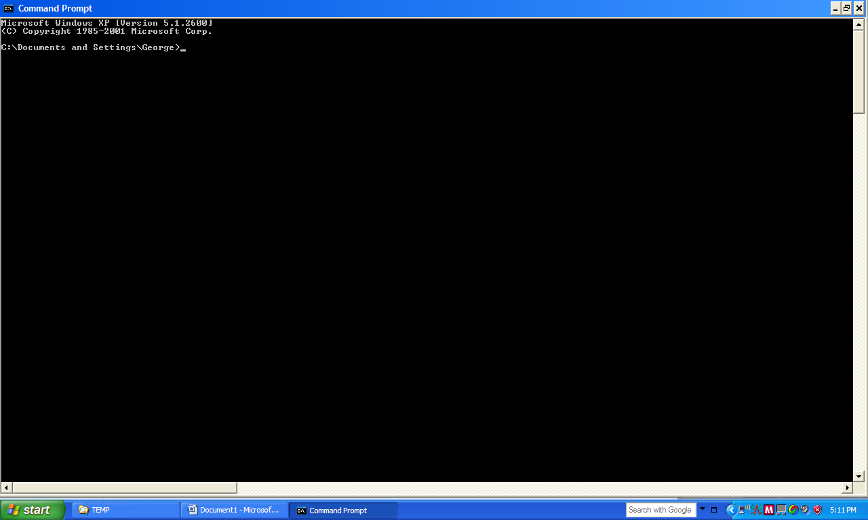
Typing cd .. will bring it one directory down. Typing cd.. again will bring it one directory down again.

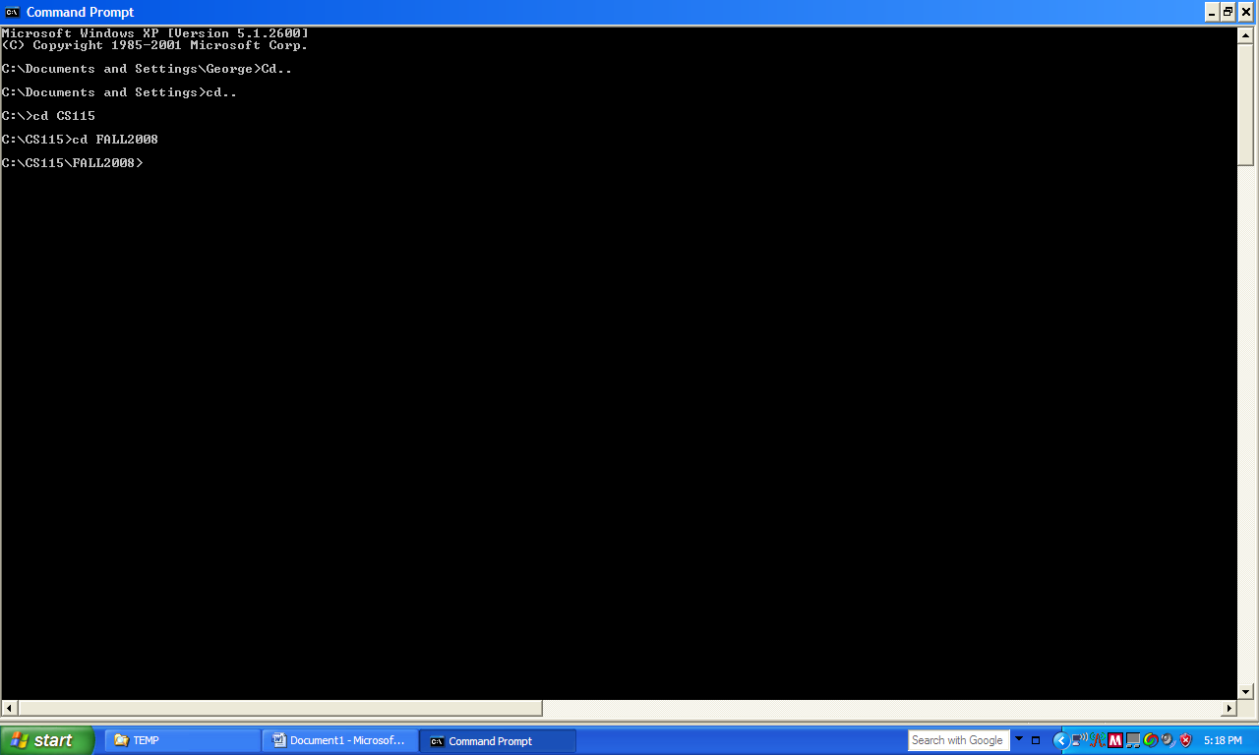

- Once you have navigated in the DOS pane to where your source file is located, compile your program by entering the java compiler command on the DOS pane and the name of the java file that you want to compile (i.e. > javac FirstProgram.java). A successful compilation will not generate any error messages.
If the compiler generates error messages go ahead and correct them in your source code and then try to compile again.

- Once the compiler compiles the program without errors, you can go ahead and interpret (execute) your program by entering this time the interpreter command on the DOS pane (i.e. >java FirstProgram)- Notice that no extension is used after the name of the file. Interpretation should produce the output of the program, visible on the DOS pane.
- (You can copy and paste from the DOS window—click at the upper left corner of the window where the dos symbol is displayed and choose “Edit->Mark” from the drop down menu. In the DOS window highlight the area that you want to mark and then go back to the drop down menu by clicking again at the upper left corner and choose “Edit->Copy”).

Show the program output below:
Answer Question 1:

- Next, let us create a way to open a DOS window that will always be in the current directory without us having to navigate through the directory structure by typing cd. We will do that by creating a .bat file.
Follow the instructions below:
- Open Notepad
- Type the word start (nothing else just the word)
- Save the file in your current directory (folder where your source code file is located) under the name dos.bat. Make sure that in “Save As Type” you choose All Files instead text type of file.
- Next, go to your folder where you saved the .bat file (it would have its own icon as in the picture below and it will be labeled as a MS_DOS Batch File). It should open a DOS window which is in the current directory (your folder).

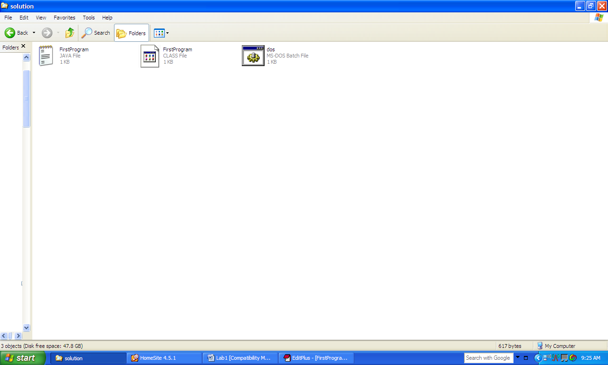

- Click on the icon of the .bat file. That action should result in a DOS window whose cursor is at the directory path of your files!!

- Question (1.1) Write the path to your current directory below:

- Copy the screen from your computer and paste it below to verify that you actually got the proper directory on DOS. (You copy the screen by pressing simultaneously the Fn button and the PrtSc button. Note that these buttons may have a different name on your machine in which case you ask for help. You then right click the mouse and paste it on this document below this line).
Question 2: Answer (paste screen copy below):

List 2 DOS commands that you have learn from Extra Credit Practice Exercise 1 and this Lab.
Answer Question 3:

TASK 2 (0.7 points)
Create a folder Task2 within the folder Lab1 (Lab1/Task2). Save all of your files pertaining to Task 2 in this new folder.
- Using EditPlus type the following program exactly as it is written following the capitalizations as given
public class SecondProgram
{

public static void main(String[] args)
{
Int a=10;
int b=5;
int c=0;
c=b+a;
System.out.println(“The sum of a and b is c=”+” “+c);
}
}
Notice that the first I is capital in Int a=10; !!!!
- Save the file with the proper name and extension in folder Lab1/Task2.

- Copy the DOS batch file from Task1 into the Task2 folder. Open a DOS window by clicking on your batch file dos.bat. Notice that this time the DOS window (pane) is automatically opened in the directory path of your current directory. Try to compile the program. The compiler will NOT compile it but instead it will give you a message regarding an error.

- Type the message from the compiler:
Answer to Question 1:

What do you think happened and what is the generic name of this type of error messages?

Answer to Question 2:

Is there a way to fix the problem? What do we have to do?
Answer to Question 3:

Did the compiler produce the .class file?
Answer to Question 4:

- Fix the problem with the program and try to compile again.
- Interpret (execute) your program.
- Write the output of the program
Answer to Question 5:

- Next open a new file and rewrite the program above to provide two outputs this time. Rename the new class ThirdProgram.
In the line above System.out.println(“The sum is:”+c); type another line that outputs the String “My name is type_your_last_name_here”.
Output is produced with the command: System.out.println(here you enter the String to be outputted).

After that line enter the line of code: System.exit(0); (just above the System.out.println(“The sum is:”+c); line).
Note that the double quotation symbols are needed in order to signify a String.

- Recompile and interpret your program. Write the output that you observe now.
Answer to Question 6:

Explain the difference (did the program produced the same output as before? If not why)? What is missing?:
Answer to Question 7:

What is the generic name for the file produced by the compiling the source code file (the .class file)?
Answer to Question 8:

Notice that every programming instruction ends with a semicolon! Each programming instruction that ends with a semicolon is called “a line of code”.
How many lines of code are in the program ThirdProgram.java?
Answer to Question 9

In the program Third Program.java we have introduced a specific primitive data type.
What is the keyword that identifies that particular data type? What kind of numbers that particular data type can represent?
Answer to Question 10

TASK 3 (0.7 points)
Create another subfolder called Task 3 inside folder Lab1 (Lab1/Task3) and save any files pertaining to this task in this new folder.
In this task you can try compiling and interpreting your programs by using the EditPlus or Notepad ++ toolbar. Go to Tools and click on Compiler menu item to compile. Any errors that can take place should appear at the bottom of the EditPlus screen. You can interpret also by clicking on tools->interpreter (or run) menu item (depending on the machine the name of the command may differ). The output should appear on the bottom of the EditPlus screen.
- Copy the source code file from the last compiled program in Task 2 into this new folder Task3 (ThirdProgram.java). Open the source code file and identify at least 4 keywords that you can in the program . List them below.
Answer to Question 1:

- Introduce an error this time by leaving the semicolon out in line: int c=0;.
- Try to compile it again.
- Write the message from the compiler.
Answer to Question 2:

- Correct the intentionally introduced compiler error and this time let us comment out one line of code so that the compiler does not see it. Comment out the line of code System.exit(0); by introducing the comments symbol in front of the line of code
//System.exit(0);
Also change the name of the program to FourthProgram and save it into a new source code file : FourthProgram.java. Recompile successfully the program.

The keyword int identifies a data type. We have not talked extensively about different data types as yet so accept the term for now. Modify the program FourthProgarm.java by changing the data types from int to double on all identifiers a,b,c.
- Compile it and interpret it.
Write the output now:
Answer to question 3:

How does this output differ than the one in program SecondProgram.java? What kind of numbers does the data type double represent?
Answer to Question 4:

Using the lecture notes, explain what a runtime error is:
Answer to Question 5:

Using the lecture notes, Explain what a logical error is:
Answer to Question 6:

Now please write some comments below about the lab. What changes will you recommend if any, so that the concepts become easier to understand at this level? Keep in mind that the lab assumes that the student has read the lectures and the assigned text chapters.
Comments:

E N D

Submission instructions
- In your submission you must include
  - This WORD document with the answers to the questions at the Lab1 folder level.
  - The source code files FirstProgram.java, SecondProgram.java, ThirdProgram.java, FourthProgram.java and the corresponding .class files FirstProgram.class, SecondProgram.class, ThirdProgram.class and FourthProgram.class in the corresponding subfolders Task1, Task 2, Task 3 as per the instructions.
  - The file dos.bat in each subfolder Task1, Task 2, Task 3.
- Zip all files ( zip the Lab1 folder and that will include all subfolders) and name the zip file using your first name followed by your last name followed by lab1
i.e. George_KayLab1.zip
- Upload the zipped file on Blackboard under the assignment folder Lab1.
- Upload the file on Blackboard by 10:00 p.m. on the due date (Blackboard time stamps automatically)
- If you don’t know how to use Blackboard make sure that you ask one of the TAs how to do it!!!!!!!!!!

Copyrights: Illinois Institute of Technology: George Koutsogiannakis-Fall 2015

