CS 115
LABORATORY 6
This Lab. Is worth 4 points.
TASK 1. (1.0 points)
Question 1 (0.3 points):
Question 1 is code only
Question 2 (0.3 points):
Create a test and listed in the table below for each condition (make sure that all possible conditions are tested):
Test Table: (add or delete rows as necessary)
Test number | User Input | Expected Output | Test Output
1 | 2 | 200 | 200
2 | -1 | The program exits | The program exits
3 | 10 | 10^10 | 1.0E10
4 | 20 | Outputs the string “The value is invalid” | Outputs the string “The value is invalid

Question 3 (0.4 points)
Creating an equals method to allow comparison between objects of a class.
After writing, compiling, and running your program: Tell us what values you want us to enter for each object so that we can properly test your program:

Object 1:
First test values: yo df 1234 34.2
Second test values: yo df 1234 34.2
Object 2:
First test values: er dfb 1234 34.2
Second test values: gerg wgerg 12345 34.5
(all of them are social security numbers)
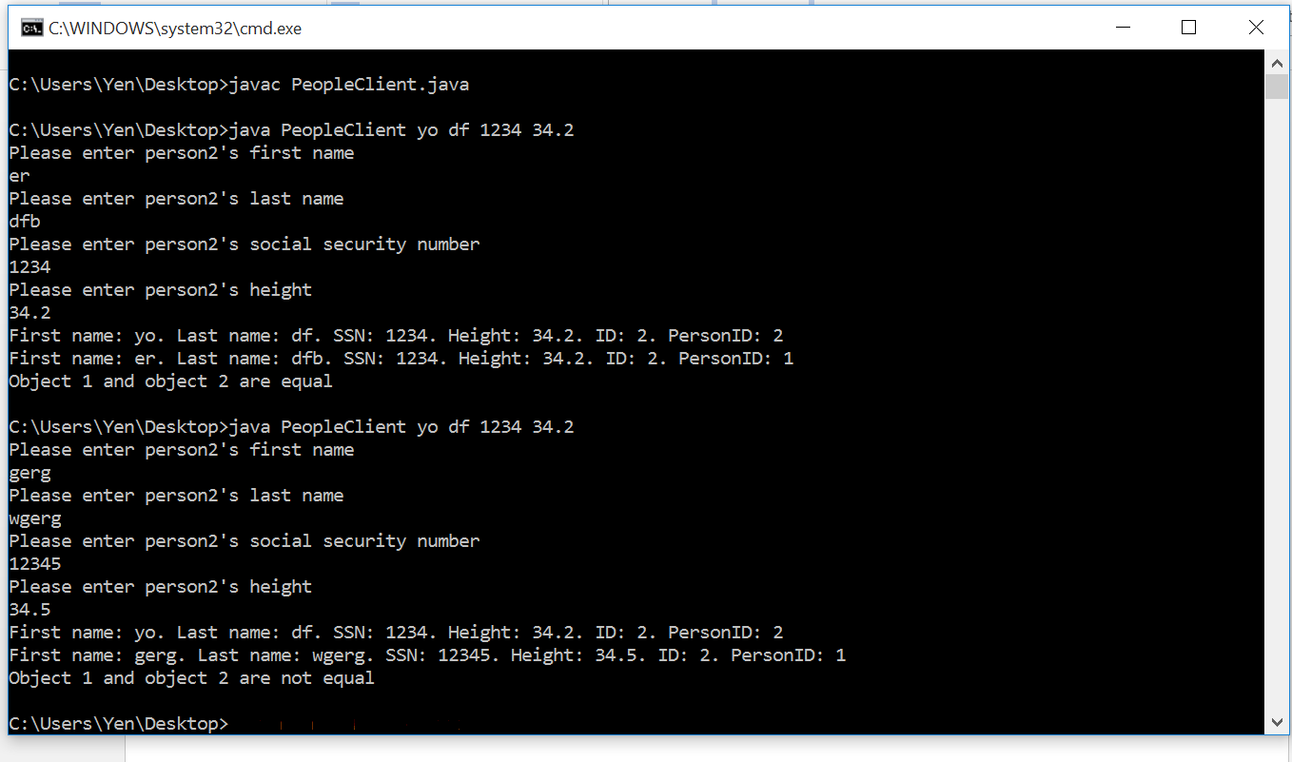

Note: remember that the false logic has to be tested also, therefore the program needs to be run twice, that is why two sets of values are requested.

TASK 2 (1.2 points)
Do exercise 52 page 278 from your text with the additions indicated in the instructions document.

TASK 3. (1.8 points- 0.3 points per question for the first 3 questions. Question 4 is worth 0.5 points, Test Plan is worth 0.4 points.)
Questions (Submit this file with the answers under TASK 3 folder)

Question 1: Consider that class MyClass has two methods: the main method and another method called myOther

public class MyClass{
public static void main(String[] args)
{
Some code here
int k=20;
String str= myOtherMethod(k)
More code here
}
public String myOtherMethod(int x)
{
Code for the method here
}
}//end of class

What’ s wrong with the above code?
The non-static method myOtherMethod(argument) cannot be called in a static method (main method)

Question 2: Rewrite the above code this time fixing the error(s).
We can fix the error by adding the keyword static in the myOtherMethod method
public static String myOtherMethod(int x)

Question 3
Do exercise 50 from chapter 5 of your text page 277. Make sure that it is a working program. Submit the source code and the compiled file.
Write the technique that you are you are going to use to receive input from the user ( we have studied 3 different ways so far of receiving input from the user): Scanner class
What is the name of your class? Season
How are you outputting the result, on DOS pane or on a JOptionPane? NotePad++ tools
TEST PLAN
Now create a test table for your program:
In the table, enter all test conditions that you are going to use in order to verify that your program works correctly:
Number Entered by User | Expected Output (season or invalid range) | Actual Program Output
110 | Summer | Summer
111 | Invalid range | Invalid range
90 | Summer | Summer
70 | Spring | Spring
50 | Fall | Fall
-5 | Winter | Winter
-6 | Invalid range | Invalid range

Question 4
This is a design question. We want to design an OOP (Object Oriented Programming) program that keeps track of the letter grade that each student in CS115 gets, and also tracks certain profile type of information for each student, like first name, last name and id. The id is a number that gets advanced every time we create a new student object. Notice that every student must have its own id number that is not shared by other student objects.
- Describe the classes that you would use. Give the name of each class and indicate if it has a main method or not and if it is a service (template class) or not. Describe the methods that you would have in each class.
First we have a service class called Student. This class will include default constructor method, non-default constructor method, mutator methods and accessor methods.
Then we have a client class called StudentClient. This class will have a main method.

- Which class has the attributes that characterize the profile of each student and any other attributes needed to track the grade for each class that the student takes? What are those attributes? List the attributes and assign proper data type for each attribute.
Class name: Student

Data Type | Identifier for the attribute | What does the attribute track?
String | firstname | The first name of the student
String | lastname | The last name of the student
int | id | The number of students created
Int | studentID | The id of a specific Student object
char | letterGrade | The letter grade of that student
Note: The number of rows in the table above does not mean anything. Add or delete
rows as needed.

- Which class is responsible for creating student objects? StudentClient
What is the purpose of creating student objects? To store a student’s data in the memory by using a set of variables and keep track of it.

- How are you going to create the objects? Do we need information from the user in order to create the objects? If yes what kind of information is needed from the user? We create students objects by asking the users about the data of the student they want to create. The information needed is the 5 attributes of the Student class.

- If information is needed from the user which input technique are you going to use to have your program obtain the information from the user? I am going to use the Scanner class to receive input from the keyboard.
Copyrights: Illinois Institute of Technology: George Koutsogiannakis-FALL 2012

