Drools rule asset repository
<insert cute acronym here>

The drools repo is based on the concept of a versioned content repository. At present the favoured back end for this is JCR (JSR-170) provided by Jackrabbit or Alfresco. However, the API should be able to be implemented with hibernate (using features such as filters to provide persistent versioning and so on).
It is very similar to a source code repository in some ways. In fact, for people using SCM such as SVN, an IDE like Eclipse will already provide this at the file level. The repository goes further then this by providing a normalised store for rule assets, which means greater searchability, rule level version control and so on.

The model

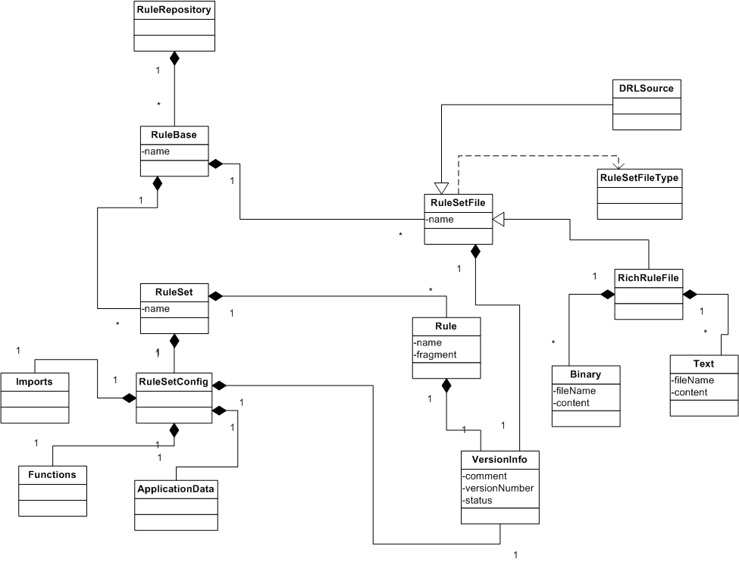

The above logical object model shows the repository structure down to the rule level. Ideally this can be expanded to go to low level rule semantics like the rule assembly language (conditions, consequences, scripts, rule attributes and so on).
This is basically a meta-model for rules. Org.drools.decisiontables.model provides something similar for the purpose of rendering DRL. The above should be able to be transformed to various output formats including: on screen views, web views, rule source files and so on.

Entities
A rule repository has many rulebases (each with a unique name).
A rulebase has many rulesets (each with a unique name)
A ruleset may either be a normalised ruleset (RuleSet) or a attachment style ruleset (RuleSetFile). RuleSetFile versioning is for things like office documents containing rules, decision tables, and possibly DRL files if peope wish to version them like this (it is also possibly that these can be parsed into a normalised RuleSet -> but it would only be for searching purposes).
A normalised RuleSet has many Rules, which is the lowest level of the repository. Rules have many properties which may be searched on (not specified).

Versioning: the objects that can be versioned are Rule, RuleSetFile and RuleSetConfig. Normalised rulesets do not have their own version, as their version is determined by their rules and the RuleSetConfig.
The above model may be use to provide local cache storage for later interation with a remote RuleRepo (if the repo is remote. A repo could possibly be local, it can be embedded).

API
Following is a rough first cut of the API. I need to ensure that this service based API conforms to all of the use cases (or enough foundation cases that others can be built on it). This API requires that a session with the users credentials is established.

/**
* This will mark the asset as checked out by the current user.
*
* The idea is to prevent anyone else working on it at the same time.
* Assets needs to be checked out, so when they are checked in their versions are updated.
* This may also lock the asset, not sure...
* Can provide seperate explicit lock methods if needed.
*/
public RuleSetFile checkoutFile(String ruleBaseName, String ruleSetName);
public RuleSetConfig checkoutRuleSetConfig(String ruleBaseName, String ruleSetName);
public Rule checkoutRule(String ruleBaseName, String ruleSetName, String ruleName);

/**
* These methods add brand new assets to the repository.
* Exceptions thrown if you don't fill out the right stuff etc.
* The names must be unique of course, or exceptions will be thrown.
*/
public RuleSetFile addNewFile(String ruleBaseName, RuleSetFile file);
public RuleSet addNewRuleSet(String ruleBaseName, RuleSet ruleSet);
public Rule addNewRule(String ruleBaseName, String ruleSetName, Rule rule);

/**
* This method updates the asset in the repository, and
* increment the version number etc.
* If someone else beat you to it, it will chuck a wobbly. Whereby you
* can tell the poor user, they are going to have to find out who it was,
* and throw a phone at their heads, russle crowe style.
* Of course, with checkouts, it should stop anyone else checking it out.
*/
public VersionInfo checkin(Asset asset, String comment);

/**
* This will change the status flag on the latest version of the asset.
* It will make sure that your version is up to date before allowing it.
*/
public VersionInfo changeStatus(Asset asset, String newStatus);

/**
* Returns a list of rulebase names in the repository.
*/
public List listRuleBaseName();

/**
* This returns a list of rule-set names for a given rulebase.
*/
public List listRuleSetNames(String ruleBase);

/**
* This will deeply load the whole RuleSet.
*/
public RuleSet retrieveRuleSet(String ruleBaseName, String ruleSetName);

/**
* This will load a RuleSetFile.
*/
public RuleSetFile retrieveRuleSetFile(String ruleBaseName, String ruleSetName);

/**
* Haven't really defined how to search for things,
* but will be on most fields.
* Can return a list of assets that match, which could be rules, rulesets etc...
* Probably need some canned queries, as well as some XPath ones.
* Can do things like search for rules modified on a certain date, in various states etc.
* TODO: get a list of basic functionality to support.
*/
public List searchRules(Properties searchProperties);

/**
* Sets up a virgin repository. Only needs to be called once.
*/
public void createNewRepo();

