** New BRMS chapter content for the rules manual **

Overall new UI
(this is to be used as the start as a screenshot of what it is all about).

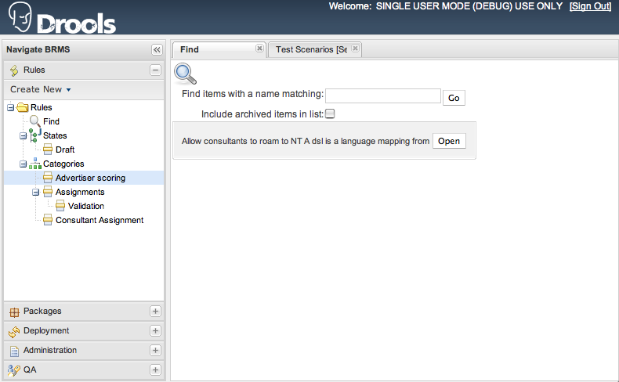

Admin (section)

New error log viewer
When executing actions in the web interface, if serious errors happen, or important events, they can be viewed in the error log viewer, which shows a view of recent events (it is not the complete list – the complete log is stored in files on the server).

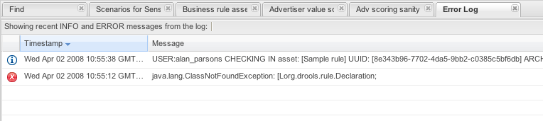

Info level items show up as the “i” icon – these are not problems, just the record of an occurrence.

Quality Assurance of rules
The BRMS supports automated tools for checking rule quality and accuracy. One of these is the static analysis tool of rules.
The other tool is to have Scenarios which test the rules and check expected results with actual results.

Analysing rule logic
The analysis tools is very simple to use. It involves finding the QA section of the application, and then selecting a package to analyse. All the rules for the package are generated, parsed, and then validated against some built in logic rules (rules are used internally to validate your rules).
This checks for well known pitfalls, and gaps in logic, or inconsistencies.
Once the tool has been run on the package, its output may look something like the following:
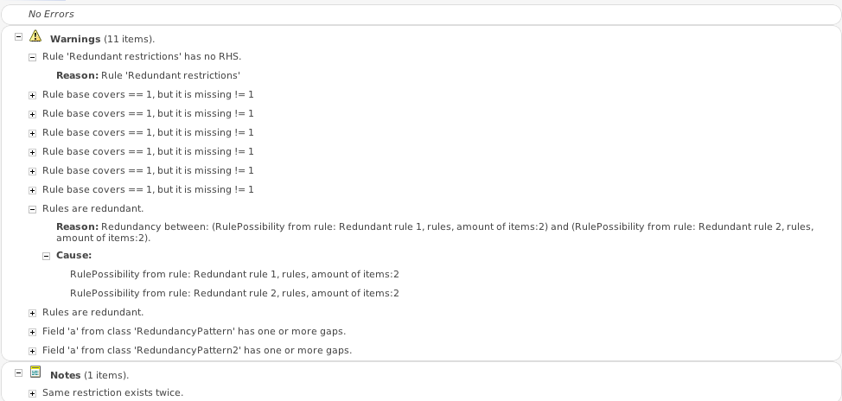
You will note there are 3 sections;
ERRORS: these are serious faults with the rules, serious enough that they will prevent the rules from taking effect at all, and should be corrected. Ideally these will be resolved before anyone uses the rules in a production application.
WARNINGS: These are potential problems with rules. They may include a rule which has no consequence, or a missing field value or a gap in a number range. From a given warning you can drill down to the rule or rules that are causing the problem. Ideally you wouldn't have warnings, but in the real world there are many that can either be ignored, or perhaps are mistaken warnings (as you know a given scenario can not occur, or is catered for by some other means).
NOTES: these are informational only, and most of the time can safely be ignored, but they may be points of interest, but are unlikely to be a problem in practice.

Finally the analysis tool will tell you what facts are used in what rules, and what fields of those facts are used.

Scenario testing of rules
Test scenarios can be created and managed in the BRMS to verify correct operation of rules.
These work best when your fact model can work in isolation of the larger application that the rules are par of. If your rules operate only on the data provided in the facts, and avoid external side effects, this allows for very effective and efficient testing of rules and packages.

A test scenario
A test scenario uses a GUI to edit data in the form of:

GIVEN (some input scenario) EXPECT (result data) (rules were activated or not activated)
(repeat – as you can have multiple cycles of this in a scenario if you wish).

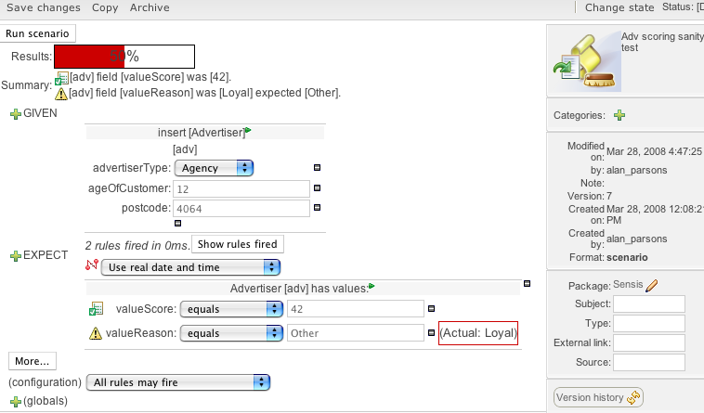
The above shows a test scenario editor, which has been run (showing the percentage success, what what failures were experienced). You can run tests in place, or as part of a test suite.
From the above picture, you can see that we are “inserting” a fact of type “Agency”, and populating fields with the given values.
We then have some expectations on the state of the data after the rules are run. In this case, we have no expectations of what rules fire, we only care about the result. We expect that the valueScore is 42, and valueReason is 'Other' (which has failed in this case, showing the actual value).
Adding a new expectation will show the following dialog:

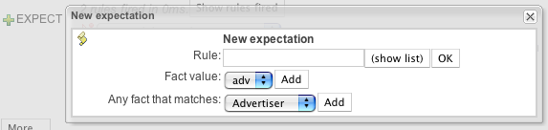
Here you can choose to expect a specific rule to fire, inspect the fields on a fact (it will show a list of facts declared on input side), or it can check the state of ANY fact it finds (it won't care which specific one it is).
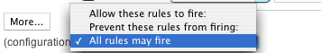

Finally, we can filter what rules take effect, either narrowing it down so this only applies to a single rule (almost like unit testing) or just filtering out certain rules that have side effects which are not wanted when running this scenario.

Scenario suites
You can get a list of all the scenarios in a package from the QA feature:
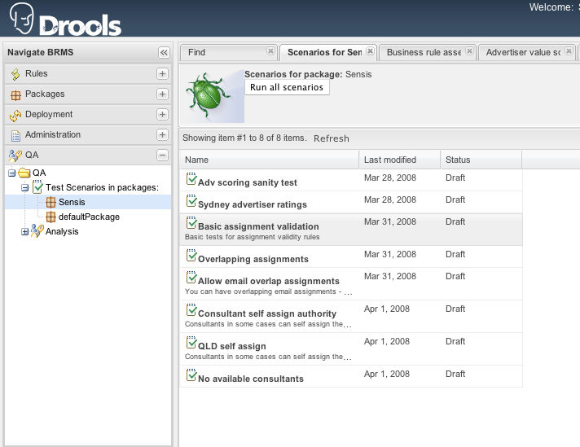
From this, you can choose to run all the scenarios as a suite, and see the results in aggregate:

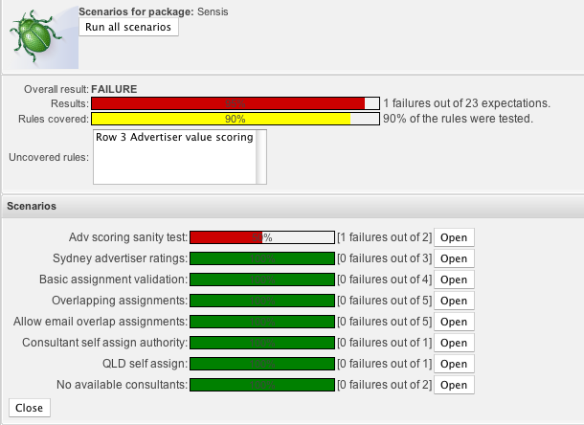
In the above run, the overal result is “FAILURE” due to there being one expectation in one scenario not being satisfied (but otherwise it is 95% satisfied).
It also shows a rule coverage percentage. This is useful to build confidence the rules will work as expected. Of course, 100% rule coverage may not always be practical, as certain rules may have side effects which you do not wish to occur in a controlled testing environment.

Web decision tables
Web based decision tables allow business analysts to edit and review rules in the tabular decision table format in a browser.
A guided editor guides the creation of the decision table in a spreadsheet like way. This is distinct from the spreadsheet based decision tables, which use an integrated template to generate rules. They can still be used together, as always, for separate parts of a rulebase.

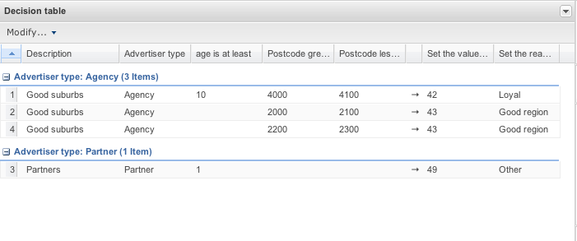

From the above, we can see that a row is a rule, and the columns are conditions, or actions (conditions are on the left of the -> symbol). You can also have all the usual rule attributes as a column, if needed (for example, to set priority).

Rows can be grouped as needed, in the above they are grouped by the “Advertiser type” condition field.
To edit a cell, you double click on it.

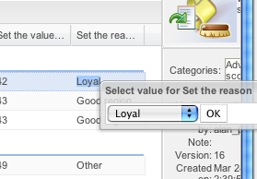

As the fields in the decision table relate to fact fields, the type of the field determines what sort of editor is used. If a data driven enumeration has been setup in the repository, then this will provide the list of options when editing a cell, which ensures valid values are entered.

Configuring the decision table
Before you can start plugging data into a decision table, you have to configure it – which will rely on there being a suitable model in the package that the table belongs to (this is just like the guided editor).

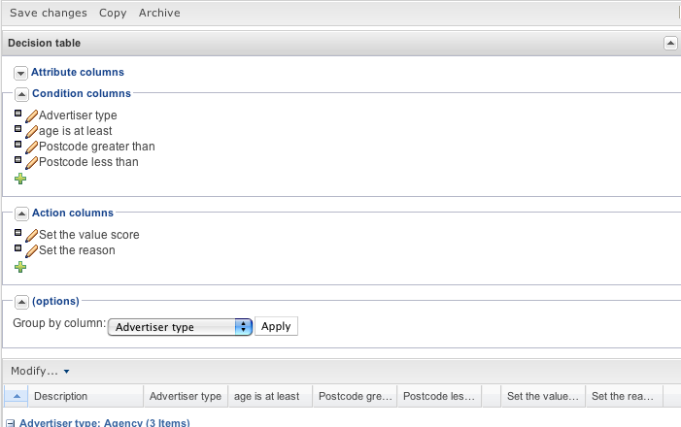
Up in the top right corner, there is a button which expands the configuration section. This will show the above.
From here, you can add attributes, condition and action columns. Each column has a decription which shows up as the header in the table.

The editor for each column is a guided editor, providing facts and fields which are dependent on the model that has been configured for the package.

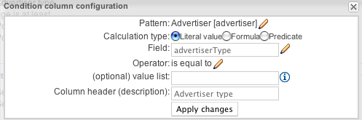

The above shows the dialog which pops up when editing or adding a new condition column.
You choose a pattern – if you pick an existing pattern, then the values from this column will contribute to the constraints of that pattern. The calculation type determines if the value in the cell is literal (ie what you see on screen) – or it maybe a little bit of code (formula) which returns a value (for example 42 / x), or it could be a little bit of code that results in being true of false (predicate).

The operator is similar to the guided editor – and depends on the type of the field. An optional value list provides values in a drop down when editing.

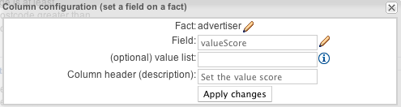
The above shows an “action” column, which is setting the field on a given fact (“advertiser” which has been setup as a condition, or may be a global).
The optional value list is a comma separated list of items which would show in a drop down (this is an alternative to data driven enumerations). When you apply the changes, the table will be redrawn, if it has any data (if there is a LOT of data, this may take a few seconds, depending on the speed of your browser. A quality and standards compliant browser like Firefox or Safari should be quite quick).

