|  |
| --- |
| **Modeling of the hydrological behavior of the Mouhoun basin with SWAT and GR6J models and identification of a flow correction method** |

**Summary**

In this study, the hydrological behavior of the Mouhoun river basin in Dapola was modeled using the SWAT and GR6J models. The aim was to propose efficient tools for short, medium and long term monitoring of water resources in order to anticipate hydrological risks. The study used estimated rainfall and temperature data from CHIRPS and JRA-55 respectively, covering the period 1981-2017, as inputs to the models. These data were pre-processed to reduce discrepancies with data from field observations. Empirical quantile-quantile (EQM), gamma quantile-quantile and scaling methods were used for correction of the estimated data. The reference data used are from five (5) synoptic stations and were subject to a quality control that allowed to remove from the time series, the data likely to be outliers. In general, the quantile-quantile method has proven to be very effective in correcting bias, especially in improving the statistical distribution of data.

In general, the results of the calibration as well as those of the validation are very satisfactory. The Nash criteria obtained at calibration are respectively 0.82 and 0.87 for the SWAT and GR6J models, in this order the values obtained at validation are 0.88 and 0.86. Although these results are very satisfactory, the representation of flood flows is less good with the SWAT model. Indeed, the flood flows are underestimated in this model, but the base water flows are well represented. The GR6J model also showed some deficiencies in the representation of base flows. The Wilcoxon test revealed a very significant heterogeneity between the simulated and observed data. In order to further improve the quality of the simulated flows, a bias correction was applied with the quantile-quantile empirical and scaling methods was very useful. The distribution of the hydrological simulations was significantly improved after this treatment.

**Key words**

o Hydrological modelling

o Bias correction

o Soil and Water Assessment Tools (SWAT)

o Rural Engineering with 6 daily parameters (GR6J)

* Mouhoun watershed in Dapola

# Introduction

Water is a natural resource that is essential for life, for socio-economic development and for maintaining the ecosystem. However, its distribution on the surface of the globe remains uneven, both in time and space.

Also, climate change as well as certain anthropogenic activities (multiplication of cultivable surfaces, urbanization, deforestation, etc.) have exacerbated the vulnerability of this resource, thus worrying all stakeholders in the water sector at all levels. Since the flow regime of Sahelian rivers is highly dependent on the rainfall regime, it is feared that climate change will make water-related problems even more frequent and severe. In addition, in recent decades there has been an increase in extreme hydro-meteorological events, putting the lives of many people at risk. During the year 2020, several West African countries have recorded large-scale hydrological phenomena (flooding). The Middle Niger experienced exceptional floods during the months of August and September that caused major flooding in Niger, Benin and Nigeria (ABN, 2020)**.**

In Burkina Faso, the magnitude of the phenomenon, that to say the increase in the frequency of occurrence of floods is also worrying. Indeed, the year 2020 was characterized by a series of floods. The report N°1 of SP/CONASUR states that 13 regions were affected, 71341 people were affected, 13 people lost their lives, 50 people were injured and 563 people were sheltered in schools and other reception centers. Most hydrological studies agree on a generalized decrease in rainfall throughout the country (Ndiaye, 2003 ; DGRE, 2017 ; Issiaka, 2017) **.**

At first sight, the decrease in cumulative rainfall will undoubtedly have an impact on the filling of water reservoirs, the recharging of water tables and the flows observed at the watershed outlets. Similarly, an increase in heavy precipitation would eventually lead to major flooding (ABN, 2020)that could impact hydraulic structures.

Naturally, the questions that arise are the following: in the current context of climate change, what strategies should be implemented for sustainable and rational management of water resources? How to anticipate possible hydrological risks?

Since we agree that sufficient knowledge of the water resource, from a quantitative point of view, as well as its dynamics in time and space of the territory is an essential prerequisite for planning and implementation of coherent development projects and programs (DGRE, 2017), it is undeniable that continuous monitoring and long-term forecasting are the capital elements on which the reflection must be focused. A commonly used approach to continuously monitor and forecast water-related risks is to anticipate likely future hydrological conditions in the basin using hydrological models (Jain *et al.*, 2018 ; Alfieri *et al.*, 2019).

It is in this perspective that the present work is inscribed, the theme of which is the following: <<**Modeling of the hydrological behavior of the Mouhoun basin with SWAT and GR6J models and identification of a flow correction method>>.**

This theme has been widely addressed by several authors (Grâce, 2019 ; Justin, 2019 ; Harouna, 2020)

However, it should be pointed out that these studies were carried out on a very small part of the Mouhoun basin. Moreover, studies proposing the correction of hydrological simulations are, to our knowledge, non-existent.

The overall objective of this study is to model the hydrological behavior of the Mouhoun basin in order to anticipate water-related risks.

More specifically, it is about:

o Post-processing of input data for hydrological models

o Implementing SWAT and GR6J models;

o Identify an effective method for correcting hydrological model outputs

This document, which summarizes the essence of our work, is subdivided into four (4) sections.

o The first section is devoted to the presentation of the material used;

o In the second section, the methods are presented;

o The third section presents the results of the different analyses;

o The fourth section is devoted to the discussion of the results.

# Material used

## Presentation of the study area

According to the ArcSWAT division, the Mouhoun to Dapola watershed straddles three countries: Burkina Faso, Mali and Ghana.

It is located between longitudes 5.38° and 1.88° W and latitudes 10.18° and 14.60° N (Figure 1 ). The main river is the Mouhoun, which rises from the sandstone plateaus in the commune of Moussodougou at an altitude of 500 m.

It covers an area of about 98805 km2, distributed as follows: 83%, 15% and 2% respectively on Burkina Faso, Mali and Ghana.

The North-South rainfall gradient subdivides the basin into three climatic zones, including the Sahelian zone, the Sudano-Sahelian zone and the Sudanian zone.

Rainfall increases from north to south, while temperatures (annual average) increase from south to north of the basin (27.2°C in Bobo-Dioulasso, 28.7°C in Dédougou) (DGRE, 2017)**.**

Geologically, the Mouhoun Basin is based on two major geological formations.

These are the basement that occupies the eastern parts of the basin and the sedimentary formations. This last type of formation offers exploitation rates of 30 to 40 m3/h to 200 m3/h (Issiaka, 2017)**.**

The vegetation formations are essentially composed of wooded savannahs, open forests and forest galleries along the Mouhoun.

On the northern part of the basin (Sahelian zone), we find vegetation made of shrub savanna and thorny plants.

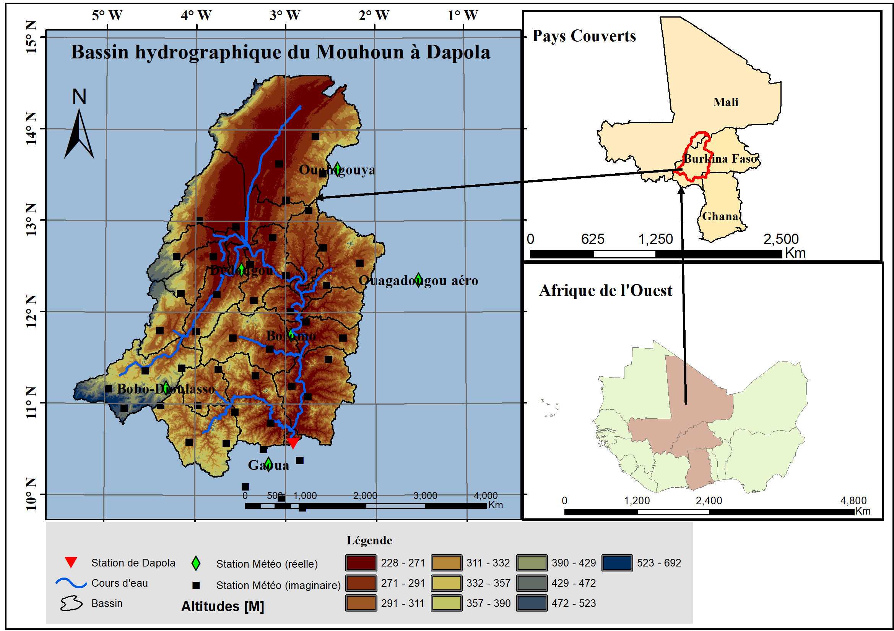

Figure 1: Geographical location of the Mouhoun Basin

## Data

Hydroclimatic data, reanalysis data and geospatial data were used in the study:

### Hydrometeorological data

**Daily flows of the Dapola station:** They cover the period 1951-2019. These data come from the database of the Direction des Etudes et de l'Information sur l'Eau (DEIE). They were used to calibrate and validate the hydrological models.

**Observed meteorological data: These are** daily observed data of precipitation, maximum and minimum temperature. They cover the period 1981-2018. They were obtained for all ten synoptic stations in Burkina Faso, from the National Meteorological Agency (ANAM) of Burkina Faso. These data were used as reference data for the correction of the reanalysis data.

### Reanalysis data

Reanalysis data are obtained by merging satellite data with in-situ (observed) data. The reanalysis data used in this study are from two satellite sources which are: Climate Hazards Group InfraRed Precipitation with Station Data (CHIRPS) and Japanese 55-year Reanalysis (JRA-55) respectively for precipitation and temperature (maximum minimum). These data are at daily time step and cover the period 1981-2018 and 1961-2018 for precipitation and temperature respectively. The precipitation data have a resolution of 0.05° x 0.05° and the temperatures 0.56° x 0.56°.

### Geospatial data

**A 90 m resolution Digital Terrain Model (DTM):** downloadable from the HydroSHEDS website. It was used to characterize the Mouhoun basin at Dapola.

**A soil and land use layer:** These were downloaded from the SWAT website. These data were used in the SWAT model to define the Hydrological Response Units (HRU).

# Methods

## Primary data processing

### Hydrological data

The primary processing of the hydrological data can be summarized as the reorganization of the time series into water years and the evaluation of the gap rate for each month Figure 2. All this was useful for the definition of the calibration and validation periods of the models. Indeed, the calibration and validation periods were chosen according to the availability of data. The calibration and validation periods of the models are 2001-2010 and 2011-2017 respectively.

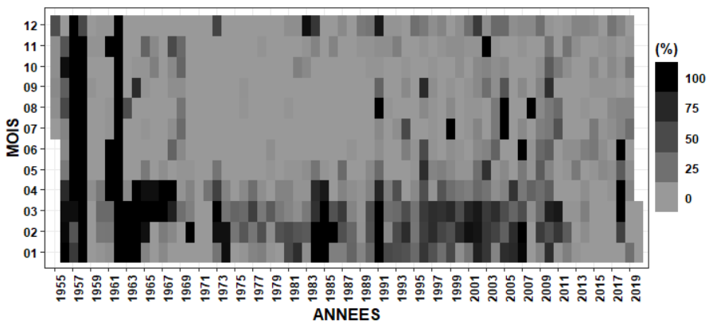

Figure 2 : Gap rate in the daily flow record of the Dapola station

### Weather data

§ **Quality control**

The purpose of quality control is to verify that a transmitted data is representative of what should be measured and that it has not been contaminated by independent factors (WMO, 2011). In order to access the expected results, it is imperative to control the quality of the data we use. The control consisted of a verification of the temporal and spatial consistency of the data. A commonly used method for checking the temporal consistency of the data is the standardization of values. The following formula is used to transform a given value to the standard Z score:

$$\frac{X_{i}-μ_{x}}{δ_{x}}>f^{'}$$

$X_{i}$: value observed on day i

$μ_{x}$: average of the series

$δ_{x}$: standard deviation of the series

$f^{'}$: multiplication factor

An observation Xi is an outlier if the absolute value of the Z-score is greater than the multiplication factor (taken to be 3). Given that the mean is very sensitive to outliers, alternatives have been developed that standardize by subtracting the median from each value and dividing by the interquartile range (Eischeid *et al.*, 1995)**.** Spatial consistency of values is checked by comparing concurrent values from neighboring stations.

* **Bias correction**

It is well known that data from terrestrial observation networks are better than those from satellite observations. However, the gap rate in the observed series and the uneven distribution of measuring stations over a given area make it difficult to use the observed data. A technique used to circumvent this obstacle is the fusion of satellite data with observed data, also known as merging. The implementation of this technique is much more complex and also requires a large volume of observed data. In the context of this study, we limit ourselves to a correction at the scale of the synoptic stations surveyed. In addition to the three synoptic stations located within the study area, two others were considered, the Ouagadougou station and the Boromo station, which are respectively located 10 km and 18 km from the basin boundaries. A wide range of bias correction methods exist in the literature. However, three (3) of them were chosen because they are recognized as effective. These are the :

**Linear scaling method: This** is a univariate approach based on the comparison of means. It consists in scaling the simulation with the difference (additive) or the quotient (multiplicative) between the observed and simulated means over the historical period. This method has two variants: the additive type and the multiplicative type. The additive type is not recommended for bounded variables. The additive type was applied to the temperature data and the multiplicative type to the precipitation and flow data.

$T_{i}^{j}\left(corrected\right)=T_{i}^{j}\left(estimated\right)+\left(μ_{obs}^{j}-μ_{estimated}^{j}\right)$**(1)**

$P_{i}^{j}\left(corrected\right)=P_{i}^{j}\left(estimated\right)×\frac{μ_{Obs}^{j}}{μ_{estimated}^{j}}$**(2)**

With :

$T_{i}^{j}$ and $P_{i}^{j}$ represent respectively the temperature and precipitation of day i (with i € [1,31]) of month j (j € [1,12]) ;

$μ_{obs}^{j}$ and $μ_{estimated}^{j}$ are respectively the observed and estimated means of month j.

One of the shortcomings of this method is the fact that it considers that the biases are linear and uses the same correction factor for the values of the month series.

**Empirical quantile-quantile method (EQM):** It is more appropriate for the correction of daily rainfall data that are characterized by high temporal and spatial variability (Lebel *et al.*, 1996). It consists of calibrating the empirically predicted cumulative distribution function (CDF) by adjusting the model quantiles to those observed (Déqué, 2007), cited by Iturbide *et al.* (2018)**.** The simulated quantiles are thus adjusted to the observed quantiles, using the cumulative distribution functions.

$$X_{d}^{corr}=F_{obs}^{-1}\left[F_{est}\left(X_{d}^{sim}\right)\right]$$

$X_{d}^{corr}$: corrected variable;

$F_{obs}^{-1}$: reciprocal of the cumulative distribution function of the observed data;

$F_{est}$: cumulative distribution function of the estimated data;

$X_{d}^{sim}$: simulated variable.

**Gamma Quantile Mapping (GQM) method:** It is applicable only on precipitation (Obada *et al.*, 2016). It makes the initial assumption that the distribution of observed and simulated data can be approximated by a gamma distribution ([Lafon et al., 2013](/l)). Therefore, the cumulative distribution functions of the two rainfall series (observed and simulated) are fitted to a gamma distribution. The Gamma distribution depends on two parameters ($k,θ$) and is used for the representation of the Probability Density Function (PDF) ([Yang et al., 2010](/l) ; [Wilks, 2011](/l)).

## Implementation of hydrological models

### Calibration

The purpose of calibration is to establish a match between simulated flows and those actually observed at the basin outlet by adjusting the internal parameters of the model. For models with a large number of parameters, in this case the SWAT model, it is advisable to perform a sensitivity study to identify the parameters that are most sensitive to the hydrological process in the basin. The method used for the sensitivity study is the Fourier amplitude sensitivity test (FAST). The criterion of Nash et Sutcliffe (1970) was used to calibrate the models. The simulation results are considered acceptable when the ([Moriasi et al., 2007](/l)).

In the following we will refer to this as :

$Q_{Obs}^{t}:$ observed flow of day t

$Q_{Sim}^{t}:$ simulated flow of day t

$\overline{Q_{Obs}}$: average of the observed flows.

$\overline{Q_{Sim}}$: average of the simulated flows.

* The criterion of [Nash et Sutcliffe (1970)](/l) criterion measures the degree of adjustment between the observed and simulated values. It varies between - $∞$ and 1. The best score is 1 but in practice this score cannot be reached.

$$NSE=1-\frac{\sum_{t}^{T}{{\left(Q_{Obs}^{t}-Q_{Sim}^{t}\right)}^{2}}}{\sum_{t}^{T}{{\left(Q_{Obs}^{t}-\overline{Q_{Obs}}\right)}^{2}}}$$

§ The coefficient $R^{2}$ describes the combined dispersion of the observed and simulated series by comparing the dispersions of each series. It is between 0 and 1. When its value tends towards 1, it indicates a decrease in the error of the variance. It is calculated by the following formula:

$$R^{2}=\frac{\sum_{t}^{T}{\left(Q_{Sim}^{t}-\overline{Q_{Sim}^{t}}\right)\left(Q_{Obs}^{t}-\overline{Q_{Obs}^{t}}\right)}}{\sqrt{{\left(Q_{Sim}^{t}-\overline{Q_{Sim}^{t}}\right)}^{2}}\sqrt{{\left(Q_{Obs}^{t}-\overline{Q_{Obs}^{t}}\right)}^{2}}}$$

§ The percentage bias expresses the average bias between the observed and simulated series. It varies between -100% and +100%. A negative value indicates an underestimation, a positive value an overestimation and a null value reflects a perfect description of the observation. It is calculated as follows:

$$PBIAIS=\frac{\sum_{t}^{T}{{\left(Q_{Obs}^{t}-Q_{Sim}^{t}\right)}^{2}}}{\sum_{t}^{T}{Q_{Obs}^{t}}}*100$$

In addition to the objective criteria, a qualitative evaluation method was used, based on the analysis of the hydrographs and the distribution of the data by means of box plots.

### Validation

Once the model has been calibrated, it is now necessary to evaluate its capacity to reproduce the future: this is the validation stage. The validation stage, as its name suggests, is designed to confirm or deny the relevance and validity of the parameters selected after calibration. It consists in forcing the model on a different period than the calibration period by using the optimal set of parameters. The results of the simulation are assessed on the basis of the criteria proposed by [Moriasi et al (2007)](/l).

## Correction of hydrological simulations

The hydrologic simulations were corrected using the quantile-quantile method and the linear scaling method, mentioned above. The corrected data were evaluated following the procedure presented above. That is, a quantitative method and a qualitative method. The quantitative method used the criteria presented above. The qualitative method was based on hydrograph and box plot analysis.

# Results

## Post-processing of input data

### Quality control

The Figure 3 and Figure 4 are an extract of the quality control results performed on the precipitation and temperature data. These data cover the period 1981-2017. Outliers are shown in red on the graphs (Figure 3). These results show that precipitation recorded (at Bobo synoptic station) on 02-09-1986, 08-09-2010 and 01-09-2015 have too much deviation and are likely to be outliers. Similarly, the maximum and minimum temperature series (recorded at the Dedougou station) show values that are too far from the series average (outliers).

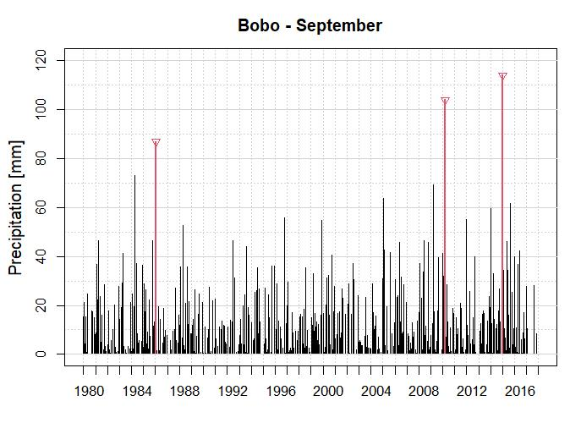

Figure 3: Quality control of precipitation data

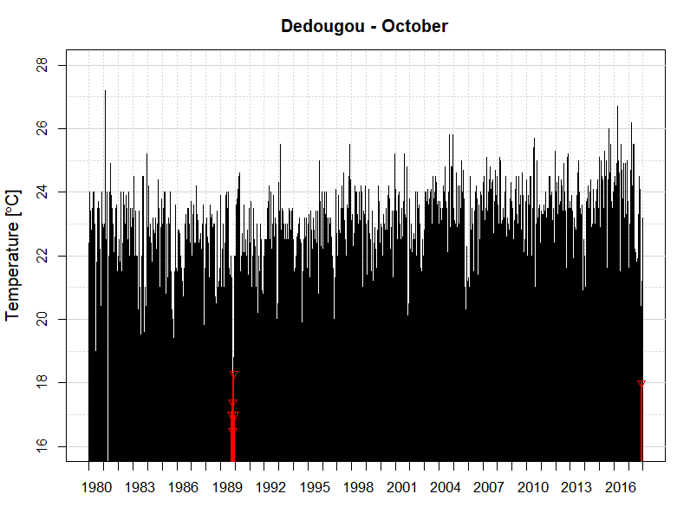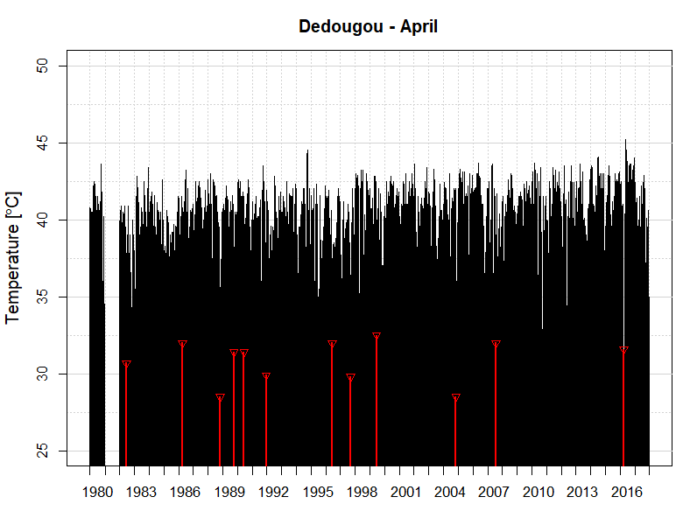

b) Maximum Temperatures

1. Minimum Temperatures

Figure 4: Quality control of temperature data

### Bias correction

Results of bias correction of precipitation and temperature data are reported in the Tableau 1.

These results show that the correction was clearly better with the temperature data than with the precipitation data. Indeed, with the exception of the percentage of bias which varied positively, we can see that all the performance criteria degraded after the correction of the rainfall data. The degradation was more significant with the Gama Quantile Mapping (GQM) method. On the other hand, with the temperature data, the performance criteria improved following the correction. The percentage of bias has even reached its optimum value and the Nash criteria are all higher than 0.5. However, the analysis of the quantile-quantile diagrams shows an improvement of the quantile values (Figure 5 and Figure 6). This is true for the precipitation and temperature data. Indeed, as can be seen on the Figure 5 and Figure 6 the corrected data are aligned with the first bisector than the raw data. Whether we consider the precipitation or temperature data, we notice that the empirical quantile mapping method is the one that offers a good fit. Below 50 mm of rainfall, the Gama Quantile Mapping method also gives good results.

|  |  |  |  |  |  |  |  |  |  |  |
| --- | --- | --- | --- | --- | --- | --- | --- | --- | --- | --- |
| **Parameters** | **Precipitation** | | | | **Tmax** | | | **Tmin** | | |
| ***Brute*** | ***Scaling*** | ***eqm*** | ***gqm*** | ***Brute*** | ***scaling*** | ***eqm*** | ***Brute*** | ***scaling*** | ***Eqm*** |
| **MAE** | 2.03 | 2.11 | 2.13 | 2.15 | 1.75 | 1.74 | 1.44 | 1.86 | 1.52 | 1.55 |
| **PBIAS %** | -0.9 | 7.1 | 0.7 | 1.2 | -0.5 | 0 | 0 | 6.3 | 0 | 0 |
| **NSE** | 0.27 | 0.22 | 0.14 | 0.11 | 0.51 | 0.51 | 0.65 | 0.48 | 0.66 | 0.64 |
| **R2** | 0.35 | 0.35 | 0.33 | 0.33 | 0.68 | 0.68 | 0.68 | 0.67 | 0.67 | 0.67 |

Tableau 1: Validation of bias correction methods

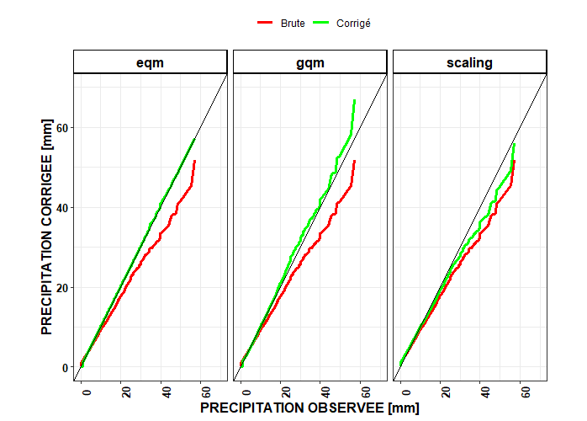

Figure 5 : Validation of bias correction methods using the quantile-quantile diagram (rain)

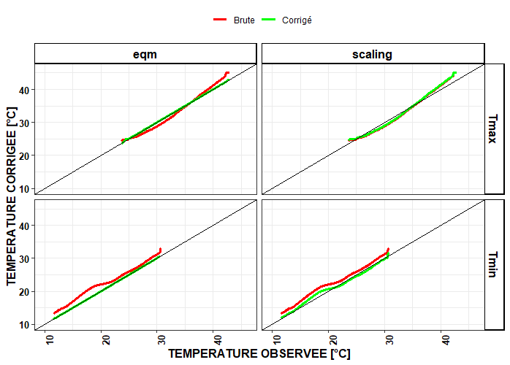

Figure 6 : Validation of bias correction methods using the quantile-quantile diagram (Temperature)

## Implementation of the models

### Sensitivity study

In this section, the results of the sensitivity study carried out on the parameters of the SWAT model are presented. It was carried out on twenty-five (25) sets of parameters. The graph in the Figure 7 presents the parameters considered in order of sensitivity. The first ten (10) parameters most sensitive to the hydrological process of the basin were retained for the calibration of the model. The figures Figure 8andFigure 9 show the evolution of the Nash value at each iteration. Based on these graphs, the initial ranges of the parameters were adjusted to improve the simulation results.

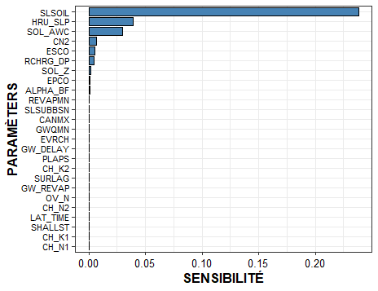

Figure 7 : Sensitivity study of the SWAT model parameters

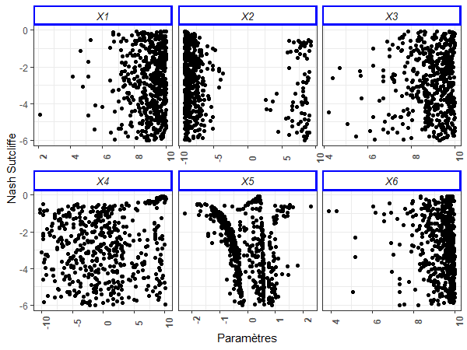

Figure 8 : Variation of Nash as a function of parameter values (GR6J)

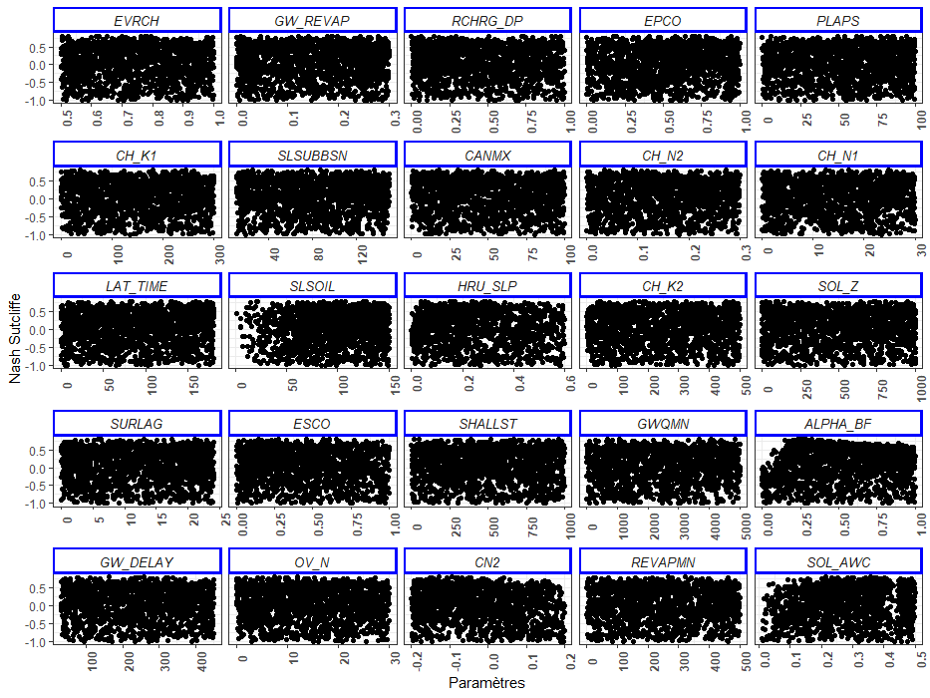

Figure 9 : Variation of Nash as a function of parameter values (SWAT)

4.2.2 Calibration & validation

The Tableau 2 summarizes the performance criteria calculated for each of these two models. Overall, the results of the calibration and validation are satisfactory. Indeed, all the criteria are in their acceptable range of values. However, we notice that the values of the criteria are more satisfactory with the GR6J model than with the model. But at validation, the opposite was observed. That is, the values of the performance criteria were found to be more satisfactory with the SWAT model than with the GR6J model.

Considering the SWAT model, the Nash criterion which is the main objective function increased from 0.82 to 0.88, the R2 increased from 0.84 to 0.89 and finally the percentage of bias (PBIAIS) from -5.7 to -2.8. On the other hand, with the exception of the coefficient R2 which improved, the other performance criteria of the GR6J model deteriorated during the validation, but remained within the acceptable range of values. The Nash criterion did not vary too much, it went from 0.87 to 0.86, a decrease of -1%.

The graphical analysis of the results by means of whisker boxes provided further information on the distribution of the simulated and observed data.

During calibration and validation, the SWAT model underestimated the maximum flows (Figure 10).

The Wilcoxon test shows heterogeneity between the simulated series and the observed series.

At calibration the p-values obtained are 6.68.10-20 and 1.7.10-2 respectively for the GR6J and SWAT models.

A decrease in p-value is observed when validating the models. The values obtained are: 4.26.10-34 and 5.71.10-4 for the GR6J and SWAT model. These values are all below the significance level (5%).

The Figure 11is a comparison of the simulated and observed hydrographs.

Whether we consider calibration or validation, we find a phase shift between the simulated and observed hydrographs.

This phase shift is more or less important depending on whether we consider the SWAT model or the GR6J model.

Indeed, the analysis of hydrographs reveals that the GR6J model represents fairly well the flood flows while the base flows are more or less overestimated.

The SWAT model has difficulty simulating flood flows, but simulates base flows well (Figure 11). The peak flow is early in the validation process for both the SWAT and GR6J models. Moreover, unlike the GR6J model, the SWAT model fails to capture small variations in the stream. In fact, as we can see on the graph below (Figure 11) the hydrograph simulated by the SWAT model is very smooth unlike that of the GR6J model which presents breaks in conformity with the observed hydrograph.

Considering the monthly hydrographs Figure 12 we can see that the models are able to represent well the periods of high water and low water. In other words, we can see that seasonality is fairly well represented by both models.

Tableau 2 : Evaluation of the performance of the models

|  |  |  |  |  |
| --- | --- | --- | --- | --- |
| Criteria | Calibration | | Validation | |
| *SWAT* | *GR6J* | *SWAT* | *GR6J* |
| MAE | 45.2 | 45.72 | 40.23 | 42.01 |
| RMSE | 78.94 | 67.45 | 67.29 | 71.39 |
| PBIAS % | -5.7 | 4.3 | -2.8 | 8.3 |
| NSE | 0.82 | 0.87 | 0.88 | 0.86 |
| R2 | 0.84 | 0.87 | 0.89 | 0.89 |

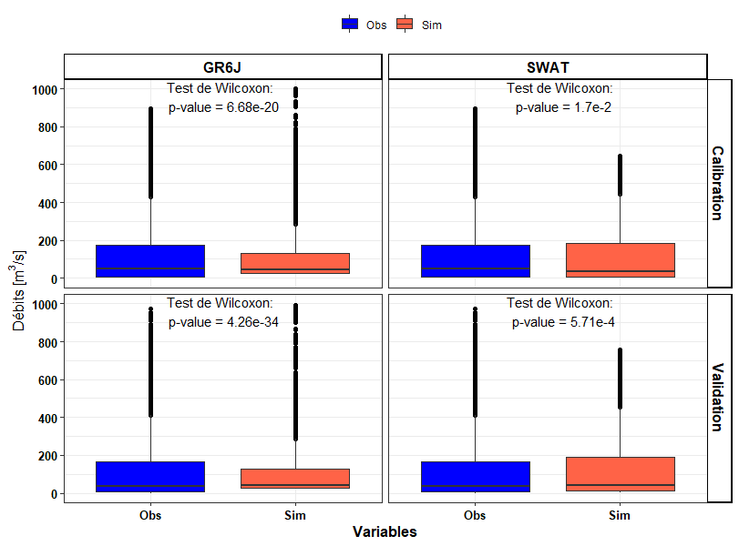

Figure 10 : Comparison of the distribution of observed and simulated data

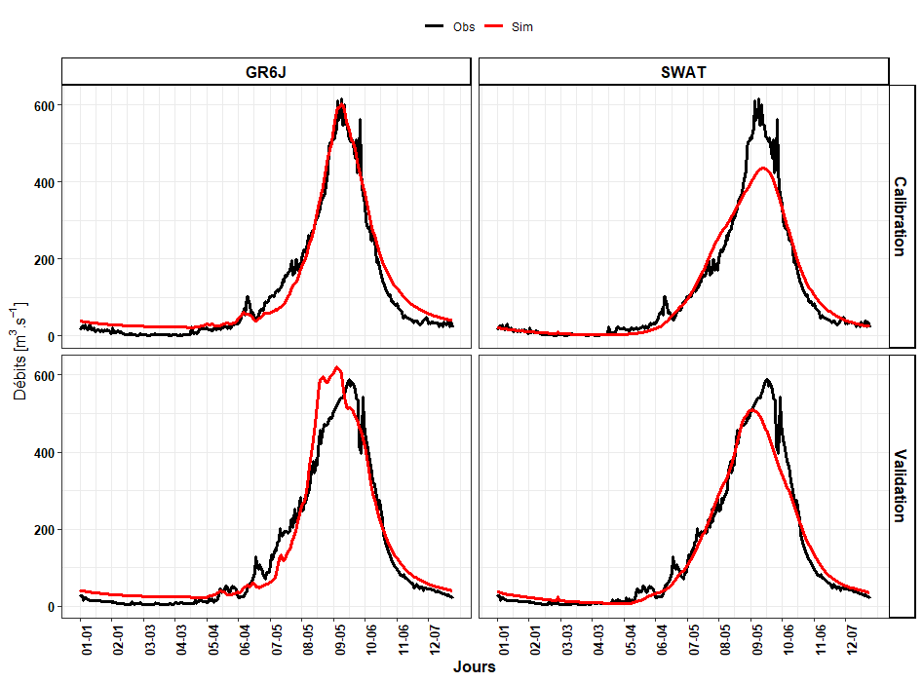

Figure 11 : Comparison of observed and simulated daily hydrographs

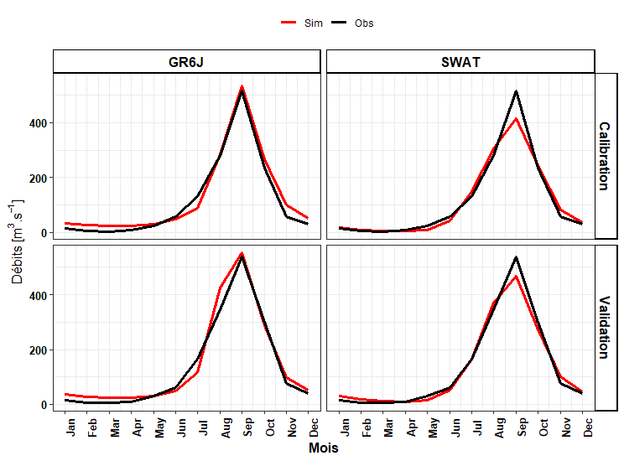

Figure 12 : Seasonality analysis

## Correction of hydrological simulations

In this section, we present the results of the correction of the hydrological simulations from the two models. As we can see in the Tableau 3 As we can see in the table, the performance criteria have all improved very significantly after the correction. These results reflect a large reduction in bias. The Figure 13 and Figure 14 further support these results. Compared to the simulated hydrographs, the corrected hydrographs better approximate the observed one. In addition, flood flows, which were underestimated by the SWAT model, improved significantly. The base flows, simulated by the GR6J model are now well represented. However, we can see that the onset of the peak flow is still early despite the correction.

Furthermore, the distribution of quantile-corrected data is identical to that of the observed data (Figure 14). The distribution of the data corrected with the scaling method is still unsatisfactory. Indeed, the Wilcoxon test indicates that the data corrected with the scaling method are not homogeneous with the observed data. Even if the p-value has evolved positively, it is still below the chosen significance level (5%).

Tableau 3 : Quantitative evaluation of the correction of hydrological simulations

|  |  |  |  |  |
| --- | --- | --- | --- | --- |
| Parameters | GR6J | | SWAT | |
| ***scaling*** | ***Eqm*** | ***scaling*** | ***Eqm*** |
| MAE | 40.94 | 35.28 | 40.82 | 36.69 |
| PBIAS % | 3 | 3.4 | 2.7 | 3.2 |
| NSE | 0.88 | 0.91 | 0.89 | 0.9 |
| R2 | 0.89 | 0.91 | 0.89 | 0.9 |

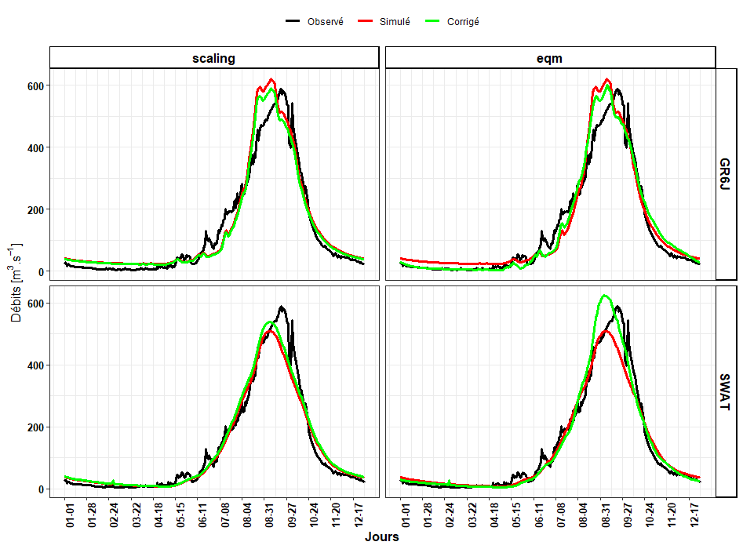

Figure 13 : Comparison of observed, simulated and corrected daily hydrographs (Period 2011-2017)

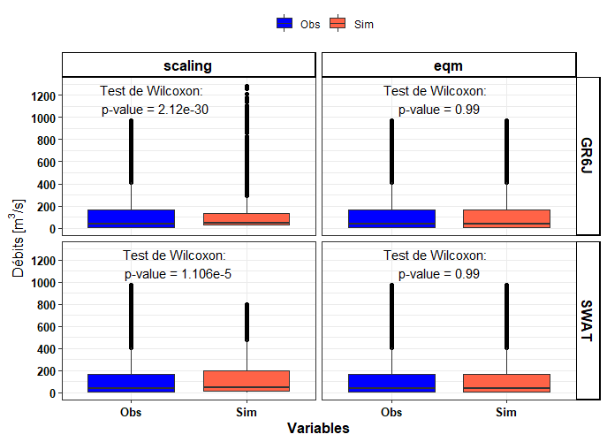

Figure 14 : Comparison of the distribution of observed and simulated hydrographs (Period 2011-2017)

# Discussion

## Post-processing of data

The primary processing was focused on meteorological data, the input data for the models.

This involved checking the quality of the reference data and correcting the climate model simulations. This step is crucial, once it is agreed that data from satellite sources are biased with respect to data from land-based observations. Several authors have also supported the idea of correcting satellite data prior to their use (Mandela, 2018; WMO, 2011).

Indeed, despite the very satisfactory spatial and temporal coverage, satellite data do not reproduce the zonal climatology well.

Quality control results revealed outliers in the precipitation and temperature series.

The outliers detected in the rainfall series correspond to extremely high values and those detected in the temperature series are extremely low values.

Such data declared as outliers should in principle be verified by reference to the records archives.

Due to the lack of records, these data were considered as missing values.

The bias correction results reveal that the performance of the methods varies as a function of the variable.

For maximum temperatures, the correction was more satisfactory with the quantile-quantile method than with the scaling method.

As a reminder, the calculated MAE values are 1.44 and 1.74 for the quantile-quantile and scaling methods respectively.

These values correspond to a reduction of 17% and 0.5% of the mean absolute error (MAE).

For minimum temperatures, the performance of bias-corrected data is better with the scaling method.

The calculated MAE values are 1.55 and 1.52 respectively for the EQM and scaling method corresponding to a reduction of 18% and 17% of the MAE.

On the other hand, for the rainfall data, the MAE has evolved downwards after the correction, showing the introduction of new biases in the time series.

Nevertheless, the quantile-quantile diagrams showed an improvement in the values of the different quantiles.

These results could be justified by the fact that the correction methods each have a specific purpose.

Some methods aim to correct specific statistical moments (mean, variance) while others correct the entire distribution of the data (Mahamadi, 2020).

Studies by Lafon et al. (2013) based in part on Piani et al. (2010) and Gudmundsson et al. (2012) have shown that quantile-quantile correction methods are designed to improve the distribution of variables.

In his study on Benin, Mandela (2018) also found that bias-corrected data perform quite better for temperature than for rainfall.

This is related to the fact that temperatures are continuous (the temperature distribution is approximate to a normal distribution) over time while precipitation is highly variable from day to day.

In other words, the temperature recorded on day i is strongly correlated with that observed on day i-1, which is not the case with precipitation data, which are characterized by very high spatial and temporal variability.

## Implementation of hydrological models

The implementation of the SWAT model required a sensitivity study of the parameters, prior to the calibration. Considering twenty-five (25) parameters, 3555 iterations were necessary to identify the parameters that significantly influence the hydrological response of the basin.

The most sensitive parameter identified was the slope length for lateral groundwater flow (SLSOIL) followed by the slope steepness of the cover area (HRU_SLP) and the available water capacity in the soil (SOL_AWC).

As part of his graduate work, Cyrille (2020) also found these same results in the Nakambé basin in Wayen.

Overall, the calibration and validation results are acceptable for both the SWAT and GR6J models.

The values of the performance criteria all satisfy the conditions defined by Moriasi *et al.* (2007) ($Nash≥0.5, R^{2}≥0.5 and PBIAIS between ±0.25$). At calibration, the GR6J model showed a better performance (NASH=0.87; PBIAS %=4.3; R2 =0.87 ) than the SWAT model (NASH=0.82; PBIAS%=-5.7; R2 =0.84 ), but at validation the performance of the GR6J model decreased slightly (NASH=0.86; PBIAS %=8.3; R2 =0.89 ). On the other hand, the performance of the SWAT model increased significantly (NASH=0.88; PBIAS%=-2.8; R2 =0.89). This very significant variation of the Nash criterion could reflect an instability of the SWAT model. Indeed, although this variation is positive, it is to be feared that the model parameters are not transferable in time. The GR6J model was more stable, the Nash criteria are 0.87 and 0.86 for calibration and validation. This gives the GR6J model greater stability.

The graphical analysis of the calibration and validation results shows a tendency for the GR6J model to overestimate flood flows. The analysis also reveals that the SWAT model underestimates flood flows, but represents base flows fairly well. These results are similar to those of some studies conducted in the Mouhoun and Nakambé basins (Grâce, 2019 ; Cyrille, 2020 ; Harouna, 2020). The authors explained the underestimation of flood flows through the quality of the data used in the model. Indeed, the quality of the simulation depends on the quality of the input data. But this could not justify almost the biases of the model. It is important to remember that hydrological models are a simplified form of reality and even if we had very high quality data, the model cannot reproduce exactly the studied phenomenon. The quality of the simulation of a model can vary more or less significantly from one area to another. Therefore, in addition to the quality of the data which can have a significant impact on the model outputs, the quality of the reference flows and the spatial heterogeneity must be taken into account. If the model is not adapted to the area, the biases related to the model are important.

Although the performance criteria are all acceptable, the Wilcoxon homogeneity test reveals heterogeneity between the simulated and observed data. The p-values calculated for both models are all below the significance level (5%).

## Correction of hydrological simulations

In general, both correction methods succeed in reducing the discrepancies between the simulated data and the data from the field observations.

However, it should be noted that the correction by the QMT method is the one that provides the best results. The results of our analyses are in line with those of several authors (Mandela, 2018 ; Bernard, 2020 ; Cyrille, 2020 ; Mahamadi, 2020) who have also shown that the empirical quantile mapping method is very effective for bias correction. This confirms once again the performance of the EQM method for bias correction of data.

In addition, the statistical distribution of the simulated series improved significantly after the correction.

However, this improvement was only significant with the empirical quantile-quantile method.

Indeed, the p-value of the test for quantile-quantile corrected data is above the significance level for both models, indicating that the simulated and observed series are homogeneous.

As mentioned above, these results are justified by the simple fact that the MSE method was designed to improve the distribution of the series.

# Conclusion

The main objective of our study was the implementation of the SWAT and GR6J hydrological models. Specifically, our study consisted of:

o correct precipitation and temperature data using the empirical quantile-quantile, scaling and gamma quantile mapping methods;

o implement the SWAT and GR6J hydrological models;

o identify a robust method for correcting model outputs.

At the end of this work, it was found that the empirical quantile-quantile method (EQM) is very robust for the correction of biases in climate products and hydrological model outputs. More specifically, this method is very suitable for correcting the distribution of time series. Studies prior to ours have also demonstrated the effectiveness of the method (Bernard, 2020 ; Cyrille, 2020 ; Mahamadi, 2020).

Overall, the calibration and validation results were satisfactory, the calculated criteria all meet the conditions defined by (Moriasi *et al.* (2007)).

Although the performance criteria are satisfactory, shortcomings are noted in the representation of flood flows in the SWAT model. More specifically, an underestimation of flood flows was noted in this model.

The application of the correction methods allowed to reduce the biases and thus to improve the representation of the flood flows. The GR6J model represented the flood flows well during the calibration, but during the validation the quality of the representation deteriorated.

For low water flows, the representation is less good, flows are overestimated.

After the correction, these flows improved significantly so that the curves of the simulated base flows (GR6J) and the observed base flows are practically superimposed. In addition, it should be noted that the onset of peak flow remained early in both models, despite the correction. Moreover, the results of the analyses showed that the GR6J model was able to capture small variations in flow, unlike the SWAT model.

Overall, the overall objective assigned to this study was successfully achieved. In the sense that the hydrological models were calibrated and validated with very acceptable performance criteria. The major difficulty of this study was the availability of observed data for the implementation of hydrological models. This forced us to calculate potential evapotranspiration based only on temperature data.

With regard to the quality of the calibration and validation results, which are very satisfactory, these models could be used for hydrological forecasting, the study of the impact of hydraulic structures on the hydrological regime, or more particularly for the assessment of the impact of climate change on the water resource. All this allows to anticipate the risks and to propose means of resilience. In order to produce very high quality hydrological simulations we suggest a coupling of models. That is, using the SWAT model to simulate base flows and the GR6 model to simulate high water flows.

Our study focused only on the Mouhoun basin. In order to improve the monitoring and evaluation of water resources on a Burkina scale, it would be interesting to conduct similar studies in the rest of the country.

# Références

**ABN A. d. B. d. N., 2020.** Note technique sur les prévisions de tendance de la crue guinéenne.

**Alfieri L., Zsoter E., Cloke H., Stephens E., Harrigan S., Hirpa F. A., Lavaysse C., Salamon P., 2019.** Range-dependent threshold uncertainty in global flood early warning. *Geophysical Research Abstracts*.

**Bernard M., 2020.** *Cartographie régionale du risque d'inondation en Afrique de l'Ouest pour l'appui à l'alerte précoce.* Cycle Ingénieur Hydrologue, Centre Régional AGRHYMET (CRA), Niamey (NIGER), 71 p.

**Cyrille N. G., 2020.** Scénarios d'évolution de la ressource en eau de surface dans le bassin versant du Nakambé à la station de Wayen à partir des scénarios climatiques RCP 4.5 et RCP 8.5. **57**.

**Déqué M., 2007.** Frequency of precipitation and temperature extremes over France in an anthropogenic scenario: Model results and statistical correction according to observed values. *Global and Planetary Change*, **57**(1-2): 16-26.

**DGRE, 2017.** Synthèse du suivi des ressources en eau, situation 2016. **116**.

**Eischeid J. K., Baker C. B., Karl T. R., Diaz H. F., 1995.** The quality control of long-term climatological data using objective data analysis. *Journal of Applied Meteorology (1988-2005)*: 2787-2795.

**Grâce K. C. E., 2019.** *Application du modèle SWAT pour la modélisation de l'écoulement dans un bassin versant peu jaugé en zone soudano-sahélienne (BURKINA FASO).* 2iE, 95 p.

**Harouna K., 2020.** *Evaluation du bilan hydrologique du bassin versant du Mouhoun à la station hydrométrique de Bazon au Burkina Faso à l'aide du modèle SWAT.* Cycle Ingérieur Hydrologue, Centre Régiona AGRHYMET (CRA), Niamey (NIGER), 62 p.

**Issiaka T., 2017.** *Analyse de la variabilité hydrologique du Mouhoun et impact sur la gestion du reservoir de Lery au BURKINA FASO en saison sèche à l'horizon 2030.* Mastère, 2iE, 69 p.

**Iturbide M., Bedia J., Herrera S., Bano J., Fernández J., Frıas M., Manzanas R., San-Martın D., Cimadevilla E., Cofino A., 2018.** climate4R: An R-based open framework for reproducible climate data access and post-processing. *Submitted to Environmental Modelling and Software*.

**Jain S. K., Mani P., Jain S. K., Prakash P., Singh V. P., Tullos D., Kumar S., Agarwal S., Dimri A., 2018.** A Brief review of flood forecasting techniques and their applications. *International Journal of River Basin Management*, **16**(3): 329-344.

**Justin Z., 2019.** Mise en oeuvre du modèle hydrologique GR4J sur le bassin versant de la Bougouriba à la station de Dan : Application au comblement des lacunes de débits de la station. **55**.

**Lebel T., Amani A., Taupin J.-D., 1996.** La pluie au Sahel: une variable rebelle à la régionalisation. *Intéractions surface continentale/atmosphère: l’expérience Hapex-Sahel*.

**Mahamadi T., 2020.** *Diagnostic des biais des précipitations des modèles climatiques et évaluation des méthodes de correction sur le bassin du Mouhoun (BURKINA FASO).* Cycle Ingénieur (Hydrologie), Centre Régional AGRHYMET (CRA), Niamey (NIGER), 54 p.

**Mandela H. C. M., 2018.** Merging des données d'observations satellitaires et in-situ pour des applications agroclimatiques au Benin. **54**.

**Moriasi D. N., Arnold J. G., Van Liew M. W., Bingner R. L., Harmel R. D., Veith T. L., 2007.** Model evaluation guidelines for systematic quantification of accuracy in watershed simulations. *Transactions of the ASABE*, **50**(3): 885-900.

**Nash J. E., Sutcliffe J. V., 1970.** River flow forecasting through conceptual models part I—A discussion of principles. *Journal of hydrology*, **10**(3): 282-290.

**Ndiaye B., 2003.** Impacts du climat et des aménagements sur le régime hydrologique du Mouhoun.

**Obada E., Alamou A., Zandagba E., Biao I., Chabi A., Afouda A., 2016.** Comparative study of seven bias correction methods applied to three Regional Climate Models in Mekrou Catchment (Benin, West Africa). *IJCET*, **6**: 1831-1840.

**WMO, 2011.** Guide des pratiques climatologiques. 152.