Note on XOH and NOH

1. N_{H} from Tau₃₅₃, E(B-V) and Radiance R

We estimate total N_{H} from the linear relationships of tau₃₅₃, E(B-V), Radiance R and total N_{H} derived from 19 LOS without CO and OH detections and 16 LOS with low N_{HI}.

Fig1: Tau₃₅₃ vs N_{H}

Fig2: E(B-V) vs N_{H}. Upper: E(B-V) from Schlafly+11, lower: E(B-V) from Planck2014.

Fig3: Radiance R vs N_{H}.

In the higher N_{H} regions, tau₃₅₃ excesses the linear correlation with N_{H}, so using tau₃₅₃ as the proxy of total N_{H} in denser regimes will overestimate total N_{H}. As shown in Fig.4, Fig.5 and Fig.6, the ratio f=N_{H-from-tau}/N_{H-from_radiance} increases as the functions of A_{V} and N_{CNM}, f=2.0-4.0 in the A_{v} range (3.0-4.6 mag). Hence, N_{H2} derived from Radiance R is lower than it from tau₃₅₃ and E(B-V), N_{H2}=[N_{H}-N_{HI}]/2.

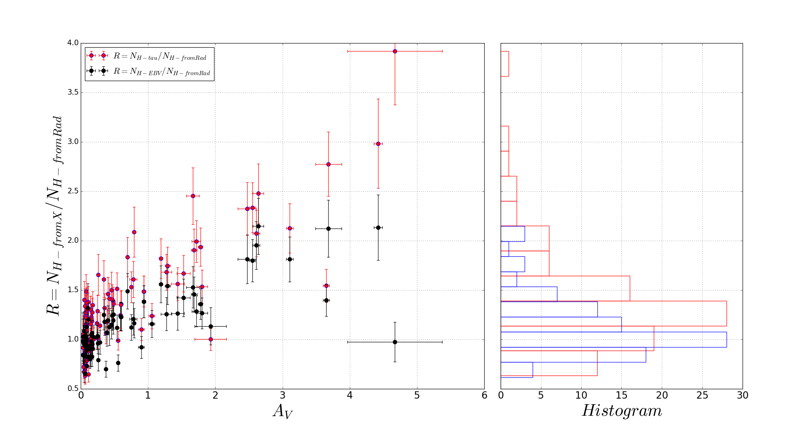
Fig4: Ratios of N_{H-from-X}/N_{H-from-radiance} vs A_{v}. X is tau₃₅₃ or E(B-V).

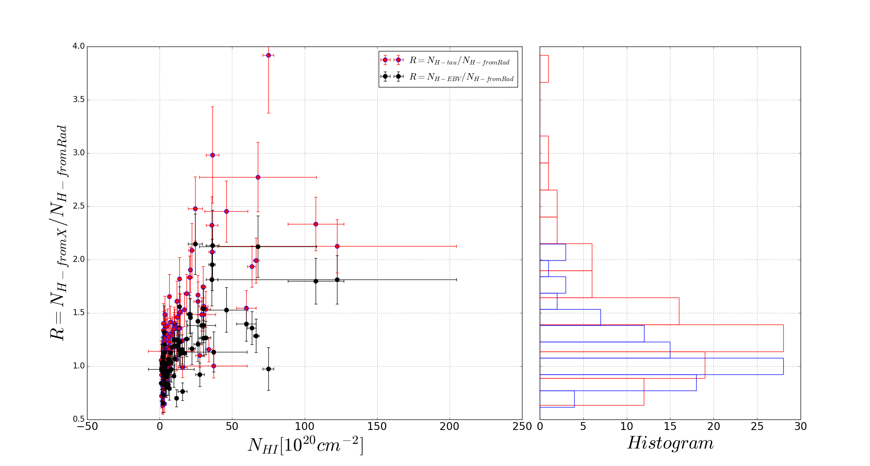
Fig5: Ratios of N_{H-from-X}/ N_{H-from-radiance} vs N_{HI} (X is tau₃₅₃ or E(B-V)).

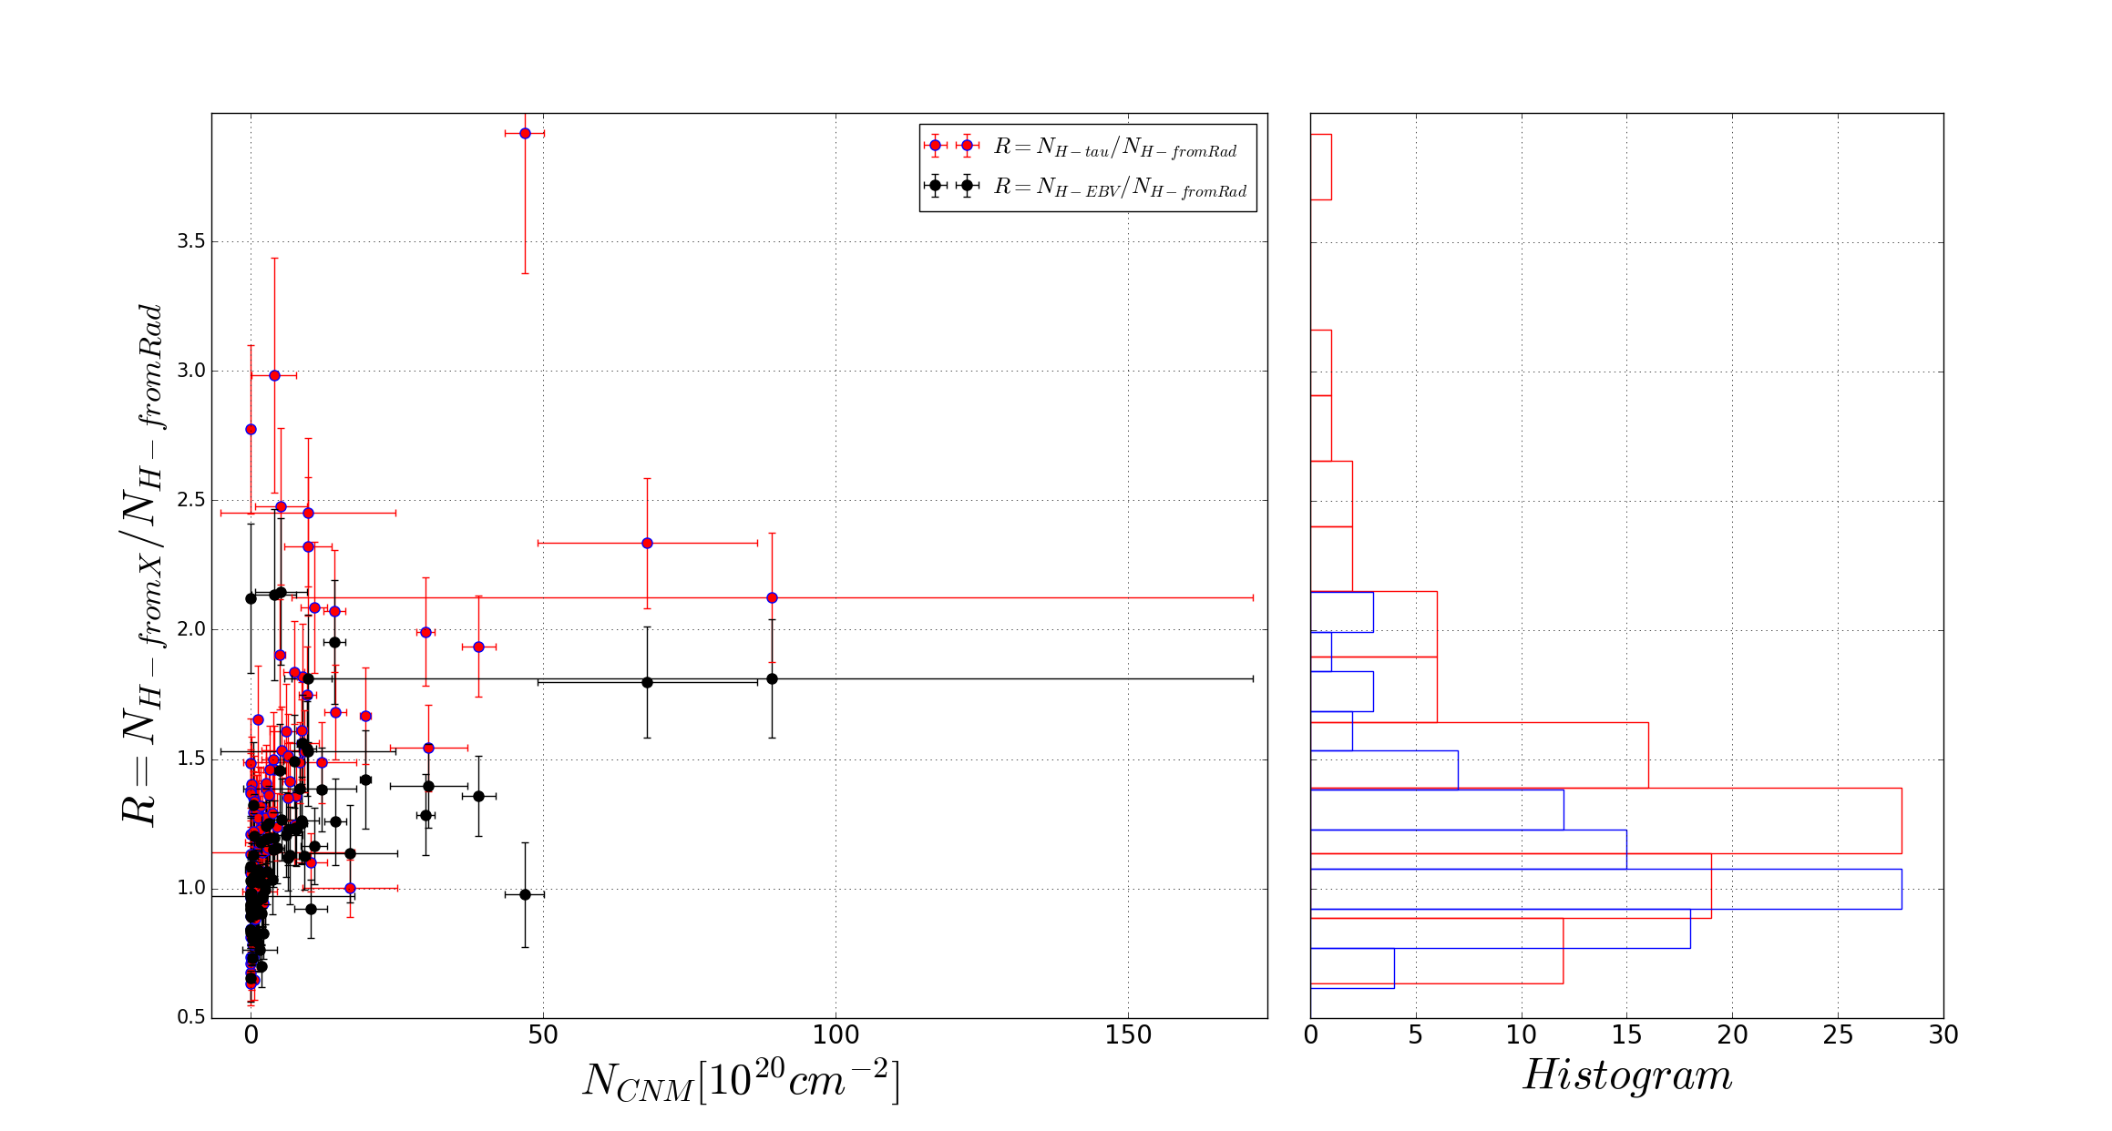
Fig6: Ratios of N_{H-from-X/} N_{H-from-radiance} vs N_{CNM}.

2. X_{OH}

Fig 7: Left: X_{OH} vs A_{v}. Right: Histogram of X_{OH}.

- X_{OH} from Tau₃₅₃ and E(B-V) are consistent, the mean values are 4.9e-8 and 1.1e-7
- X_{OH} from radiance is spread out, increases rapidly (0.7-7)x10⁻⁷ as Av increases from 0.3 to 2.8 mag, mean value is 2.5e-7

Xu et al. 2016 found that across the boundary of Taurus molecular cloud the X_{OH} decreases from 8x10⁻⁷ to 1x10⁻⁷ as A_{V} increases from 0.4 to 2.7 mag. This is somewhat opposite to the trend of our X_{OH}, we take all the gas clumps along sightlines into account, but they study a local molecular cloud and their overabundance of OH in outer cloud region may be driven by the shock wave. (DIFFERENCE. WHY????? The different environment? or the OH PRODUCTION caused by SHOCK WAVE: additional channel of OH production active, possibly due to the shock (e.g., Draine \& Katz 1986a) produced by the colliding streams. When shock waves propagate through the molecular ISM the ambient gas is compressed, heated, and accelerated.
When temperature is above 300 K, the neutral-neutral reactions become important, which yield the overabundance of OH).

Many efforts (models or observations) have been devoted to derive the OH abundance ratio in different environment conditions:

- Models of translucent and diffuse molecular clouds with \av\ from 0.1 to 1 mag and T_{K} from 50 to 100 K by Viala (1986) found that the X_{OH} varied from 3.8x10⁻⁹ to 9.4x10⁻⁹.

- Also from comprehensive models of diffuse and translucent clouds with N_{H} from 250 to 1000 \cc and T_{K} from 20 to 100 K, van Dishoeck & Black (1986) yielded OH abundances ranging from 2.7x10⁻⁹ to 1.7x10⁻⁷.

- Magnani et al. (1988) found the X_{OH} in the range 2x10⁻⁷ to 4x10⁻⁶ for a small sample of translucent clouds.

- Andersson \& Wannier (1993) obtained the OH abundance of ~10⁻⁷ from the model of halo around dark molecular clouds. Weselak et al. (2010) derived OH abundance of (1.05+/-0.24)x10⁻⁷ from OH absorption line observations of 5 translucent sightlines; these results are almost identical to the X_{OH} estimated by Liszt & Lucas (2002).

The past studies indicate that the OH abundance ratio in molecular regions varies in a wide range (4x10⁻⁹ to 1x10⁻⁶), in this paper we also determine our own OH abundance, we use observations from Arecibo telescope to provide N_{OH} and N_{HI}; then employ tau₃₅₃, R, E(B-V) (along with our own conversion factors) as surrogates for N_{H2}=(N_{H}-N_{HI})/2. In this case, we examine only 17 specific sightlines where N_{H2}>0. We assume that the linear correlations (deduced from tau₃₅₃, R, E(B-V) and N_{HI} towards sightlines having only HI detections) still hold in the regions of molecular clouds. In this manner, a direct estimates of the OH/H₂ abundance ratio can be obtained from 3 different methods, thus allow us to check the consistence among the derived OH abundances within a wide range of visual extinction A_{V} (0.03-4.8 mag).

As N_{H} estimated from Radiance is lower than from Tau₃₅₃ and E(B-V) in denser regions, so is the N_{H2}. X_{OH}=N_{OH}/N_{H2} obtained from Radiance is higher than from tau₃₅₃ and E(B-V). But 1-sigma errors of X_{OH} from Radiance are huge because uncertainty of N_{H2} dominates by uncertainty of N_{HI} (N_{H2}=[N_{H}-N_{HI}]/2), N_{H2} from Radiance is lower, resulting in the relative error sigma(N_{H2})/N_{H2} is huge.

I thought the covariance between Radiance and N_{HI} would help because we use the linear correlation between them, but it doesn't improve.

Then I think there would be a relation between N(H) (obtained from Radiance) and N(HI) because N_{H2}=[N_{H}-N_{HI}]/2, I read some books and asked some people, but I don't still have the answer.

However, I don't think this can improve because the errors on N_{HI} along the sightlines are huge.

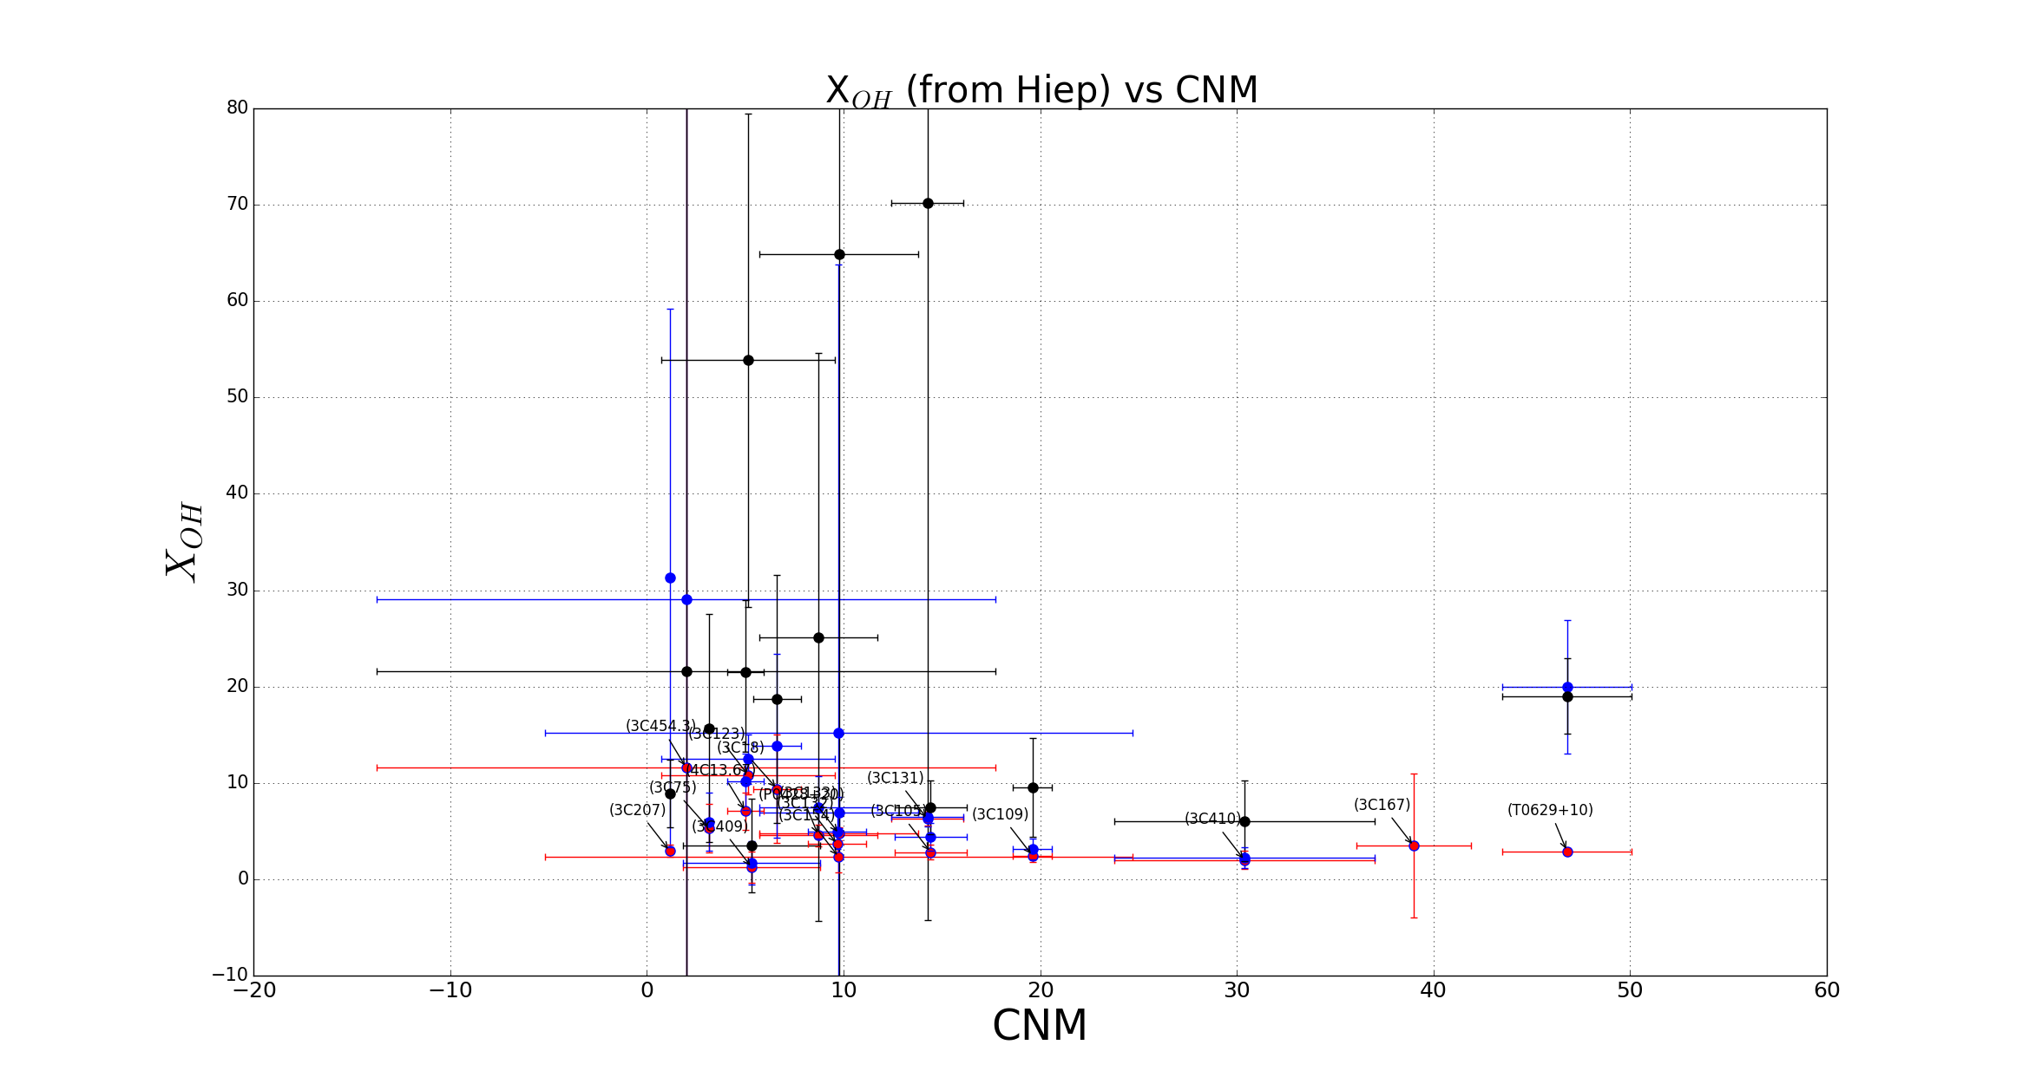
Fig 8: X_{OH} vs N_{CNM}

