**Thermal dust emission *τ353* to total proton column density *NH***

- The Planck paper on All-sky model of thermal dust emission (2013) (<https://arxiv.org/pdf/1312>[.](https://arxiv.org/pdf/1312.1300v5.pdf" \l "_blank)) indicates a link between the optical depth of thermal dust emission at 353GHz, *τ353*, and the total gas column density *NH*:

*τ353 = σ353\*NH* *(1)*

where: *σ353:* dust-to-gas conversion factor or Dust opacity  
 *τ353* map and *τ353* error map (release R1.20) can be accessed here:

[**http://irsa.ipac.caltech.edu/data/Planck/release\_1/all-sky-maps/previews/HFI\_CompMap\_ThermalDustModel\_2048\_R1.20/index.html**](http://irsa.ipac.caltech.edu/data/Planck/release_1/all-sky-maps/previews/HFI_CompMap_ThermalDustModel_2048_R1.20/index.html)

- The values of *σ353* vary from region to region as shown in Table 3, thank you for sending me these masks.

|  |  |  |
| --- | --- | --- |
| Mask | <*σ353*>  [cm2H-1] | *σ(σ353)*  [cm2H-1] |
| Whole sky | 8.4x10-27 | 3.0x10-27 |
| G56 | 7.1x10-27 | 1.9x10-27 |
| |b| > 15o | 7.0x10-27 | 2.0x10-27 |
| G45 | 6.8x10-27 | 1.8x10-27 |
| G35 | 6.5x10-27 | 1.8x10-27 |
| South Cap | 6.5x10-27 | 1.9x10-27 |
| Low *NHI* | 6.6x10-27 | 1.7x10-27 |
| Lowest 1% | 7.9x10-27 | 1.9x10-27 |

Table 1: Mask used in Planck 2013 paper for the values of <*σ353*> and its uncertainties *σ(σ353).*

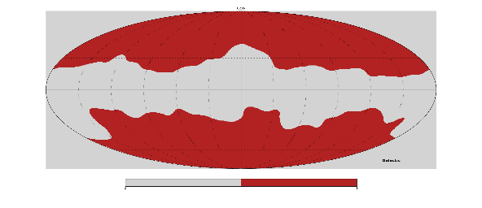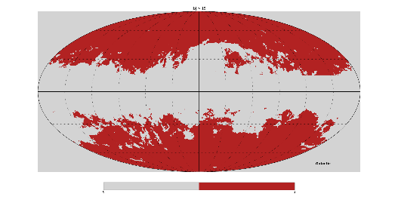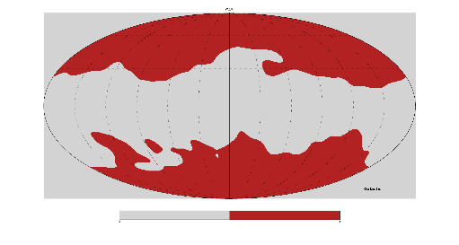

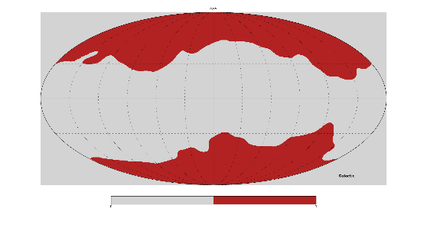

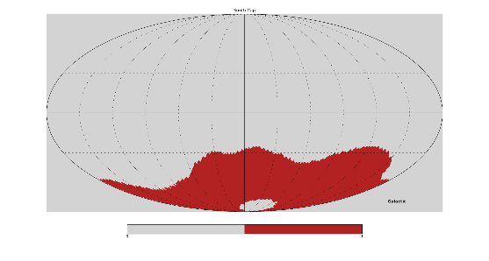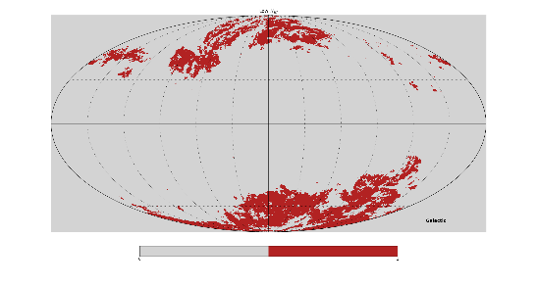

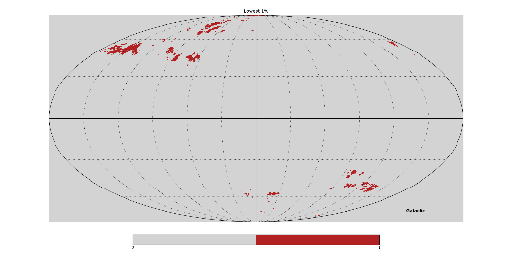

*Figure ??: The masks from Planck 2013 paper.*

- I use the equation (1) to calculate the total gas column densities *NH* along 26 lines-of-sight where CO lines are not detected.

- I installed HEALPix software (in Python, it is healpy package) to read Planck FITS data file, the optical depth map of thermal dust emission at 353GHz, *τ353*, in Mollview, and Cartview is displayed in Figure ??:

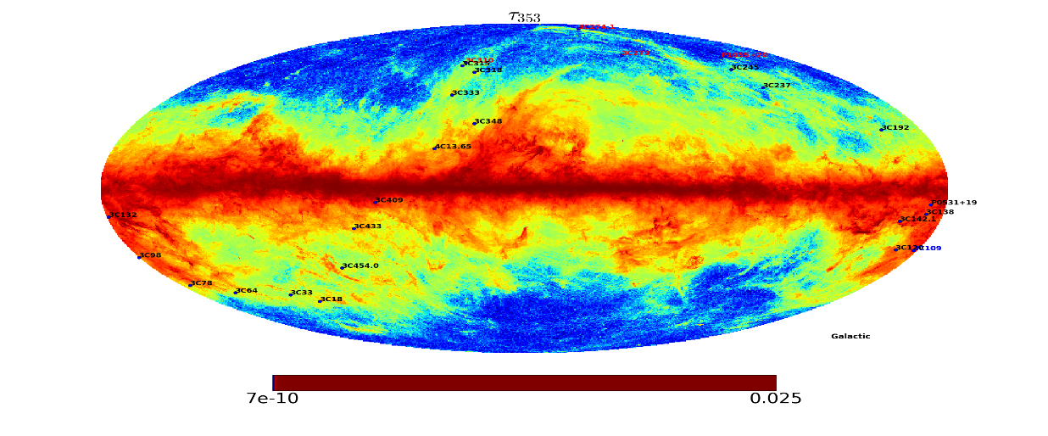

*Figure ??: Optical depth map of thermal dust emission at 353GHz, τ353, in Mollview and Cartview and positions of 26 sources without CO.*

- I also calculate the Total Proton Column Density *NH* from *τ353* for the above 26 MS line-of-sights using Fukui conversion factors (Fukui et al. 2015), namely:

*NH = [2.0 x 1026 ± <no error>] \* τ353 (2)*

The purpose of this is to compare and check if there exists a consistency (?^^?).

- For selected MS line-of-sights, I compute the Mean Value of *τ353* in an area about the Arecibo Beam (3.5').

- It means:

- Define a very small area around the point-source at (*l0,b0*) with the radius of 3.5 arcmin, the beam of Arecibo telescope.

- Find the pixels within the area.

- Get the value of optical depth *τ353* in each pixel.

- Take the average of all *τ353* values, and this is the value of *τ353* obtained.

- The *τ353*error for each point source will similarly be calculated.

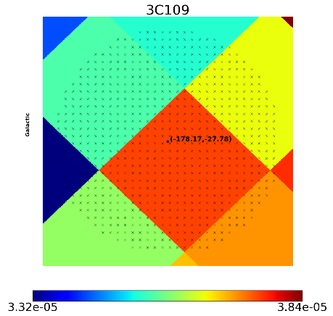- Examples are shown in figure ??

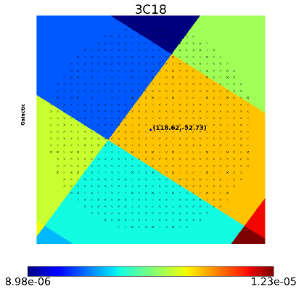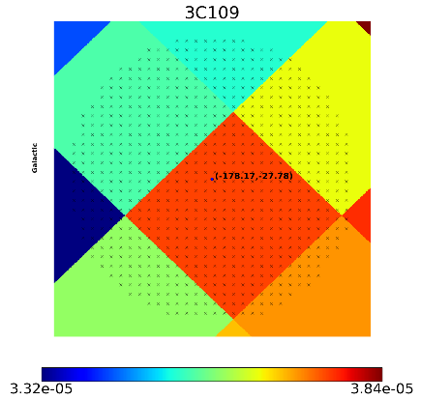

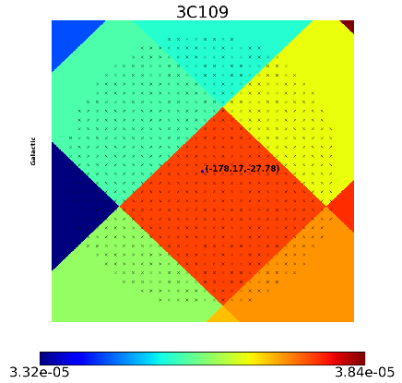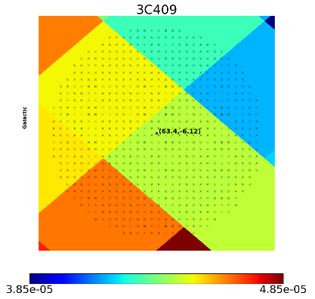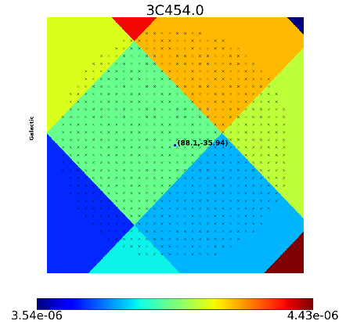

*Figure ??: Patches of τ353 map around point-sources showing the pixels within the round area of 3.5 arcminutes.*

- The errors of the whole *τ353* map are ~ 5%, see the figure below:

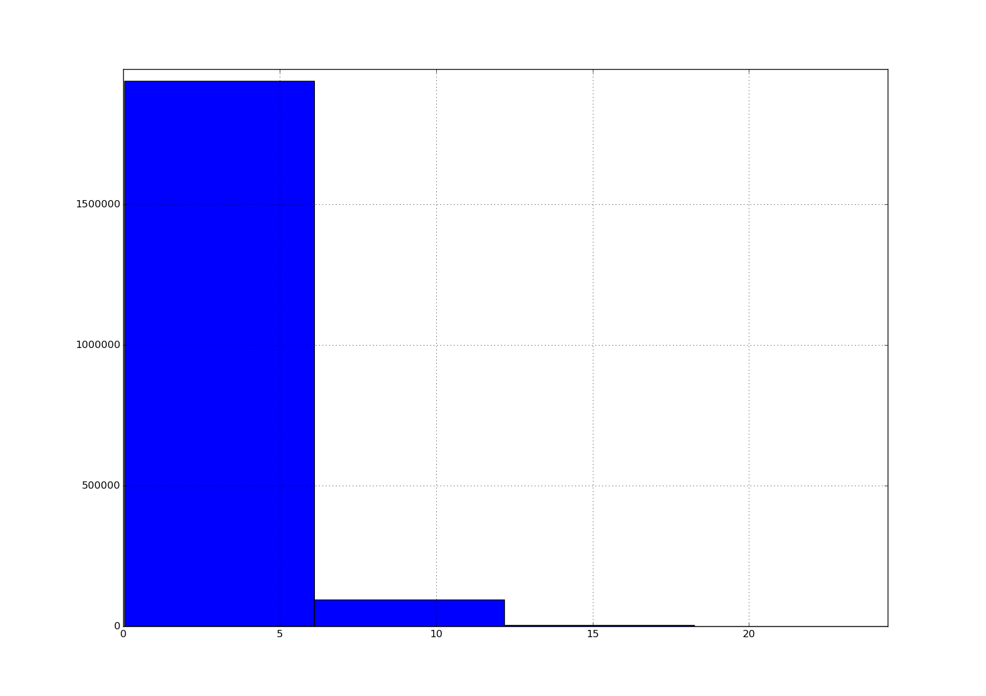

*Figure ??: Errors of the τ353 map*

- Along 26 lines-of-sight without CO, I see that :

+ If use Planck conversion factor, *NH* values obtained are closed to Heiles & Troland *NHI* values (the factor ~ 1.48).

+ If use Fukui conversion factor, *NH* values obtained are about double the Heiles & Troland *NHI* values (the factor ~ 2.31) as shown in below figure.

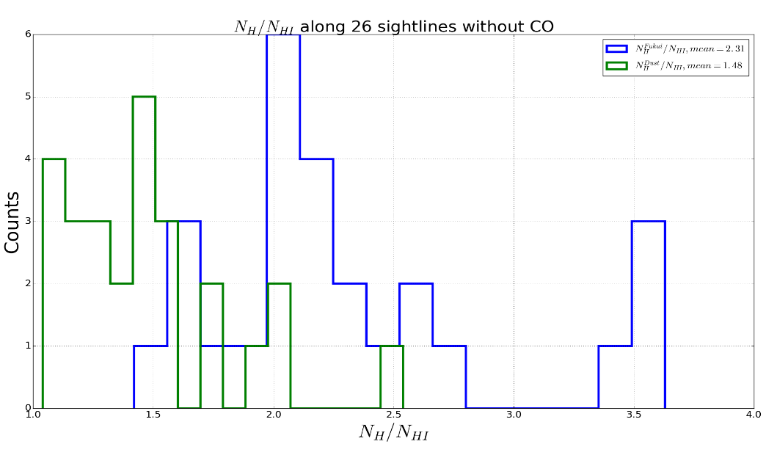

*Figure ??: Histogram of NH/NHI along 26 sources without CO obtained from equations 1 and 2 for Fukui and Planck conversion factors respectively. The mean value of NH\_Fukui/NHI = 2.31 and NH\_Dust/NHI = 1.48*

- Considering only 26 sources without the presence of CO, there is a agreement in Total Gas Column Density values *NH* (*NHI* in fact ) obtained from Millennium Survey and Planck data on thermal dust optical depth *τ353*. In the assumption of optically thick HI emission line that Fukui et al. 2015 made, the *NH* calculated from 26 selected sources using their conversion factor is about twice higher.

- I've just found some interesting information:

1. The distribution of *NHI\_Fukui*/*NHI\_Heiles* that I computed is comparable to that from the paper Fuikui et al. 2015, both of them are about 1.0-3.0. Please see the figure below.

(Jo: Hmm... I guess this doesn't seem too surprising, considering that our sub-sample of sight lines in this HI-only analysis tends to be dominated by warm HI (is that right?). i.e. the N(HI)\_heiles values are not vastly different from the optically thin HI values? Then the ratio of N(HI\_fukui)/N(HI)\_thin shouldn't be too different to N(HI\_fukui)/N(HI)\_heiles.)

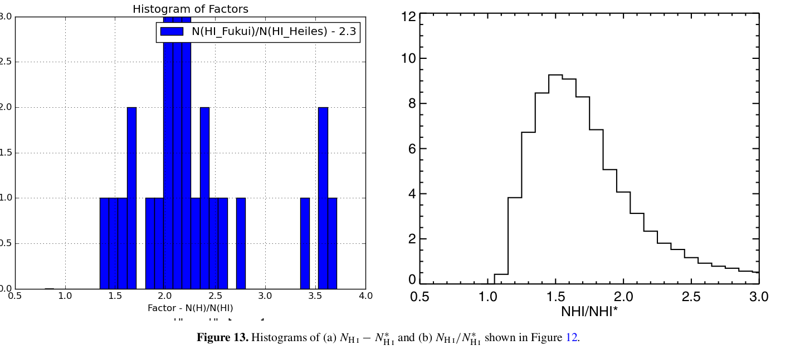

Yes, that's right, the sub-sample (26 sources) is dominated by Warm HI. There are 19/26 light-of-sights having *NHI\_Warm* > *NHI\_Cold*, and so 7/26 sources with *NHI\_Warm* < *NHI\_Cold*. *(Please see figure ??)*. In this figure, I just want to check if I'm correct.

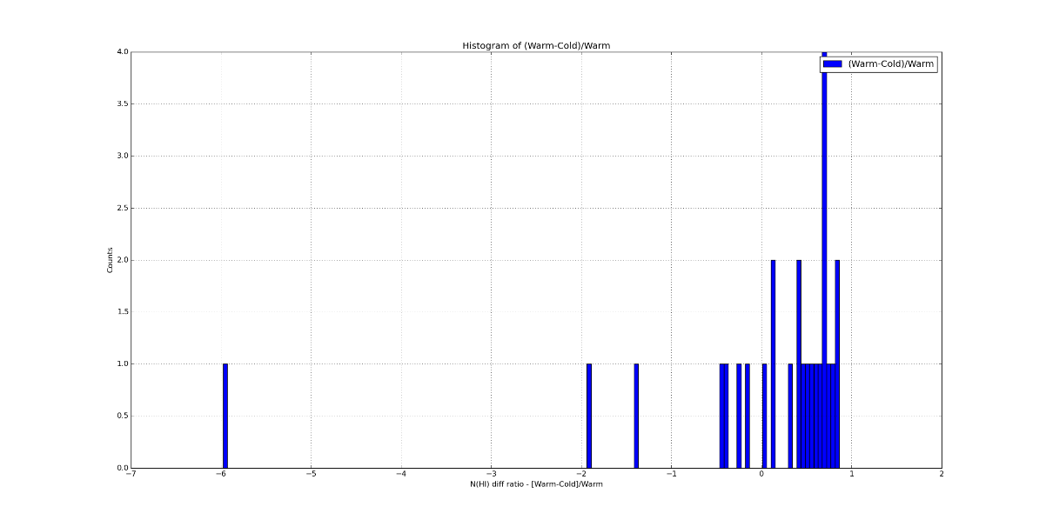

*Figure ??: Comparison between NCNM and NWNM.*

2. I calculated *f = NH\_planck/NHI* then I plot: *f vs NHI*. It seems that there is a linear relation between them *f* and NHI as illustrated inthe figures below:

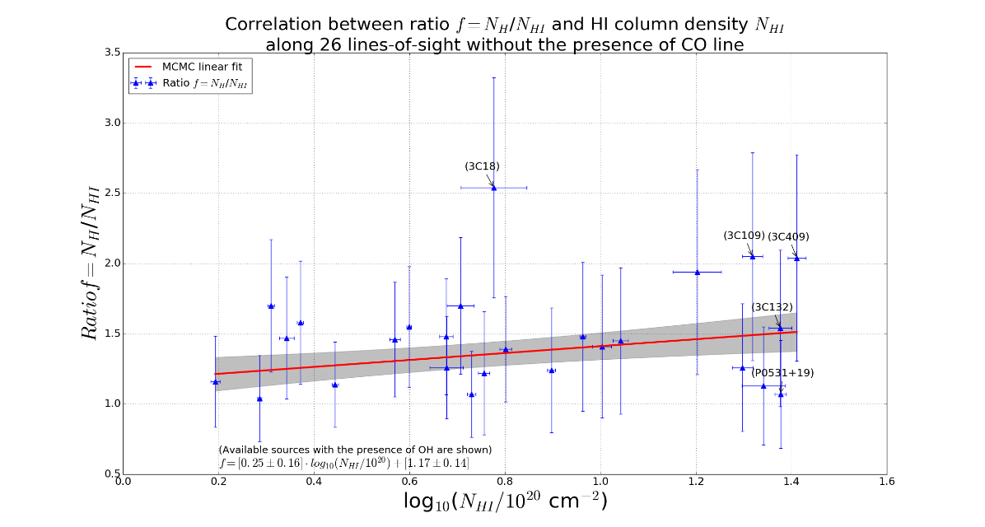

Figure ??: The ratio *f = NH /NHI* as a function of log10(NHI/1020 cm-2). The linear fit determined for 26 data points without the presence of CO is indicated as red line.

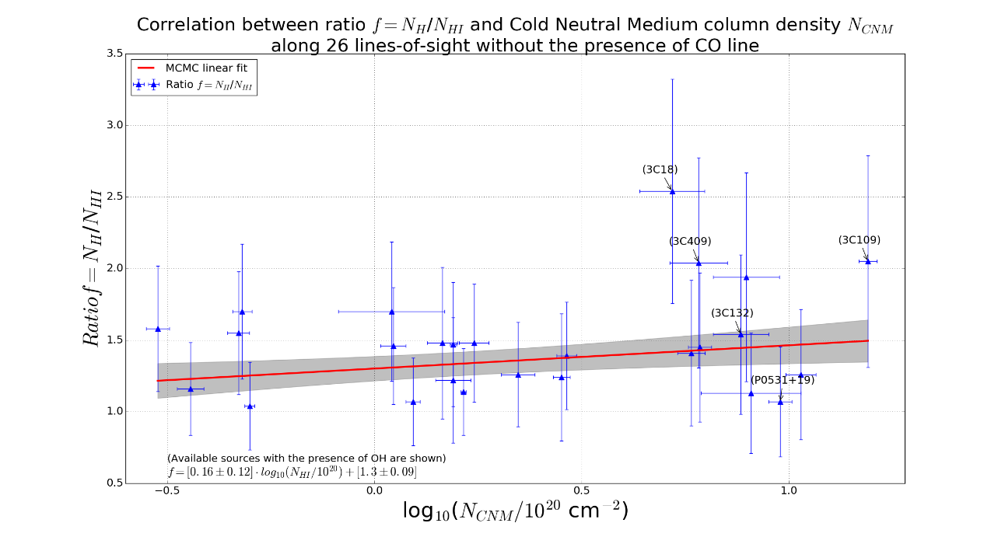

Figure ??: Same as Figure ?? above but only for Cold Neutral Medium. The linear fit is indicated as red line.

(First thoughts: there is more hidden material as you go to higher HI column densities (and the Fukui factor just overestimates things more). If true, this is definitely very interesting! It says there is a larger fraction of dark ISM (presumably CO-dark H2 in our case since Heiles' numbers already include opaque HI) where there is more HI to begin with. What I hope/suspect should be driving this correlation is a correlation between the factor and larger CNM column densities. i.e. you find more CO-dark H2 where the atomic gas tends to be colder/denser. Can you compare that? Plot log(N(HI)\_heiles[cold components only]) vs the factor? That plot would be interesting to see!)

- Large fraction of CO-dark H 2 is found in the sightlines where there is more atomic hydrogen. From the correlation between the ratio f and CNM column densities, it seems that one can find more CO-dark H 2 where the atomic gas tends to be colder or denser.

- I have so far used the offset ~1 beam width (3.5') around the sources, but as illustrated below, I also calculated for larger offsets for comparison, x-axis *NHI* from *Tau353* divided by the *NHI* from Heiles and Troland:

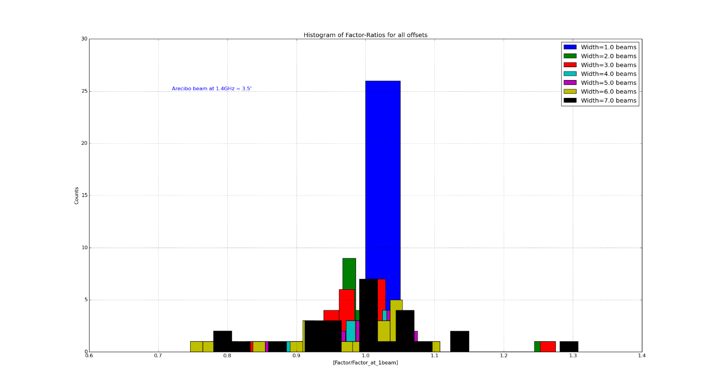Figure ??:

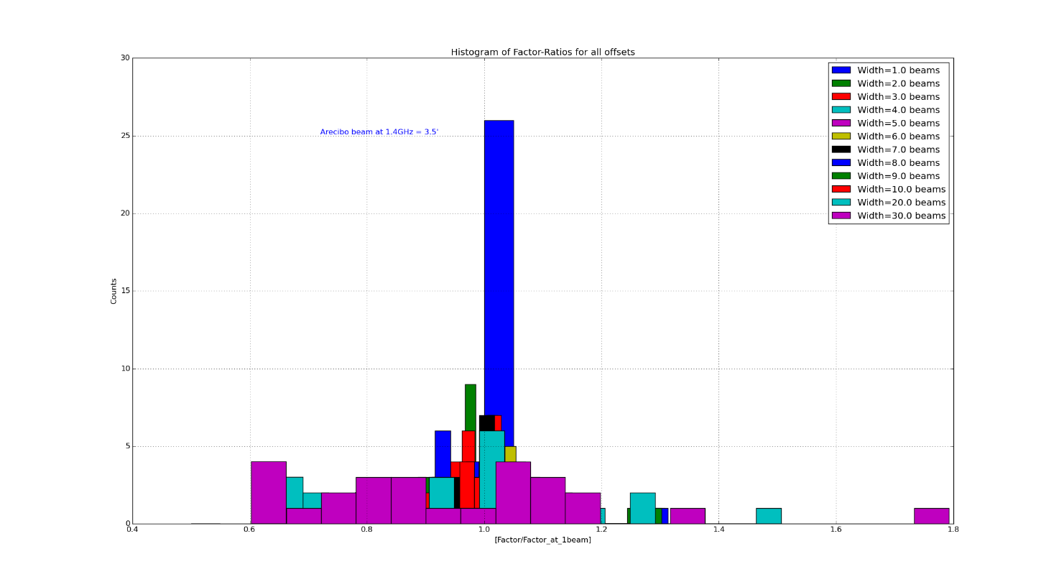

- I see that the ratio of *NH\_Planck* at all offsets is close to it at offset of 1 beam-width.

- The distribution of ratios for all offsets.

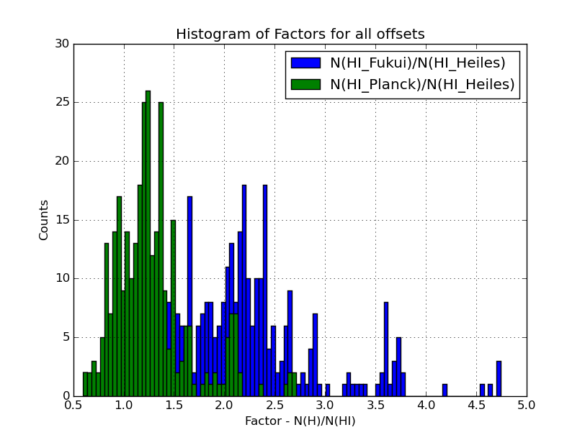Figure ??: