HI data from Arecibo Millennium Survey

See python scripts:
1. plot_specs.py
2. read_specs_data.py
3. nhi_heiles_uncertainty.py
4. plot_nhi_uncertainty.py

I. HI column densities N*_{HI} under the optically thin assumption from Millennium Survey (MS) data
Aim:
- Compare the total N_{HI} from paper with the N*_{HI} obtained from the optically thin assumption to do/understand how much HI could be underestimated.

Note: Optically thin assumption means the optical depth τ << 1 and no T(b) background.
Eg: For N_{HI}=2.10²⁰ (cm⁻²):
CNM: T_{s} ~ 100K, τ~1: Optically thick
WNM: T_{s} ~ 10.000K, τ<<1: Optically thick
How?:
- Step 1: Use the "expected emission profiles" from Heiles & Troland (2003), which were derived for each of the MS sources, to compute HI column density N*_{HI} under the optically thin assumption.
- Step 2: Compare optically thin HI column densities N*_{HI} with the total HI column densities N_{HI} derived for each line-of-sight via the combination of emission and absorption spectra (table 2 in the paper).
- The difference gives us a measure of how much material would be missed under the optically thin assumption - i.e. an opacity correction, typical value is 10%.

Process:
- Use Arecibo HI data from Heiles paper 2003 for 79 sources, download from http://vizier.cfa.harvard.edu/viz-bin/VizieR-3?-source=J/ApJS/145/329/table2&-out.form=%2bA
- (Show Sources in Galaxy Cordinates)
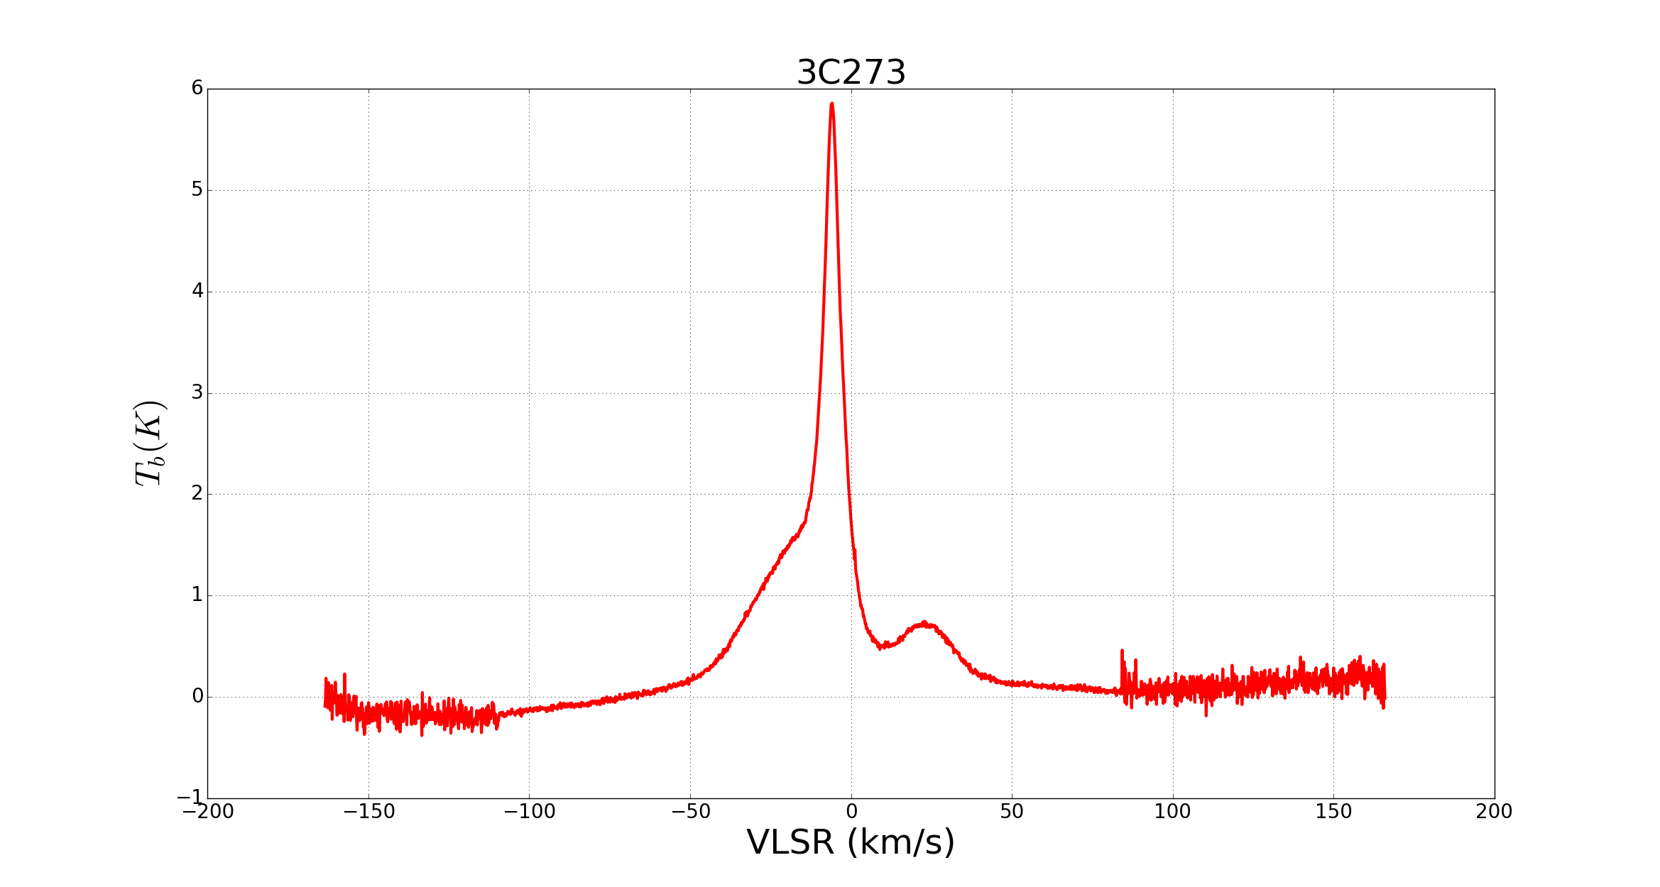
- Plot 79 spectra, T_{b} (K) vs V_{LSR} (km/s), where T_{b} = 0.5*StokesI. This is Stokes I , which is TWICE the conventionally defined brightness temperature.
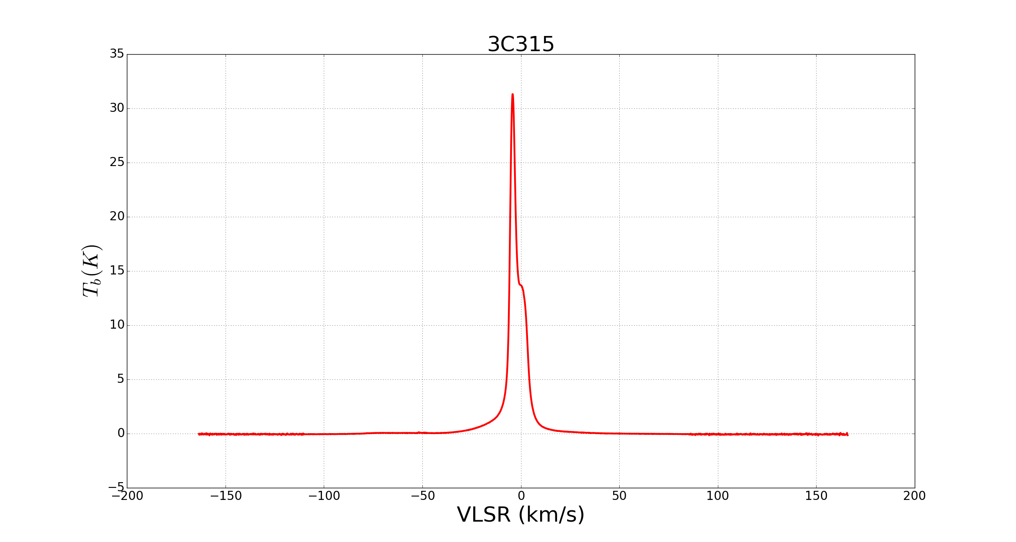
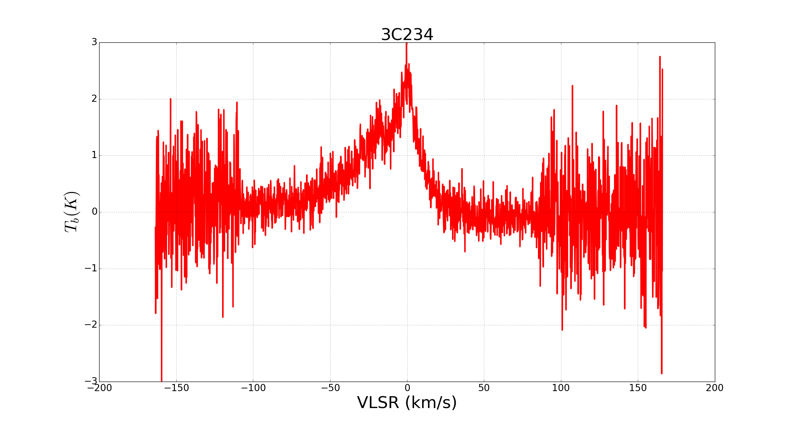
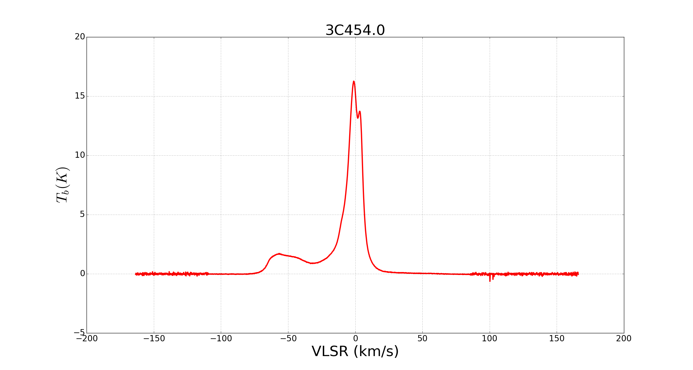
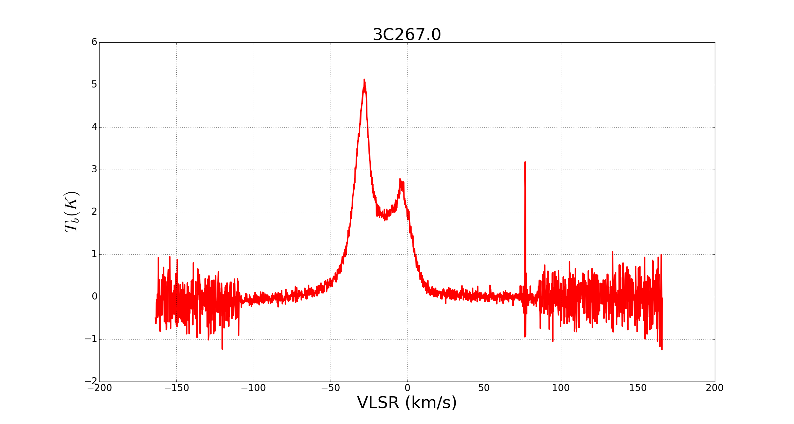
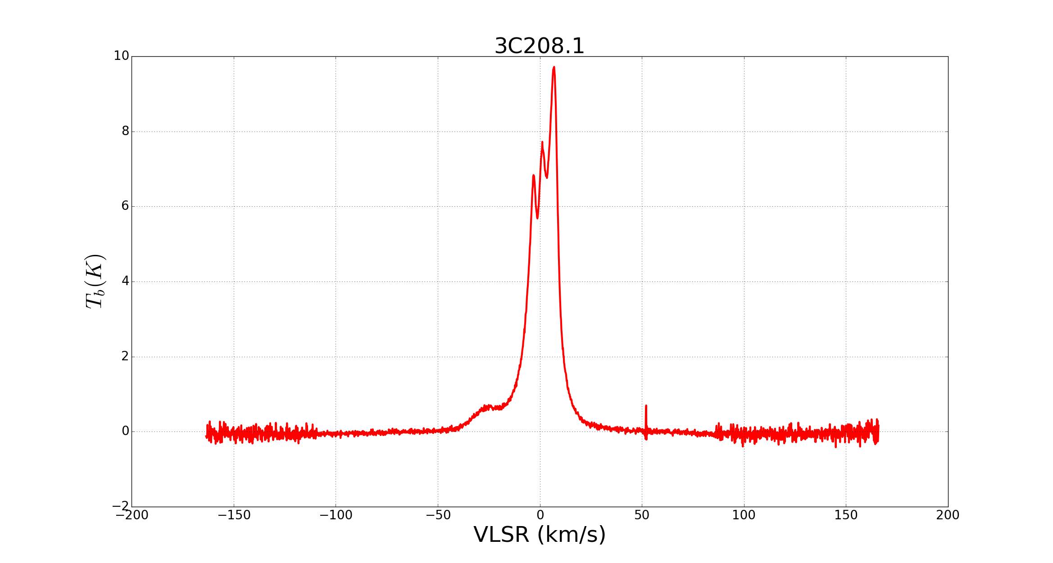

Figure ??: Example of HI spectra from Millennium Survey.

- HI spectra in general are clean, some with spike at a specific bin, some with noise, most with noise at 2 ends.
- For each spectrum, I define the velocity interval [v₁, v₂] containing the emission lines as illustrated in the figure below.
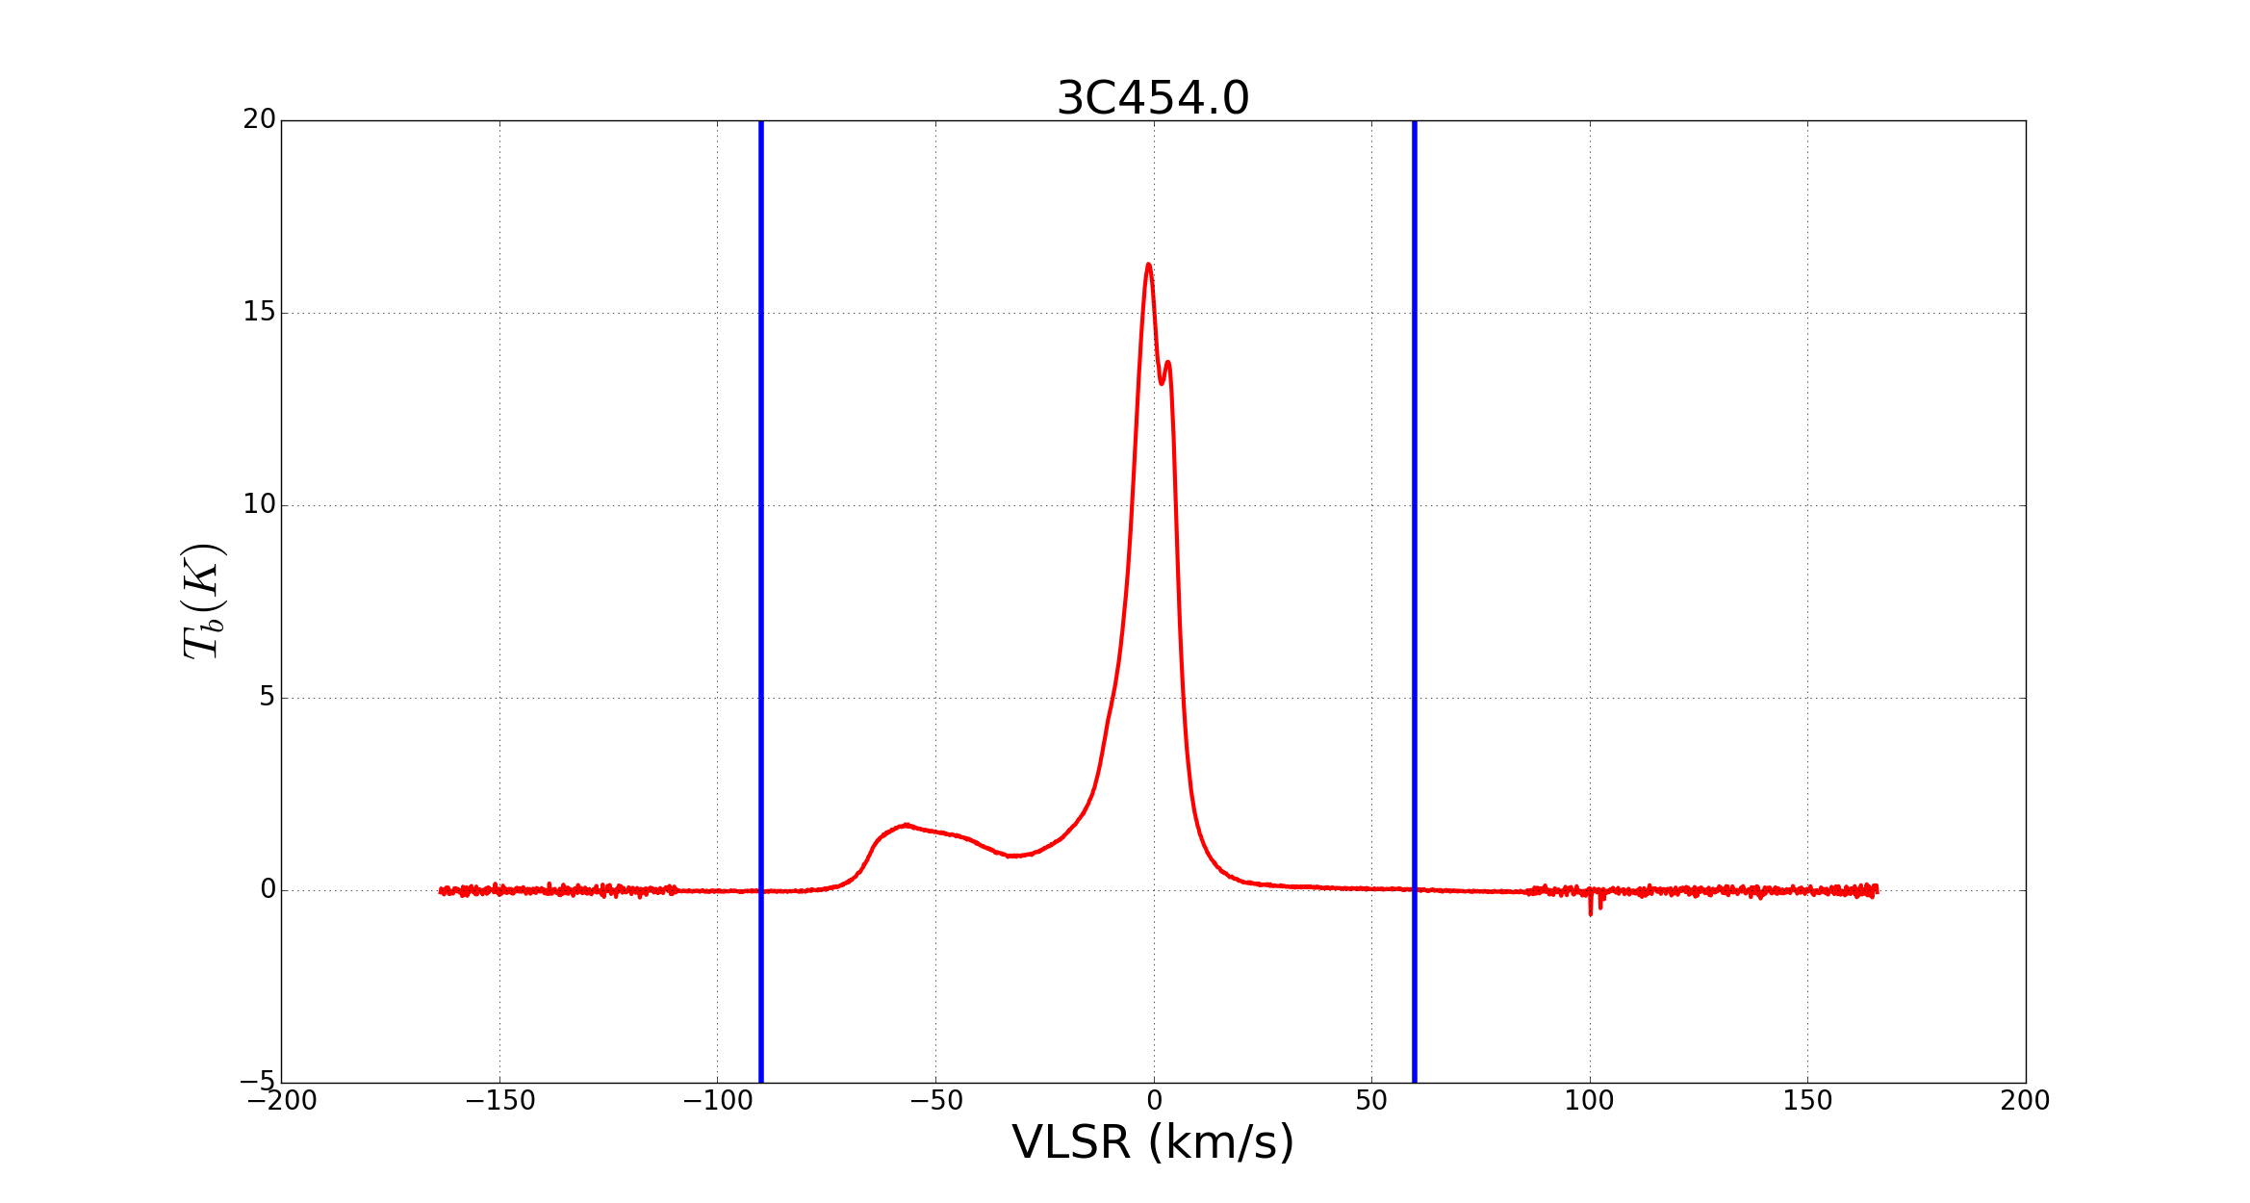

- Integrate the spectrum from v1 to v2 to get the HI integrated intensities W_{HI}.
- The optically thin HI column densities N*_{HI} are then estimated as:
N*_{HI} = 1.8224·10¹⁸ W_{HI} (cm⁻²)
- The results for each source are listed in (Table 1).

# V_{start} V_{end} Start index End index N_{HI} [1e20 cm⁻²] Source
------------------------------------------------------------------------------------------------------------
0 -65.0 40.0 1434 782 5.08 3C18
1 -40.0 20.0 1279 906 2.74 3C33-1
2 -70.0 55.0 1465 689 2.77 3C33
3 -27.0 23.0 1198 888 2.82 3C33-2
4 -35.0 24.0 1248 882 5.96 3C64
5 -33.0 25.0 1236 875 7.39 3C75-1
6 -60.0 34.0 1403 819 7.31 3C75
7 -40.0 25.0 1279 875 7.64 3C75-2
8 -60.0 40.0 1403 782 8.89 3C78
9 -30.0 25.0 1217 875 8.47 3C79
10 -30.0 25.0 1217 875 8.65 CTA21
11 -38.0 27.0 1267 863 9.82 P0320+05
12 -63.0 30.0 1422 844 10.78 NRAO140
13 -65.0 30.0 1434 844 9.45 3C93.1
14 -30.0 28.0 1217 857 11.18 P0347+05
15 -40.0 40.0 1279 782 9.61 3C98-1
16 -30.0 35.0 1217 813 9.73 3C98
17 -30.0 40.0 1217 782 9.33 3C98-2
18 -30.0 33.0 1217 826 9.35 3C105
19 -40.0 34.0 1279 819 13.72 3C109
20 -50.0 35.0 1341 813 17.34 P0428+20
21 -55.0 35.0 1372 813 9.25 3C120
22 -90.0 35.0 1589 813 15.49 3C123
23 -80.0 40.0 1527 782 21.94 3C131
24 -80.0 45.0 1527 751 19.66 3C132
25 -80.0 40.0 1527 782 23.16 3C133
26 -70.0 40.0 1465 782 17.17 3C138
27 -63.0 38.0 1422 795 40.16 3C141.0
28 -50.0 40.0 1341 782 30.5 T0526+24
29 -30.0 47.0 1217 739 16.91 3C142.1
30 -48.0 42.0 1329 770 21.86 P0531+19
31 -38.0 45.0 1267 751 45.52 T0556+19
32 -50.0 46.0 1341 745 40.07 4C22.12
33 -60.0 47.0 1403 739 31.26 3C154
34 -78.0 60.0 1515 658 44.36 T0629+10
35 -50.0 85.0 1341 503 42.21 3C167
36 -80.0 50.0 1527 720 7.41 3C172.0
37 -40.0 50.0 1279 720 2.39 DW0742+10
38 -40.0 60.0 1279 658 2.89 3C190.0
39 -80.0 54.0 1527 695 3.89 3C192
40 -65.0 65.0 1434 627 4.15 P0820+22
41 -40.0 50.0 1279 720 4.86 3C207
42 -50.0 55.0 1341 689 2.99 3C208.0
43 -50.0 55.0 1341 689 2.73 3C208.1
44 -60.0 35.0 1403 813 1.02 3C223
45 -85.0 50.0 1558 720 3.29 3C225a
46 -70.0 50.0 1465 720 3.2 3C225b
47 -50.0 45.0 1341 751 2.62 3C228.0
48 -100.0 50.0 1652 720 1.61 3C234
49 -80.0 52.0 1527 708 1.16 3C236
50 -80.0 80.0 1527 534 1.96 3C237
51 -65.0 40.0 1434 782 2.09 3C245
52 -80.0 55.0 1527 689 1.54 P1055+20
53 -78.0 20.0 1515 906 1.51 P1117+14
54 -90.0 26.0 1589 869 1.64 3C263.1
55 -80.0 20.0 1527 906 1.73 3C264.0
56 -77.0 34.0 1509 819 2.28 3C267.0
57 -75.0 27.0 1496 863 2.38 3C272.1
58 -73.0 100.0 1484 410 1.99 3C273
59 -67.0 50.0 1447 720 2.24 3C274.1
60 -50.0 20.0 1341 906 2.04 4C07.32
61 -60.0 40.0 1403 782 1.11 4C32.44
62 -75.0 72.0 1496 583 2.07 3C286
63 -72.0 50.0 1478 720 1.27 3C293
64 -50.0 25.0 1341 875 2.58 4C19.44
65 -80.0 30.0 1527 844 2.64 4C20.33
66 -80.0 40.0 1527 782 3.42 3C310
67 -45.0 42.0 1310 770 4.04 3C315
68 -85.0 35.0 1558 813 4.14 3C318
69 -80.0 40.0 1527 782 4.43 3C333
70 -40.0 65.0 1279 627 5.2 3C348
71 -75.0 65.0 1496 627 8.67 3C353
72 -60.0 70.0 1403 596 8.51 4C13.65
73 -107.0 85.0 1695 503 13.48 4C13.67
74 -100.0 55.0 1652 689 20.81 3C409
75 -105.0 50.0 1683 720 38.31 3C410
76 -80.0 60.0 1527 658 7.65 3C433
77 -80.0 55.0 1527 689 5.19 3C454.0
78 -80.0 55.0 1527 689 6.26 3C454.3

Table 1: HI column densities N*_{HI} under the optically thin assumption for 79 MS lines-of-sigh.

- From the Heiles 2003 paper, calculate the total HI column density N_{HI} for each source by summing its cold N_{CNM} and warm N_{WNM} components. These values are to a certain extent accurate and reliable because they are derived from on-/off source observation method.

- The N*_{HI} estimates are made using the assumption of opacity τ<<1 and should give an underestimate in cases where there is appreciable cold gas. From values in table 2, one should find some places where the true column density N_{HI} is underestimated by up to 50%, mostly where the HI columns are already high (see red lines in Table 2).

- Take the difference/ratio between N_{HI} and N*_{HI} (Table 2)
# id V_{start} V_{end} StartID EndID N*_{HI}[1e20] N_{HI}[1e20] N_{HI}_ratio(%) source
#--------------------------------------------------------------------------------------------------------
0 -65.0 40.0 1434.0 782.0 5.08 5.99 15.19 3C18
1 -40.0 20.0 1279.0 906.0 2.74 2.81 2.49 3C33-1
2 -70.0 55.0 1465.0 689.0 2.77 2.78 0.36 3C33
3 -27.0 23.0 1198.0 888.0 2.82 2.92 3.42 3C33-2
4 -35.0 24.0 1248.0 882.0 5.96 6.33 5.85 3C64
5 -33.0 25.0 1236.0 875.0 7.39 7.97 7.28 3C75-1
6 -60.0 34.0 1403.0 819.0 7.31 7.89 7.35 3C75
7 -40.0 25.0 1279.0 875.0 7.64 8.23 7.17 3C75-2
8 -60.0 40.0 1403.0 782.0 8.89 10.06 11.63 3C78
9 -30.0 25.0 1217.0 875.0 8.47 9.37 9.61 3C79
10 -30.0 25.0 1217.0 875.0 8.65 9.56 9.52 CTA21
11 -38.0 27.0 1267.0 863.0 9.82 11.2 12.32 P0320+05
12 -63.0 30.0 1422.0 844.0 10.78 29.49 63.45 NRAO140
13 -65.0 30.0 1434.0 844.0 9.45 12.32 23.3 3C93.1
14 -30.0 28.0 1217.0 857.0 11.18 13.45 16.88 P0347+05
15 -40.0 40.0 1279.0 782.0 9.61 10.37 7.33 3C98-1
16 -30.0 35.0 1217.0 813.0 9.73 11.02 11.71 3C98
17 -30.0 40.0 1217.0 782.0 9.33 10.25 8.98 3C98-2
18 -30.0 33.0 1217.0 826.0 9.35 14.68 36.31 3C105
19 -40.0 34.0 1279.0 819.0 13.72 20.82 34.1 3C109
20 -50.0 35.0 1341.0 813.0 17.34 23.89 27.42 P0428+20
21 -55.0 35.0 1372.0 813.0 9.25 15.94 41.97 3C120
22 -90.0 35.0 1589.0 813.0 15.49 27.38 43.43 3C123
23 -80.0 40.0 1527.0 782.0 21.94 28.55 23.15 3C131
24 -80.0 45.0 1527.0 751.0 19.66 23.81 17.43 3C132
25 -80.0 40.0 1527.0 782.0 23.16 28.5 18.74 3C133
26 -70.0 40.0 1465.0 782.0 17.17 19.84 13.46 3C138
27 -63.0 38.0 1422.0 795.0 40.16 52.69 23.78 3C141.0
28 -50.0 40.0 1341.0 782.0 30.5 96.85 68.51 T0526+24
29 -30.0 47.0 1217.0 739.0 16.91 21.96 23.0 3C142.1
30 -48.0 42.0 1329.0 770.0 21.86 23.84 8.31 P0531+19
31 -38.0 45.0 1267.0 751.0 45.52 53.63 15.12 T0556+19
32 -50.0 46.0 1341.0 745.0 40.07 85.23 52.99 4C22.12
33 -60.0 47.0 1403.0 739.0 31.26 35.58 12.14 3C154
34 -78.0 60.0 1515.0 658.0 44.36 59.25 25.13 T0629+10
35 -50.0 85.0 1341.0 503.0 42.21 50.24 15.98 3C167
36 -80.0 50.0 1527.0 720.0 7.41 7.71 3.89 3C172.0
37 -40.0 50.0 1279.0 720.0 2.39 2.43 1.65 DW0742+10
38 -40.0 60.0 1279.0 658.0 2.89 2.82 2.48 3C190.0
39 -80.0 54.0 1527.0 695.0 3.89 3.97 2.02 3C192
40 -65.0 65.0 1434.0 627.0 4.15 4.23 1.89 P0820+22
41 -40.0 50.0 1279.0 720.0 4.86 5.25 7.43 3C207
42 -50.0 55.0 1341.0 689.0 2.99 2.99 0.0 3C208.0
43 -50.0 55.0 1341.0 689.0 2.73 2.76 1.09 3C208.1
44 -60.0 35.0 1403.0 813.0 1.02 0.98 4.08 3C223
45 -85.0 50.0 1558.0 720.0 3.29 3.4 3.24 3C225a
46 -70.0 50.0 1465.0 720.0 3.2 3.28 2.44 3C225b
47 -50.0 45.0 1341.0 751.0 2.62 2.61 0.38 3C228.0
48 -100.0 50.0 1652.0 720.0 1.61 1.61 0.0 3C234
49 -80.0 52.0 1527.0 708.0 1.16 1.21 4.13 3C236
50 -80.0 80.0 1527.0 534.0 1.96 2.2 10.91 3C237
51 -65.0 40.0 1434.0 782.0 2.09 2.03 2.96 3C245
52 -80.0 55.0 1527.0 689.0 1.54 1.57 1.91 P1055+20
53 -78.0 20.0 1515.0 906.0 1.51 1.57 3.82 P1117+14
54 -90.0 26.0 1589.0 869.0 1.64 1.68 2.38 3C263.1
55 -80.0 20.0 1527.0 906.0 1.73 1.73 0.0 3C264.0
56 -77.0 34.0 1509.0 819.0 2.28 2.33 2.15 3C267.0
57 -75.0 27.0 1496.0 863.0 2.38 2.39 0.42 3C272.1
58 -73.0 100.0 1484.0 410.0 1.99 1.93 3.11 3C273
59 -67.0 50.0 1447.0 720.0 2.24 2.36 5.08 3C274.1
60 -50.0 20.0 1341.0 906.0 2.04 2.11 3.32 4C07.32
61 -60.0 40.0 1403.0 782.0 1.11 1.05 5.71 4C32.44
62 -75.0 72.0 1496.0 583.0 2.07 2.04 1.47 3C286
63 -72.0 50.0 1478.0 720.0 1.27 1.28 0.78 3C293
64 -50.0 25.0 1341.0 875.0 2.58 2.65 2.64 4C19.44
65 -80.0 30.0 1527.0 844.0 2.64 2.69 1.86 4C20.33
66 -80.0 40.0 1527.0 782.0 3.42 3.71 7.82 3C310
67 -45.0 42.0 1310.0 770.0 4.04 4.77 15.3 3C315
68 -85.0 35.0 1558.0 813.0 4.14 4.75 12.84 3C318
69 -80.0 40.0 1527.0 782.0 4.43 5.09 12.97 3C333
70 -40.0 65.0 1279.0 627.0 5.2 5.69 8.61 3C348
71 -75.0 65.0 1496.0 627.0 8.67 10.85 20.09 3C353
72 -60.0 70.0 1403.0 596.0 8.51 9.16 7.1 4C13.65
73 -107.0 85.0 1695.0 503.0 13.48 16.72 19.38 4C13.67
74 -100.0 55.0 1652.0 689.0 20.81 25.81 19.37 3C409
75 -105.0 50.0 1683.0 720.0 38.31 48.22 20.55 3C410
76 -80.0 60.0 1527.0 658.0 7.65 7.89 3.04 3C433
77 -80.0 55.0 1527.0 689.0 5.19 5.38 3.53 3C454.0
78 -80.0 55.0 1527.0 689.0 6.26 6.53 4.13 3C454.3
Table 2: HI column densities N*_{HI} under the optically thin assumption and total HI column densities N_{HI} in comparison for 79 MS lines-of-sigh.

- Correlation between the total HI column densities derived for each sightline, N_{HI}, and the HI column densities under the optically thin assumption, N*_{HI}, is shown in Figure ?? and Figure ??. While figure ?? is the histogram of the ratio f=N_{HI} /N*_{HI} in percentage, figure ?? displays the ratio f as a function of log₁₀(N*_{HI} /10²⁰ cm⁻² ). Clearly, the ratio f increases with N*_{HI}.
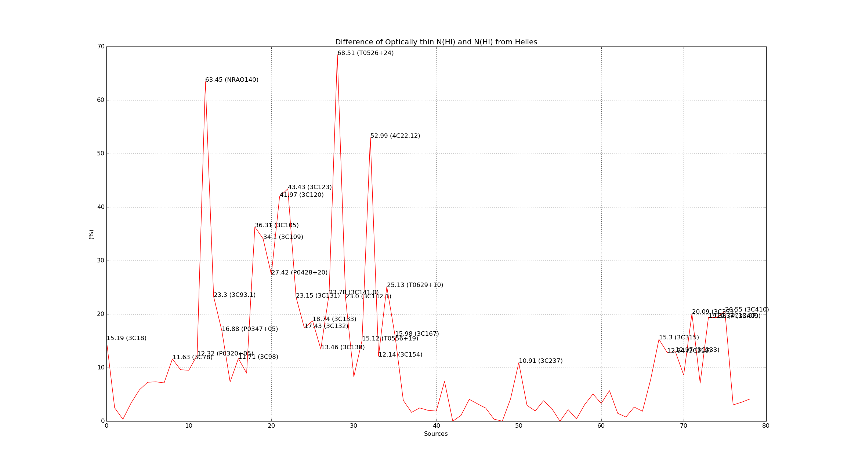
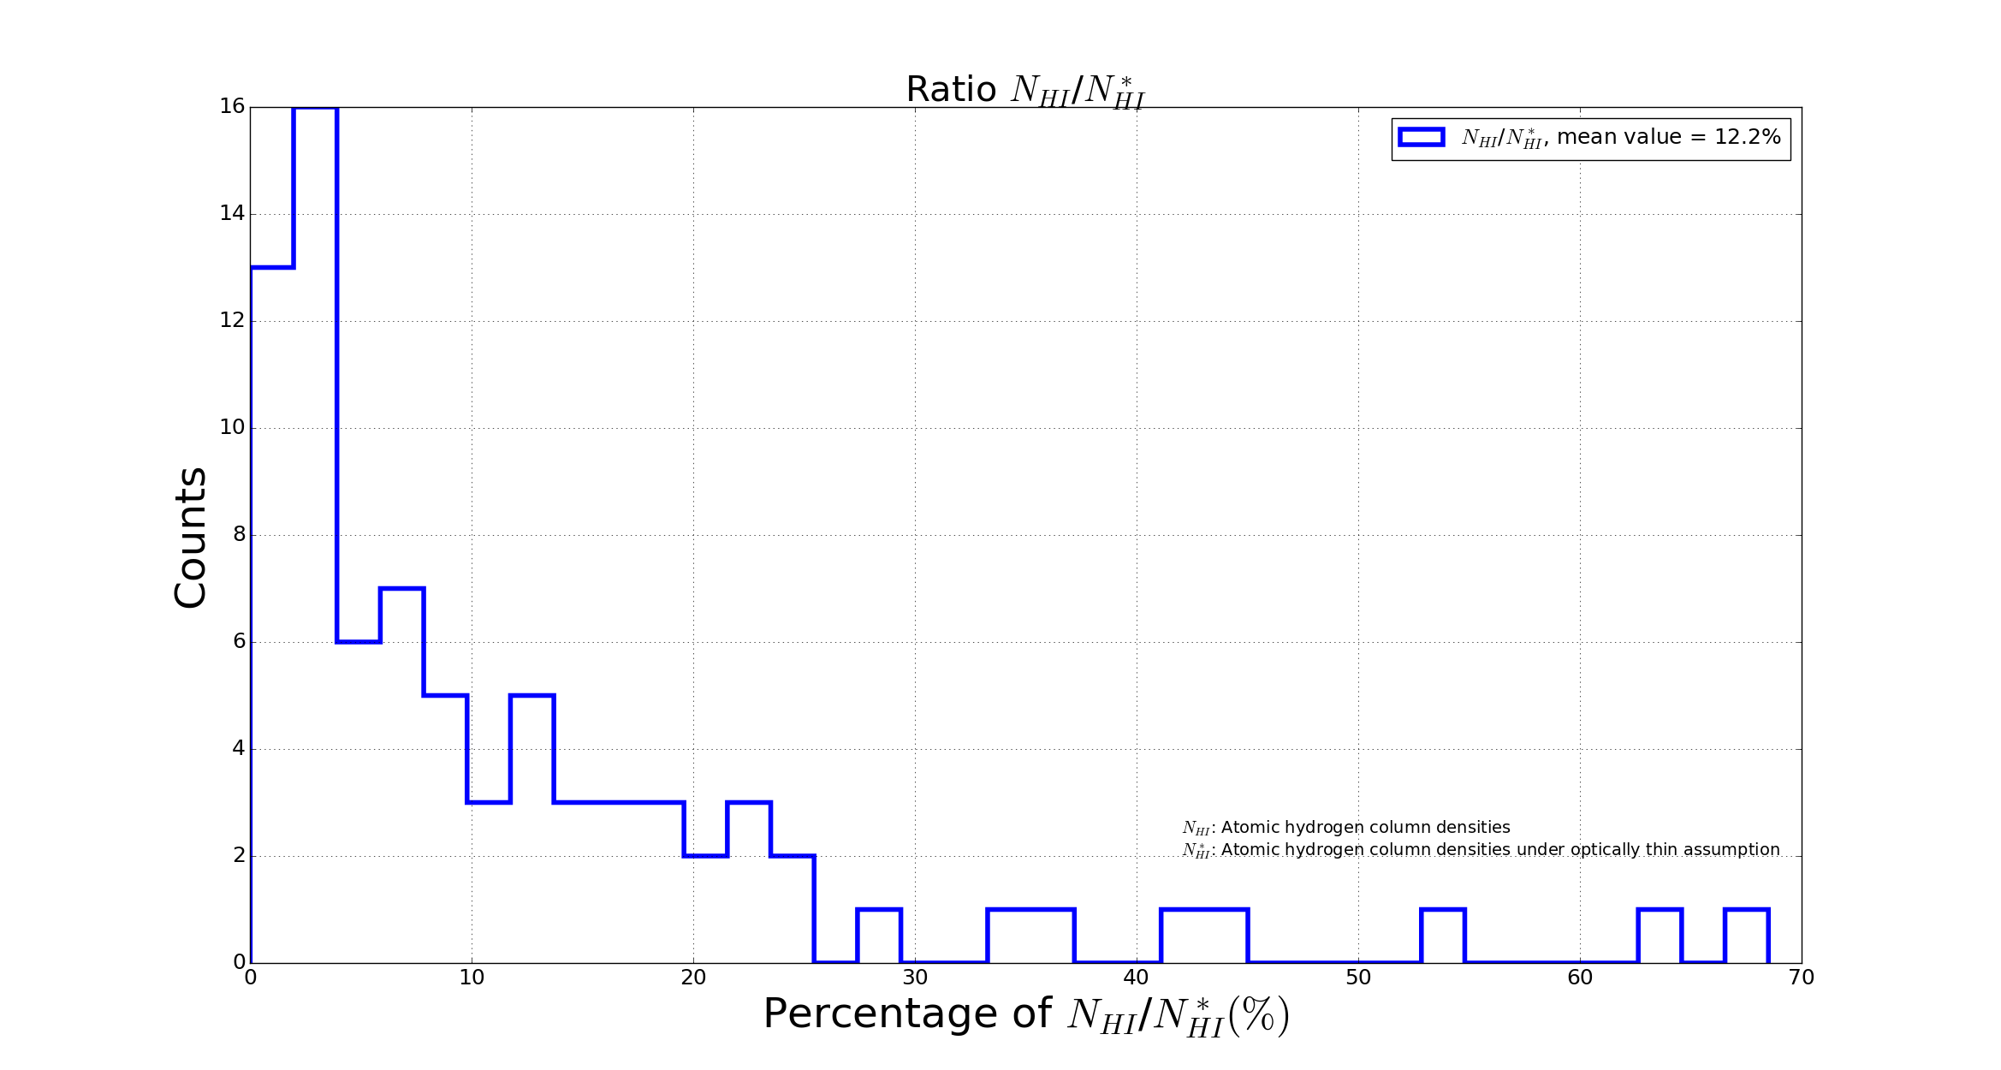
Figure ??: Histogram of N_{HI} /N*_{HI} in percentage

- The difference gives us a measure of how much material would be missed under the optically thin assumption - i.e. an opacity correction.
→ Result:
ratio R = N*_{HI}/N_{HI}
- 32/79 sources have ratio values <= 5%.
- 47/79 sources have ratio values <= 10%.
- 32/79 sources could be considered as optically thin with ratio values <= 5% ??
- The HI mass increases by ~12% compared to the optically thin assumption (as illustrated in Figure ??). This is consistent with the typical value (~10%) throughout the Galaxy.

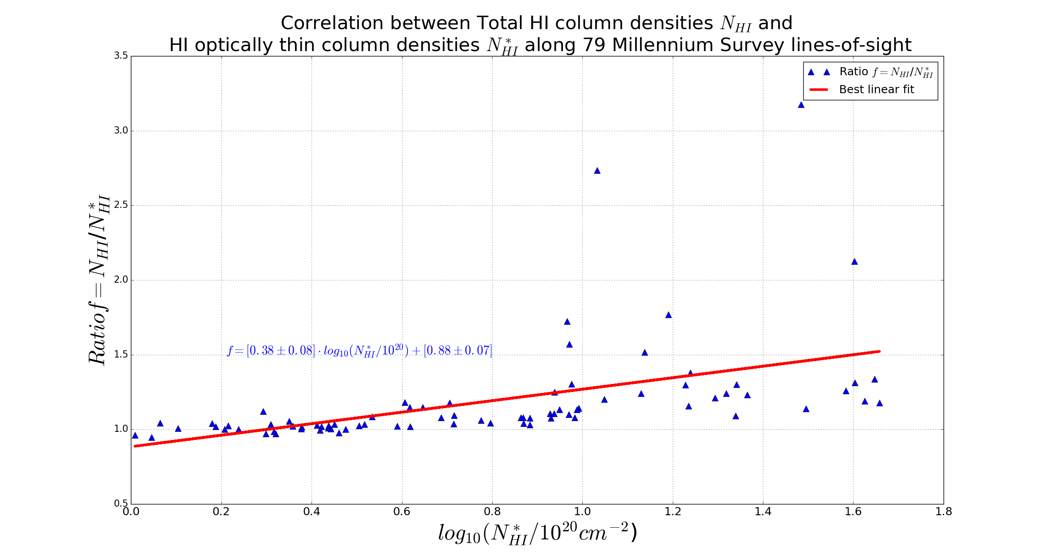

Figure ??: Correlation between NHI and N*HI along 79 MS sightlines.

II. Uncertainty of the total HI column densities N_{HI}
- In the paper, the uncertainties on HI column density are not estimated. The value of N_{HI} for each Gaussian component is computed given opacity τ, excitation temperature T_{s} and the line-width Δv using the standard equation. Since the MS paper gives uncertainties on each of those values, one just needs to propagate those errors through in the usual way.

1. For WNM:
I estimate the uncertainties by using the optically thin assumption, that is:
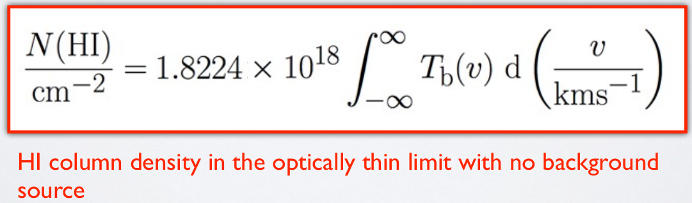
y = N_{HI} = const*∫T_{b}*exp[-(v-v₀)²/σ²]dv
where:
const = 1.8224*10¹⁸ [cm⁻²K⁻¹km⁻¹s]
σ = FWHM/(2√ln2), given FWHM = Δv in the paper.
Consequently, Δσ = Δ(FWHM)/(2√ln2)
Have: Δ²y = (Δy/ΔT_{b})²ΔT²_{b} + (Δy/Δv₀)²Δ²v₀ + (Δy/Δσ)²Δ²σ
Δy/ΔT_{b} = const*∫exp[-(v-v₀)²/σ²]dv = const*σ*√π
Δy/Δv₀ = (2*const*T_{b}/σ²)∫x*exp[-x²/σ²]dv = 0
Δy/Δσ = const*T_{b}*√π
→ Δy = ΔN_{HI} = const*√[π*(σ²ΔT_{b}² + T²_{b}*Δ²σ)]

2. For CNM
I use the function of T_{s} and τ_{v} to compute N_{HI} namely:
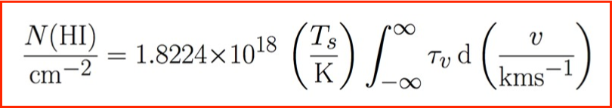
Where (from the paper):
- T_{s} is a variable with its uncertainty
- tau is a Gaussian, τ = τ₀*e^{[-(v-v0)^2/σ^2]}, τ₀ is the central opacity of the component.
- τ has its uncertainty
- v₀ with its uncertainty
- σ with its uncertainty, note that in the paper, Δv is FWHM, so σ = FWHM/(2*√ln2)
Use the Gaussian integral to calculate the derivatives:
y = N_{HI} = const*T_{s}*∫τ₀*exp[-(v-v₀)²/σ²]dv, where const = 1.8224*10¹⁸ [cm⁻²K⁻¹km⁻¹s]
Have: Δ²y = (Δy/ΔT_{s})²Δ²T_{s} + (Δy/Δτ)²Δ²v₀ + (Δy/Δv₀)²Δ²v₀ + (Δy/Δσ)²Δ²σ
Δy/ΔT_{s} = const*τ_{0*}∫exp[-(v-v₀)²/σ²]dv = const*τ₀*σ*√π
Δy/Δτ = const*T_{s}∫exp[-(v-v₀)²/σ²]dv = const*T_{s}*σ*√π
Δy/Δv₀ = (2*const*τ*T_{s}/σ²)∫x*exp[-x²/σ²]dv = 0
Δy/Δσ = const*τ₀*T_{s}*√π
→ Δy = ΔN_{HI} = const*√[π*(σ²ΔT_{s}²*τ²₀ + T²_{s}*Δ²σ*τ²₀ +σ²T²_{s}Δ²_{τ})]
Note: σ = FWHM/(2√ln2), given FWHM = Δv in the paper.
And Δσ = Δ(FWHM)/(2√ln2)

→ Then combine the two.
N_{HI} = N_{CNM} + N_{WNM}
Therefore, σ_{N(HI)} = √[Σ_{i}σ²_{N(CNM)_i} + Σ_{k}σ²_{N(WNM)_k}]

The figure shows the histogram of total N_{HI} uncertainties for 78 lines-of-sight. 3 sources with high uncertainties are in Galactic plane or with low latitude:
T0556+19 l = 190.0893, b = -2.1665
T0526+24 l = 181.3551, b = -5.1933
NRAO140 l = 159.0002, b= -18.7646
The mean value is ~ 6.6%
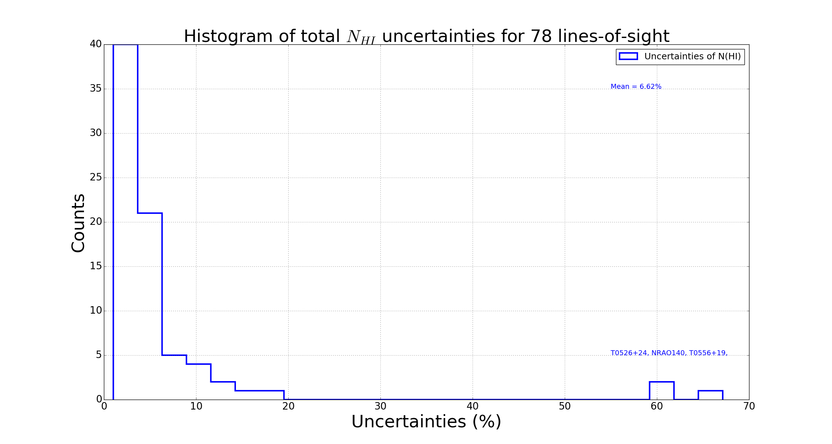
Figure ??: Histogram of N_{HI} uncertainties for 78 MS lines-of-sight

## ============= END =============== ##

I had been concerned about how the assumed ordering of emission/absorption components affected the uncertainties. Having read the paper more carefully, I realise that the errors quoted on tau, Ts and the linewidth already take that effect into account. i.e. they varied the order, recalculated the parameters in each case, and used a weighted average of all trials to derive their uncertainties.

- The problem is:
For CNM components, it is (tau_0;n) from equation, derived directly from the least-squares fit to the opacity profile. For WNM components it is the upper limit to peak opacity (tau_0;k) , estimated by eye (paper session 3.6), and has a very large error.
Here, for CNM components, the uncertainty on tau_o is set to Zero.
Overall, the obtained uncertainties for N(HI) are NOT accurate.

For 26 sources without CO,
- 19/26 sources with the uncertainties < 10%
- The largest uncertainty is from 3C18 (21.74%) because the contribution of tau (0.077 +/- 0.019) of a cold component.

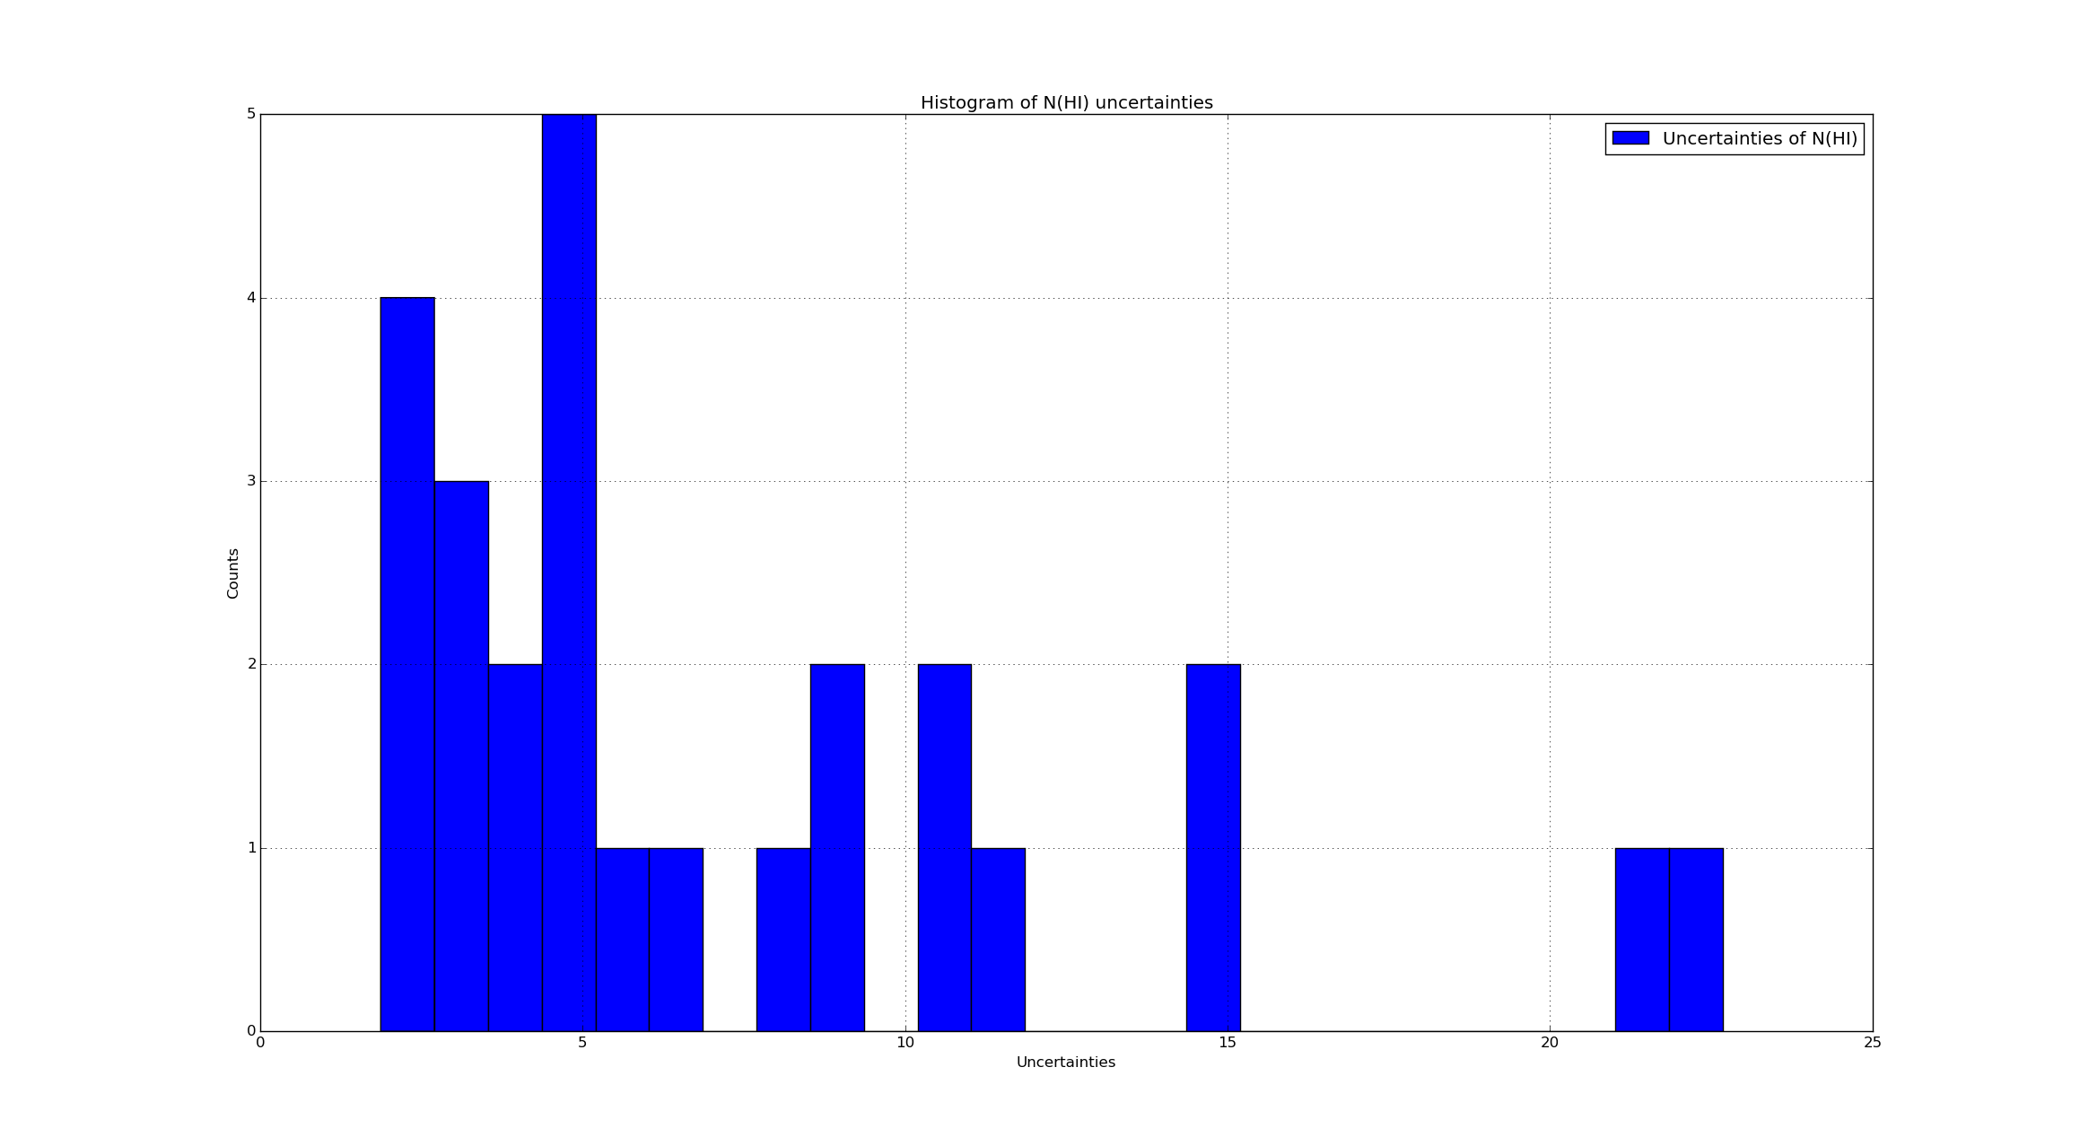

However, [Prof.] For WNM components, tau is always small, so it's fine to calculate N(HI) from the optically thin assumption. i.e. in the optically thin limit, N(HI, WNM) is actually not dependent on tau or Tex at all, just on Tb(peak) and delta-v. Integrating that Gaussian and multiplying by 1.8 x 10^18 should give you your WNM column density, and the uncertainties on tau and Tex do not factor in.
Therefore, I think:

