Works on OH data from Arecibo telescope

Aim:
- Find if OH exists in 79 MS lines-of-sight.
- Check if we can find OH in the clouds where there's more HI.

Data:
- Download the OH data from Arecibo Millennium Survey.
- Observations along 100 sightlines have been taken using On/Off-source method:
'1325+32', '3C105', '3C109', '3C120', '3C123N', '3C123', '3C131', '3C132', '3C133', '3C138', '3C141.0', '3C142.1', '3C154E', '3C154', '3C167E', '3C167', '3C172.0', '3C18', '3C190.0', '3C192N', '3C192', '3C207', '3C208.0', '3C208.1', '3C223', '3C225aN', '3C225a', '3C225b', '3C234', '3C236', '3C237N', '3C237', '3C245', '3C264.0', '3C270', '3C272.1', '3C273N', '3C273', '3C274.1', '3C286', '3C287', '3C293', '3C298', '3C310', '3C315', '3C318', '3C33-1', '3C33-2', '3C333', '3C33', '3C348', '3C409', '3C410', '3C454.3', '3C64', '3C75-1', '3C75-2', '3C75N', '3C75', '3C78W', '3C78', '3C79', '3C93.1', '3C98-1', '3C98-2', '3C98', '4C07.32', '4C13.65', '4C13.67', '4C16.33', '4C19.44N', '4C19.44', '4C21.28', '4C22.12', '4C32.44', '4C35.23', 'CTA21', 'DW0742+10', 'G196.6+0.2', 'G197.0+1.1', 'HD149881', 'HD215733', 'HD93521', 'NRAO140', 'P0320+05', 'P0347+05', 'P0428+20', 'P0531+19', 'P0820+22', 'P1055+20N', 'P1055+20', 'P1117+14', 'Q1552+19', 'T0526+24', 'T0556+19', 'T0629+10', 'T0640+09', 'TauA', 'W49', 'W51c3'

- Data structure:
IDL> help, LA
** Structure <19883498>, 24 tags, length=122928, data length=122926, refs=1:
SRCNAME STRING Array[100]
RA1950 FLOAT Array[100]
DEC1950 FLOAT Array[100]
ELL FLOAT Array[100]
BEE FLOAT Array[100]
CFR_BD0 FLOAT 1420.41 MHz
CFR_BD1 FLOAT 1665.40 MHz
CFR_BD2 FLOAT 1667.36 MHz
NRC INT 100
VLSR_BD0 FLOAT Array[2048]
VLSR_BD1 FLOAT Array[2048]
VLSR_BD2 FLOAT Array[2048]
I_EM_AVG_BD0 FLOAT Array[2048]
I_EM_MED_BD0 FLOAT Array[2048]
I_ABS_AVG_BD0 FLOAT Array[2048]
I_ABS_MED_BD0 FLOAT Array[2048]
I_EM_AVG_BD1 FLOAT Array[2048]
I_EM_MED_BD1 FLOAT Array[2048]
I_ABS_AVG_BD1 FLOAT Array[2048]
I_ABS_MED_BD1 FLOAT Array[2048]
I_EM_AVG_BD2 FLOAT Array[2048]
I_EM_MED_BD2 FLOAT Array[2048]
I_ABS_AVG_BD2 FLOAT Array[2048]
I_ABS_MED_BD2 FLOAT Array[2048]

Note:

“””
median versus average:
The average of a bunch of points is the least-squares value. That is,
when you calculate the sum of the squares of the residuals,
sum_of_squares_of_residuals = \Sigma (\Delta y)_n^2
where (\Delta y)_n is the residual
(\Delta y)_n = y_n - y0
where y0 is the adopted result of combining all of the measurements
y_n. If you adopt y0 as being the value that minimizes the sum of
squares of residuals, then y0 is referred to as the 'least-squares
value'. For a bunch of datapoints y_n, taking the average gives a value
for y_0 that is the same as the least-squares value. So the average
value is the same as the least-squares value.
When the probability density function (PDF) of the residuals follows a
Gaussian (we call this 'Gaussian statistics'), then the least-squares
value is the best estimate for y0. This is the 'AVG' spectrum.
In contrast, the median value is the one for which the number of
ppositive residuals equals the number of negative ones. This is the same
as the median. For Gaussian statistics, the median is NOT the
best estimate. The median is, however, the best estimage when the PDF of
the residuals follows a double-sided exponential PDF.
(see sections 0, 6, 13, especially 13.5, of my handout on least squares,
available at
http://w.astro.berkeley.edu/~h
(click on 'lsfit2008.pdf').
Now, in practice:
If the two spectra I_EM_AVG and I_EM_MED differ only because I_EM_MED is
noisier, then you can be pretty sure that the PDF is Gaussian, i.e. that
there are no interference spikes. So the proper thing to do is to take
the average spectrum I_EM_AVG.
However, if the AVG spectrum has features that are not present in the
MEDIAN spectrum, then the PDF is not gaussian, probably because of
interference. Then one option is to simply use the median. Better is to
look in detail at the data and edit out bad datapoints (using a program
such as our 'flag_rfi.pro') to make the statistics Gaussian, or at least
nearly so; then you can take the average of the edited data.
So the idea here is to use the difference between AVG and MED an
indicator for whether or not you need to edit the data.
“””

- BD0 is HI at 1420.4 MHz. BD1 is OH at 1665 MHz and BD2 is OH at 1667 MHz.
- Each spectrum has 2048 channels with the bandwidth of ~0.77643MHz and the step of ~0.37912 kHz (0.06829 km/s).

- I_EM_AVG_BD* is the Off-source spectra, T_{off-source}.
- I_ABS_AVG_BD* is the on-source antenna temperature minus the off-source antenna temperature: (T_{on-source} – T_{off-source}) = T_{continuum}*e^{-τ}.

On the emission lines, the continuum baseline is the off-source system
temperature (actually, twice that; what's plotted is Stokes I, which is
the sum of the two orthogonal polarizations). This is normally about 50
K. It can be higher if the background continuum is high, which might
happen near the Galactic plane.
On the absorption lines: the continuum baseline is the on-source antenna
temp minus the off source antenna temp (again, times two because it's
Stokes I). Thus, in the case of 3C131, the source deflection (on - off)
is about 47.7 K. This is not related to the off-source system temp,
except insofar as if the source is extended it might be producing some
antenna temp in the 'off-source' position. You can convert the vertical
scale of the 3C131 absorption plot to exp(-tau) simply by dividing all
of the spectral points by 47.7 K.

T_{off-source} = I_EM_AVG_BD*
T_{abs} = T_{on-source} – T_{off-source} = I_ABS_AVG_BD*
For the on/off-source measurements, I use the following equations to calculate the excitation temperature T_{ex} and Opacity e^{-τ}:
T_{off-source} = T_{bg}*e^{-τ} + T_{ex}(1-e^{-τ})
T_{on-source} = (T_{bg} + T_{c})*e^{- τ} + T_{ex}(1-e^{-τ})
So that:
e^{-τ} = (T_{on-source} – T_{off-source})/T_{continuum}
T_{ex} = (T_{off-source} – T_{bg}*e^{-τ}) / (1-e^{-τ})

- In practice, T_{off-source} and T_{on-source} include the receiver temperature, T_{rx}, which is about 50K (in Stokes I). Thus, two equations above need to incorporate T_{rx}:

T_{off-source} = T_{bg}*e^{-τ} + T_{ex}(1-e^{-τ}) + T_{rx}
T_{on-source} = (T_{bg} + T_{c})*e^{- τ} + T_{ex}(1-e^{-τ}) + T_{rx}

- Now, what is T_{rx}? Off the line, the equation for T_{off-source} is

T_{off-source} = T_{bg} + T_{rx}

- T_{bg} contains the cosmic background, 2.8 K, plus the Galactic contribution, which I estimate from the Haslam et al. 408 MHz survey and apply a spectral index of 2.8 for brightness temperature. With this, the Galactic component typically comes out to be about 0.6 K or so, so this means that

T_{off-source} ~ 3.4 + T_{rx}
T_{off-source} is 51.1K, so T_{rx} is 47.7K.

- Among 100 sources observed, I find there are 23 sources where OH is present, they are:
Source l b
==========================
3C105 187.63 -33.61
3C109 181.83 -27.78
3C123 170.58 -11.66
3C131 171.44 -7.80
3C132 178.86 -12.52
3C133 177.73 -9.91
3C154 185.59 4.00
3C167 207.31 1.15
3C18 118.62 -52.73
3C207 212.97 30.14
3C409 63.40 -6.12
3C410 69.21 -3.77
3C454.3 86.11 -38.18
3C75 170.26 -44.91
4C13.67 43.50 9.15
4C22.12 188.05 0.05
G196.6+0.2 196.64 0.17
G197.0+1.1 196.98 1.10
P0428+20 176.81 -18.56
P0531+19 186.76 -7.11
T0526+24 181.36 -5.19
T0556+19 190.09 -2.17
T0629+10 201.53 0.51

- As mentioned above, in order to estimate the continuum background brightness temperature for OH main lines, I use the all-sky continuum map from Haslam et al. 408 MHz survey and then apply a spectral index of 2.8 for brightness temperature.
T_{bg} = 2.8 + T_{bg408}*(408./ν)^{2.8}
where:
ν: frequencies of two OH main lines (1665.402 MHz or 1667.359MHz)
T_{bg408}: Continuum brightness Temperature at 408 MHz, which is the average of the values within the area of Arecibo beam width (3.5 arcminutes) around 23 lines-of- sight, as illustrated in Figure ??.
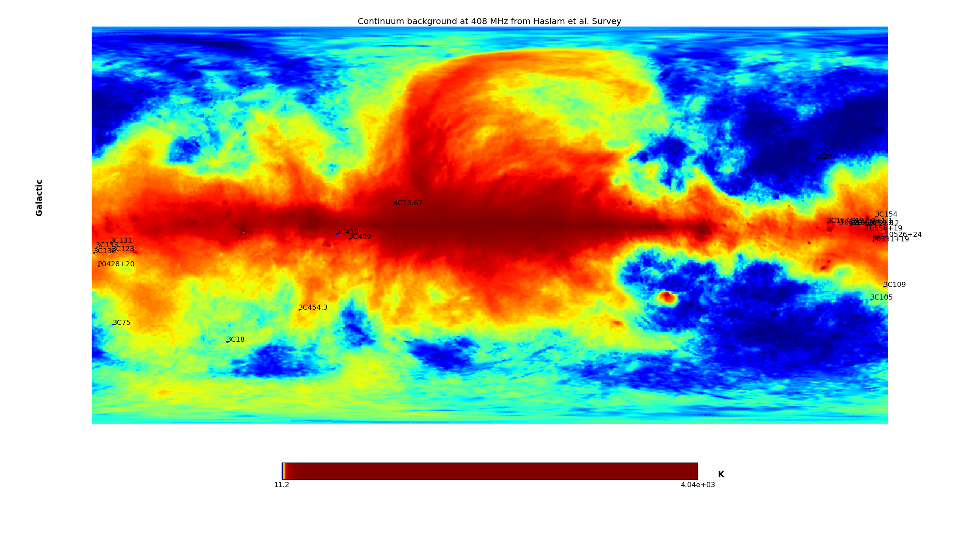

Figure ??: All-sky map of Continuum brightness Temperature at 408 MHz from Haslam et al.
- Patches around lines-of-sight
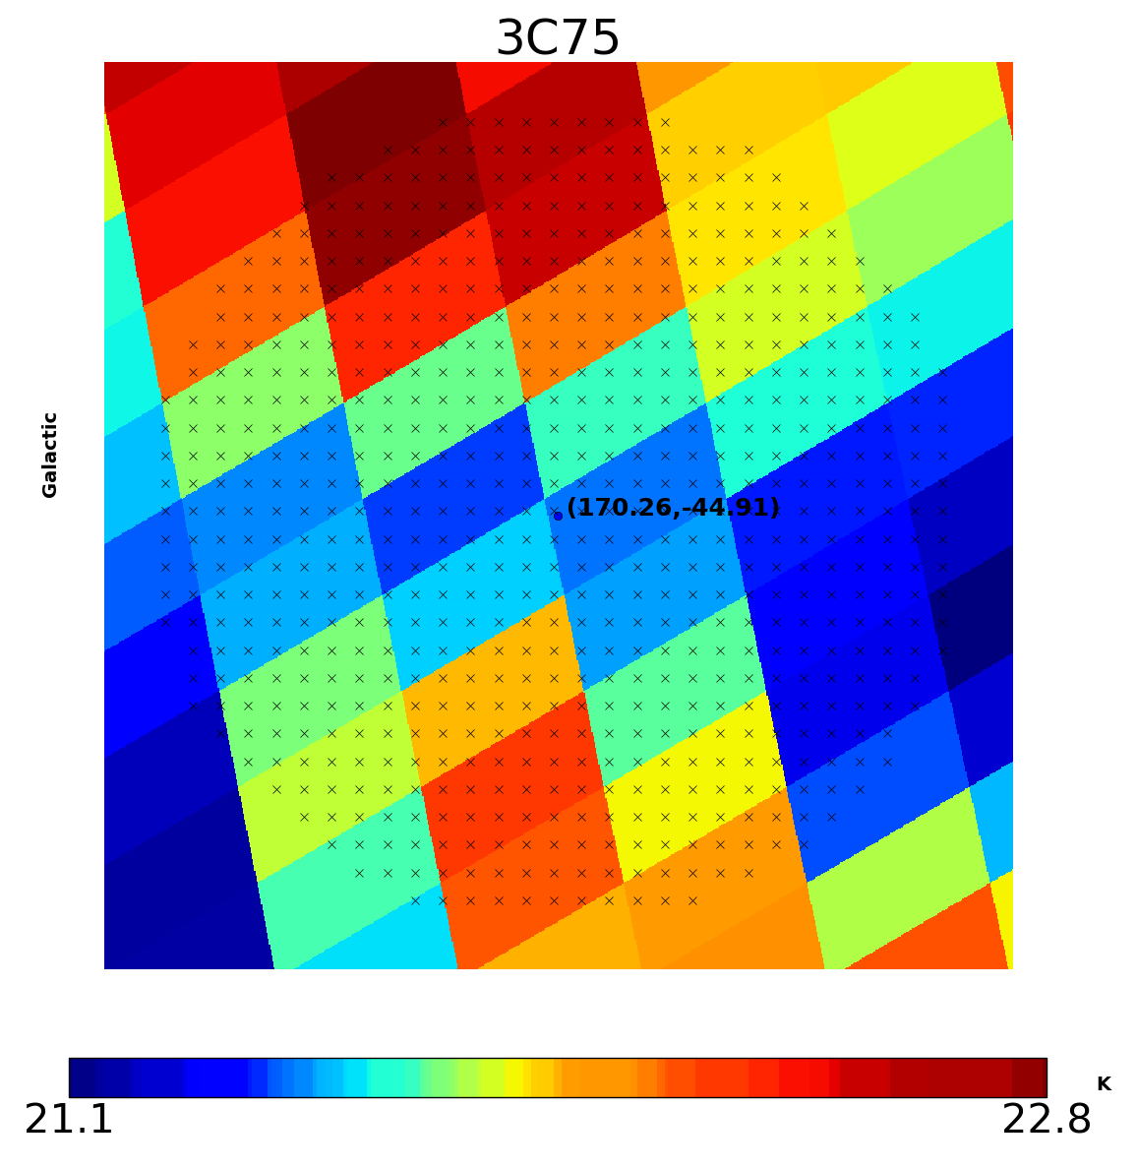
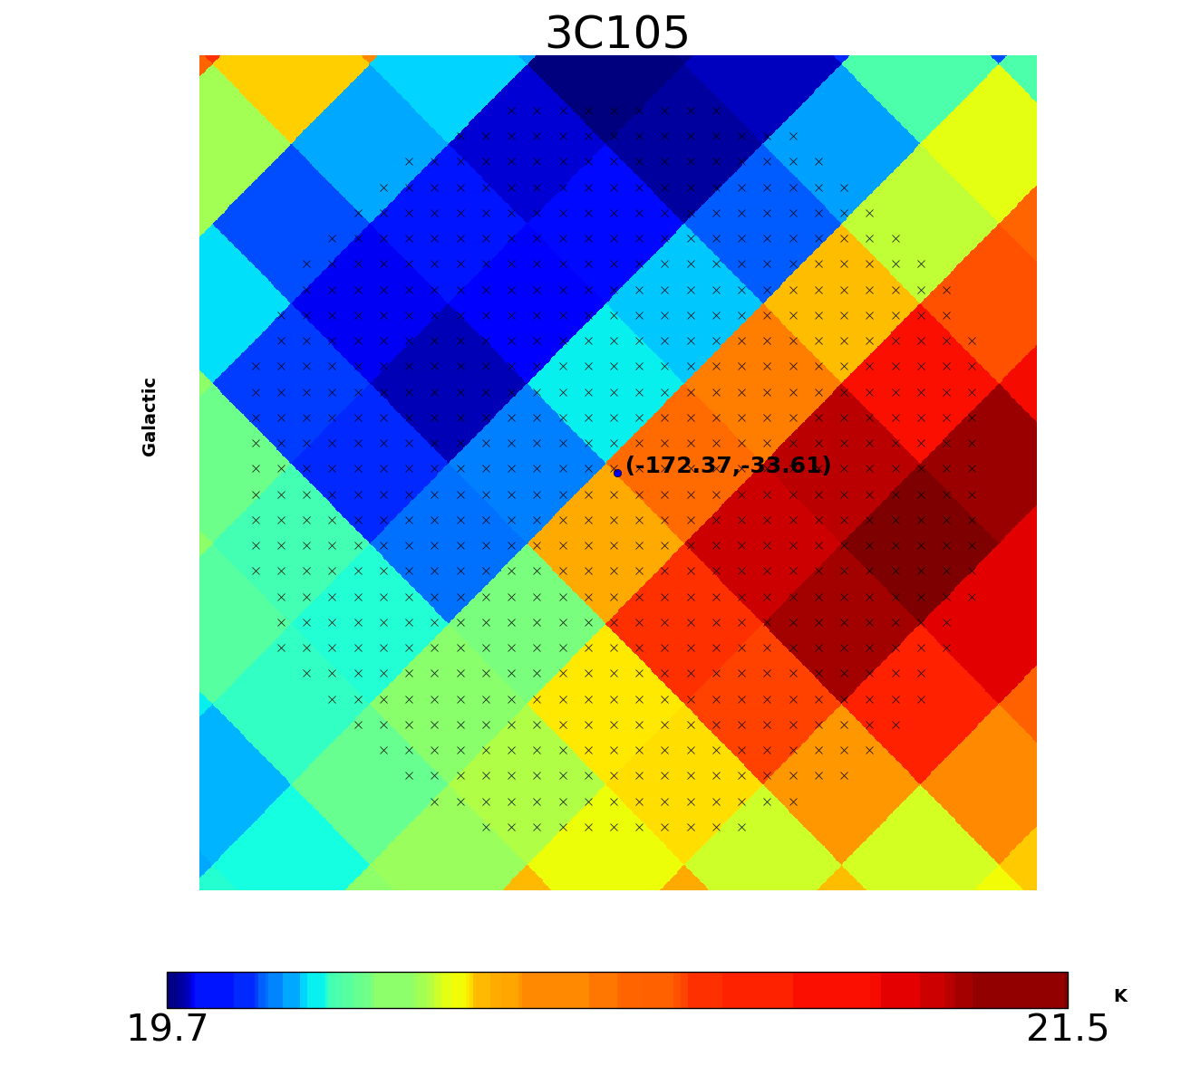

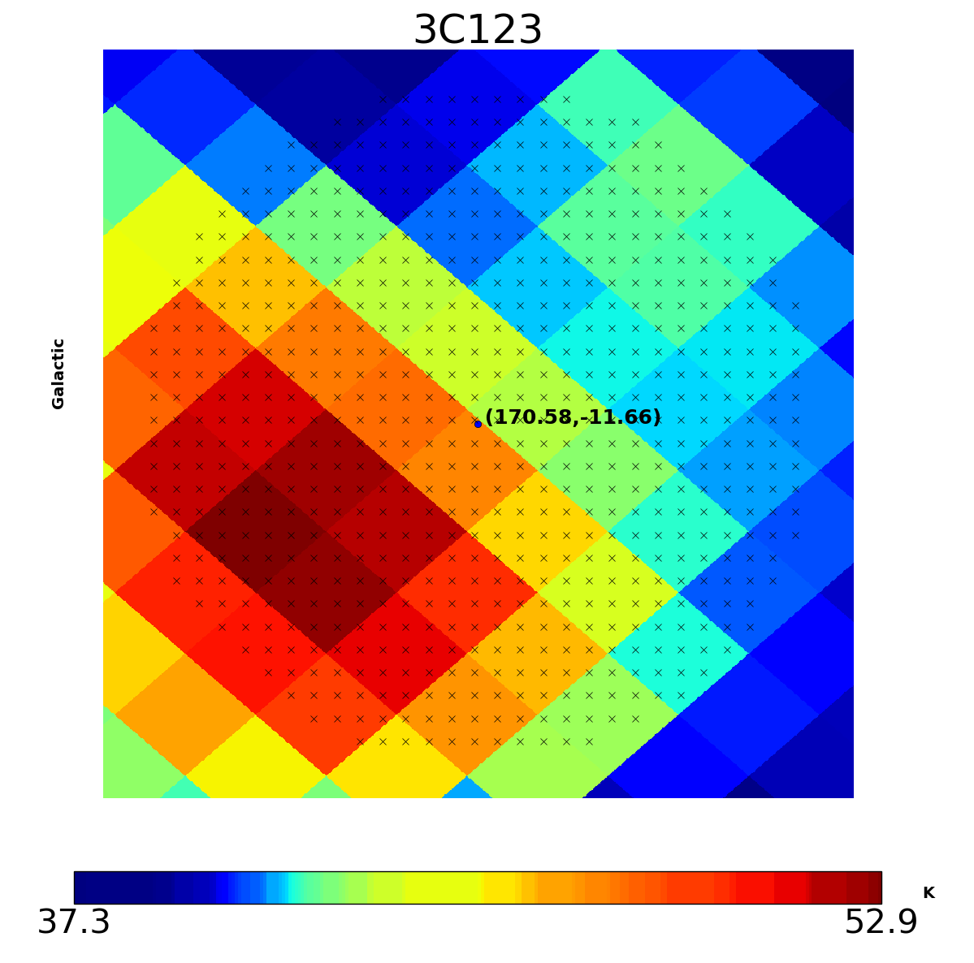
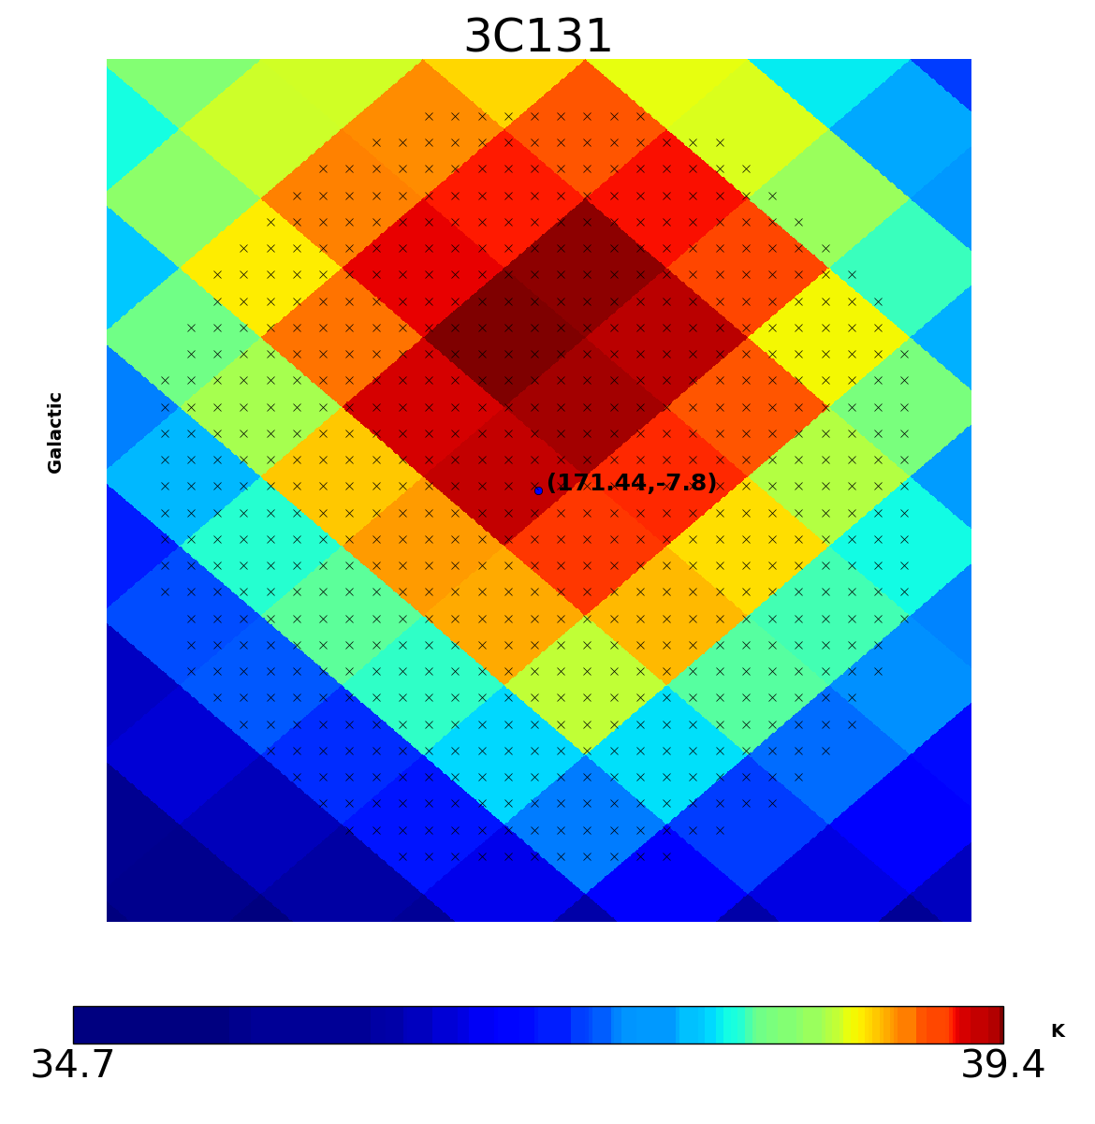
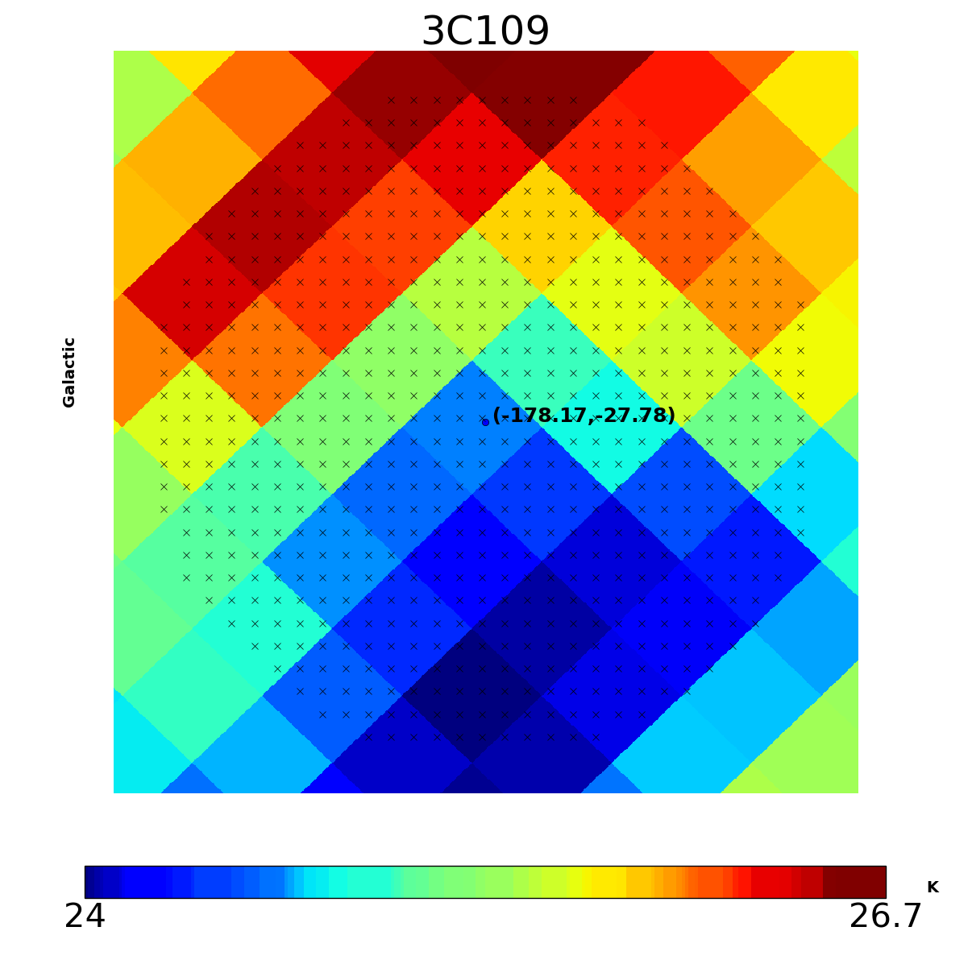

Figure ??: Patches of continuum background temperature at 408MHz T_{bg408} map around point-sources showing the pixels within the round area of beam width 51 arcminutes.

- Ningyu and Dili also used the MS data and we found the same result. Namely, the sources with OH but without CO are:
3C18, 3C109, 3C409, 3C132, P0531+19
(not really clear on P0531+19 because of its weak absorption lines).
The sources 3C109, 3C409, 3C132, P0531+19 are found in the regions with high N_{HI}. Please see the figure ??.
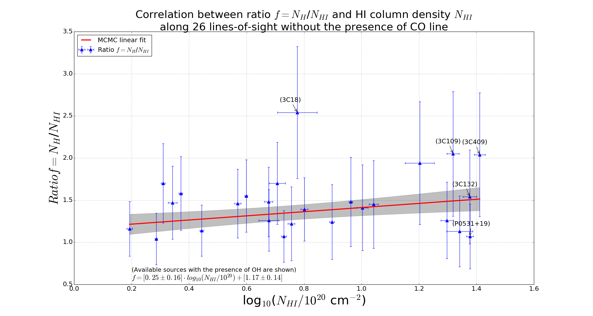

Figure ??: <title>

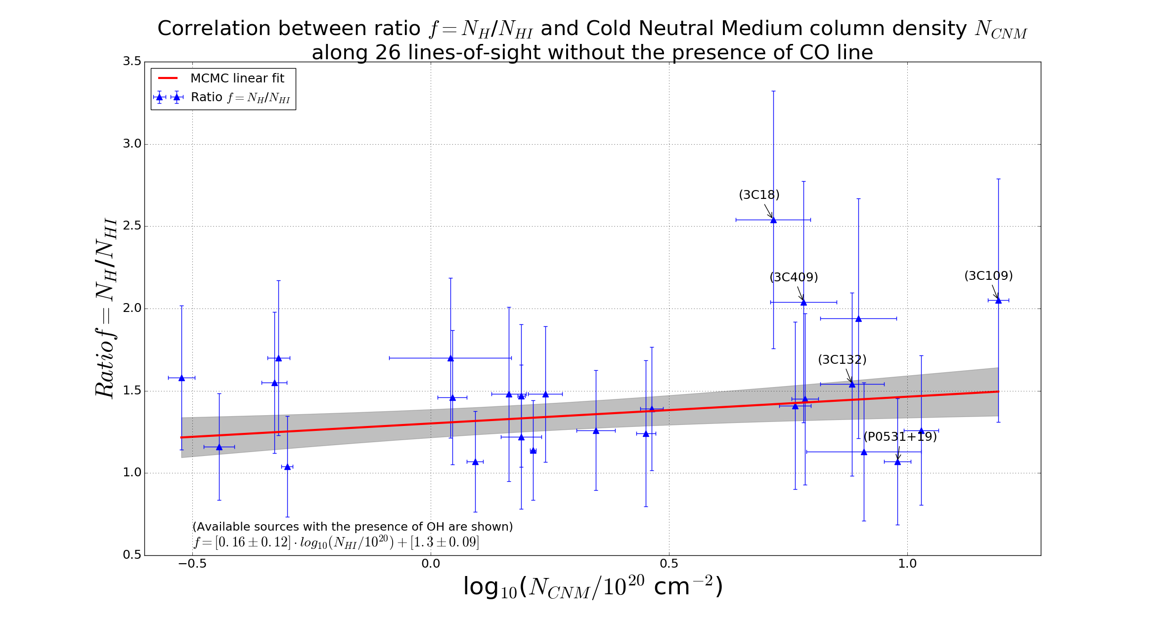

Figure ??: <title>

- I use the OH data from MS to calculate the Column Densities of OH1665 and OH1667 for each line-of-sight:

Step 1: I compute the opacity e^{-τ} from On/off-source measurements. And I plot the Absorption spectra.
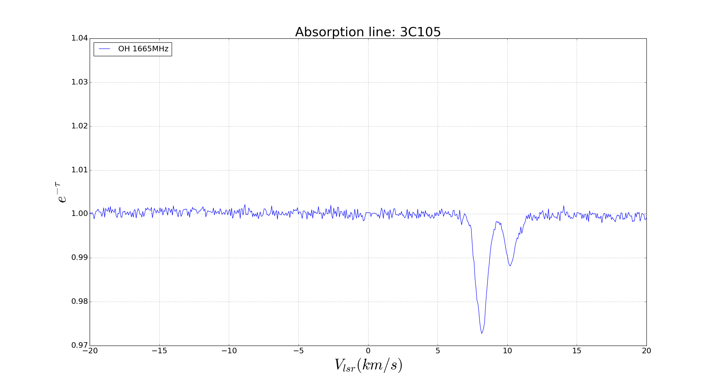
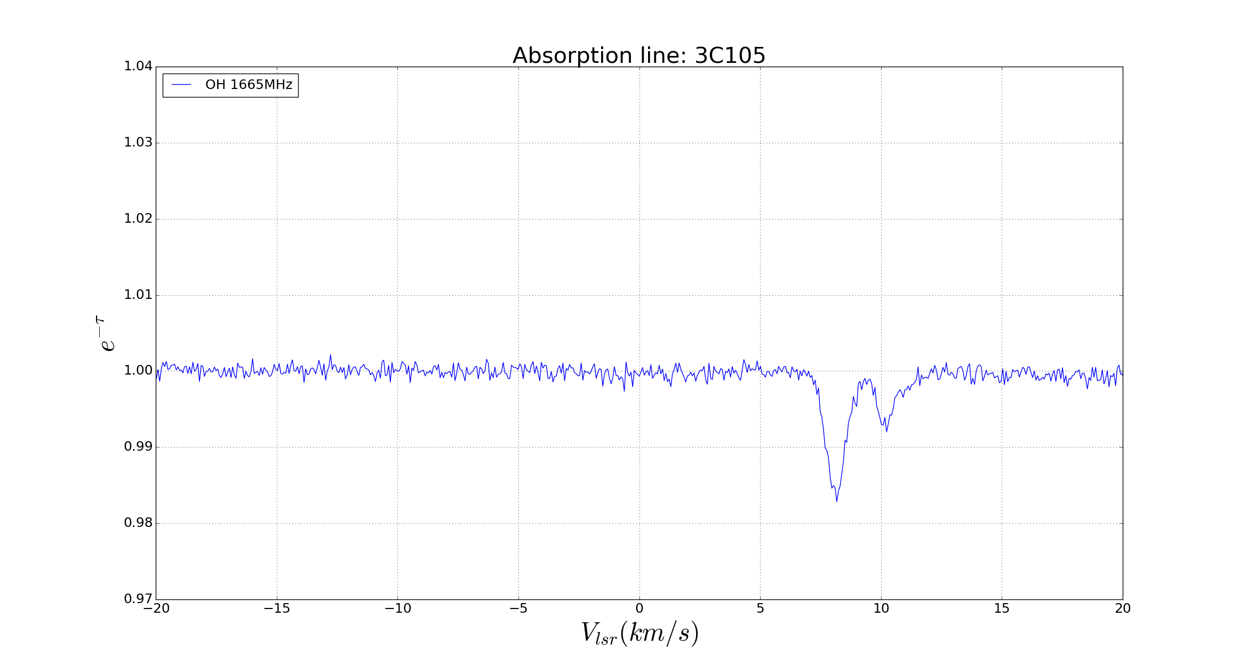

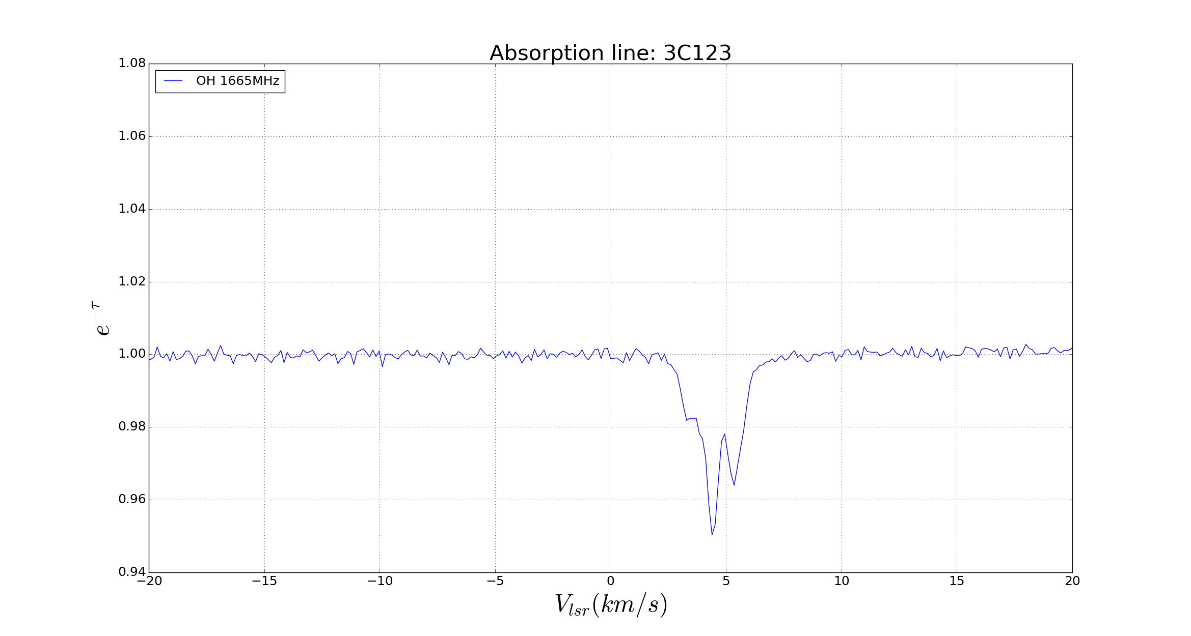
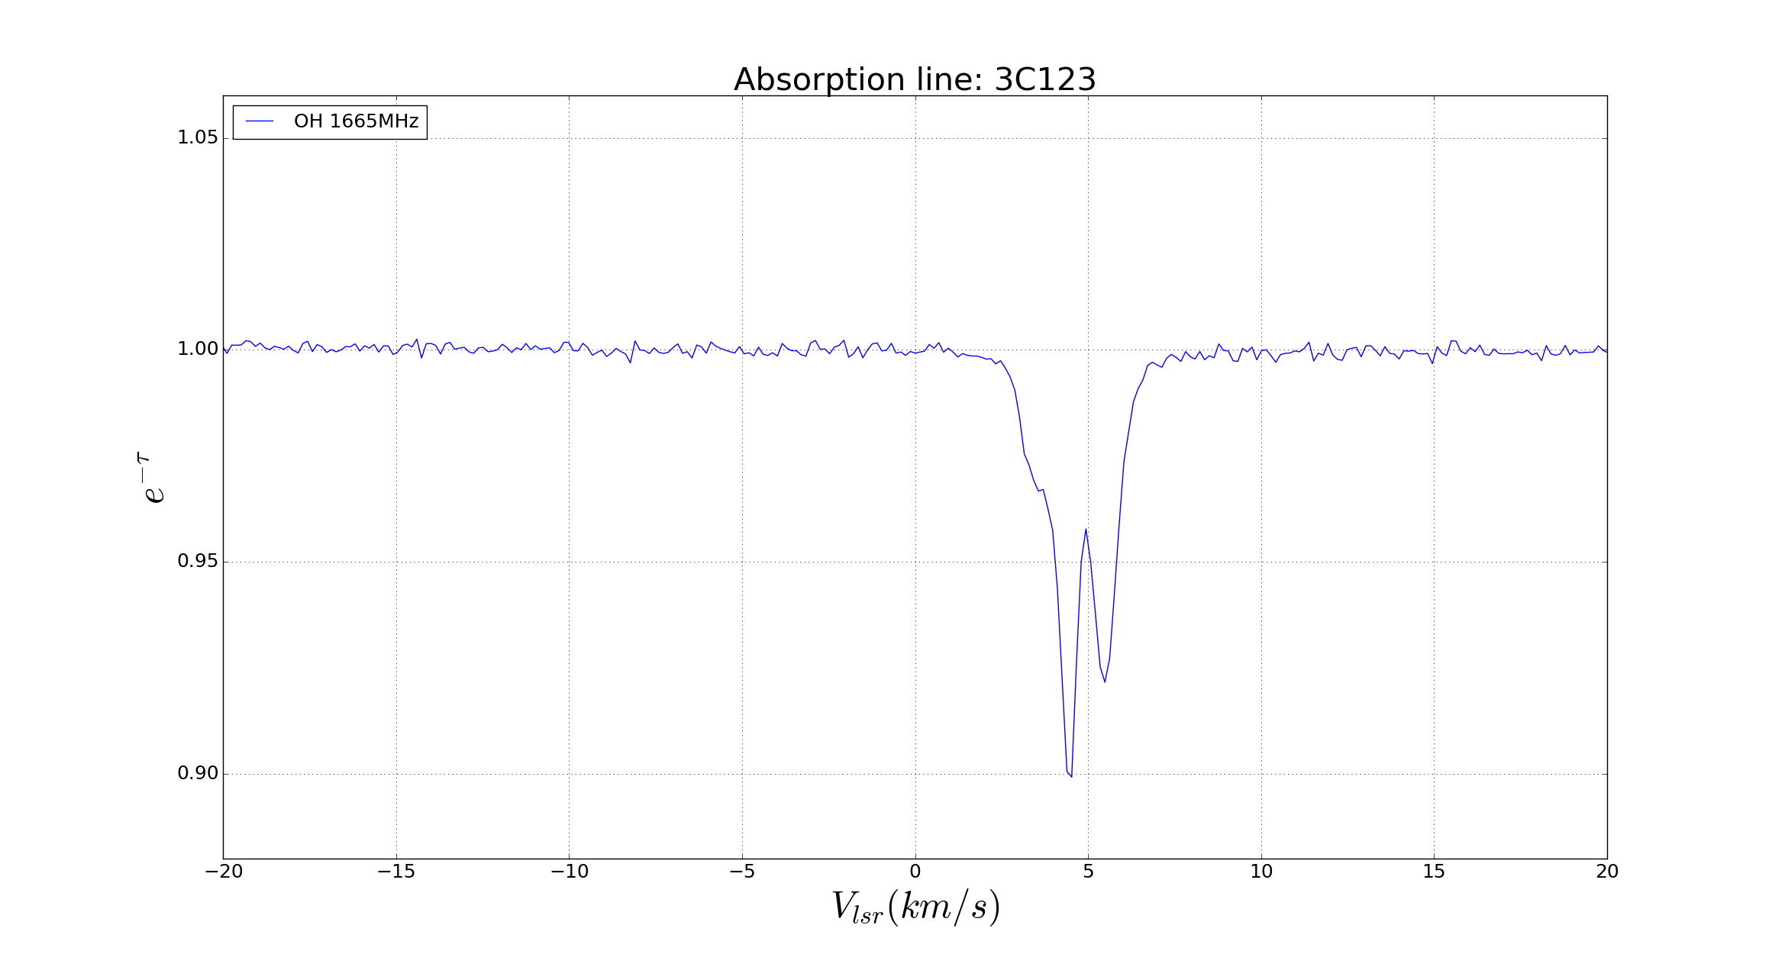

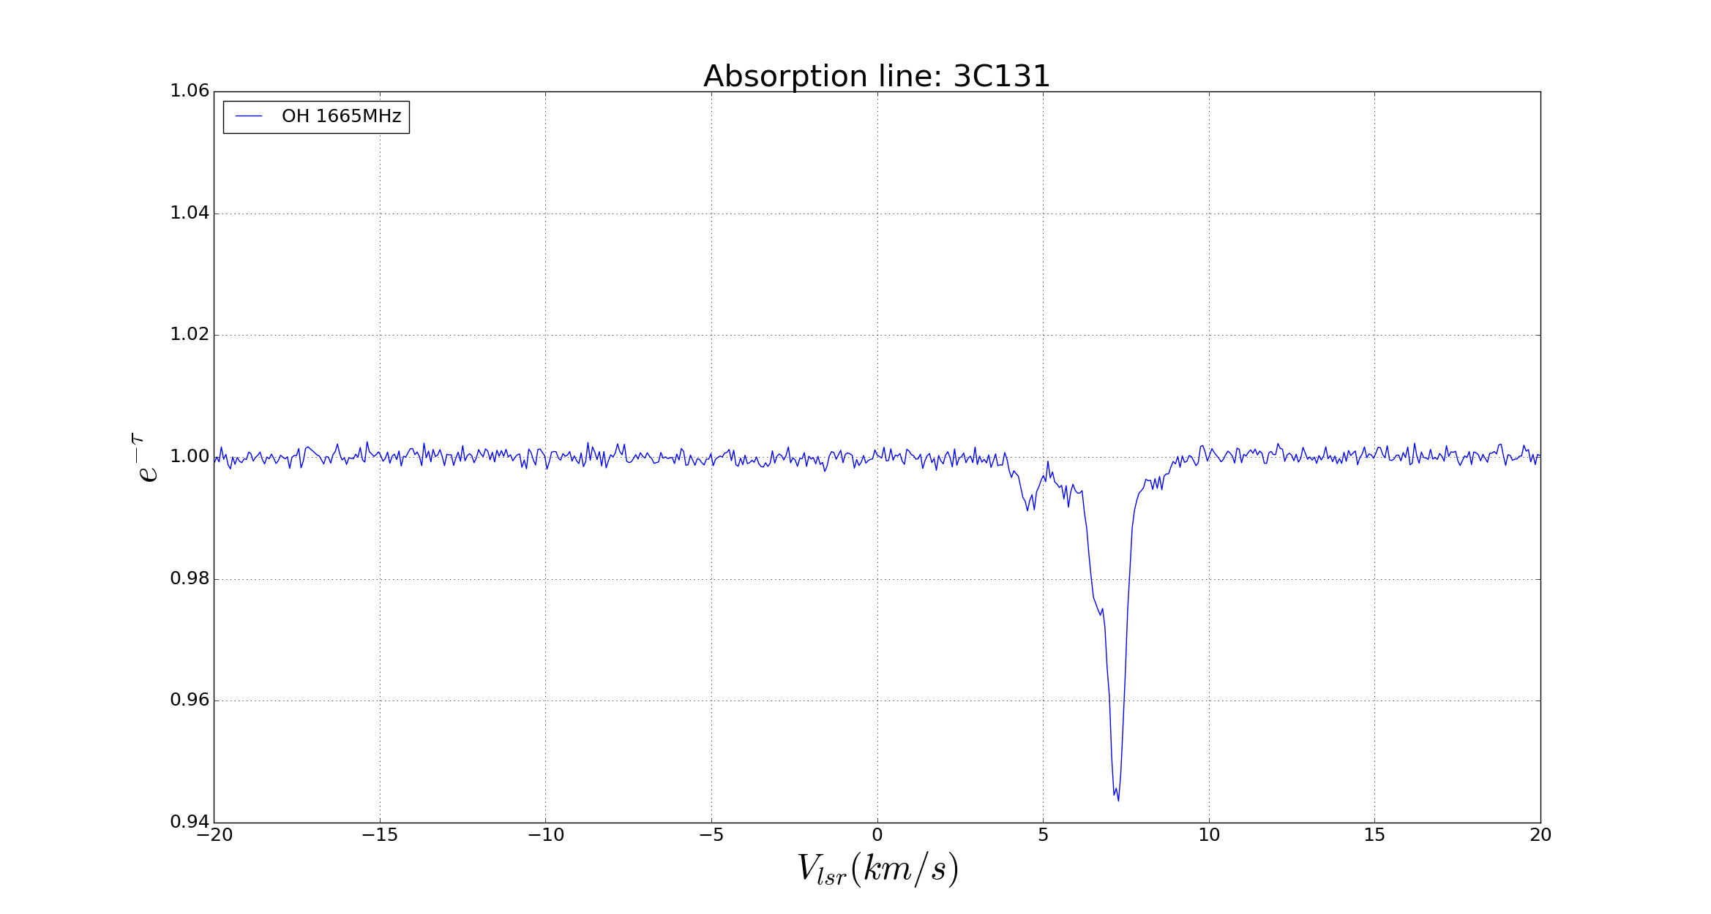
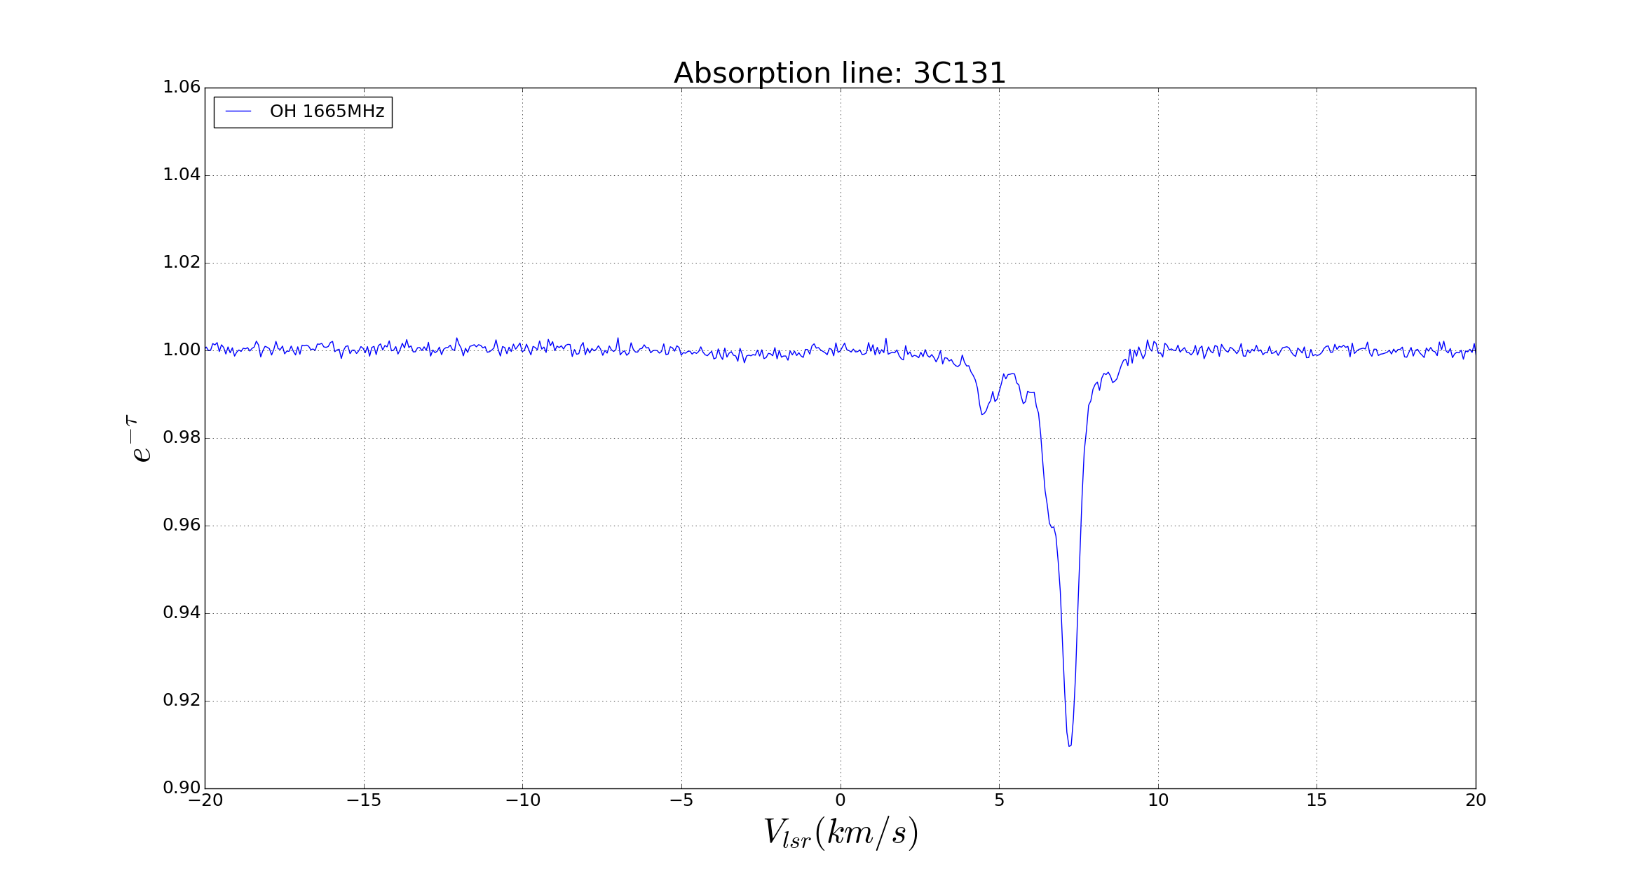

Figure ??: Absoption spectra of OH 1665MHz (left column) and OH 1667MHz (right column)

Step 2: I apply Gaussian fit for opacity e^{-τ} spectra just to obtain the velocity ranges (FWHM) of the peaks.
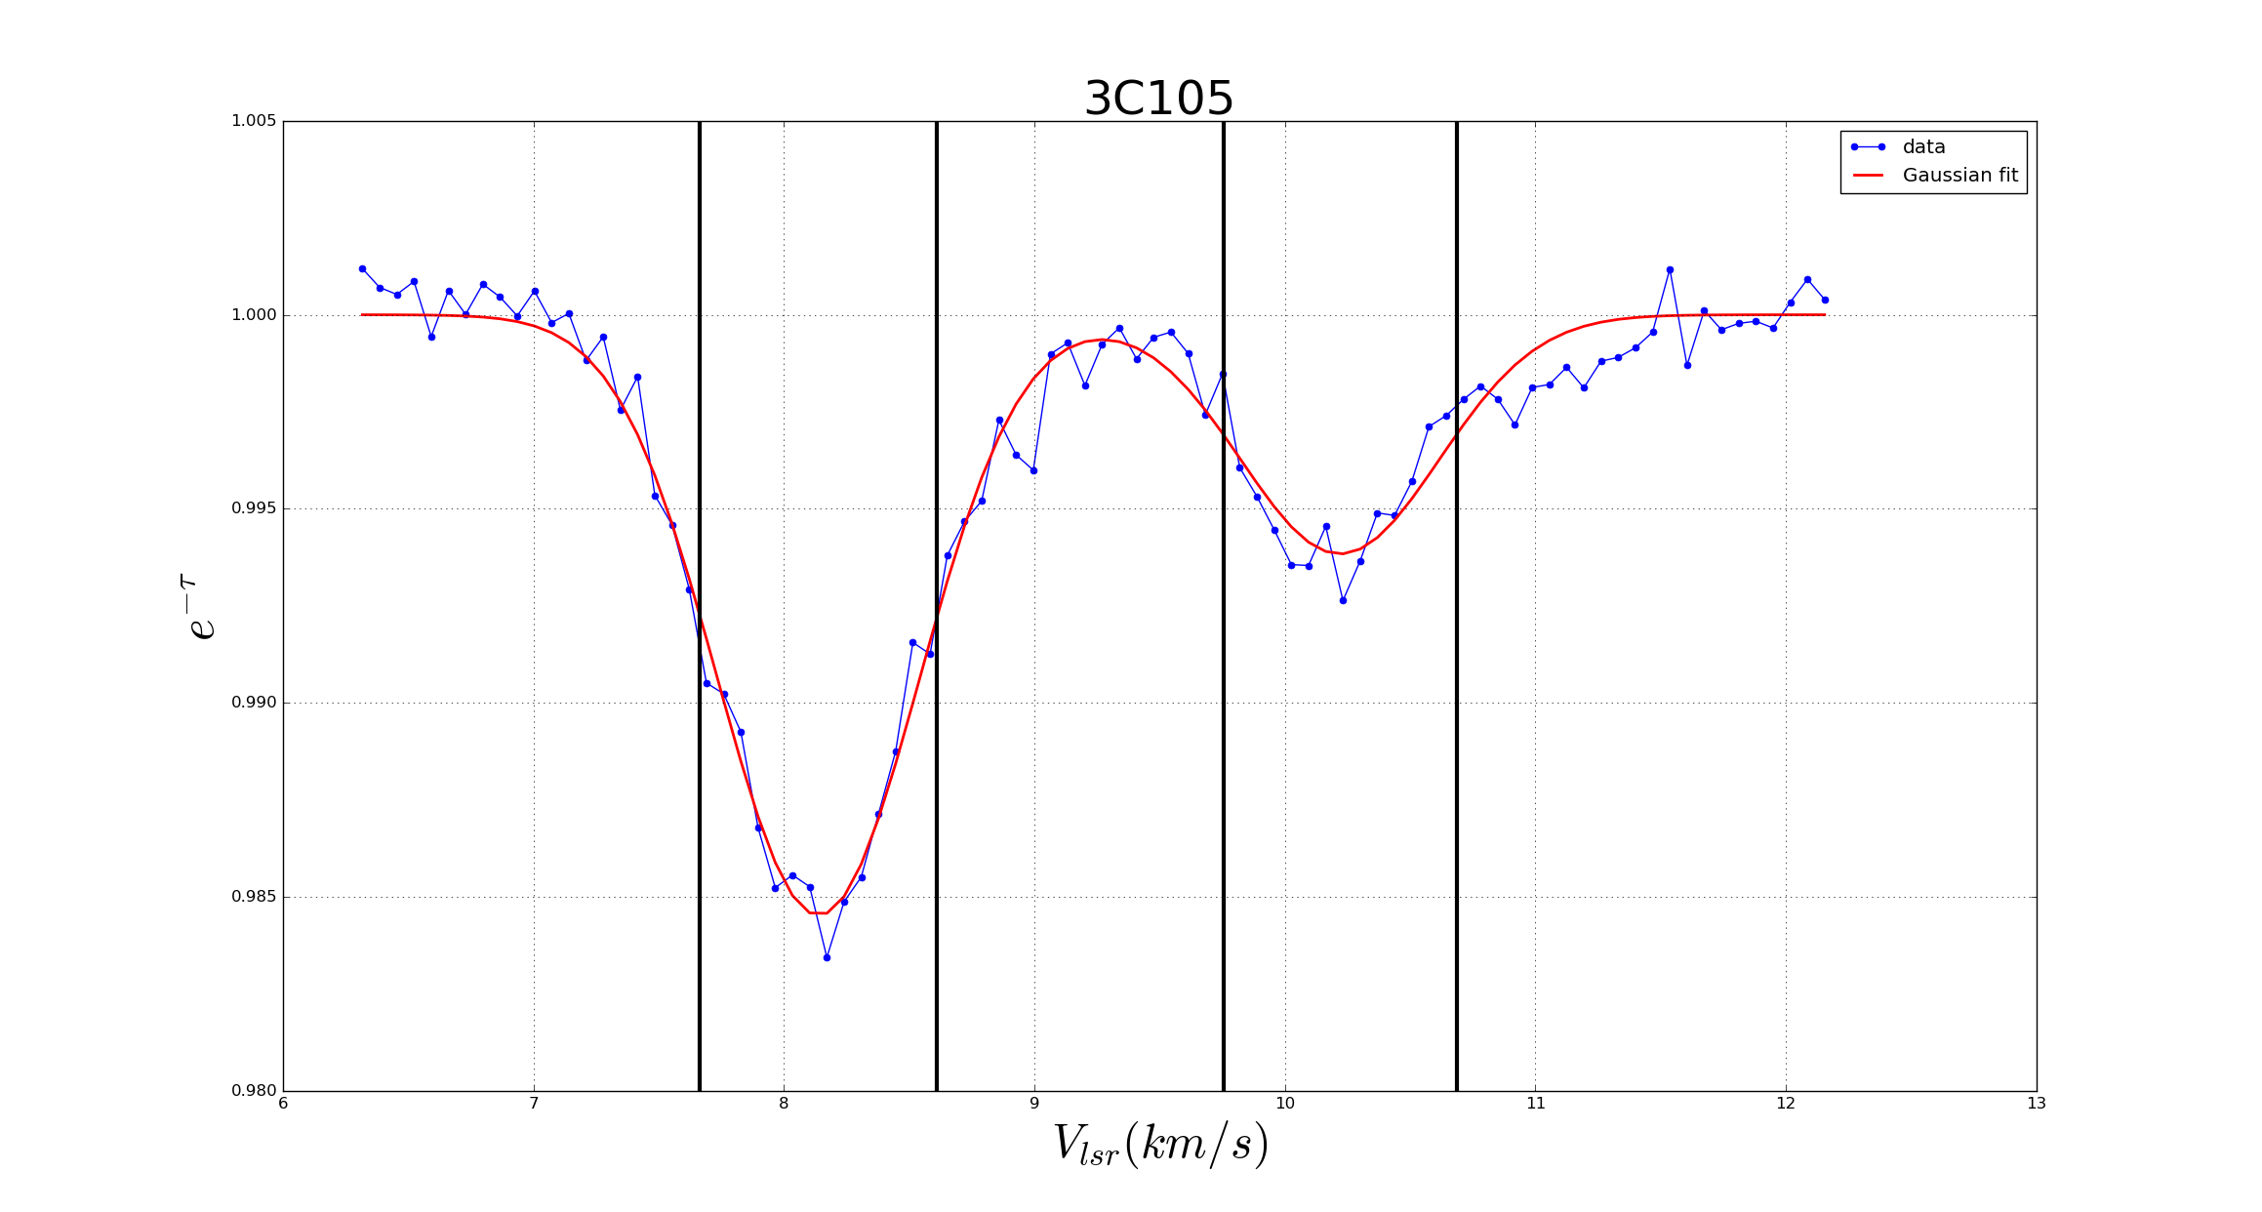
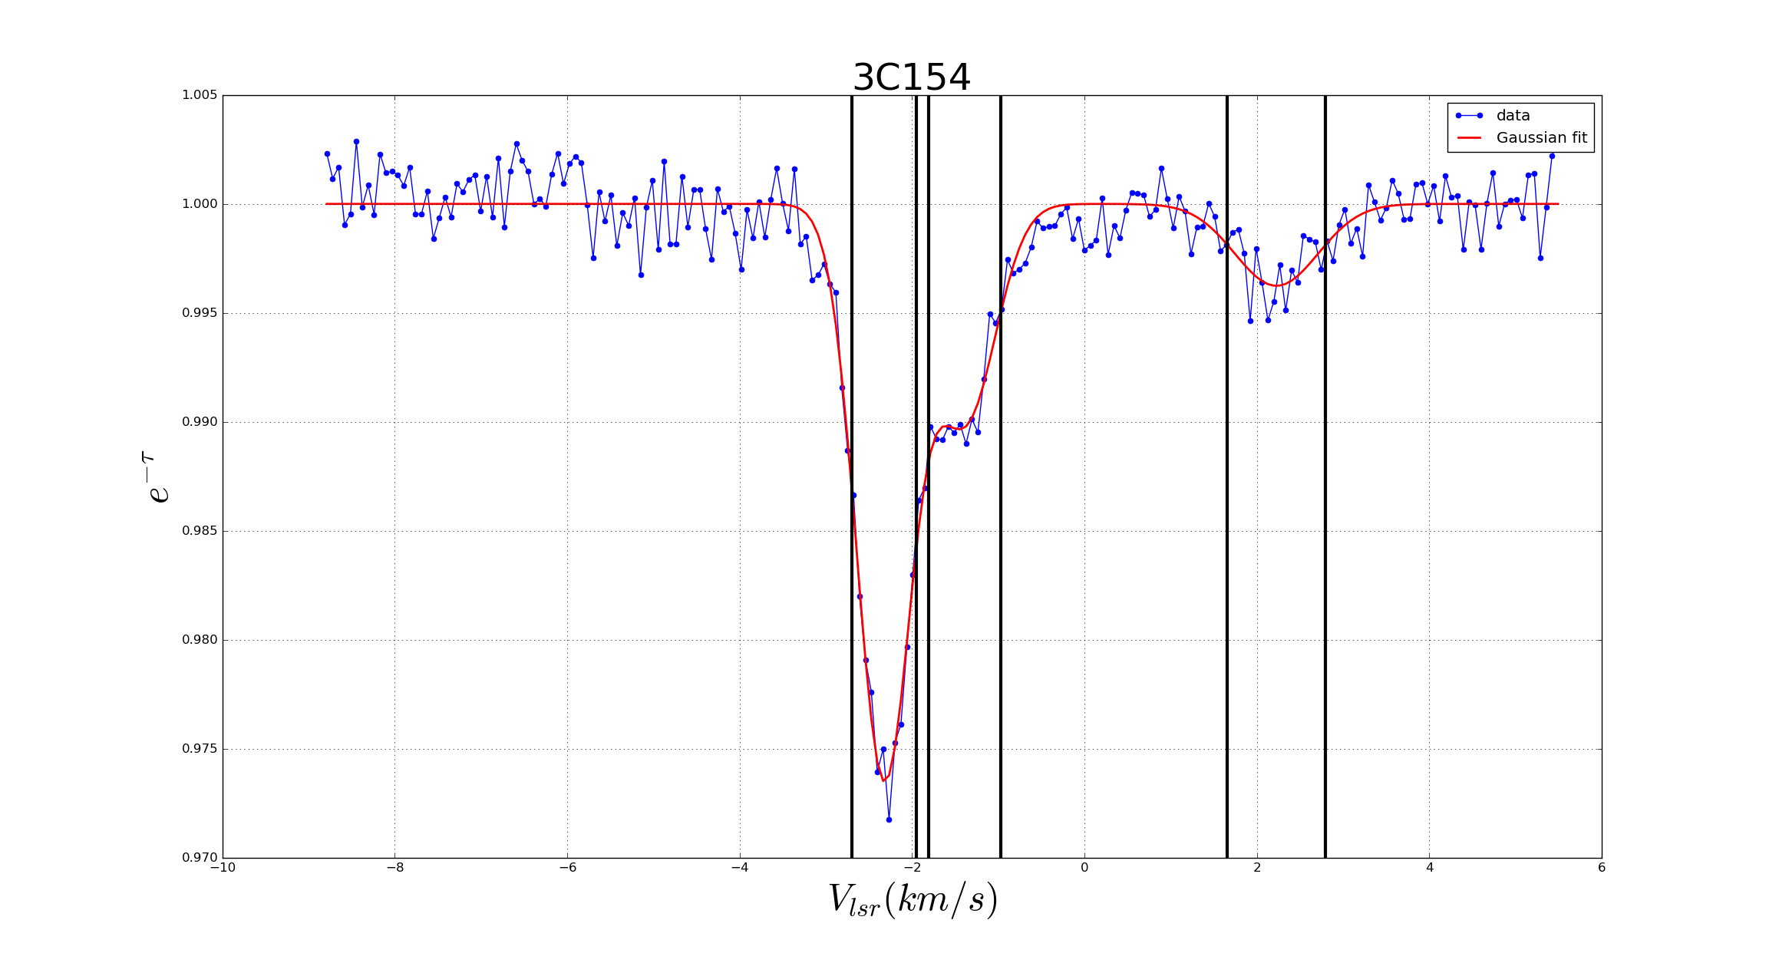

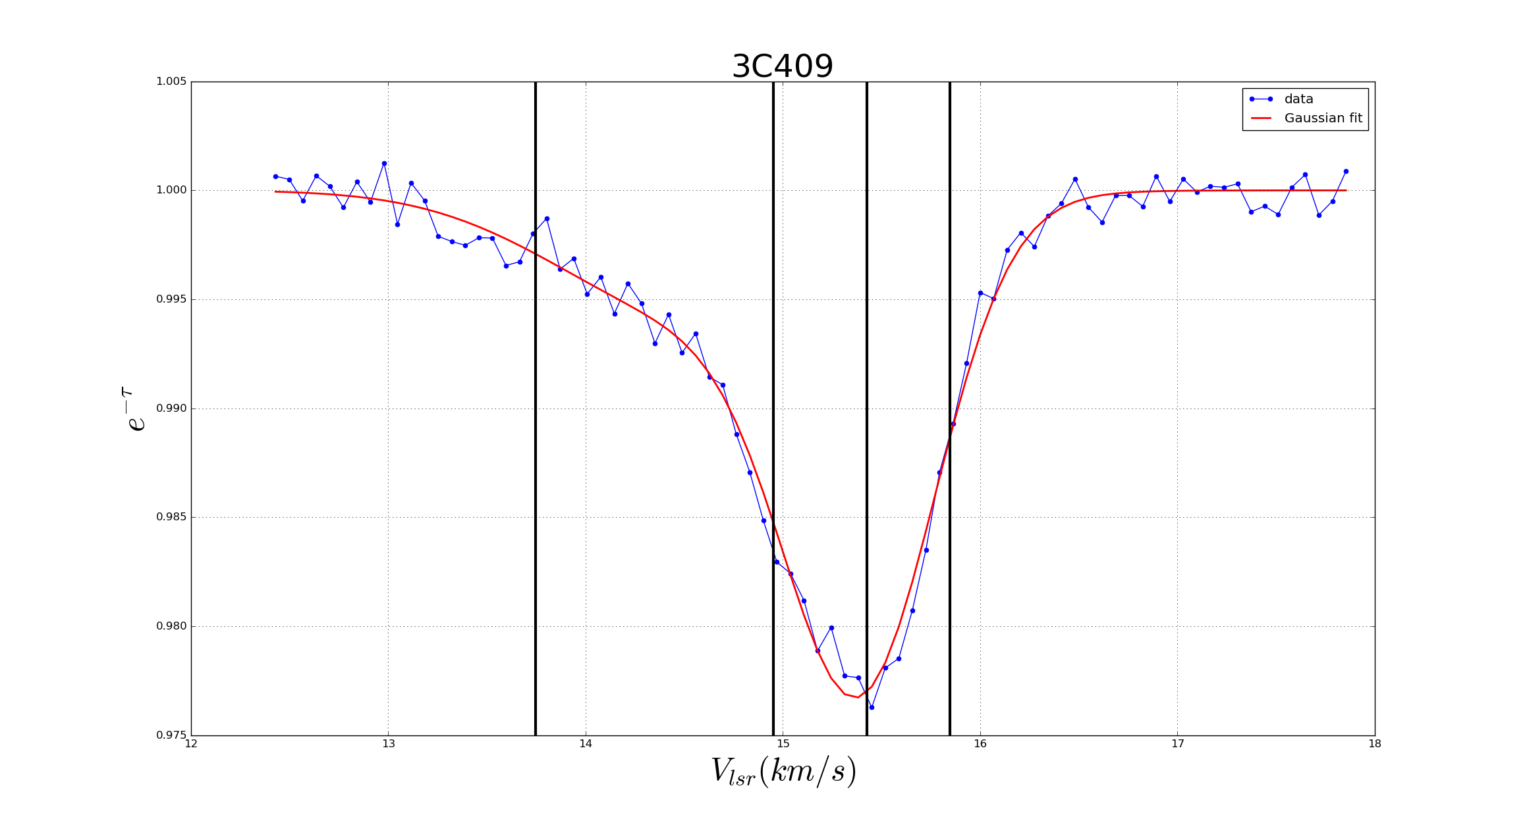
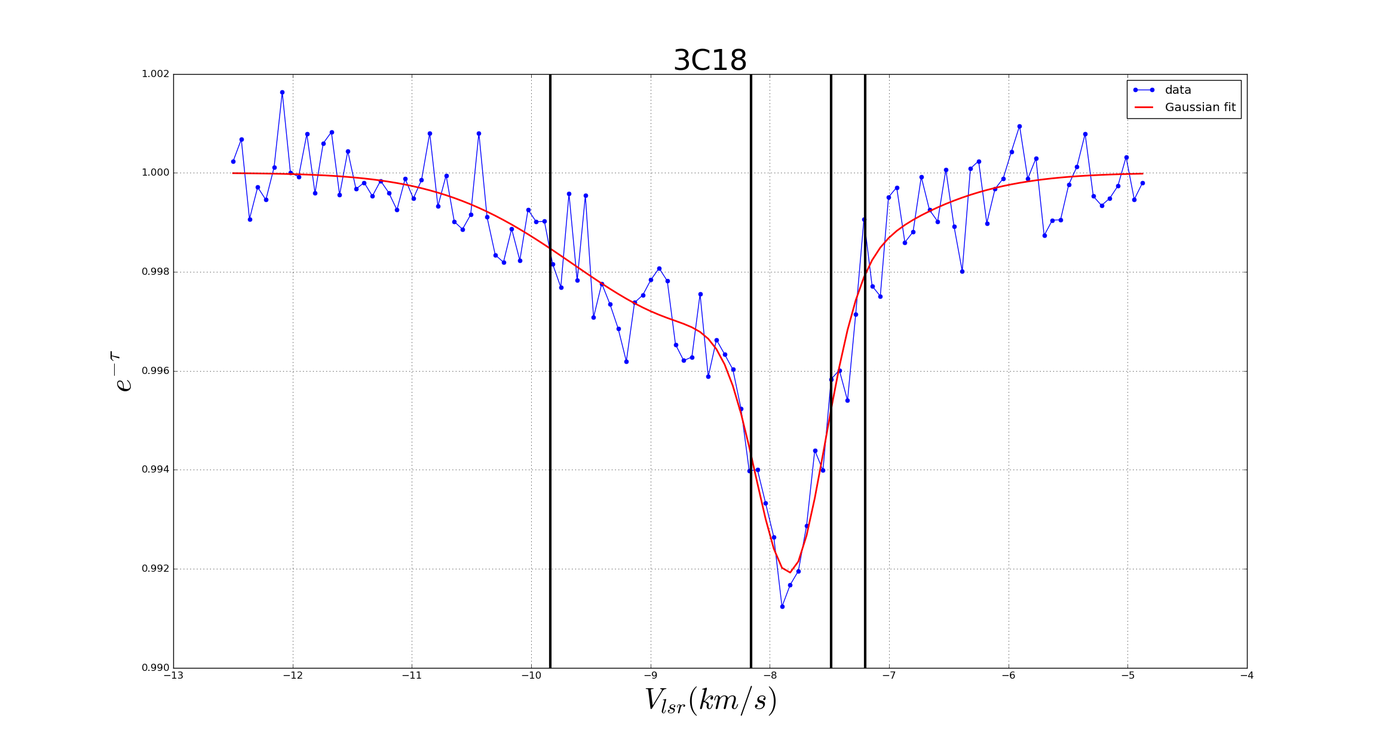

Figure ??: Opacity spectra (blue) and Gaussian fit (red) with the velocity ranges (FWHM) of the peaks.

Step 3: I use the e^{-τ} (in fact τ values) to calculate the Excitation Temperature T_{ex}. From τ spectra, I derive the 1-σ standard deviation of τ.
I see that the T_{ex} spectra are quite flat within the velocity ranges of the peaks. Thus, I choose ONLY the ranges within the FWHM [v₀-FWHM/2, v₀+FWHM/2] to calculate the Mean values of T_{ex} with the criterion that τ within the velocity range must be large than 2σ_{τ}.
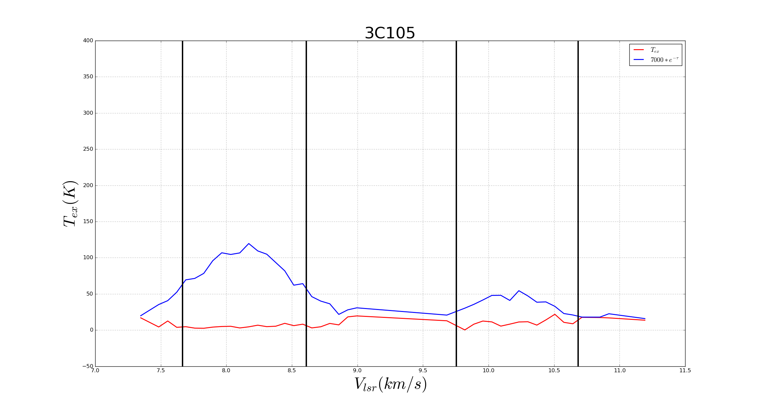
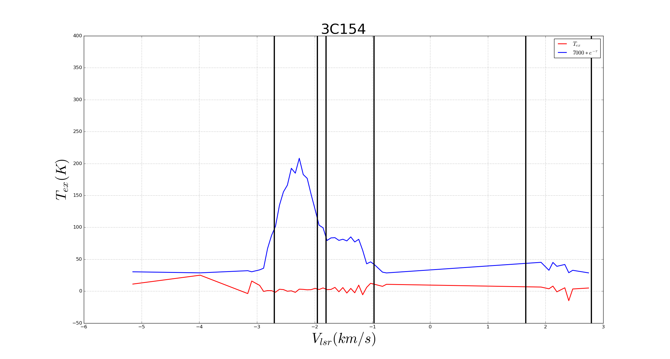

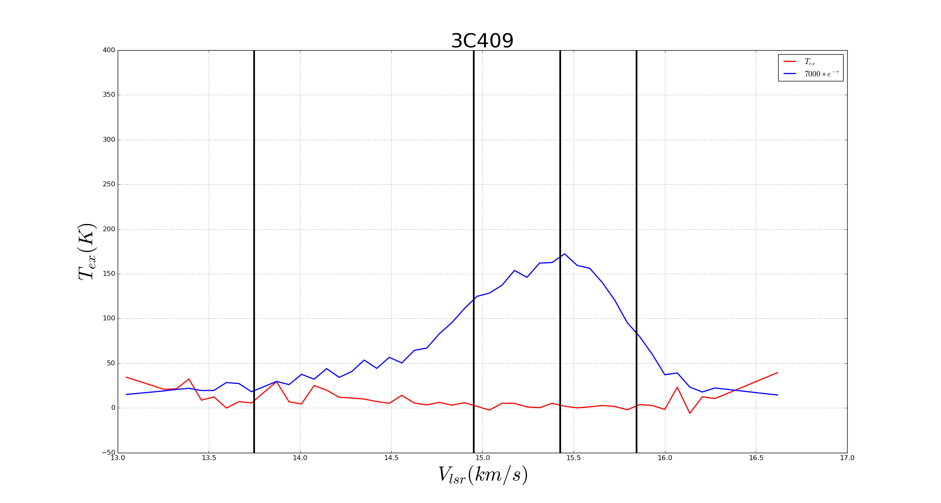
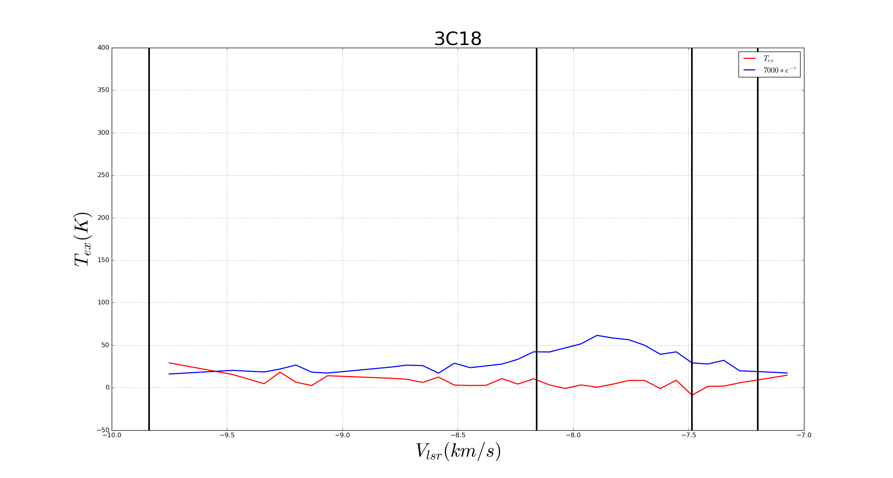

Figure ??: Excitation spectra T_{ex} within the FWHM velocity ranges.

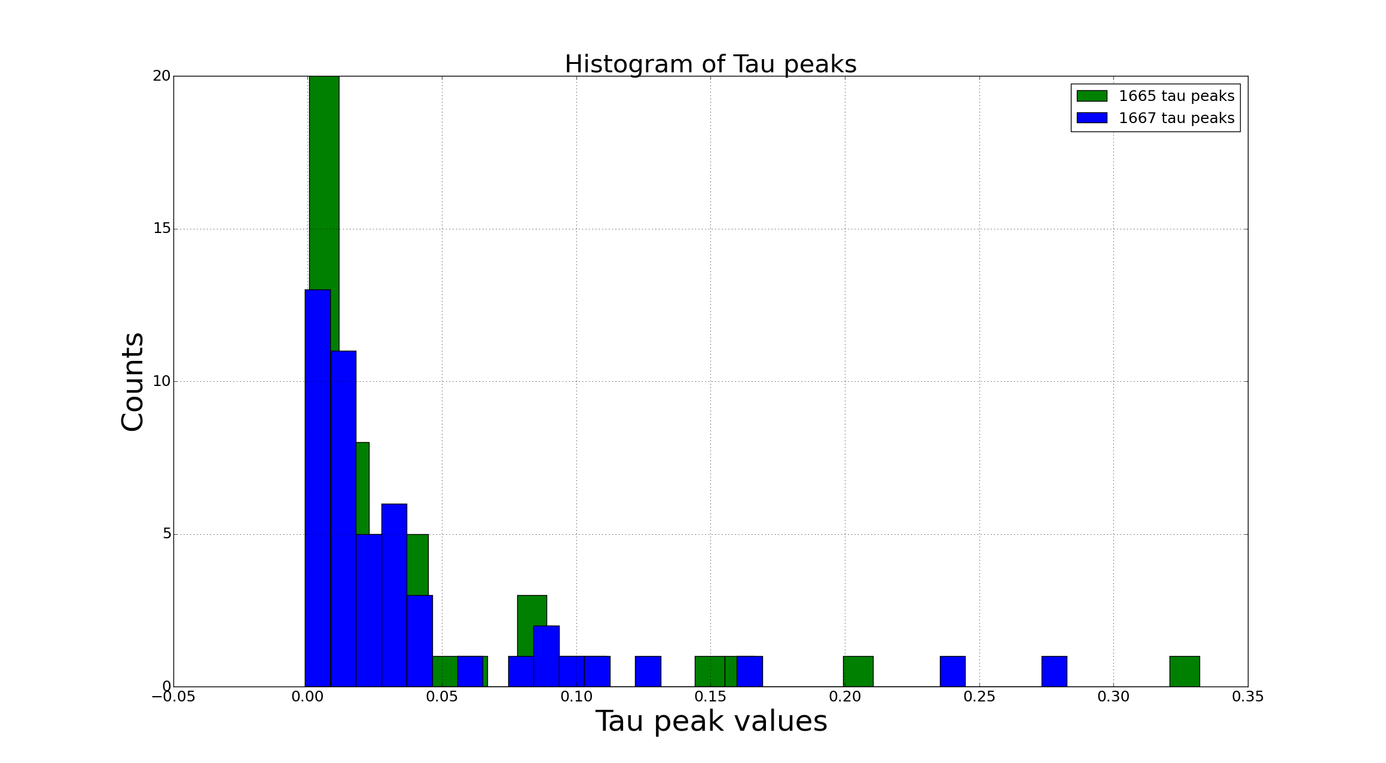

Figure ??: Histogram of Tau peak values

Step 4: Compute the Column Densities of OH_{1665MHz} and OH_{1667MHz} using the following equations:
N_{OH}[cm⁻²] = [8πνkΣg_{i}/(c²g_{l}A_{ul}h)]*T_{ex}∫τ_{ν}dν
where:
c = 3x10⁸ (m/s)
Σg_{i} = 5+3+5+3 = 16
g_{l} = 3 for 1665MHz line, const = 3.99757843817e14
g_{l} = 5 for 1667MHz line, const = 2.21841824609e14
And Einstein coefficients are given by Destombes, 1977:
- Line 1612MHz, A_{ul} = 1.302x10⁻¹¹
- Line 1665MHz, A_{ul} = 7.177x10⁻¹¹
- Line 1667MHz, A_{ul} = 7.778x10⁻¹¹
- Line 1720MHz, A_{ul} = 9.496x10⁻¹²

Results:
1. There exists the main-line anomalies of OH, this means these main lines are not, in general, in Local Thermal Equilibrium.
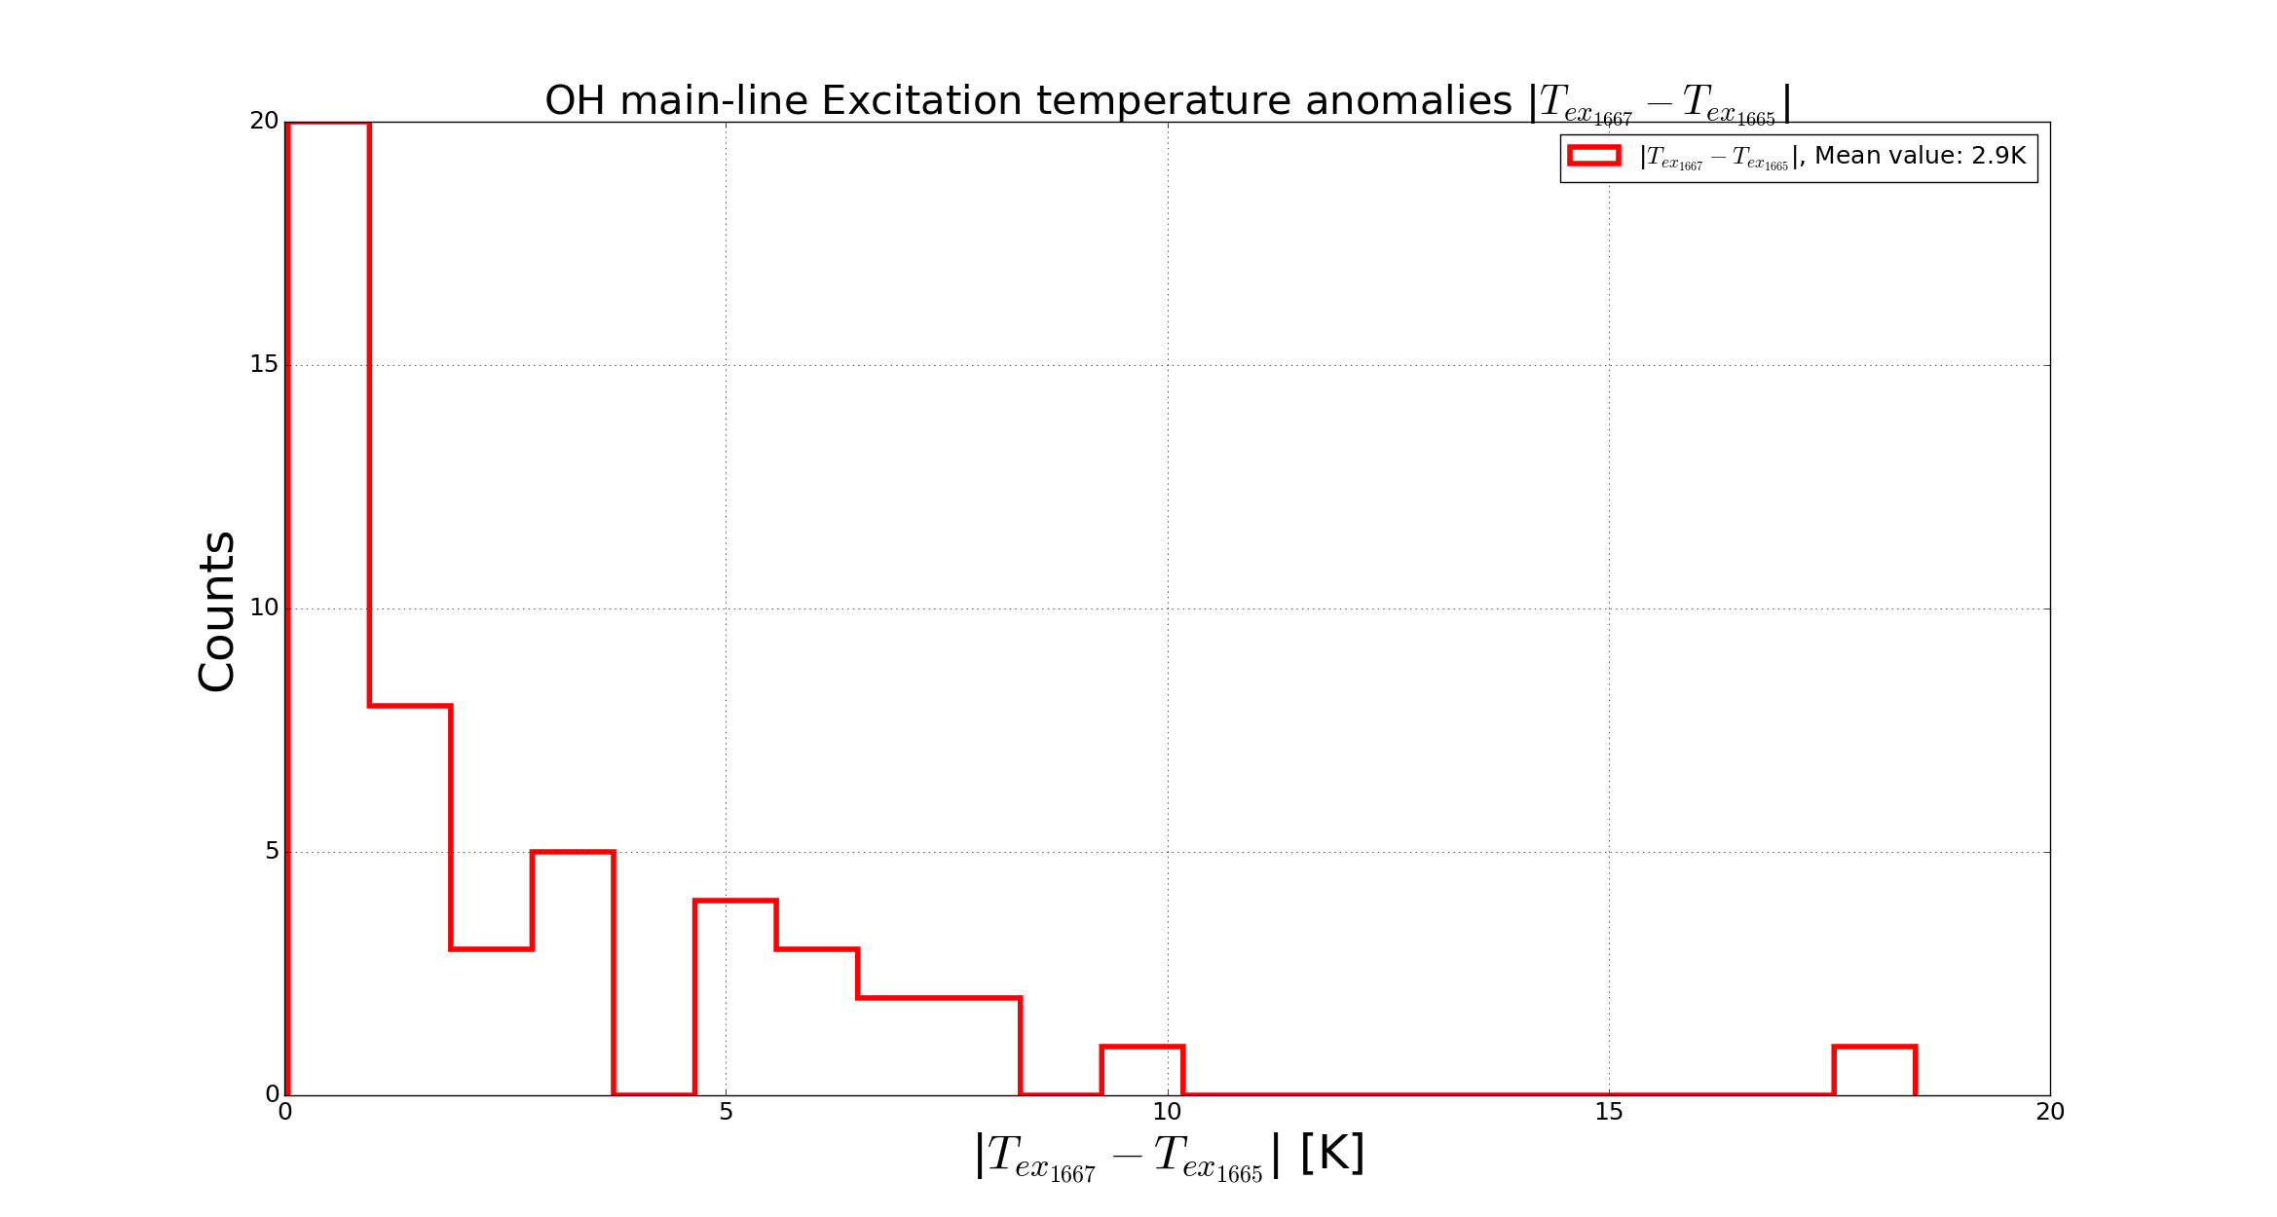

Figure ??: Excitation temperature anomalies of 2 main lines of Hydroxyl. Mean value is 2.9K.
2. The OH/H₂ ratio abundance is N_{OH} ~10⁻⁷ ∙N_{H} (cm⁻²), this result is consistent with other work [1] .
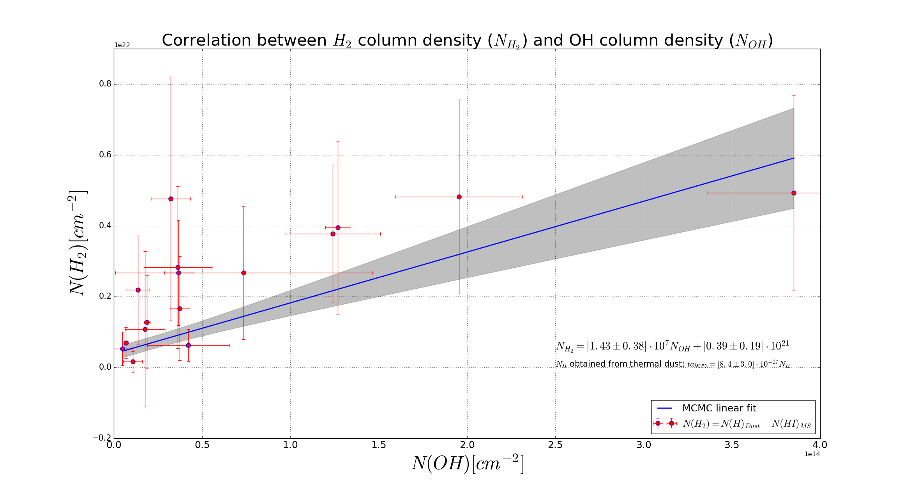

Figure ??: OH/H 2 ratio abundance: N_{OH}/N_{H2} ~ 10⁻⁷.

3. We find OH in the regions where the values of N_{HI} are high.
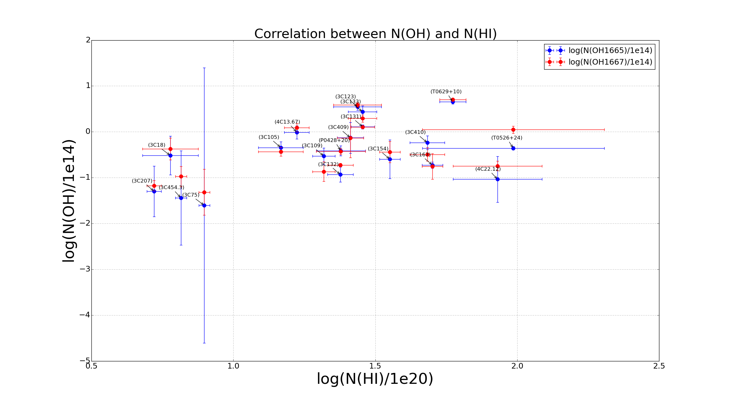

Figure ??: Correlation between N_{OH} and N_{HI}.

References:
[1] Liszt, H., & Lucas, R. 1999, in Highly Redshifted Radio Lines, ed. C. L. Carilli, S. J. E. Radford, K. M. Menter, & G. I. Langston, ASP Conf. Ser., 156, 188

