Works with OH data from Arecibo

Aim:
- Find if OH exists in 79 sources (lines-of-sight).
- Check if we can find OH where there's more HI.

Data:
- Download the OH data from Arecibo Millennium Survey (../oh/data/makelines.save).
- They observed 100 sources (lines-of-sight) with On-/Off sources method:
'1325+32', '3C105', '3C109', '3C120', '3C123N', '3C123', '3C131', '3C132', '3C133', '3C138', '3C141.0', '3C142.1', '3C154E', '3C154', '3C167E', '3C167', '3C172.0', '3C18', '3C190.0', '3C192N', '3C192', '3C207', '3C208.0', '3C208.1', '3C223', '3C225aN', '3C225a', '3C225b', '3C234', '3C236', '3C237N', '3C237', '3C245', '3C264.0', '3C270', '3C272.1', '3C273N', '3C273', '3C274.1', '3C286', '3C287', '3C293', '3C298', '3C310', '3C315', '3C318', '3C33-1', '3C33-2', '3C333', '3C33', '3C348', '3C409', '3C410', '3C454.3', '3C64', '3C75-1', '3C75-2', '3C75N', '3C75', '3C78W', '3C78', '3C79', '3C93.1', '3C98-1', '3C98-2', '3C98', '4C07.32', '4C13.65', '4C13.67', '4C16.33', '4C19.44N', '4C19.44', '4C21.28', '4C22.12', '4C32.44', '4C35.23', 'CTA21', 'DW0742+10', 'G196.6+0.2', 'G197.0+1.1', 'HD149881', 'HD215733', 'HD93521', 'NRAO140', 'P0320+05', 'P0347+05', 'P0428+20', 'P0531+19', 'P0820+22', 'P1055+20N', 'P1055+20', 'P1117+14', 'Q1552+19', 'T0526+24', 'T0556+19', 'T0629+10', 'T0640+09', 'TauA', 'W49', 'W51c3'
- Among 100 sources observed, I find there are 23 sources where OH is present, they are:
src l b
======================================
3C105 187.632553101 -33.6090278625
3C109 181.827896118 -27.7768802643
3C123 170.581436157 -11.6607217789
3C131 171.436828613 -7.79669475555
3C132 178.859802246 -12.5218839645
3C133 177.725738525 -9.91240787506
3C154 185.593215942 4.00309324265
3C167 207.311920166 1.15291512012
3C18 118.621551514 -52.7265319824
3C207 212.968109131 30.1389598846
3C409 63.3982963562 -6.12196683884
3C410 69.2087936401 -3.76806855202
3C454.3 86.1108169556 -38.1830825806
3C75 170.255615234 -44.9111557007
4C13.67 43.4968528748 9.15430736542
4C22.12 188.052368164 0.0470512732863
G196.6+0.2 196.640350342 0.167616575956
G197.0+1.1 196.982910156 1.10338318348
P0428+20 176.808151245 -18.5568180084
P0531+19 186.763473511 -7.10847568512
T0526+24 181.355117798 -5.19333171844
T0556+19 190.089324951 -2.16651010513
T0629+10 201.531524658 0.5078779459
- Data structure:
IDL> help, LA
** Structure <19883498>, 24 tags, length=122928, data length=122926, refs=1:
SRCNAME STRING '1325+32'
RA1950 FLOAT 13.4204
DEC1950 FLOAT 32.1163
ELL FLOAT 66.1535
BEE FLOAT 80.8381
CFR_BD0 FLOAT 1420.41
CFR_BD1 FLOAT 1665.40
CFR_BD2 FLOAT 1667.36
NRC INT 0
VLSR_BD0 FLOAT Array[2048]
VLSR_BD1 FLOAT Array[2048]
VLSR_BD2 FLOAT Array[2048]
I_EM_AVG_BD0 FLOAT Array[2048]
I_EM_MED_BD0 FLOAT Array[2048]
I_ABS_AVG_BD0 FLOAT Array[2048]
I_ABS_MED_BD0 FLOAT Array[2048]
I_EM_AVG_BD1 FLOAT Array[2048]
I_EM_MED_BD1 FLOAT Array[2048]
I_ABS_AVG_BD1 FLOAT Array[2048]
I_ABS_MED_BD1 FLOAT Array[2048]
I_EM_AVG_BD2 FLOAT Array[2048]
I_EM_MED_BD2 FLOAT Array[2048]
I_ABS_AVG_BD2 FLOAT Array[2048]
I_ABS_MED_BD2 FLOAT Array[2048]

- BD0 is HI. BD1 is OH1665 and BD2 is OH1667.
- Each spectrum has 2048 channels with the bandwidth of ?? MHz and the step of ?? (0.06829 km/s)
AVG is average, MED means Median.
“””
median versus average:
The average of a bunch of points is the least-squares value. That is,
when you calculate the sum of the squares of the residuals,
sum_of_squares_of_residuals = \Sigma (\Delta y)_n^2
where (\Delta y)_n is the residual
(\Delta y)_n = y_n - y0
where y0 is the adopted result of combining all of the measurements
y_n. If you adopt y0 as being the value that minimizes the sum of
squares of residuals, then y0 is referred to as the 'least-squares
value'. For a bunch of datapoints y_n, taking the average gives a value
for y_0 that is the same as the least-squares value. So the average
value is the same as the least-squares value.
When the probability density function (PDF) of the residuals follows a
Gaussian (we call this 'Gaussian statistics'), then the least-squares
value is the best estimate for y0. This is the 'AVG' spectrum.
In contrast, the median value is the one for which the number of
ppositive residuals equals the number of negative ones. This is the same
as the median. For Gaussian statistics, the median is NOT the
best estimate. The median is, however, the best estimage when the PDF of
the residuals follows a double-sided exponential PDF.
(see sections 0, 6, 13, especially 13.5, of my handout on least squares,
available at
http://w.astro.berkeley.edu/~h
(click on 'lsfit2008.pdf').
Now, in practice:
If the two spectra I_EM_AVG and I_EM_MED differ only because I_EM_MED is
noisier, then you can be pretty sure that the PDF is Gaussian, i.e. that
there are no interference spikes. So the proper thing to do is to take
the average spectrum I_EM_AVG.
However, if the AVG spectrum has features that are not present in the
MEDIAN spectrum, then the PDF is not gaussian, probably because of
interference. Then one option is to simply use the median. Better is to
look in detail at the data and edit out bad datapoints (using a program
such as our 'flag_rfi.pro') to make the statistics Gaussian, or at least
nearly so; then you can take the average of the edited data.
So the idea here is to use the difference between AVG and MED an
indicator for whether or not you need to edit the data.
“””

I_EM_AVG_BD1 is the Off-source spectra. I_ABS_AVG_BD1 is the on-source antenna
temperature minus the off-source antenna temperature (Ton – Toff) = Tcont*e^{-tau}.

On the emission lines, the continuum baseline is the off-source system
temperature (actually, twice that; what's plotted is Stokes I, which is
the sum of the two orthogonal polarizations). This is normally about 50
K. It can be higher if the background continuum is high, which might
happen near the Galactic plane.
On the absorption lines: the continuum baseline is the on-source antenna
temp minus the off source antenna temp (again, times two because it's
Stokes I). Thus, in the case of 3C131, the source deflection (on - off)
is about 47.7 K. This is not related to the off-source system temp,
except insofar as if the source is extended it might be producing some
antenna temp in the 'off-source' position. You can convert the vertical
scale of the 3C131 absorption plot to exp(-tau) simply by dividing all
of the spectral points by 47.7 K.

Toff = I_EM_AVG_BD2
Tabs = Ton - Toff = I_ABS_AVG_BD2
For the on/off-source measurements, I'm using the following equations to calculate the T_{ex} and
e^{-tau}:
T_{off} = T_{bg}*e^{-tau} + T_{ex}(1-e^{-tau})
T_{on} = (T_{bg} + T_{c})*e^{-tau} + T_{ex}(1-e^{-tau})
So that:
e(-tau) = (Ton - Toff )/Tc
Tex = [Toff - Tbg*e(-tau)] / [1-e(-tau)]

In practice, Toff and Ton include the receiver temp, Trx, which is about 50 K (in Stokes I).
Thus, your first two equations need to incorporate Trx, which makes them look like this:

Toff = Tbg*e(-tau) + Tex(1-e(-tau)) + Trx
Ton = (Tbg + Tc)*e(-tau) + Tex(1-e(-tau)) + Trx

Now, what is Trx? well, off the line, the equation for Toff is

Toff= Tbg + Trx

Tbg contains the cosmic background, 2.8 K, plus the Galactic contribution, which I estimate from the Haslam et al. 408 MHz survey and applly a spectral index of 2.8 for brightness temp. With this, the Galactic component typically comes out to be about 0.6 K or so, so this means that

Toff ~ 3.4 + Trx

Toff is 51.1, so Trx is 47.7.

In order to estimate the continuum background for OH lines, I use the Healpy map from Haslam et al. 408 MHz survey. I take the average of the data points within the area of Arecibo beam width around 23 lines-of-sight.
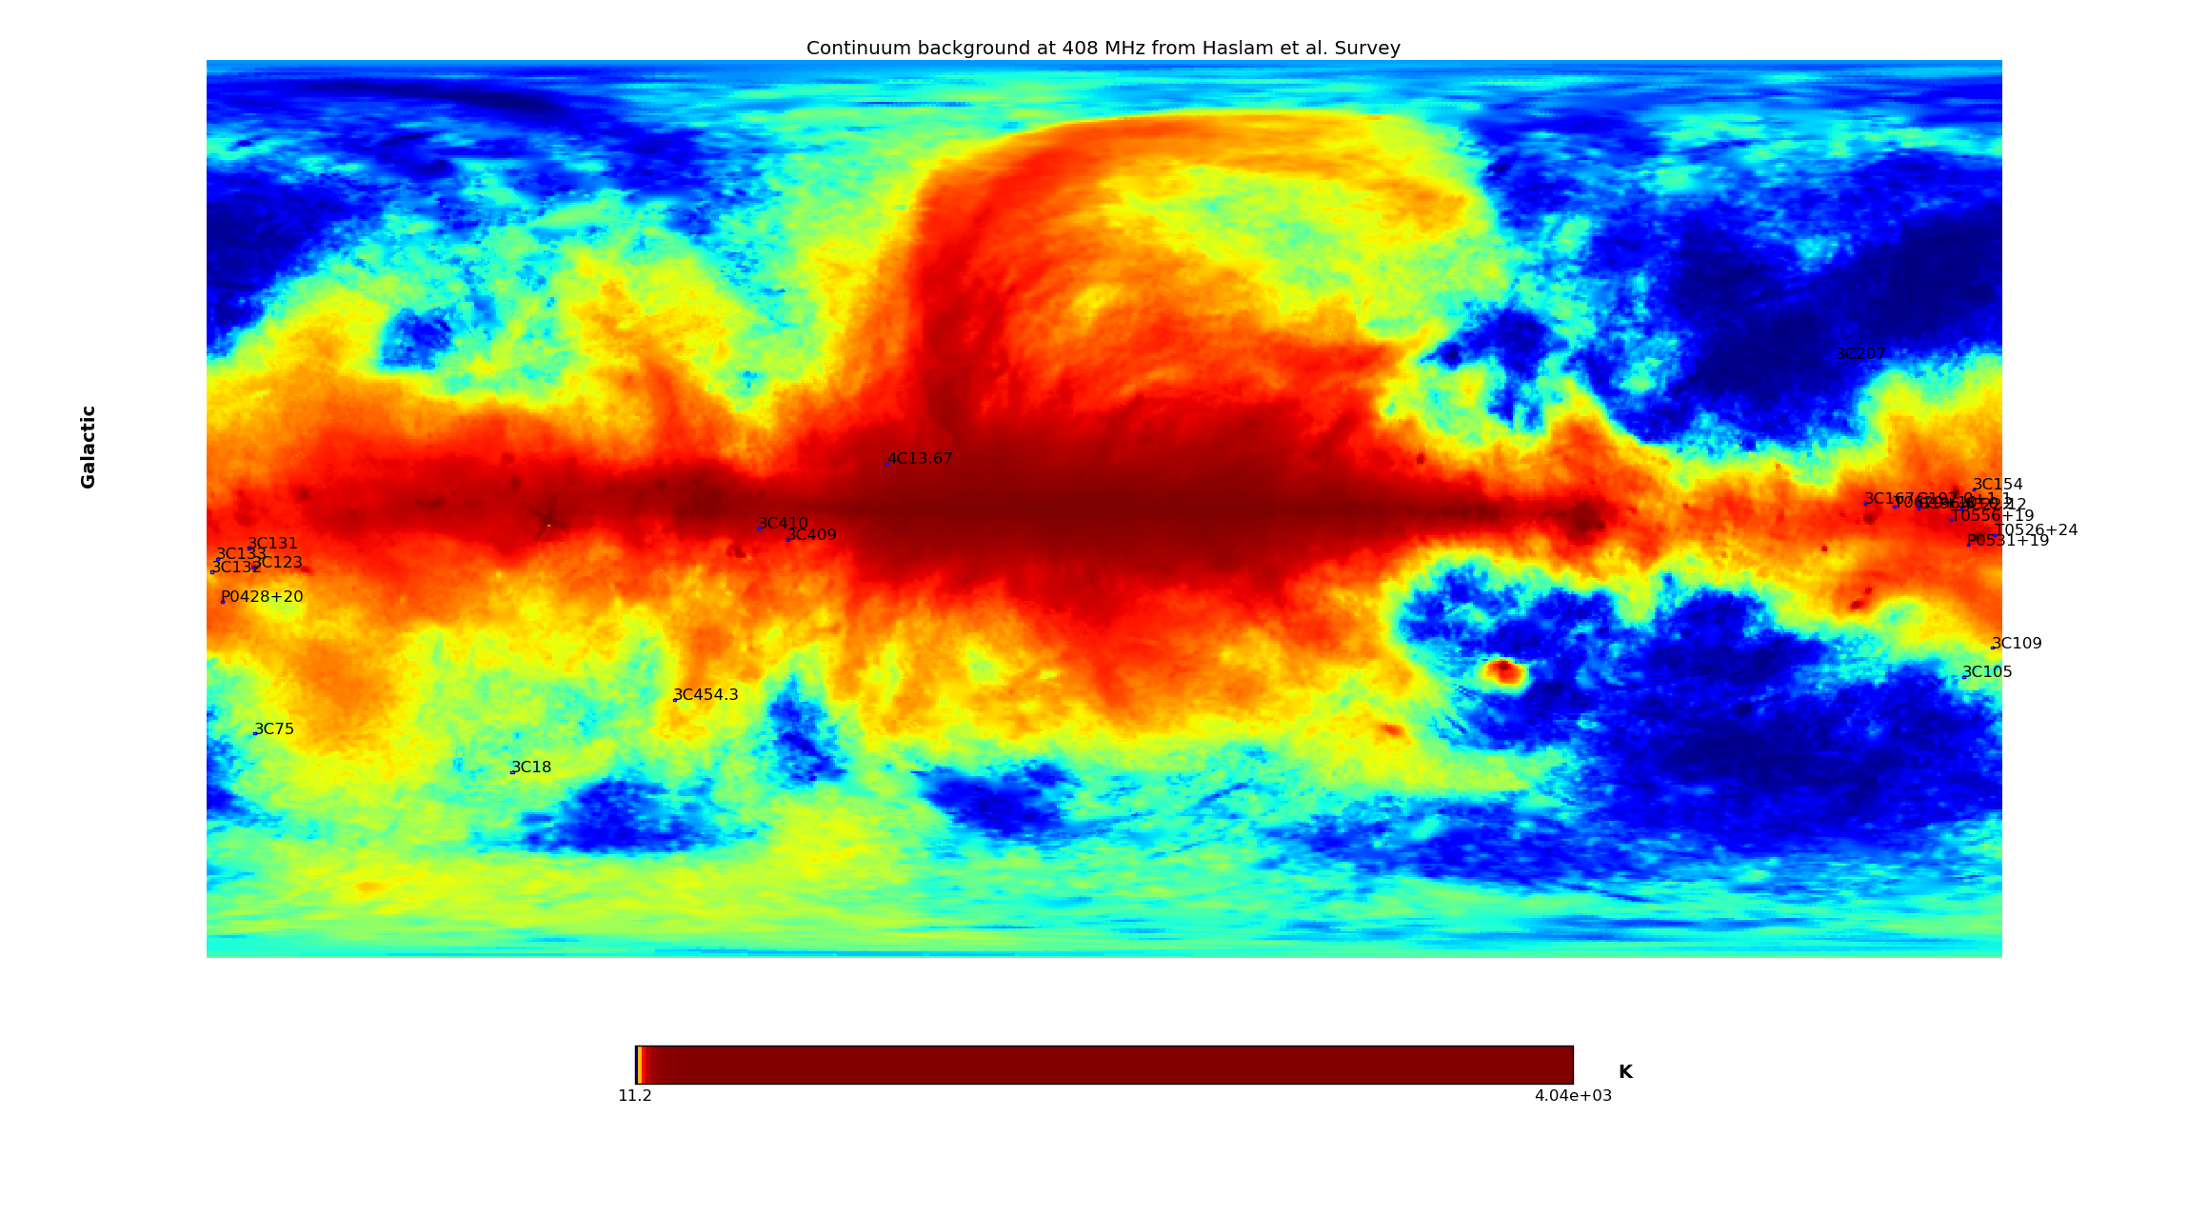
+ Galactic Map (healpy_haslam_408.py > plot_haslam_408mhz_map)

+ Patches around each line-of-sight (healpy_haslam_408.py > plot_haslam_408mhz_patche)
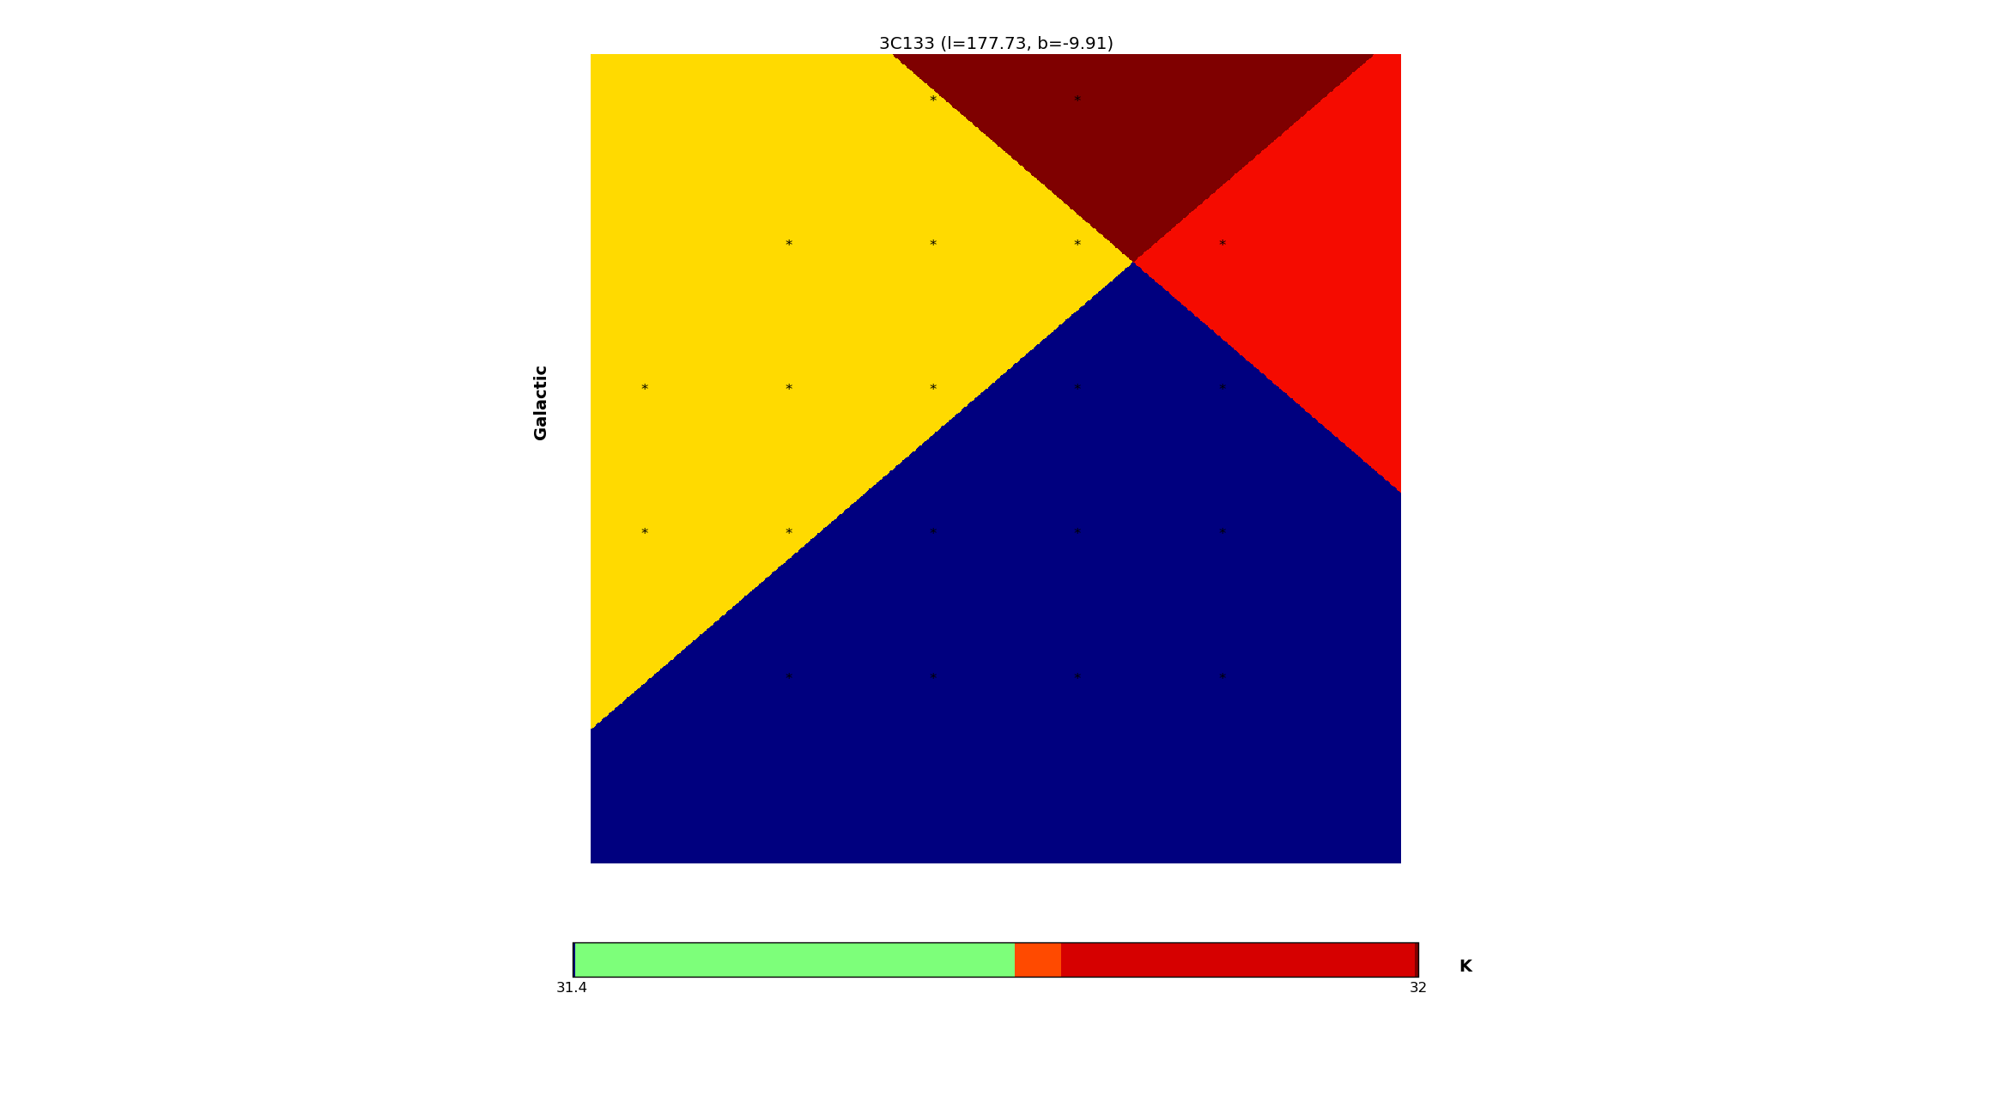
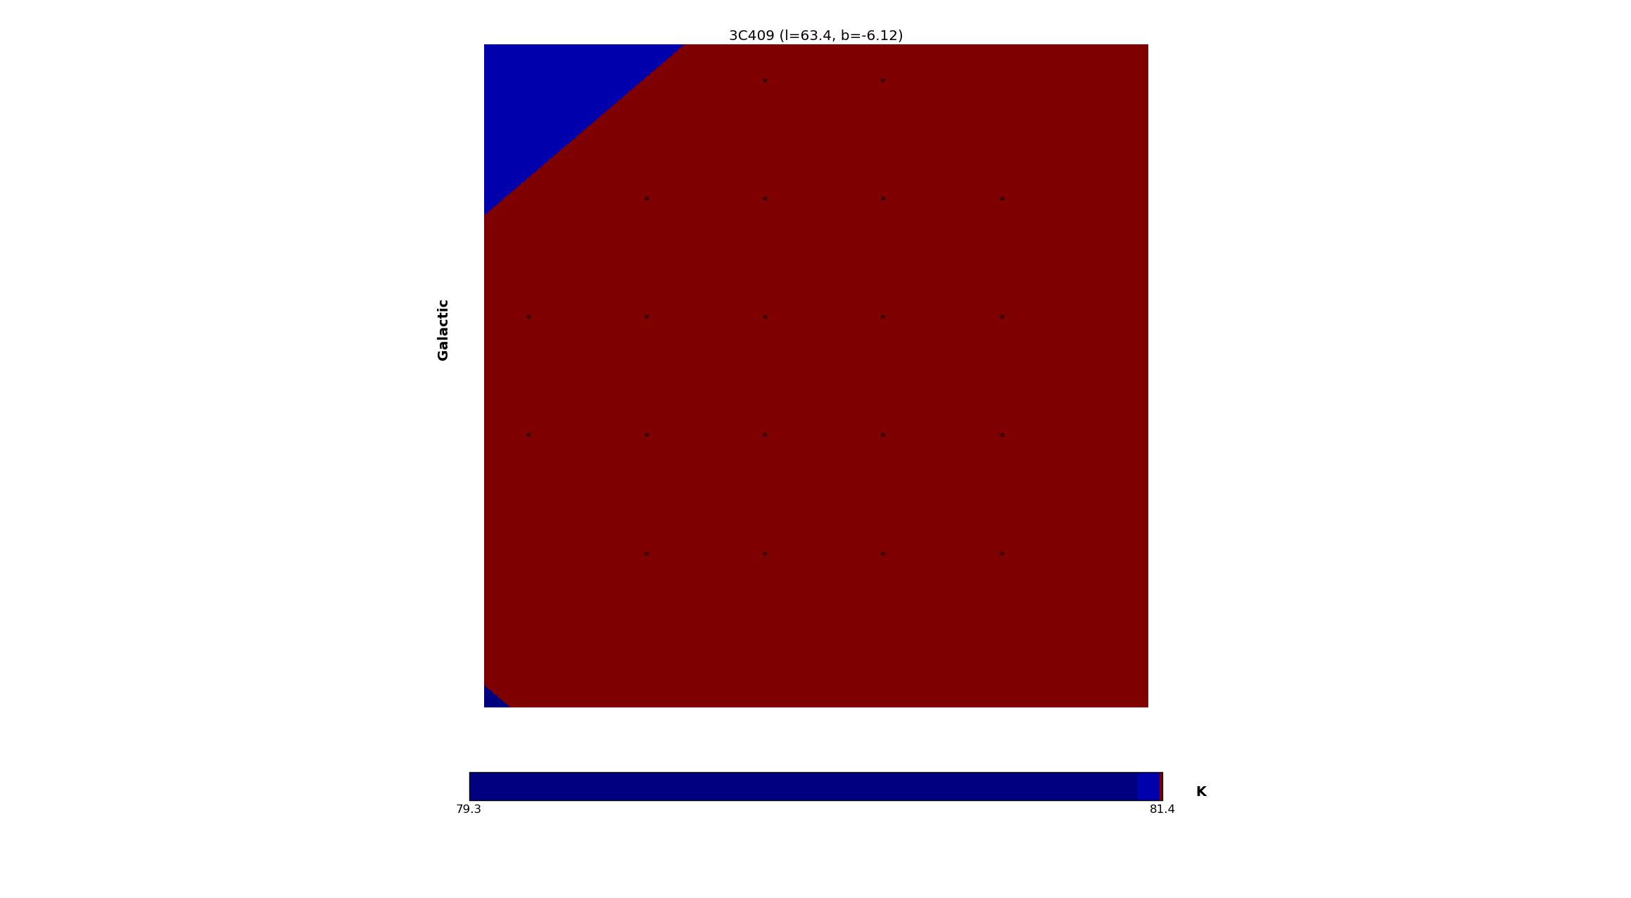
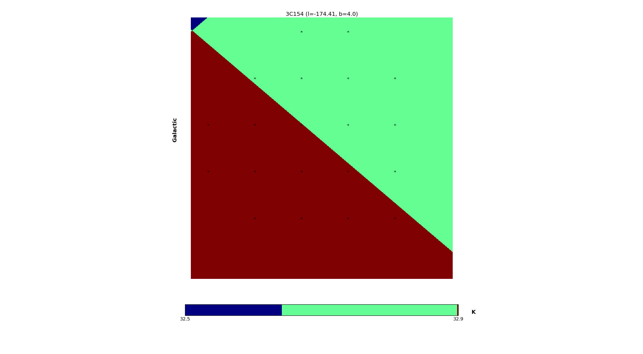

I'm using OH data from Arecibo. Ningyu and Dili are also using this data and they have results. (Please see the files: DiLi_DarkGas.pdf and DiLi_spec.pdf).
+ In the file: DiLi_spec.pdf, he plots spectra of all lines (HI, OH1665, OH1667, CO lines)
+ In the file: DiLi_DarkGas.pdf, some statistics on the presence of lines for each light-of-sight. In this file, red-colour rows show the sources with OH but without CO.
I found the same result.
Namely, the sources with OH but without CO are:
3C18, 3C109, 3C409, 3C132, P0531+19 (not really clear on P0531+19 because of its weak absorption lines).
The sources 3C109, 3C409, 3C132, P0531+19 are found in the regions with high N(HI). Please see the figure: f_vs_nhi_with_OH_src.png
So, it means that we may find more OH where there's more HI? Or, we may find OH in the region where the values of N(HI) are high.
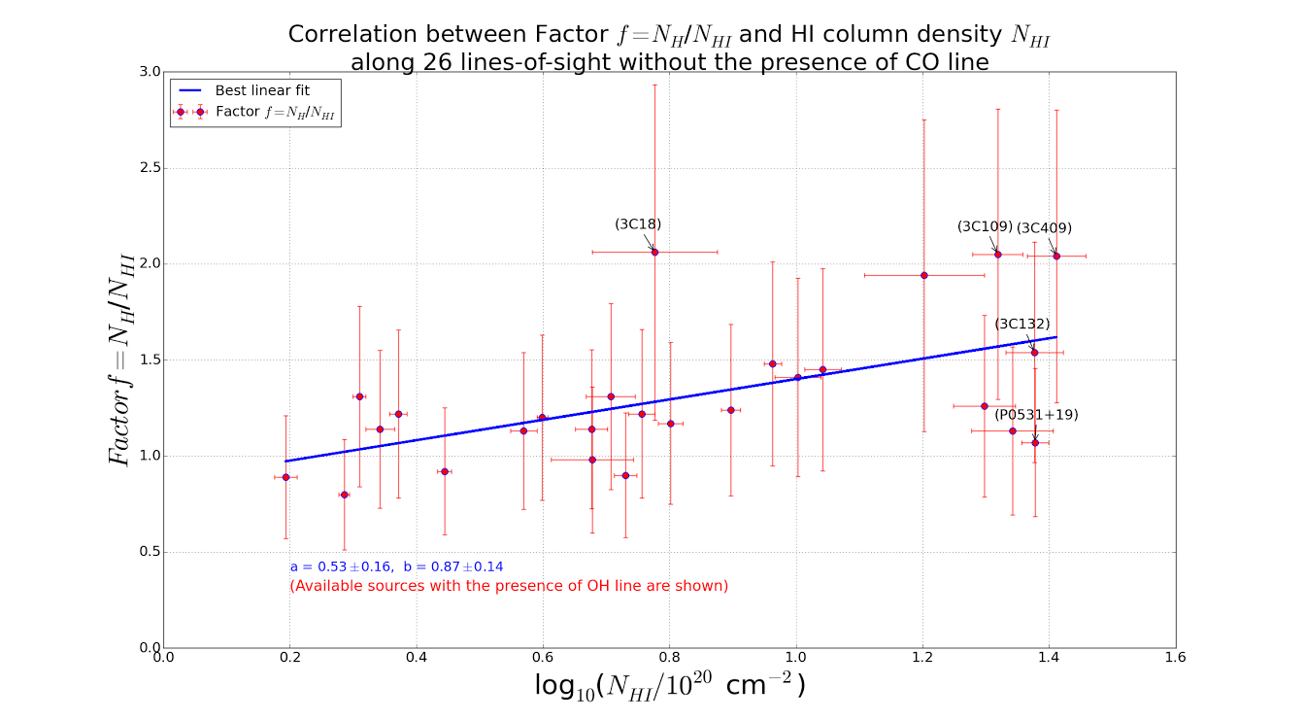

From MS data on HI and OH, I calculate the e(-tau) from on/off-source measurements. And I plot the Absorption lines.

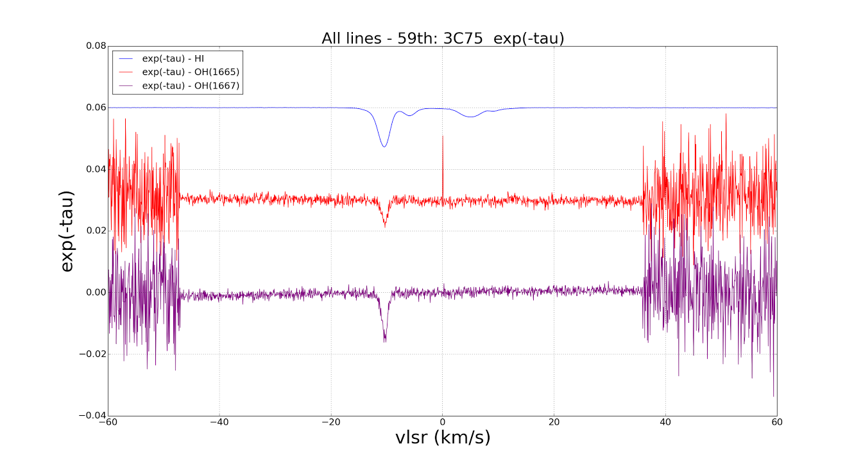

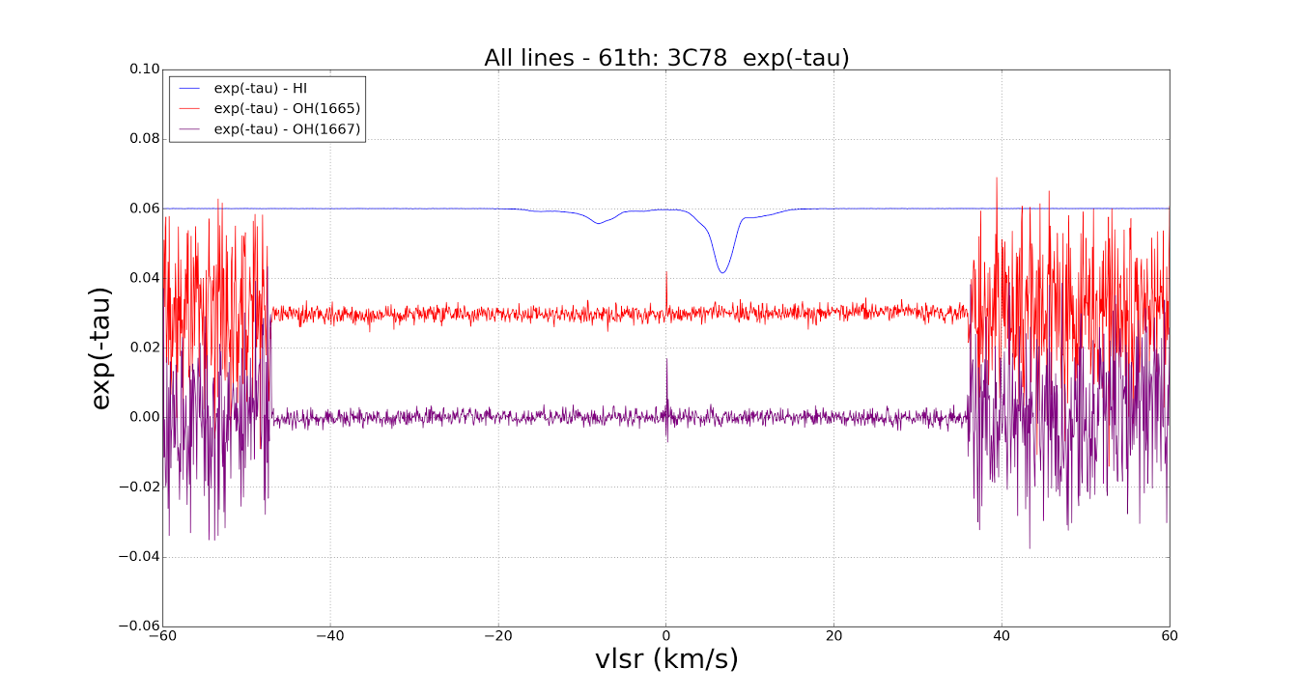

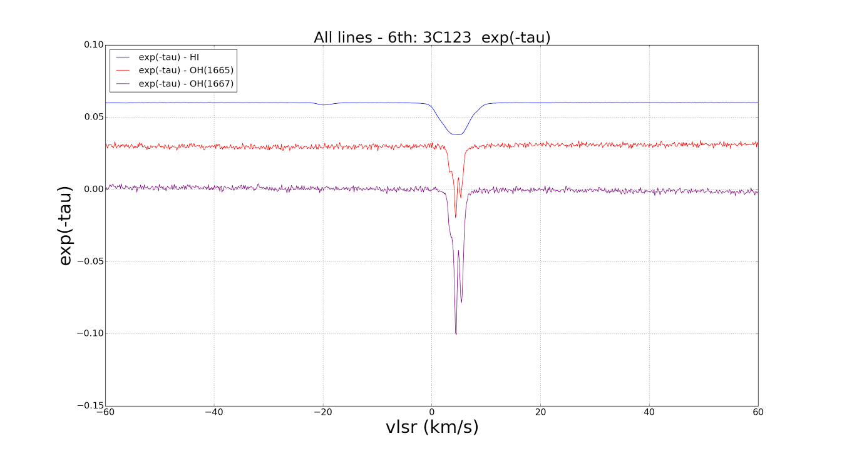

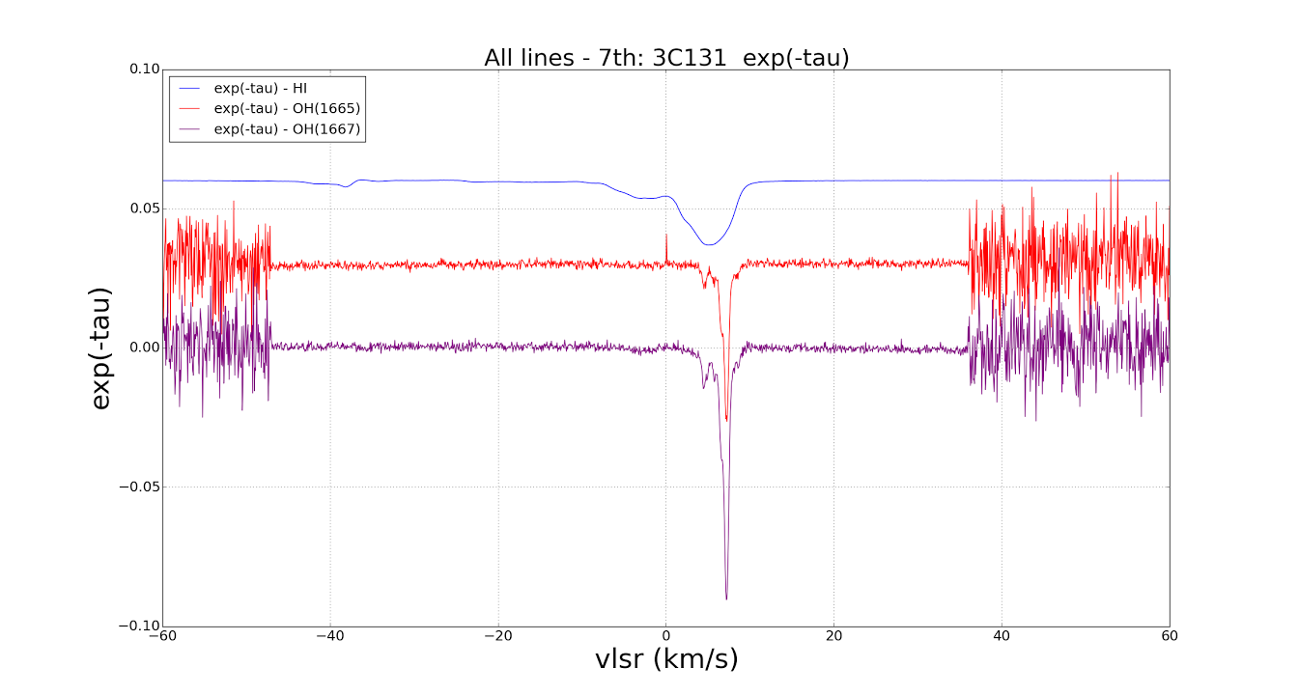

There are spikes at V=0 (km/s). I get rid of the interference spikes at VLSR=0, and then, take the Average between them.

I use the OH data from MS to calculate the Column Densities of OH1665 and OH1667 for each line-of-sight.
To do this:
Step 1: I compute the e(-tau) from On/off-source measurements.
Step 2: I make Gaussian fit for e(-tau) just to obtain the velocity range of the peaks.
Step 3: I use the e(-tau) to calculate the Excitation Temperature (and of course the Tau values).
From Tau spectra, I derive the 1-sigma standard deviation of Tau.
I see that the Tex spectra are quite flat within the velocity range of the peaks. So, I choose ONLY the ranges inside the FWHM (v0-FWHM/2 to v0+FWHM/2) to calculate the Mean values of Tex with the criterion that Tau within the velocity range must be large than 2 tau sigma (2* tau_standard_deviation).

Step 4: Compute the Column Densities of OH1665 and OH 1667

To have images (go to ../oh/ts_from_onoff_spectra/ then run noh.py and noh2.py, check the function cal_tex or cal_tex_print)

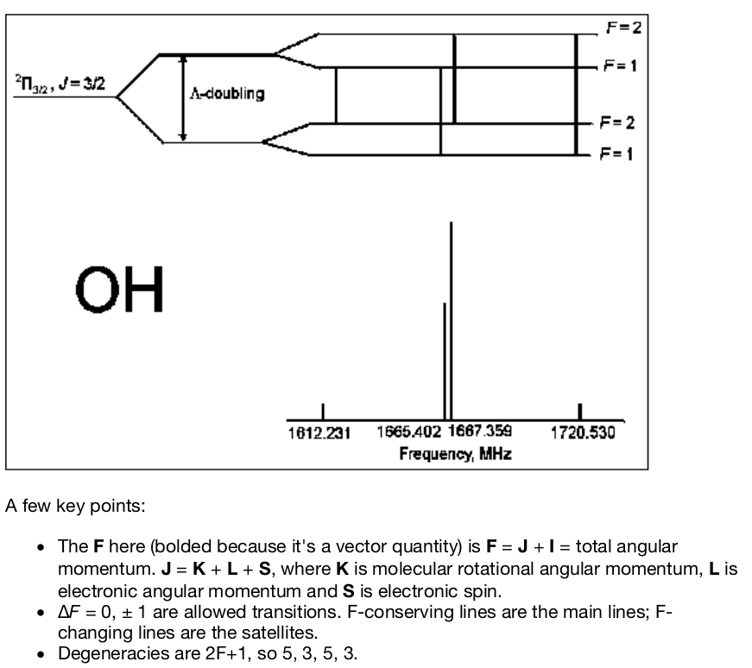
Einstein coefficients are given by Destombes, 1977:
1612MHz, A = 1.302e-11
1665MHz, A = 7.177e-11
1667MHz, A = 7.778e-11
1720MHz, A = 9.496e-12

I use the following equations to calculate the Column Densities of OH from 1665MHz and 1667MHz:
N_{OH}[cm⁻²] = [8πνkΣg_{i}/(c²g_{l}A_{ul}h)]*T_{ex}∫τ_{ν}dν = const* T_{ex}∫τ_{ν}dν
Σg_{i} = 5+3+5+3 = 16
g_{l} = 3 for 1665MHz line, so const = 3.99757843817e14
g_{l} = 5 for 1667MHz line, so const = 2.21841824609e14

Now, recalculate NOH, plot all figures with average values of Tbg from 408 Healpy map.

