Note on:
Planck early results. XIX. All-sky temperature and dust optical depth from Planck and IRAS. Constraints on the "dark gas" in our Galaxy
(12/2011)

I. Aims
1. Establish a relation between Optical depth of thermal dust emission and Total proton column density, i.e τ_{D} = constant*N_{H}
2. Derive the fraction of Dark-Gas from the above correlation.

In order to do this, all sky maps of temperature and optical depth of thermal dust emission have been built from Planck-HFI (350μm-2mm) and IRAS (100μm – to constraint the dust temperature) data.

II. Observation & data
A. Data used in this study:
1. Planck data: Only HFI (350μm-2mm DR2 release) data used.
2. HI data: data from LAB (Leiden/Argentine/Bonn) used to trace the HI. The HI intensity W_{HI} was integrated in the velocity range -400 < vlsr < 400 km/s.
3. CO data
- In Galactic plan, use data from Dame et al. (2001) Survey.
- At high latitudes, use the unpublished high latitude survey obtained from the CfA telescope (Dame et al. 2010)
- At intermediate Galactic latitudes, use data from NANTEN survey obtained from Chile.

4. IR data
IRAS 100μm data are used to constraint the dust temperature.

Each data set is then combined into HEALPix.

B. Background levels (Offset subtraction)
- To compute the apparent temperature and optical depth of thermal dust emission accurately over the whole sky, subtraction of any offset (I⁰_{ν}) in the intensity data is required.
- In this study, an estimation of the above offset was made in a reference region with |b_{II}| > 20º and N^{HI}_{H} < 1.2x10²¹H/cm².
- The offset values for each frequency were subtracted from the map in the rest of this analysis.

III. Dust temperature and dust optical depth
1. Dust temperature
The IRIS 100μm and 2 highest frequencies 857 and 545 GHz data were used to determine the dust temperature T_{D} map (and its corresponding uncertainty map).
From the map, dust temperature in the whole sky varies from 14K to 24K.

2. Optical depth determination
After computing the T_{D}, map of thermal dust Optical depth (τ_{D}(λ)) for each wavelength is derived using:

τ_{D}(λ) = I_{ν}(λ)/B_{ν}(T_{D})

where B_{ν} is Planck Fucntion and I_{ν}(λ) is the intensity map.
The uncertainty (∆τ_{D}) on τ_{D}(λ) are also computed.

The correlation between the optical depth and the total proton column density is shown in the folowing figure:

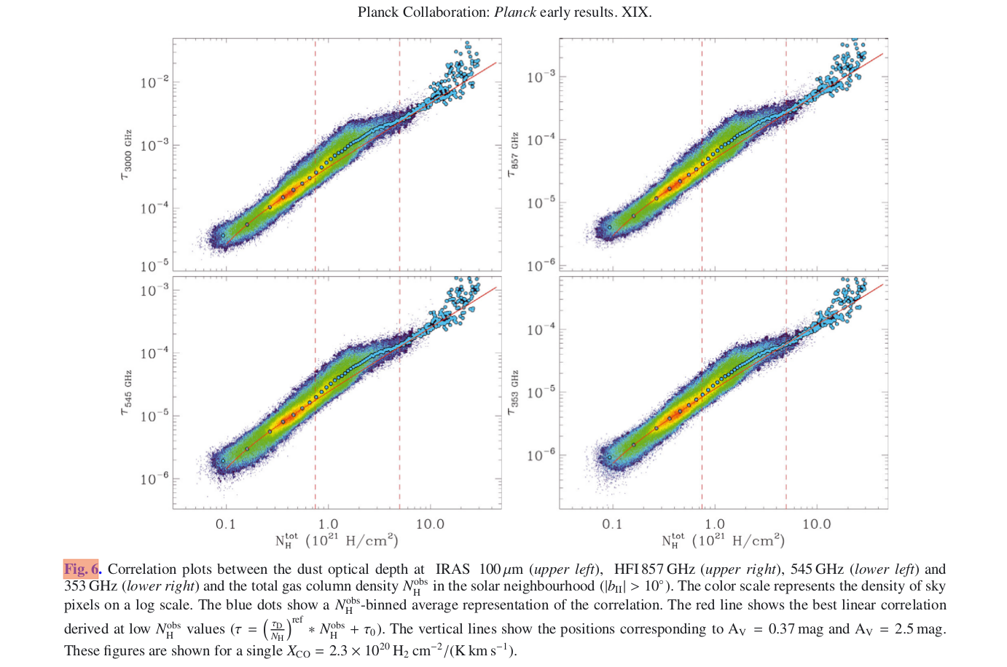
For these plot, a fixed value of X_{CO} =2.3x10²⁰ [H₂cm⁻²/(K.kms⁻¹)] is used.
Some derived comments:
- At lowest column density (N^{tot}_{H}), the correlation between optical depth and column density of observed gas is LINEAR.
- At high column density (N^{tot}_{H}), the correlation between optical depth and column density of observed gas is LINEAR.
- At intermediate column density values (N^{tot}_{H}), the correlation between optical depth and column density of observed gas is NOT LINEAR with the dust optical depth in excess of the correlation. This excess emission is attributed to the thermal emission by dust associated with a “dark gas” phase.

IV. Dust/gas correlation
Model of the dust opacity ():

τ_{M}(λ) = (τ_{D}(λ)/N_{H})^{ref} (N_{HI} + 2X_{CO}W_{CO})

where (τ_{D}(λ)/N_{H})^{ref} : reference dust emissivity measured in low N_{H} regions

From HI data, HI column density N_{HI} is computed.
From CO data, one obtains the W_{CO}

Then, do the fitting with 3 free parameters: (τ_{D}(λ)/N_{H})^{ref} , X_{CO}, A^{DG}_{V}
The best fit parameters for (τ_{D}(λ)/N_{H})^{ref} , X_{CO} and A^{DG}_{V} for each frequency are obtained, in particular, at 353GHz:
τ_{D}/N_{H}^{obs} = (1.18±0.17)x10⁻²⁶ [cm²]
X_{CO} = (2.31±0.47)x10²⁰ [H₂cm⁻²/(K.kms⁻¹)]
A^{DG}_{V} = (4.07±1.28)x10⁻¹ [mag]

The ratio of the dark gas mass to HI gas mass (M^{X}_{H}/M^{HI}_{H}) and to H₂ gas mass (M^{X}_{H}/M^{CO}_{H}) are obtained by using the average (τ_{D}/N_{H})^{ref} and X_{CO} values above.

On average, at high b, M^{X}_{H}/M^{HI}_{H} ~ 28%±3%, M^{X}_{H}/M^{CO}_{H} ~ 118±12%

