|  |  |
| --- | --- |
|  | **FPT ACADEMY INTERNATIONAL**  **FPT – APTECH COMPUTER EDUCATION** |

**Centre Name: ACE-HCMC-2-FPT.**

**Address: 590 Cach Mang Thang 8, District 3, Ho Chi Minh City, Viet Nam.**

**Perfume Store Management System**

Design Document

|  |  |  |
| --- | --- | --- |
| **Supervisor:** | Trần Phước Sinh | |
| **Semester:** | 2 | |
| **Batch No:** | F2-13-1704-T0 | |
| **Group No:** | 2 | |
| **Order:** | **Full name** | **Roll No.** |
| 1. | Lê Tuấn Vũ | Student1022111 |
| 2. | Nguyễn Quang Trung | Student1022120 |
| 3. | Nguyễn Khánh Long | Student1022160 |
| 4. | Hoàng Minh Tuấn | Student1021968 |

Month …01.. Year 2018…

**TABLE OF CONTENTS**

Contents

**I.** **Problem Definition:** 5

**1.** **Introduction:** 5

**2.** **Proposed Solution:** 5

**II.** **Customer Requirement Specification:** 6

**1.** **Users of System:** 6

**3.** **System Requirements:** 8

**4.** **Software Requirements:** 8

**5.** **Development software:** 8

**6.** **Technology:** 8

**III.** **Architecture and Design of the Project:** 11

**IV.** **User-Case Diagram:** 11

**V.** **DFD Diagram:** 14

**1.** **Level 0:** 14

**VI.** **Flowcharts Diagram:** 19

**1.** **Flowchart login**: 19

**2.** **Flowchart add new a product:** 20

**3.** **Flowchart edit a product:** 21

**4.** **Flowchart delete a product:** 22

**5.** **Flowchart search:** 23

**VII.** **ERD Diagram.** 24

**1.** **Users** 24

**2.** **Stores** 25

**3.** **Roles** 25

**4.** **OrderDetails** 25

**5.** **Bills** 25

**6.** **Customers** 26

**7.** **Categories** 26

**8.** **Products** 27

**VIII.** **Database Design/Structure:** 30

**1.** **Data diagram** 30

**2.** Tables 31

**IX.** **GUI design.** 36

**1.** **First Frame.** 36

**2.** **Inventory** 38

**3.** **Sales.** 43

**4.** **Manager** 52

**5.** **Director.** 61

Review 1

1. **Problem Definition:**
2. **Introduction:**

Today, perfume is a **anniversary. So after a long time. We also change every thing but we will remember perfume with a anniversary at past. So to day, so much people sell perfume and create a shop for buy perfume. It make very much money for every body sell it.**

Create a perfume store, manage sales, manage money. They are big work with much task. And director perfume store will work hard if they do it by hand.

So, We produce Perfume Store System Management. It will help the store director work so fast, so easy. Application will help sales, inventory, manager and director easy view.

Perfume store management system is a software provide good interface with some functional for manager. A user can login, then they can manage bill, money, sales, products .v.v..

Functional of application has ben developed to provide a lot of benefit to user. Help to management inventory easier. All business process faster and correctly. Base Java programming language can run on any platform. Our application can execute even on many platform difference if they setup Java Runtime Environment. Therefore system will implemented widely and reality higher.

1. **Proposed Solution:**

System have 4 users type: sales, manager, inventory and director.

Perfume Store System don’t have registration form for new user, creating the account would be done by director and manager.

When login, if login success, each user have each permission. And each permission have difference menu of system.

1. **Customer Requirement Specification:**
2. **Users of System:**
3. **Sales:**

Sales is a staff of store, they will provide product information when a customer request. If customer agree, sales will produce a bill ,create it and buy products. Sales can search and delete a bill but they must wait for manager agree.

1. **Inventory.**

Inventory manager is a manager of system. While system have many store, this system have only one store. This staff will check inventory everyday, and produce quantity of product when a product not available in inventory. Everyday, this staff will send report for director.

1. **Manager**

Manager have high permission. Each store, will have a manager. Mission of this staff is : Money manager, sales manager. It mean they will manager to store.

Every day, each manager of each store will create report of store and send to director

1. **Director**

System have only one director, only one. This person can add a new store and manager to all store in system. This person can add new or delete manager in each store, delete and add new inventory staff. And also, this person will see all report from manager.

1. **Functional Requirements:**

* **Login to the system:**
  + Input and verify: Username, password, role.
  + Output: Show message of login status. If login success, a main interface appear
* **Change the password.**
  + Input and verify: old password and new password.
  + Output: Show message success.
* **View inventory.**
  + Show: all information of all products.
* **Search products.**
  + Input: product name or categories or price.
  + Output: Show information of products.
* **Search bill:**
  + Input: customer ID, or while time, or Total.
  + Output: show information of bill.
* **Search customer:**
  + Input: customer name.
  + Output: show information of customer.

1. **Sales:**

* **Produce order.**
  + Input: Products ID and Quantity.
  + Output: Product list was ordered by sales with the fields like product name, quantity, price and total money.
* **Delete bill.**
  + Input: cause message for task cancel order.
* **Produce bill.**
  + Input: Customer ID, discount, VAT and Product list was ordered. If Customer ID don’t exist, Sales will add a new customer.
  + Output: Show order details with the fields like sale name, date, customer name, product list and total money.
* **View sale information.**
  + Show: all information of sale with Sale ID input when login.

1. **Inventory:**

* **Add, delete, edit and search categories:**
  + Input: information of categories.
  + Output: show categories list with information.
* **Add, delete, edit and search products:**
  + Input: information of products.
  + Output: show products list with information.
* **Validate the inventory:**
  + Show how many products are sold and show change quantity product in the inventory.
* **View inventory status:**
  + Show total categories.
  + Show total products.
  + Show total quantity.
* **Generate report:**
  + Produce unsold inventories each month.
  + Produce receipt summary report.
  + Produce expire products report.

1. **Manager:**

**Add, remove, edit, search sales account.**

Input: information of sales.

Output: show sales list with information.

**View store status:**

Show how many bills have been generated.

Show how much order have been canceled.

Show how much money is transacted.

**Check bills was delete.**

Show order list was canceled with wrong entry by the sales.

**Generate report:**

Produce transfer report for each of the products, category, sales, time.

Produce income report.

Produce sold quantity of each product, category report.

1. **Director.**

* **Add, remove, edit manager and inventory account.** 
  + Input: Information of account.
  + Output: Show manager and inventory account list.
* **Add, remove, edit store.** 
  + Input: Information of store.
  + Output: Show store list.
* **View report:**
  + Show report from inventory sales.
  + Generate report form report of manager of each store.

1. **System Requirements:**

* Pentium 4, 1.8 Ghz or better.
* 256 MB of RAM.
* 100 MB of HDD capacities available.

1. **Software Requirements:**

* OS with Windows XP SP2.
* SQL Server 2012.
* JDK 1.7

1. **Development software:**

* Netbean IDE 8.2
* Microsoft Office Viso 2013.
* Microsoft Office Word 2013.
* SQL Server Management Studio.

1. **Technology:**

* Java SE.
* Java Swing.

**Review 1 – Task Sheet**

|  |  |  |  |  |  |  |
| --- | --- | --- | --- | --- | --- | --- |
| **Project Ref. No:** | | **Project Title** | **Date of Preparation of Activity Plan** | | | |
| **Sr.**  **No.** | **Task** | **Actual Start Date** | **Actual Days** | **Team Member Name** | **Status** |
| 1 | Problem Definition | Perfume Store Management System | 22/01/2018 | 5 | All member | Complete |
| 2 | Customer Requirement Specification |

Activity Plan Prepare By : Group 2 January 24, 2018

**Group Leader Faculty**

*Lê Tuấn Vũ Trần Phước Sinh*

Review 2

1. **Architecture and Design of the Project:**

Graphic User Interface

Tier 1

Presentation Tier

Data Processing

Tier 2

Processing Tier

Tier 3

Database Tier

Database Access

1. **User-Case Diagram:**

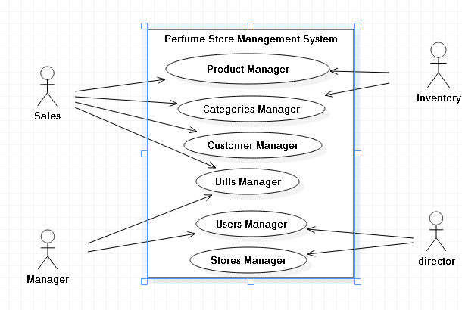

* Sales:

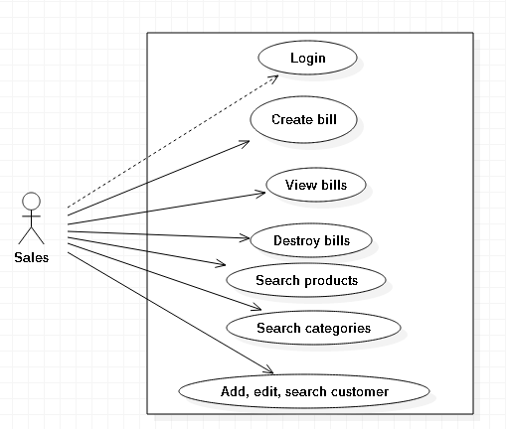

* Inventory:

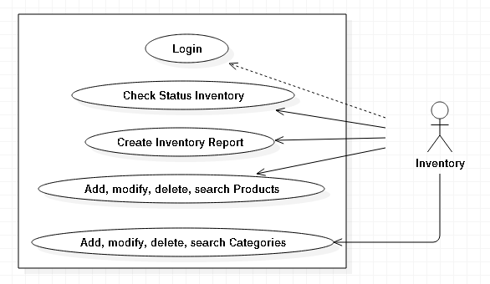

* Manager:

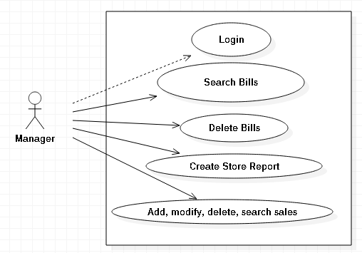

* Director

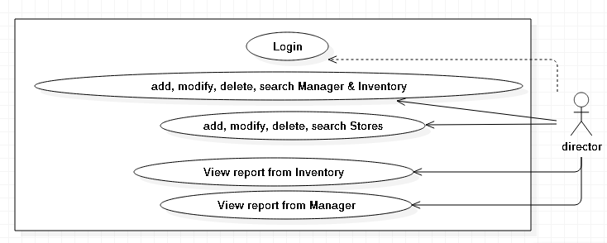

1. **DFD Diagram:**
2. **Level 0:**

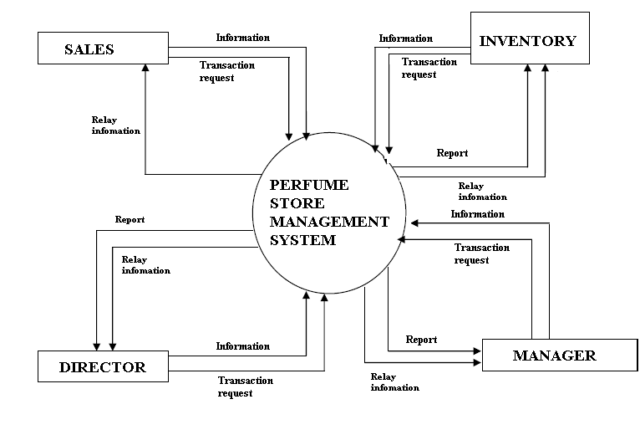

1. **DFD level 1 for sales:**

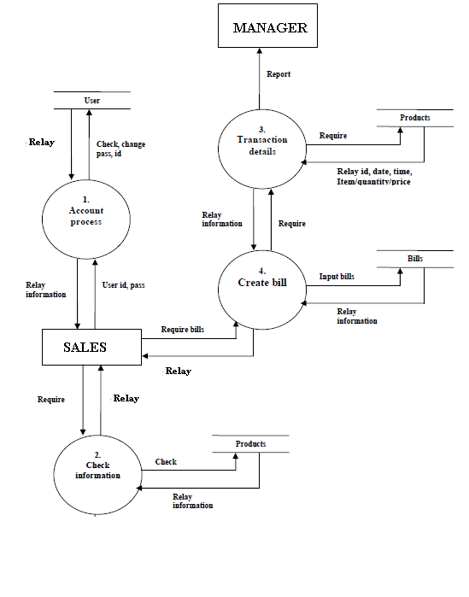

* **DFD level 1 for manager:**

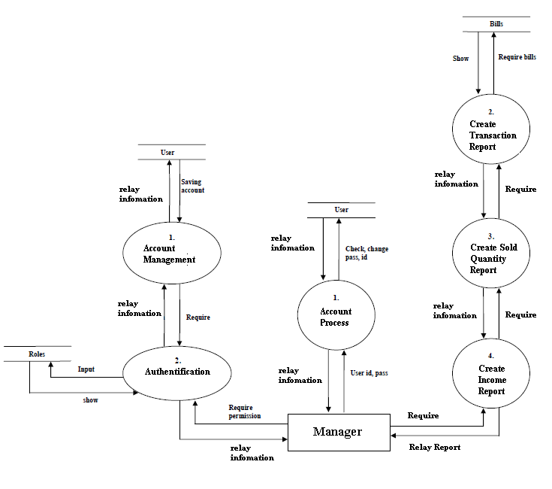

* **DFD level 1 for inventory.**

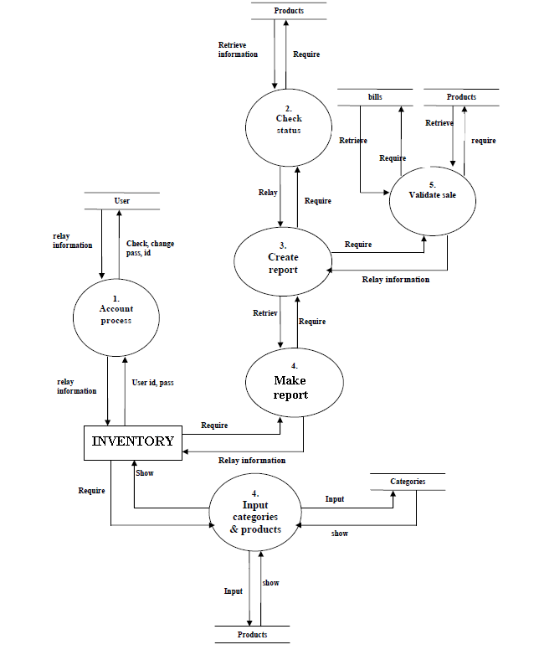

* **DFD level 1 for director**

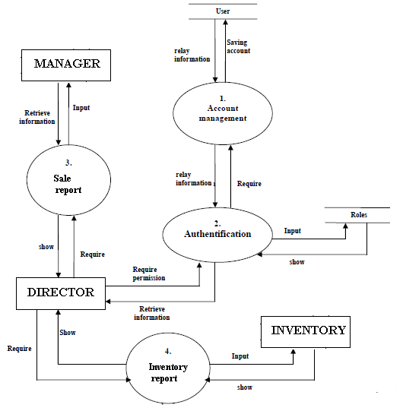

1. **Flowcharts Diagram:**
2. **Flowchart login**:

NO

YES

Display window main

Stop

Check username, password, role

Display error

Input username, password, role

Start

1. **Flowchart add new a product:**

NO

NO

Display error

Stop

Display successful

Insert product

successful

YES

Validate successful

YES

Input product information

Start

1. **Flowchart edit a product:**

NO

NO

Display error

Stop

Display successful

Update product

successful

YES

Validate successful

YES

Input product information

Start

1. **Flowchart delete a product:**

NO

NO

Display error

Stop

Display successful

Update product

successful

YES

Validate successful

YES

Input product information

Start

1. **Flowchart search:**

Display product information

NO

NO

Display error

Stop

Select product

successful

YES

Validate successful

YES

Input name of product

Start

1. **ERD Diagram.**

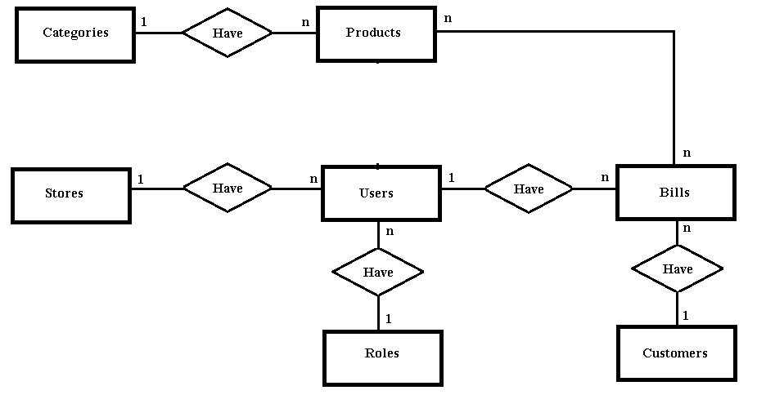

* 1. **Users**

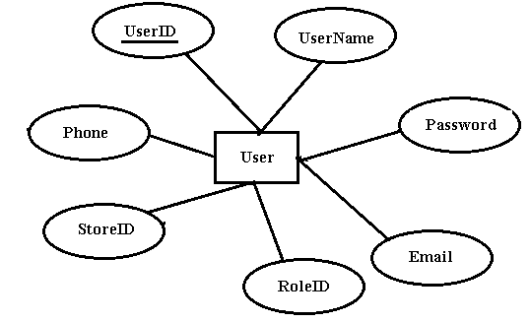

* 1. **Stores**

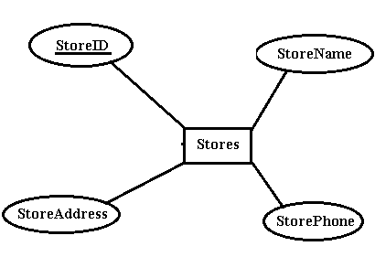

* 1. **Roles**

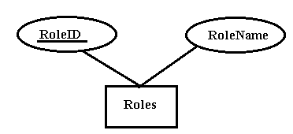

* 1. **OrderDetails**

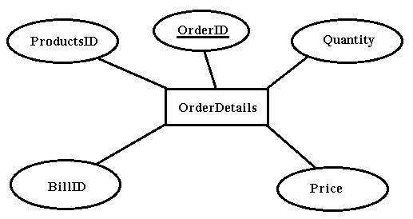

* 1. **Bills**

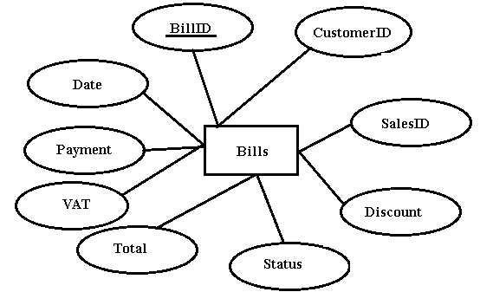

* 1. **Customers**

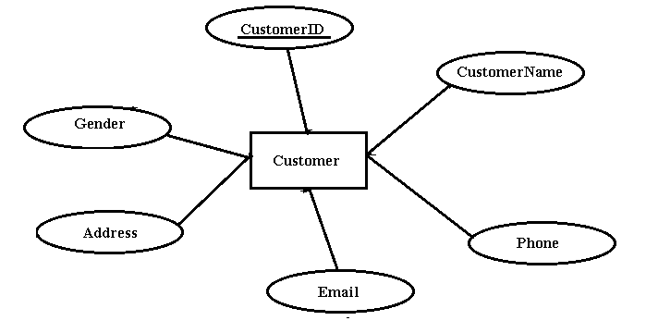

* 1. **Categories**

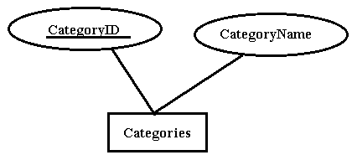

* 1. **Products**

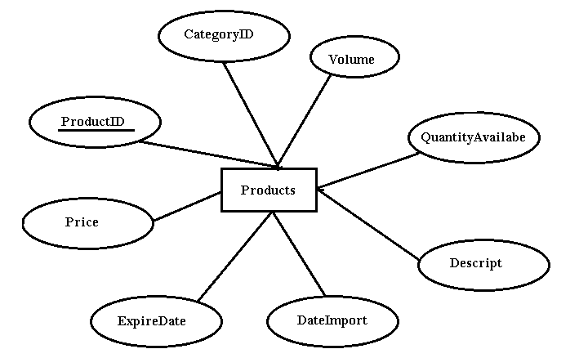

**Review 2 – Task Sheet**

|  |  |  |  |  |  |  |
| --- | --- | --- | --- | --- | --- | --- |
| **Project Ref. No:** | | **Project Title** | **Date of Preparation of Activity Plan** | | | |
| **Sr.**  **No.** | **Task** | **Actual Start Date** | **Actual Days** | **Team Member Name** | **Status** |
| 1 | Architecture | Perfume Store Management System | 24/1/2018 | 7 | All member | Complete |
| 2 | User-Case |
| 3 | Algorithms |
| 4 | DFD Diagrams |
| 5 | E-R Diagrams |

Activity Plan Prepare By : Group 2 January 29th, 2018

**Group Leader Faculty**

*Lê Tuấn Vũ Trần Phước Sinh*

Review 3

1. **Database Design/Structure:**
   1. **Data diagram**

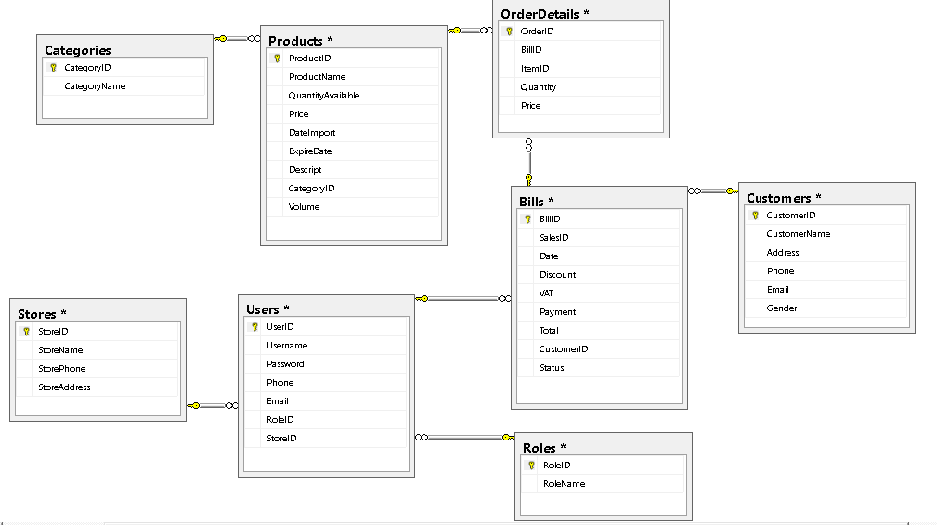

* 1. Tables
* Users

|  |  |  |  |  |  |  |  |
| --- | --- | --- | --- | --- | --- | --- | --- |
| **Field Name** | **Data Type** | **Size** | **Null** | **Default** | **Key** | **Table field ref** | **Description** |
| UserID | varchar | 10 | no |  | PK |  | Identifier of user |
| UserName | varchar | 20 | no |  |  |  | Username for login of user |
| Password | varchar | 20 | no |  |  |  | Password for login user |
| Phone | varchar | 20 | yes |  |  |  | Phone number of user |
| Email | varchar | 20 | yes |  |  |  | Email of user |
| RoleID | varchar | 10 | no |  | FK | Roles.RoleID | Role ID of user |
| StoreID | varchar | 10 | no |  | FK | Stores.StoreID | ID of Store |

* Roles

|  |  |  |  |  |  |  |  |
| --- | --- | --- | --- | --- | --- | --- | --- |
| **Field Name** | **Data Type** | **Size** | **Null** | **Default** | **Key** | **Table field ref** | **Description** |
| RoleID | varchar | 10 | No |  | PK |  | Role ID of user |
| RoleName | varchar | 20 | No |  |  |  | Role Name of user |

* Categories

|  |  |  |  |  |  |  |  |
| --- | --- | --- | --- | --- | --- | --- | --- |
| **Field Name** | **Data Type** | **Size** | **Null** | **Default** | **Key** | **Table field ref** | **Description** |
| CategoryID | varchar | 10 | No |  | PK |  | ID of Category |
| CategoryName | nvarchar | 50 | No |  |  |  | Name of the Category |

* Products

|  |  |  |  |  |  |  |  |
| --- | --- | --- | --- | --- | --- | --- | --- |
| **Field Name** | **Data Type** | **Size** | **Null** | **Default** | **Key** | **Table field ref** | **Description** |
| ProductID | varchar | 10 | No |  | PK |  | ID of the Products |
| ProductName | nvarchar | 50 | No |  |  |  | Name of the Products |
| QuantityAvailable | int |  | No | 0 |  |  | Quantity of Products |
| Price | int |  | No | 0 |  |  | Price of Products |
| DateImport | datetime |  | Yes |  |  |  | Date import of Products |
| Descript | varchar | 50 | Yes |  |  |  | Descript of Products |
| CategoryID | varchar | 10 | No |  | FK | Categories.CategoryID | Category ID of Products |
| ExpireDate | datetime |  | Yes |  |  |  | Expire Date of Products |
| Volume | int |  | No | 0 |  |  | Volume of Products |

* Customer

|  |  |  |  |  |  |  |  |
| --- | --- | --- | --- | --- | --- | --- | --- |
| **Field Name** | **Data Type** | **Size** | **Null** | **Default** | **Key** | **Table field ref** | **Description** |
| CustomerID | varchar | 10 | No |  | PK |  | ID of Customer |
| CustomerName | nvarchar | 50 | No |  |  |  | Name of Customer |
| Address | nvarchar | 50 | Yes |  |  |  | Address of Customer |
| Phone | varchar | 20 | Yes |  |  |  | Phone of Customer |
| Email | varchar | 20 | Yes |  |  |  | Email of Customer |
| Gender | varchar | 10 | Yes |  |  |  | Gender of Customer |

* Bills

|  |  |  |  |  |  |  |  |
| --- | --- | --- | --- | --- | --- | --- | --- |
| **Field Name** | **Data Type** | **Size** | **Null** | **Default** | **Key** | **Table field ref** | **Description** |
| BillID | varchar | 10 | No |  | PK |  | ID of Bill |
| SalesID | varchar | 10 | No |  | FK | Users.UserID | ID of sales create Bill |
| Date | datetime |  | No |  |  |  | Date create Bill |
| Discount | int |  | Yes | 0 |  |  | Discount of Bill |
| VAT | int |  | Yes | 10 |  |  | VAT of Bill |
| Payment | varchar | 10 | No |  |  |  | Payment of Bill |
| Total | int |  | No | 0 |  |  | Total money of Bill |
| CustomerID | varchar | 10 | No |  | FK | Customers.CustomerID | ID of Customer |
| Status | bit |  | No | True |  |  | Status of Bill |

* OrderDetails

|  |  |  |  |  |  |  |  |
| --- | --- | --- | --- | --- | --- | --- | --- |
| **Field Name** | **Data Type** | **Size** | **Null** | **Default** | **Key** | **Table field ref** | **Description** |
| OrderID | varchar | 10 | No |  | PK |  | ID of Order |
| BillID | varchar | 10 | No |  | FK | Bills.BillID | ID of Bill |
| ProductID | varchar | 10 | No |  | FK | Products.ProductsID | ID of Product |
| Quantity | int |  | No | 0 |  |  | Quantity product of Bill |
| Price | int |  | No | 0 |  |  | Price of Bill |

* Stores

|  |  |  |  |  |  |  |  |
| --- | --- | --- | --- | --- | --- | --- | --- |
| **Field Name** | **Data Type** | **Size** | **Null** | **Default** | **Key** | **Table field ref** | **Description** |
| StoreID | varchar | 10 | No |  | PK |  | ID of Store |
| StoreName | nvarchar | 50 | No |  |  |  | Name of Store |
| StorePhone | varchar | 20 | Yes |  |  |  | Phone of Store |
| StoreAddress | nvarchar | 50 | Yes |  |  |  | Address of Store |

1. **GUI design.**
   1. **First Frame.**

* **Login.**

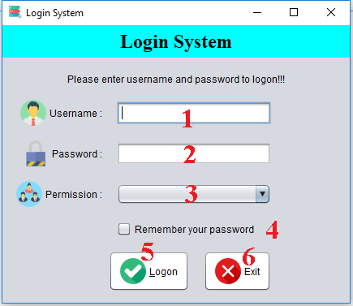

|  |  |  |  |  |  |  |
| --- | --- | --- | --- | --- | --- | --- |
| **No** | **Name** | **Type** | **Validation** | **Event** | **Description** | **Status** |
| 1 | txtUsername | JTextField | Not blank |  | Username to login | **Enable** |
| 2 | txtPassword | JPasswordField | Not blank |  | Password to login | **Enable** |
| 3 | cbbRole | JComboBox |  |  | System have 4 roles:  + Director.  + Manager.  + Inventory.  + Sales | **Enable** |
| 4 | chkRemember | JCheckBox |  |  | System remember username & password | **Enable** |
| 5 | btnLogon | JButton |  | Action Performed | If information login are valid, Login to Main Frame | **Enable** |
| 6 | btnExit |  |  | Action Performed | Close this form | **Enable** |

* **Main**

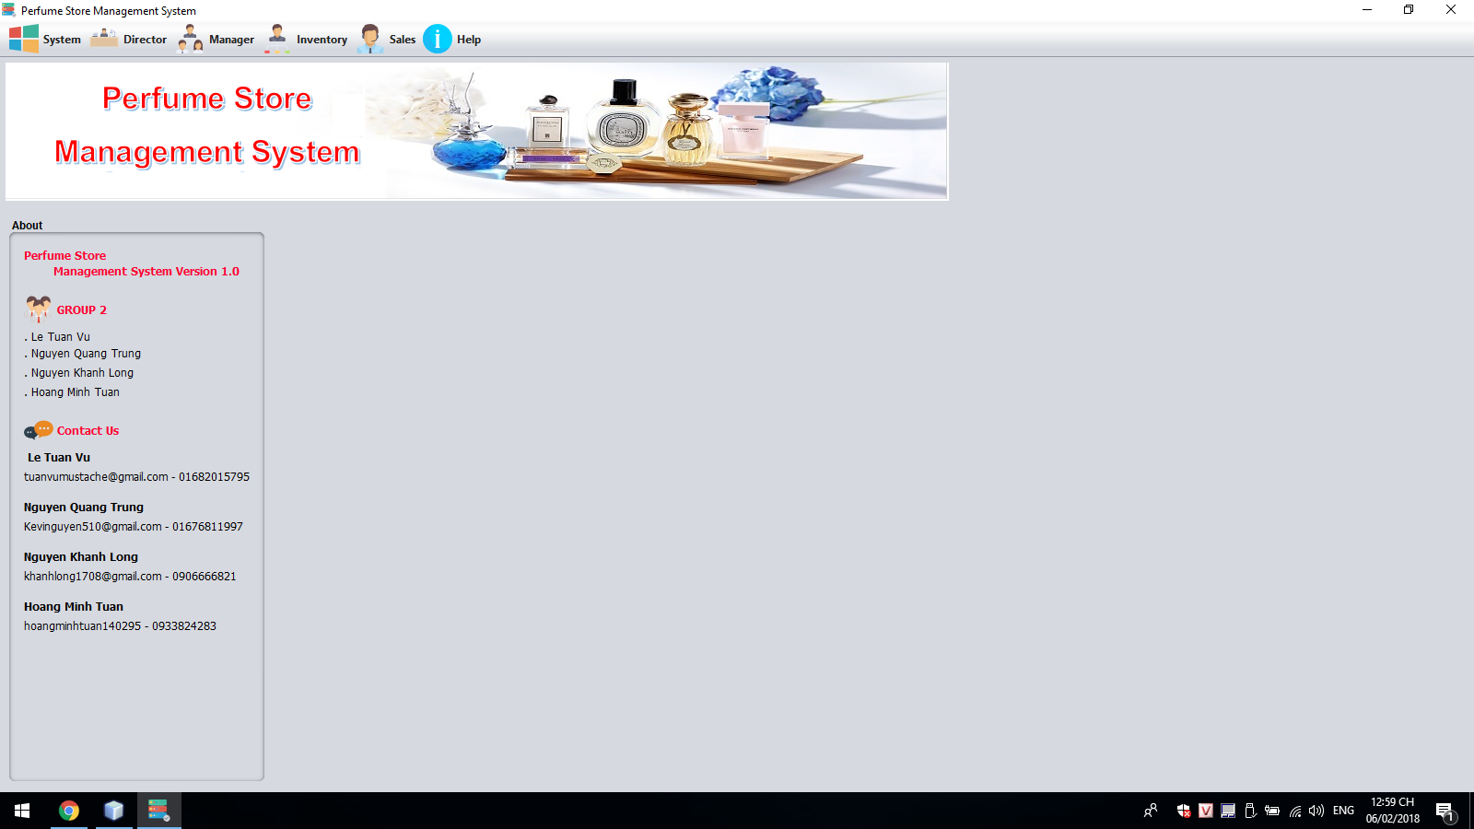

* 1. **Inventory**
* **Inventory Manager**

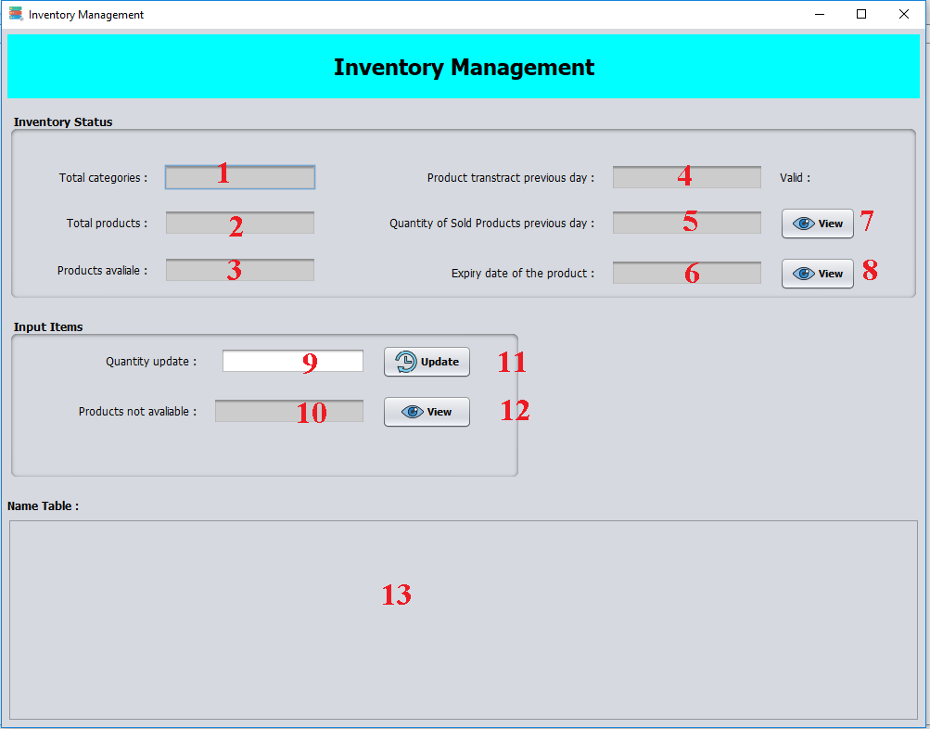

|  |  |  |  |  |  |  |
| --- | --- | --- | --- | --- | --- | --- |
| **No** | **Name** | **Type** | **Validation** | **Event** | **Description** | **Status** |
| 1 | txtTotalCate | JTextField |  |  | Quantity of categories | **Disable** |
| 2 | txtTotalProduct | JTextField |  |  | Quantity of products | **Disable** |
| 3 | txtProductAvailabe | JTextField |  |  | Quantity of Product available | **Disable** |
| 4 | txtProductTranstract | JTextField |  |  | Quantity of Product not available | **Disable** |
| 5 | txtSoldQuantity | JTextField |  |  | Quantity of Sold Product | **Disable** |
| 6 | txtExpireDate | JTextField |  |  | Quantity of Expire Product | **Disable** |
| 7 | btnSoldQuantity | JButton |  | Action Performed | View Table Sold Product list | **Enable** |
| 8 | btnExpireDate | JButton |  | Action Performed | View Table Expire Product list | **Enable** |
| 9 | txtQuantityUpdate | JTextField | Quantity > 0 |  | Quantity user want update for product | **Enable** |
| 10 | txtProductTranstract | JTextField |  |  | Quantity of Transfer Product | **Disable** |
| 11 | btnQuantityUpdate | JButton |  | Action Performed | Update quantity for product | **Enable** |
| 12 | btnProductNAvailabe | JButton |  | Action Performed | View Table Product not available list | **Disable** |
| 13 | tableInventory | JLabel |  |  | Table Inventory |  |

* **Categories.**

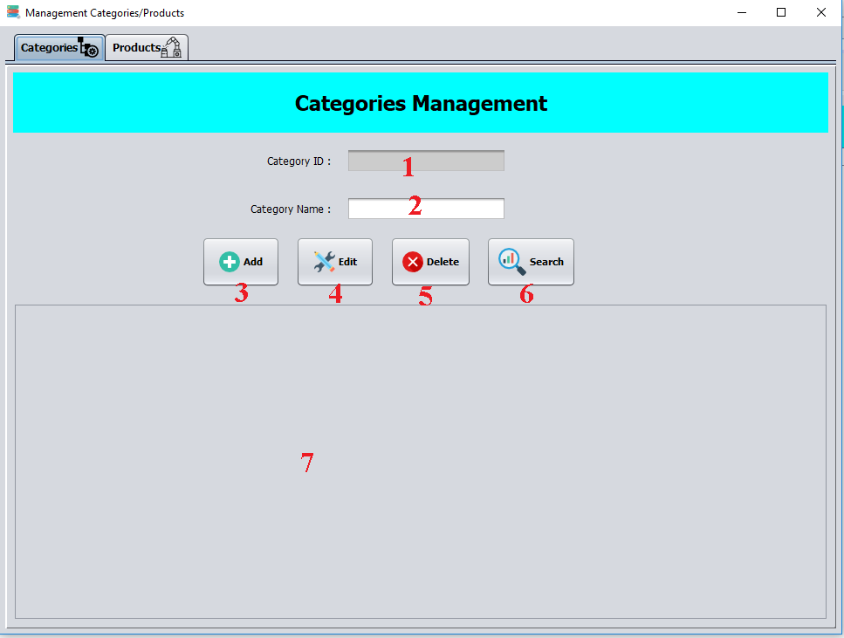

|  |  |  |  |  |  |  |
| --- | --- | --- | --- | --- | --- | --- |
| **No** | **Name** | **Type** | **Validation** | **Event** | **Description** | **Status** |
| 1 | txtCategoryID | JTextField |  |  | ID of Category | **Disable** |
| 2 | txtCategoryName | JTextField | no blank |  | Name of Category | **Enable** |
| 3 | btnAdd | JButton |  | Action Performed | If input valid, SQL will add new category | **Enable** |
| 4 | btnEdit | JButton |  | Action Performed | If input valid, SQL will update this category | **Enable** |
| 5 | btnDelete | JButton |  | Action Performed | If input valid, SQL will delete this category | **Enable** |
| 6 | btnSearch | JButton |  | Action Performed | If input valid, show table category list with input name. | **Enable** |
| 7 | tableCategories | JTable |  |  | Show category list | **Enable** |

* **Products**

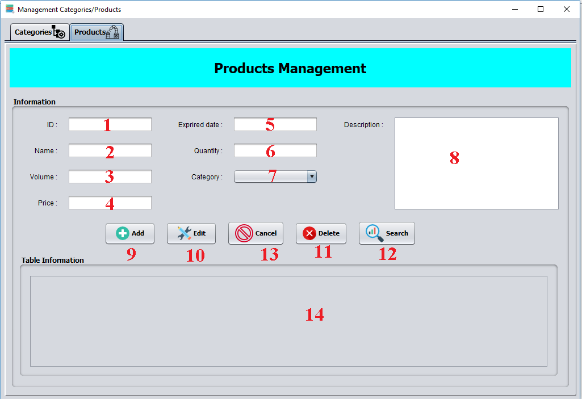

|  |  |  |  |  |  |  |
| --- | --- | --- | --- | --- | --- | --- |
| **No** | **Name** | **Type** | **Validation** | **Event** | **Description** | **Status** |
| 1 | txtProductID | JTextField |  |  | ID of Product | **Disable** |
| 2 | txtProductName | JTextField | not blank |  | Name of Product | **Enable** |
| 3 | txtVolume | JTextField | Volume>0 |  | Volume of Product | **Enable** |
| 4 | txtPrice | JTextField | Price>0 |  | Price of Product | **Enable** |
| 5 | txtExpireDate | JTextField | MM/DD/YY |  | Expire Date of Product | **Enable** |
| 6 | txtQuantity | JTextField | Quantity>0 |  | Quantity of Product | **Enable** |
| 7 | cbbCategory | JComboBox |  |  | Category of Product | **Enable** |
| 8 | txtDescription | JTextArea |  |  | Description of Product | **Enable** |
| 9 | btnAdd | JButton |  | Action Performed | If input valid, SQL will add new product | **Enable** |
| 10 | btnEdit | JButton |  | Action Performed | If input valid, SQL will update this product | **Enable** |
| 11 | btnDelete | JButton |  | Action Performed | If input valid, SQL will delete this product | **Enable** |
| 12 | btnSearch | JButton |  | Action Performed | If input valid, show table product list with input name. | **Enable** |
| 13 | btnCancel | JButton |  | Action Performed | Refresh all textfield | **Enable** |
| 14 | tableProduct | JTable |  |  | Show product list |  |

* 1. **Sales.**
* **Order.**

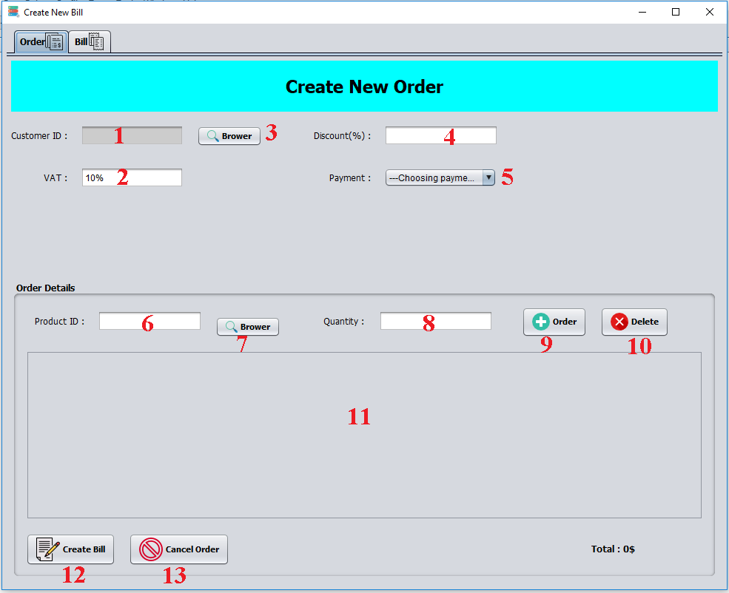

|  |  |  |  |  |  |  |
| --- | --- | --- | --- | --- | --- | --- |
| **No** | **Name** | **Type** | **Validation** | **Event** | **Description** | **Status** |
| 1 | txtCustomerID | JTextField | not blank |  | ID of Customer | **Disable** |
| 2 | txtVAT | JTextField | VAT>=10 |  | VAT of Bill | **Enable** |
| 3 | btnBrowserCus | JButton | not blank | Action Performed | Show Customer list | **Enable** |
| 4 | txtDiscount | JTextField | 0 <= Discount  <= 20 |  | Discount of Bill | **Enable** |
| 5 | cbbPayment | JComboBox |  |  | Payment of Bill | **Enable** |
| 6 | txtProductID | JTextField | not blank |  | ID of Product | **Disable** |
| 7 | btnBrowserProd | JButton |  | Action Performed | Show list of product | **Enable** |
| 8 | txtQuantity | JTextField | Quantity>0 |  | Quantity of Product | **Enable** |
| 9 | btnOrder | JButton |  | Action Performed | If input valid, Table Order add product | **Enable** |
| 10 | btnDelete | JButton |  | Action Performed | Delete a line of Order | **Enable** |
| 11 | tableOrder | JTable |  |  | Show Product Order list |  |
| 12 | btnCreate | JButton |  | Action Performed | If input valid, Create a Bill | **Enable** |
| 13 | btnCancel | JButton |  | Action Performed | Cancel Order | **Enable** |

* **Sale Bill Management**

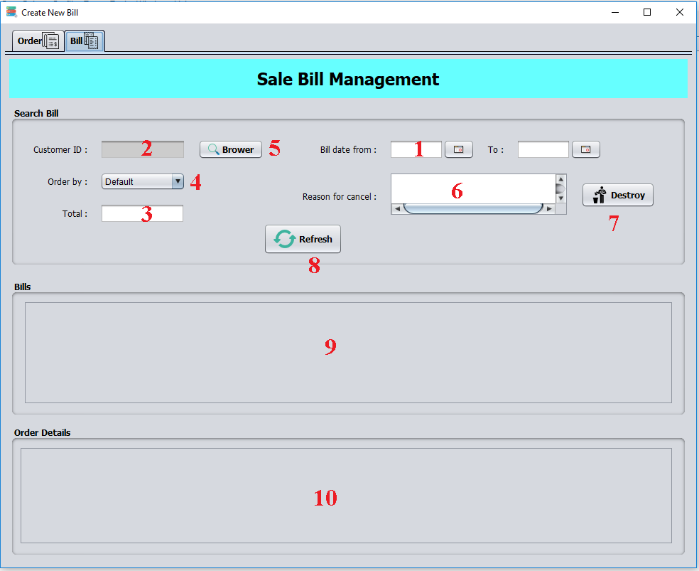

|  |  |  |  |  |  |  |
| --- | --- | --- | --- | --- | --- | --- |
| **No** | **Name** | **Type** | **Validation** | **Event** | **Description** | **Status** |
| 1 | txtDateFrom | JTextField | MM/DD/YY |  | Input date want search bill have date from | **Disable** |
| 2 | txtCustomerID | JTextField | not blank |  | ID of Customer | **Enable** |
| 3 | txtTotal | JTextField | Total > 0 |  | Total money of Bill | **Enable** |
| 4 | cbbOrder | JComboBox |  |  | Order by name of date | **Enable** |
| 5 | btnBrowser | JButton |  | Action Performed | Show Customer list | **Enable** |
| 6 | txtReason | JTextArea | not blank |  | Reason for destroy a Bill | **Enable** |
| 7 | btnDestroy | JButton |  | Action Performed | Destroy a Bill | **Enable** |
| 8 | btnRefesh | JButton |  | Action Performed | Refresh table Bill | **Enable** |
| 9 | tableBill | JTable |  |  | Show Bill list |  |
| 10 | tableOrderDetails | JTable |  |  | Show Bill Details |  |

* **Customer Manager.**

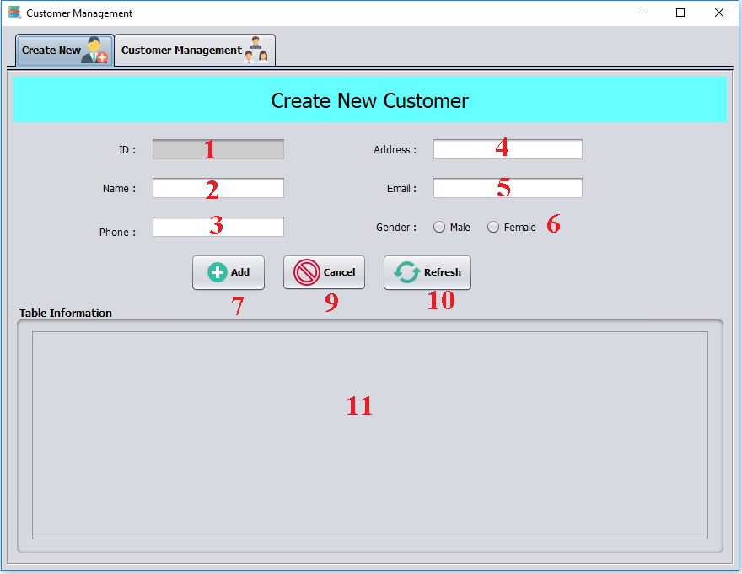

|  |  |  |  |  |  |  |
| --- | --- | --- | --- | --- | --- | --- |
| **No** | **Name** | **Type** | **Validation** | **Event** | **Description** | **Status** |
| 1 | txtCustomerID | JTextField |  |  | ID of Customer | **Disable** |
| 2 | txtCustomerName | JTextField | not blank |  | Name of Customer | **Enable** |
| 3 | txtPhone | JTextField | 11 Integer |  | Phone of Customer | **Enable** |
| 4 | txtAddress | JTextField |  |  | Address of Customer | **Enable** |
| 5 | txtEmail | JButton | Email format | Action Performed | Email of Customer | **Enable** |
| 6 | chkGender | JRadioButton |  |  | Gender of Customer | **Enable** |
| 7 | btnAdd | JButton |  | Action Performed | If input valid, SQL will add new Customer | **Enable** |
| 9 | btnCancel | JButton |  | Action Performed | Reset all testfield | **Enable** |
| 10 | btnRefresh | JButton |  | Action Performed | Refresh table Customer. | **Enable** |
| 11 | tableCustomer | JTable |  |  | Show Customer list |  |

* **Customer Management.**

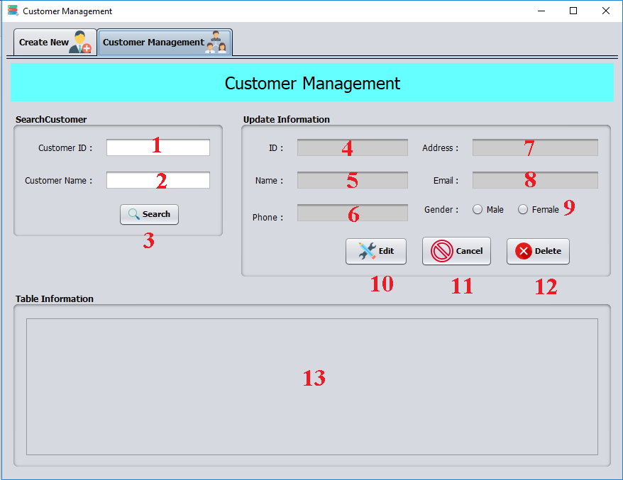

|  |  |  |  |  |  |  |
| --- | --- | --- | --- | --- | --- | --- |
| **No** | **Name** | **Type** | **Validation** | **Event** | **Description** | **Status** |
| 1 | txtCustomerID | JTextField |  |  | ID of Customer | **Disable** |
| 2 | txtCustomerName | JTextField |  |  | Name of Customer | **Enable** |
| 3 | btnSearch | JButton |  | Action Performed | If input valid, show table customer information | **Enable** |
| 4 | txtID | JTextField |  |  | table Customer list | **Disable** |
| 5 | txtName | JTextField | not blank |  | Name of Customer | **Disable** |
| 6 | txtPhone | JTextField | 11 Integer |  | Phone of Customer | **Disable** |
| 7 | txtAddress | JTextArea |  |  | Address of Customer | **Disable** |
| 8 | txtEmail | JTextField | Email format |  | Email of Customer | **Disable** |
| 9 | chkGender | JRadioButton |  |  | Gender of Customer | **Disable** |
| 10 | btnEdit | JButton |  | Action Performed | If input valid, system will update information of Customer | **Enable** |
| 11 | btnCancel | JButton |  | Action Performed | Reset all textfield | **Enable** |
| 12 | btnDelete | JButton |  | Action Performed | If input valid, system will delete customer | **Enable** |
| 13 | tableCustomer | JTable |  |  | Show customers list with information |  |

* **Search Products**

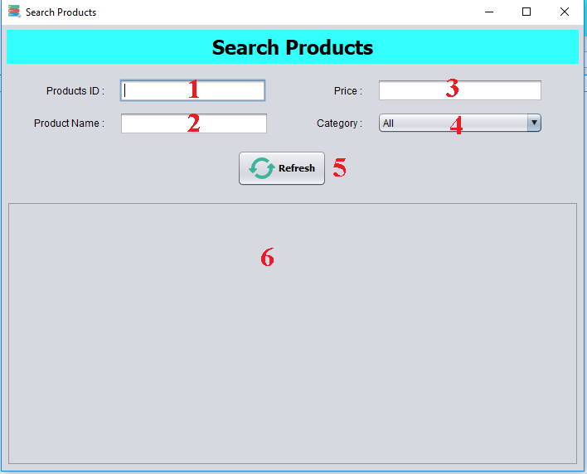

|  |  |  |  |  |  |  |
| --- | --- | --- | --- | --- | --- | --- |
| **No** | **Name** | **Type** | **Validation** | **Event** | **Description** | **Status** |
| 1 | txtProductID | JTextField | not blank |  | ID of Product | **Disable** |
| 2 | txtProductName | JTextField | not blank |  | Name of Product | **Enable** |
| 3 | txtPrice | JTextField | Price>0 |  | Price of Product | **Enable** |
| 4 | cbbCategory | JComboBox |  |  | Category of Product | **Enable** |
| 5 | btnRefresh | JButton |  | Action Performed | If input valid, show table product list | **Enable** |
| 6 | tableProduct | JTable |  |  | Table Product list | **Enable** |

1. **Manager**

* **Create New Sale.**

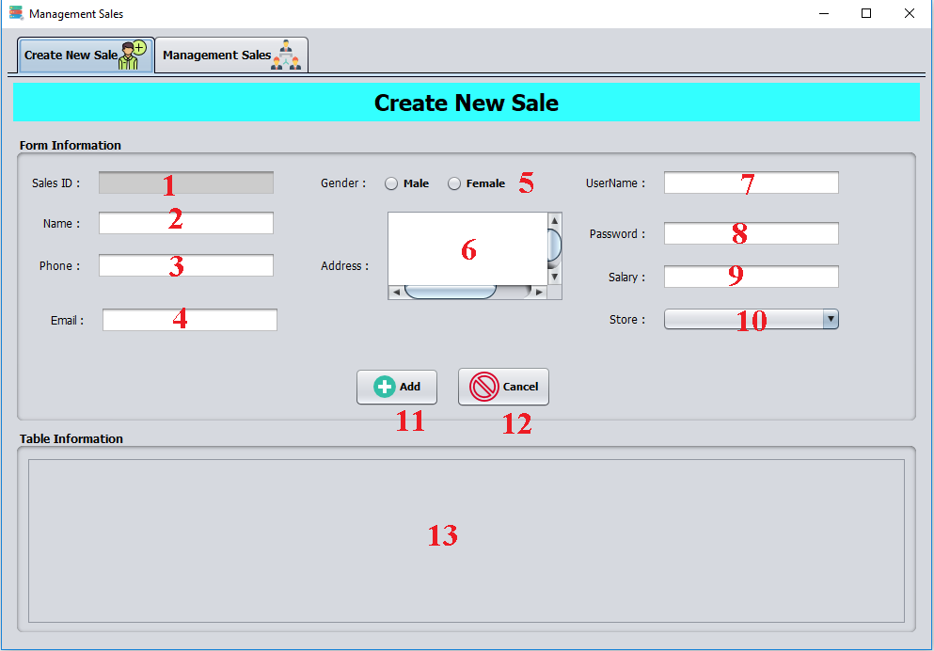

|  |  |  |  |  |  |  |
| --- | --- | --- | --- | --- | --- | --- |
| **No** | **Name** | **Type** | **Validation** | **Event** | **Description** | **Status** |
| 1 | txtID | JTextField | not blank |  | ID of Sales | **Disable** |
| 2 | txtName | JTextField | not blank |  | Name of Sales | **Enable** |
| 3 | txtPhone | JTextField | 11 integer |  | Phone of Sales | **Enable** |
| 4 | txtEmail | JTextField | Email format |  | Email of Sales | **Enable** |
| 5 | chkGender | JRadioButton |  |  | Gender of Sales | **Enable** |
| 6 | txtAddress | JTextArea |  |  | Address of Sales | **Enable** |
| 7 | txtUserName | JTextField | not blank |  | Username of Sales | **Enable** |
| 8 | txtPassword | JPasswordField | not blank |  | Password of Sales | **Enable** |
| 9 | txtSalary | JTextField | Integer |  | Salary of Sales | **Enable** |
| 10 | cbbStores | JComboBox |  |  | Store of Sales | **Enable** |
| 11 | btnAdd | JButton |  | Action Performed | If input valid, system will add new sales account | **Enable** |
| 12 | btnCancel | JButton |  | Action Performed | Reset all textfield | **Enable** |
| 13 | tableSales | JTable |  |  | Show Sales list with information |  |

* **Management Sales.**

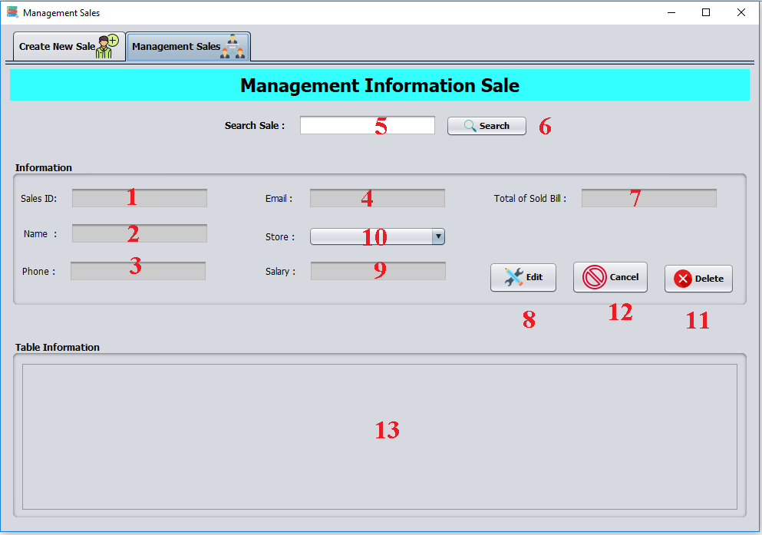

|  |  |  |  |  |  |  |
| --- | --- | --- | --- | --- | --- | --- |
| **No** | **Name** | **Type** | **Validation** | **Event** | **Description** | **Status** |
| 1 | txtID | JTextField | not blank |  | ID of Sales | **Disable** |
| 2 | txtName | JTextField | not blank |  | Name of Sales | **Disable** |
| 3 | txtPhone | JTextField | not blank |  | Phone of Sales | **Disable** |
| 4 | txtEmail | JTextField | Email format |  | Email of Sales | **Disable** |
| 5 | txtNameSearch | JTextField |  |  | Name of Sales | **Disable** |
| 6 | btnSearch | btnSearch |  | Action Performed | Search sales information by name | **Enable** |
| 7 | txtTotalSold | JTextField |  |  |  | **Disable** |
| 8 | btnEdit | JButton |  | Action Performed | If input valid, system will update sales account | **Enable** |
| 9 | txtSalary | JTextField |  |  | Salary of Sales | **Disable** |
| 10 | cbbStores | JComboBox |  |  | Store of Sales | **Disable** |
| 11 | btnDelete | JButton |  | Action Performed | If input valid, system will delete sales account | **Enable** |
| 12 | btnCancel | JButton |  | Action Performed | Reset all textfield | **Enable** |
| 13 | tableSales | JTable |  |  | Show Sales list with information |  |

* **View Bill.**

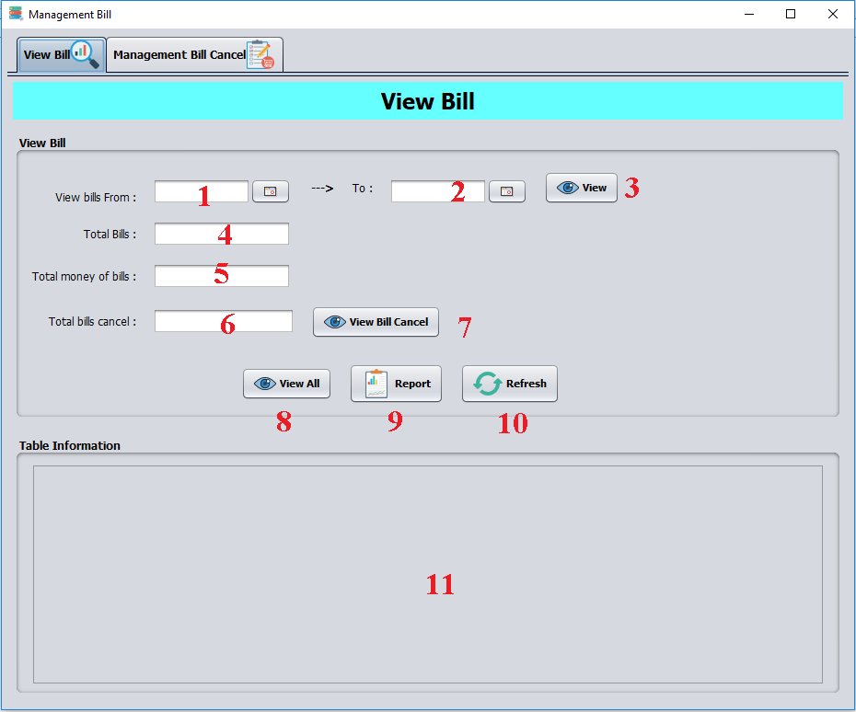

|  |  |  |  |  |  |  |
| --- | --- | --- | --- | --- | --- | --- |
| **No** | **Name** | **Type** | **Validation** | **Event** | **Description** | **Status** |
| 1 | txtDateFrom | JTextField | DD/M/YY |  | input date for search | **Enable** |
| 2 | txtDateTo | JTextField | DD/M/YY |  | input date for search | **Enable** |
| 3 | btnView | JButton |  | Action Performed | View Bill by date | **Enable** |
| 4 | txtTotalBill | JTextField |  |  | Total Bills | **Disable** |
| 5 | txtTotalBillM | JTextField |  |  | Total money of Bills | **Disable** |
| 6 | txtTotalBillC | JTextField |  |  | Total Bills Canceled | **Disable** |
| 7 | btnViewCancel | JButton |  | Action Performed | View Bills Canceled list | **Enable** |
| 8 | btnViewAll | JButton |  | Action Performed | Show information of bill | **Enable** |
| 9 | btnReport | JButton |  | Action Performed | Generate report | **Enable** |
| 10 | btnRefresh | JButton |  | Action Performed | Refresh table bills | **Enable** |
| 11 | tableBills | JTable |  |  | Show information of bill |  |

* **Management Bills.**

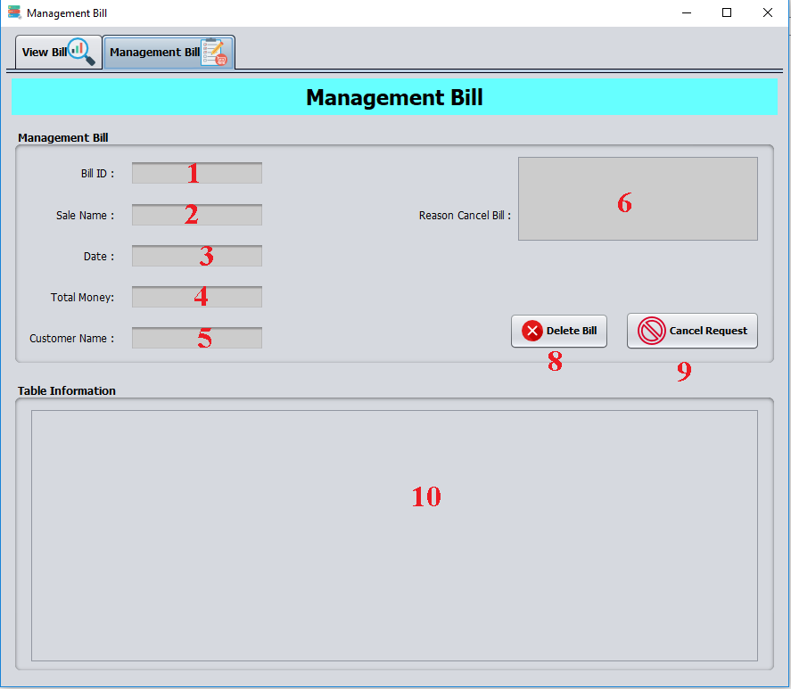

|  |  |  |  |  |  |  |
| --- | --- | --- | --- | --- | --- | --- |
| **No** | **Name** | **Type** | **Validation** | **Event** | **Description** | **Status** |
| 1 | txtBillID | JTextField |  |  | ID of Bill | **Disable** |
| 2 | txtSaleName | JTextField |  |  | Name of Sales | **Disable** |
| 3 | txtDate | JTextField |  |  | Date of Bill | **Disable** |
| 4 | txtTotalMoney | JTextField |  |  | Total money | **Disable** |
| 5 | txtCustomerName | JTextField |  |  | Name of Customer | **Disable** |
| 6 | txtReason | JTextField |  |  | Reason why sales delete a bills | **Disable** |
| 8 | btnDelete | JButton |  | Action Performed | Delete Bill by ID | **Enable** |
| 9 | btnCancel | JButton |  | Action Performed | Reset all textfield | **Enable** |
| 10 | tableBill |  |  |  |  |  |

* **Send Mail.**

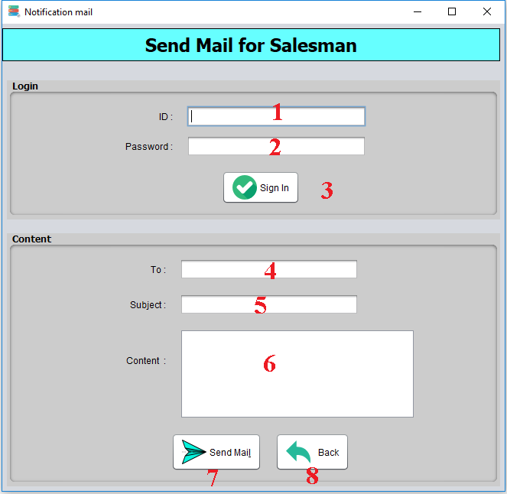

|  |  |  |  |  |  |  |
| --- | --- | --- | --- | --- | --- | --- |
| **No** | **Name** | **Type** | **Validation** | **Event** | **Description** | **Status** |
| 1 | txtID | JTextField | not blank |  | ID of mail | **Enable** |
| 2 | txtPassword | JPasswordField | not blank |  | Password of mail | **Enable** |
| 3 | btnSignIn | JButton |  | Action Performed | Sign in for mail | **Enable** |
| 4 | txtTo | JTextField | not blank |  | Who receive mail | **Enable** |
| 5 | txtSubject | JTextField |  |  | Subject of mail | **Enable** |
| 6 | txtContent | JTextField |  |  | Content of mail | **Enable** |
| 7 | btnSend | JButton |  | Action Performed | Send mail. | **Enable** |
| 8 | btnBack | JButton |  | Action Performed | Back to system | **Enable** |

1. **Director.**

* **Management Stores.**

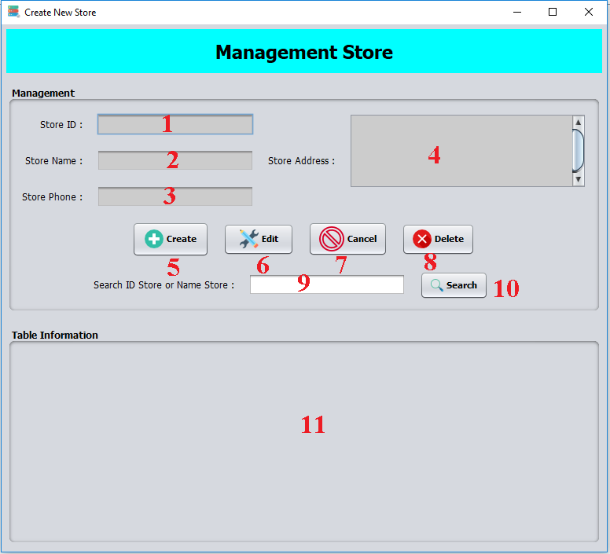

|  |  |  |  |  |  |  |
| --- | --- | --- | --- | --- | --- | --- |
| **No** | **Name** | **Type** | **Validation** | **Event** | **Description** | **Status** |
| 1 | txtID | JTextField |  |  | ID of Store | **Diable** |
| 2 | txtName | JTextField | not blank |  | Name of Store | **Diable** |
| 3 | txtPhone | JTextField | 11 interger |  | Phone of Store | **Diable** |
| 4 | txtAddress | JTextArea | not blank |  | Address of Store | **Diable** |
| 5 | btnAdd | JButton |  | Action Performed | If input valid, system will add new store | **Enable** |
| 6 | btnEdit | JButton |  | Action Performed | If input valid, system will edit store | **Enable** |
| 7 | btnCancel | JButton |  | Action Performed | Reset all textfield | **Enable** |
| 8 | btnDelete | JButton |  | Action Performed | If input valid, system will delete store | **Enable** |
| 9 | txtSearch | JTextField |  |  | Search by name or id of Store | **Enable** |
| 10 | btnSearch | JButton |  | Action Performed | Search by name or id of Store | **Enable** |
| 11 | tableStore |  |  |  | Show Store list with information |  |

* **Create Manager.**

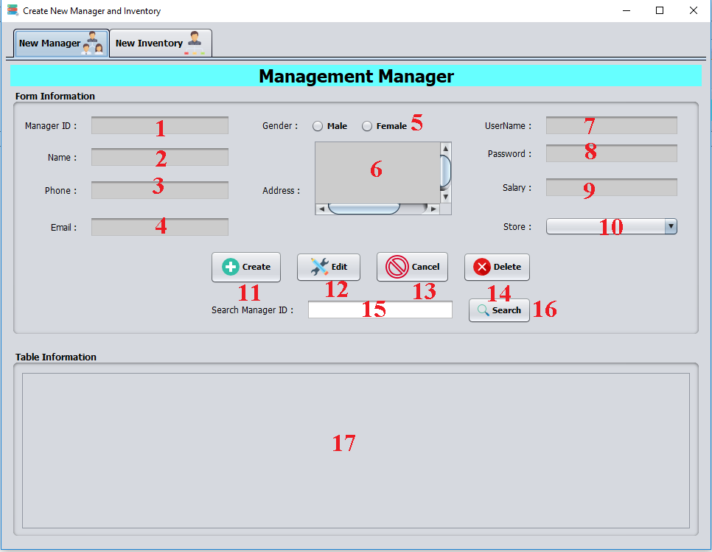

|  |  |  |  |  |  |  |
| --- | --- | --- | --- | --- | --- | --- |
| **No** | **Name** | **Type** | **Validation** | **Event** | **Description** | **Status** |
| 1 | txtID | JTextField | not blank |  | ID of Manager | **Disable** |
| 2 | txtName | JTextField | not blank |  | Name of Manager | **Disable** |
| 3 | txtPhone | JTextField | 11 integer |  | Phone of Manager | **Disable** |
| 4 | txtEmail | JTextField | Email format |  | Email of Manager | **Disable** |
| 5 | chkGender | JRadioButton |  |  | Gender of Manager | **Disable** |
| 6 | txtAddress | JTextArea |  |  | Address of Manager | **Disable** |
| 7 | txtUserName | JTextField | not blank |  | Username of Manager | **Disable** |
| 8 | txtPassword | JPasswordField | not blank |  | Password of Manager | **Disable** |
| 9 | txtSalary | JTextField | integer |  | Salary of Manager | **Disable** |
| 10 | cbbStores | JComboBox |  |  | Store of Manager | **Disable** |
| 11 | btnAdd | JButton |  | Action Performed | If input valid, system will add new Manager account | **Enable** |
| 12 | btnEdit | JButton |  | Action Performed | If input valid, system will add new Manager account | **Enable** |
| 13 | btnCancel | JButton |  | Action Performed | Reset all textfield | **Enable** |
| 14 | btnDelete | JButton |  | Action Performed | Delete a Manager by ID | **Enable** |
| 15 | txtSearch | JTextField |  |  | Search Manager by Name | **Enable** |
| 16 | btnSearch | JButton |  | Action Performed | Search Manager by Name | **Enable** |
| 17 | tableManager | JTable |  |  | Show Managers list with information |  |

* **Create Inventory.**

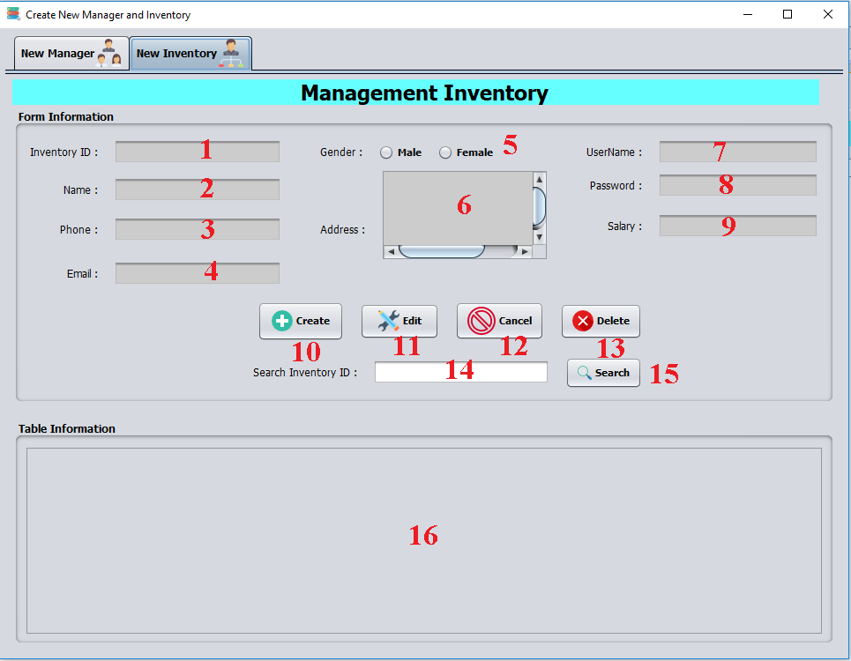

|  |  |  |  |  |  |  |
| --- | --- | --- | --- | --- | --- | --- |
| **No** | **Name** | **Type** | **Validation** | **Event** | **Description** | **Status** |
| 1 | txtID | JTextField | not blank |  | ID of Invetory | **Disable** |
| 2 | txtName | JTextField | not blank |  | Name of Invetory | **Disable** |
| 3 | txtPhone | JTextField | 11 integer |  | Phone of Invetory | **Disable** |
| 4 | txtEmail | JTextField | Email format |  | Email of Invetory | **Disable** |
| 5 | chkGender | JRadioButton |  |  | Gender of Invetory | **Disable** |
| 6 | txtAddress | JTextArea |  |  | Address of Invetory | **Disable** |
| 7 | txtUserName | JTextField | not blank |  | Username of Invetory | **Disable** |
| 8 | txtPassword | JPasswordField | not blank |  | Password of Invetory | **Disable** |
| 9 | txtSalary | JTextField | integer |  | Salary of Invetory | **Disable** |
| 10 | btnAdd | JButton |  | Action Performed | If input valid, system will add new Invetory account | **Enable** |
| 11 | btnEdit | JButton |  | Action Performed | If input valid, system will add new Invetory account | **Enable** |
| 12 | btnCancel | JButton |  | Action Performed | Reset all textfield | **Enable** |
| 13 | btnDelete | JButton |  | Action Performed | Delete a Invetory by ID | **Enable** |
| 14 | txtSearch | JTextField |  |  | Search Invetory by Name | **Enable** |
| 15 | btnSearch | JButton |  | Action Performed | Search Invetory by Name | **Enable** |
| 16 | table Invetory | JTable |  |  | Show Managers list with information |  |

**Review 3 – Task Sheet**

|  |  |  |  |  |  |  |
| --- | --- | --- | --- | --- | --- | --- |
| **Project Ref. No:** | | **Project Title** | **Date of Preparation of Activity Plan** | | | |
| **Sr.**  **No.** | **Task** | **Actual Start Date** | **Actual Days** | **Team Member Name** | **Status** |
| 1 | Database design | Perfume Store Management System | 01/02/2018 | 7 | Hoàng Minh Tuấn | Completed |
| Nguyễn Quang Trung |
| Lê Tuấn Vũ |
| 01/02/2018 | 7 | Nguyễn Khánh Long | Completed |
| 2 | GUI design |

Activity Plan Prepare By : Group 2 February 7nd, 2018

**Group Leader Faculty**

*Lê Tuấn Vũ Trần Phước Sinh*