|  |  |
| --- | --- |
| Class & Module | IAW301  Lab 3: Command Execution Basic Testing |
| Name | Nguyen Duc Kien |
| IC No. | He141763 |
| Date & Time | 8.25AM 17/09/2020 |

**Exercise 1. Low Security**

Command: 192.168.234.133; pwd

Print working directory

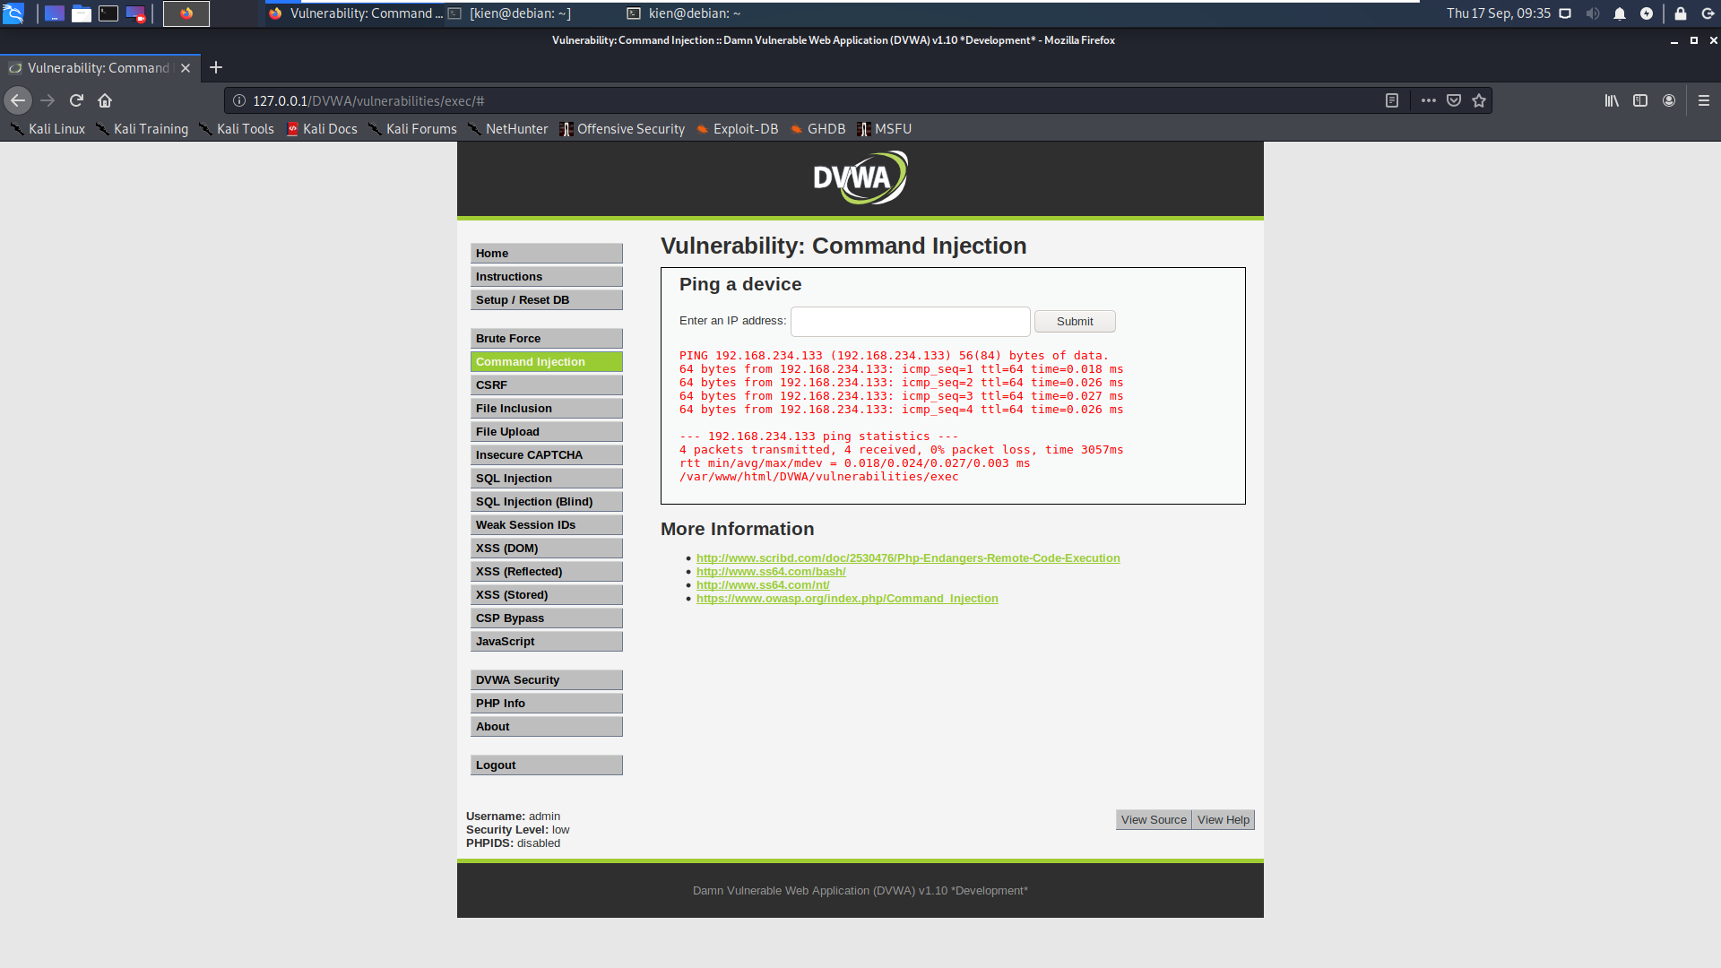

**Exercise 2. Medium security**

Command: 192.168.234.133; pwd

In medium: && and ; are excluded. However can use | as a replacement, for more info use ||

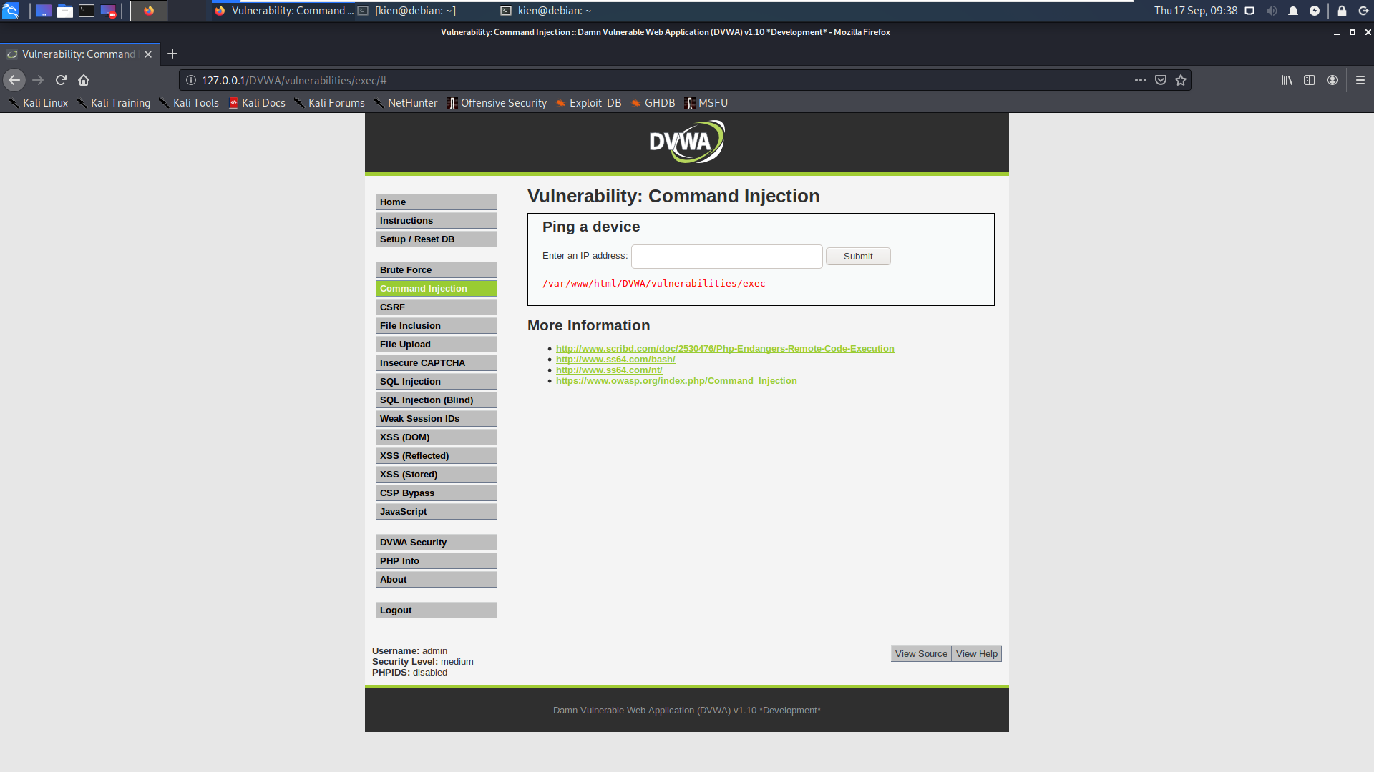

When using ||

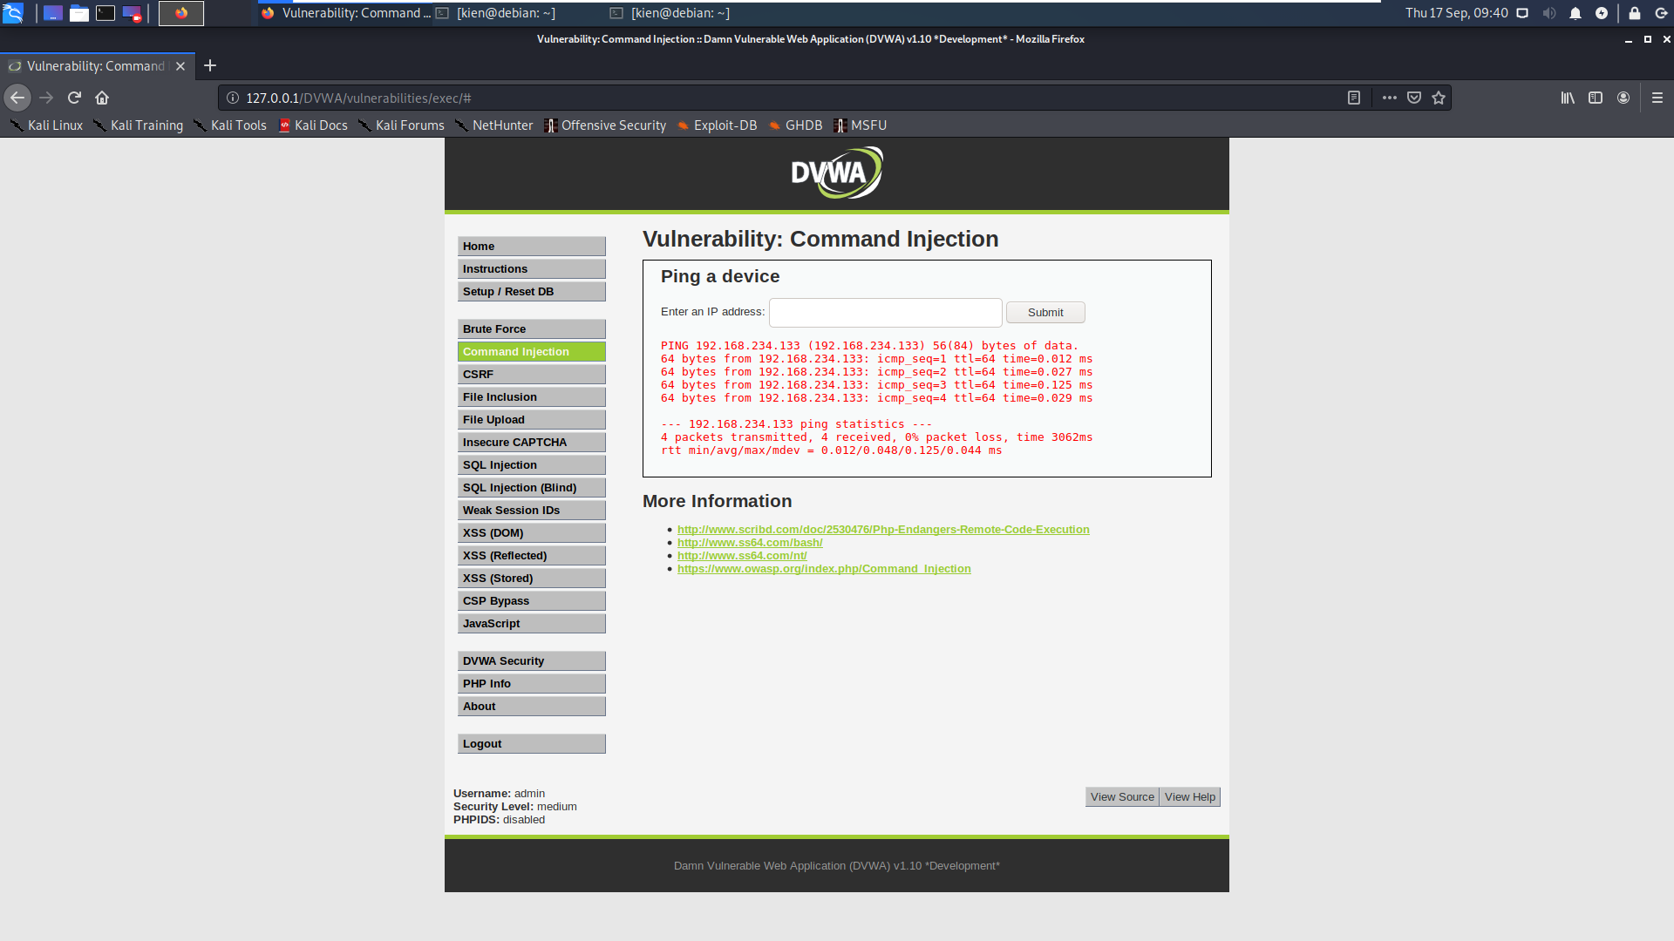

**Exercise 3. High security**

Command: 192.168.234.133|| pwd

