|  |  |
| --- | --- |
| Class & Module | IAW301  Lab 9: Unrestricted File Upload |
| Name | Nguyen Duc Kien |
| IC No. | HE141763 |
| Date & Time | 10.56AM October 1, 2020 |

**1.1 Low Security**

Screenshot 1:

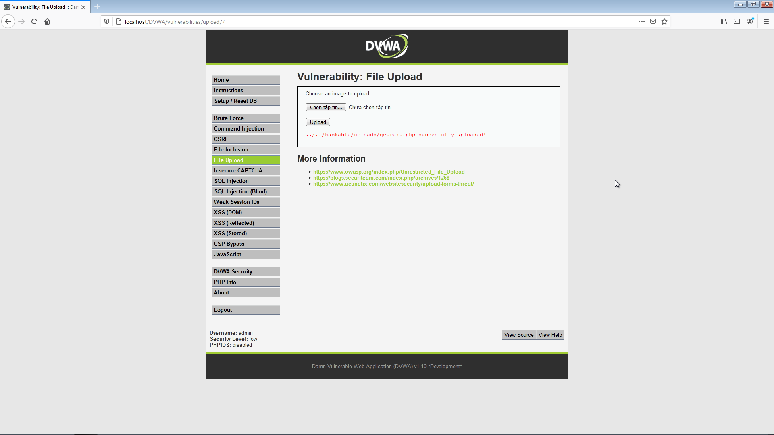

Screenshot 2:

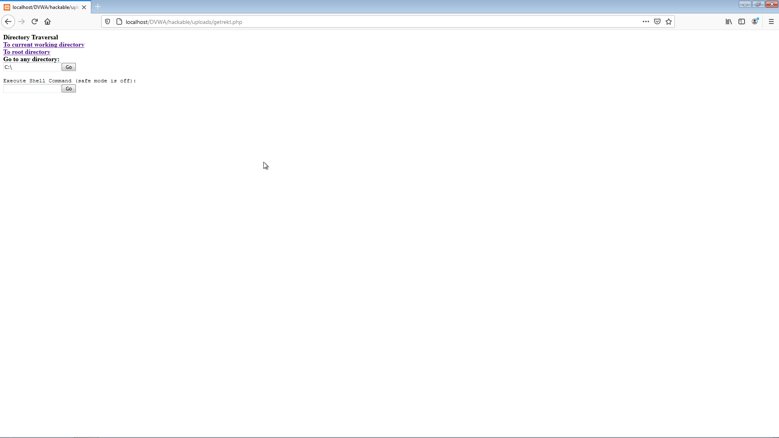

**1.2 Security: Medium**

Screenshot 1:

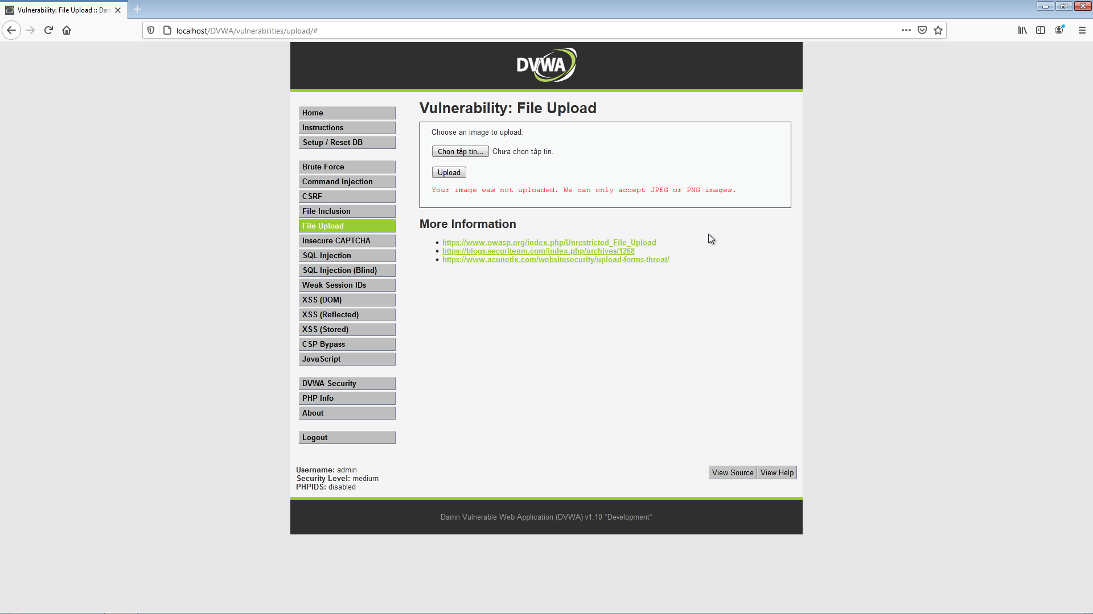

In medium security level, we can no longer upload ‘”.php” file, instead we have to upload “.jpeg” file. However, we can cheat this step using BurpSuite

Screenshot 2: Using BurpSuite to catch the post method

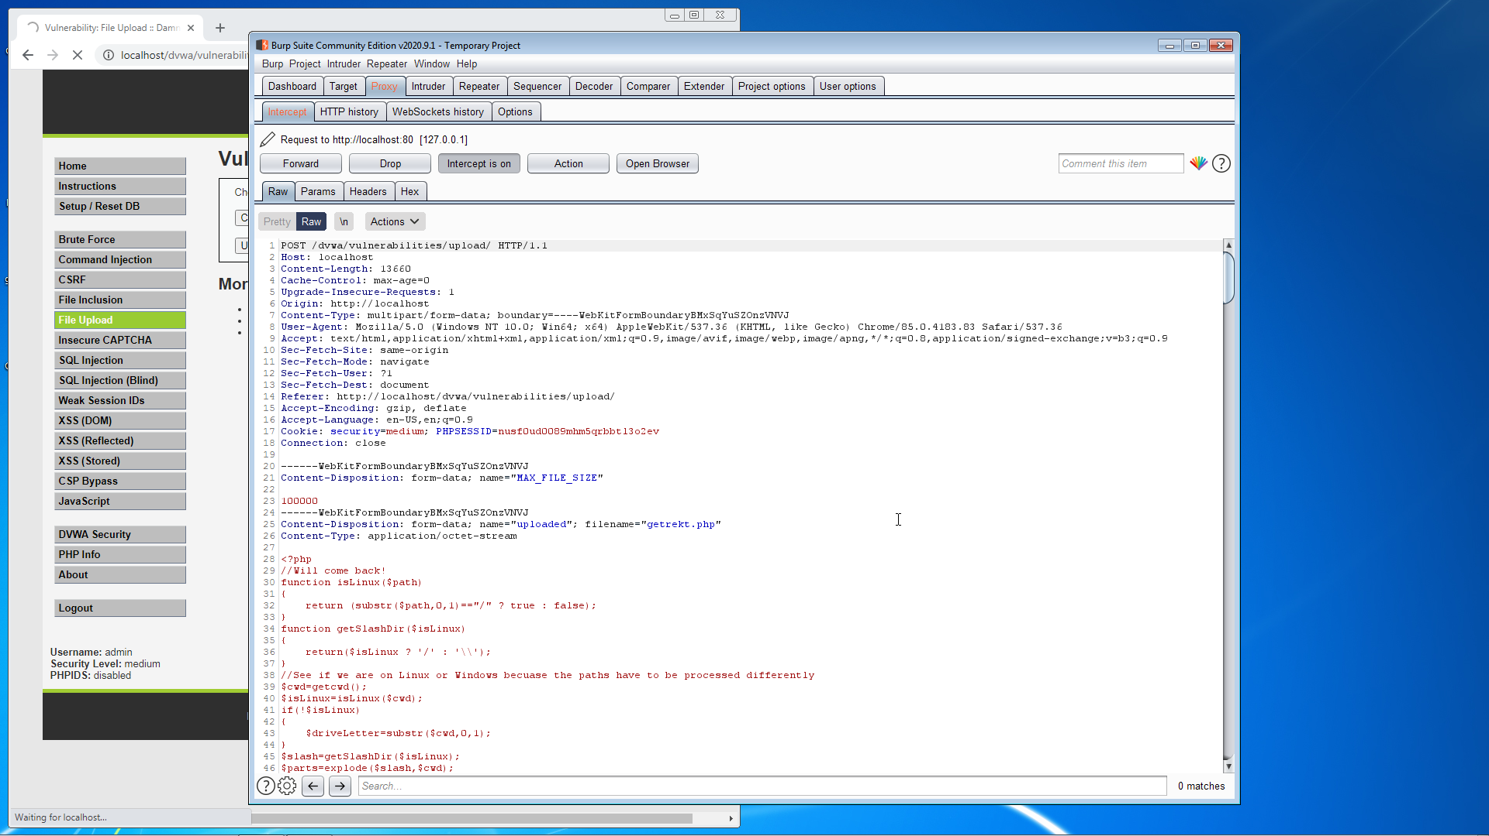

Screenshot 3: After editing things we forward the direction of the post method

(Change Content-Type to image/jpeg)

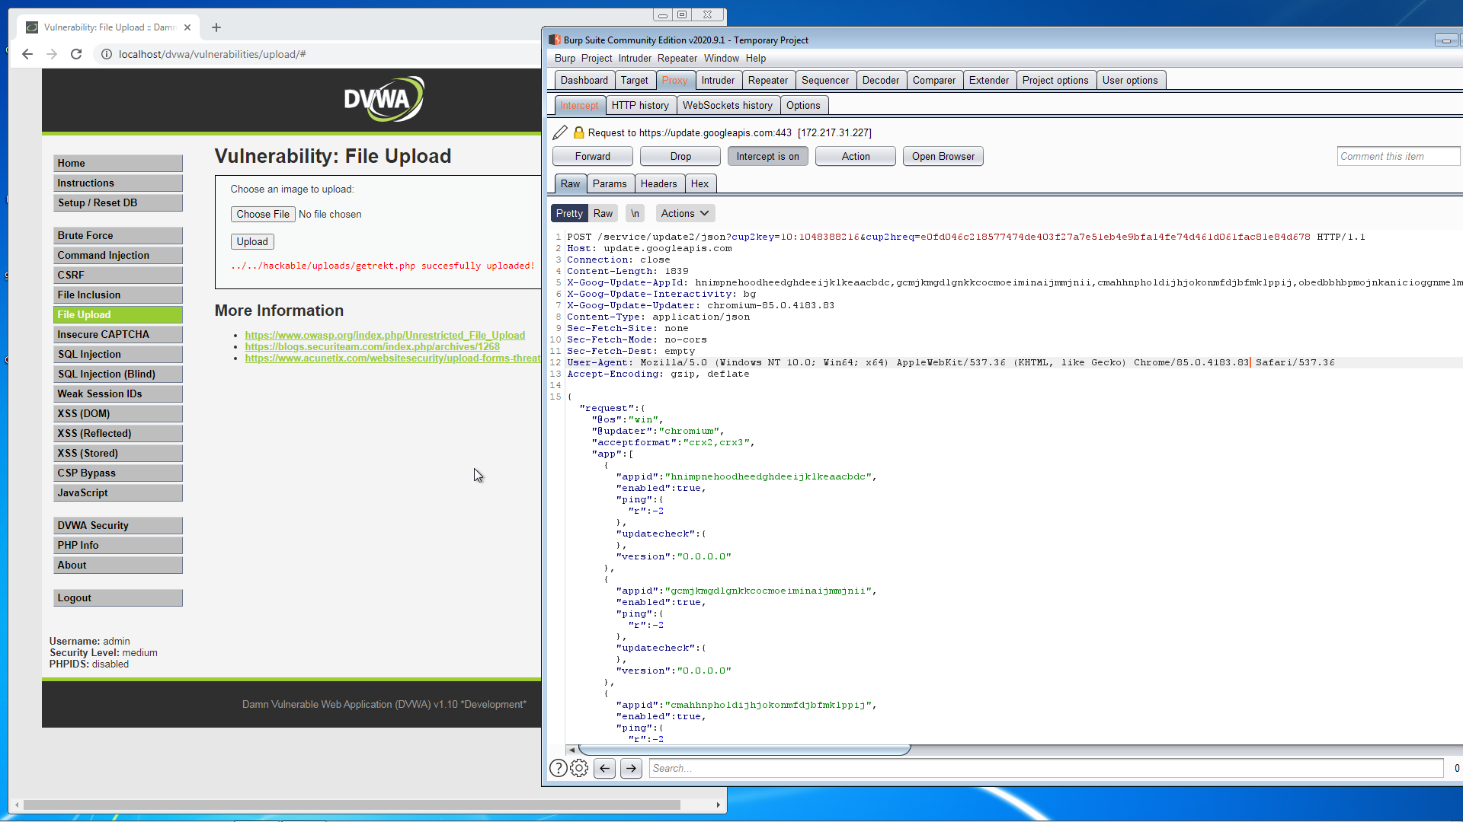

Cheated successfully, we have the result when forwarding the link

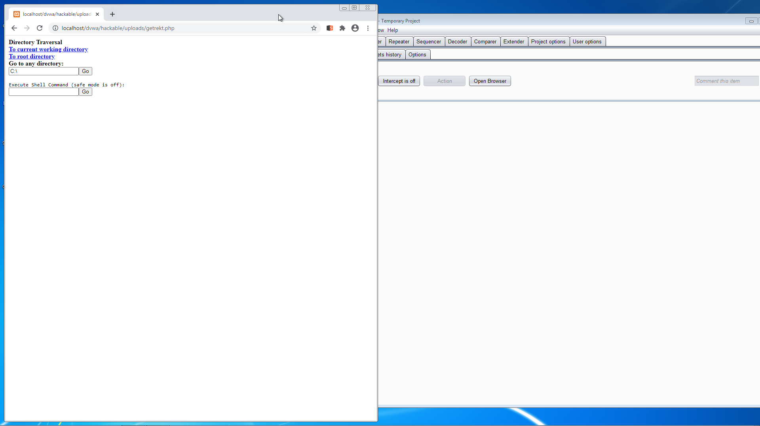

**1.3 Security: High**

Screenshot 1: in high security, we can no longer cheat the same way as medium. However, take a look at cookie, replace high security with low, and we can easily upload file to the database, check again in dvwa security, the secure level is still set to high 🡪 high level security passed

