|  |  |
| --- | --- |
| Class & Module | IAW301  Lab 13: CTF sql injection |
| Name | Nguyễn Đức Kiên |
| IC No. | HE141763 |
| Date & Time | October 13, 2020 |

#### Exercise 1.1 Login portal 1

Query used: use “admin’ or ‘2’ > ‘1” because the “=” operator is filtered and we have the flag

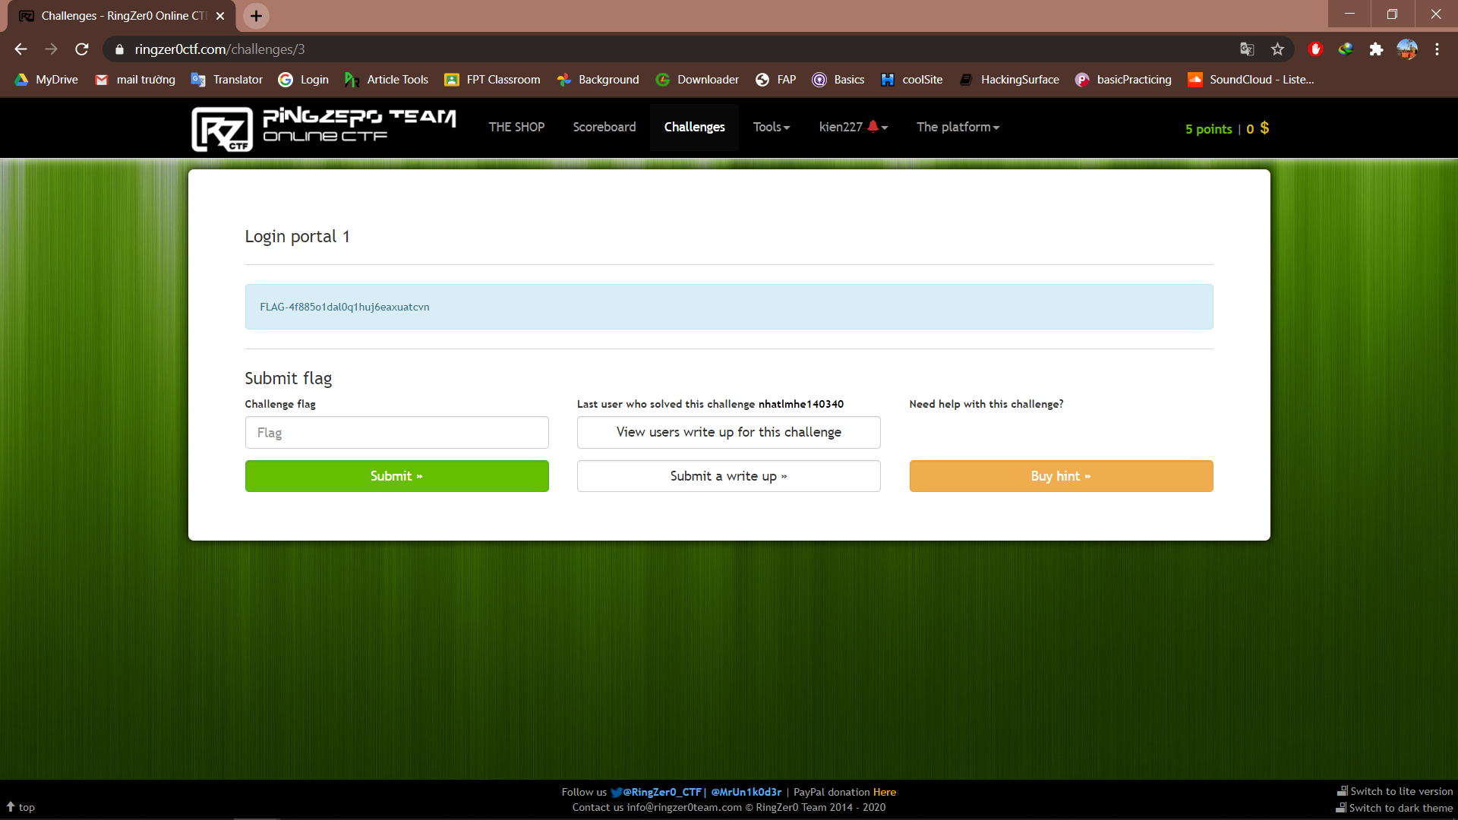

**Exercise 1.2 ACL rulezzz the world**

Step 1: inspect the page we have

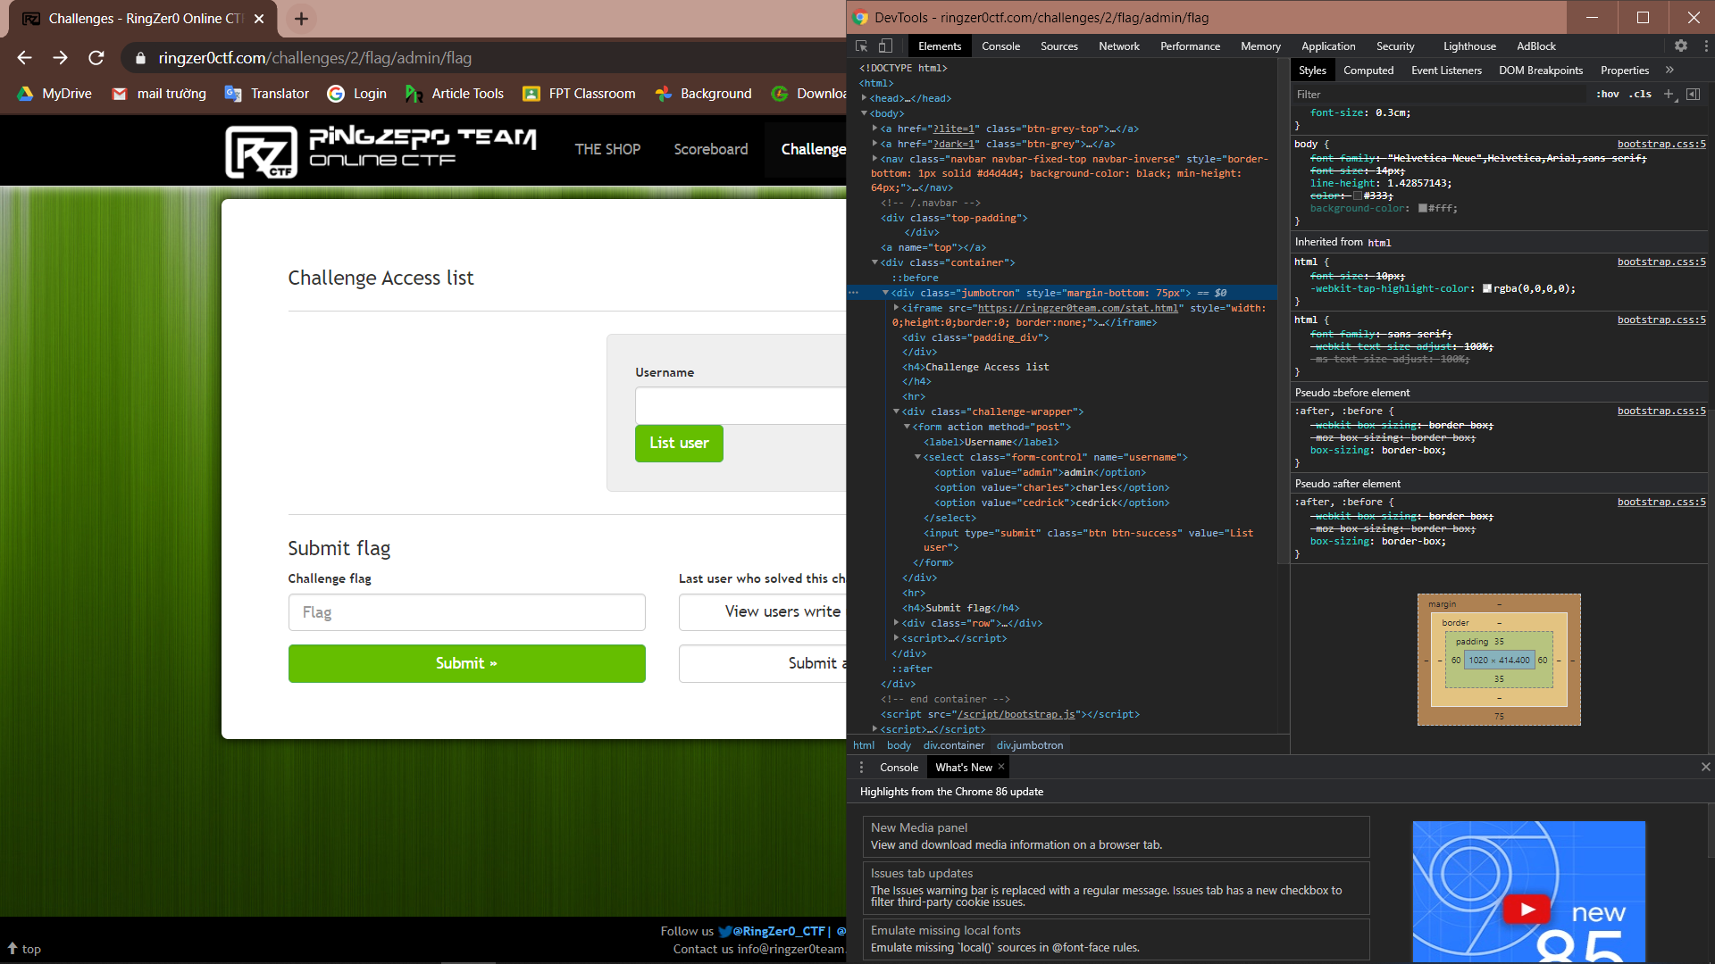

Step 2: change the value of admin to “admin’ or ‘2’ > ‘1” and press list user to forward the request, we have:

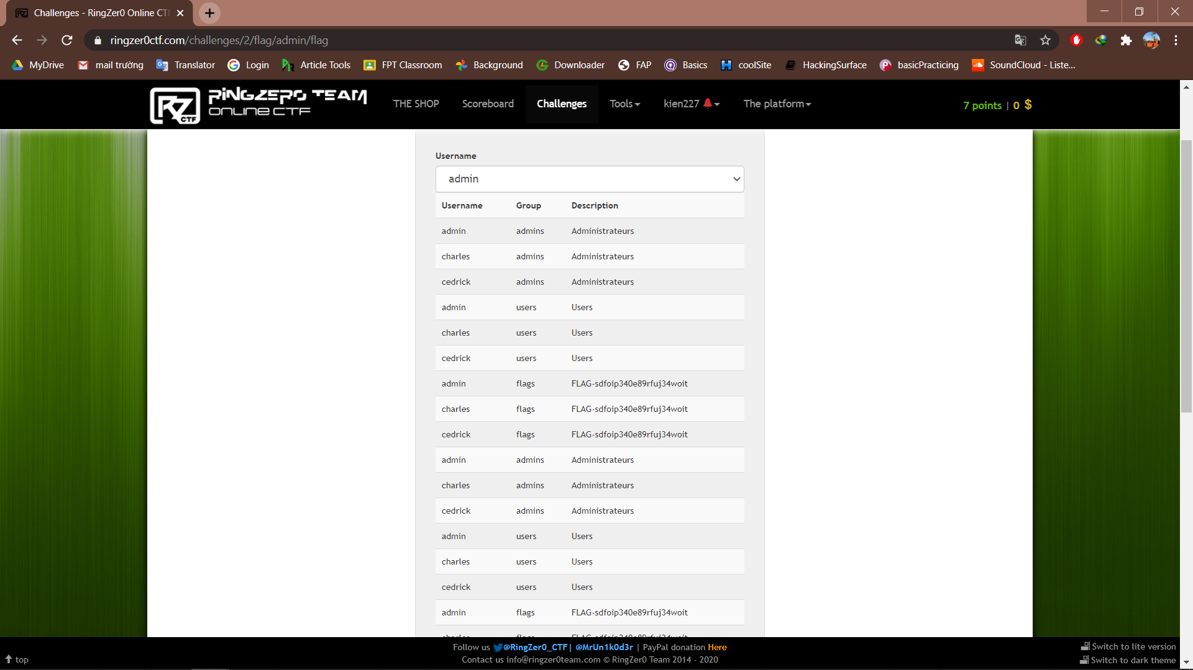

**Exercise 1.3 Login portal 2**

The key to solve this problem is the sha hash function, understanding how it works we use the input

impossibletoguess' UNION SELECT 1, sha1 (1) # and password “1”

after inputting this we have:

