|  |  |
| --- | --- |
| Class & Module | IAW301  Lab 17: DOM Based Cross Site Scripting |
| Name | Nguyễn Đức Kiên |
| IC No. | HE141763 |
| Date & Time | October 20, 2020 |

#### Exercise 1.1 Low Security

Script used: <script>alert(1)</script>

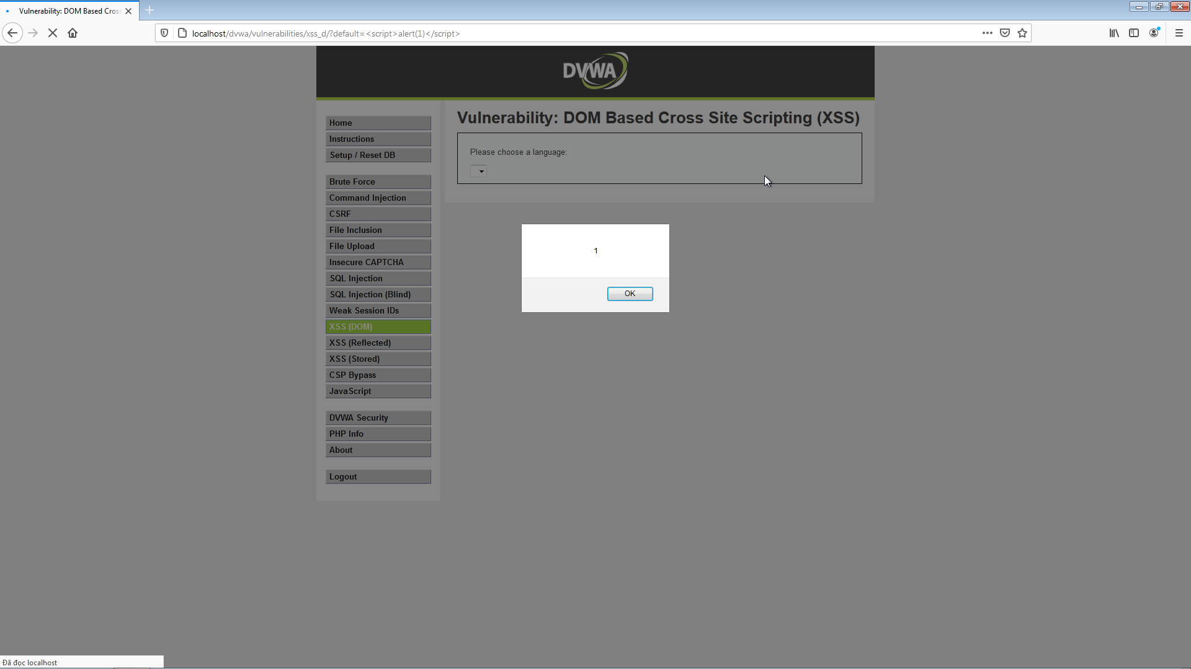

**Exercise 1.2 Medium Security**

Script used: <</select><img src = “#” onclick = alert(1)>

By clicking on the image, we get the alert we want. Note that the </select> tag is supposed to close the language choosing, so we use this as a entrance for further injection.

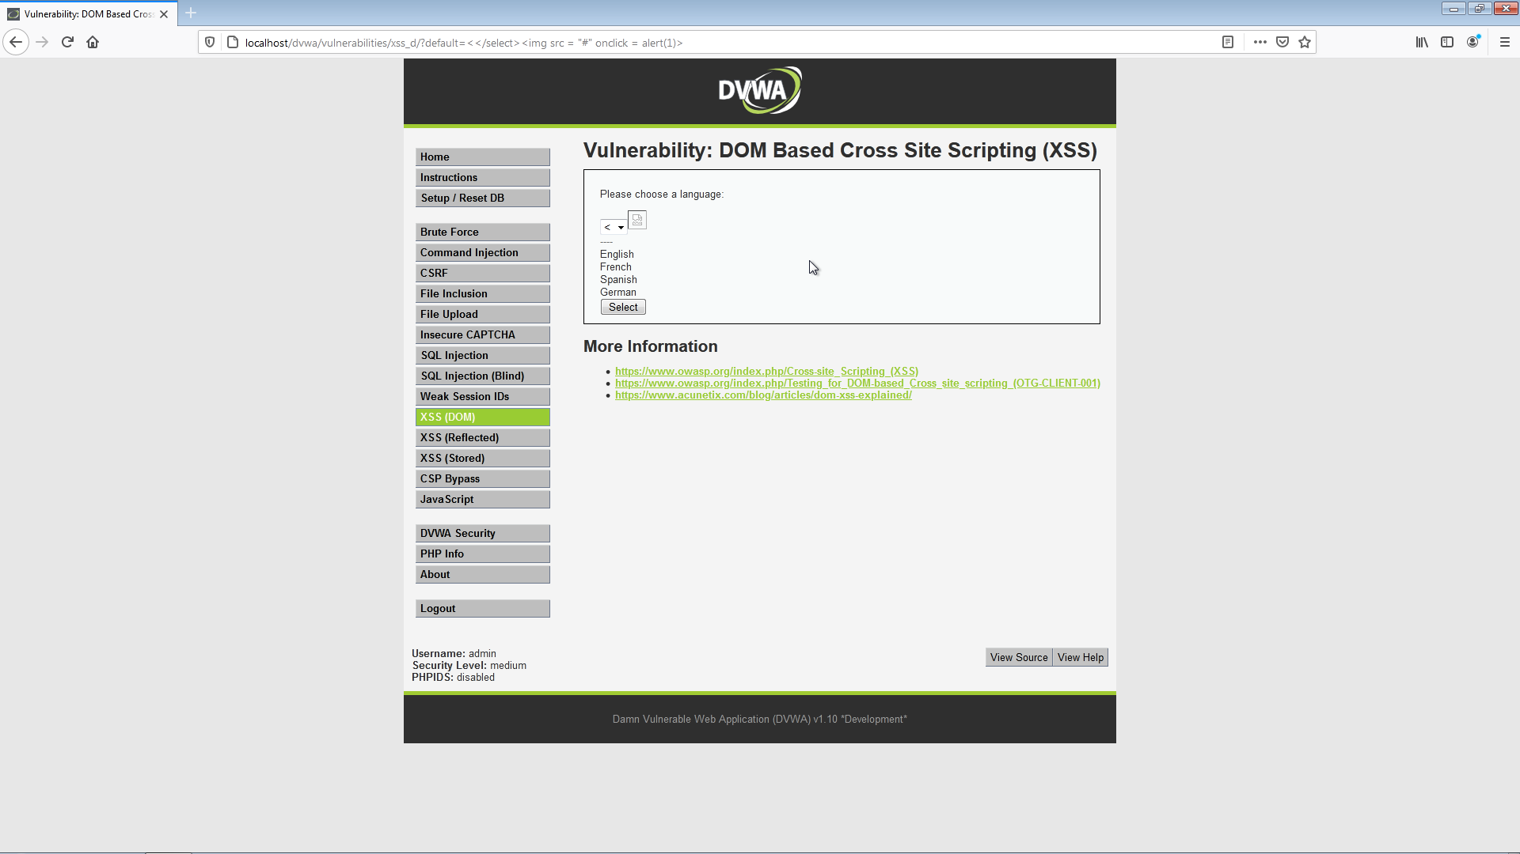

**Exercise 1.3 High Security**

First we try adding the &test after the url, noticed that the option for combo box has changed.

Script to use: <script>alert(1)</script> add this after the original url, notify that the “&” must be included first.

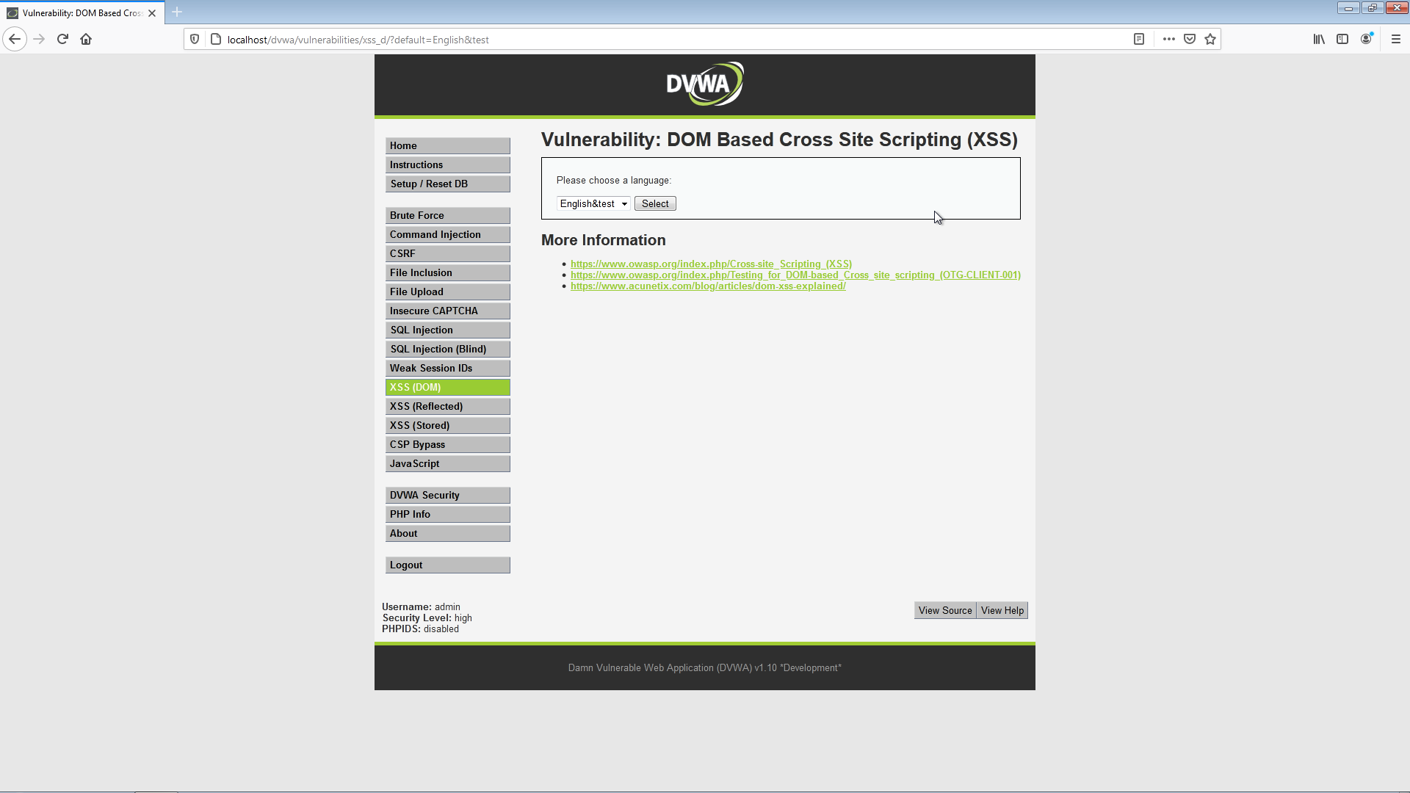

Script to use: <script>alert(1)</script> add this after the original url, notify that the “&” must be included first.

