|  |  |
| --- | --- |
| Class & Module | IAW301  Lab 20: RingZer0 CTF Challenge |
| Name | Nguyễn Đức Kiên |
| IC No. | HE141763 |
| Date & Time | October 27, 2020 |

#### Exercise 1.1 Words mean something

#### 

As can be seen we can’t translate or do anything with the text given, turn on dev tool which is already configured in browser.

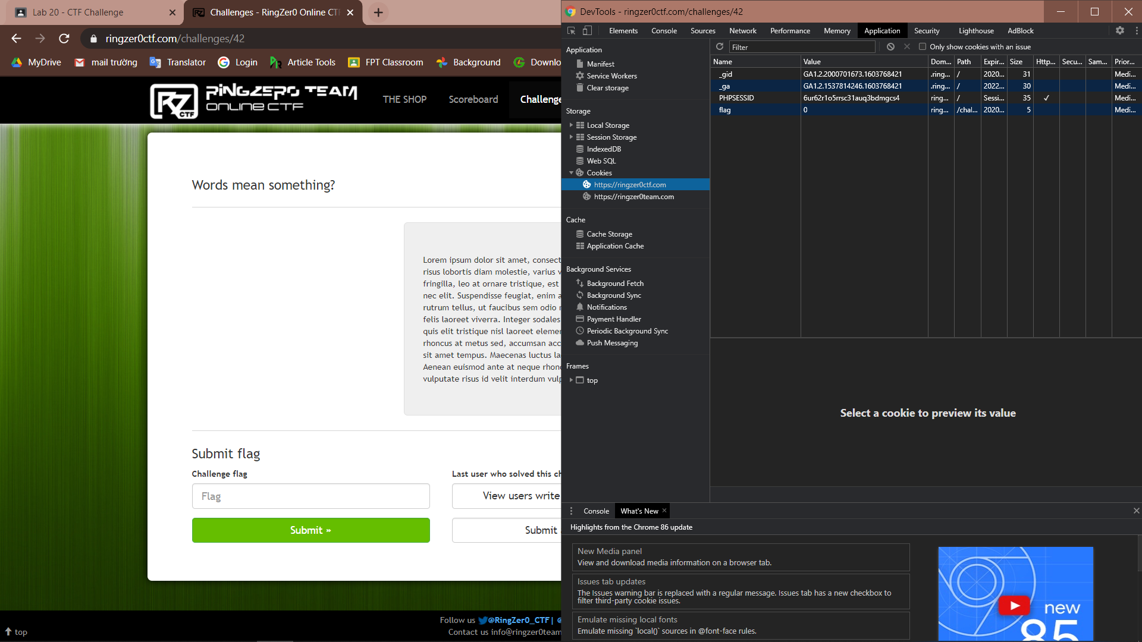

In the application tab, choose our site, noticed the flag element value is set to 0, right click and edit it to 1, refresh the page we have the flag.

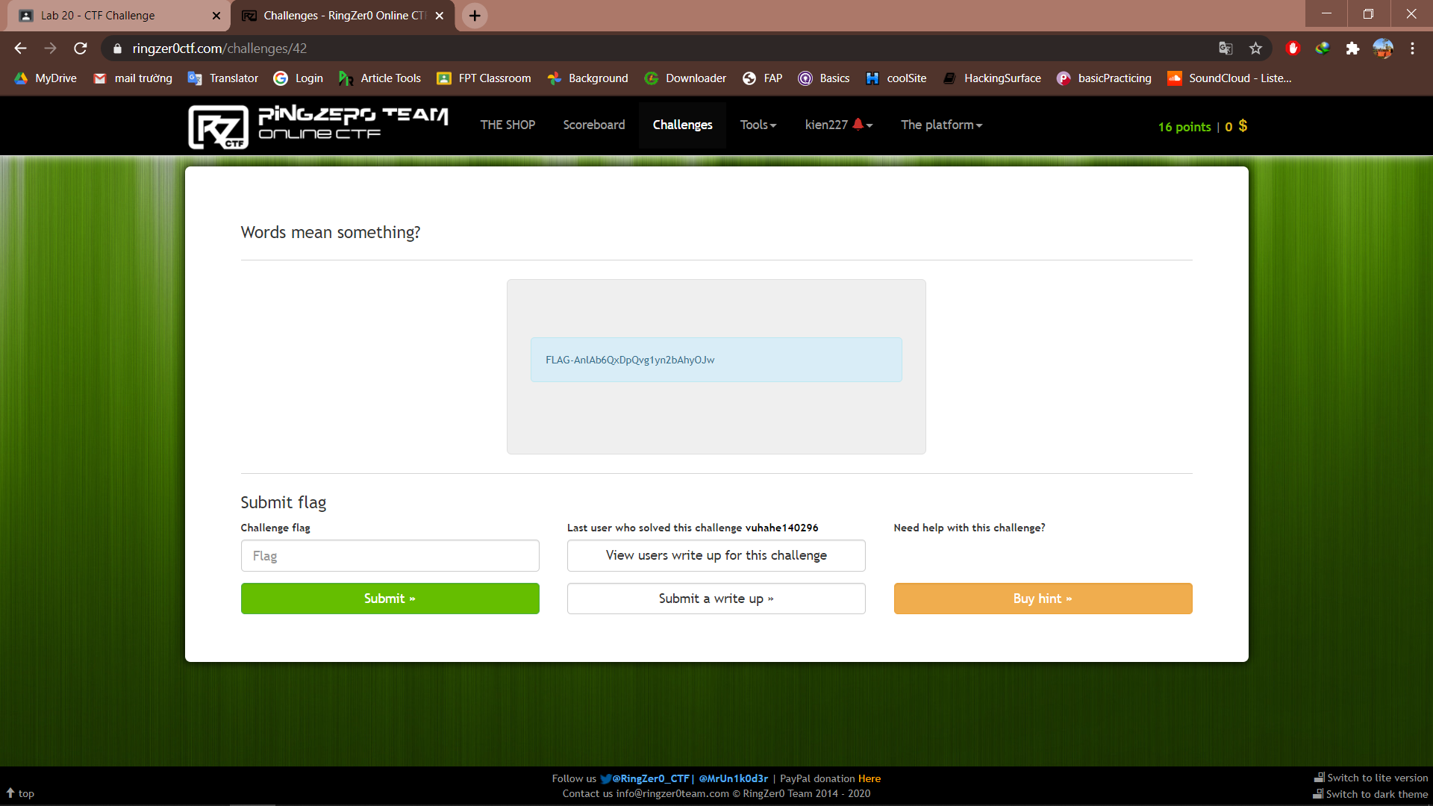

**Exercise 1.2 Big Brother is watching**

In the picture we can see the hint “even Google cannot find this one”, we can start by fowarding our site to robots.txt

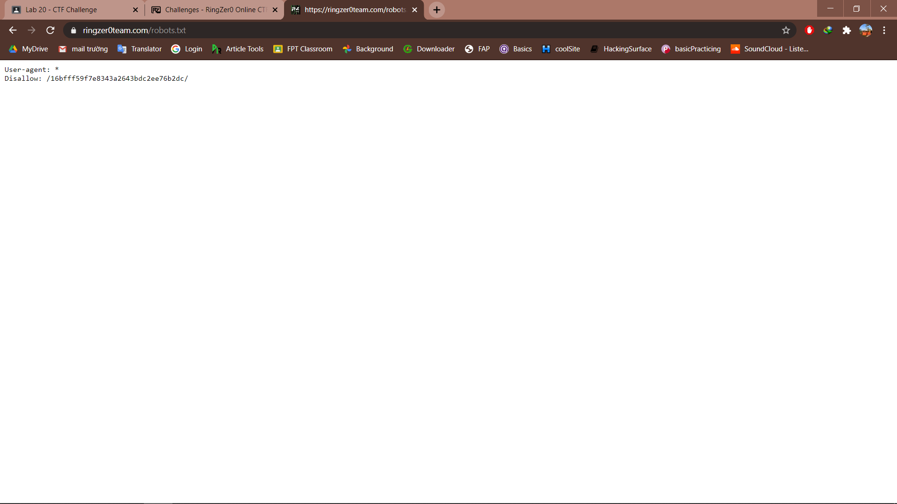

We can see something like part of an url, copy and forward to the link we have

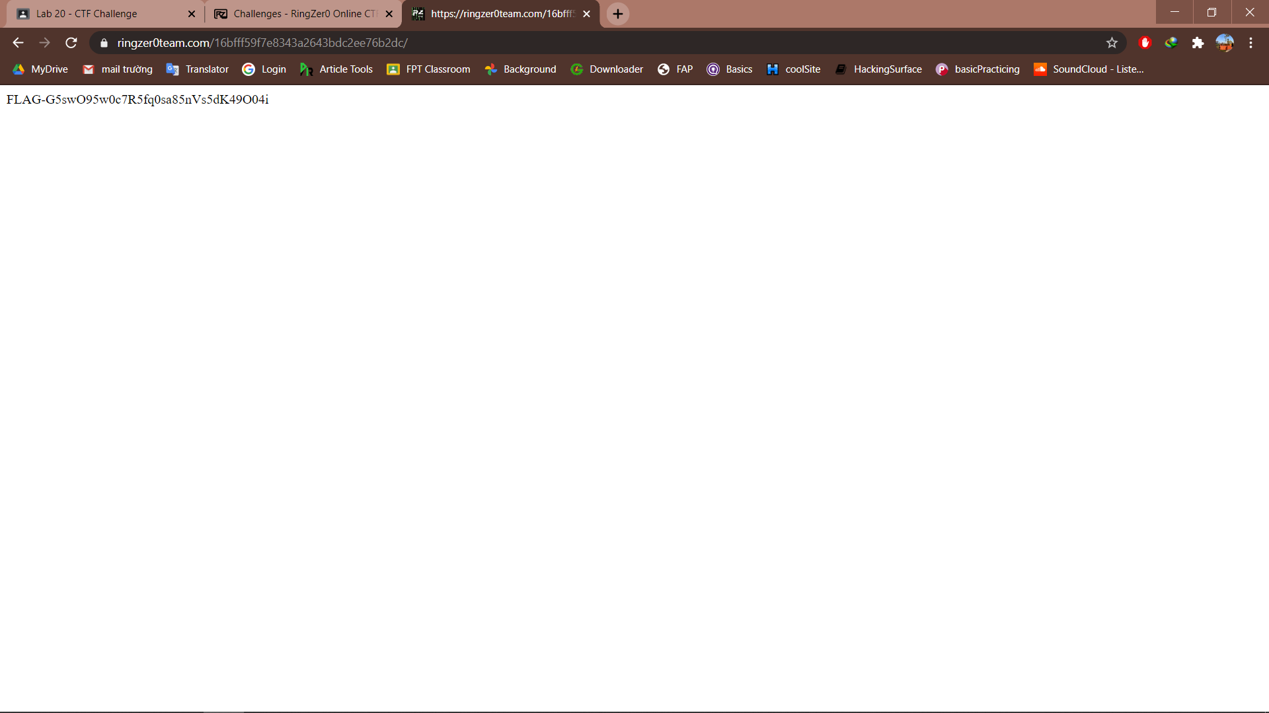

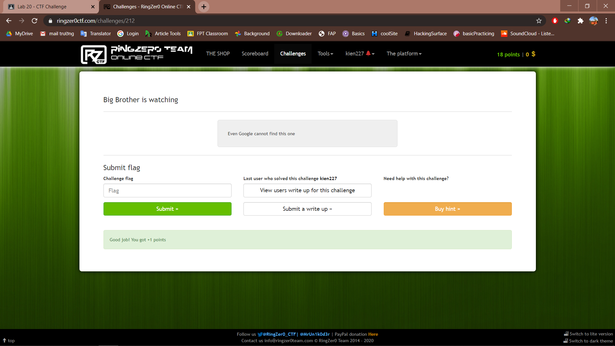

**Exercise 1.3 Password reset**

Noticed that there is a php script which give us a clue to solve the ‘k id’

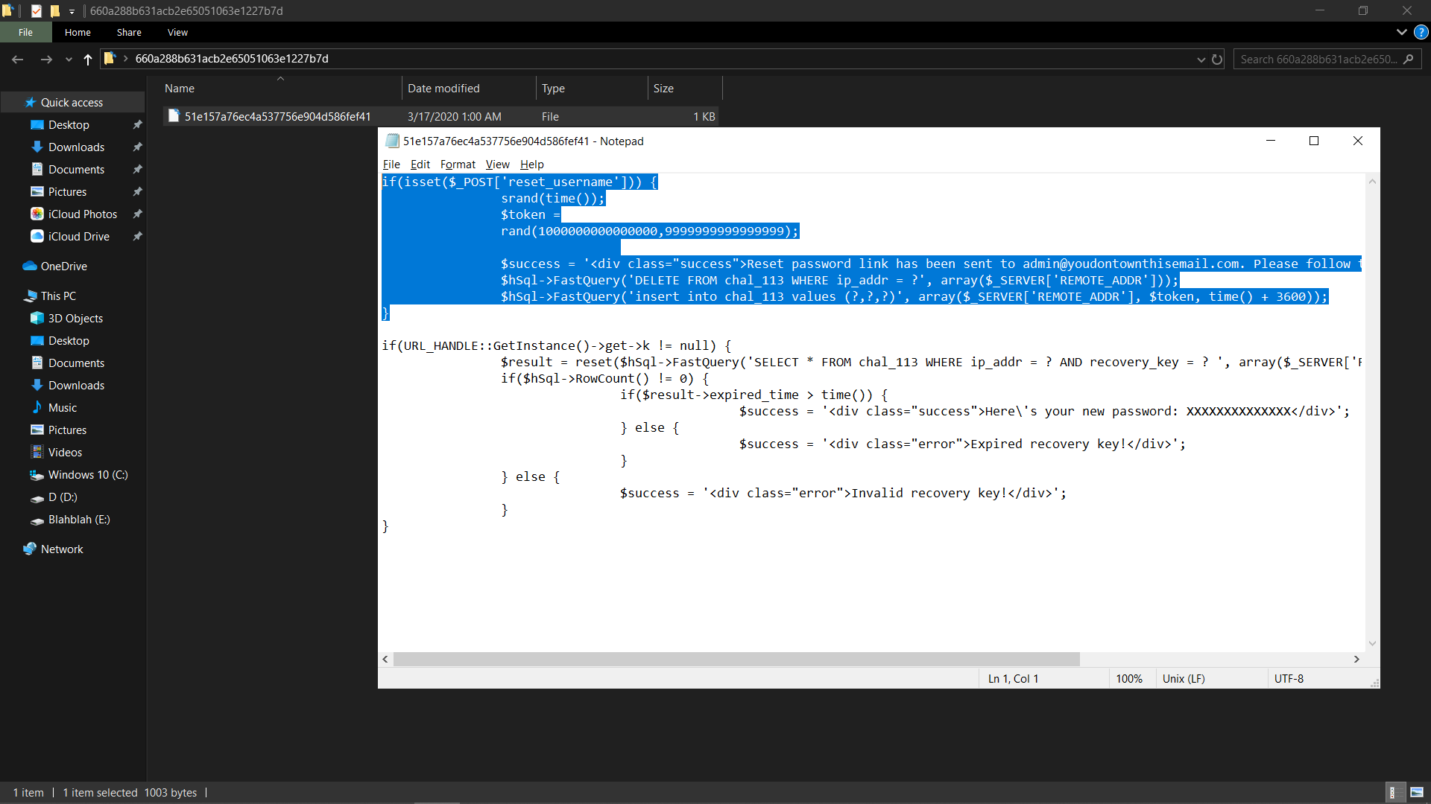

After checking for a while, I realized that this code can be executed in php 7.0.1 version

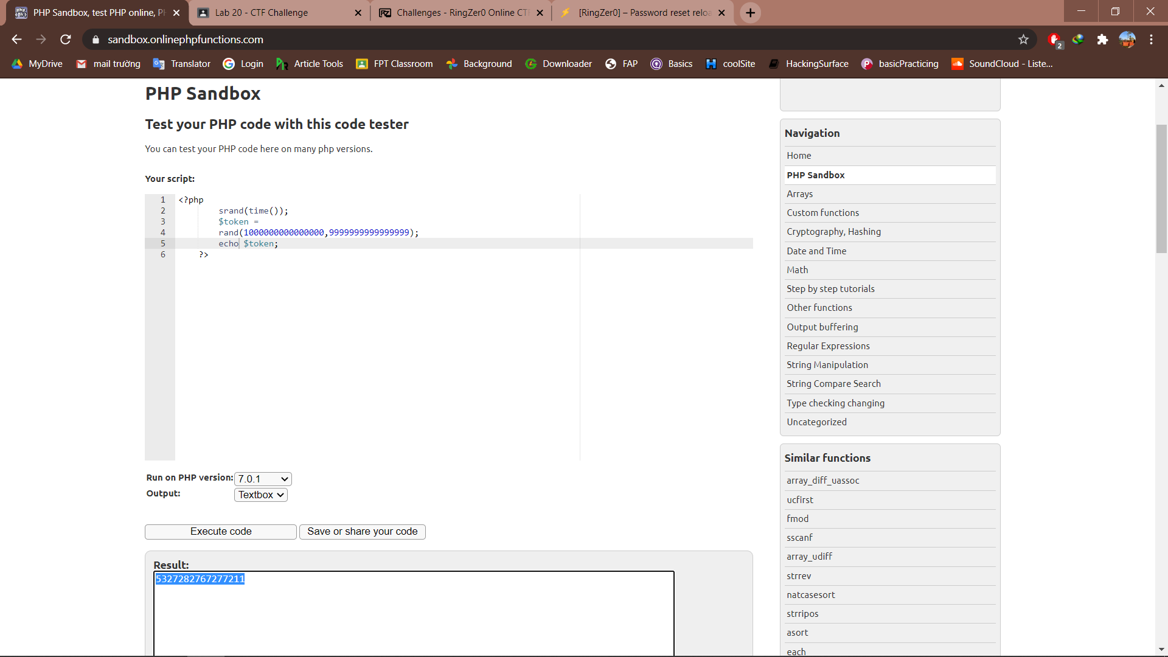

The echo command is to output the result, now we copy this output and put after the ‘k id’

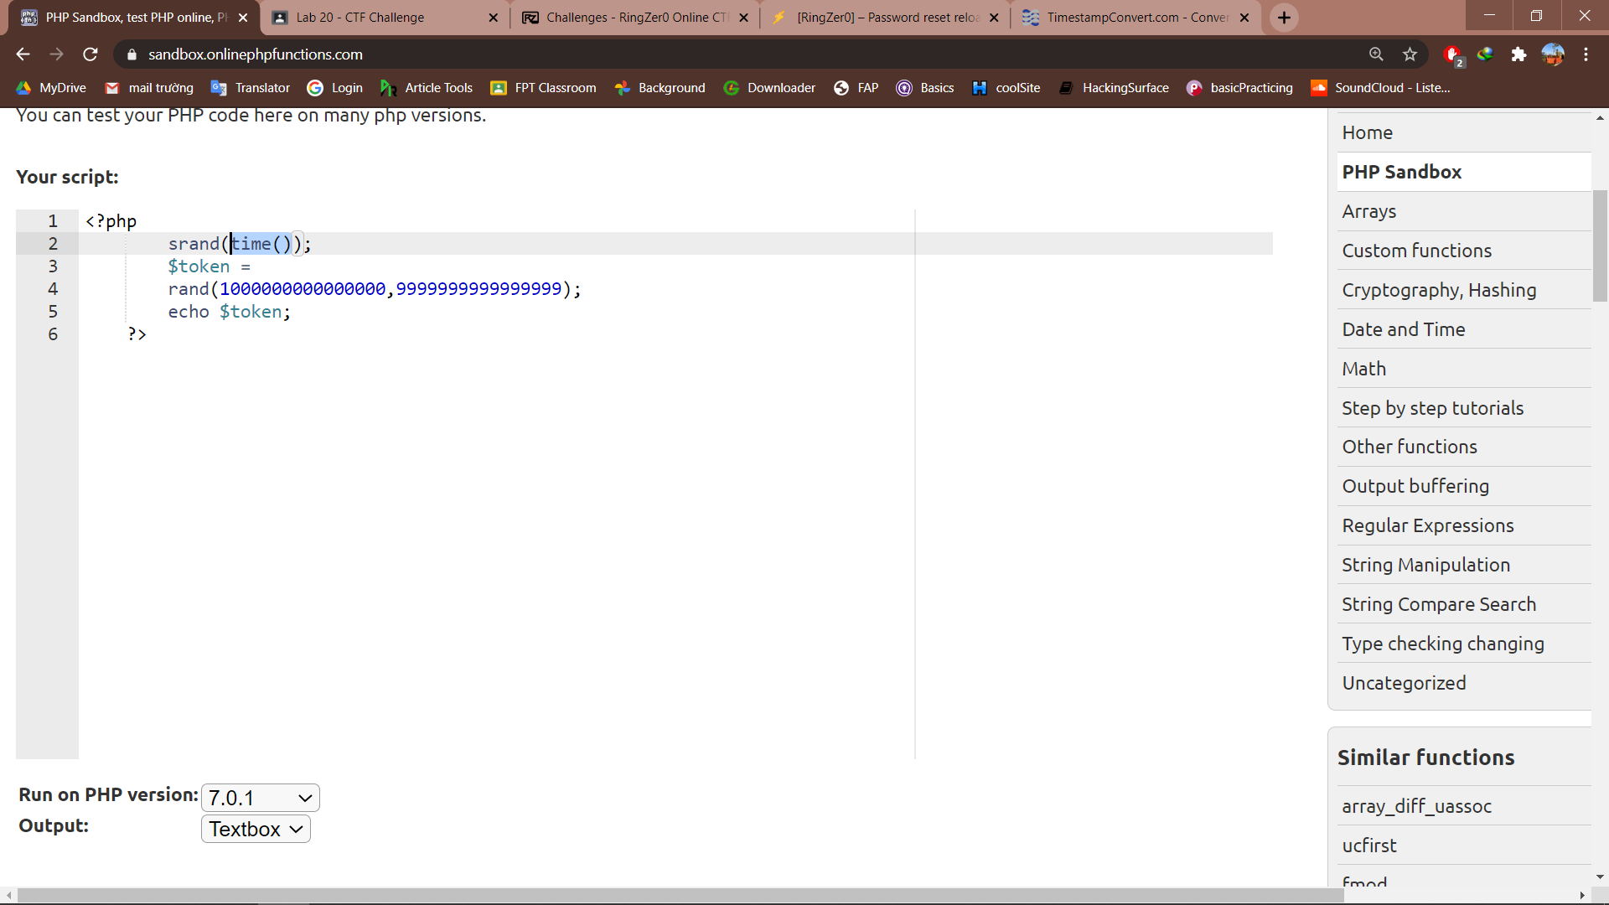

As can be seen there is a time() parametter, go back to the ctf site to check for the time we request to reset password

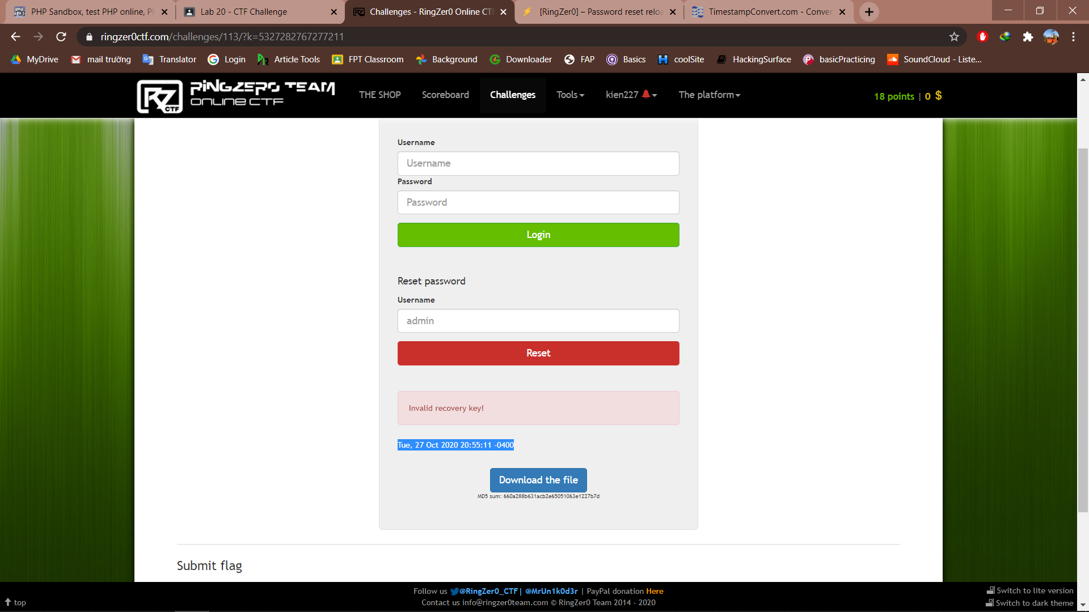

Now headback to the php executor and use strtotime() function to convert our date to time automatically

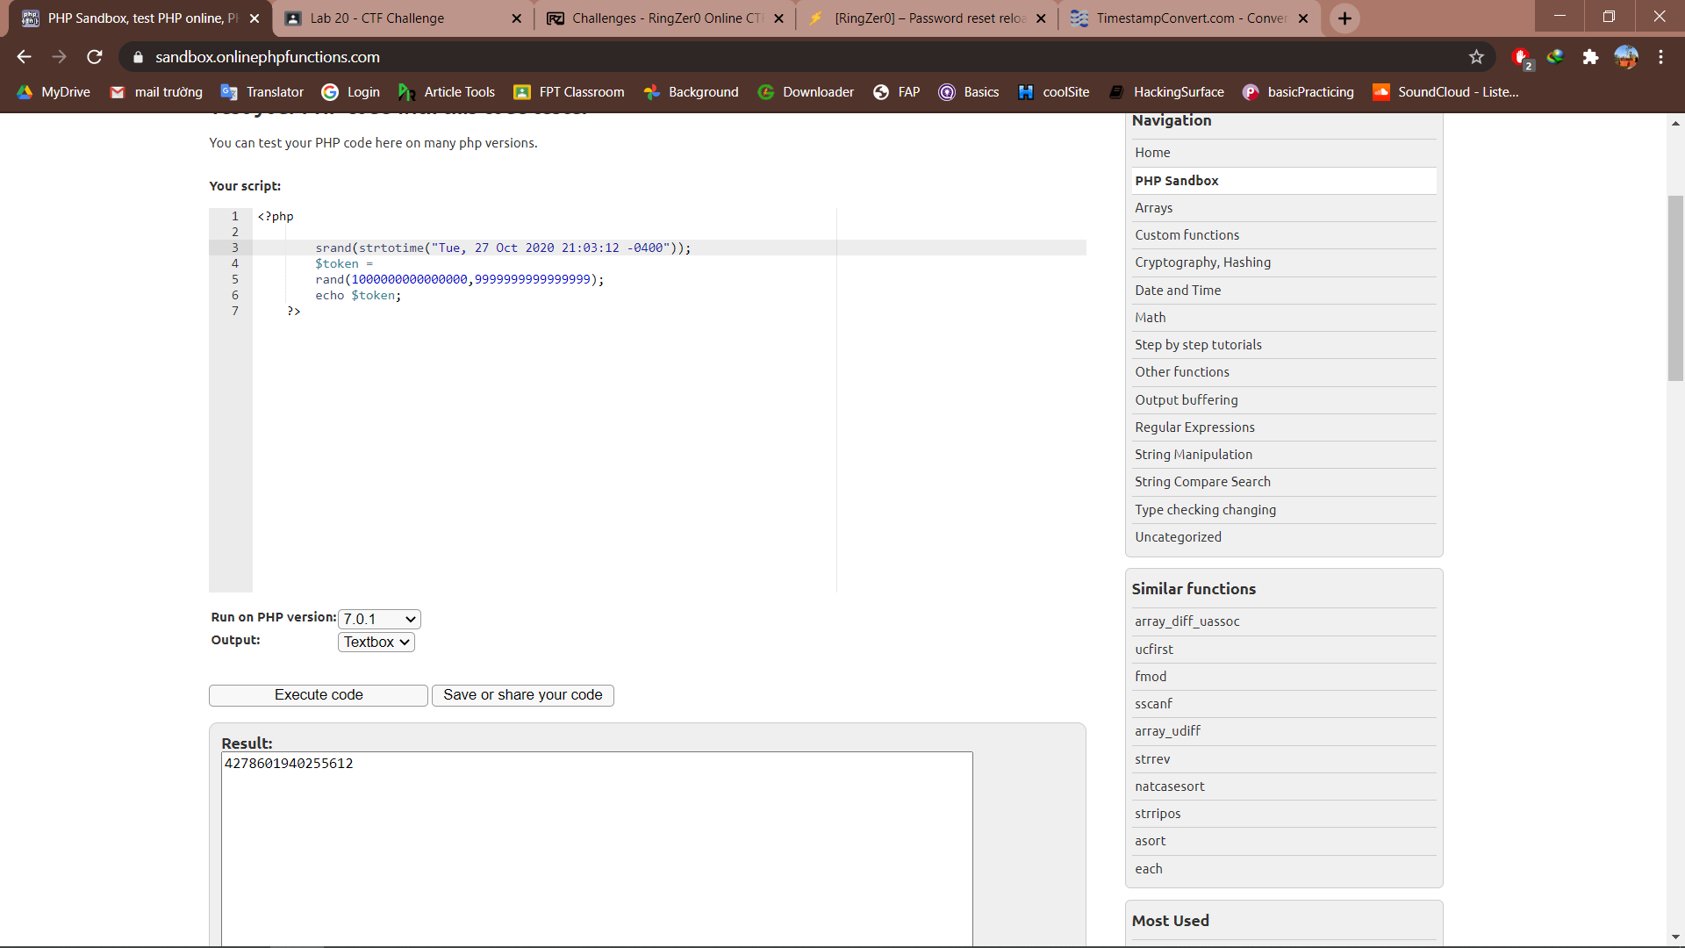

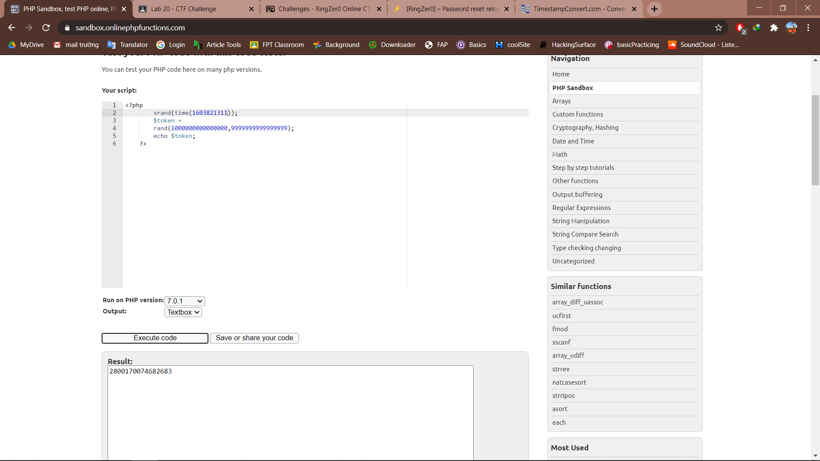

Copy and paste the output to the link given, we have

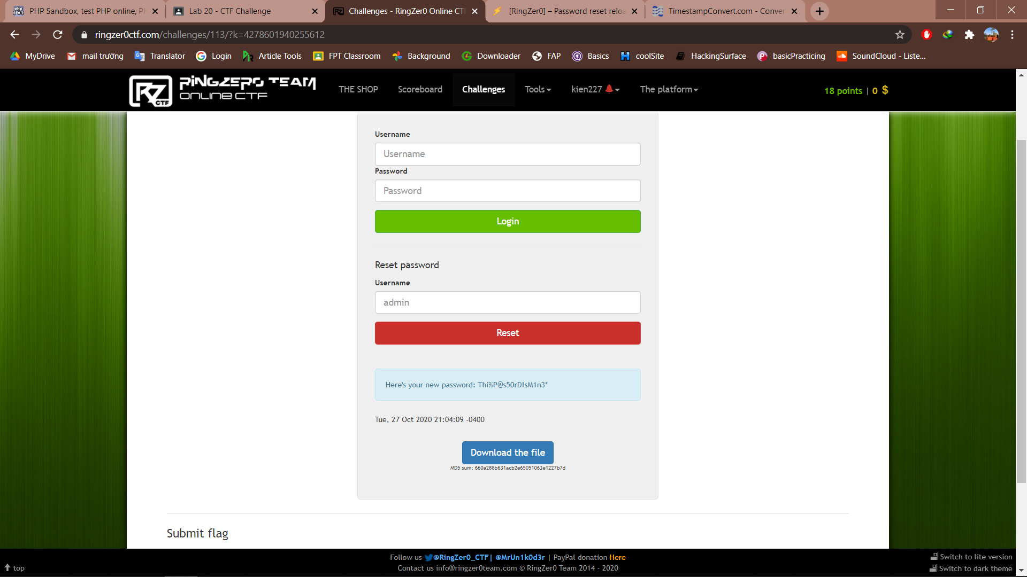

Login with our new password, we have the flag

