|  |  |
| --- | --- |
| Class & Module | IAW301  Lab 25: Using Spider Feature in Burp Suite |
| Name | Nguyễn Đức Kiên |
| IC No. | HE141763 |
| Date & Time | November 10, 2020 |

First let’s start with configuring our network proxy, in firefox head to preferences and config the proxy as below.

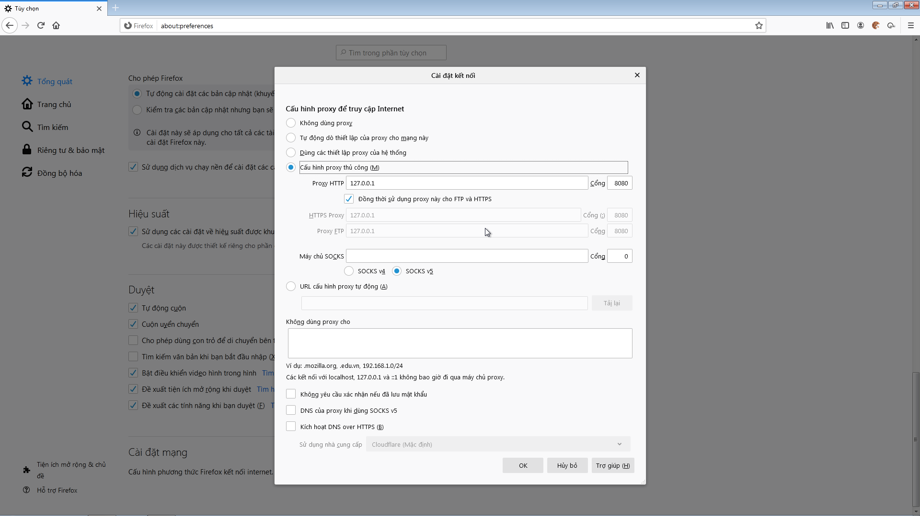

Now head to DVWA through our ipv4 address, mine is 192.168.234.129/DVWA/

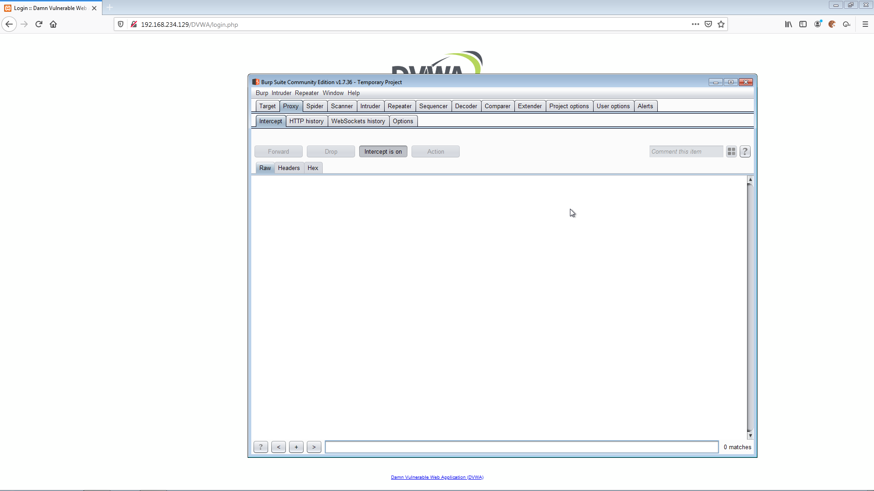

In Burp Suite choose the target tab🡪 site map

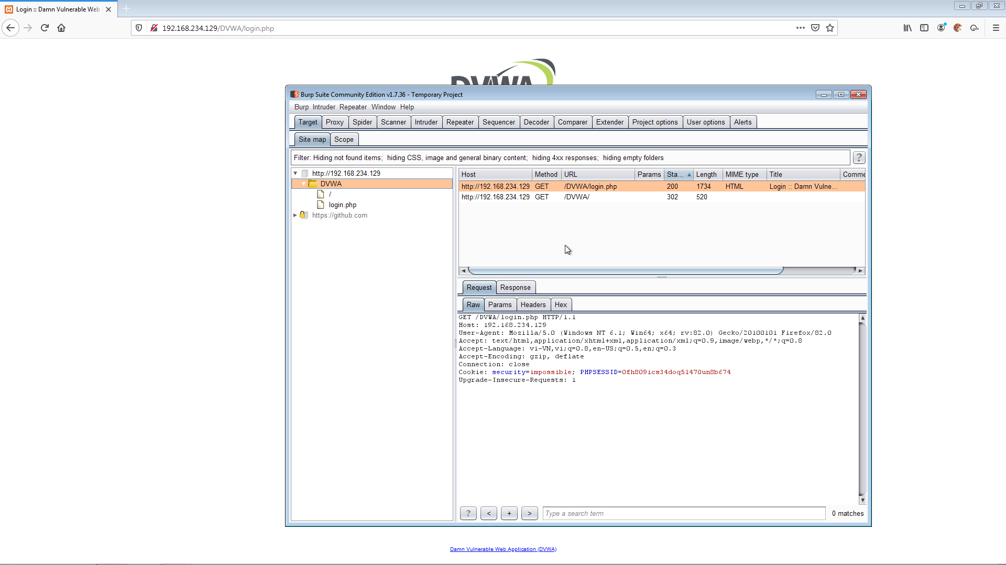

As can be seen, we started to crawl the website, now head to spider tab.

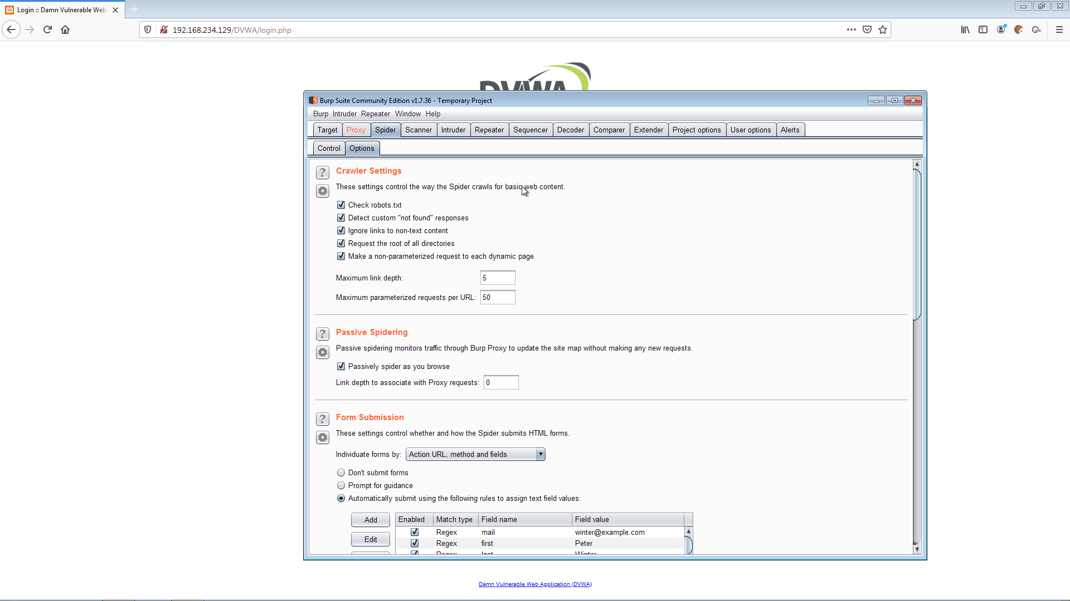

Click option, select automatically submit these credentials

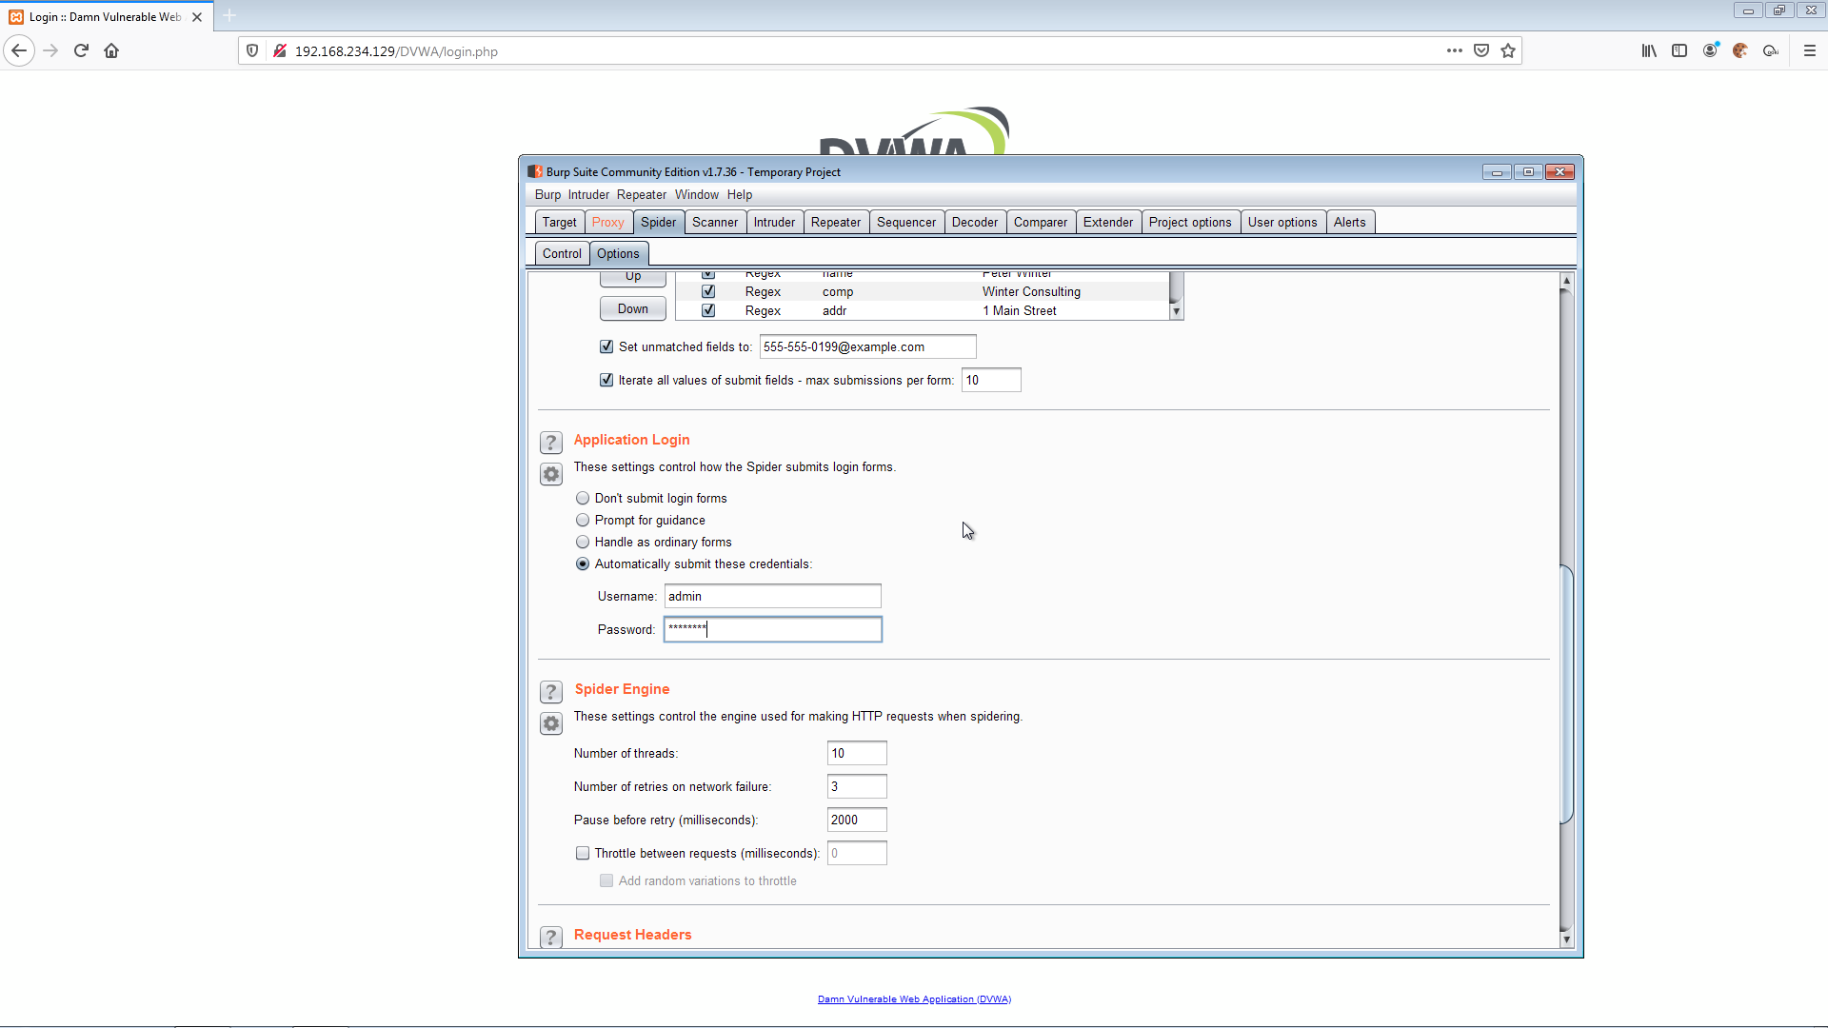

Back to the site map, right click our host, choose spider this host, and click yes

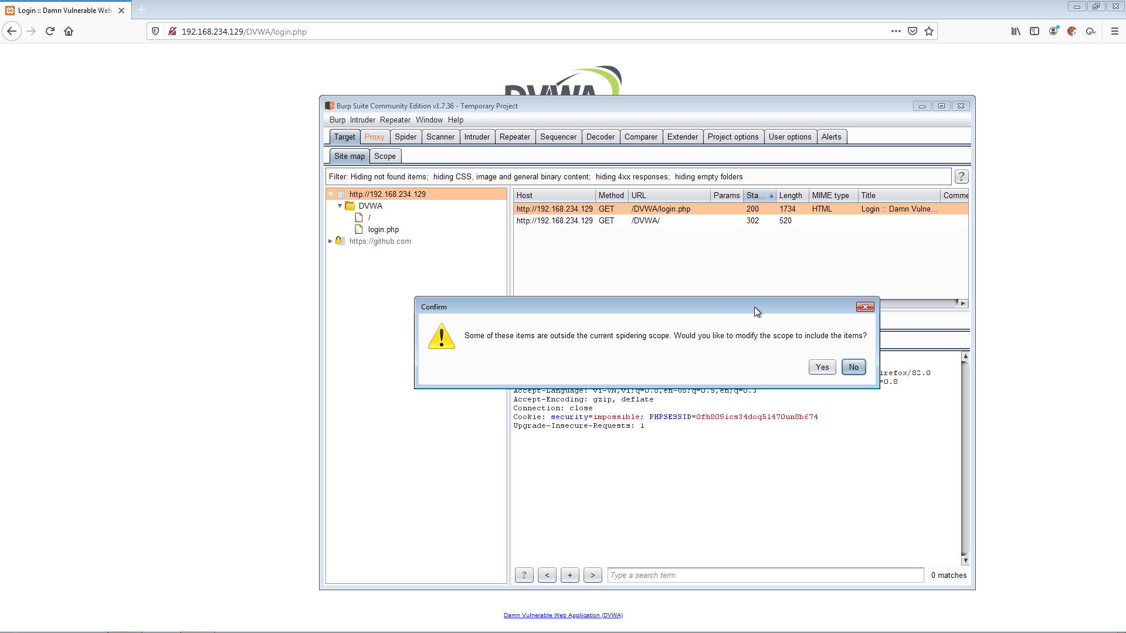

Burp will scan and give us some details of our website, as shown below in the picture

