|  |  |
| --- | --- |
| Class & Module | IAW301  Lab 29: CTF Challenge |
| Name | Nguyễn Đức Kiên |
| IC No. | HE141763 |
| Date & Time | November 21, 2020 |

#### Exercise 1.1 Area 51

#### 

#### As can be seen, the flag is hidden and the hint is to use htaccess secure method

#### 

#### First we will get the cookies of this session and we have:

66paos7gremn9i2ct35g5heta5

#### Now we head to Postman app to send Put request to the site, with the cookie above

#### 

#### Search for the response in the field below, we notice the flag

#### 

#### Submit successfully

#### 

**Exercise 1.2 Headache**

Again we head to the application tab to get the cookie

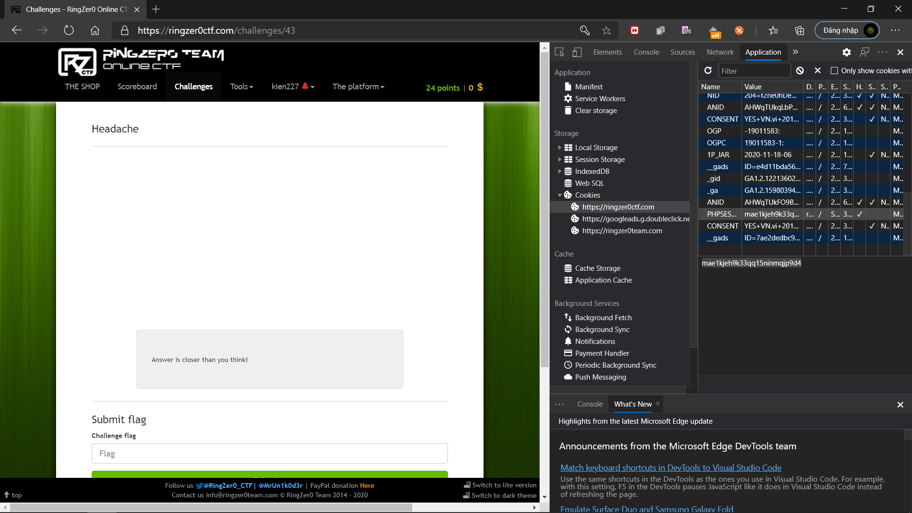

Now we use Postman with Get method to send request to the site, with the cookie above

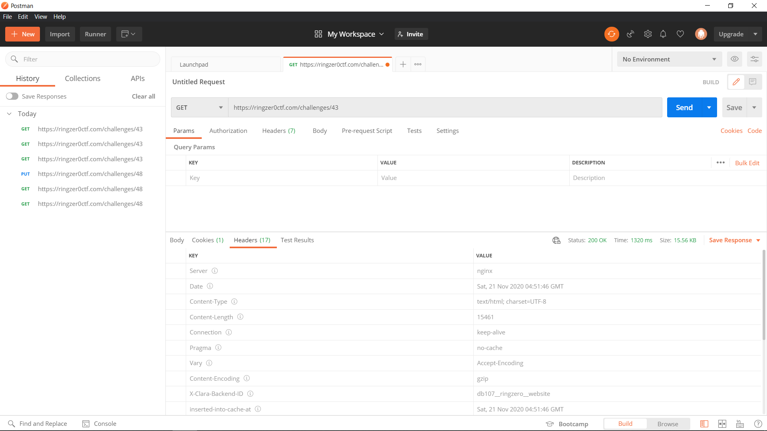

Edit the cookie

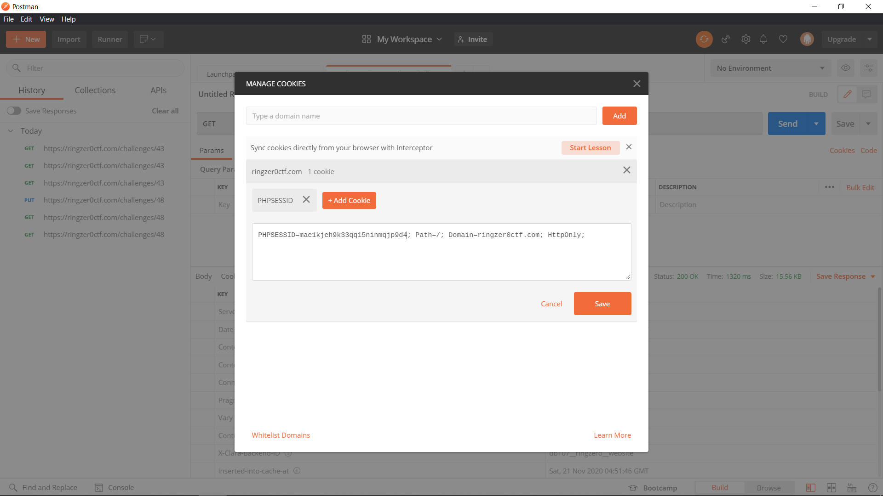

After sending the request, we noticed the flag in the header section

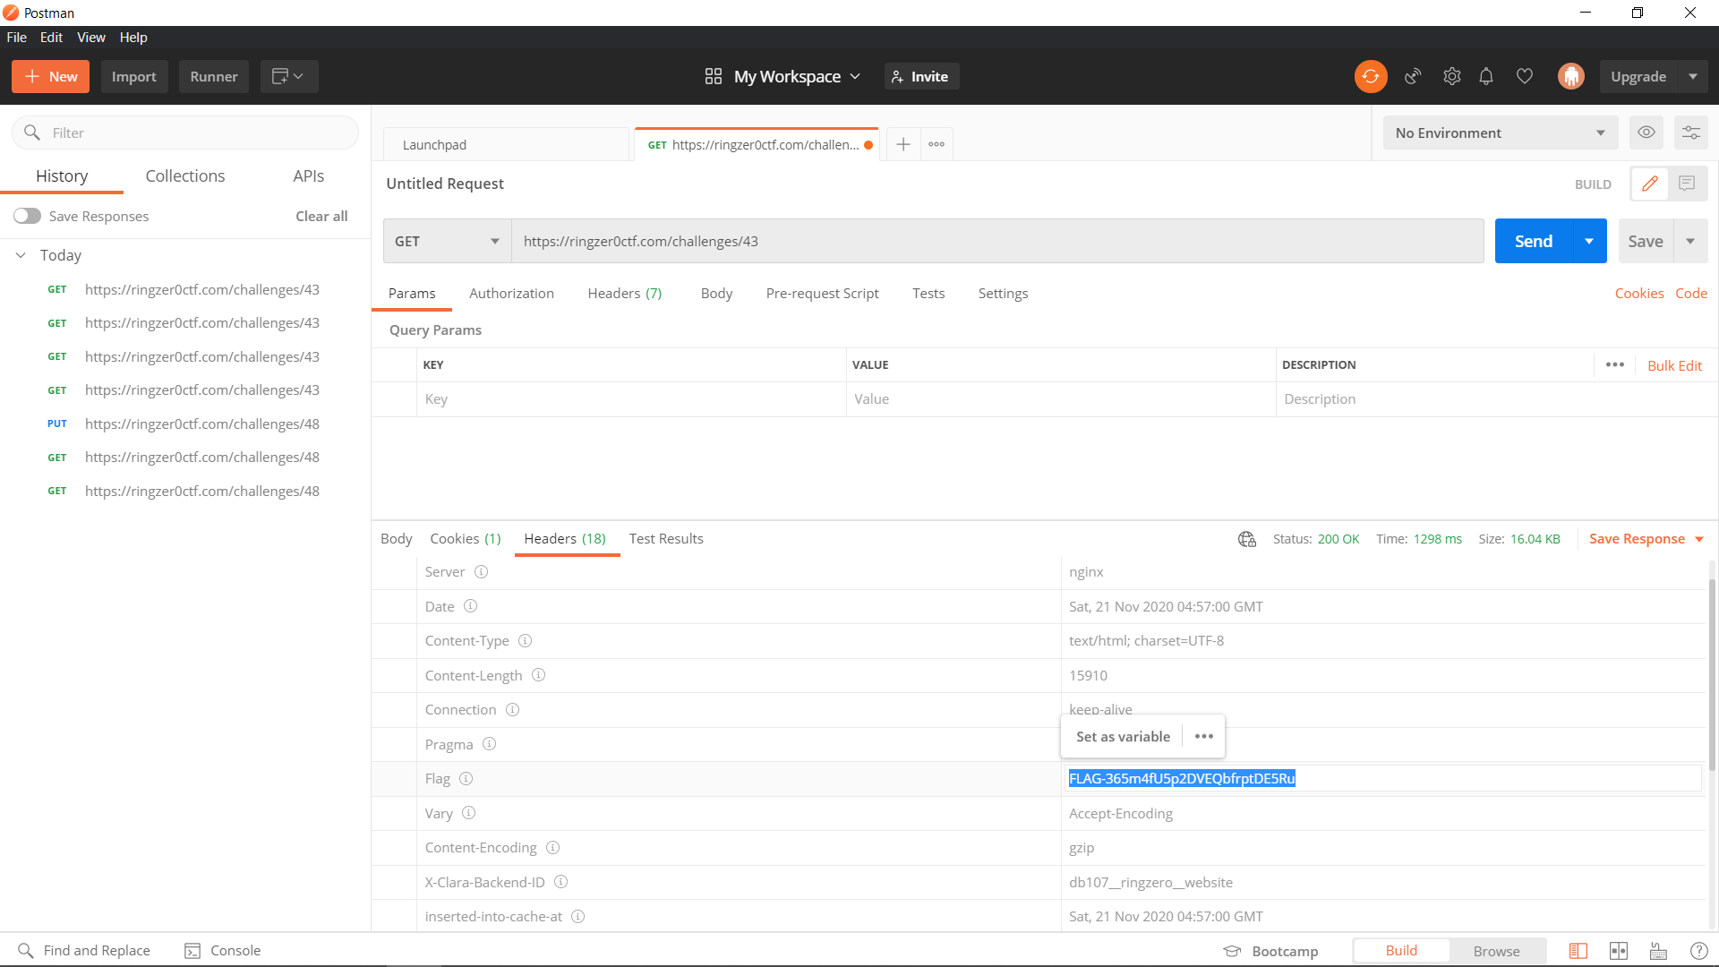

Back to zingzer0 and submit the flag successfully

