

**ATLAS CSS BOY Operator Interface Requirements Specification**

|  |  |  |  |  |  |  |  |  |  |  |  |  |  |  |  |  |  |  |  |  |  |  |  |  |  |  |  |  |  |  |  |  |  |  |  |  |  |  |  |  |  |  |  |  |  |  |  |
| --- | --- | --- | --- | --- | --- | --- | --- | --- | --- | --- | --- | --- | --- | --- | --- | --- | --- | --- | --- | --- | --- | --- | --- | --- | --- | --- | --- | --- | --- | --- | --- | --- | --- | --- | --- | --- | --- | --- | --- | --- | --- | --- | --- | --- | --- | --- | --- |
| |  |  |  |  | | --- | --- | --- | --- | | **APS AES/CTL**  **Specifications Document #** | **ATLAS Operator Interface Requirements Specification** | **Revision** | **0.1** | | **Requirements Specification for ATLAS Operator Interface** | | | |  |  |  |  | | --- | --- | --- | | Alex Dunn |  |  | | Intern, Technical (Author) | Signature | Date | |  |  |  | | Bryan Orr |  |  | | Co-Op, Technical (Author) | Signature | Date | |  |  |  | | Richard Farnsworth |  |  | | Controls Group Leader | Signature | Date | |  |  |  | | Ned Arnold |  |  | | Computer Systems Engineer | Signature | Date | |  |  |  | |  |  |  | |

|  |  |  |  |  |
| --- | --- | --- | --- | --- |
| **Version** | **Sections Affected** | **Description of Change** | **Author** | **Date** |
| 00 | All | Initial Document Release | Bryan Orr, Alex Dunn | Jul 23, 2012 |
|  |  |  |  |  |
|  |  |  |  |  |
|  |  |  |  |  |

CONTENTS

1 INTRODUCTION 5

1.1 Purpose 5

1.2 Scope 5

1.3 Assumptions and Constraints 5

1.4 Document Overview 5

2 DESIGN METHODOLOGY 5

3 FUNCTIONAL REQUIREMENTS 5

3.1 User Requirements 5

3.2 Operator Screen Requirements 6

3.3 Expert Screen Requirements 6

3.4 Data Buffer Screen Requirements 7

4 OTHER REQUIREMENTS 7

4.1 Software Interfaces 7

4.2 Communications Interfaces 7

4.3 Hardware/Software Requirements 7

4.4 Operational Requirements 7

4.5 System Reliability 7

APPENDIX A - Glossary 8

APPENDIX B - Figures 9

Table 1: Summary of functional requirements 6

Table 2: Magnet Interlocks 16

Table 3: Current Lead Interlocks 16

Table 4: SCU0 Warnings Provided 18

# INTRODUCTION

An operator interface for the Argonne Tandem Linac Accelerator System (ATLAS) utilizing Control System Studio Best Operator Interface Yet (CSS BOY) is required to control and monitor the ATLAS hardware.

## Purpose

This document describes the design requirements of the operator interface for the ATLAS project. The interface is a GUI built on an Eclipse framework called CSS BOY which will interface with EPICS.

## Scope

The interface will be built using CSS BOY from <http://ics-web.sns.ornl.gov/css/products.html> . Although system interfaces are common at Argonne, the use of CSS BOY is new and therefore may require insight into system limitations and deployment structure. Because many of the widgets and display components for ATLAS have already been chosen, the interface will be designed with these specific components in mind.

## Assumptions and Constraints

### Assumptions

Before the operator interface design can begin, the specification requirements document must first be completed and all interested parties must agree to the information contained herein.

Functional testing of the operator interface can be performed using an EPICS soft IOC. Ned will eventually provide a soft IOC with realistic data for testing purposes.



### Constraints

Time constraints?

## Document Overview

The design methodology will be briefly described before presenting the details of the functional requirements.

The appendices include a glossary of terms used throughout this document as well as interface design diagrams.

# DESIGN METHODOLOGY

This document was developed through communication with Ned Arnold. Experience with CSS BOY was gained hands-on and through John Hammonds.

# FUNCTIONAL REQUIREMENTS

## User Requirements

## Operator Screen Requirements

See Figure 1 in Appendix B for an early stage CSS BOY mock up. See Figure 3 in Appendix B for an MEDM mock-up of the strip charts that will be included. Note that MEDM to CSS BOY conversion on this screen produces crashes, so we will produce it manually.

### LLRF4 Registers

Highlighted PV’s from all_params.adl should be shown on the Operator screen with buttons, readbacks, or sliders. Attempt to accommodate all highlighted PV’s.

### Buttons

OPERATOR: front.opi

EXPERT: expert.opi, formerly all_params.adl

DATA BUFFER, SEL MODE, and XGUI will be specified in the future.

### Plots

The waveforms contain 1024 elements.

The top display should utilize:

$(TS)LLRF4:STATS0:S1_ampl_s_wf

$(TS)LLRF4:STATS0:S1_phase_s_wf

$(TS)LLRF4:STATS0:S2_ampl_s_wf

$(TS)LLRF4:STATS0:S2_phase_s_wf

The bottom display should utilize:

$(TS)LLRF4:STATS0:S3_ampl_s_wf

$(TS)LLRF4:STATS0:S3_phase_s_wf

$(TS)LLRF4:STATS0:S4_ampl_s_wf

$(TS)LLRF4:STATS0:S4_phase_s_wf

### RF Manual Controls

AMPL: $(TS)LLRF4:DRV0:out_amp_set_ao

PHASE: $(TS)LLRF4:DRV0:out_amp_set_ao

CAVITY TUNING: ?

FREQ OFFSET: $(TS)LLRF4:DRV0:ou_freq_set_ao

CAV FLD: ?

FWD PWR: ?

REV PWR: ?

### Frequency Auto Scan

## Expert Screen Requirements

See Figure 2 in Appendix B for an MEDM mock-up of this screen. Note that MEDM to CSS BOY conversion on this screen produces crashes, so we will produce it manually.

# OTHER REQUIREMENTS

# Software Interfaces

Currently there is not an interface control document which specifies the software interfaces but for APS all interfaces would be compatible with other APS project applications and would use the EPICS software toolkit which would be developed, deployed, and maintained by the AES Controls Group.

# Communications Interfaces

This control shall be capable of communicating information to and from the system via the LAN using the EPICS Channel Access (CA) communication protocol.

# Hardware/Software Requirements

If a soft IOC were to be used then the system would require an already existing workstation for the IOC to run on; however, if other hardware I/O were to be required then the hardware platform would most likely be the standard APS VME64x rack mounted crate manufactured by Dawn VME Products. The workstation would likely be running Red Hat Linux Enterprise operating system while the VME crate would run the vxWorks operating system; both are compatible with EPICS. These hardware are provided by the ATLAS project.

# Operational Requirements

This control system must be operational 24/7 during ATLAS experiments.

# System Reliability

1. A single Eclipse workspace can not be opened in more than one session at a given time. This could pose a challenge if multiple users need to access the interface simultaneously.
2. CSS BOY has not yet been deployed in the field. Crashes due to Java or other hardware/software incompatibilities are conceivable. This will need to be monitored closely

# APPENDIX A - Glossary

CSS BOY – Control System Studio Best Operator Interface Yet

EPICS – Experimental Physics Industrial Control System

GUI – Graphical User Interface

MEDM – Motif Editor Display Manager (Standard APS EPICS Display Screens)

PV – Process Variable (Specific value in EPICS database)

# APPENDIX B - Figures

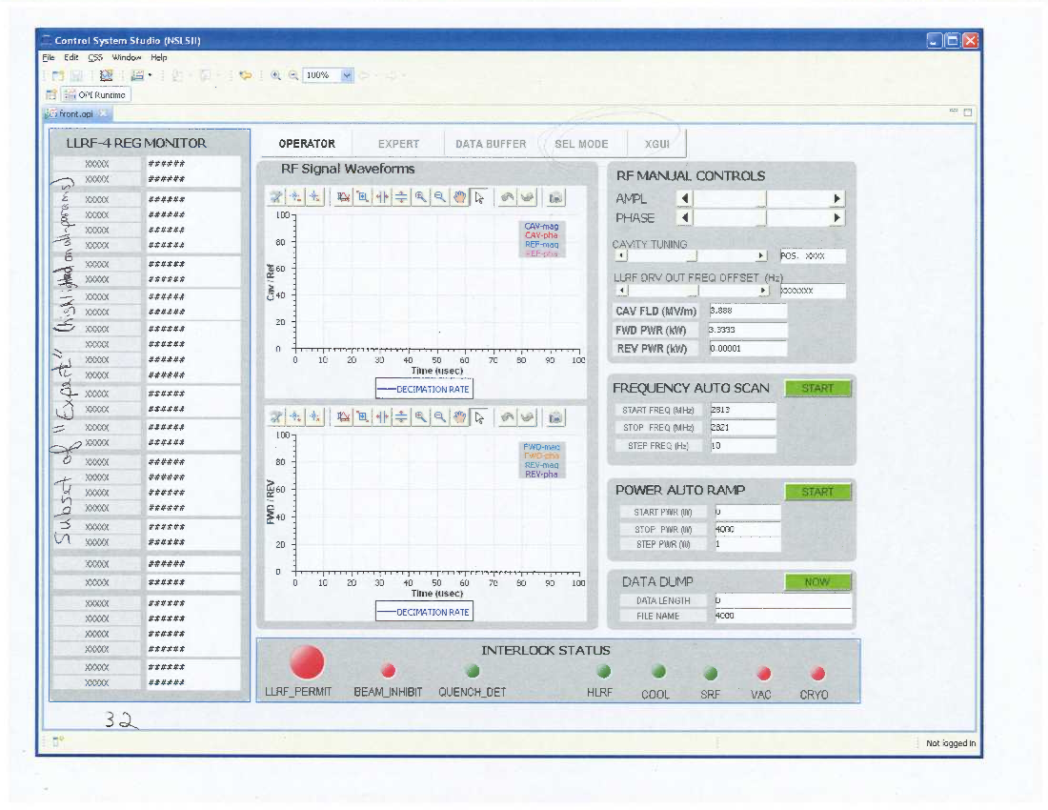

Figure 1: Operator Screen in CSS BOY (Work in Progress)

Values with XXXX or #### will be filled in with PV’s.

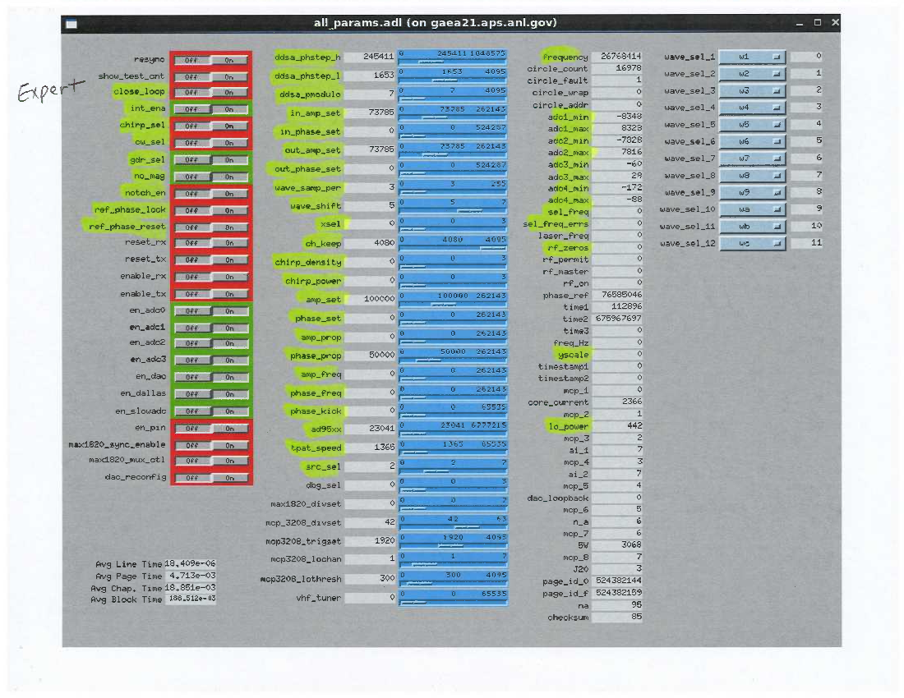

Figure 2: Expert Screen in MEDM

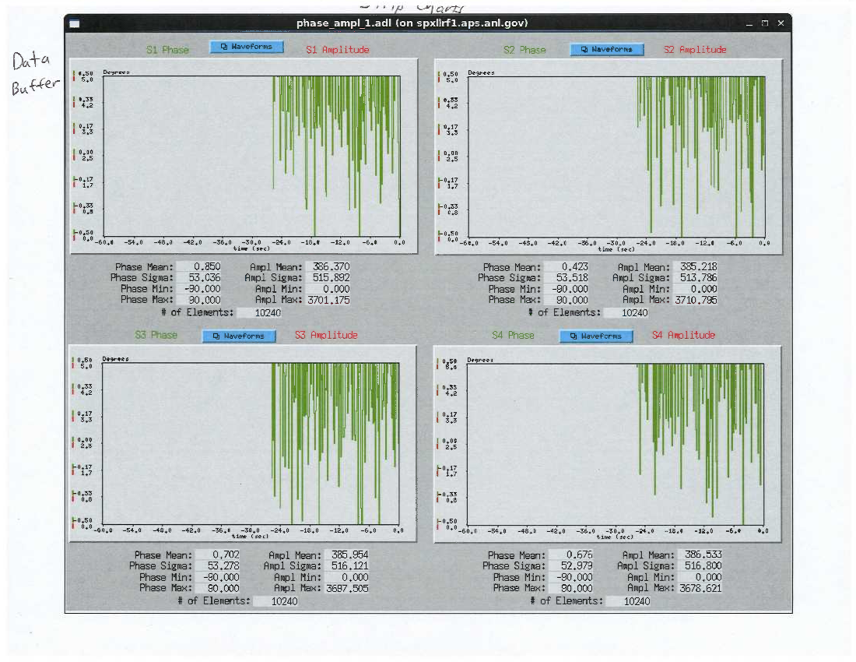

Figure 3: Strip Charts in MEDM

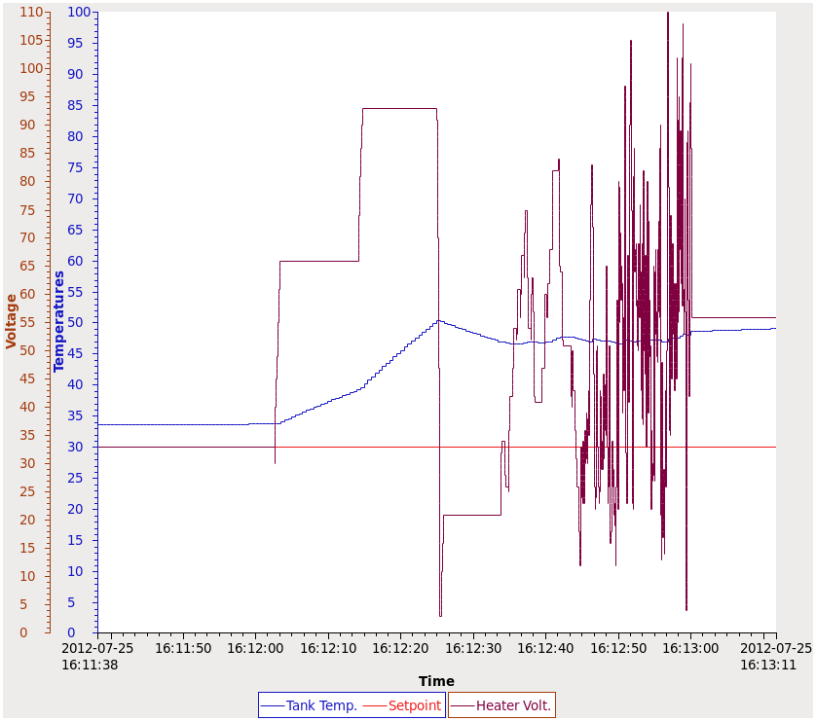

Figure 4: Strip Chart Demonstration in CSS BOY

Can be embedded in any CSS BOY screen