ANOMALY SIMULATION RESULTS

1. The function calls with incorrect data
The screenshot shows the error message caused by using the incorrect data type. The data type of forwardPackets argument must be number.
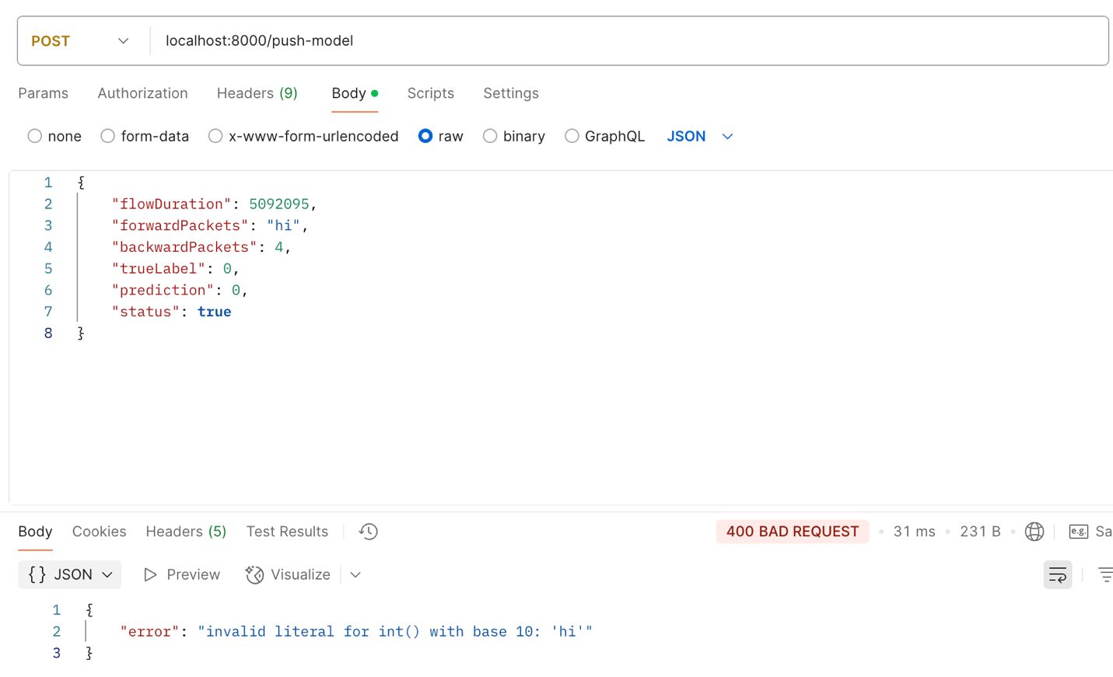

The screenshot shows the error message caused by using the incorrect data type. The data type of prediction argument must be number.
