DEMO SCENARIOS

1. The push model

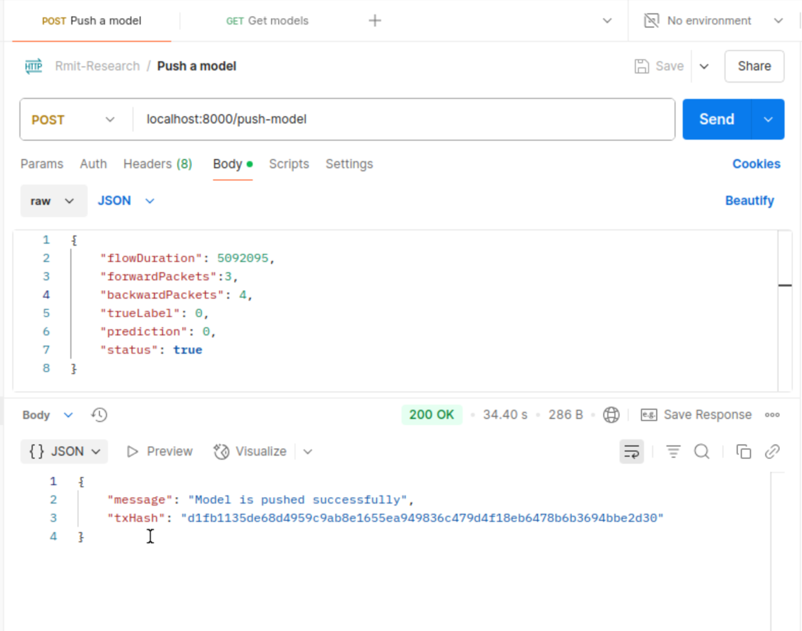
Figure 1. The push-model api

2. The get model
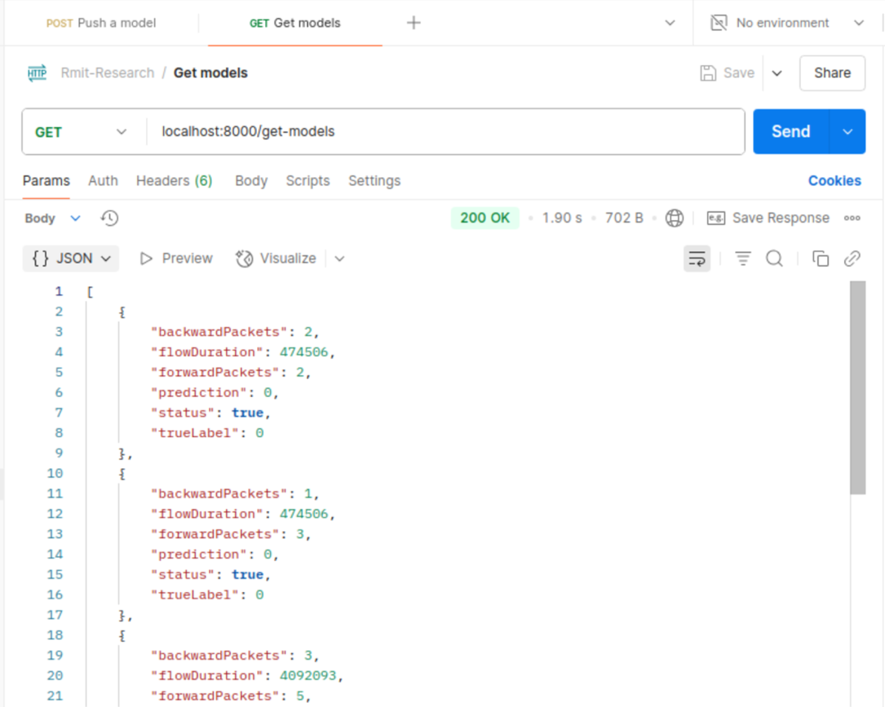
Figure 2. The get-models api

