FINAL REPORT

1. Installation guide
Install forge
curl -L https://foundry.paradigm.xyz | bash
Deployment
forge create --rpc-url <your_rpc_url> --private-key <your_private_key>
contract/src/MLModels.sol:MLModels
Install required packages
cd contract_connector
pip install -r requirements.txt
Build server
cd contract_connector
flask --app app.py run --host=0.0.0.0 --port=8000

2. Real-world scenario outcomes
2.1. The push model

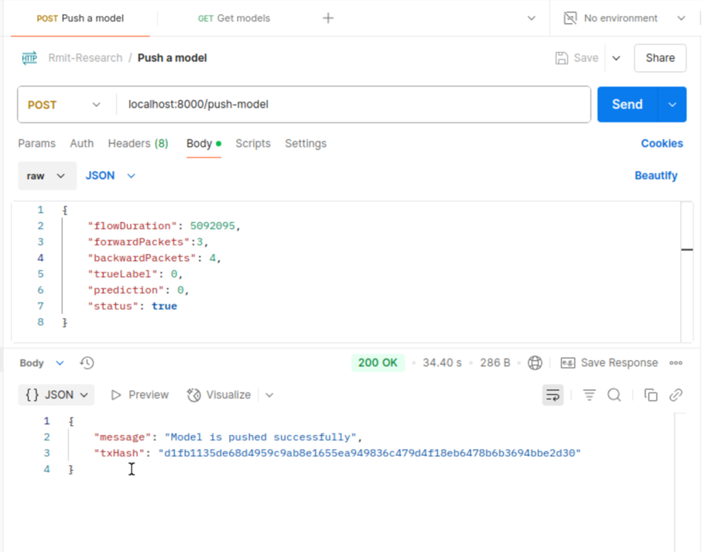
Figure 1. The push-model api

2.2. The get model
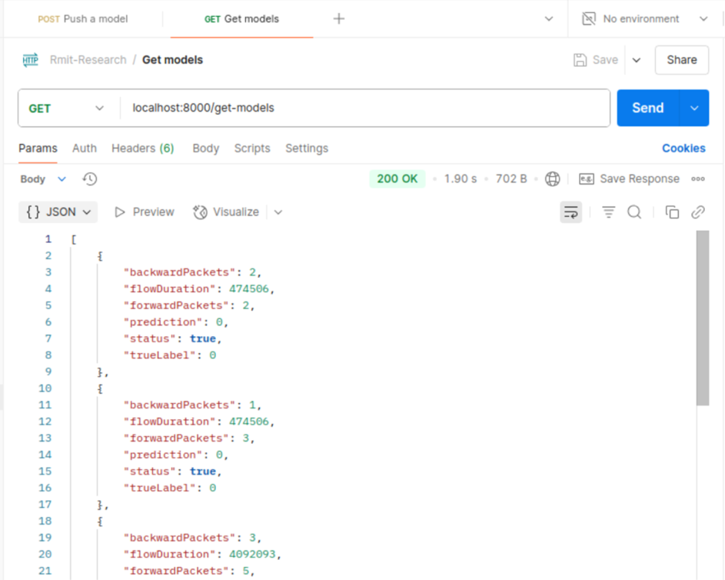
Figure 2. The get-models api

3. Conclusions
This project demonstrates the successful deployment and interaction of a smart contract–based model management system integrated with a Flask API. The system supports two key functionalities:
- Model Push Functionality: Users can push trained models to the blockchain-backed backend using a RESTful POST API (/push-model). The API confirms successful uploads and returns a unique transaction hash, ensuring immutability and traceability.
- Model Retrieval Functionality: Via the GET API (/get-models), users can retrieve stored models along with associated metadata such as flow duration, packet details, predictions, and true labels. This allows for easy auditing and validation of stored ML outcomes.
The results validate the system's capability to handle basic model storage and retrieval tasks in a decentralized and transparent manner, suitable for use cases in secure model tracking, collaborative AI development, or forensic auditing.

4. Future Work
To extend the system's impact and robustness, the following enhancements are recommended:
- Security Improvements: Incorporate authentication and access control to ensure that only authorized users can push or retrieve models.
- Scalability Enhancements: Transition to a more scalable infrastructure, such as IPFS for storing large model files off-chain while retaining hashes on-chain for integrity verification.
- Model Versioning: Implement a version control mechanism to manage updates or retraining of models over time.
- Performance Optimization: Benchmark response times and storage performance with larger datasets and more concurrent users to assess system bottlenecks.
- User Interface (UI): Develop a web-based front end for easier interaction with the APIs, enabling non-technical users to interact with the system seamlessly.
- Advanced Analytics: Integrate visualization and analytics tools for tracking model performance trends or drift over time.

