FINAL SYSTEM EVALUATION REPORT

1. Demo Scenarios
1.1. The push model
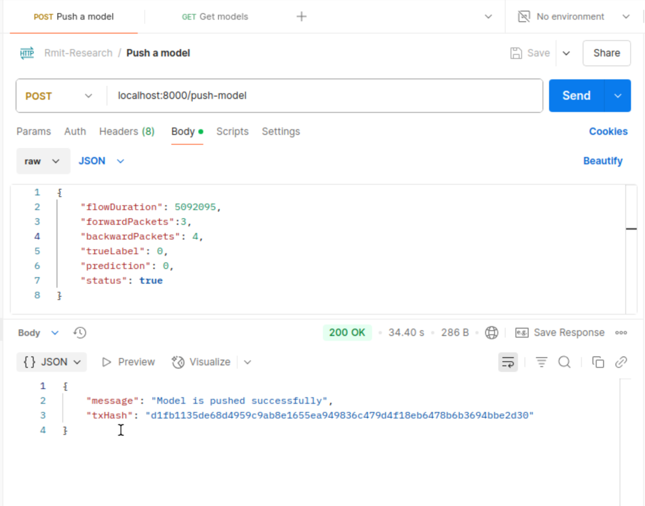
Figure 1. The push-model api

1.2. The get model
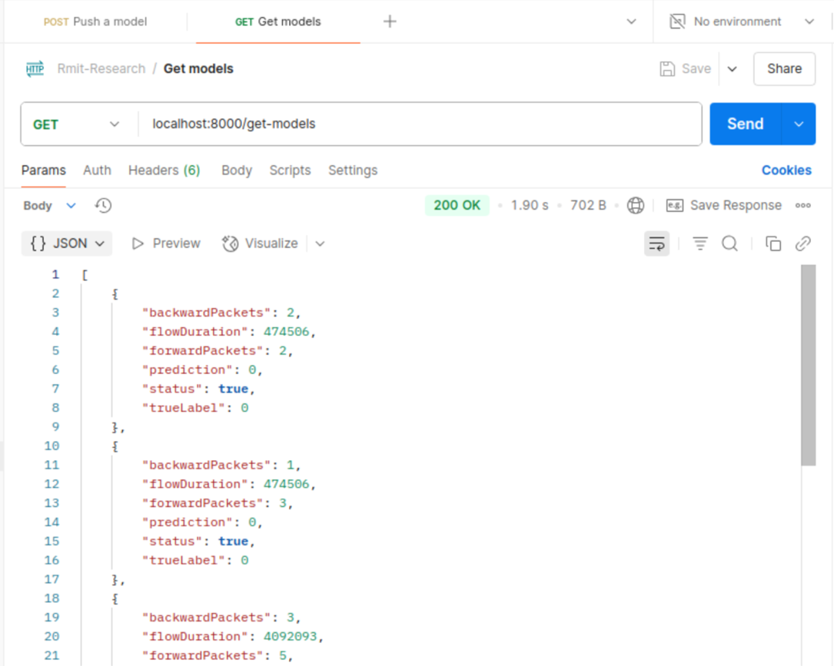
Figure 2. The get-models api

2. Anomaly Simulation Result
The screenshot shows the error message caused by using the incorrect data type. The data type of forwardPackets argument must be number.
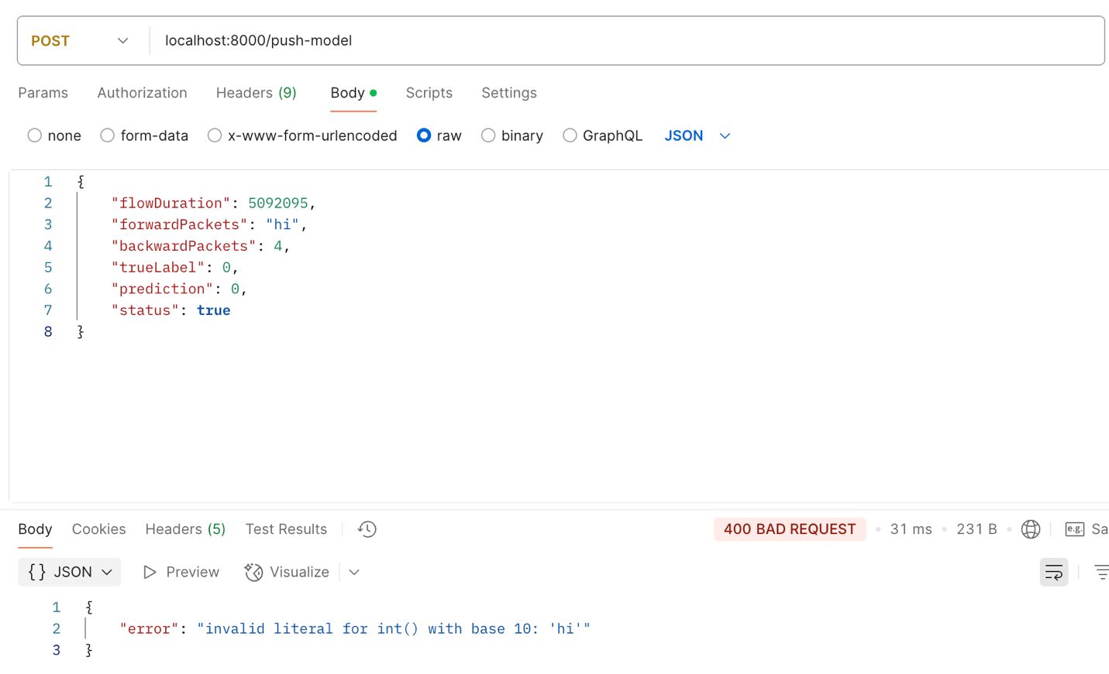
The screenshot shows the error message caused by using the incorrect data type. The data type of prediction argument must be number.
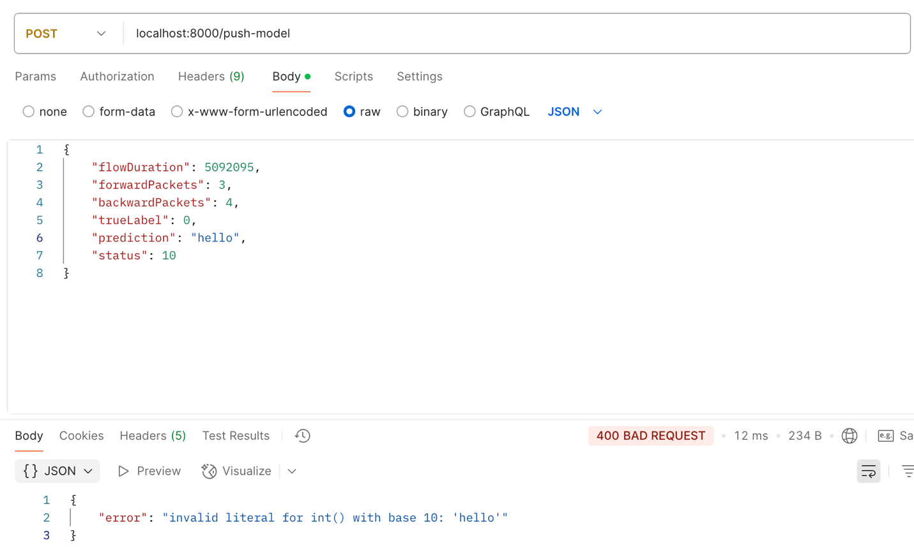

3. Real-world Test Report
3.1. The Get Model API
The `get-model` API provides a response containing detailed information about network flow data in Ethereum. Each entry in the response array includes the folloing attributes:
- backwardPackets: The number of packets sent from the destination to the source.
- flowDuration: The duration of the network flow in milliseconds.
- forwardPackets: The number of packets sent from the source to the destination.
- prediction: The model’s prediction for the flow.
- status: A boolean indicating the success of the operation (`true` for success).
- trueLabel: The actual label of the flow.
Example Response
[
{
“backwardPackets”: 2,
“flowDuration”: 474506,
“forwardPackets”: 2,
“prediction”: 0,
“status”: true,
“trueLabel”: 0
},
{
“backwardPackets”: 1,
“flowDuration”: 474506,
“forwardPackets”: 3,
“prediction”: 0,
“status”: true,
“trueLabel”: 0
},
{
“backwardPackets”: 3,
“flowDuration”: 4092093,
“forwardPackets”: 5,
“prediction”: 0,
“status”: true,
“trueLabel”: 0
},
]

3.2. The Push Model API
The `push-model` API is used to deploy a model to Ethereum. Upon successful deployment, the API returns a response indicating the completion of the process.
- message: A confirmation message stating that the model has been pushed successfully.
- txHash: A unique transaction hash that can be used to track the model deployment process.
Example Response
{
“message”: “Model is pushed successfully”,
“txHash”: “420e2f5004b94f85c400bdd8a7746cb30611ed595728d90c549b49e0866465a4”
}

