NMAP SCAN REPORT

1. The scan command
The TCP scan command is shown below.
sudo nmap -sT 172.16.147.162
The UDP scan command is shown below.
sudo nmap -sU 172.16.147.162

2. The key finds
The table shows the data related to open ports returned by nmap.
Port | State | Service
80/tcp | open | http
8000/tcp | open | http-alt

3. The relevant screenshots
These screenshots are related to call the nmap commands stated in the section 1.
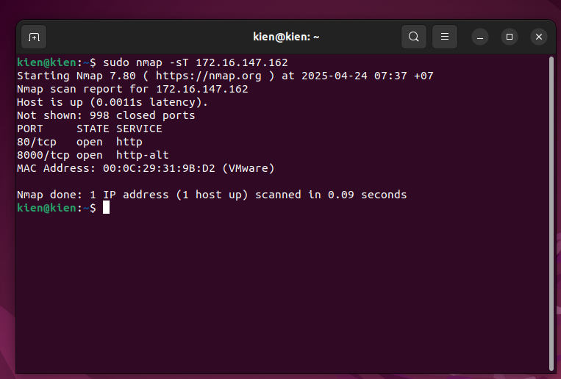
Figure 1. nmap to get TCP ports

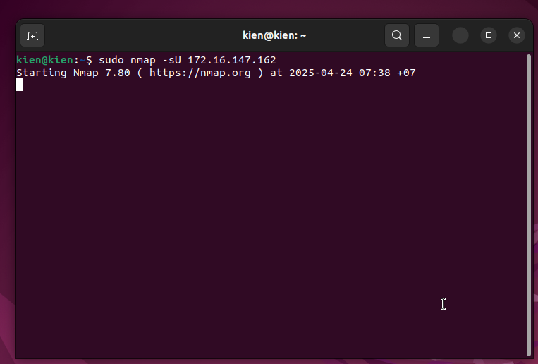
Figure 2. nmap to get UDP ports

