OPENVAS REPORT
1. Config
This is the screenshot of docker containers related to OpenVAS
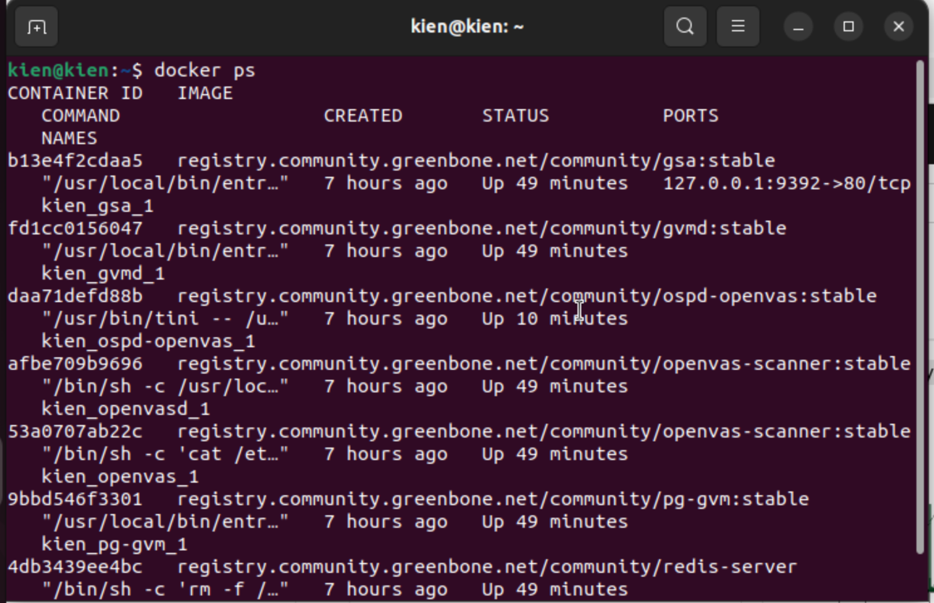

2. Tables of CVEs
This is the screenshots of all tables
