PTE PENETRATION SUMMARY

1. Installation
OpenVAS
Metasploit
2. OpenVAS
2.1. Configs
This is the docker configs related to OpenVAS.
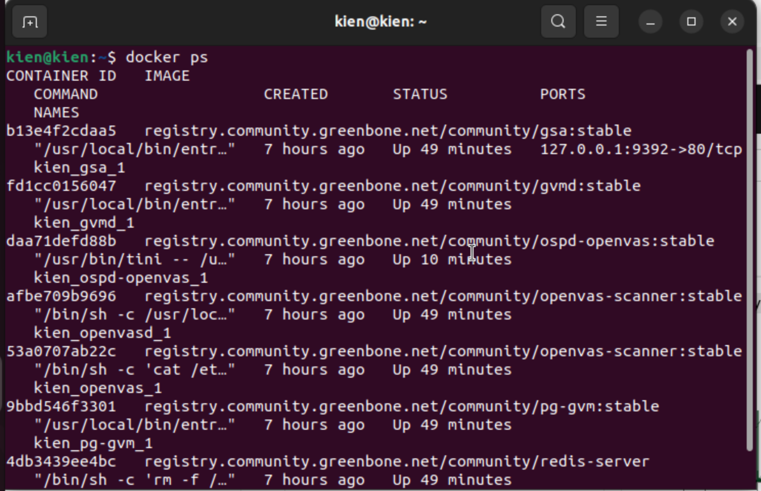
2.2. Top-5 CVEs
The screenshot shows the top-5 CVEs on the virtual machine that hosts some APIs connected to the Ethereum testnet.
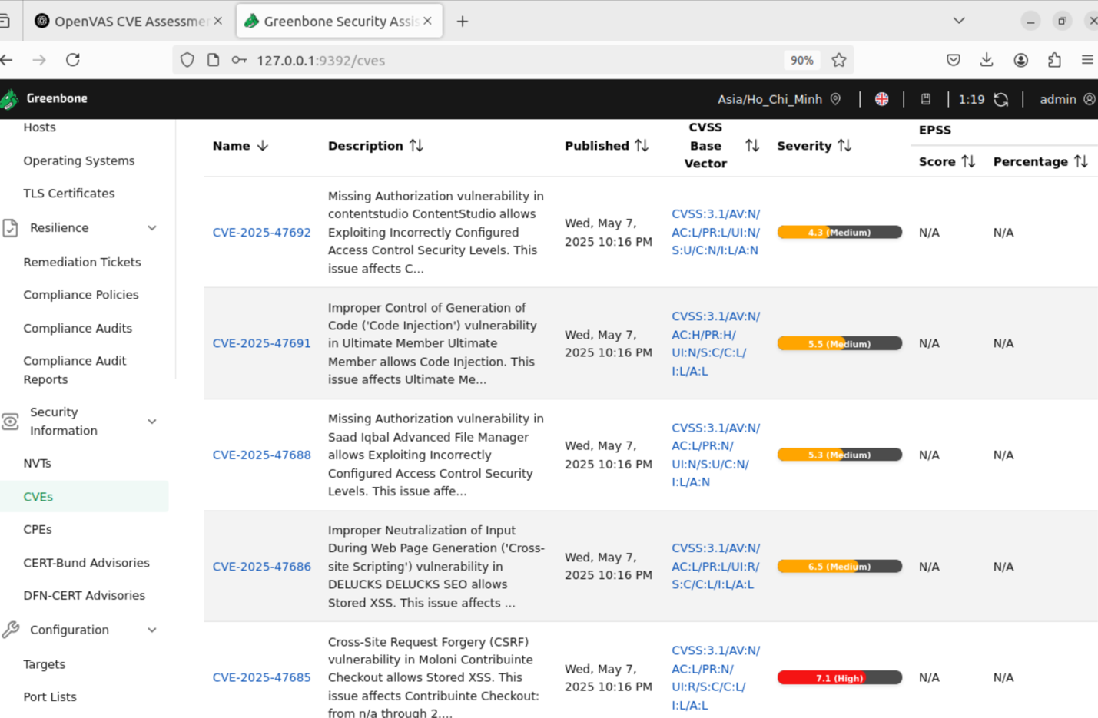

2.3. The CVEs related to blockchain
The screenshots show the CVEs relevant to smart contracts and middleware.
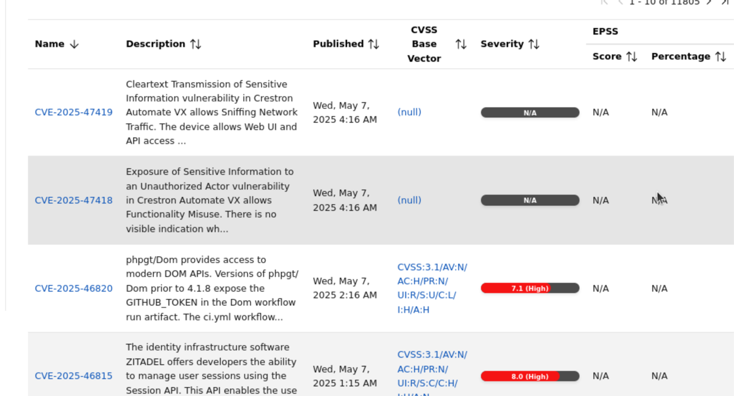
Figure 1. Screenshot 1
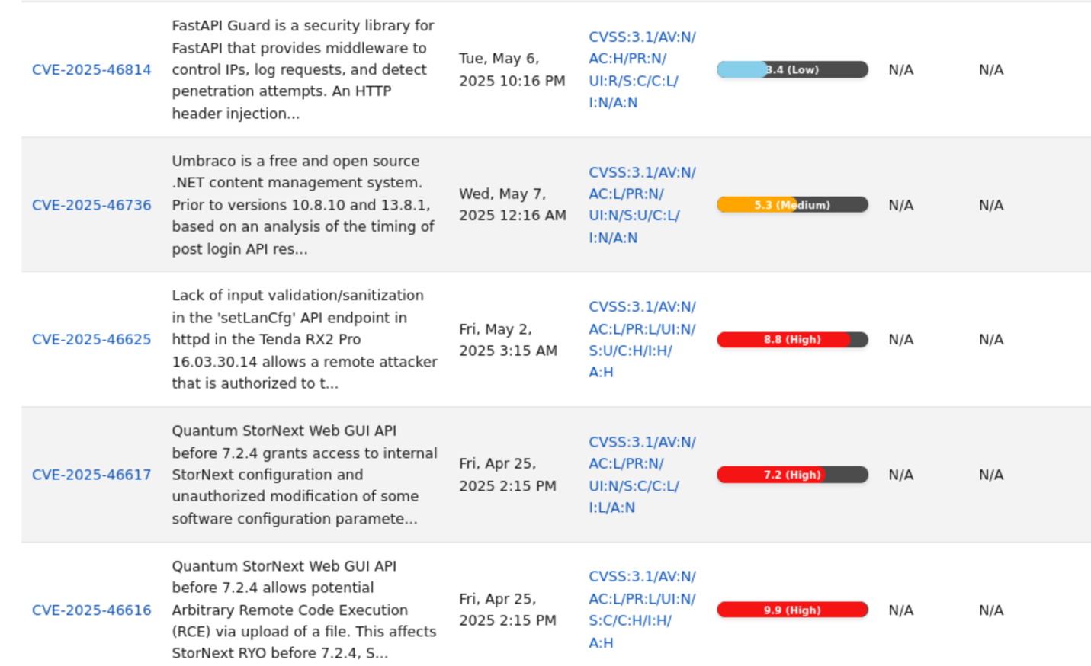
Figure 2. Screenshot 2

3. Metasploit
The screenshots show the exploits conducted for testing the connection between APIs and Ethereum.
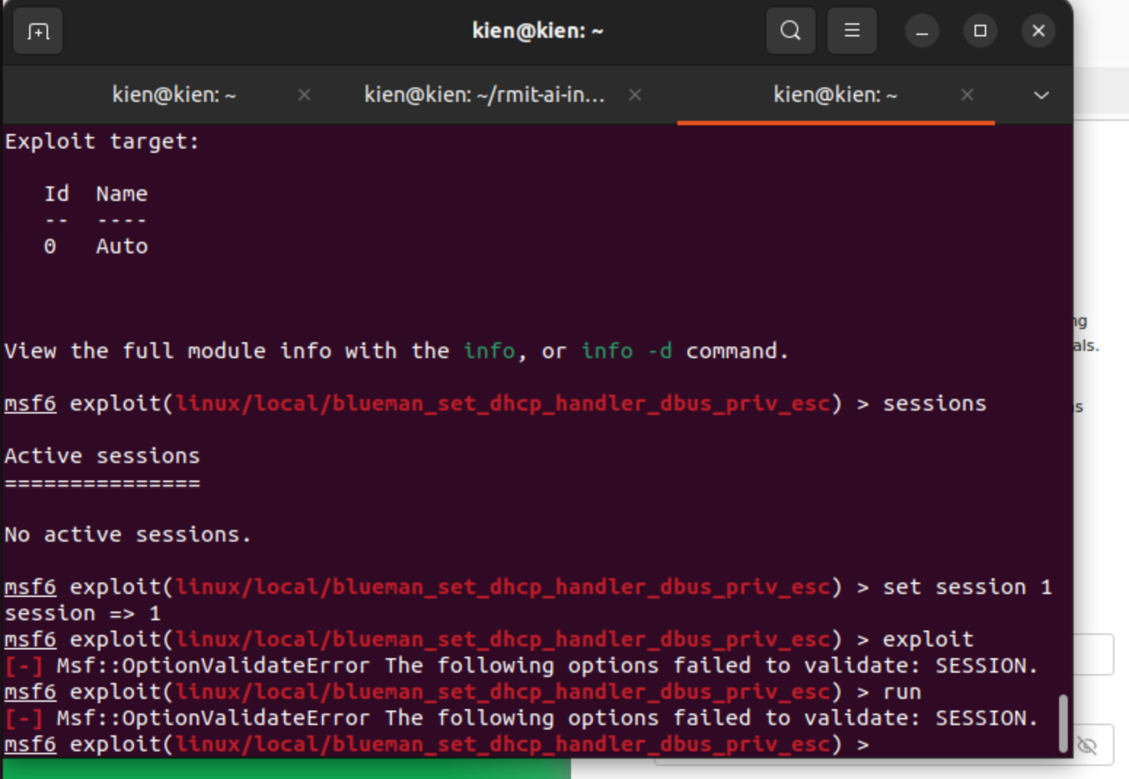
Figure 1. The exploit uses linux

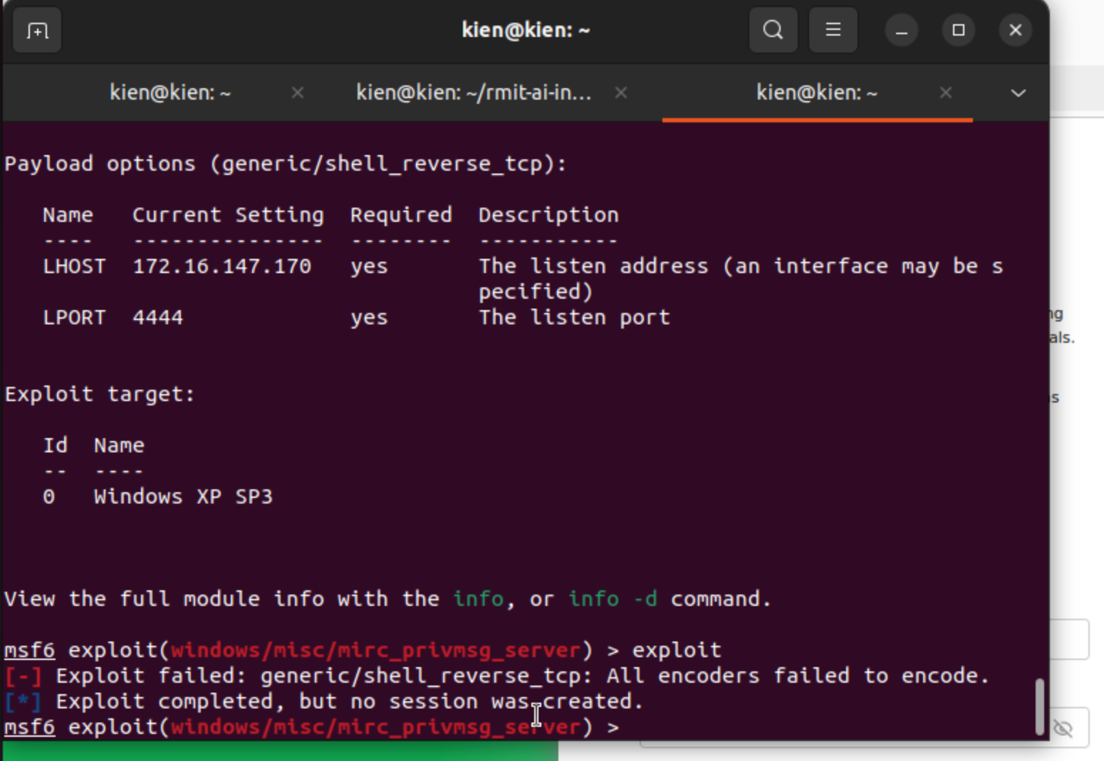
Figure 2. The exploit uses Windows

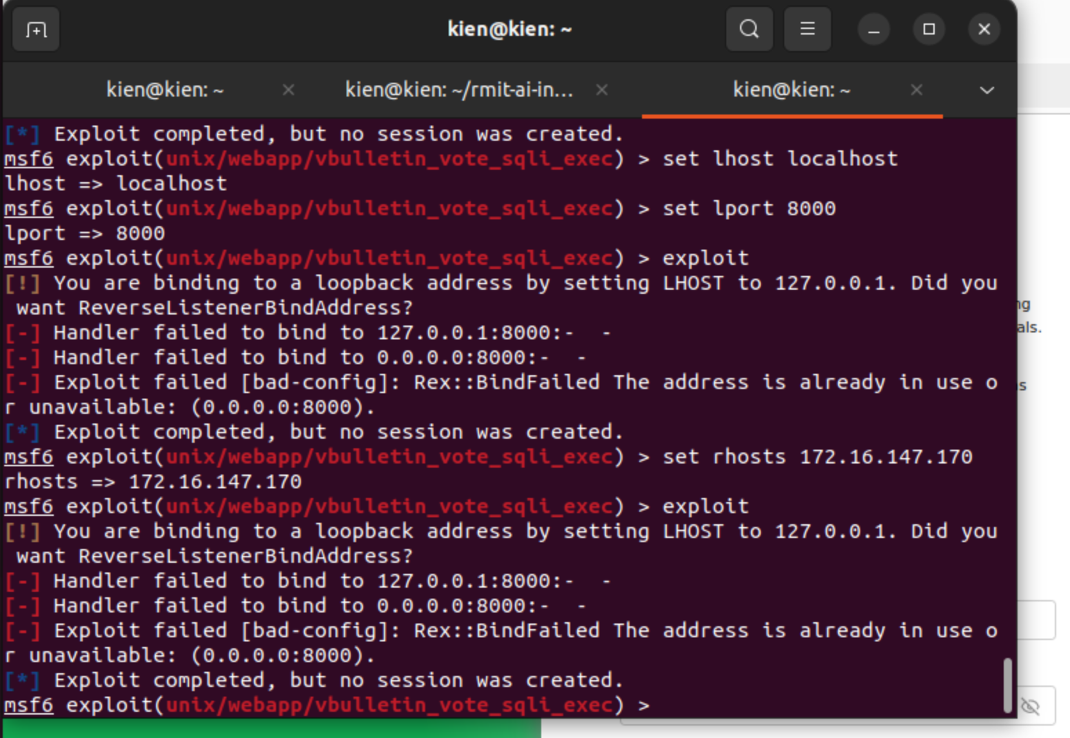
Figure 3. The exploits to localhost:8000

