PTES SCOPE DENIFITION

1. Mininet
This is the screenshot of a custom topology in Mininet. This topology contains 2 hosts and 1 switch.
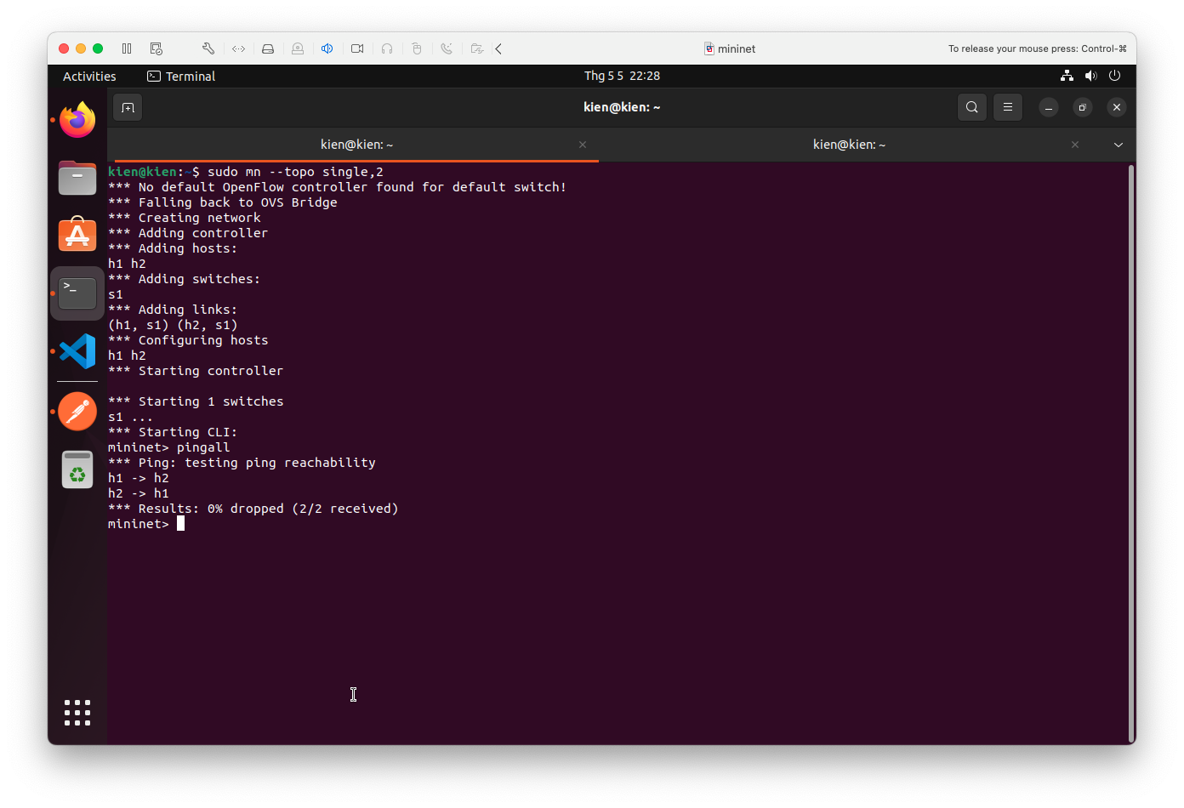
2. The blockchain api
This is the screenshot of apis and their response related to Ethereum. We collect the data from machine learning models and push them into Ethereum through apis below. 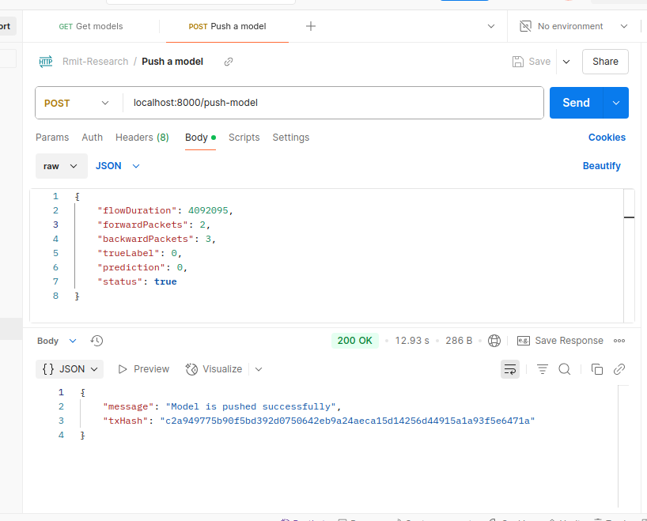
Figure 1. The push-model api
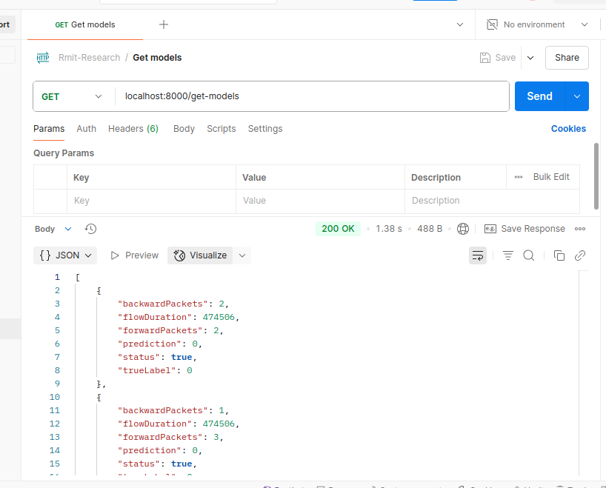
Figure 2. The get-models api

3. The transaction
This is the screenshot of the transaction created by the push-model api.
