TEST DEPLOYMENT

1. Logs
These logs show the APIs interacting with Ethereum testnet. Also, all interactions happen in a Linux virtual machine.

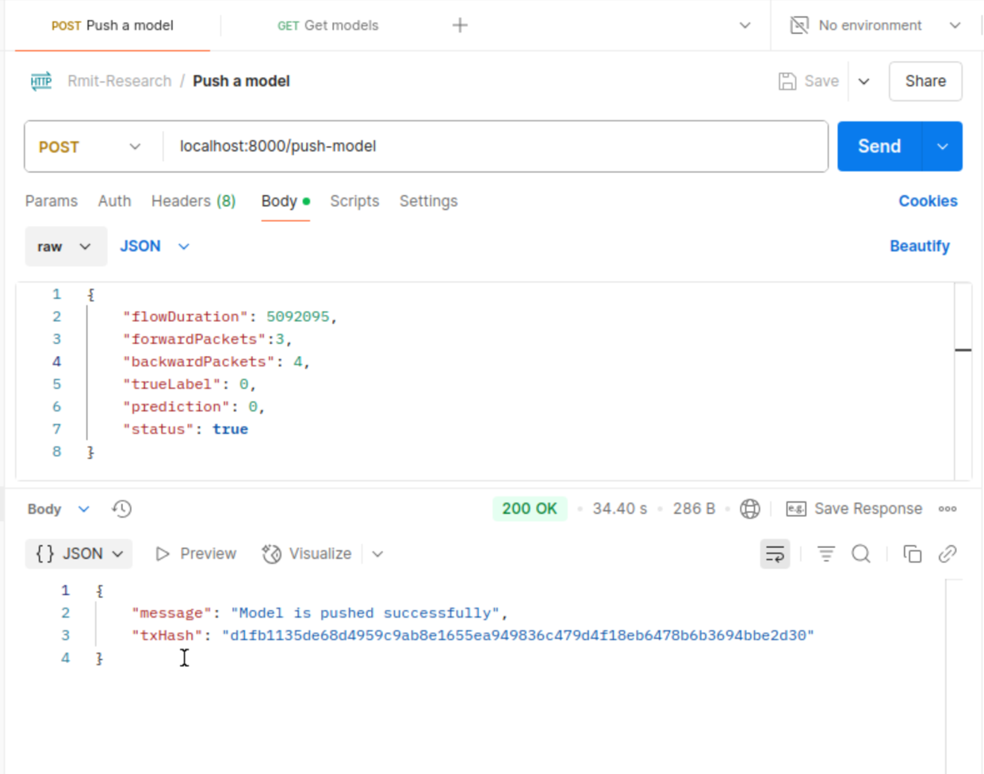
Figure 1. The push-model api

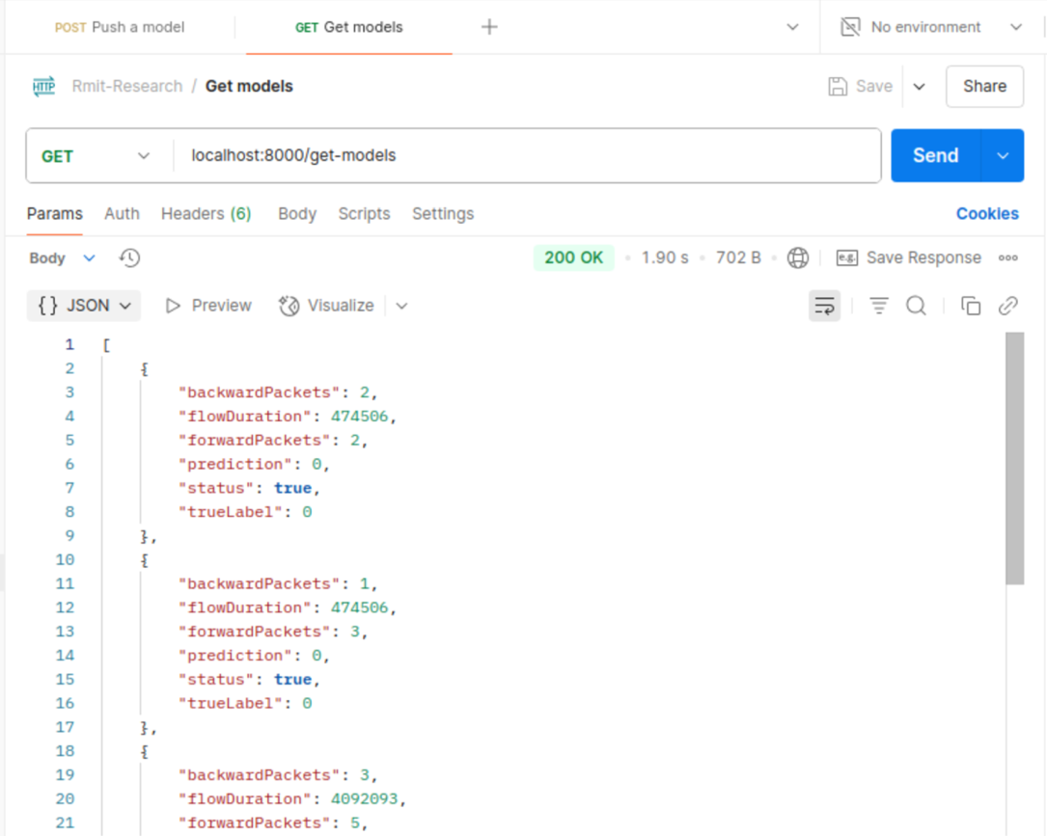
Figure 2. The get-models api

2. OpenDaylight
The screenshot shows the command line interface of OpenDaylight.

