**SECURITY TEST REPORT**

**1. Unauthorized access**

The invalid threatModel is provided to the input data.

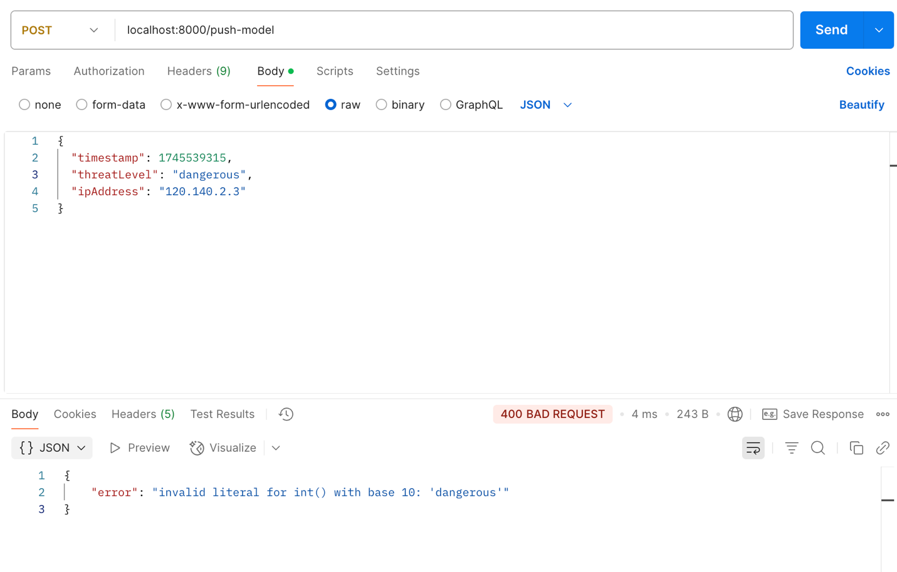

The invalid ipAddress is provided to the input data.

