**STABILITY PERFORMANCE REPORT**

**1. The API response time**

This is the API response time for adding a new record to Ethereum

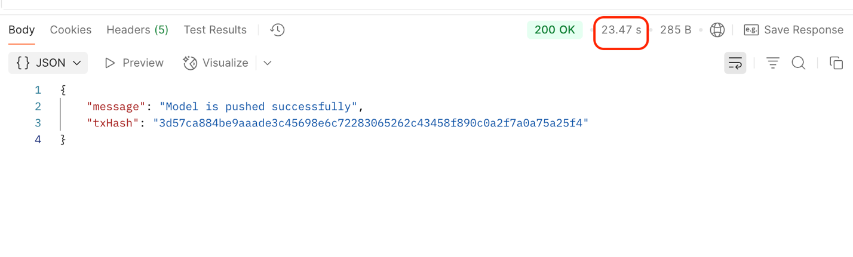

**2. The transaction**

This is the newly created transaction for the previous record

