1. **Introduction**
2. **Description/formulation of the problem**

I use the Concrete Compressive Strength dataset to perform linear regression. The input includes first eight columns (Cement, Blast Furnace Slag, Fly Ash, Water, Superplasticizer, Coarse Aggregate, Fine Aggregate, Age) as input and the nineth column as output (Concrete compressive strength)

From the given eight input, I will first try to do Uni-variate linear regression on each feature input to try to predict the outcome of the output. Then, I will do Multi-variate linear regression on all eights feature to try to predict the output. For both the Uni-variate linear regression and Multi-variate linear regression, I will use MSE as loss function/metric to measure the performance of linear regression. The lower the MSE, the better the model would be.

Finally, I will compare 9 models’ performance on both train and test dataset to draw conclusions from them.

1. **Details of your algorithm**
2. Uni-variate linear regression

Model formula: pred = m * x + b

Loss function (MSE): L = =

(the summation is performed on all data point)

Goal: minimize the MSE

Update rule: as the negative gradient direction is the steepest direction, I update both parameters b and m of its direction of negative gradient (with step size ):

mnew = m - = m -

bnew = b - = b - = b -

I keeps updating with certain number of iteration (10000 in my program).

1. Multi-variate linear regression

The idea is same for uni-variate linear regression, only the formula changes.

Model formula: pred = ( . ) (dot product between a and x)

= (a0, a1, …, an) – a0 is the intercept and = (1, x1, x2, …, xn) where xi is the input feature.

Loss function (MSE): L = = = * ||2

(X is the whole dataset’s input – n * (numFeature + 1) matrix, is the output – n * 1 matrix)

new = - = a – XT * ()

1. **Pseudo-code**
2. Uni-variate linear regression

n = .shape[0]

loss =

m = b = random()

itr = 0

While itr < 20000:

y_pred =

m =

b = b – * sum()

loss =

itr += 1

return m, b

1. Multi-variate linear regression

X = append(1, X)

a = [random() for _ in (numFeature + 1)]

loss = norm(X * a - y)) ^ 2

itr = 0

While itr < 20000:

a = a – * X * (X * a - y)

loss = norm(X * a - y)) ^ 2

return a

1. **Results**
2. **MSEs of models on the training/ testing dataset**

|  |  |  |  |
| --- | --- | --- | --- |
| Index | Feature used | MSE train | MSE test |
| 1 | Cement | 249.3 | 110.8 |
| 2 | Blast Furnace Slag | 1002.9 | 343.6 |
| 3 | Fly Ash | 1115.1 | 750.2 |
| 4 | Water | 358.1 | 186.9 |
| 5 | Superplasticizer | 741.6 | 303.4 |
| 6 | Coarse Aggregate | 322.3 | 166.0 |
| 7 | Fine Aggregate | 333.4 | 171.5 |
| 8 | Age | 931.5 | 666.2 |
| All (multi regression) | All | 118.6 | 62.1 |

1. **Plots of trained uni-variate models**

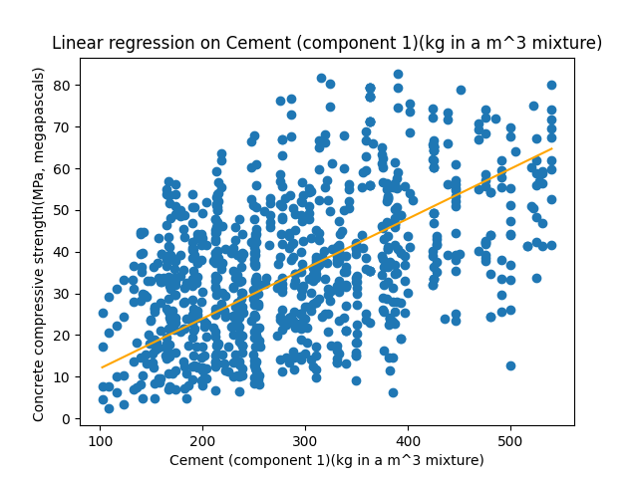

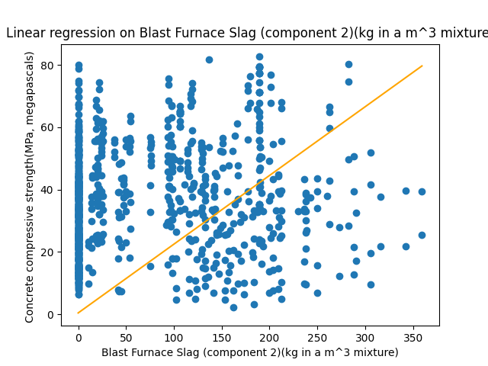

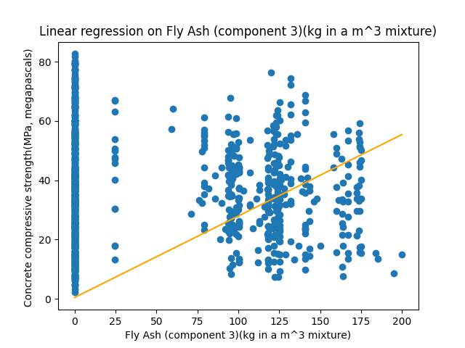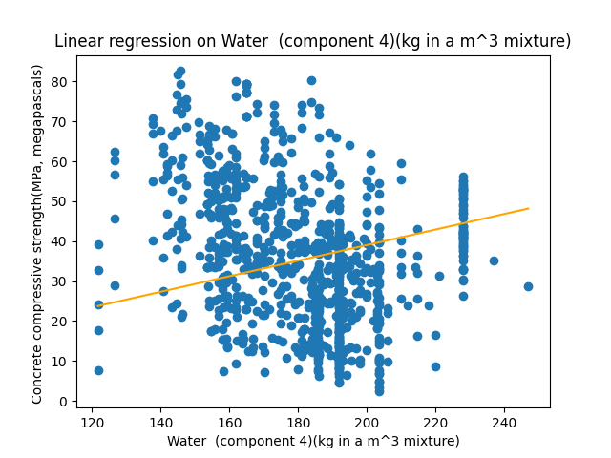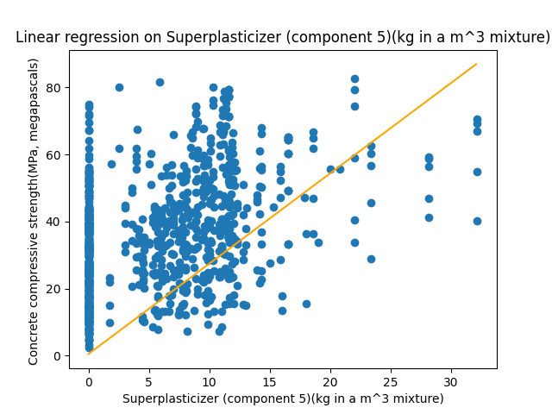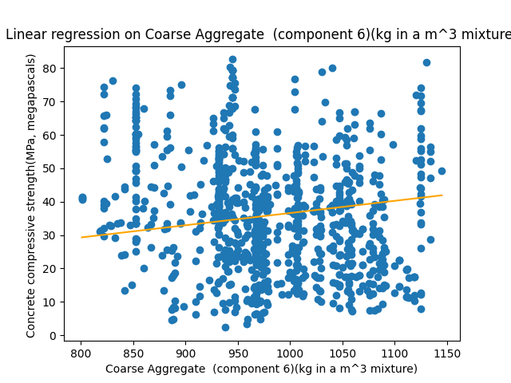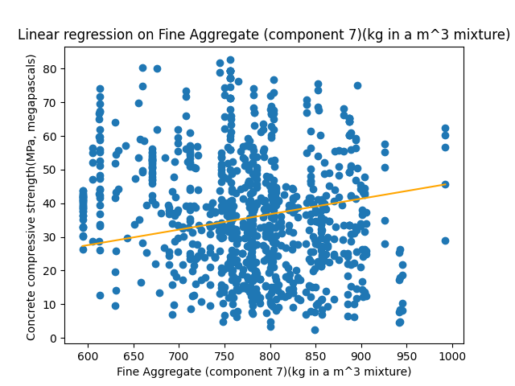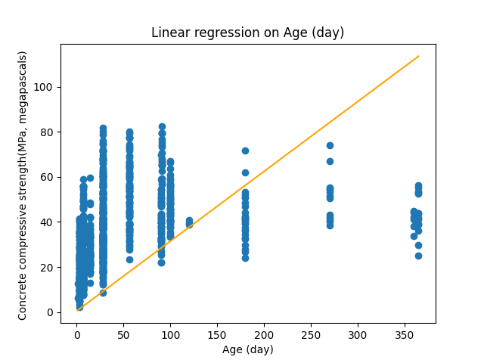

1. **Discussion**
2. **Different models compared in performance on the training data**

Sorted by the MSE on training data, we have:

The first row with lowest MSE on train data is multi-variate linear regression. The rest is uni-variate linear regression models.

We can see from the table that, on training data, it is the multi-variate linear regression that performs best. This makes sense, because the multi-variate linear regression has more data (8 features) to fit the output, compared to the other 8 uni-variate linear regression models that only have 1 feature to fit the output.

Between the 8 features, the ranking on performance on train data from best to worst is:

* Cement (component 1)
* Coarse Aggregate (component 6)
* Fine Aggregate (component 7)
* Water (component 4)
* Superplasticizer (component 5)
* Age (component 8)
* Blast Furnace Slag (component 2)
* Fly Ash (component 3)

Also, from the MSE on train data, we see that same model that performs well on train data also perform well on test data (the mse_test column is sorted from lowest to highest, except for the Blast Furnace Slag – the model somehow performs not so good on train data, but perform relatively better on test data)

1. **Performance of the uni-variate models predicted or failed to predict which features were “more important”in the multi-variate model(s)**

As the uni-variate model fit the data better, we can conclude that the model is “more important” in the multi-variate model.

So, similarly we have the order of “importance” between features on the multi-variate model:

Additionally, we have the coefficient (a) of the multi-variate linear regression model: a = [-4.57743033e-05 , 1.15877312e-01, 9.70640305e-02, 1.03922580e-01, -1.39596850e-01, 3.72044528e-02, 1.55534825e-03, 1.20004092e-02, 1.07326558e-01]

Arrange the coefficient with the respective feature (sorted by MSE on train data), we have

* Cement (component 1): 0.1159
* Coarse Aggregate (component 6): 0.00156
* Fine Aggregate (component 7): 0.012
* Water (component 4): -0.1396
* Superplasticizer (component 5): 0.0372
* Age (component 8): 0.1073
* Blast Furnace Slag (component 2): 0.09706
* Fly Ash (component 3): 0.1039

If we sort the features by their coefficient, we have

* Water (component 4): -0.1396
* Cement (component 1): 0.1159
* Age (component 8): 0.1073
* Fly Ash (component 3): 0.1039
* Blast Furnace Slag (component 2): 0.09706
* Superplasticizer (component 5): 0.0372
* Fine Aggregate (component 7): 0.012
* Coarse Aggregate (component 6): 0.00156

The order in magnitude of the coefficient does not match exactly on the order of the uni-variate model’s performance. I would explain the failure because the magnitude of features are different. The coefficient of the multi-variate linear regression model does not necessarily evaluate the importance of the feature with respect to the final output (for example, the coefficient can be small when the feature is relatively big compared to the output). Moreover, I am currently using the same step size and number of iteration for all the models. Some models may not be trained enough to reach the optimal position. Or, maybe the step size does not fit the feature’s magnitude.

1. **Draw some conclusions about what factors predict concrete compressive strength.**

From the uni-variate model’s performance and the coefficient of the multi-variate linear regression model, we can pick some features that have high rank on both data that I think can be the factors that predict concrete compressive strength:

* Cement (component 1)
* Water (component 4)

I believe these 2 components contribute to the concrete compressive strength.