**LAB 6:**

METAL: SILVER NANOPARTICLES

CHARACTERIZATION USING UV-VIS SPECTROSCOPY

**Course : Biomaterials_ S2_ 2020-21_G01**

**Instructor : Assoc. Prof. Nguyen Thi Hiep**

**Teaching Assistants : Ms. Vo Ngoc Hai Chau**

**: Mr. Nguyen Quang Huy**

**Student name : Dai Quang Minh**

**Student ID : BEBEIU18059**

Table of content

**1.** **Introduction** 3

**2.** **Objectives** 9

**3.** **Materials** 9

**4.** **Experimental procedure** 9

**5.** **Results and Discussion** 11

**6.** **Conclusion** 13

**7.** **Acknowledgement** 14

**8.** **References** 14

1. **Introduction**
   1. **Nanosilver particles:**

Silver nano particles have been found to possess anti-bacterial properties and silver silica modified geopolymer mortar proves to be more efficient than OPC mortars in applications in CO2 rich environments. nano-silver particles have greater specific surface area compared with the same mass of material in larger particles and have a greater surface area-to-volume ratio. A 10-nm particle has approximately 35–40% of its atoms on the surface compared with 15–20% of the atoms on a particle larger than 30 nm in diameter. Nanoparticles have a broad surface area in comparison to their mass or length, which increases their reactivity and sorption behaviour. Smaller silver nanoparticles have more reaction sites (i.e., sites that can receive electrons) on their surfaces and are more sensitive to oxygen, a natural electron donor, than larger particles, which means that smaller silver nanoparticles have more reaction sites (i.e., sites that can receive electrons) on their surfaces and are more sensitive to oxygen, a natural electron donor. As a result, smaller particles can have a larger impact on environments or human health as biological agents or stressors. Nanotechnology is becoming more common and important in fields such as health care, cosmetics, food and feed, environmental health, mechanics, optics, biomedical sciences, chemical industries, electronics, space industries, drug-gene delivery, energy science, optoelectronics, catalysis, single electron transistors, light emitters, nonlinear optical devices, and photo-electronics. Nanoparticles (NPs) have structures ranging from 1 to 100 nanometers. **[1]**

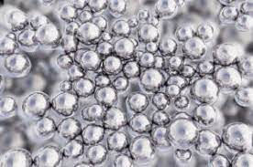 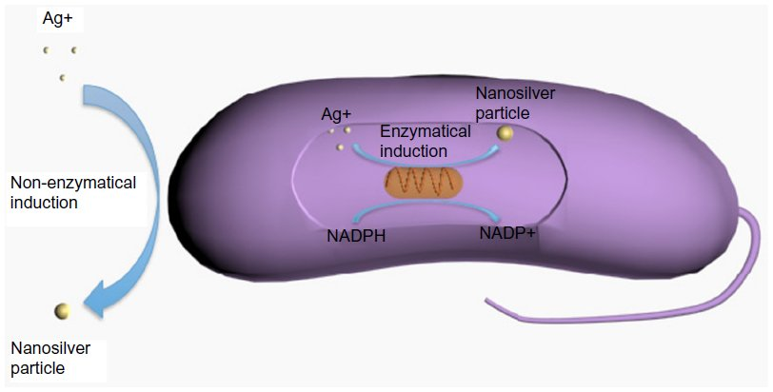

*Figure 1: Nanosilver particle*

In at least one dimension, nanosilver particles (NSPs) range in size from 1 to 100 nm. The surface area-to-volume ratio of NSPs increases significantly as particle size decreases, resulting in major improvements in their physical, chemical, and biological properties. For hundreds of years, NSPs have been among the most widely used nanomaterials in our health-care environment. Because of their antibacterial, antifungal, antiviral, and anti-inflammatory properties, NSPs have recently sparked a lot of curiosity in biomedical applications. Biosensor materials, composite fabrics, cryogenic superconducting materials, consumer devices, and electrical components will all benefit from silver NPs' antimicrobial and conductivity properties. NSPs have been used in a variety of applications, including diagnosis, recovery, opioid administration, surgical equipment coating, wound dressings, medical textiles, and contraception. Since the use of nanosilver products is growing, a deeper understanding of nanosilver biological interactions and toxicity is becoming increasingly important. **[2]**

There are several methods for making silver NPs, each of which produces NPs with varying degrees of stability and aggregation, as well as control over crystal growth, morphology, scale, and size distribution. Variable sizes, forms, morphology, and even durability result from different synthetic NSP paths. In general, these techniques can be divided into three categories: Synthesis may be physical, chemical, or biological (or green). In this lab, we'll look at two different ways to make nanosilver. **[2]**

**Chemical synthesis:**

Chemical reduction is the most common form of nanosilver synthesis, and it uses three main components to regulate NSP growth: silver salt, reductants, and a stabilizer or capping agent. Silver nitrate is one of these silver salts that is often used for NSPs due to its low cost and chemical consistency as opposed to other silver salts. Boron hydride, citrate, ascorbate, and hydrogen gas are among the reductants. Since borohydride may also serve as an NSP stabilizer and prevent NSP aggregation during its decomposition, it is a good reducing agent that can result in small particles with a faster reduction rate. In a two-phase water-organic method, NSPs may also be made. This approach generates nanoparticles that are uniform and controllable. The rate of contact may be regulated by the degree of interphase transport between the aqueous and oil phases in this system; however, large quantities of surfactant and organic solvent can contaminate the surface of formed NSPs and removing surfactant and organic solvent is time-consuming and costly. **[3]**

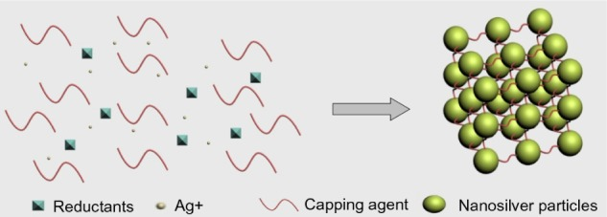

*Figure 2: Chemical synthesis of nanosilver particles.*

**Physical synthesis:**

The primary physical methods for extracting nanosilver from metal samples are evaporation/condensation and laser ablation. To manufacture NSPs, the evaporation/condensation method uses a furnace tube under atmospheric pressure; however, traditional furnace tubes have many disadvantages, including high energy consumption and a long time to reach thermal stability. Jung et al used a small ceramic heater with a local heating field, which enabled the evaporated vapor to cool at a satisfactory rate, resulting in a high concentration of nanosilver. Laser synthesis produces pure nanosilver colloids by ablation of metals in solution without the use of chemical reagents. Laser fluence and the number of laser shots influence nanosilver concentration and morphology. Larger particle size and concentration are the product of increased laser fluence and time. Tien et al. recently published a paper about a novel arc-discharge process for producing silver suspension in pure water without the use of surfactants or stabilizers. Silver wires were used as positive and negative electrodes in their study, and they were etched in pure water. The surface layer of the silver wires was evaporated and condensed in the water during discharge, resulting in stable and well-dispersed NSPs of 20–30 nm in duration. **[3]**

* 1. **UV-Vis spectroscopy**

UV-VIS spectroscopy, like FTIR, is a method for determining the purity of drug compounds. Many molecules contain chromophores, which absorb ultra violet or visible light at particular wavelengths. The absorption of spectra produced from these samples at given wavelengths can be directly compared to the sample concentration using the Beer Lambert law. Normally, UV and UV-VIS spectra are recorded at high and low pH, and the effects of both are compared to established criteria for the sample in question. UV-VIS is a simple and inexpensive technique that allows for sample recovery and good separation of pure compounds without the need for derivitisation. For street samples containing complex mixtures, it is less useful **[4].** UV-Vis Spectroscopy is a widely used technique for determining the composition of a solution. It is based on the assumption that concentration and color intensity are associated, and Beer's Law demonstrates this relationship.

I (λ) = I0 (λ) e-ε e (λ) cl

where: I(λ) is the intensity of the light of wavelength λ travels through the sample.

I0(λ) is the intensity of the light with wavelength λ before traveling through the sample.

εe(λ) is the extinction coefficient in base e (M−1cm−1)

c is the concentration of the initial quantum state of the sample (M)

l is the sample path length (cm)

UV-Vis spectroscopy is a method of absorption spectroscopy in which the molecule absorbs UV-visible radiation. The excitation of electrons from lower to higher energy levels occurs as UV-visible radiation is absorbed. Only certain functional groups (chromophores) in organic molecules with low excitation energy valence electrons can absorb ultraviolet and visible light. Because of the high absorption of heme groups, C-Cyts are an excellent target molecule for UV-visible spectroscopy. The heme's strong UV-visible absorption bands are caused by the transitions, which provide details about the heme's type, oxidation, and spin state of the central iron ion. Biofilms can be measured in vivo under physiologically relevant conditions using UV-visible spectroscopy **[5]** As white light (which includes all wavelengths in the UV-Vis pectrum) is shone through a colored compound, it selectively absorbs one wavelength while reflecting the others. This is because the molecule's electrical structure only allows for discrete energy levels. The amount of energy required to excite a molecule from one energy level to the next corresponds to a wavelength defined by the equation:

$$= \frac{hc}{E}$$

where: h= 6.626 x 10-34 (Js) is the Planck constant.

c= 3 x 108 (ms-1) is the speed of light.

E (J) is the difference in energy level

UV/visible spectroscopy can be used to detect organometallic organisms, but it cannot be used to track the organic portion of standard metathesis reactions. Ruthenium species that are essential in alkene metathesis are usually brightly colored (red or green) and have molar absorptivities of about 103 L mol1 cm1. This method has thus been widely applied to the study of precatalyst initiation, in which the decrease in precatalyst absorbance can be tracked over time and used to calculate rate constants for precatalyst initiation with various complexes, substrates, and solvents. The color observed is the complementary color of that the sample absorbed. This relationship is demonstrated in the complimentary color wheel **[6].** A sample that strongly absorbs a wavelength of 400nm, for example, will appear yellow. The colors that are diametrically opposed form an absorbed observed pair.

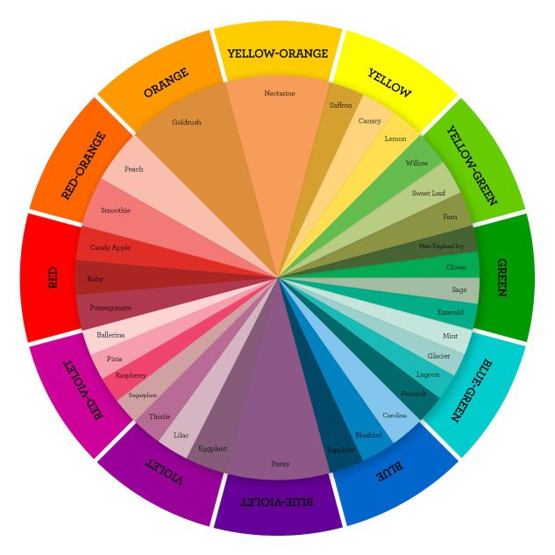

*Figure 3: Complementary color wheel.*

Absorption spectroscopy and reflectance spectroscopy in the UV–vis spectral field are used in UV–vis spectroscopy. Molecules with -electrons or non-bonding electrons (n-electrons) can absorb UV or visible light and be excited to higher anti-bonding molecular orbitals. In the ultraviolet or visible region, molecules undergo electronic transitions, while in the IR region, they undergo vibrational transitions. UV–vis spectroscopy differs from IR spectroscopy in the excitation wavelengths except that molecules undergo electronic transitions in the ultraviolet or visible region, while they undergo vibrational transitions in the IR region. Since most biomaterials are not in a solution, the molar extinction coefficients of certain biomaterials in a solution are uncertain, and calibration curves are difficult to obtain, this application of UV–vis spectroscopy to biomaterials is not widely used. Instead of concentrations, UV–vis spectroscopy is used to determine the absorbance spectra of a sample containing biomaterials. The absorption spectrometer is illustrated schematically in the diagram below. The absorption spectrometer uses a monochromator to screen and only let a small spectrum of wavelengths flow through the sample in order to determine the intensity of the light reflected through it. The photons strike a photodetector, which generates an electric pulse equal to the amount of light observed, which is then processed by the device to generate an absorption spectrum. **[7]**

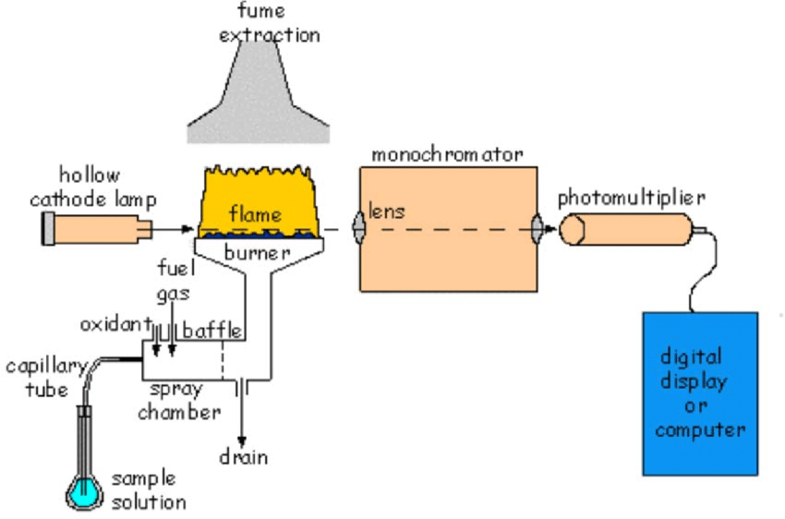

*Figure 4: Schematics of the absorption spectrometer. To pick the desired wavelength, it uses a set of mirrors and diffraction gratings. It is possible to get a readout of the emitted light.*

In order to be loaded into the UV-Vis spectrometer, solutions are stored in cuvettes. An example of a readout obtained from a nanogold (AuNP) solution as shown below. The wavelength with the greatest absorbance, as seen in the spectrogram, is 525 nm, which corresponds to the color orange. Since red and green are contrasting colors, the light that travels through the sample and reaches our eyes is red. This matches the appearance of the AuNP solution that was obtained.

*Figure 5: UV-Vis spectrogram of nanogold solution.*

**Microplate reader**

A microplate reader is a laboratory device that measures chemical, biological, or physical reactions, properties, and analytes in microplate wells. A microplate is made up of small wells where different reactions take place. The involvement of an analyte or the progression of biochemical processes was converted into optical signals in these reactions. These signals are detected by the microplate reader, which quantifies the parameter of interest. Several biological and chemical assays in a microplate are quantified using a microplate reader. Nowadays, the availability of a wide range of reagent kits allows a microplate reader to be used in a wide range of fields and applications. Plate readers are used in environmental science, as well as the agricultural and cosmetics industries, in addition to biological, biochemical, and medicinal research in both academic and industrial settings. The multimode microplate reader is a flexible instrument that can be used for a variety of tasks. Measuring UV-Vis absorbance (which we can use in the lab), fluorescence intensity, luminescence, and other parameters are among them. While the UV-Vis spectrometer can only measure one sample at a time, the microplate reader can measure several samples (up to 96 in this lab) at the same time! The UV-Vis spectrometer's working theory is the same. **[8]**

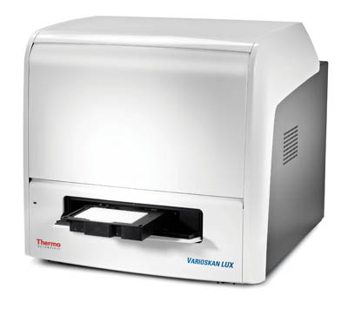 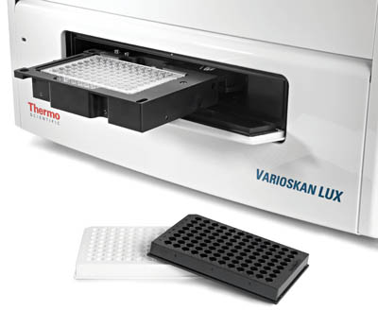

*Figure 6: Varioskan LUX Multimode Microplate Reader*

**Cuvette material**

It can be difficult to use cuvettes for UV VIS measurements. Since not all cuvette materials are suitable for all experiments, some basic knowledge is needed. We'll take you through the crucial considerations to remember when buying a UV VIS cuvette using this page as a reference. The material of the cuvette used to store your solution is another critical concern when calculating UV-Vis spectroscopy. Optical glass, UV quartz, IR quartz, and sapphire are the four most popular materials used in cuvettes. Each content refers to a particular wavelength range in which precise and consistent measurements can be made. The more wavelength range that can be accurately measured, the more expensive the object. Both of these materials have advantages and disadvantages. **[9]**

* **Optical glass:** If you're working on a limited budget, an Optical Glass cuvette is the way to go. This cuvette material is excellent for work in the visible range, with a transmitting range of 340-2,500 nm. The majority of applications will fall under this spectrum, and many will not need the additional UV points that the other materials have.
* **UV Quartz:** Optical Glass is a step up from UV Quartz. Quartz costs a little more, but it has a wider transmission spectrum, ranging from 190 to 2,500 nm. A UV quartz cuvette is needed for UV experiments, and we strongly advise against cutting corners here because your data will suffer as a result of using a low-cost UV cell.
* **IR Quartz:** For UV VIS measurements, IR Quartz is an excellent substitute for cuvettes. The transmitting range is 220-3,500 nm, so you get some UV but also a good range of infrared.
* **Sapphire:** Sapphire is a fantastic material for cuvettes. Sapphire is a super strong stone that is both scratch resistant and corrosion resistant. On sapphire, the transmission frequency is a staggering 250-5,000 nm. Of course, this is the costliest of the four, making it ideal for those with a limited budget and require a wide optical range. Note the material used for your cuvette in today's trial, and research which cuvette material is best for AgNPs.

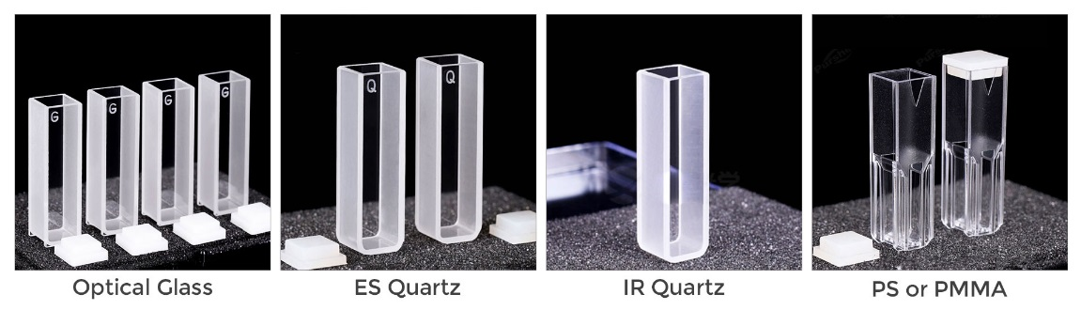

*Figure 7: UV-vis Spectrophotometer cuvette materials*

*Table 1: Wavelength range for different types of cuvette materials*

1. **Objectives**

* Synthesize silver nanoparticles and understand its applications
* Understand the fundamentals of UV-Vis spectroscopy and how to do it.

1. **Materials**

* Chemicals: Tri-sodium citrate.2H2O, acid tannic, silver nitrate (AgNO3),

1. **Experimental procedure**

My team is assigned to synthesize silver NPs using chemical method (this lab section has 2 methods: chemical method and irradiation method)

1. 0.147 g Tri-sodium citrate.2H2O was dissolved in 50 mL distilled water at 90°C.

*Figure 8: Tri-sodium citrate.2H2O was dissolved in distilled water at 90°C.*

1. Then 0 μL,50 μL, or 100 μL of acid tannic was applied for 10-15 minutes (our team is assigned to add 50 μL of acid tannic)

*Figure 9: 50 μL of acid tannic was added and the the color changes.*

1. After that, 200 μL of silver nitrate (AgNO3) 50 mM (0.17 g/ 20 mL H2O) was applied to the solution, which was constantly boiled and stirring for 15-20 minutes after the color changed.

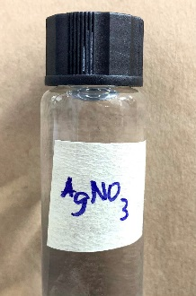

*Figure 10: 200 μL of silver nitrate (AgNO3) 50 mM (0.17 g/ 20 mL H2O).*

1. The finished product was cooled to room temperature.

*Figure 11: Comparison of final solution with different volume of acid tannic added (50 μL, 100 μL, 500 μL, respectively).*

1. From wavelength 200 to 600nm, the absorbance spectra of AgNPs is measured using a UV-Vis spectrometer or a microplate reader.

*Figure 12: The absorbance spectra of AgNPs were measured with a UV-Vis spectrometer or microplate reader.*

1. **Results and Discussion**

*Figure 13: UV-Vis spectrometer measurement of AgNPs*

From the UV- Vis measurement of AgNPs with the volume of acid tannic added to solution equal to 50 μL, we found a graph with a maximum peak at approximately 420 nm. The graph has only 1 single maximum peak and the peak at this wavelength is also very pronounced (the absorbance values ​​at 420nm are significantly higher than the absorbance values ​​at the other wavelengths). In addition, the graph of UV- Vis measurement of AgNPs with volume of acid tannic added to solution equal to 50 μL has only 1 peak and this is also the maximum peak as mentioned above. Hence, this proves that with a volume of acid tannic added to solution equal to 50 μL, nano silver particles will exist in the final solution. The nano silver particle is absorbed at wavelength from 408 nm to 420 nm, and this is also the maximum peak seen from the graph above, indicating that nano silver particle is present in the final solution.

*Figure 14: UV-Vis spectrometer measurement of AgNPs (volume of acid tannic added=100 μL)*

From the UV- Vis measurement of AgNPs with the volume of acid tannic added to solution equal to 100 μL, we found a graph with a maximum peak at approximately 408 nm. Although other absorbance values at other wavelengths are almost as high as the absorbance values ​​at 408nm, the absorbance values ​​at 408nm are still higher than the absorbance values ​​at the other wavelengths. Thus, the peak at this wavelength (408 nm) is the pronounced peak need to be assessed. Thanks to the peak at wavelength 408 nm, it proves that with a volume of acid tannic added to solution equal to 100 μL, nano silver particles will exist in the final solution. The nano silver particle is absorbed at wavelength from 408 nm to 420 nm, and this is also the maximum peak seen from the graph above, indicating that nano silver particle is present in the final solution.

*Figure 14: UV-Vis spectrometer measurement of AgNPs (volume of acid tannic added=500 μL)*

From the UV- Vis measurement of AgNPs with the volume of acid tannic added to solution equal to 500 μL, we do not find the maximum peak at any wavelengths. This is because the amount of tannic acid added to the solution is too much, leading to the absorbance value at some wavelengths exceeding the specified level, leading to the solution no longer being stable enough to produce a nano silver particle like physics. theory. The nano silver particle can also be generated but will disappear or be converted to a different substance or state, the nano silver particle cannot exist in the final solution without too much acid tannic. Thus, we cannot find any pronounced peak to assess whether nano silver particle exist in final solution or not. Due to this, it proves that with a volume of acid tannic added to solution equal to 500 μL, nano silver particles cannot be created or existed in the final solution (the nano silver particle is absorbed at wavelength from 408 nm to 420 nm).

**Comparison of different volume of acid tannic added (50 μL, 100 μL, 500 μL):**

* **50 μL:** The graph has only 1 single maximum peak and the peak at this wavelength is also very pronounced (the absorbance values ​​at 420nm are significantly higher than the absorbance values ​​at the other wavelengths). In addition, the graph of UV- Vis measurement of AgNPs with volume of acid tannic added to solution equal to 50 μL has only 1 peak and this is also the maximum peak as mentioned above. Hence, this proves that with a volume of acid tannic added to solution equal to 50 μL, nano silver particles will exist in the final solution
* **100 μL:** Although other absorbance values at other wavelengths are almost as high as the absorbance values ​​at 408nm, the absorbance values ​​at 408nm are still higher than the absorbance values ​​at the other wavelengths. Thus, the peak at this wavelength (408 nm) is the pronounced peak need to be assessed. Thanks to the peak at wavelength 408 nm, it proves that with a volume of acid tannic added to solution equal to 100 μL, nano silver particles will exist in the final solution
* **500 μL:** We do not find the maximum peak at any wavelengths. This is because the amount of tannic acid added to the solution is too much, leading to the absorbance value at some wavelengths exceeding the specified level, leading to the solution no longer being stable enough to produce a nano silver particle like physics. theory. The nano silver particle can also be generated but will disappear or be converted to a different substance or state, the nano silver particle cannot exist in the final solution without too much acid tannic. Thus, we cannot find any pronounced peak to assess whether nano silver particle exist in final solution or not. Due to this, it proves that with a volume of acid tannic added to solution equal to 500 μL, nano silver particles cannot be created or existed in the final solution

🡪 With a volume of acid tannic added to solution equal to 50 μL and 100 μL, nano silver particles will exist in the final solution. On the other hand, with a volume of acid tannic added to solution equal to 500 μL, nano silver particles cannot be created or existed in the final solution.

1. **Conclusion**

For this lab session (Metal: Silver nanoparticles. Characterization using UV-Vis spectroscopy), our group gain many helpful knowledges such as: Synthesize silver nanoparticles and understand its applications, understand the fundamentals of UV-Vis spectroscopy and how to do it. Moreover, this lab session provides us some major significant findings. With a volume of acid tannic added to solution equal to 50 μL and 100 μL, nano silver particles will exist in the final solution. On the other hand, with a volume of acid tannic added to solution equal to 500 μL, nano silver particles cannot be created or existed in the final solution.

In future, the UV-Vis spectroscopy should be further investigated and take advantage to apply for determination of characteristics of various biomaterials. Moreover, the technique of the UV-Vis spectroscopy should also be studied and improved to be more convenient, efficient and productive to utilize popularly.

1. **Acknowledgement**

I would like to express my special thanks of gratitude to my teacher (Assoc. Prof. Nguyen Thi Hiep) as well as my teaching assistants (Ms. Vo Ngoc Hai Chau, Mr. Nguyen Quang Huy) who gave me the golden opportunity to do this wonderful lab session on the topic (Metal: Silver nanoparticles. Characterization using UV-Vis spectroscopy) which also helped me in doing a lot of research and i came to know about so many new things I am really thankful to them.

1. **References**

**[1]** Beaudrie, C., Kandlikar, M. and Ramachandran, G., 2021. Using Expert Judgment for Risk Assessment.

**[2]** Xing, M., Ge, L., Wang, M., Li, Q., Li, X. and Ouyang, J., 2021. Nanosilver particles in medical applications: synthesis, performance, and toxicity.

**[3]** Güzel, R. and Erdal, G., 2021. Synthesis of Silver Nanoparticles.

**[4]** NicDaéid, N., 2021. Systematic Drug Identification.

**[5]** Pentassuglia, S., Agostino, V. and Tommasi, T., 2021. EAB—Electroactive Biofilm: A Biotechnological Resource.

**[6]** Nelson, D. and Percy, J., 2021. The Influence of Structure on Reactivity in Alkene Metathesis.

**[7]** Wang, H. and Chu, P., 2021. Surface Characterization of Biomaterials.

**[8]** Walsh, B., Thornton, S., Penny, R. and Breit, S., 2021. Microplate reader-based quantitation of collagens.

**[9]** Eriksson, E. and Agmo Hernández, V., 2021. Choice of cuvette material can influence spectroscopic leakage and permeability experiments with liposomes.