China Post-Graduate Mathematical Contest in Modeling
International Track Registration and Submission Manual

Contents
1 Registration 1
1.1 Obtain the Registration Link 1
1.2 Open the Registration Link in a Browser 1
1.3 Enter Team Leader Information 1
1.4 Enter Team Information 2
1.5 Enter Team Member Information 2
1.6 Submit Registration 3
2 Submission 4
2.1 Obtain the Submission Link 4
2.2 Open the Submission Link in a Browser 4
2.3 Download Problems 4
2.4 View the Problem Decompression Password 5
2.5 Submit Paper 5
2.6 Submit Attachments 6
2.7 View Paper 7

Registration

Obtain the Registration Link
Obtain the registration link from the Participation Guidelines on the English-language website of the China Post-Graduate Mathematical Contest in Modeling.

Open the Registration Link in a Browser
Copy the registration link and open it in the browser address bar. The registration page contains three sections: team leader information, team information, and team member information.

Enter Team Leader Information
Recommendation: For universities in China (including the Chinese mainland, Hong Kong, Macao, and Taiwan), it is recommended to enter the university name in Chinese. For other international universities, the university name may be entered in English or Chinese.
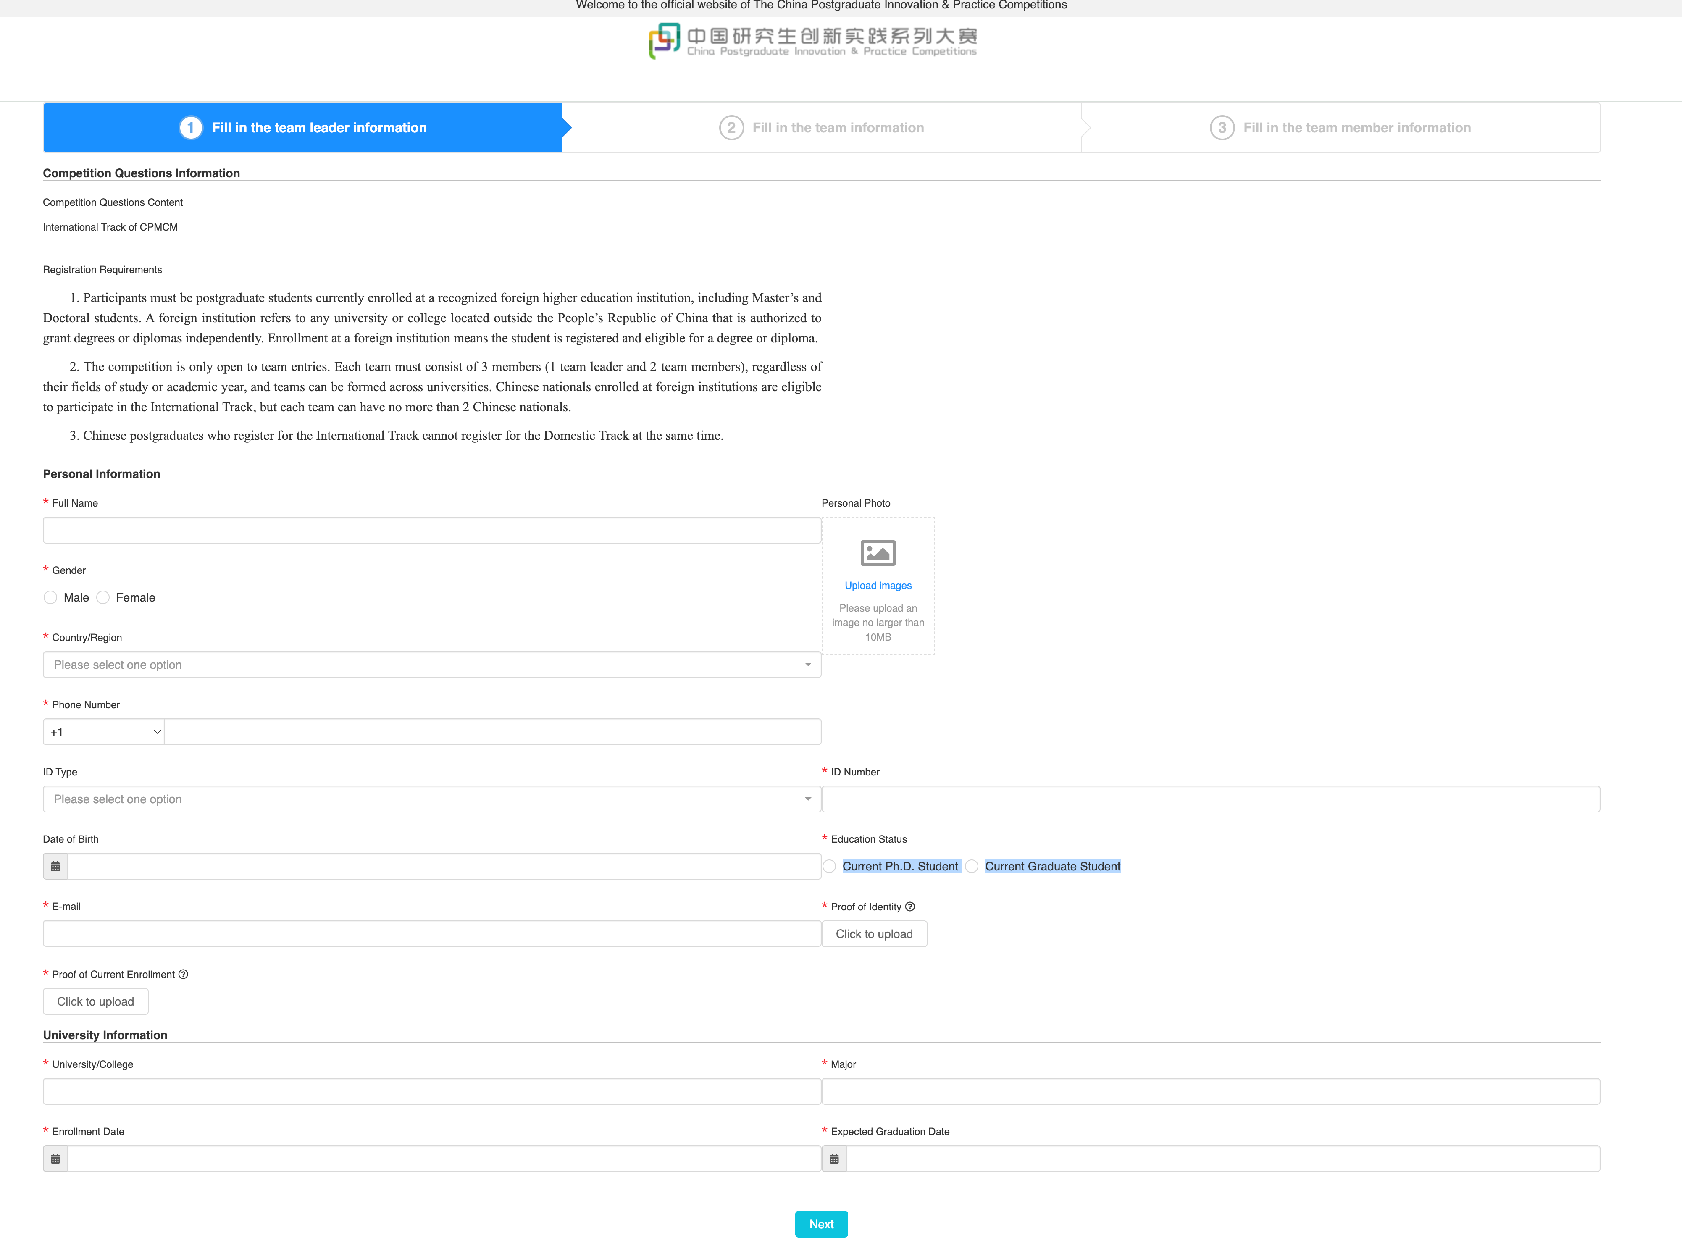
Enter Team Leader Information

Enter Team Information
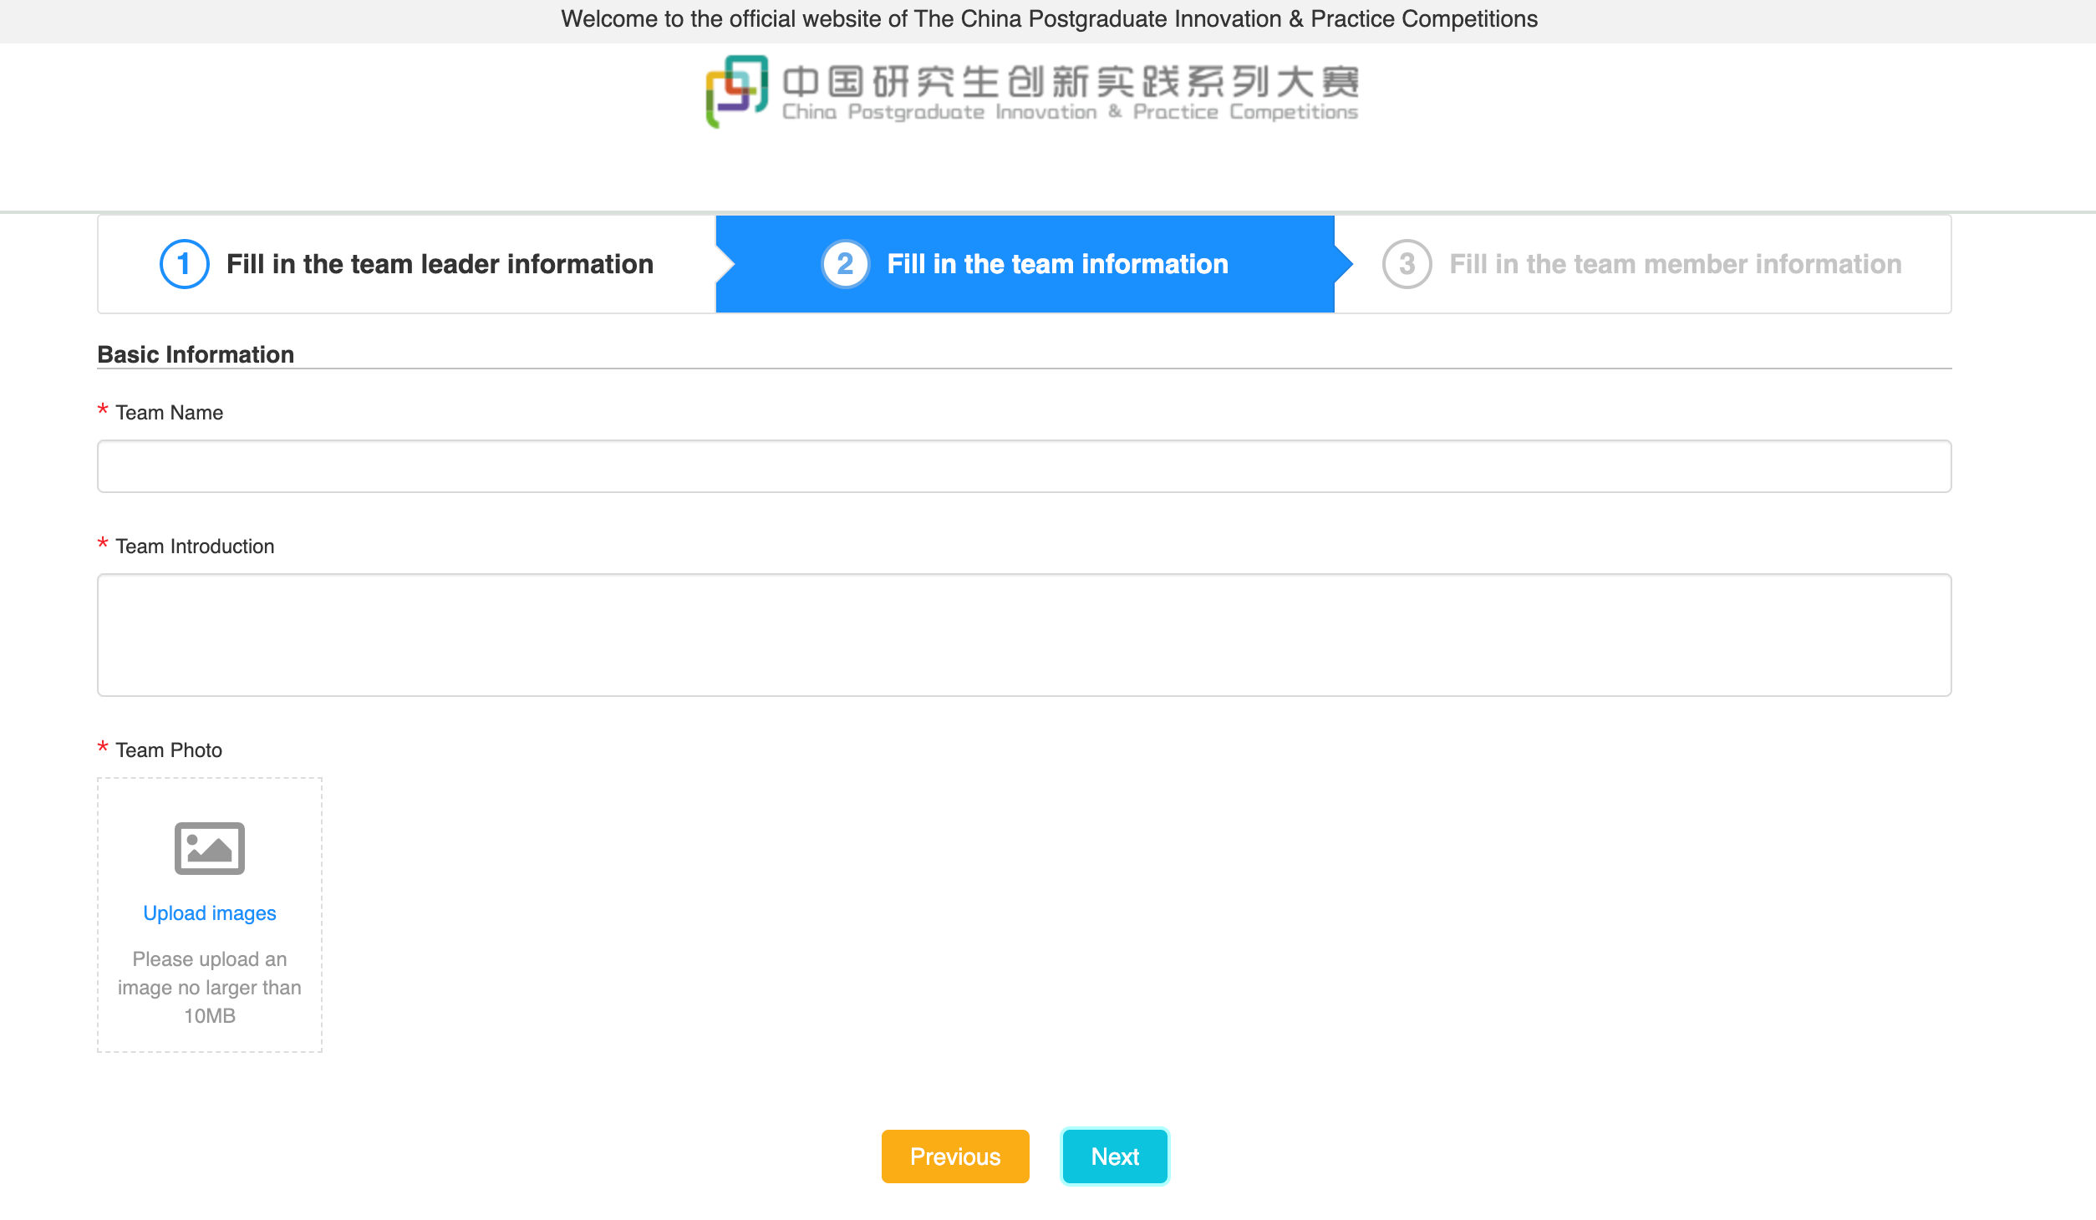
Enter Team Information

Enter Team Member Information
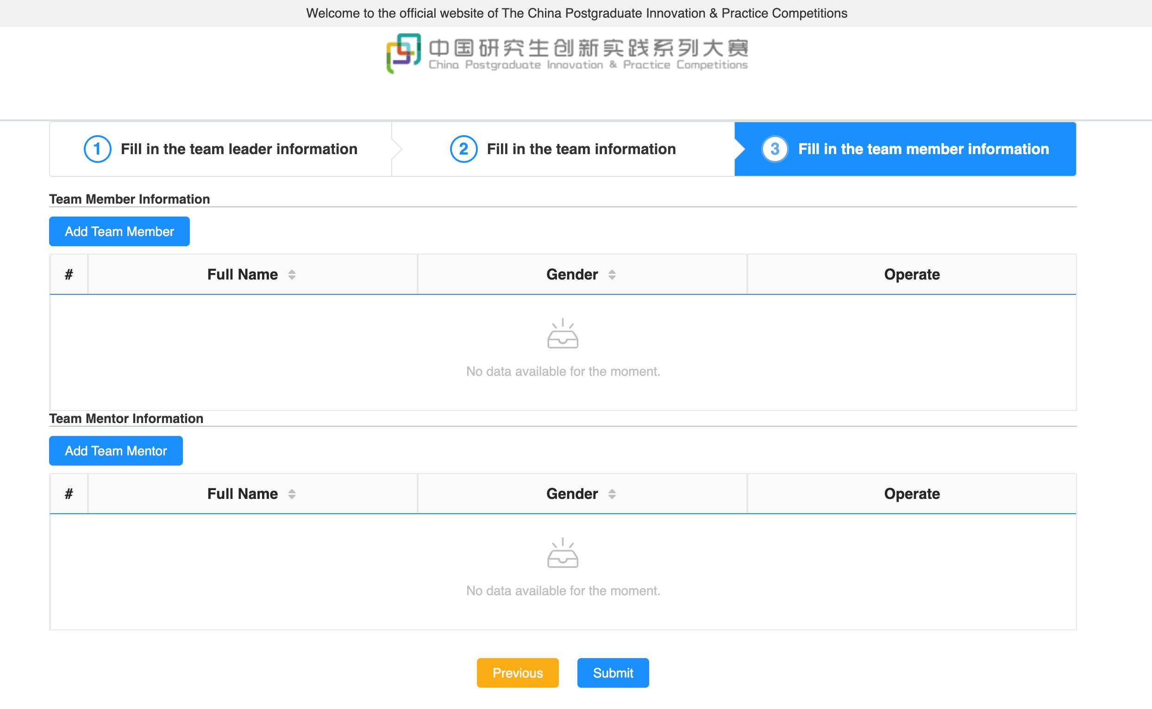
Enter Team Member Information

Submit Registration
After submitting the registration, it is recommended to save the URL in the browser address bar so that you can use the same link later to view the team registration information.
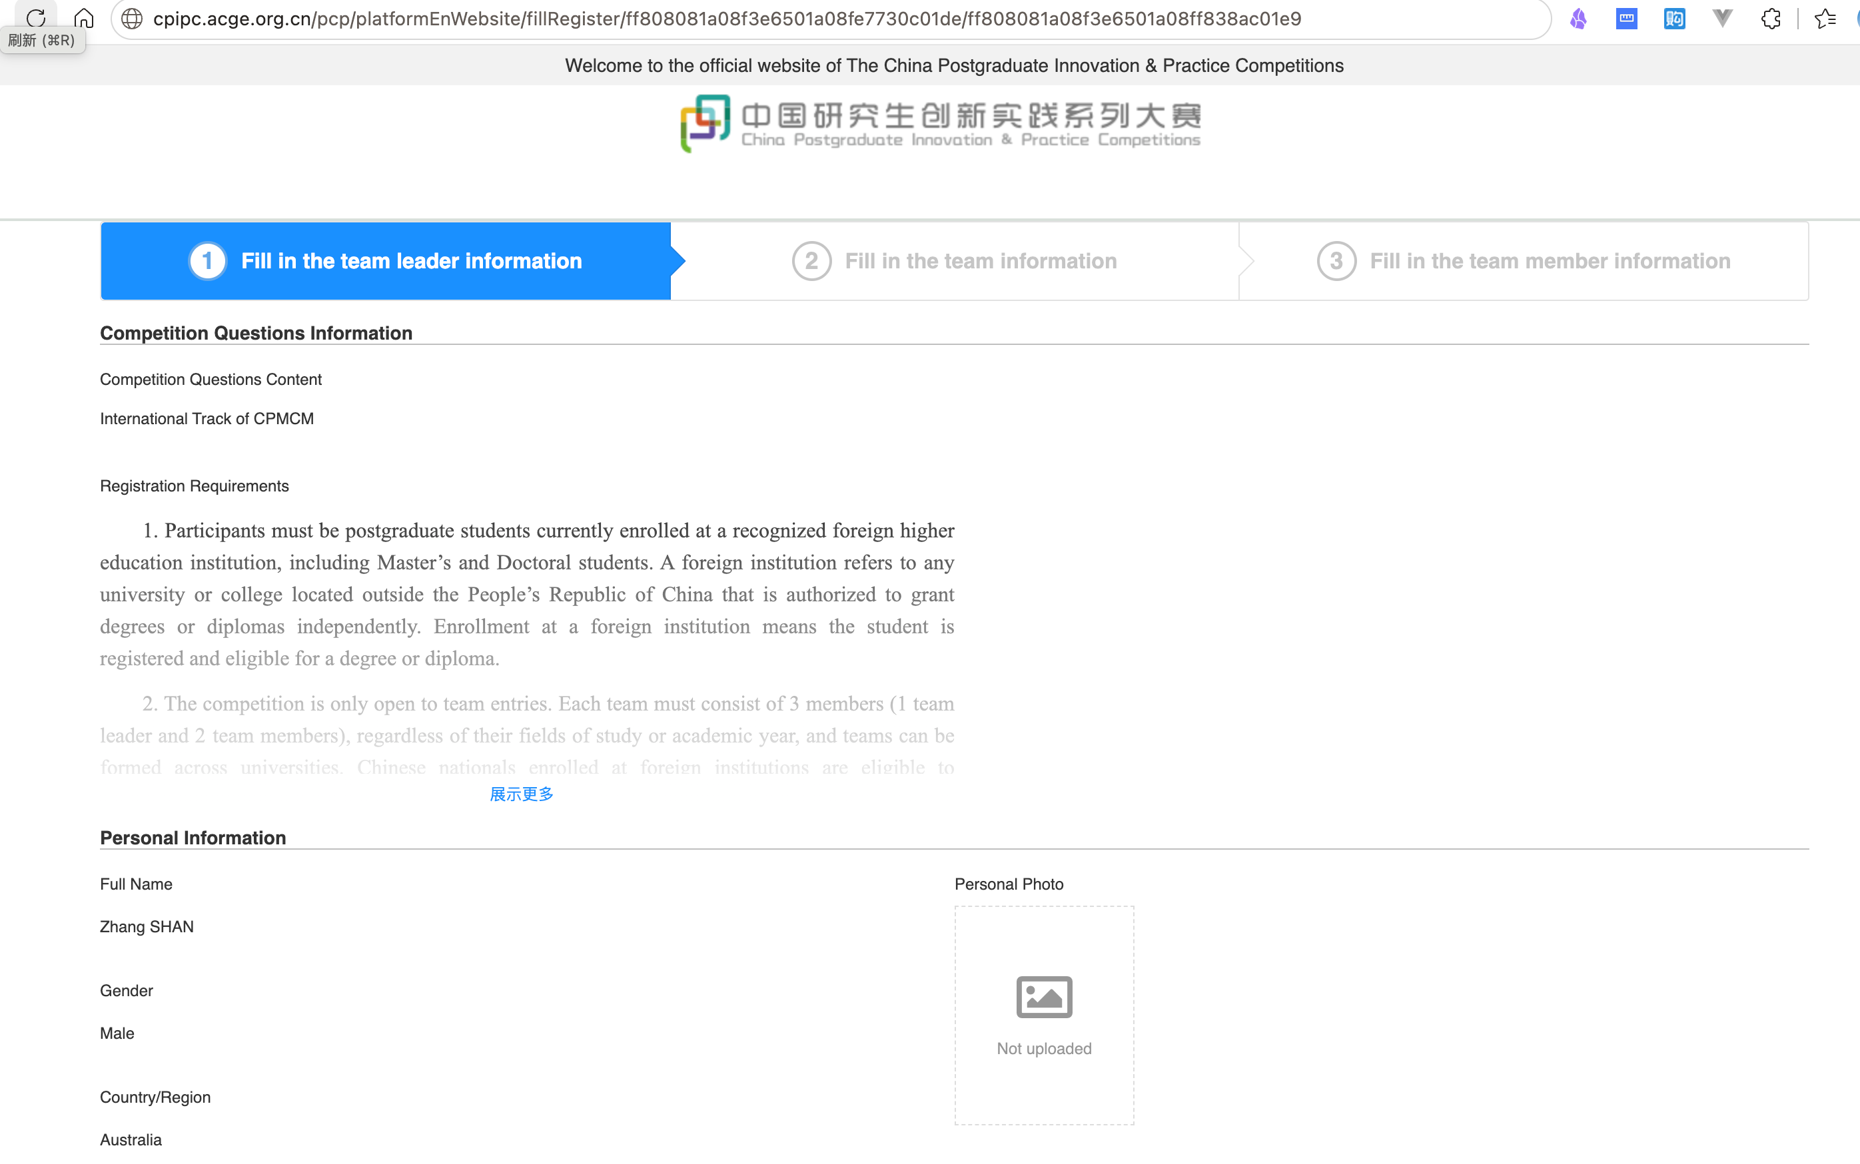
View Team Information

Submission

Obtain the Submission Link
After registration closes, the Organizing Committee will provide each international team with a submission link.

Open the Submission Link in a Browser
Open the submission link in a browser and submit the work as instructed. The submission process consists of the following stages, which are available only during the corresponding time windows:
- Download Problems
- View the Problem Decompression Password
- Submit Paper
- Submit Attachments
- View Paper
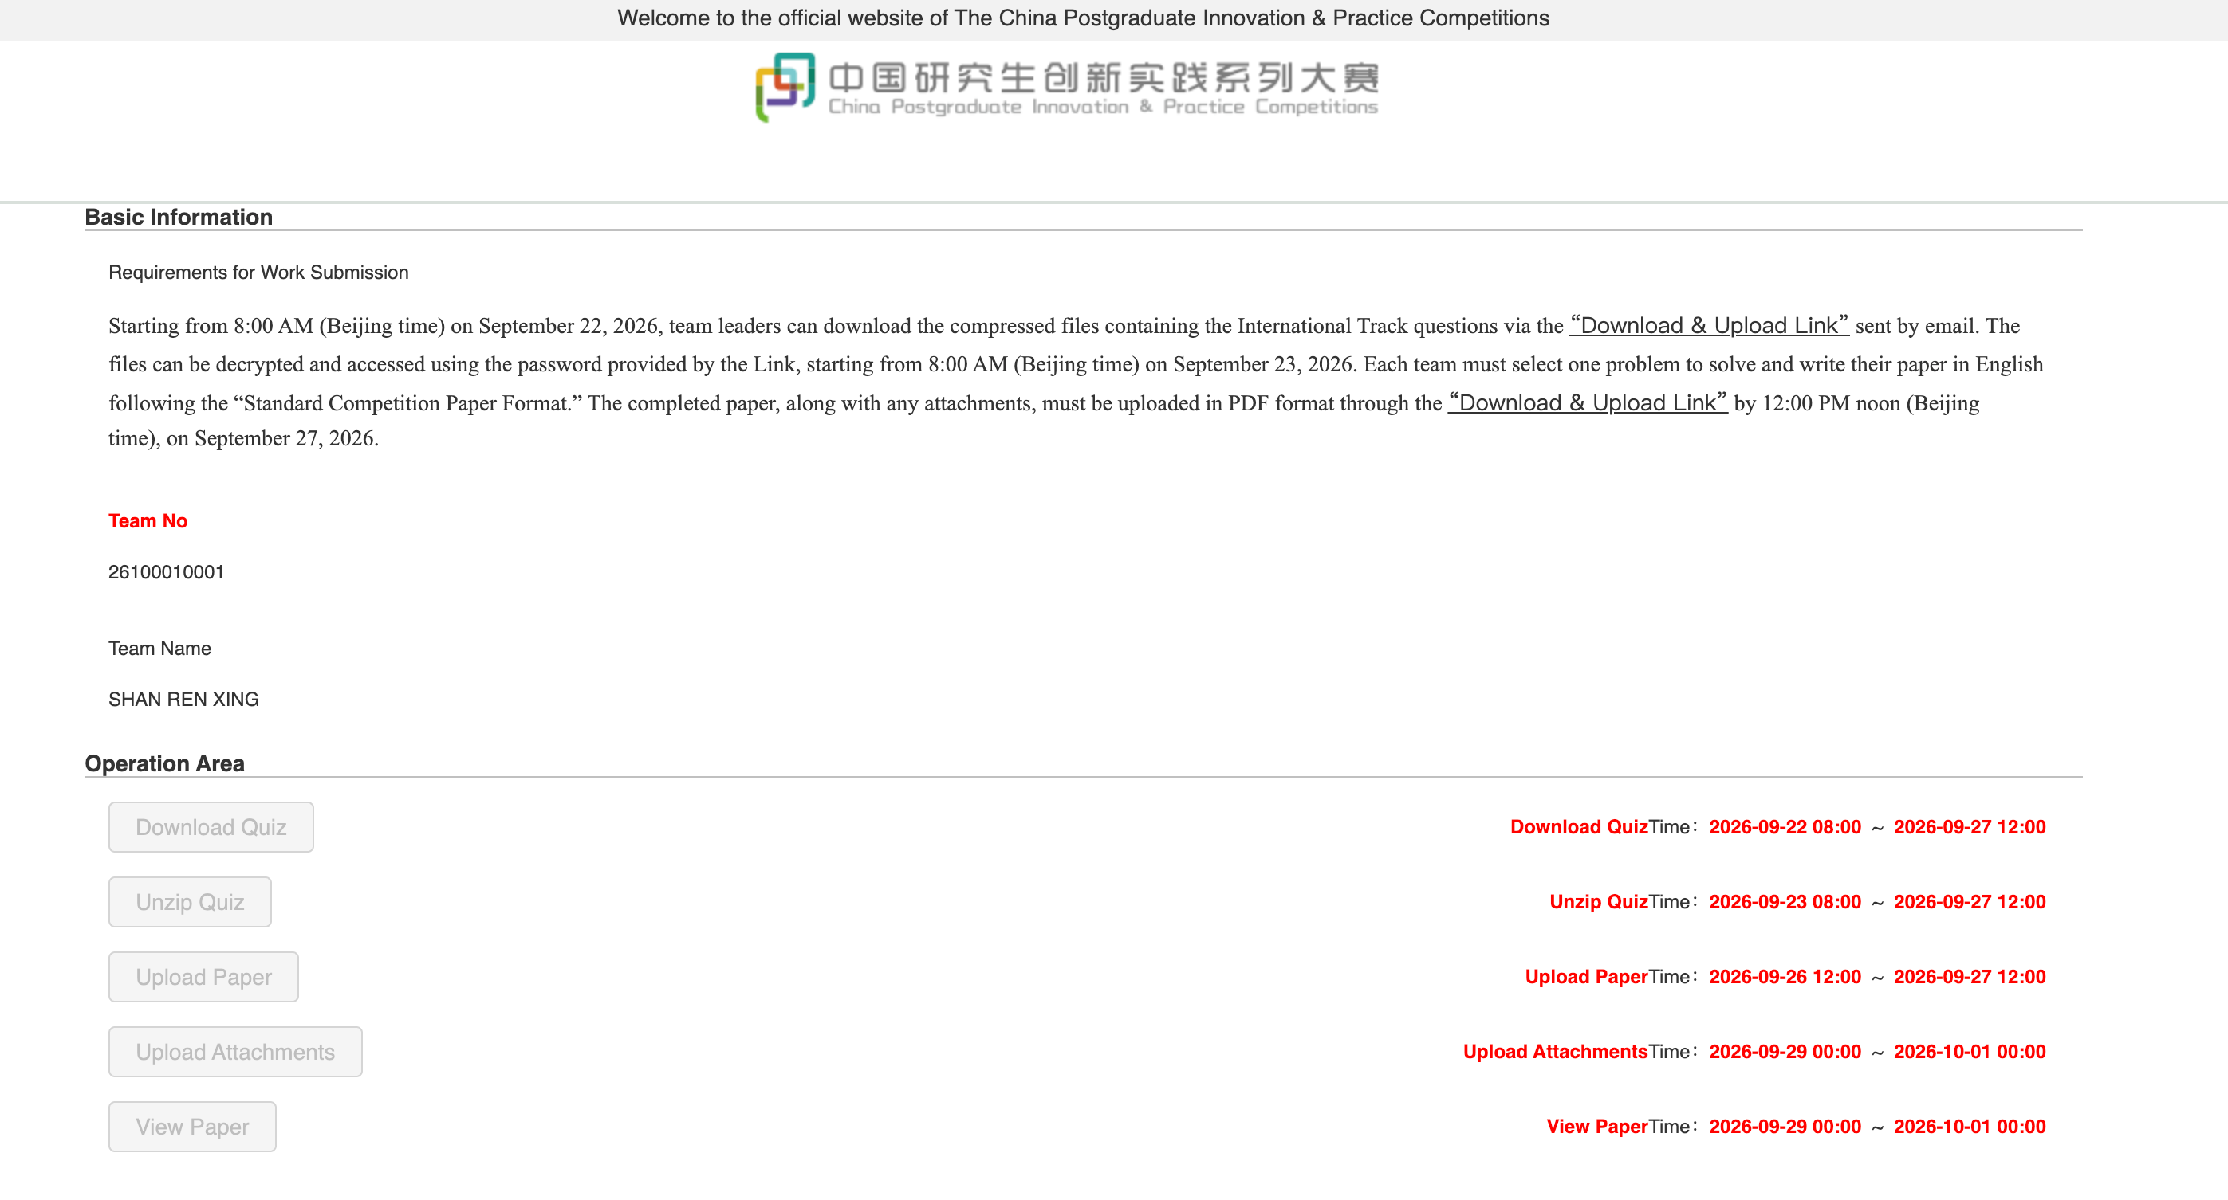
Submission Page

Download Problems
Note: The information shown in the screenshots is for illustrative purposes only. Please refer to the actual information displayed on the live page.
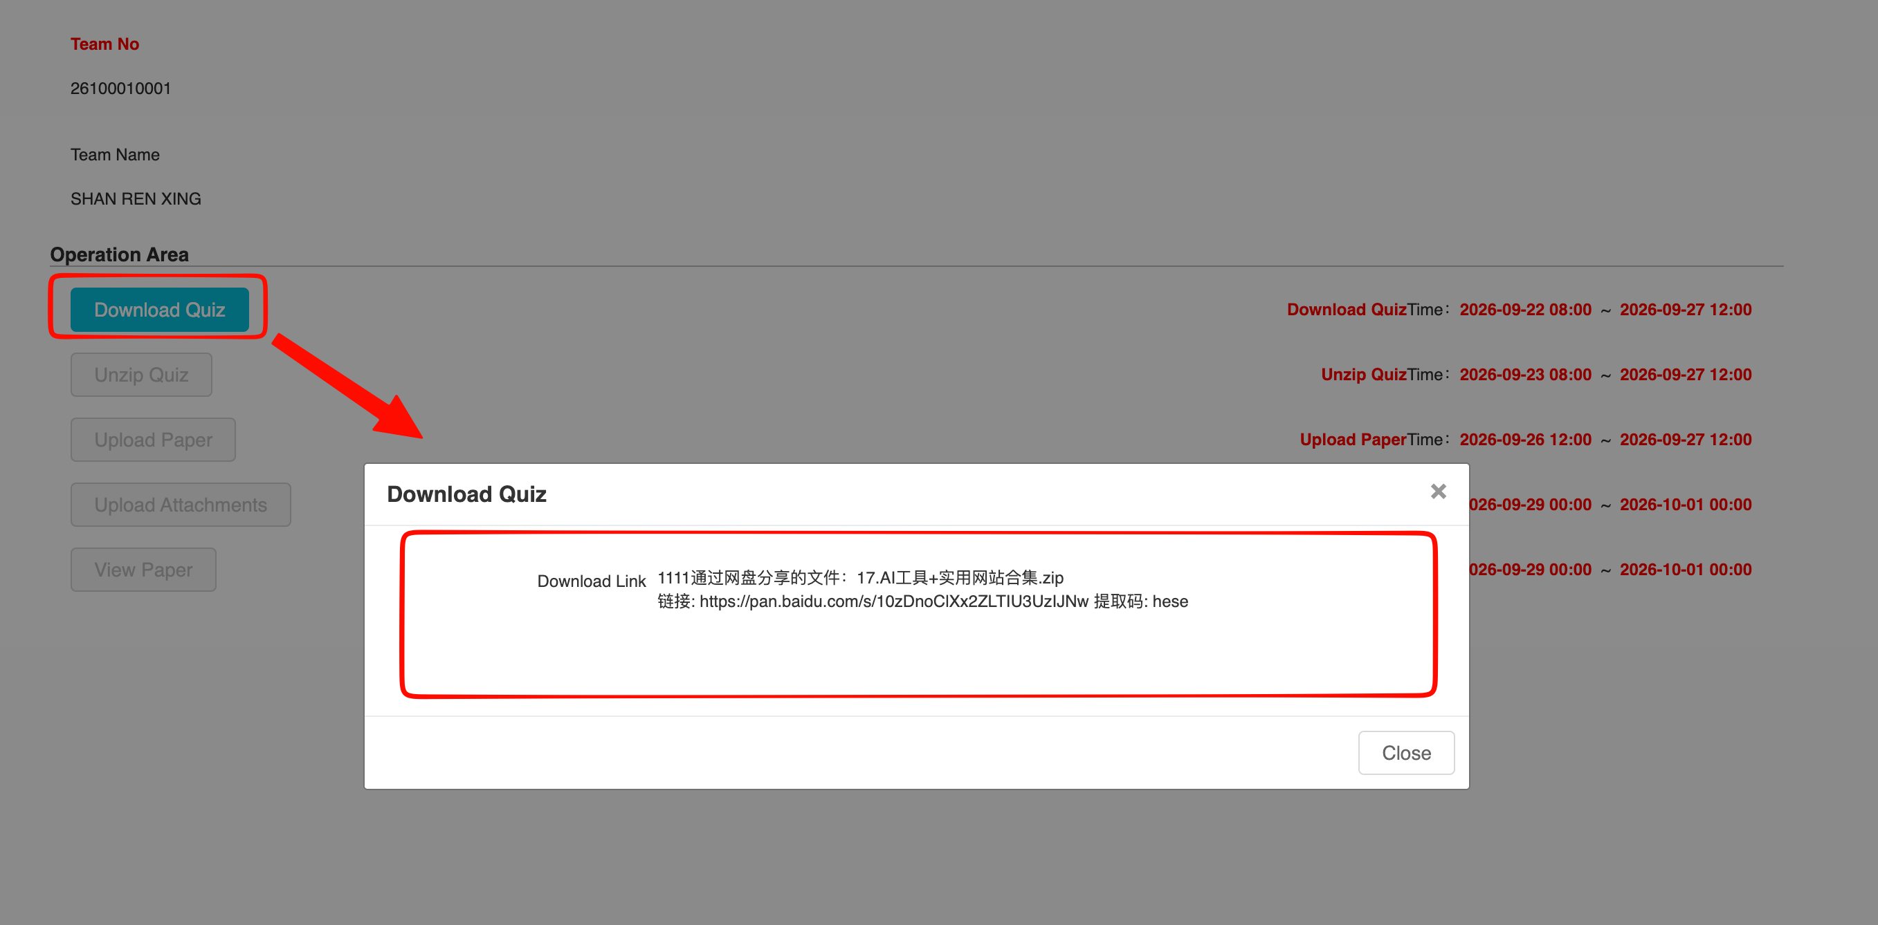
Problem Download Page

View the Problem Decompression Password
Note: The information shown in the screenshots is for illustrative purposes only. Please refer to the actual information displayed on the live page.
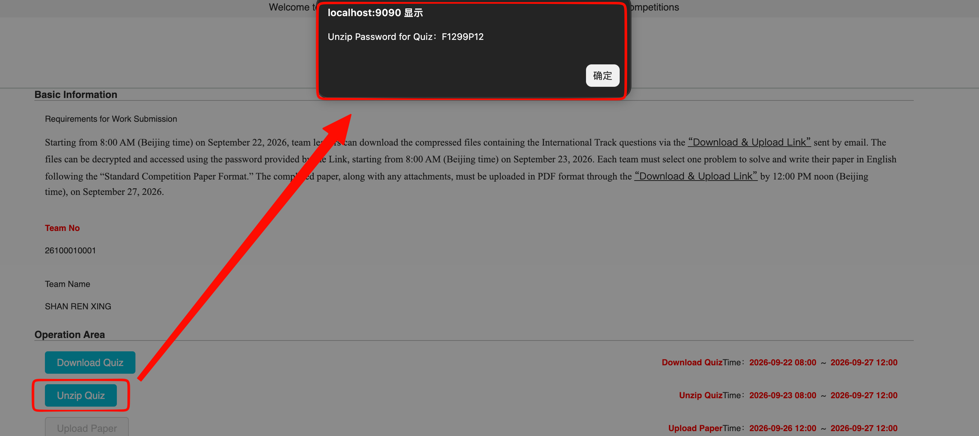
Problem Decompression Password Page

Submit Paper
On the paper upload page, select the problem number answered by your team and upload the paper as a PDF file.
Note: The information shown in the screenshots is for illustrative purposes only. Please refer to the actual information displayed on the live page.
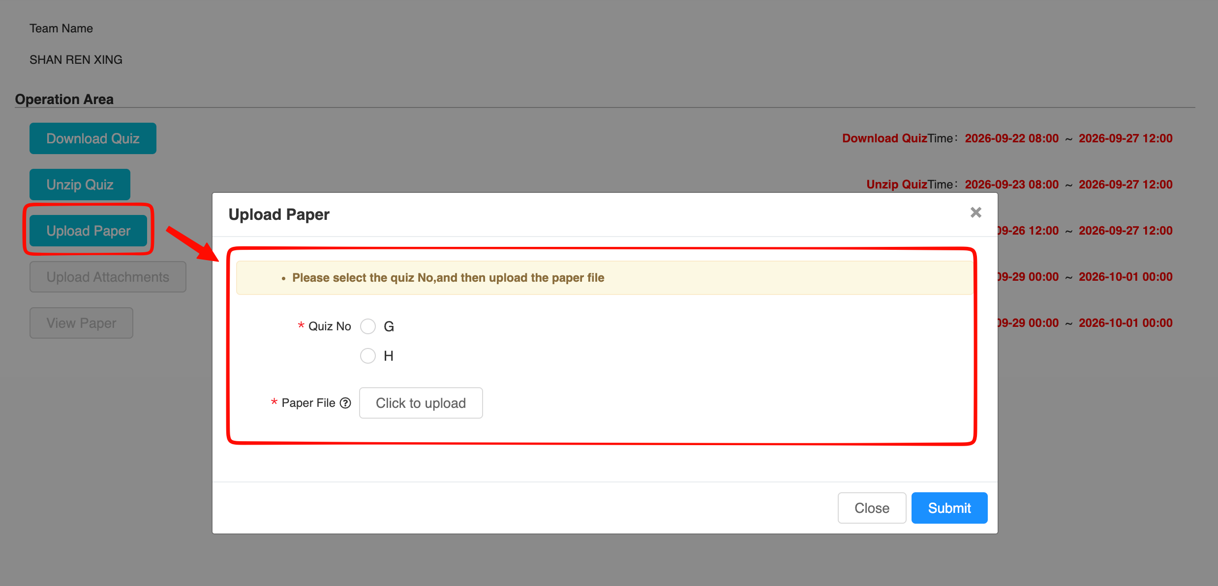
Paper Upload Page

Submit Attachments
Note: The information shown in the screenshots is for illustrative purposes only. Please refer to the actual information displayed on the live page.
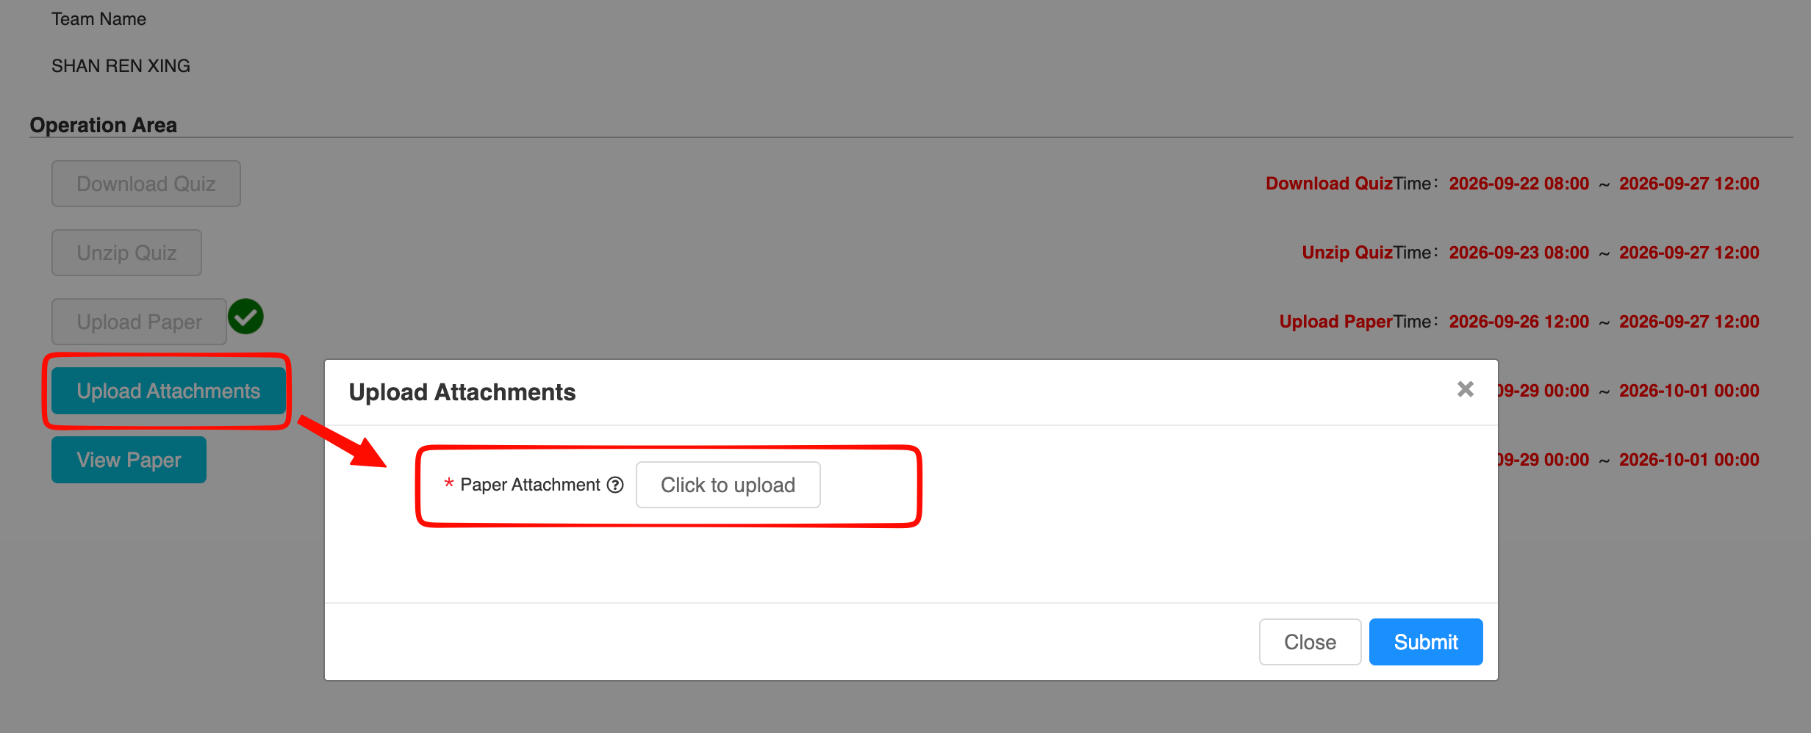
Attachment Upload Page

View Paper
Note: The information shown in the screenshots is for illustrative purposes only. Please refer to the actual information displayed on the live page.
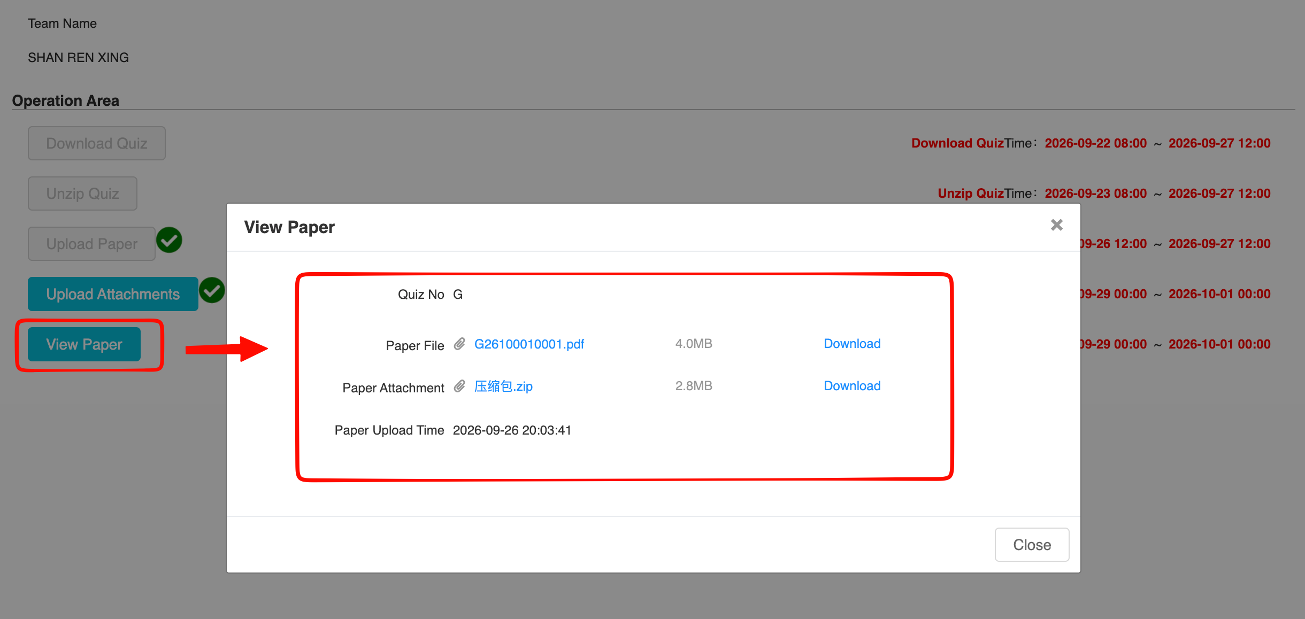
View Paper Page

