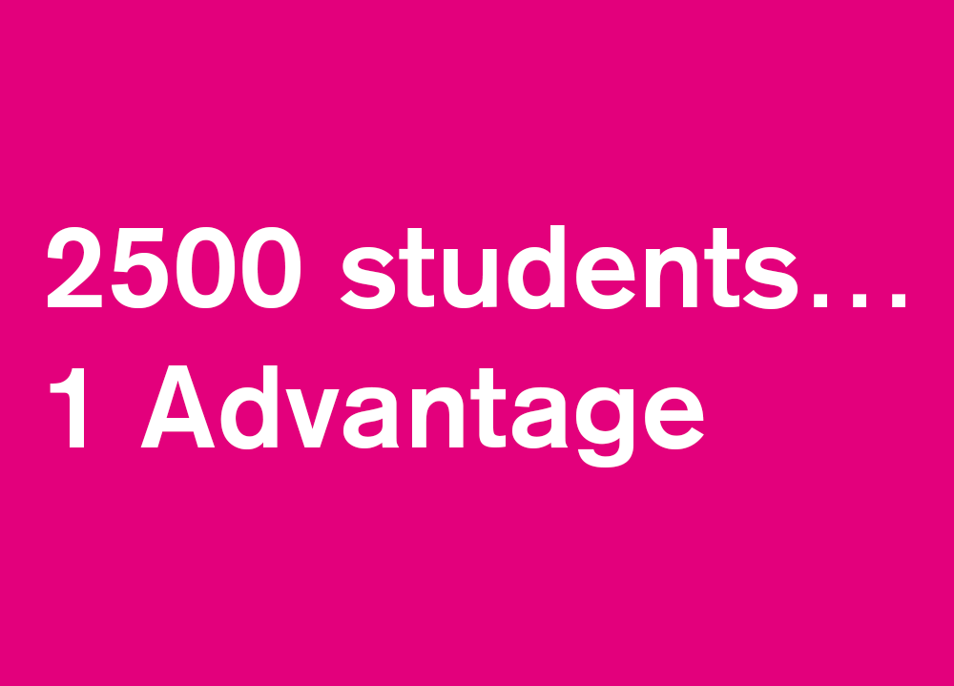

**Name:**

**Degree and Year of study:**

**Student ID:**

**The Nottingham Advantage Award**

The Nottingham Advantage Award focuses on student skills, employability and personal and academic progression. It develops the competencies, learning and evaluation skills that employers are looking for.

Undergraduate students taking modules on the Advantage Award are required to complete a portfolio. This will give you the opportunity to reflect on the activities you’ve done, evaluate the outcomes, and consider the other options you could have taken. This is called reflective learning. Working through the sections of this portfolio will ensure you get the most out of your experiences as well as complete the necessary work for the module.

**The Learning Log**

The Nottingham Advantage Award focuses on student skills, employability and personal and academic progression. It develops the competencies, learning and evaluation skills that employers are looking for.

Students taking modules as part of the Award are required to complete a learning log. This will give them the opportunity to reflect on the activities they’ve done, evaluate the outcomes, and consider the other options they could have taken. This is called reflective learning.

Working through the sections of this log, as you attend the programme, will ensure you get the most out of your experiences as well as complete the necessary work for the module.

This log is split in to three sections. Section One should be completed before commencing your project. Section Two should be completed once your project has been completed. Section Three should be completed at the end of the project.

Reflecting upon your work is extremely important as it can help you to analyse your strengths and weaknesses, think about what you might do differently if presented with a similar situation again, identify key learning points, and also think about how to plan and evaluate activity effectively.

**If you have any queries about this module please contact** [**jennifer.balloch@nottingham.ac.uk**](mailto:jennifer.balloch@nottingham.ac.uk)

**Section One**

Please complete the following questions before commencing the programme.

What do you hope to gain from this module? (Max 100 words)

|  |
| --- |
| From this module, I am hoping to gain an insight to the workings of the real world as this may be the tasks I undertake once I have left university. This will give me a taste of how my transferable skills set will be used when I move into a financial role, which will be useful for me as it will provide me with an idea of what skills I need and so, I can focus on improving them. In summary, I want to gain a glimpse into the business acumen necessary for an assurance or consultancy role. |

What skills do you think you possess that will be relevant for this module? (Max 100 words)

|  |
| --- |
| Numerical and analytical skills are going to be necessary in this module as well as experience and relevant knowledge of spreadsheets and presentation applications to carry out interpolation and extrapolation and presentation skills are vital in order to present findings and recommendations to Capital One. Communication and team working skills will be important in order to relay and feedback information which creates a healthy and positive atmosphere to peers. Finally, being decisive on a well-informed problem which can be justified is going to be an important skill during this module as it proves that presented recommendations are thought through. |

What skills do you hope to develop from taking part in this module? (Max 100 words)

|  |
| --- |
| I am hoping to have an insight into what a business acumen entails and what will be expected from me if I was to move into a consultancy or assurance role. I am also expecting to be able to identify and explain the procedures needed when making informed decisions in the real world. While the problem I will have to deal with in this module is unique, I expect to be able to apply the thought processes and skills needed. A skill which I particularly hope to improve is my oral presentation skills and being concise when delivering the presentation. |

|  |  |  |  |  |  |  |  |  |  |  |  |  |  |  |  |  |  |  |  |  |  |  |  |  |  |  |  |  |  |  |  |  |
| --- | --- | --- | --- | --- | --- | --- | --- | --- | --- | --- | --- | --- | --- | --- | --- | --- | --- | --- | --- | --- | --- | --- | --- | --- | --- | --- | --- | --- | --- | --- | --- | --- |
| **GENERAL Skills** | | | | | | | | | | | | | | | | | | | | | | | | | | | | | | | | |
| **Skill area** | **Please self-assess your skills before starting the programme**  *1=no experience; 5=highly skilled* | | | | | | | | | | | | | | | | | | | | | | | | | | | | | | **Comments** | |
| **Team working** – working with others to achieve a common goal. |  | | | | | | | | | | | | | | | | | | | | | | | | | | | | | |  | |
|  | 1 |  | | 2 | |  | | 3 | | | | |  | 4 | | | | |  | 5 | | |  | | | N/A | | |  |
|  |  |  | |  | |  | |  | | | | |  |  | | | | |  | ✓ | | |  | | |  | | |  |
|  | | | | | | | | | | | | | | | | | | | | | | | | | | | | | |
| **Presentation skills (oral)** – an understanding the best way to effectively ‘pitch’ an idea |  | | | | | | | | | | | | | | | | | | | | | | | | | | | | | |  | |
|  | | | 1 | |  | | 2 | |  | | 3 | | | |  | | 4 | | | |  | | | 5 | | |  | | |
|  | | | ✓ | |  | |  | |  | |  | | | |  | |  | | | |  | | |  | | |  | | |
|  | | | | | | | | | | | | | | | | | | | | | | | | | | | | | |
| **Presentation skills (written)** – presentation of ideas in a concise, structured and persuasive manner |  | | | | | | | | | | | | | | | | | | | | | | | | | | | | | |  | |
|  | | | 1 | |  | | 2 | | |  | | 3 | | | |  | | 4 | | | |  | | | 5 | | |  | | |  | |
|  | | |  | |  | | ✓ | | |  | |  | | | |  | |  | | | |  | | |  | | |  | | |
|  | | | | | | | | | | | | | | | | | | | | | | | | | | | | | |  | |
| **Networking & Collaboration** – identifying opportunities for collaboration and developing useful ongoing relationships through networking |  | | | | | | | | | | | | | | | | | | | | | | | | | | | | | |  | |
|  | | | 1 | |  | | 2 | |  | | 3 | | | |  | | 4 | | | |  | | | 5 | | |  | | |
|  | | |  | |  | | ✓ | |  | |  | | | |  | |  | | | |  | | |  | | |  | | |
|  | | |  | |  | |  | |  | |  | | | |  | |  | | | |  | | |  | | |  | | |
| **Organisation –** prioritising work and managing time effectively |  | | | | | | | | | | | | | | | | | | | | | | | | | | | | | |  | |
|  | | | 1 | |  | | 2 | |  | | 3 | | | |  | | 4 | | | |  | | | 5 | | |  | | |
|  | | |  | |  | |  | |  | |  | | | |  | |  | | | |  | | | ✓ | | |  | | |
|  | | | | | | | | | | | | | | | | | | | | | | | | | | | | | |

|  |  |  |  |  |  |  |  |  |  |  |  |  |
| --- | --- | --- | --- | --- | --- | --- | --- | --- | --- | --- | --- | --- |
|  | **SPECIALIST SKILLS** | | | | | | | | | | |  |
| **Commercial Awareness** – an understanding of the drivers which are important for success in business (the market, operational and financial aspects) |  | | | | | | | | | | |  |
|  | 1 |  | 2 |  | 3 |  | 4 |  | 5 |  |
|  |  |  | ✓ |  |  |  |  |  |  |  |
|  | | | | | | | | | | |
| **Opportunity Awareness** – ability to critically evaluate business opportunities |  | | | | | | | | | | |  |
|  | 1 |  | 2 |  | 3 |  | 4 |  | 5 |  |
|  |  |  | ✓ |  |  |  |  |  |  |  |
|  | | | | | | | | | | |
| **Numerical Analysis** - ability to and extract insight from and manipulate numerical data |  | | | | | | | | | | |  |
|  | 1 |  | 2 |  | 3 |  | 4 |  | 5 |  |
|  |  |  |  |  |  |  |  |  | ✓ |  |
|  | | | | | | | | | | |
| **Business Finances** – ability to prepare basic financial planning documents |  | | | | | | | | | | |  |
|  | 1 |  | 2 |  | 3 |  | 4 |  | 5 |  |
|  | ✓ |  |  |  |  |  |  |  |  |  |
|  | | | | | | | | | | |

**Section Two**

**Please complete the following questions after you have completed the project.**

How do you feel the module went? (Max 100 words)

|  |
| --- |
|  |

What aspects of the module do you feel you managed successfully whether as an individual or part of a team? What went less well? (Max 100 words)

|  |
| --- |
|  |

What skills did you use during this project? What new skills did you gain? (Max 100 words)

|  |
| --- |
|  |

Would you do anything differently if you did the module again? (Maximum 100 words)

|  |
| --- |
|  |

What have you learnt from this experience? (max 100 words)

|  |
| --- |
|  |

How can you use the skills you have learnt to help you in the future? (Which skills and how?) (Max 100 words)

|  |
| --- |
|  |

**Please now complete the following skills audit to rate how your skills have developed through taking part in this module**

|  |  |  |  |  |  |  |  |  |  |  |  |  |  |  |  |  |  |  |  |  |  |  |  |  |
| --- | --- | --- | --- | --- | --- | --- | --- | --- | --- | --- | --- | --- | --- | --- | --- | --- | --- | --- | --- | --- | --- | --- | --- | --- |
| **GENERAL Skills** | | | | | | | | | | | | | | | | | | | | | | | | |
| **Skill area** | **What impact has the project had on your skills?*1****=very negative 2=negative 3=neutral 4=positive* ***5****=very positive* | | | | | | | | | | | | | | | | | | | | | | | **Explanation**  *Describe how your skills have been affected* |
| **Team working** – working with others to achieve a common goal. |  | | | | | | | | | | | | | | | | | | | | | | |  |
|  | 1 |  | | 2 | |  | | 3 | | |  | 4 | | |  | 5 | |  | | N/A | |  |
|  |  |  | |  | |  | |  | | |  |  | | |  |  | |  | |  | |  |
|  | | | | | | | | | | | | | | | | | | | | | | |
| **Presentation skills (oral)** – an understanding the best way to effectively ‘pitch’ an idea |  | | | | | | | | | | | | | | | | | | | | | | |  |
|  | | | 1 | |  | | 2 | |  | 3 | | |  | 4 | | |  | | 5 | |  | |
|  | | |  | |  | |  | |  |  | | |  |  | | |  | |  | |  | |
|  | | | | | | | | | | | | | | | | | | | | | | |
| **Presentation skills (written)** – presentation of ideas in a concise, structured and persuasive manner |  | | | | | | | | | | | | | | | | | | | | | | |  |
|  | | | 1 | |  | | 2 | |  | 3 | | |  | 4 | | |  | | 5 | |  | |
|  | | |  | |  | |  | |  |  | | |  |  | | |  | |  | |  | |
|  | | | | | | | | | | | | | | | | | | | | | | |
| **Networking & Collaboration** – identifying opportunities for collaboration and developing useful ongoing relationships through networking |  | | | | | | | | | | | | | | | | | | | | | | |  |
|  | | | 1 | |  | | 2 | |  | 3 | | |  | 4 | | |  | | 5 | |  | |
|  | | |  | |  | |  | |  |  | | |  |  | | |  | |  | |  | |
|  | | |  | |  | |  | |  |  | | |  |  | | |  | |  | |  | |
| **Organisation –** prioritising work and managing time effectively |  | | | | | | | | | | | | | | | | | | | | | | |  |
|  | | | 1 | |  | | 2 | |  | 3 | | |  | 4 | | |  | | 5 | |  | |
|  | | |  | |  | |  | |  |  | | |  |  | | |  | |  | |  | |
|  | | | | | | | | | | | | | | | | | | | | | | |

|  |  |  |  |  |  |  |  |  |  |  |  |  |
| --- | --- | --- | --- | --- | --- | --- | --- | --- | --- | --- | --- | --- |
|  | **SPECIALIST SKILLS** | | | | | | | | | | |  |
| **Commercial Awareness** – an understanding of the drivers which are important for success in business (the market, operational and financial aspects) |  | | | | | | | | | | |  |
|  | 1 |  | 2 |  | 3 |  | 4 |  | 5 |  |
|  |  |  |  |  |  |  |  |  |  |  |
|  | | | | | | | | | | |
| **Opportunity Awareness** – ability to critically evaluate business opportunities |  | | | | | | | | | | |  |
|  | 1 |  | 2 |  | 3 |  | 4 |  | 5 |  |
|  |  |  |  |  |  |  |  |  |  |  |
|  | | | | | | | | | | |
| **Numerical Analysis** - ability to and extract insight from and manipulate numerical data |  | | | | | | | | | | |  |
|  | 1 |  | 2 |  | 3 |  | 4 |  | 5 |  |
|  |  |  |  |  |  |  |  |  |  |  |
|  | | | | | | | | | | |
| **Business Finances** – ability to prepare basic financial planning documents |  | | | | | | | | | | |  |
|  | 1 |  | 2 |  | 3 |  | 4 |  | 5 |  |
|  |  |  |  |  |  |  |  |  |  |  |
|  | | | | | | | | | | |

**Section Three**

**Please attach a copy of your recommendations to this document!**

**Completion Checklist**

|  |  |
| --- | --- |
| Completed Section 1 and Skills Audit 1 |  |
| Completed Section 2 and Skills Audit 2 |  |
| Submitted electronic entry to Sarah Allen |  |

**We hope you have enjoyed the module!**

**For information about the module and additional resources please visit** [**http://workspace.nottingham.ac.uk/display/naamy**](http://workspace.nottingham.ac.uk/display/naamy)