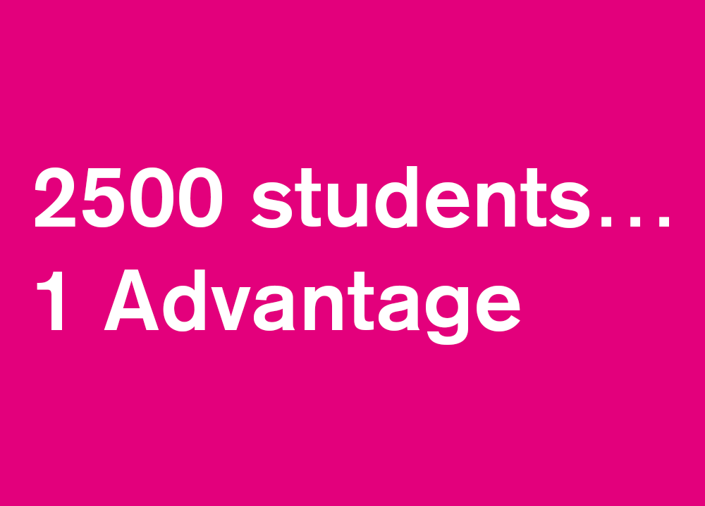

**Name:**

**Degree and Year of study:**

**Student ID:**

**The Nottingham Advantage Award**

The Nottingham Advantage Award focuses on student skills, employability and personal and academic progression. It develops the competencies, learning and evaluation skills that employers are looking for.

Undergraduate students taking modules on the Advantage Award are required to complete a portfolio. This will give you the opportunity to reflect on the activities you’ve done, evaluate the outcomes, and consider the other options you could have taken. This is called reflective learning. Working through the sections of this portfolio will ensure you get the most out of your experiences as well as complete the necessary work for the module.

**The Learning Log**

The Nottingham Advantage Award focuses on student skills, employability and personal and academic progression. It develops the competencies, learning and evaluation skills that employers are looking for.

Students taking modules as part of the Award are required to complete a learning log. This will give them the opportunity to reflect on the activities they’ve done, evaluate the outcomes, and consider the other options they could have taken. This is called reflective learning.

Working through the sections of this log, as you attend the programme, will ensure you get the most out of your experiences as well as complete the necessary work for the module.

This log is split in to three sections. Section One should be completed before commencing your project. Section Two should be completed once your project has been completed. Section Three should be completed at the end of the project.

Reflecting upon your work is extremely important as it can help you to analyse your strengths and weaknesses, think about what you might do differently if presented with a similar situation again, identify key learning points, and also think about how to plan and evaluate activity effectively.

**If you have any queries about this module please contact** [**jennifer.balloch@nottingham.ac.uk**](mailto:jennifer.balloch@nottingham.ac.uk)

**Section One**

Please complete the following questions before commencing the programme.

What do you hope to gain from this module? (Max 100 words)

|  |
| --- |
| From this module, I am hoping to gain an insight to the workings of the real world as this may be the tasks I undertake once I have left university. This will give me a taste of how my transferable skills set will be used when I move into a financial role, which will be useful for me as it will provide me with an idea of what skills I need and so, I can focus on improving them. In summary, I want to gain a glimpse into the business acumen necessary for an assurance or consultancy role. |

What skills do you think you possess that will be relevant for this module? (Max 100 words)

|  |
| --- |
| Numerical and analytical skills are going to be necessary in this module as well as experience and relevant knowledge of spreadsheets and presentation applications to carry out interpolation and extrapolation and presentation skills are vital in order to present findings and recommendations to Capital One. Communication and team working skills will be important in order to relay and feedback information which creates a healthy and positive atmosphere to peers. Finally, being decisive on a well-informed problem which can be justified is going to be an important skill during this module as it proves that presented recommendations are thought through. |

What skills do you hope to develop from taking part in this module? (Max 100 words)

|  |
| --- |
| I am hoping to have an insight into what a business acumen entails and what will be expected from me if I was to move into a consultancy or assurance role. I am also expecting to be able to identify and explain the procedures needed when making informed decisions in the real world. While the problem I will have to deal with in this module is unique, I expect to be able to apply the thought processes and skills needed. A skill which I particularly hope to improve is my oral presentation skills and being concise when delivering the presentation. |

|  |  |  |  |  |  |  |  |  |  |  |  |  |  |  |  |  |  |  |  |  |  |  |  |  |  |  |  |  |  |  |  |  |
| --- | --- | --- | --- | --- | --- | --- | --- | --- | --- | --- | --- | --- | --- | --- | --- | --- | --- | --- | --- | --- | --- | --- | --- | --- | --- | --- | --- | --- | --- | --- | --- | --- |
| **GENERAL Skills** | | | | | | | | | | | | | | | | | | | | | | | | | | | | | | | | |
| **Skill area** | **Please self-assess your skills before starting the programme**  *1=no experience; 5=highly skilled* | | | | | | | | | | | | | | | | | | | | | | | | | | | | | | **Comments** | |
| **Team working** – working with others to achieve a common goal. |  | | | | | | | | | | | | | | | | | | | | | | | | | | | | | |  | |
|  | 1 |  | | 2 | |  | | 3 | | | | |  | 4 | | | | |  | 5 | | |  | | | N/A | | |  |
|  |  |  | |  | |  | |  | | | | |  |  | | | | |  | ✓ | | |  | | |  | | |  |
|  | | | | | | | | | | | | | | | | | | | | | | | | | | | | | |
| **Presentation skills (oral)** – an understanding the best way to effectively ‘pitch’ an idea |  | | | | | | | | | | | | | | | | | | | | | | | | | | | | | |  | |
|  | | | 1 | |  | | 2 | |  | | 3 | | | |  | | 4 | | | |  | | | 5 | | |  | | |
|  | | | ✓ | |  | |  | |  | |  | | | |  | |  | | | |  | | |  | | |  | | |
|  | | | | | | | | | | | | | | | | | | | | | | | | | | | | | |
| **Presentation skills (written)** – presentation of ideas in a concise, structured and persuasive manner |  | | | | | | | | | | | | | | | | | | | | | | | | | | | | | |  | |
|  | | | 1 | |  | | 2 | | |  | | 3 | | | |  | | 4 | | | |  | | | 5 | | |  | | |  | |
|  | | |  | |  | | ✓ | | |  | |  | | | |  | |  | | | |  | | |  | | |  | | |
|  | | | | | | | | | | | | | | | | | | | | | | | | | | | | | |  | |
| **Networking & Collaboration** – identifying opportunities for collaboration and developing useful ongoing relationships through networking |  | | | | | | | | | | | | | | | | | | | | | | | | | | | | | |  | |
|  | | | 1 | |  | | 2 | |  | | 3 | | | |  | | 4 | | | |  | | | 5 | | |  | | |
|  | | |  | |  | | ✓ | |  | |  | | | |  | |  | | | |  | | |  | | |  | | |
|  | | |  | |  | |  | |  | |  | | | |  | |  | | | |  | | |  | | |  | | |
| **Organisation –** prioritising work and managing time effectively |  | | | | | | | | | | | | | | | | | | | | | | | | | | | | | |  | |
|  | | | 1 | |  | | 2 | |  | | 3 | | | |  | | 4 | | | |  | | | 5 | | |  | | |
|  | | |  | |  | |  | |  | |  | | | |  | |  | | | |  | | | ✓ | | |  | | |
|  | | | | | | | | | | | | | | | | | | | | | | | | | | | | | |

|  |  |  |  |  |  |  |  |  |  |  |  |  |
| --- | --- | --- | --- | --- | --- | --- | --- | --- | --- | --- | --- | --- |
|  | **SPECIALIST SKILLS** | | | | | | | | | | |  |
| **Commercial Awareness** – an understanding of the drivers which are important for success in business (the market, operational and financial aspects) |  | | | | | | | | | | |  |
|  | 1 |  | 2 |  | 3 |  | 4 |  | 5 |  |
|  |  |  | ✓ |  |  |  |  |  |  |  |
|  | | | | | | | | | | |
| **Opportunity Awareness** – ability to critically evaluate business opportunities |  | | | | | | | | | | |  |
|  | 1 |  | 2 |  | 3 |  | 4 |  | 5 |  |
|  |  |  | ✓ |  |  |  |  |  |  |  |
|  | | | | | | | | | | |
| **Numerical Analysis** - ability to and extract insight from and manipulate numerical data |  | | | | | | | | | | |  |
|  | 1 |  | 2 |  | 3 |  | 4 |  | 5 |  |
|  |  |  |  |  |  |  |  |  | ✓ |  |
|  | | | | | | | | | | |
| **Business Finances** – ability to prepare basic financial planning documents |  | | | | | | | | | | |  |
|  | 1 |  | 2 |  | 3 |  | 4 |  | 5 |  |
|  | ✓ |  |  |  |  |  |  |  |  |  |
|  | | | | | | | | | | |

**Section Two**

**Please complete the following questions after you have completed the project.**

How do you feel the module went? (Max 100 words)

|  |
| --- |
| The module was far more insightful than I expected, it gave me an idea of the critical and business thinking mind-set I would need to be in when I move into the real world. The module provided me with the opportunity to hone in on communication and analytical skills as well as being decisive by providing me with case studies to analyse. The case studies forced me to provide a justifiable solution to a business problem. |

What aspects of the module do you feel you managed successfully whether as an individual or part of a team? What went less well? (Max 100 words)

|  |
| --- |
| Collating our suggested solutions in a group was successful as it gave an opportunity to understand different view perspectives and aspects of the problem that I had not already realised such as other risks which I had not considered into the solution. This collaboration helped in being able to manage the coursework problem as it provided a level of confidence with how to approach business problems. However, while I felt the coursework was designed to promote individuality, I still felt the coursework was slightly ambiguous as here was little information provided other than a spreadsheet model and a brief description. |

What skills did you use during this project? What new skills did you gain? (Max 100 words)

|  |
| --- |
| The project forced me to develop my spreadsheet skills and with that my understanding of new functions within excel. I have also developed my analytical skills as I know have a greater insight into what is entailed in a business decision as I was not initially sure which aspects I should be focussing on as problems in case studies were overwhelming with information. My presentational skills have been broadened as I was not sure how to formerly write a memo or deliver a succinct business presentation. |

Would you do anything differently if you did the module again? (Maximum 100 words)

|  |
| --- |
| If I were to do the module again I would focus more time on understanding how much justification is needed with a business proposal and to what extent it needs to be explained as the audience I would be delivering to would already have prior knowledge. I would also focus my presentation on being tailored more to what my audience gives more interest to whether it is customer loyalty, profit, quality of the product and so on. |

What have you learnt from this experience? (max 100 words)

|  |
| --- |
| I have learnt which key aspects to look for within a business problem and proposition and I am now aware of what the proposition is meant to include. I have also learnt how to present proposals as well as findings in a memo and in a presentation in an informative yet concise manner which is also relevant to our presentation audience. I also found it very useful to have a reaction proposition in addition to your proposition. This was we have a contingency plan. |

How can you use the skills you have learnt to help you in the future? (Which skills and how?) (Max 100 words)

|  |
| --- |
| The skills I have learnt from this module are predominantly transferable skills which can be applied to many different scenario. These skills are communicational, analytical, organisational, and time-management skills. These were necessary to provide a prompt yet well thought through proposal. In addition to this, I have often struggled to be concise so this module helped with my succinctness. |

**Please now complete the following skills audit to rate how your skills have developed through taking part in this module**

|  |  |  |  |  |  |  |  |  |  |  |  |  |  |  |  |  |  |  |  |  |  |  |  |
| --- | --- | --- | --- | --- | --- | --- | --- | --- | --- | --- | --- | --- | --- | --- | --- | --- | --- | --- | --- | --- | --- | --- | --- |
| **GENERAL Skills** | | | | | | | | | | | | | | | | | | | | | | | |
| **Skill area** | **What impact has the project had on your skills?*1****=very negative 2=negative 3=neutral 4=positive* ***5****=very positive* | | | | | | | | | | | | | | | | | | | | | | **Explanation**  *Describe how your skills have been affected* |
| **Team working** – working with others to achieve a common goal. |  | | | | | | | | | | | | | | | | | | | | | | The module case studies were designed to be discussed as a group so a discussion of potential solution came about organically. |
|  | 1 |  | | 2 | |  | | 3 | | |  | 4 | | |  | 5 |  | | N/A | |  |
|  |  |  | |  | |  | |  | | |  |  | | |  | ✓ |  | |  | |  |
|  | | | | | | | | | | | | | | | | | | | | | |
| **Presentation skills (oral)** – an understanding the best way to effectively ‘pitch’ an idea |  | | | | | | | | | | | | | | | | | | | | | | I formerly had not presented to an audience before so it was a welcomed learning curve. |
|  | | | 1 | |  | | 2 | |  | 3 | | |  | 4 | |  | | 5 | |  | |
|  | | |  | |  | |  | |  |  | | |  |  | |  | | ✓ | |  | |
|  | | | | | | | | | | | | | | | | | | | | | |
| **Presentation skills (written)** – presentation of ideas in a concise, structured and persuasive manner |  | | | | | | | | | | | | | | | | | | | | | | I used to struggle with succinctness but after being described a step-by-step presentation it helped to break down my work into a concise presentation. |
|  | | | 1 | |  | | 2 | |  | 3 | | |  | 4 | |  | | 5 | |  | |
|  | | |  | |  | |  | |  |  | | |  | ✓ | |  | |  | |  | |
|  | | | | | | | | | | | | | | | | | | | | | |
| **Networking & Collaboration** – identifying opportunities for collaboration and developing useful ongoing relationships through networking |  | | | | | | | | | | | | | | | | | | | | | | There was little room for networking as we were limited to communication between the people on our tables and the Capital One staff delivering the sessions. |
|  | | | 1 | |  | | 2 | |  | 3 | | |  | 4 | |  | | 5 | |  | |
|  | | |  | |  | | ✓ | |  |  | | |  |  | |  | |  | |  | |
|  | | |  | |  | |  | |  |  | | |  |  | |  | |  | |  | |
| **Organisation –** prioritising work and managing time effectively |  | | | | | | | | | | | | | | | | | | | | | | The deadlines were put across as strict so it was vita our memos and presentations were sent on time. This meant having to manage my studies for my degree in addition to this NAA module. |
|  | | | 1 | |  | | 2 | |  | 3 | | |  | 4 | |  | | 5 | |  | |
|  | | |  | |  | |  | |  |  | | |  | ✓ | |  | |  | |  | |
|  | | | | | | | | | | | | | | | | | | | | | |

|  |  |  |  |  |  |  |  |  |  |  |  |  |
| --- | --- | --- | --- | --- | --- | --- | --- | --- | --- | --- | --- | --- |
|  | **SPECIALIST SKILLS** | | | | | | | | | | |  |
| **Commercial Awareness** – an understanding of the drivers which are important for success in business (the market, operational and financial aspects) |  | | | | | | | | | | | While this module was short, it has provided me with a glimpse into the mind-set necessary to be working in this field of work and the key factors that play a heavy part in the consideration of business decisions. |
|  | 1 |  | 2 |  | 3 |  | 4 |  | 5 |  |
|  |  |  |  |  |  |  | ✓ |  |  |  |
|  | | | | | | | | | | |
| **Opportunity Awareness** – ability to critically evaluate business opportunities |  | | | | | | | | | | | The sessions stressed the importance of risks when considering proposals and that these risks encourage us to revaluate our proposals and perhaps look again for another solution which takes into considerations new information. |
|  | 1 |  | 2 |  | 3 |  | 4 |  | 5 |  |
|  |  |  |  |  |  |  | ✓ |  |  |  |
|  | | | | | | | | | | |
| **Numerical Analysis** - ability to and extract insight from and manipulate numerical data |  | | | | | | | | | | | The coursework was designed to be independent studying which meant we had to do our own numerical analysis of the model which proved to be quite challenging but also a learning curve. |
|  | 1 |  | 2 |  | 3 |  | 4 |  | 5 |  |
|  |  |  |  |  |  |  | ✓ |  |  |  |
|  | | | | | | | | | | |
| **Business Finances** – ability to prepare basic financial planning documents |  | | | | | | | | | | | I believe the coursework was limiting in a sense that I do not feel able to prepare financial planning documents as this was not included in the module. The module was focused on how to present ideas and which areas to look at. |
|  | 1 |  | 2 |  | 3 |  | 4 |  | 5 |  |
|  |  |  |  |  | ✓ |  |  |  |  |  |
|  | | | | | | | | | | |

**Section Three**

**Please attach a copy of your recommendations to this document!**

**Completion Checklist**

|  |  |
| --- | --- |
| Completed Section 1 and Skills Audit 1 | ✓ |
| Completed Section 2 and Skills Audit 2 | ✓ |
| Submitted electronic entry to Sarah Allen | ✓ |

**We hope you have enjoyed the module!**

**For information about the module and additional resources please visit** [**http://workspace.nottingham.ac.uk/display/naamy**](http://workspace.nottingham.ac.uk/display/naamy)