
The Department of Computer Science

Image Recognition and Classification of Human Activity Using Convolution Neural Networks (CNN)

CIS4114: Research & Development Project

Student: Kieran Burrell

Supervisor: Dr Ardhendu Behera

Date: August 2022

Word Count = 8271

This report is submitted in partial fulfilment of the requirements for the MSc Big Data Analytics Degree at Edge Hill University.

Abstract
This paper focuses on the human activity recognition (HAR) problem, in which the inputs are a wide variety of images, and the outputs are predefined single activities. In this problem, extracting effective features for identifying activities is critical and particularly challenging for similar activities. Most existing work relies on heuristic hand-crafted feature design and shallow feature learning architectures, which cannot find those distinguishing features to accurately classify different activities. In this study, a convolutional neural network (CNN) was applied to automate feature extraction from the raw images in a systematic way to determine the single activity of each image. The neural network, which has a total of 5,039,087parameters consists of 2 initial convolution layers followed by four convolution blocks each containing two separable convolutions, a batch normalisation, and a max-pooling layer, leading into four fully connected layers with a final 15 neuron SoftMax layer for classification. To improve the training speed the GPU was utilised for computational power. To reduce overfitting in the convolution and fully connected blocks the dropout method was applied and proved to increase the performance of the model. Overall, the proposed model developed in this research achieved an accuracy of 89.42%. However, when used to generate prediction this dropped to 55.24% failing to distinguish between two sets of similar activities. Despite showing promise for the deep learning (DL) approach in the field of HAR, this paper suggests that further developments would be needed to capture the relationship between similar activities for HAR classification.

Table of Contents
Abstract 2
Glossary 5
Acknowledgements 6
Dedication 7
Chapter 1: Introduction 8
1.1: Motivation 10
1.2: Aim & Objectives 11
1.3: Scope 13
1.4: Project Methodology 14
1.5: Selected Methods 15
1.6: Deliverables/Expected Outcomes 16
1.7: Structure of Thesis 17
Chapter 2: Literature Review 18
Chapter 3: Problem Analysis & Requirements 21
3.1: Problem Analysis 21
3.2: Requirements 21
Chapter 4: Design 22
4.1: Dataset 22
4.2: Model Architecture 23
Chapter 5: Implementation 25
Chapter 6: Testing 32
6.1: Experimentation 32
6.1.1: Base Model 33
6.1.2: EfficientNetB0 Boosted Model 35
6.2: Results 37
6.2.1: Base Model 37
6.2.2: EfficientNetB0 Boosted Model 39
6.3: Evaluation 41
Chapter 7: Conclusion 42
7.1: Summary 42
7.2: Critical Evaluation 43
7.3: Future Work 44
Chapter 8: References 45
Chapter 9: Appendix 49
Appendix A: Ethical Form 49
Appendix B: Potential Dataset List 50

Glossary
Acronym | Term | Description
AI | Artificial Intelligence | The theory and development of computer systems able to perform tasks normally requiring human intelligence
API | Application Programming Interface | A software intermediary that allows two applications to talk to each other.
CNN | Convolution Neural Network | A class of neural networks that specializes in processing data that has a grid-like topology, such as an image.
DL | Deep Learning | A type of machine learning based on artificial neural networks in which multiple layers of processing are used to extract progressively higher-level features from data.
GCN | Graph Convolutional Networks | An approach for semi-supervised learning on graph-structured data. It is based on an efficient variant of convolutional neural networks which operate directly on graphs.
GPU | Graphic Processing Unit | A specialised processor originally designed to accelerate graphics rendering. GPUs can process many pieces of data simultaneously, making them useful for machine learning, video editing, and gaming applications.
HAR | Human Activity Recognition | The process of interpreting human motion using computer and machine vision technology.
IoT | Internet of Things | The interconnection via the internet of computing devices embedded in everyday objects enables them to send and receive data.
IPv6 | Internet Protocol version 6 | The latest version of the Internet protocol allows computers to uniquely identify and locate other computers and devices on the Internet.
ML | Machine Learning | The use and development of computer systems that can learn and adapt without following explicit instructions, by using algorithms and statistical models to analyse and draw inferences from patterns in data.
SDLC | Software Development Life Cycle | A structured process that enables the production of high-quality, low-cost software, in the shortest possible production time.

Acknowledgements
I would first like to thank Ardhendu Behera for his help and support as my dissertation tutor, and guidance towards the topic of this dissertation and during the project. Additionally, I would like to thank Jacob Crewe for providing me with server access to run my testing and experimentation along with technical assistance and support throughout the project. Finally, I would like to thank my mother, Michelle Haywood, who to this day is still the best at finding and helping correct the silly errors and mistakes in my written work, I could not have done it without you.

Dedication
This thesis is dedicated to my amazing family who has supported me throughout my project and time at university. Particularly my mother and stepfather, Michelle Haywood and Steve Cowley, my father and stepmother, Craig Burrell and Giselle Burrell, and finally my brothers Rhys Burrell and Ethan Cowley; I hope that my efforts over the past couple of years have made you all proud. Additionally, I would like to dedicate this thesis to all my friends who made my university experience what it was and who have all been by my side through the period of the project. Namely, Kyle Owen, Jacob Crewe, Haydn Coffey, Chloe Guy-Jobling, Callum Darbyshire, Niamh Hewertson, Maxwell Helm, and Megan Langton you are some of the best friends I could have asked for and you all made it worth every moment. A special thank you to Amelia Crossley for the daily reminder and support in completing the project in the final months. Finally, I could not have done this without my best friend and flatmate, Alicia Dornan, thank you for being the distraction when I needed it, the smiling face to keep me going, and the angry telling off when I was slacking. You helped drive me forward without even knowing it sometimes, you little legend.

Chapter 1: Introduction
As of recent, the phrase “Internet of Things” (IoT) has become one of the biggest talking points when discussing the future of technology, the concept that billions of intelligently communicating devices can be connected to exchange data with each other over the Internet without requiring human interaction (Holler et al., 2014; Gillis, 2022). This paradigm provides an opportunity to progress beyond the scope of machine-to-machine communication, employing an expansive array of networking protocols, domains, and applications (Miraz et al., 2015); all aimed at making the Internet more pervasive, personal, and intimate in daily life (Evans, 2011). As with any ground-breaking technology, practical applications have been somewhat lethargic in uptake due to an assortment of challenges both societal and technological. However, the majority of issues can be derived from three preeminent technological obstacles that directly affect the interoperability of IoT rather than human intransigence of the concept. These impediments are the standardisation of protocols addressing the latest requirements concerning privacy and security, successful and global implementation of IPv6 to reduce network management complexities due to the vast number of devices and provided further enhanced security features (Cisco, 2012), and finally supplying reliable power to sensors and devices include those in remote and distant locations (Miraz et al., 2015).
Ubiquitous computing is a concept associated with the IoT and refers to technologies that can appear everywhere using any device reaching every aspect of a user’s life, similar to the IoT paradigm. These embedded systems act by providing value or data without ever getting in the way (hypr, 2021). Often considered the successor to mobile computing, this concept generally makes use of wireless technology, the internet, and advanced electronics such as sensors to obtain vast amounts of data or ‘big data’ (Shea, 2021). Pervasive computing, ambient intelligence and the IoT all reflect this ubiquitous approach. However, in practice, the difference between these concepts is rather minor, with them all sharing the common goal of assisting users and providing continuous optimisation through technology integration in the environment (Loye, 2019). Despite this, the term ubiquitous computing is no longer just a goal and is instead becoming inferred as what is meant by computing. The expectation from modern technology is already for information to be readily accessible from a variety of devices through largely invisible infrastructure (Parmask et al., 2021).
Big data is worthless in a vacuum. Its potential value is unlocked when leveraged to drive evidence-based decision-making (Gandomi and Haider, 2015), a method that is becoming increasingly popular in both academia and industry (Ghazal et al., 2013; Hofacker, Malthouse and Sultan, 2016). This can be largely accounted to the advantages it can provide in both fields (Demchenko, De Laat and Membrey, 2014), organisations have begun to embrace the theory of big data to provide insight and predict future trends. Additionally, many utilise this concept to help boost aspects across the entire business through predictive sales and improved targeted advertising (Mgudlwa and Iyamu, 2018). This concept is often applied in academia when analysing data for research methods across all fields. In the application of health, big data is being used to find new cures and better understand and predict the spread of diseases (Rocklöv et al., 2019). Whereas other fields such as policing have used this technology to predict criminal activity (Richardson, 2019). Big data is processed by computer software or applications, which has led to the term big data analytics (Mayer-Schönberger and Cukier, 2013). A common technique applied for processing big data is machine learning (ML) to intelligently analyse data and develop automated data-driven models for used decision-making.
Deep learning (DL) is an aspect of ML designed to imitate the workings of the human brain in processing data and creating patterns for use in decision-making (Hargrave, 2019). Breakthroughs in this field have shown that convolution neural networks (CNN) can be used as high-performance classifiers for image and speech recognition (Abadi et al., 2016; Krizhevsky, Sutskever and Hinton, 2017). However, these techniques for feature extraction and classification are not limited to images and speech. Human Activity Recognition (HAR) aims to understand human activity possessing a wide range of potential applications. It is also suitable for DL techniques considering invariance and temporally correlated readings of time-series signals, hierarchical structure of activities, and HAR feature extraction problems (Ronao and Cho, 2016). The use of smartphone sensor data for HAR has begun to grow more prominent in recent years due to the growing demand in areas of ubiquitous computing (Chen et al., 2012). In particular, HAR has several potential applications including healthcare monitoring, assisted living, and smart homes but lacks development due to the computational expense of tasks such as feature extraction and feature classification that require the execution of millions of arithmetic operations (Rodriguez-Borbon et al., 2020).

1.1: Motivation
As we move closer to an era of ubiquitous computing and the paradigm becomes more practically available in aspects of day-to-day life, research in HAR will become more apparent through real-life applications. Particularly, recognition of daily activities is essential for maintaining a healthy lifestyle, patient rehabilitation and activity shifts among elderly citizens that can help to detect and diagnose serious illnesses (Nweke et al., 2018). For those who require assisted living, this area of research could be applied to help detect when someone has fallen or collapsed and with technical automation could potentially become the difference in saving a life. HAR research has grown more prominent in recent years through several studies using sensor-based data to determine activity (Anguita et al., 2012; Yang et al., 2015). However, HAR research using image classification is still limited due to the computational expense of feature extraction and feature classification (Rodriguez-Borbon et al., 2020).

1.2: Aim & Objectives
This project aims to successfully determine if CNNs can be used in HAR to distinguish and classify human activities with high accuracy. The developed solution will be evaluated, tested and hyper-tuned so an improved model can then be applied to the dataset to achieve the highest possible accuracy.
Each of the following objectives must be completed for the project to be successful as each objective will result in a deliverable required for the completion of the final project report. The objectives and deliverables of this project are as follows:
No. | Objective | Deliverable | How it will be achieved
1 | To identify and evaluate existing CNN techniques used for HAR classification. | Background & Literature Review | Research papers and other academic resources will be examined to look at existing CNN solutions, particularly those deployed in the application of HAR. Similar methods can be applied to build a solution as part of this research by evaluating and identifying successful models.
2 | To conduct an exploration into publicly available HAR datasets and analyse the size, quality, reliability, and type of data in each of the datasets. | Appendix | Research into publicly available HAR datasets must be explored to examine the variety and complexity of the datasets available for this project.
3 | To identify the most suitable dataset for the study. | Problem Analysis | Reviewing the various HAR datasets obtained in the previous objective, a decision will then be made on which dataset/s is/are most suitable for the project.
4 | To design and implement the CNN model to classify the HAR dataset. | Design & Implementation | A CNN solution/s can then be developed using coding techniques from prior knowledge and experience, accompanied by the HAR-specific techniques found in objective one. This solution must be able to distinguish activities using the dataset/s.
5 | To evaluate the performance of the models on the dataset and continue to fine-tune the model to obtain high accuracy on the testing dataset. | Testing | Once the initial solution has been developed, the model will undergo continuous testing to evaluate the performance of the solution and fine-tune the parameters to obtain the highest possible accuracy.
6 | To propose a CNN model specifically for HAR which can be used for future work within the field. | Conclusion | Finally, once the solution has been rigorously tested and the performance evaluated. The model can then be proposed as a solution for any future work in HAR.

1.3: Scope
This project is attempting to see if a trained DL system can be used effectively to determine human activities and provide a model for potential future work and applications in similar aspects within e-health, a field that continues to grow and become incorporated into our day-to-day lives. Since the potential applications of this project could be used in practical scenarios such as assisted living involving real people who are dependent on this technology for their health. The margin for error is incredibly small therefore the system must be highly effective to allow the use of the research in future developments or adaptation for practical deployment.
To obtain this goal an extensive background and literature review will be conducted to collect qualitative data to understand existing CNN techniques and their effectiveness and drawbacks, particularly those methods employed in research on HAR classification. Additionally, an exploration into available HAR datasets must undergo to examine the variety and complexity of the datasets available in this field and their suitability for use in this project. Upon the completion of this extensive research, CNN techniques and suitable datasets can then be identified and collated into a review to be employed in the design and development stages of the project.
Using the findings from the research review, a prototype CNN model can then be developed. The practical techniques required for this stage will be drawn from prior knowledge and experience from working with CNN integrated with the HAR-specific methods obtained in the previous research. Once an initial solution has been developed and can distinguish correctly between the human activities, further development can begin in the testing stages through fine-tuning parameters and alterations of CNN techniques to improve the overall performance of the model and obtain the highest possible accuracy. This project intends to develop a highly accurate CNN model that could be for HAR and provide recommendations on techniques and datasets for future work in this field.

1.4: Project Methodology
For the development of this project, there are two potentially suitable methodologies for this style of study, the Agile approach, and the Waterfall approach. The Agile methodology is an iterative process that provides flexibility and easy response to change throughout the software development life cycle (SDLC) (Zima, 2015). Agile allows the prototyping of software throughout its development which would mean that the prototype models could be continually improved upon to achieve better accuracy and precision when the model is being used for predictions. The Waterfall methodology is the traditional process of software development which presents a linear approach to collecting requirements and software design before beginning the development and testing phases (Young, 2014). Successive steps are not begun until the previous one has been completed which presents a simple-to-follow methodology in which tasks are clearly outlined and steps are well documented. McCormick (2012) suggests that Agile provides a more flexible approach than Waterfall and creates a more efficient model since changes in the project can be considered and incorporated into the model, unlike Waterfall which focuses on tasks and their sequence (McCormick, 2012). Since the project objectives can be considered static and unlikely to change, the Waterfall approach could be deemed an appropriate methodology for this project, particularly for some of the early tasks in this project such as problem analysis and design. Despite this it is likely that the implementation and testing stages will instead follow the agile methodology to allow the system to be easily prototyped and assessed during its development. In summary, this project will use a combination of the Waterfall and Agile methodologies depending on the requirements of the project at the time.

1.5: Selected Methods
When researching, both qualitative and quantitative data will be obtained via a literature review, that looks at existing CNN techniques, their advantages and disadvantages, and their application in similar aspects to this project. The quantitative aspect obtained will be based on the accuracy of the model and used for a qualitative discussion on the effectiveness and suitability of the algorithm for detecting human activity. There is a vast range of HAR datasets and those alike used for research studies (Chen et al., 2021), these will also need to be analysed and assessed to determine the most suitable sets.
As for the design and development stage, both qualitative and quantitative data will be recorded. Quantitative data will be collected from the performance of each prototype model. After this data has been recorded it can be compared against other prototype models developed throughout the project to determine the most accurate and effective classifier and determine the effectiveness of each of the layers of the model when specifically developed for human activity recognition. Qualitative research can then be generated by discussing the reason affecting the performance and the relationship between each of the prototype models and their performance.
For the development of the CNN model, the Python programming language is being used in the Spyder Development Environment. Within this environment, Keras – the DL API – will be used to implement and execute the CNN techniques. The Keras module is imported from the TensorFlow Library. Both are open-source platforms used for ML and contain programming aspects that are key to the software development in this project. Additionally, both libraries have extensive online documentation which can be used to find existing techniques and methods of classification, they are both commonly used in DL studies. As for the testing and evaluation of the project, the performance of the image classification system will use the sklearn library’s evaluation metrics. These metrics can be generated to view the accuracy, recall and f-measure of any ML classifier and applying this method to the DL model will create quantitative data allowing the comparison and evaluation of the overall performance of the prototype models. As the development of the classification system continues the runtime of the system will be recorded and compared to previous developments. Following each change in the development of the classification system, the performance of the algorithm can be compared and critically analysed to find the most effective techniques.

1.6: Deliverables/Expected Outcomes
The success of the project will be measured through the project deliverables which detail the outcomes. In this study, the deliverables loosely follow the project’s objectives split into a practical prototype and an accompanying report:
- A technical report detailing the investigation into CNN and other DL techniques used for classification, an exploration into publicly available HAR datasets and their suitability for this project, and finally the design, implementation, and evaluation of the prototype model developed specifically for HAR.
- A prototype system that classifies the human activity dataset/s with high accuracy and efficiency.
Following the completion of this project and the deliverables, the subsequent outcomes are expected to emerge:
- Appropriate DL techniques for use in HAR will be fully realised.
- It is expected HAR is also suitable for DL techniques considering invariance and temporally correlated readings of time-series signals, hierarchical structure of activities, and HAR feature extraction problems.
- The effectiveness of DL techniques on a variety of HAR datasets will be fully realised and compared.
- Most effective DL techniques can then be recommended for future work and potential applications.

1.7: Structure of Thesis
Subsequently, after this chapter, a detailed literature review will be conducted to provide an understanding of existing research on topics of DL techniques for classification, HAR classification, and the conjunction of these two topics. The research will be discussed and critically reviewed to identify a variety of DL techniques which have been employed effectively for classification. The literature will also provide information on DL techniques that have previously been used specifically in HAR research, a discuss which techniques were effective and which should be avoided in the design and implementation stages. The chapter proceeding will focus on the problem definition of the project, analysing the problem itself and identifying what the project is aiming to resolve. Before combining the findings with the previously acquired research to derive a list of requirements for the system. Once the problem has been defined and the system requirements have been decided, the next chapter will focus on the design of the model architecture and the DL techniques which will be adopted in this project. Additionally, the dataset in which the system be trained and tested will be obtained and prepared in the file directory. The following chapter will then detail the implementation of the system, including a discussion on the decisions made during this process along with a description of techniques being employed at each step of the system. Once completed, the penultimate chapter will then depict the testing stage of the project, describing the experimentation using the HAR dataset and revealing the effectiveness of the proposed system. The closing chapter will then present a summary of the project and evaluate the success of the research before proposing recommendations and potential future direction of work concerning the area of this project.

Chapter 2: Literature Review
Early work in the field of HAR found that using the accelerometer for detecting posture and motion was highly reliable (Foerster, Smeja and Fahrenberg, 1999). However, the majority of work found that a combination of multiple sensors placed across the body along with a data mining algorithm yielded satisfactory results (Bao and Intille, 2004). A variety of ML algorithms have been used to classify HAR such as decision trees to classify basic activities using Wii remote data (Khan, 2013) and artificial neural networks for classifying human activity from accelerometer data (Sharma, Lee and Chung, 2008). Further work from Wu et al declared the k-nearest neighbours to be the most suitable classifier (Wu et al., 2012), however, each of these studies failed to successfully classify similar activities. Focusing further on smartphone sensors, Shoaib et al showed the combination of an accelerometer and gyroscope sensors improved the overall recognition performance when individually the performance was lacking (Shoaib et al., 2014). While Anguita et al (2012) employ a method that adapts the support vector machine and uses 561 hand-designed features to recognise six different activities (Anguita et al., 2012). Each of these works has used a set of hand-designed features making them difficult to compare with each other due to the differences in the experiments, and difficulties each found when classifying similar activities.
Research involving deep learning techniques and automatic feature extraction of HAR is limited. Some of the earlier methods manage to successfully extract features from time series data by making use of a variety of sparse-coding techniques and restricted Boltzmann machines (RBM) (Plötz, Hammerla and Olivier, 2011; Bhattacharya et al., 2014; Li et al., 2014). Although each of the studies mentioned is a fully connected method, they fail to capture the local dependency characteristics of the sensor reading (LeCun and Bengio, 1998). The applications of CNNs using accelerometer and gyroscope data initially surfaced through Duffner et al. (2014) work on gesture recognition which found that utilising CNN’s outperformed other state-of-the-art methods in this field (Duffner et al., 2014). Further research provided by Zeng et al. (2015) applied CNNs to HAR using sensor signals but faced the problems of using time-series data (Zeng et al., 2015) whereas Zheng et al. (2014) only applied a single-layered CNN, both disregarding the advantage of hierarchically extracting features (Zheng et al., 2014). By using a hierarchical model approach Yang et al. (2015) confirmed the advantages of using CNN over other machine learning methods stating that when ‘unified in one model, feature learning and classification are mutually enhanced’ causing CNN to outperform the other algorithms (Yang et al., 2015). As with many other fields which use real-world data, DL will likely become the primary technique for HAR-related studies.
Deep convolutional neural networks (CNN) are a DL AI technique that has been previously used for image classification. Krizhevsky, Sutskever and Hinton (2017) train a large, deep CNN to classify 1.2 million high-resolution images into one thousand different classes. The neural network created, has 60 million parameters and 650,000 neurons, consisting of five convolutional layers, some of which are followed by max-pooling layers, and three fully connected layers. In this research, the method of “dropout” is used to reduce overfitting in the fully connected layers which proved to be highly effective. Overall, the results showed that a large, deep CNN is capable of achieving record-breaking results on a highly challenging dataset using purely supervised learning. Though it's worth noting that the removal of a single convolutional layer degrades the performance and results in a loss of about 2% accuracy, thus the depth of the neural network is a priority for achieving good results (Krizhevsky, Sutskever and Hinton, 2017). However, this study did not use any unsupervised pre-training due to limitations in computational power, meaning that improvements to results were only obtained through an increase in the size of the model and the time taken to train it. Despite this, the research builds a foundation for this project showing that deep convolutional neural networks are a suitable method for image classification. However, the result showed that the lowest error rate which could be achieved was 15.3% which means more research would need to take place should this method be applied with high accuracy and precision – as this project aims to do.
Convolution layers in CNN work by multiplying the input neuron with a set of weights known as filters or kernels. The filters act as a sliding window across the whole image and enable CNNs to learn features from neighbouring cells (Brownlee, 2019). Neural Networks have gained massive success in the last decade. However, early variants of Neural Networks could only be implemented using regular or Euclidean data, while a lot of data in the real world have underlying graph structures which are non-Euclidean. The non-regularity of data structures has led to recent advancements in Graph Neural Networks. In the past few years, different variants of Graph Neural Networks are being developed with Graph Convolutional Networks (GCN) being one of them. GCN performs a similar operation where the model learns the feature by inspecting the neighbouring nodes. The major difference between CNNs and GCNs is that CNNs are specially built to operate on regular (Euclidean) structured data, while GCNs are the generalised version of CNN's where the numbers of nodes connections vary, and the nodes are unordered (irregular on non-Euclidean structured data) (Mayachita, 2020). Kipf and Welling (2017) present a scalable approach for semi-supervised learning on graph-structured data that is based on this GCN approach using spectral graph convolutions, their research creates a model which scales linearly in the number of graph edges and learns hidden layer representations that encode both local graph structure and features of nodes (Kipf and Welling, 2017). This technique improves on existing methods based on graph-Laplacian regularisation (Zhu, Ghahramani and Lafferty, 2003; Belkin, Niyogi and Sindhwani, 2006; Weston et al., 2012) stating that they are limited due to their assumption that edges encode mere similarities of nodes. Additionally, this research says that skip-gram-based methods are limited by the fact that they are based on a multi-step pipeline which is difficult to optimise. Kipf and Welling’s (2017) proposed model can overcome both limitations, while still comparing favourably in terms of efficiency to related methods.
In psychology, attention is the cognitive process of selectively concentrating on one of a few things while ignoring others (James, 1890). A neural network is an effort to mimic human brain actions in a simplified manner. Applying the method of attention to deep learning bought the introduction of the attention mechanism which attempts to implement the same action of selectively concentrating on a few relevant things while ignoring others in deep neural networks. The attention mechanism emerged as an improvement over the encoder decoder-based neural machine translation system in natural language processing (NLP) and was later used in other applications such as computer vision (Loye, 2019). The attention mechanism was initially introduced by Bahdanau et al (2015) who provided a simple but elegant idea design for NLP whereby they suggested that not only can all the input words be considered in the context vector, but relative importance should also be given to each one of them. This meant that whenever the proposed model generates a sentence, it searches for a set of positions in the encoder's hidden states where the most relevant information is available. This idea is what is known as the ‘Attention mechanism’. Bahdanau et al emphasise embeddings of all the words in the input (represented by hidden states) while creating the context vector. They did this by simply taking a weighted sum of the hidden states and applying them to all the words in the input (Bahdanau, Cho and Bengio, 2015). In the application of computer vision more specifically image captioning, a convolutional neural network is used to extract feature vectors known as annotation vectors from the image. This produces an L number of D dimensional feature vectors, each of which is a representation corresponding to a part of an image. In Xu et al. (2015), features have been extracted from a lower convolutional layer of the CNN model so that a correspondence between the extracted feature vectors and the portions of the image can be determined. On top of this, an Attention mechanism is applied to selectively give more importance to some of the locations of the image compared to others, for generating caption(s) corresponding to the image. A slightly modified version of Bahdanau et al. (2015) Attention has been used here. Instead of taking a weighted sum of the annotation vectors (similar to hidden states explained earlier), a function has been designed that takes both the set of annotation vectors and the alignment vector, and outputs a context vector instead of simply creating a dot product (Xu et al., 2015).

Chapter 3: Problem Analysis & Requirements

3.1: Problem Analysis
HAR research has slowly progressed over the last two decades. Particularly, some of the earliest uses of ML from Khan (2013) and Wu et al. (2012) have come a long way to understand the HAR problem. However, this research failed to successfully classify similar activities due to the complexity. Some of the more recent studies from Duffner et al. (2014) and Zeng et al. (2015) found that applying methods of DL provided an advantage over other ML methods. Notably, Yang et al. (2015) stated that ‘unified in one model, feature learning and classification are mutually enhanced’ causing CNN to outperform the other ML algorithms. Although several of these studies make use of fully connected methods, they still fail to capture the local dependency characteristics when classifying activities. As a result, modern research in the field has been fairly limited, therefore, this research will be aiming to apply some of the latest DL methods and techniques to distinguish human activity with improved results on previous research.

3.2: Requirements
The system requirements closely align with the aims and objectives of the project. As previously stated, the project aims to successfully determine if CNNs can be used in HAR to distinguish and classify human activities with high accuracy. To complete this aim, this research will be focused on providing evidence of suitable methods of implementing CNN techniques along with their effectiveness when applied to a HAR dataset. Once developed the proposed techniques can then be adapted further to be used in practical applications or future work in the field. The requirements for the initial system are as follows:
- Import HAR dataset used for training and testing the system
- Create a CNN model specifically for HAR classification
- Fit the training data to the model and evaluate the accuracy
- Predict the classes of the testing data using the model and evaluate the performance
During the implementation of the system, there will be several available methods and techniques for completing each of the requirements, and the decisions over techniques used will be discussed during the implementation.

Chapter 4: Design

4.1: Dataset
During the preliminary research, 10 HAR-related datasets were identified as potential candidates for this project (See Appendix B). Datasets 4, 7, and 8 have been selected as appropriate collections for this project based on the dataset’s size, variety, and validity. In a review of these datasets, Dataset 4 the ‘MHEALTH’ dataset comprises body motion and vital signs recordings for 10 volunteers of the diverse profile while performing 12 physical activities. Dataset 8 the ‘KU-HAR’ dataset contains information on 18 different activities collected from 90 participants (75 male and 15 female) using smartphone sensors (Accelerometer and Gyroscope). Although both these datasets are obtained from credible sources and represent a variety of data that can be used to classify human activity, neither have the computational complexity of dataset 7 since they both are made up of values in the format of CSV files rather than images. Dataset 7 contains a total of 18000 images representing 15 different classes of Human Activities. The total number of images is split into two datasets of labelled and unlabelled images of 12600 and 5400 images respectively with each set containing an equal number of images from the 15 classes. Each image has only one human activity category, all of which are saved in a separate file from the images folders of the labelled classes. The 15 available classes are as follows: 'calling', ’clapping’, ’cycling’, ’dancing’, ‘drinking’, ‘eating’, ‘fighting’, ‘hugging’, ‘laughing’, ‘listeningtomusic’, ‘running’, ‘sitting’, ‘sleeping’, texting’, ‘using_laptop’. This project will use dataset 7 however, only using the labelled images for fitting the model and creating predictions so that they can be compared to evaluate the performance of the model.

4.2: Model Architecture
To begin the proposed model contains two initial convolutional layers, followed by a max-pooling layer. Following this, is the start of four predefined convolutional blocks each made up of two separable convolution layers, a batch normalisation layer, and a max-pooling layer. Additionally, after the third and fourth blocks follow a dropout layer. Processing the final convolutional layer is a flatten layer and four predefined dense blocks. Each of the dense blocks has a fully connected layer with 512, 256, 128, and 64 neurons respectively, followed by batch normalisation and dropout layers. The final dense layer has 15 neurons representing the probability of each of the activity classes. ReLU was used as the activation function for each layer, and SoftMax for the final dense layer. The details of each layer are shown below in Table 1.
Table 1: Description of Model Layers
Layer Type | Output Shape | Parameters
Conv2D | (None, 200, 200, 16) | 448
Conv2D | (None, 200, 200, 16) | 2320
MaxPooling2D | (None, 100, 100, 16) | 0
Separable Conv2D | (None, 100, 100, 32) | 688
Separable Conv2D | (None, 100, 100, 32) | 1344
Batch Normalization | (None, 100, 100, 32) | 128
MaxPooling2D | (None, 50, 50, 32) | 0
Separable Conv2D | (None, 50, 50, 64) | 2400
Separable Conv2D | (None, 50, 50, 64) | 4736
Batch Normalization | (None, 50, 50, 64) | 256
MaxPooling2D | (None, 25, 25, 64) | 0
Separable Conv2D | (None, 25, 25, 128) | 8896
Separable Conv2D | (None, 25, 25, 128) | 17664
Batch Normalization | (None, 25, 25, 128) | 512
MaxPooling2D | (None, 12, 12, 128) | 0
Dropout | (None, 12, 12, 128) | 0
Separable Conv2D | (None, 12, 12, 256) | 34170
Separable Conv2D | (None, 12, 12, 256) | 68096
Batch Normalization | (None, 12, 12, 256) | 1024
MaxPooling2D | (None, 6, 6, 256) | 0
Dropout | (None, 6, 6, 256) | 0
Flatten | (None, 9216) | 0
Dense | (None, 512) | 4719104
Batch Normalization | (None, 512) | 2048
Dropout | (None, 512) | 0
Dense | (None, 256) | 131328
Batch Normalization | (None, 256) | 1024
Dropout | (None, 256) | 0
Dense | (None, 128) | 32896
Batch Normalization | (None, 128) | 512
Dropout | (None, 128) | 0
Dense | (None, 64) | 8256
Batch Normalization | (None, 64) | 256
Dropout | (None, 64) | 0
Dense | (None, 15) | 975
Total Parameters: 5,039,087
Trainable Parameters: 5,036,207
Non-Trainable Parameters: 2,880
The number of filters in each convolutional layer was gradually increased from 16 to 32 to 64 to 128 to 256, with the strides for each layer being 3 x 3. Batch normalization was used to standardise the inputs, and max pooling was then used to provide spatial variance, used to account for varying appearances.

Chapter 5: Implementation
  - Importing and Analysing Dataset
The selected dataset is stored in a single folder of the labelled images with an accompanying CSV file containing the class labels for each image (See Figure 1).
Figure 1: CSV File
filename | label
Image_1.jpg | sitting
Image_2.jpg | using_laptop
Image_3.jpg | hugging
Image_4.jpg | sleeping
Image_5.jpg | using_laptop
Initially, the CSV file is read into a Pandas data frame using the Pandas read_csv function and then modified to have the column names ‘filepaths’ and ‘labels’ respectively. Next, the entries in the file path are modified to contain the full path of images so the program can be easily imported later in the program. Subsequently, the data frame is then split using the sklearn train_test_split function applying a training size of 0.9 meaning that 90% of the imported images are placed in the training data frame while the remaining 10% are further split into validation and testing data frames equally. Additionally, the ‘labels’ column was passed into the stratify parameter of the train_test_split therefore subsets have the same proportion of class labels as the input data frame. Furthermore, the shuffle property was set to true and a random state of 123 was passed at each split. Ultimately this means that from the initial 12600 labelled images in the dataset, 11340 images were allocated for training the model, 630 for validating the model during the training phase, and 630 for testing the model post-training (See Figure 2).
Figure 2: Data frame Sizes
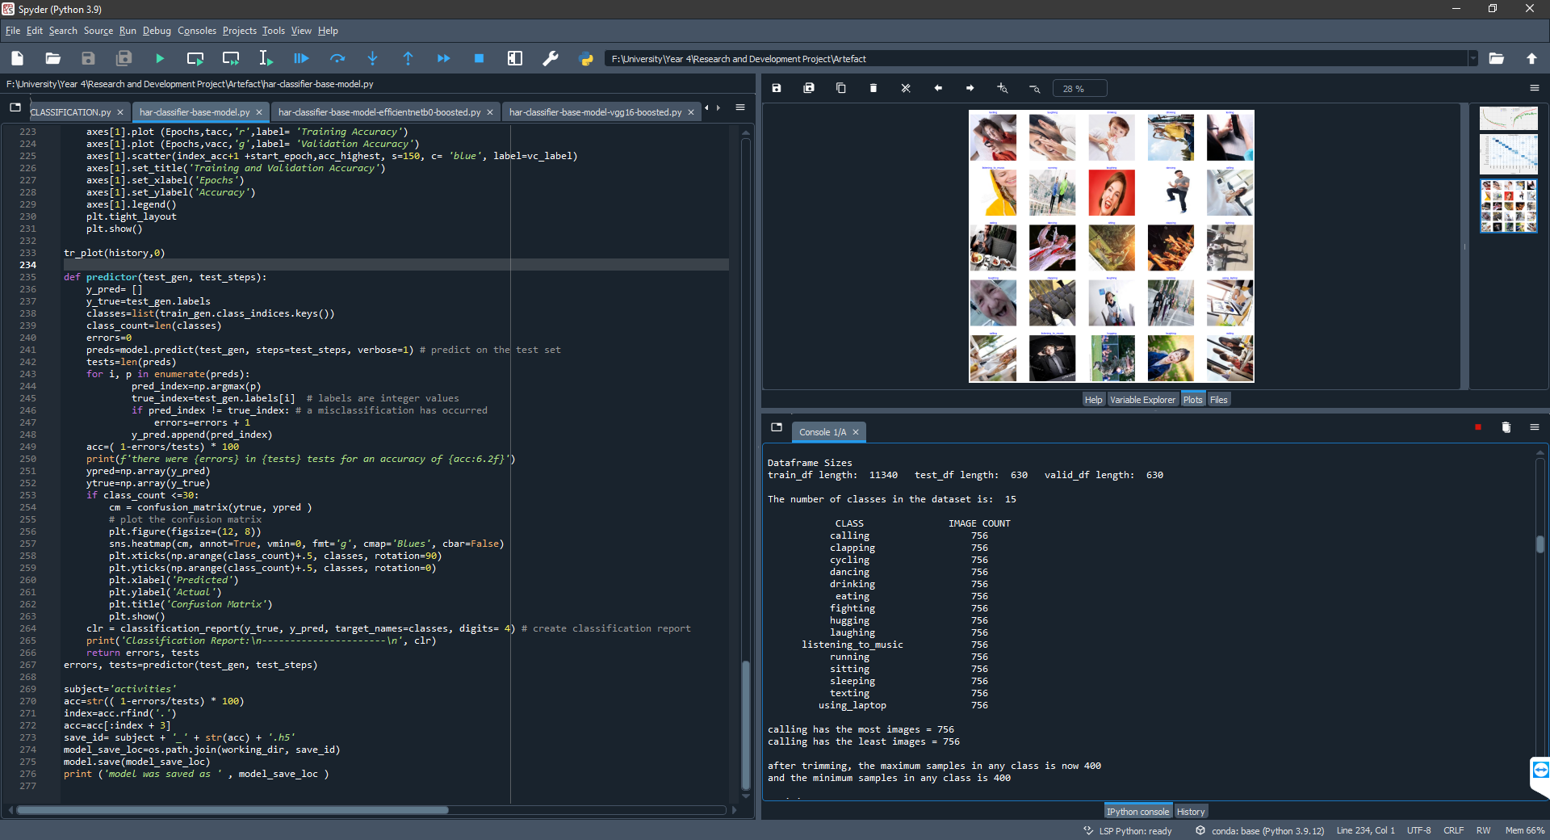

As aforementioned, the ‘labels’ column was passed into the stratify parameter so that each of the subsets contains a balanced number of classes. This technique is applied to reduce the chance of the model overfitting by assuring that it is trained from an equal number of images from each class (See Figure 3).
Figure 3: Training Set Class Distribution

  - Trimming Dataset
Due to the vast size of the dataset and the hardware limitations of the system used for development, the dataset is then trimmed by taking the data frame along with the desired maximum and minimum number of samples integers to return a data frame where each class has no more than the maximum number of samples images in any class. If a class has less than the minimum number of sample images the class is excluded from the data frame. For this project both the maximum and the minimum number of samples was set to 400 (See Figure 4) since any further increase caused the GPU memory to be exhausted and the system.
Figure 4: Maximum and Minimum Number of Samples
  - Importing Images
Since the dataset has been split and allocated to each of the subsets and trimmed to fit the limitations of the system. Next, the system begins importing the images. To implement this, two ImageDataGenerators are declared, the first for the training set which applies image augmentation such as a random horizontal flip and a random rotation of 90 degrees and the second used for the validation and testing set which does not apply any data augmentation since these subsets are used for analysing the accuracy of the model. A sample of the imported training set with the data augmentation applied can be seen below in Figure 5.
Figure 5: Sample Images
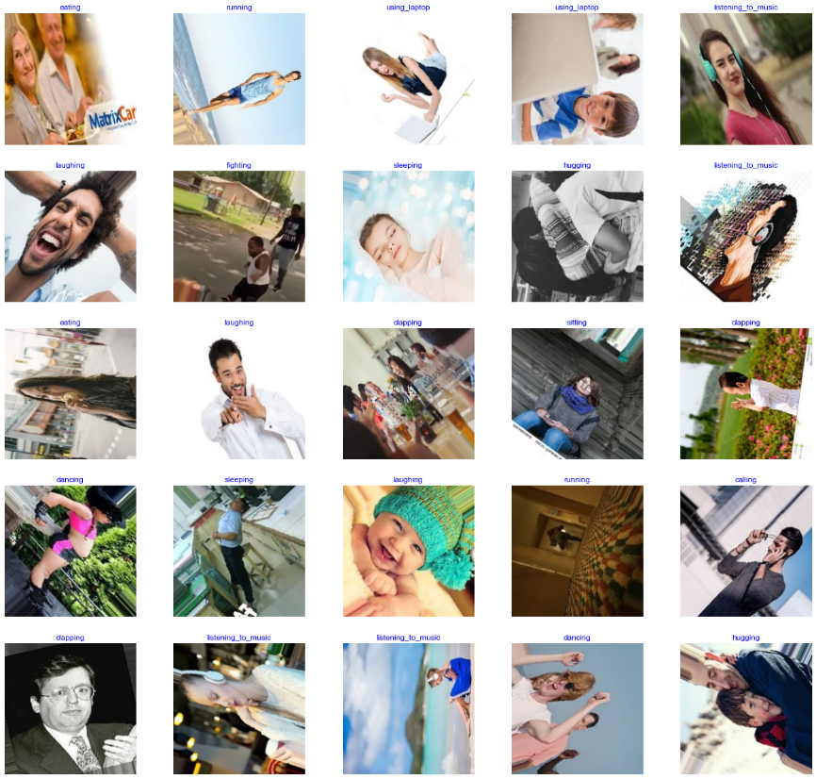
Using each of the ImageDataGenerators and the Keras flow_from_directory function, each subset is then imported into the system (See Figure 6). As shown below, following the trimming this results in a total of 6000 images to be used for training the model.
Figure 6: Importing Images from the Directory
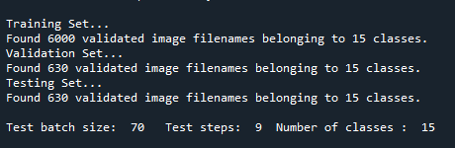
  - Creating Model and Implementing Pre-Trained Model
In preparation for training the model, the system predefines the model as a function with the convolutional and dense layers being declared in blocks of layers that can also be repeatedly called since they are functions. Each predefined block has input parameters to allow the blocks to be re-used several times with slight changes in values. For the convolutional block, the number of filters and the inputs are passed into the function, whereas for the dense block, the number of units, dropout rate and the inputs are passed. First, the inputs are passed through the Keras Input function, passing the input shape as the target image size. Following this, the data is then passed through a rescale layer with a scale of 1 / 255. Next, the previously described model architecture was implemented using four of the predefined convolutional blocks and four of the predefined dense blocks.
When implementing the pre-trained model to boost the HAR model, the EfficientNetB0 model is declared removing the top of the model and passing in the image size as the input shape along with the target number of classes (15) and the input tensor as inputs. To use the booster model in parallel with the base model, the final classification layer and setting the previous layer as the new output layer. The booster model is then flattened and processed through a dense layer with 15 units for the 15 classes. In the penultimate layer, the models are concatenated in which they are forced to agree on the parameters before being processed through the final dense layer for classification.

  - Training Model
Since the creation of the model has been previously defined as a function, a call can be made passing in the image shape to return the model for training. Following this, the model is then complied with the Keras Adam optimiser with a learning rate of 0.0001, the value of the learning rate was altered throughout the implementation to find the best value for this model. The loss parameter is then set to categorical_crossentropy since this multiclass categorical classification rather than binary. Lastly, the metrics parameter is set to ‘accuracy’. Afterwards, the number of epochs is declared with the value dependant on the current experiment, this value is the number of complete passes that undergo during the training. Next, using the Keras model fit method is called and stored in a variable called ‘history’ so the training can be later plotted. Upon calling the fit method, the training and validation dataset and number of epochs are also passed into the method. Using the history variable both the training and validation loss and accuracy are then plotted so the progress of the model in training can be easily visualised, an example of this plot can be seen in the experimentation section.
  - Generating Predictions
Once the model had been trained, it can then be used to generate the predictions for the images in the testing set. To do this a function is defined that takes in the testing set with the testing steps (See Figure 6) to generate predictions. The predicted classes are obtained by passing the testing set into the Keras model .predict method before the predictions are enumerated to obtain the predicted classes index for each prediction. The classes indexes are then compared against the true classes index to see if misclassification has occurred and finally the overall accuracy is calculated based on the number of errors found and the number of original tests (See Figure 7).
Figure 7: Model Accuracy on Test Set Example
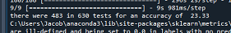
Additionally, this method generates both a confusion matrix and classification report using the sklearn methods. The sklearn confusion matrix is then plotted into a heatmap so the actual vs predicted classes can be easily visualised, while the classification report is printed to the console (See Figure 8) so the precision, recall and f1-score can be seen for each class. Finally, the model is then saved should it need to be recalled later.
Figure 8: Classification Report Example
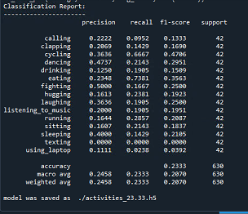

Chapter 6: Testing
As is common with research with CNN and generally in the field of DL (Goodfellow, Bengio and Courville, 2016), the testing and experimentation stages of this project make use of the GPU to enable accelerated training. Since neural networks usually involve large and numerous buffers of parameters, activation values, and gradient values, each of which must be completely updated during every step of training. These buffers are large enough to fall outside the cache of a traditional desktop computer, so the memory bandwidth of the system often becomes the rate-limiting factor. Using the GPU over the CPU provides significant advantages due to their high memory bandwidth and a high degree of parallelism allowing them to process individual neurons independently from other neurons in the same layer. The software used to enable accelerated training in this project is TensorFlow 2.9, Python 3.9 and CUDA 11.2. The hardware specification of the system used for experimentation is as follows: an i5-7400 CPU, 16 GB RAM, and an NVIDIA GeForce GTX 1060 3GB GPU.

6.1: Experimentation
This section shows the performance of each model over time during the training phase. For each of the experiments, the previously stated hardware was used. It must be noted that each experiment was trained to the specified number of epochs and then the predictions as seen in section 6.2 were generated and the model was saved, therefore, each experiment is a different model trained from 0 rather than continuing training. This was to assure that if the model began to overfit the data that it would not affect any of the other experiments.

6.1.1: Base Model
Figures 9, 10, and 11 below show the loss and accuracy over time for the base model after 100, 250 and 500 epochs. Additionally, recorded beneath each of the figures is the final accuracy and validation of the model.
Figure 9: Base Model - 100 Epochs
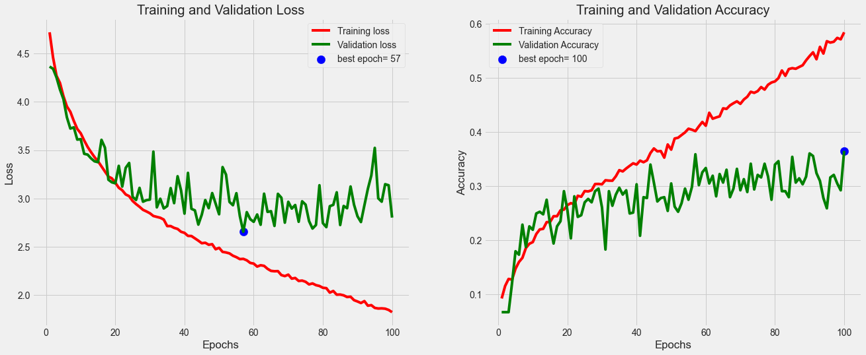
Final Epoch - Accuracy: 58.43%, Validation Accuracy: 36.51%
Figure 10: Base Model - 250 Epochs
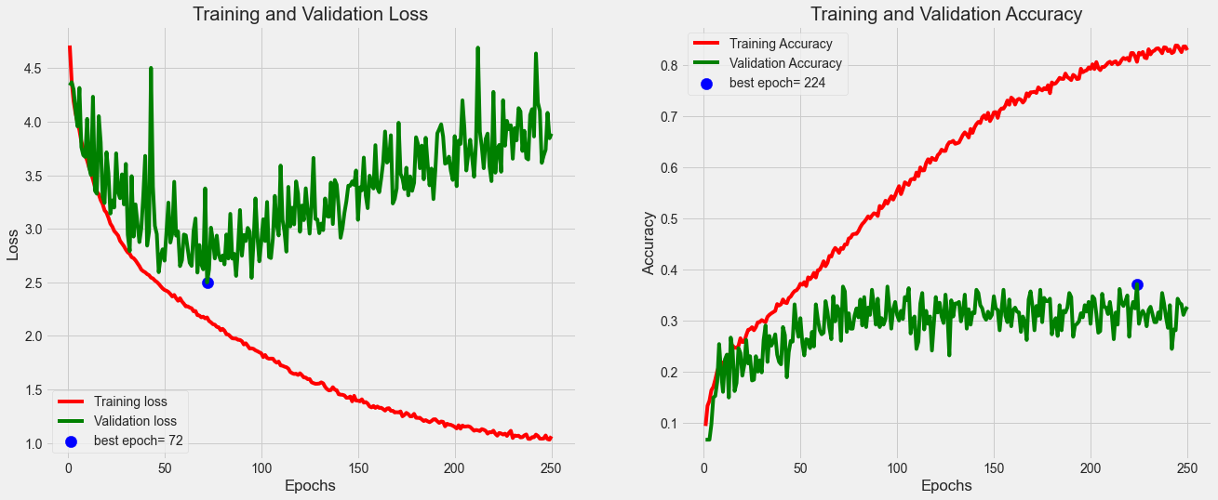
Final Epoch - Accuracy: 82.97%, Validation Accuracy: 32.70%
Figure 11: Base Model - 500 Epochs
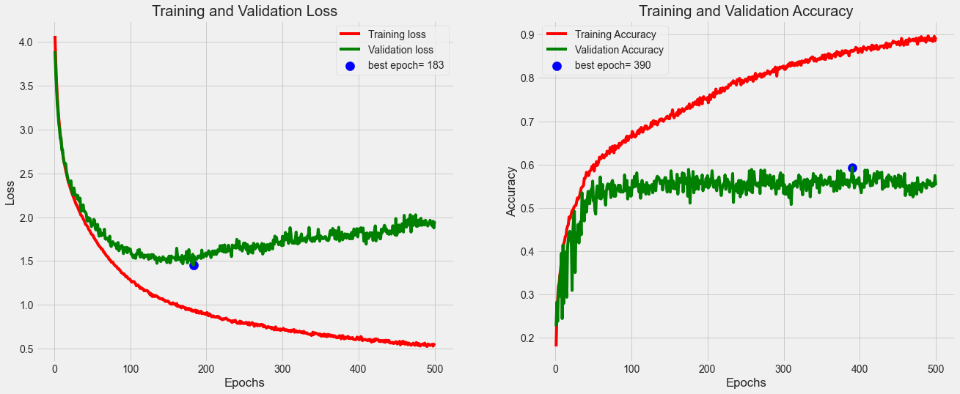
Final Epoch - Accuracy: 89.42%, Validation Accuracy: 55.24%

6.1.2: EfficientNetB0 Boosted Model
Figures 12, 13, and 14 below show the loss and accuracy over time for the EfficientNetB0 boosted model after 100, 250 and 500 epochs. Additionally, recorded beneath each of the figures is the final accuracy and validation of the model.
Figure 12: EfficientNet Boosted Model - 100 Epochs
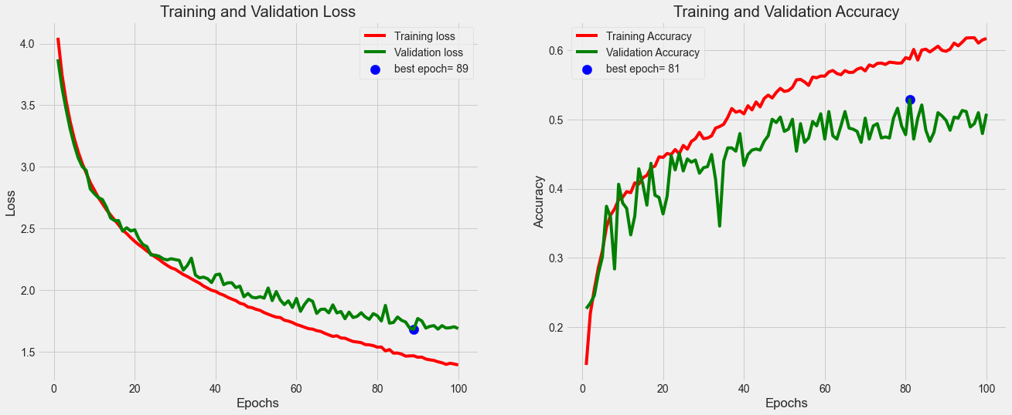
Final Epoch - Accuracy: 61.65%, Validation Accuracy: 50.79%
Figure 13: EfficientNet Boosted Model - 250 Epochs
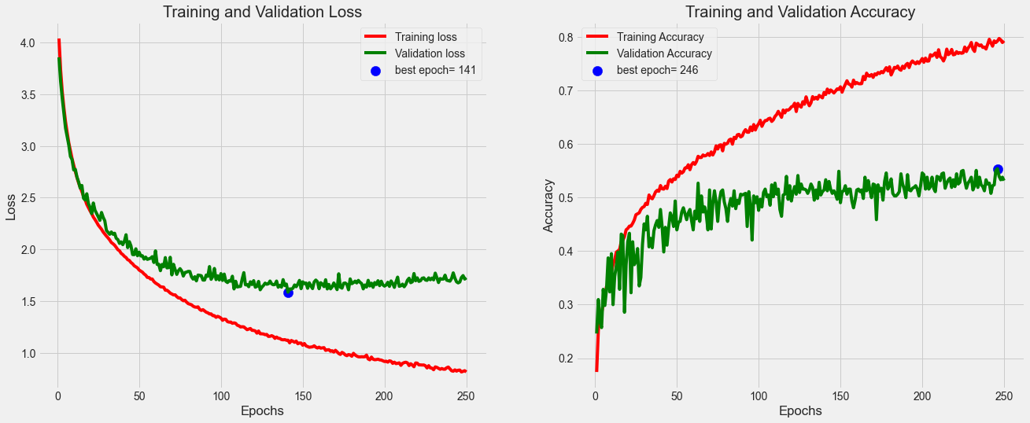
Final Epoch - Accuracy: 79.30%, Validation Accuracy: 53.17%
  - 500 Epochs
Figure 14: EfficientNet Boosted Model - 500 Epochs
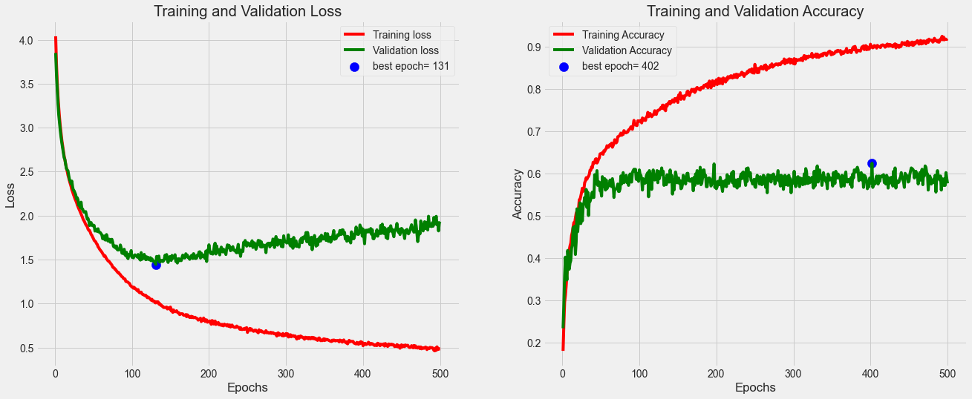
Final Epoch - Accuracy: 91.82%, Validation Accuracy: 57.62%

6.2: Results

6.2.1: Base Model
Figures 15, 16, and 17 below show the confusion matrix for the predicted classes for the base model after 100, 250 and 500 epochs. Additionally, recorded beneath each of the figures is the overall accuracy of the testing set.
Figure 15: Base Model Confusion Matrix - 100 Epochs
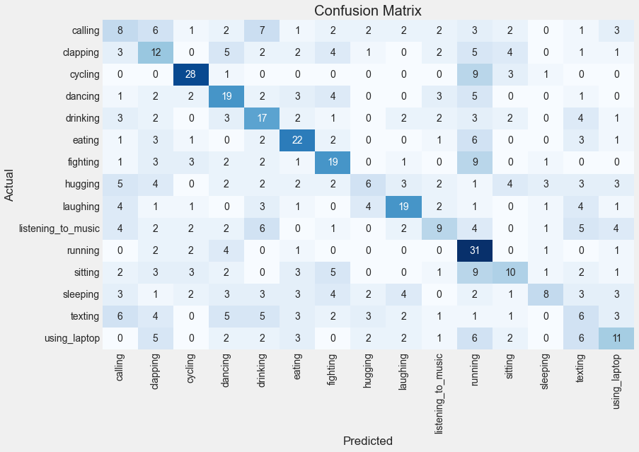
Accuracy on Testing Set: 35.71%
Figure 16: Base Model Confusion Matrix - 250 Epochs
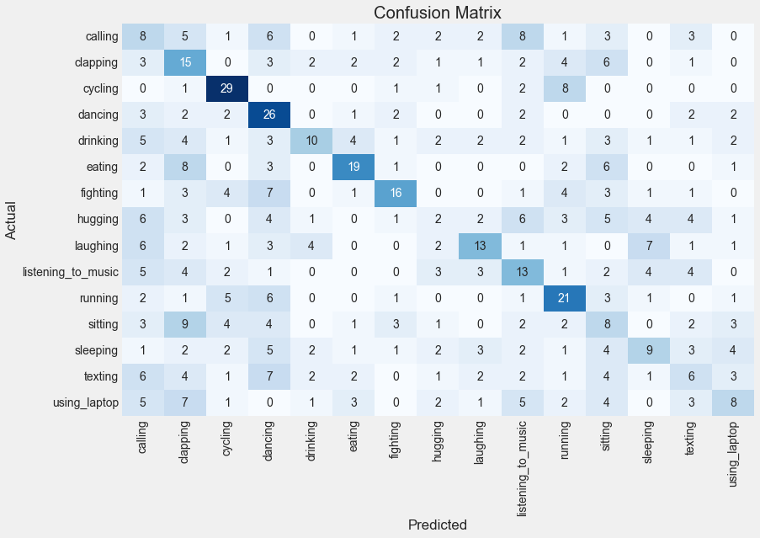
Accuracy on Test Set: 32.22%
Figure 17: Base Model Confusion Matrix - 500 Epochs
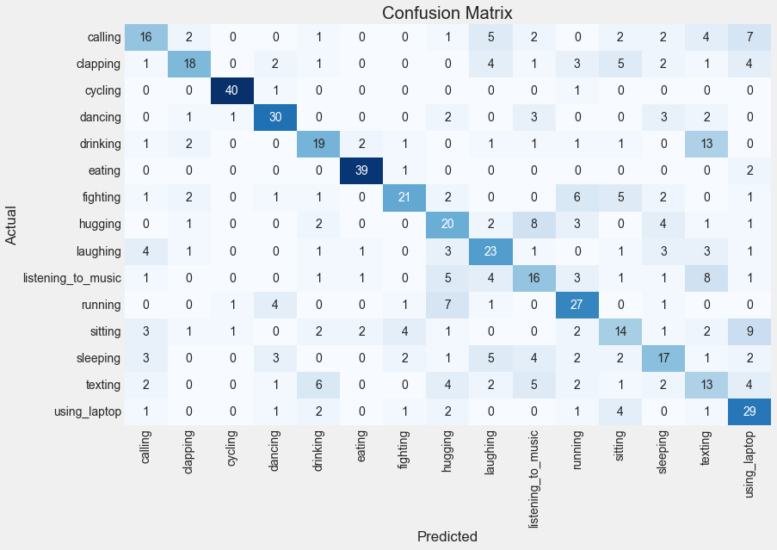
Accuracy on Test Set: 54.29%

6.2.2: EfficientNetB0 Boosted Model
Figures 18, 19, and 120 below show the confusion matrix for the predicted classes for the EfficientNet boosted model after 100, 250 and 500 epochs. Additionally, recorded beneath each of the figures is the overall accuracy of the testing set.
Figure 18: EfficientNet Boosted Model Confusion Matrix - 100 Epochs
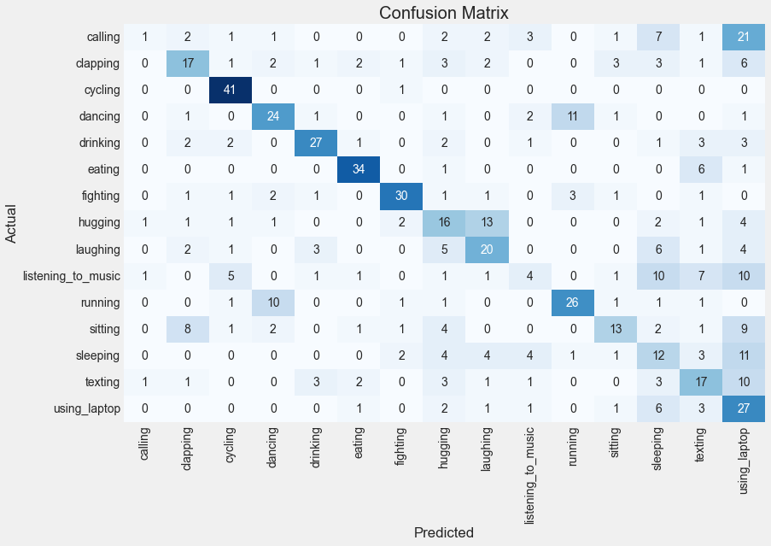
Accuracy on Test Set: 49.05%
Figure 19: EfficientNet Boosted Model Confusion Matrix - 250 Epochs
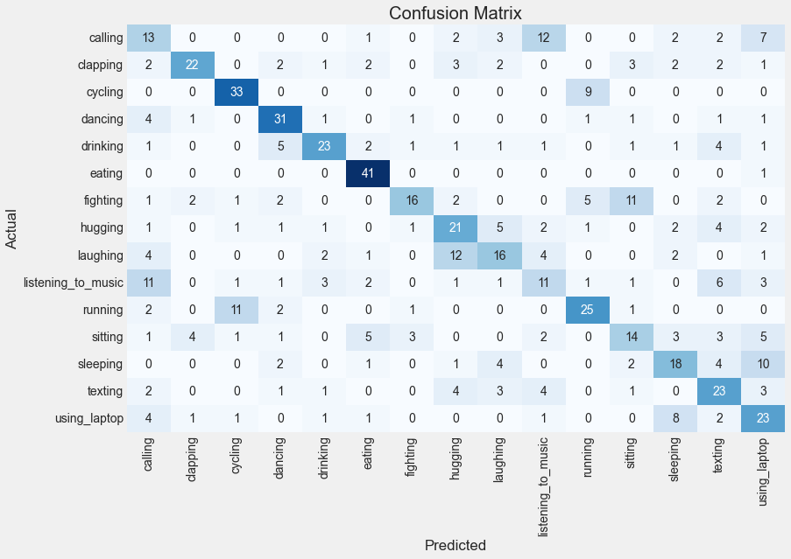
Accuracy on Test Set: 52.38%

Figure 20: EfficientNet Boosted Model Confusion Matrix - 500 Epochs
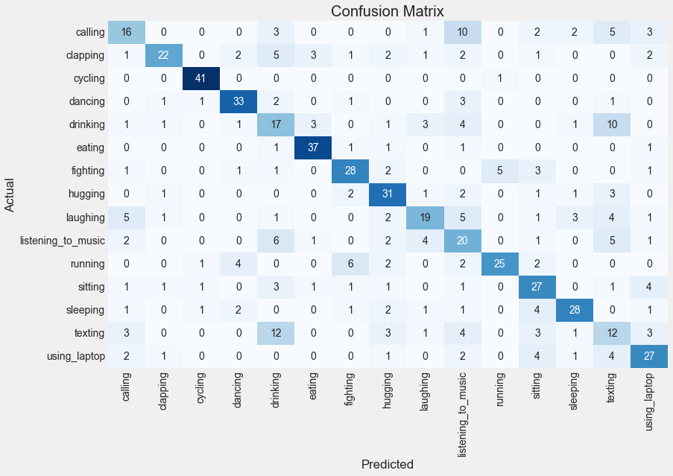
Accuracy on Test Set: 60.79%

6.3: Evaluation
In an evaluation of both the base model and the EfficientNet boosted model, both achieved good accuracy during the training phases after 500 epochs of 89.42% and 91.82% respectively however, failed to understand the relationships between the data as the validation accuracy was much lower, 55.24% and 57.62% respectively. This usually indicates that there are meaningful differences between the data that the model has been trained with and the validation data provided for accuracy. However, since each of the datasets has a balanced number of classes as explained in the implementation, it can be ruled out that the model is overfitting towards a single class. Instead, the performance suggests that the model being used is too complex and the number of learning parameters in the model is too great therefore, instead of generalising the data the model is learning solely the training data rather than understanding the relationship between them.
This theory is confirmed by the prediction results, where after 500 epochs the model and EfficientNet boosted model, achieved an accuracy of 54.29% and 60.79%. It can be seen in each of the confusion matrices that both models successfully classified many of the activities correctly with a handful of outliers primarily coming from a failure to distinguish between similar activities. Common misclassification was shared between ‘drinking’ and ‘texting’ which indicates that both models failed to understand the relationship between these classes. Additionally, several misclassifications were shared between ‘listening to music’ and ‘calling’ again suggesting that both models struggled to understand the relationship between these classes. Overall, this showed that using the pre-trained EfficientNet model did provide a small increase in performance however, the history suggests that the same performance can be achieved from the base model with an increased number of epochs. Additionally, both models successfully classified several of the predictions however, as aforementioned failed to understand the relationship between a few similar classes, overall resulting in an average performance.

Chapter 7: Conclusion

7.1: Summary
The project aimed to develop and classification system to accurately distinguish between human activity using CNN to help solve the HAR problem. The model developed has a total of 5,039,087 parameters – 5,036,207 trainable and 2,880 non-trainable – spanning across 34 different layers with several convolutions, max pooling, and separable convolution layers used to apply filter the images to extract the features followed by a flattening and several dense layers used to connect features and generate a final the classification. The aim of the project has been fulfilled with the creation of the prototype software and DL models used to classify the dataset of images along with several appropriate DL techniques being applied. The prototype models managed to successfully classify several of the classes in the dataset, however, failed to distinguish between a couple of sets of similar activities resulting in an average overall accuracy.
The methodology used in the development of this system has also proven to be successful and extremely helpful with the continuous development of the models. This has helped with determining which combination of model layers was more effective in each iteration and the changes could be easily implemented and changed throughout the development of this system.
The results of this research show that the model would need further development and possible simplification to generalise and fully understand the relationship between some of the similar classes. Despite this, the DL approach taken to image classification showed it can be useful in detecting certain classes in the dataset. Currently, the developed model would be unsuccessful when being ape applied in a practical application, however, this research showed promise that a DL approach could be successful in future if further developed to distinguish between the classes where the model faced difficulties with understanding the relationship and difference between them.

7.2: Critical Evaluation
The system developed by the project although not being highly accurate as originally intended did show that a DL approach can be used to distinguish between certain classes of activities. Despite applying many suitable DL techniques, several improvements can still be made to improve the model’s performance and usability so that it can be applied in a practical application. Firstly, the current system has been implemented in the Spyder IDE which although excellent for the development of this type of system but would not be as ideal in a practical environment, therefore, this system would need additional development to become a more usable application. Additionally, significant improvements are needed on the model itself to better understand the difference between similar activity classes. Aside from the average accuracy achieved, the remaining aims and objectives of the project have been successful, and the research has proven that DL is a suitable method for classifying human activity.
Throughout the development of this project, many difficulties were experiment due to hardware limitations of the system available. This resulted in a struggle to develop a system which would be able to handle the vast amount of data in the dataset and still create the relationship to understand the data so that the model can classify with high accuracy. Despite the dataset containing 12600 labelled images, in practicality, only 6000 images were used for training since the hardware could not handle anymore without exhausting the GPU memory.

7.3: Future Work
In the avenue of possible future developments of the project, the model developed can act as a base model for researchers to further develop a highly accurate method of classifying human activity. Much of the limitations of the model and the project are largely down to the accessibility of the high-end development system since the GPU used for this project only had a memory of 3GB. Additionally, the literature review details the use of object detection and attention model for image classification systems, the practical implementation of this is a particularly high level of programming which was not feasible in this study due to the limited hardware components. Secondly, to broaden the study a larger dataset would be required with a greater variety of activities that would help push this technology closer to being used in a practical application. Increasing the number of classes would increase the complexity of the HAR problem therefore additional work would need to be done on the proposed model to better generalise the data and gain a better understanding of the relationships between the images, improving the classification of similar activities.

Chapter 8: References
Abadi, M. et al. (2016) ‘TensorFlow: Large-Scale Machine Learning on Heterogeneous Distributed Systems’. Available at: https://arxiv.org/abs/1603.04467v2 (Accessed: 19 November 2021).
Anguita, D. et al. (2012) ‘Human activity recognition on smartphones using a multiclass hardware-friendly support vector machine’, in Lecture Notes in Computer Science (including subseries Lecture Notes in Artificial Intelligence and Lecture Notes in Bioinformatics). Springer, Berlin, Heidelberg, pp. 216–223. doi:10.1007/978-3-642-35395-6_30.
Bahdanau, D., Cho, K.H. and Bengio, Y. (2015) ‘Neural machine translation by jointly learning to align and translate’, in 3rd International Conference on Learning Representations, ICLR 2015 - Conference Track Proceedings.
Bao, L. and Intille, S.S. (2004) ‘Activity recognition from user-annotated acceleration data’, Lecture Notes in Computer Science (including subseries Lecture Notes in Artificial Intelligence and Lecture Notes in Bioinformatics), 3001, pp. 1–17. doi:10.1007/978-3-540-24646-6_1.
Belkin, M., Niyogi, P. and Sindhwani, V. (2006) ‘Manifold regularization: A geometric framework for learning from labeled and unlabeled examples’, Journal of Machine Learning Research, 7, pp. 2399–2434. Available at: http://www.cse.msu.edu/ (Accessed: 14 May 2021).
Bhattacharya, S. et al. (2014) ‘Using unlabeled data in a sparse-coding framework for human activity recognition’, Pervasive and Mobile Computing, 15, pp. 242–262. doi:10.1016/j.pmcj.2014.05.006.
Brownlee, J. (2019) How Do Convolutional Layers Work in Deep Learning Neural Networks?, Deep Learning for Computer Vision. Available at: https://machinelearningmastery.com/convolutional-layers-for-deep-learning-neural-networks/ (Accessed: 14 May 2021).
Chen, K. et al. (2021) ‘Deep learning for sensor-based human activity recognition: Overview, challenges, and opportunities’, ACM Computing Surveys. ACM PUB27 New York, NY, USA. doi:10.1145/3447744.
Chen, L. et al. (2012) ‘Sensor-based activity recognition’, IEEE Transactions on Systems, Man and Cybernetics Part C: Applications and Reviews, pp. 790–808. doi:10.1109/TSMCC.2012.2198883.
Cisco (2012) ‘How Can Service Providers Face IPv4 Address Exhaustion? - Cisco’, (June), pp. 1–28. Available at: https://www.cisco.com/c/en/us/products/collateral/ios-nx-os-software/enterprise-ipv6-solution/whitepaper_c11-698132.html.
Demchenko, Y., De Laat, C. and Membrey, P. (2014) ‘Defining architecture components of the Big Data Ecosystem’, in 2014 International Conference on Collaboration Technologies and Systems, CTS 2014. IEEE Computer Society, pp. 104–112. doi:10.1109/CTS.2014.6867550.
Duffner, S. et al. (2014) ‘3D gesture classification with convolutional neural networks’, in ICASSP, IEEE International Conference on Acoustics, Speech and Signal Processing - Proceedings. Institute of Electrical and Electronics Engineers Inc., pp. 5432–5436. doi:10.1109/ICASSP.2014.6854641.
Evans, D. (2011) ‘The internet of things how the next evolution of the internet is changing everything (april 2011)’, White Paper by Cisco Internet Business Solutions Group (IBSG) [Preprint]. Available at: http://postscapes.com/cisco-internet-of-things-white-paper-how-the-next-evolution-of-the-internet-is-changing-everything.
Foerster, F., Smeja, M. and Fahrenberg, J. (1999) ‘Detection of posture and motion by accelerometry: a validation study in ambulatory monitoring’, Computers in Human Behavior, 15(5), pp. 571–583. doi:10.1016/S0747-5632(99)00037-0.
Gandomi, A. and Haider, M. (2015) ‘Beyond the hype: Big data concepts, methods, and analytics’, International Journal of Information Management, 35(2), pp. 137–144. doi:10.1016/j.ijinfomgt.2014.10.007.
Ghazal, A. et al. (2013) ‘BigBench: Towards an industry standard benchmark for big data analytics’, in Proceedings of the ACM SIGMOD International Conference on Management of Data, pp. 1197–1208. doi:10.1145/2463676.2463712.
Gillis, A. (2022) What is IoT (Internet of Things) and How Does it Work?, TechTarget. Available at: https://www.techtarget.com/iotagenda/definition/Internet-of-Things-IoT (Accessed: 16 August 2022).
Goodfellow, I., Bengio, Y. and Courville, A. (2016) Deep Learning. MIT Press. Available at: https://www.deeplearningbook.org/ (Accessed: 14 May 2021).
Hargrave, M. (2019) Deep Learning Definition | DeepAI. Available at: https://www.investopedia.com/terms/d/deep-learning.asp (Accessed: 3 January 2021).
Hofacker, C.F., Malthouse, E.C. and Sultan, F. (2016) ‘Big Data and consumer behavior: imminent opportunities’, Journal of Consumer Marketing, 33(2), pp. 89–97. doi:10.1108/JCM-04-2015-1399.
Holler, J. et al. (2014) From Machine-To-Machine to the Internet of Things, From Machine-To-Machine to the Internet of Things. Elsevier Ltd. doi:10.1016/C2012-0-03263-2.
hypr (2021) What is Ubiquitous Computing?, Security Encyclopedia. Available at: https://www.hypr.com/ubiquitous-computing/ (Accessed: 27 October 2021).
James, W. (1890) The principles of psychology, Vol I., The principles of psychology, Vol I. Henry Holt and Co. doi:10.1037/10538-000.
Khan, A.M. (2013) ‘Recognizing Physical Activities Using Wii Remote’, International Journal of Information and Education Technology, pp. 60–62. doi:10.7763/ijiet.2013.v3.234.
Kipf, T.N. and Welling, M. (2017) ‘Semi-supervised classification with graph convolutional networks’, in 5th International Conference on Learning Representations, ICLR 2017 - Conference Track Proceedings. International Conference on Learning Representations, ICLR.
Krizhevsky, A., Sutskever, I. and Hinton, G.E. (2017) ‘ImageNet classification with deep convolutional neural networks’, Communications of the ACM, 60(6), pp. 84–90. doi:10.1145/3065386.
LeCun, Y. and Bengio, Y. (1998) ‘Convolutional networks for images, speech, and time series. In The handbook of brain theory and neural networks’, MIT Press: Cambridge, MA, USA, pp. 255–258. Available at: https://dl.acm.org/doi/10.5555/303568.303704 (Accessed: 27 April 2022).
Li, Y. et al. (2014) ‘Unsupervised feature learning for human activity recognition using smartphone sensors’, in Lecture Notes in Computer Science (including subseries Lecture Notes in Artificial Intelligence and Lecture Notes in Bioinformatics). Springer, Cham, pp. 99–107. doi:10.1007/978-3-319-13817-6_11.
Loye, G. (2019) ‘Attention mechanism’, FLOYDHUB, pp. 0–16. Available at: https://blog.floydhub.com/attention-mechanism/ (Accessed: 14 May 2021).
Mayachita, I. (2020) Understanding Graph Convolutional Networks for Node Classification | by Inneke Mayachita | Towards Data Science, Towards Data Science. Available at: https://towardsdatascience.com/understanding-graph-convolutional-networks-for-node-classification-a2bfdb7aba7b (Accessed: 14 May 2021).
Mayer-Schönberger, V. and Cukier, K. (2013) Big Data: A Revolution that Will Transform how We Live, Work, and Think. Available at: https://books.google.co.uk/books?id=uy4lh-WEhhIC&lr=&source=gbs_navlinks_s (Accessed: 18 November 2021).
McCormick, M. (2012) ‘Waterfall vs. Agile Methodology’.
Mgudlwa, S. and Iyamu, T. (2018) ‘Integration of social media with healthcare big data for improved service delivery’, SA Journal of Information Management, 20(1). doi:10.4102/sajim.v20i1.894.
Miraz, M.H. et al. (2015) ‘A review on Internet of Things (IoT), Internet of Everything (IoE) and Internet of Nano Things (IoNT)’, in 2015 Internet Technologies and Applications, ITA 2015 - Proceedings of the 6th International Conference. Institute of Electrical and Electronics Engineers Inc., pp. 219–224. doi:10.1109/ITechA.2015.7317398.
Nweke, H.F. et al. (2018) ‘Deep learning algorithms for human activity recognition using mobile and wearable sensor networks: State of the art and research challenges’, Expert Systems with Applications. Pergamon, pp. 233–261. doi:10.1016/j.eswa.2018.03.056.
Parmask, H. et al. (2021) The History of Ubiquitous Computing, Sutori. Available at: https://www.sutori.com/en/story/the-history-of-ubiquitous-computing--SMuA4RazAxWSKRXHENnAGSx2 (Accessed: 8 January 2022).
Plötz, T., Hammerla, N.Y. and Olivier, P. (2011) ‘Feature learning for activity recognition in ubiquitous computing’, in IJCAI International Joint Conference on Artificial Intelligence, pp. 1729–1734. doi:10.5591/978-1-57735-516-8/IJCAI11-290.
Richardson, P. (2019) Combating crime with Big data, analytics and artificial intelligence, hedgehog lab. Available at: https://hedgehoglab.com/blog//combat-crime-big-data-analytics-ai (Accessed: 19 November 2021).
Rocklöv, J. et al. (2019) ‘Using big data to monitor the introduction and spread of Chikungunya, Europe, 2017’, Emerging Infectious Diseases, 25(6), pp. 1041–1049. doi:10.3201/eid2506.180138.
Rodriguez-Borbon, J.M. et al. (2020) ‘Heterogeneous Acceleration of HAR Applications’, IEEE Transactions on Circuits and Systems for Video Technology, 30(3), pp. 888–902. doi:10.1109/TCSVT.2019.2895304.
Ronao, C.A. and Cho, S.B. (2016) ‘Human activity recognition with smartphone sensors using deep learning neural networks’, Expert Systems with Applications, 59, pp. 235–244. doi:10.1016/j.eswa.2016.04.032.
Sharma, A., Lee, Y.D. and Chung, W.Y. (2008) ‘High accuracy human activity monitoring using neural network’, in Proceedings - 3rd International Conference on Convergence and Hybrid Information Technology, ICCIT 2008, pp. 430–435. doi:10.1109/ICCIT.2008.394.
Shea, S. (2021) What is Ubiquitous Computing (Pervasive Computing)?, TechTarget. Available at: https://internetofthingsagenda.techtarget.com/definition/pervasive-computing-ubiquitous-computing (Accessed: 27 October 2021).
Shoaib, M. et al. (2014) ‘Fusion of smartphone motion sensors for physical activity recognition’, Sensors (Switzerland), 14(6), pp. 10146–10176. doi:10.3390/s140610146.
Weston, J. et al. (2012) ‘Deep learning via semi-supervised embedding’, Lecture Notes in Computer Science (including subseries Lecture Notes in Artificial Intelligence and Lecture Notes in Bioinformatics), 7700 LECTU, pp. 639–655. doi:10.1007/978-3-642-35289-8_34.
Wu, W. et al. (2012) ‘Classification accuracies of physical activities using smartphone motion sensors’, Journal of Medical Internet Research, 14(5). doi:10.2196/jmir.2208.
Xu, K. et al. (2015) ‘Show, attend and tell: Neural image caption generation with visual attention’, in 32nd International Conference on Machine Learning, ICML 2015, pp. 2048–2057.
Yang, J.B. et al. (2015) ‘Deep convolutional neural networks on multichannel time series for human activity recognition’, IJCAI International Joint Conference on Artificial Intelligence, 2015-Janua(Ijcai), pp. 3995–4001.
Young, D. (2014) ‘Software Development Methodologies’. Available at: https://www.researchgate.net/publication/255710396_Software_Development_Methodologies.
Zeng, M. et al. (2015) ‘Convolutional Neural Networks for human activity recognition using mobile sensors’, in Proceedings of the 2014 6th International Conference on Mobile Computing, Applications and Services, MobiCASE 2014. Institute of Electrical and Electronics Engineers Inc., pp. 197–205. doi:10.4108/icst.mobicase.2014.257786.
Zheng, Y. et al. (2014) ‘Time series classification using multi-channels deep convolutional neural networks’, in Lecture Notes in Computer Science (including subseries Lecture Notes in Artificial Intelligence and Lecture Notes in Bioinformatics). Springer, Cham, pp. 298–310. doi:10.1007/978-3-319-08010-9_33.
Zhu, X., Ghahramani, Z. and Lafferty, J. (2003) ‘Semi-Supervised Learning Using Gaussian Fields and Harmonic Functions’, in Proceedings, Twentieth International Conference on Machine Learning, pp. 912–919.

Chapter 9: Appendix

Appendix A: Ethical Form


Appendix B: Potential Dataset List
ID | Description | File Size | Format | Number of Class
1 | Activity Recognition from Single Chest-Mounted Accelerometer Dataset - Uncalibrated Accelerometer Data is collected from fifteen participants performing 7 activities. The dataset provides challenges for identifying and authenticating people using motion patterns. | 46.4 MB | CSV | 7
2 | Two Person Interaction Kinect Dataset - RGB, Depth Map and Skeleton Positions of Two person | 3.14 GB | TXT | 8
3 | Human Activity Recognition from video | 1.16 GB | AVI | 6
4 | MHEALTH Dataset - comprises body motion and vital signs recordings for ten volunteers of the diverse profile while performing several physical activities. Sensors placed on the subject's chest, right wrist and left ankle are used to measure the motion experienced by diverse body parts, namely, acceleration, rate of turn and magnetic field orientation. The sensor positioned on the chest also provides 2-lead ECG measurements, which can be potentially used for basic heart monitoring, checking for various arrhythmias, or looking at the effects of exercise on the ECG. | 160.51 MB | TXT | 12
5 | MotionSense Dataset: Smartphone Sensor Data - This dataset includes time-series data generated by accelerometer and gyroscope sensors (attitude, gravity, userAcceleration, and rotationRate). It is collected with an iPhone 6s kept in the participant's front pocket using SensingKit which collects information from the Core Motion framework on iOS devices. | 216.24 MB | CSV | 6
6 | Human Activity Recognition with Smartphones - The Human Activity Recognition database was built from the recordings of thirty study participants performing activities of daily living (ADL) while carrying a waist-mounted smartphone with embedded inertial sensors. | 67.46 MB | CSV | 6
7 | Human Action Recognition (HAR) Dataset - The dataset features fifteen different classes of Human Activities and contains 18000 labelled images including the validation images. | 328.18 MB | JPG | 15
8 | KU-HAR: Human Activity Recognition Dataset (v 1.0) - This dataset contains information on eighteen different activities collected from ninety participants (75 male and fifteen female) using smartphone sensors (Accelerometer and Gyroscope). It has 1945 raw activity samples collected directly from the participants, and 20750 subsamples extracted from them. | 1.27 GB | CSV | 18
9 | LFW - People (Face Recognition) - The dataset contains more than 13,000 images of faces collected from the web. Each face has been labelled with the name of the person pictured. 1680 of the people pictured have two or more distinct photos in the data set. | 243.58 MB | TGZ/TXT | N/A
10 | Fitbit Fitness Tracker Data - Thirty eligible Fitbit users consented to the submission of personal tracker data, including minute-level output for physical activity, heart rate, and sleep monitoring. Individual reports can be parsed by export session ID (column A) or timestamp (column B). Variation between output represents the use of diverse types of Fitbit trackers and individual tracking behaviours/preferences. | 338 MB | CSV | N/A

