Dynamic Systems and Controls

Lab 11

Kieran Cosgrove

Part 1

1. With 5 data points on PWM vs output speed in rad/s, the linear regression in orange below gives us the open loop gain.

|  |  |  |  |  |
| --- | --- | --- | --- | --- |
| Wm ref (rad/s) | Wm exp (rad/s) | PWM output (int) | Wm error (rad/s) | Percent Error (%) |
| 220 | 200 | 145 | 20 | 9% |
| 270 | 260 | 178 | 10 | 3.7% |
| 340 | 335 | 225 | 4 | 1.1% |

Part 2

1. Step reference

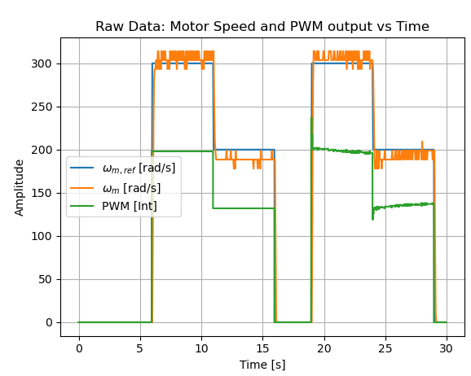

Sinusoidal reference closed loop

Sinusoidal reference open loop

1. Gain values

I increased Kp first until I was able to reach the desired value. I then increased Ki & Kd until I was able to decrease my steady state error and reduce & improve response time. Kp (PWM*s/rad), Ki (PWM/rad), Kd (PWM*s^2/rad).

1. Simulation

Rise Time:   
Experimental-0.180s   
Simulated-0.093s   
Percent Overshoot:   
Experimental-5%   
Simulated-3%   
Settling Time:   
Experimental-0.5s   
Simulated-0.2s