Lab 2 – Kieran Cosgrove

1. Setup

Used string and tape to hold phone off of the ground, using gyroscope to measure angular velocities as it twisted at a steady state time period.

1. Sample angular velocity measurement – my phone being a Pixel 5

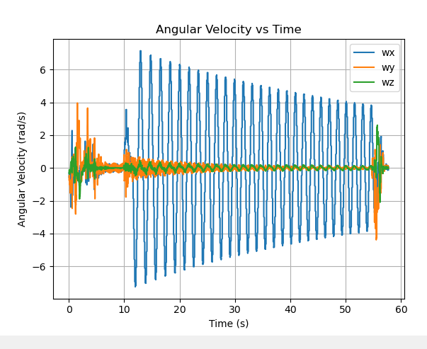

1. Lab Work Exercise 4 – Item 1

The model derived in class for determining the moment of inertia of an object using the bifilar pendulum came to this equation:

This equation was derived by making small angle assumptions – i.e. the displacement of the cord horizontally is equal to the sin of the angle of the movement of the cord vertically. Also, the cord & mass are assumed to be completely stiff. The system is also assumed to be undamped (no dissipation torque due to friction).

1. Lab Work Exercise 4 – Item 2

A ‘for loop’ is used in the Python code to estimate period of oscillation. The period is found by averaging the distance between all the peaks in the given oscillation time range. The peaks are found using a function called find_peaks which finds if there is a maximum value with no value greater than it in the nearest 50 data points before & after it.

1. Lab Work Exercise 4 – Item 4
2. Phone Type: Pixel 5

b & c) Key Phone Specifications & bifilar setup parameters – found from Wikipedia and hand measurements.

d) This was tested without a phone case on it! 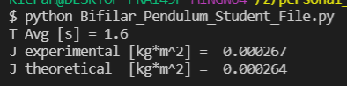

6. Comparison of theoretical and experimental x-axis MOI values

The experimental value is very close to the theoretical value – the experimental value is slightly higher than the theoretical value though. Sources of error would be approximating the phone to have a constant density – the distribution of electronics inside of it would mean this is probably not the case, and there isn’t an easy way to model this. Another source of error is friction damping, which would increase the period and cause an increase in moment of inertia. Another source of error is not making the center of gravity perfectly in the middle of the two strings, which would cause parallel axis theorem to take affect leading to an increased moment of inertia. A final source of error is the stiffness of the string (which is certainly lower than the phones stiffness) which could be sensitive to the change in load and therefore change the phone height linearly as well.