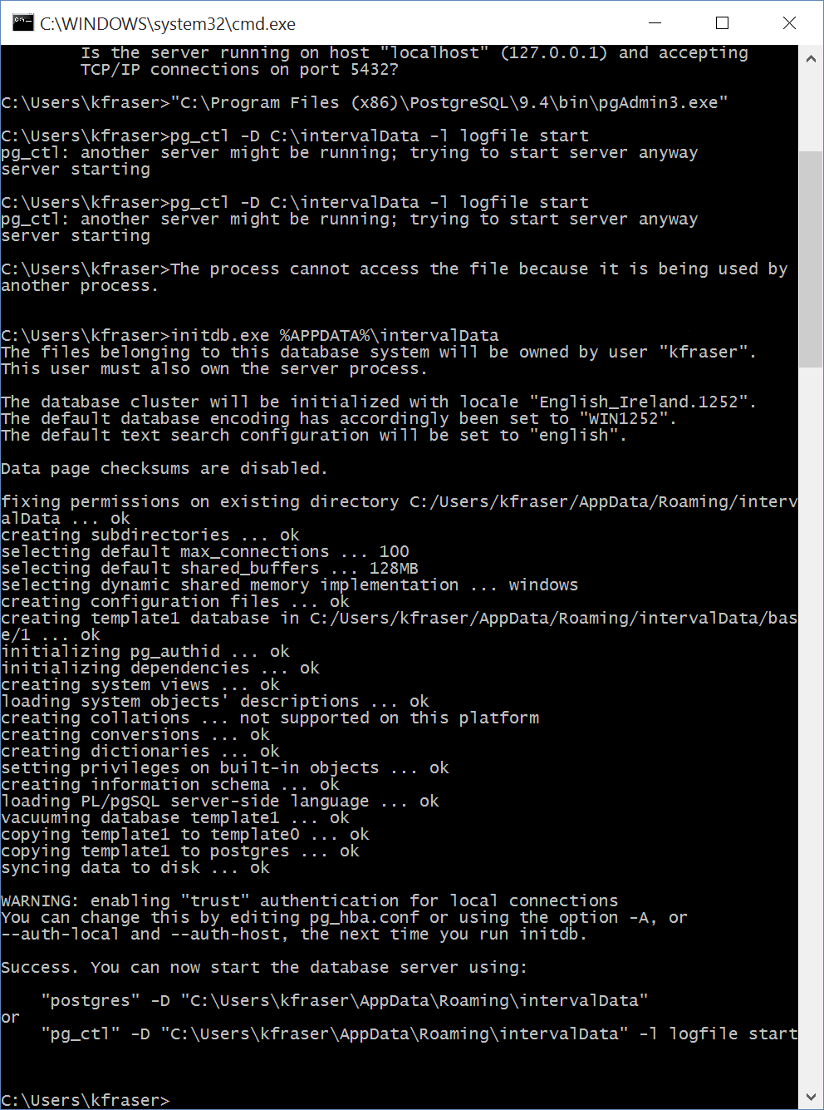

# Useful Commands:

Log in to database for query:

psql -d mydb -U myuser