

|  |  |  |
| --- | --- | --- |
| Development of a Core Vocabulary Learning Tool for children with learning disabilities | | |
| Kieran Hogan | C12561353 | Damian Bourke |

Table of Contents

1. Project statement 4

The objectives 4

2. What research has been done and what are the outputs? 4

Background research 4

Disabilities and Learning 4

Communication and Approaches 6

Alternative existing solutions to the problem you are solving 8

Anna’s Solution 8

App Solutions 9

Technologies researched 11

Mobile Platform 11

Web Application 12

Client 12

Server 13

Database 13

Web Services 14

Data Visualisation 15

Animation Technologies 15

Other relevant research done 16

Interview/Contact 16

Other students doing community projects 16

Resultant findings/requirements 16

Requirements Doc 16

Bibliography (research sources) 17

Background Research 17

Technologies Researched 20

3. Analysis: Describe clearly what your solution will do 21

Student Tablet Application 21

Supervisor Web Application 22

Summary 22

4. Approach and Methodology 22

Scrum 23

5. Design 23

Technical architecture diagram: 23

System Architecture 23

Model View Controller 24

Nielsen’s Heuristics 25

Other design documents 25

Use Cases 25

Storyboards 26

6. Prototyping and Development 28

Prototyping 28

Development 28

7. Testing 29

8. Issues and risks 30

9. Plan and future work 30

Gantt chart 31

10. Conclusions 32

# Project statement

The main goal of this project is to teach a five year old with language learning disabilities, dyspraxia and dyslexia to understand core vocabulary through use of symbols. This user struggles with reading, writing and use of language on a whole, and by learning these symbols, they can then use them to communicate with AAC (Augmentative and Alternative Communication) systems. The aim is to develop a user oriented tablet based system that presents animations and interactive games that represent these symbols. The user has to guess correct symbols, and use these symbols learned to control an onscreen game or character. A web interface will also be developed to present the users supervisor (guardian or therapist) with constructive feedback on the user’s progress. The main objective is to teach the user the meaning of the symbols, in a fun and interactive manor. This would allow the user to communicate using AAC.

### The objectives

The main objectives of the outlined system are:

* To teach the user the meaning of vocabulary via symbols in a fun and interactive way.
* To develop an effective and usable tablet UI, with user driven design at the core.
* To develop a way for the users progress to be tracked and analysed.

Meeting these objectives will contribute to satisfy the overall system goal, and address the problem.

# What research has been done and what are the outputs?

## Background research

Research for this project began when there was a DIT working with communities talk from a speaker who will be referred to as Anna. Anna has a daughter that will be referred to as Sarah, who has dyspraxia, dyslexia and learning disabilities. She is unable to read or write, and has very few words. Anna during the talk mentioned that if there was a way for Sarah to learn symbols that represent words, it would improve her communications skills greatly. This is where the project idea stemmed. To research this project successfully, different core elements needed to be researched. The background research investigates two main areas at the core. These areas are Disabilities, and Communications and Approaches.

### Disabilities and Learning

There are a huge number of disabilities related to peoples learning abilities. They vary in intensity and severity between individuals, and can have a huge impact on people’s lives. Conventional learning methods do not work with these individuals, and as a result they require alternative teaching methods.

#### Language Based Learning Disabilities and Learning Limitations

Language learning is the area of how we as humans develop language skills. From when we are very young, our exposure to spoken language is key as we become students of words. Language learning disabilities are easy to detect early in a child’s life, and as a result can it can be easier to provide treatment and extra assistance for them (Molnar and Sebastian-Galles, 2014).

Many children and adults worldwide suffer from learning disabilities. In Canada a study was conducted that found “*among children aged 5 to 14, learning limitations (LLs) was the largest disability reported (about 69.3% of the children with disabilities)*” (Statistics Canada, 2006). Language based learning disabilities are a huge part of this, and they can be a complicated and delicate subset of learning disabilities. They affect written and spoken language, and can vary in severity. The disabilities can cause minor impedance of language use, to complete inability to speak or write (Newhall, 2012). Language learning is difficult to address as without being able to read, alternative methods of language representation must be used for language learning to be possible.

#### Dyspraxia

Dyspraxia is a disability that affects mainly balance and coordination, and is summarised as a “*developmental coordination disorder*”. (Dyspraxia Association of Ireland, 2015) It effects many of a person’s abilities and general functions, like balance, special awareness and behaviour. However it is not directly related to a person’s intelligence. It is also more common in children, because many cases can be solved and nurtured with therapy in younger years (Dyspraxia Association of Ireland, 2015).

Children who live with dyspraxia often struggle with language learning and processing. In 2000, the Journal of Clinical and Experimental Neuropsychology published a study of a 5 year old child with dyspraxia. The study was conducted over two years and showed the neural effect of dyspraxia on the brain. It was found from the study that children with dyspraxia struggle with “*production aspects of language*” (Le Normand et al., 2000).

Typically it is important to treat people who suffer with dyspraxia with patience and care. Children who suffer from dyspraxia will usually be offered therapeutic help with wherever they struggle with the disability. It is important to note that dyspraxia is commonly related to other issues like dyslexia (Patino, 2014).

#### Dyslexia

Dyslexia is a learning disability that affects people’s ability to read and write. It is a lifelong disorder that can range from mild to quite severe, depending on individual cases. It can effect areas other than these, like rhythm and learning numbers, colours and shapes. It is also commonly diagnosed along with other disabilities like Dyspraxia, and can dramatically affect language learning abilities (Dyslexia Association of Ireland, no date).

Like dyspraxia, having dyslexia does not mean a person is less intelligent. People who suffer from dyslexia sometimes just require more time to process information if it is written, or may the information to be spoken to them through and audible source. Both dyslexia and dyspraxia are difficult disabilities to live with. However there is refined therapies and tools available to target specific areas to help individuals work around these disabilities. It is hoped that the application system will successfully become one of these tools, and help the student users understanding of vocabulary.

#### Learning with Disabilities

Teaching how to read, write and speak to a five year old child with learning disabilities is drastically different to teaching a normal five year old child. Teaching a normal five year old child usually involves them learning the alphabet and rhymes. At this age they would usually be speaking, and asking questions and have a capability to converse. (ReadingByPhonics, no date)

However, teaching a five year old with learning disabilities requires a completely different approach. One similarity that is good practice across the board is reading to the child. However, it may be necessary to read a simpler story to a child with learning disabilities. It is also recommended to teach in a fun manner, for instance making a game out of learning. (Johnson, 2015)

### Communication and Approaches

According to the American Speech-Language-Hearing Association, every individual with a disability has communicative rights. These rights were originally established in 1992 by the National Joint Committee for the Communication Needs of Persons with Severe Disabilities. These rights include every person having the right to request and accept, the right to refusal and rejection, the right to self-expression, and many others (American Speech-Language-Hearing Association, 2014).

#### Symbol Systems and AAC

Concrete symbol systems are systems that implement symbols that accurately and easily represent counterpart reality objects and words. These symbols are typically then used for communication purposes. These symbols can range from everything between actions to objects. Tangible systems are a more detailed area of concrete symbols that look exactly like real world objects that the user would be familiar with. These are better for children with very severe disabilities (Rowland and Schweigert, 2000).

Learning from symbolic objects is a tricky and somewhat complex area. Representing a language as symbols is complex as the symbol itself is an object, and its representation is of another object. The most important factor of symbols is that its symbolic representation is understood as universally and easily as possible. From a study documented by Uttal et al., it was found that concrete objects being used by children as symbols helped them to understand their meaning (Uttal and DeLoache, 2006).

Augmentative and Alternative Communication is solely about effective communication. A huge area of AAC involves the use of symbols. Minspeak was one of the first of these, and it did so with sequences of symbols and required no literary skills (Baker, 2009). Important factors in AAC include accessibility, ease of use, and clear audio speech. It is intended that the project application will implement similar rules and principals in place (Prentke Romich Company, 2008).

#### Low Tech Boards

Low tech boards are typically pdfs or handmade alternatives to AAC that can be used by communication impaired individuals. They involve the user pointing at the symbols of the words to communicate (which may not always be possible, depending on the user’s particular disabilities). PRC Unity board is a low tech board that requires very little technical knowhow. It comes in the form of an easily printable pdf (Prentke Romich Company, no date). LAMP (Language Acquisition through Motor Planning) board is another board similar to the PRC Unity board. This one uses the methodology of LAMP however. This methodology involves the importance of sequencing of symbols to create logical sentences (Prentke Romich Company, no date).

#### Sign Language

Sign language is another alternative communication system, however in some regards it can be seen as just as hard to learn as written and spoken language (Foundation for People with Learning Disabilities, no date). Sign language can sometimes be quite a viable option for language learning, and it can be quite closely related to symbolic systems. Makaton is a sign language style symbolic system developed for people with a variety of disabilities and difficulties (Makaton, 2015). However, due to our user group’s dyspraxia, sign language is not a viable alternative for communication.

#### Learning with Animation and Sound

Animation offers students the opportunity to see a vivid representation of the subject (Bates, 2013). This animated representation of words for example, can closely relate to real world examples, and helps the students to understand their meaning. It is also important to acknowledge the importance of sound in learning. From when we are very young children, we learn to associate sounds with words. Although it is less clear to tell where words end and begin in everyday spoken language as opposed to written language, hearing words spoken slowly and isolated is integral to learning to speak and understand languages. The sounds of words and the meanings are vital to language learning. Phonics and phonemes are integral to learning to speak. (Saffran, 2014). The use of animation and sound will drive one of the game aspects of this system, and in turn help to meet the objective of teaching the user vocabulary through symbols.

#### Learning with Video Games

Video games are a controversial form of entertainment. They are considered by some to promote violent and abnormal behaviour. However, studies have been conducted which lead us to believe they are beneficial for mental health and coordination. People who suffer from learning disabilities benefit greatly from interactivity and video games. Certain attention must be made to aspects of the game however. It is important for the user to be rewarded for successful completion of levels in the game, and for this reward to be worthwhile and enjoyable for the user. It is also important for challenging aspects of a game to meet an appropriate difficulty for the user. This can be established by having the difficulty increase, as the user improves at the game (Kulman, Watkins, and Carlson, 2012). This will also contribute greatly to teaching the user symbols and what they represent.

#### Vocabulary and Core Vocabulary

According to AAClanguagelab.com, vocabulary can be broken into core and fringe vocabulary. Core vocabulary has many characteristics. It is what makes up the majority of a sentence or conversation, and is typically words which are used frequently. They can apply to a broad number of topics and environments, and are typically used repeatedly in conversation. Examples of core vocabulary are universal pronouns like ‘you’ and ‘me’, verbs like ‘do’, ‘like’ and ‘watch’, and question words (Prentke Romich Company, no date).

Core vocabulary is the most integral part of language vocabulary. The idea of focusing on teaching people with language learning disabilities these core words is that they are “*re-usable*” and “*promote generative language*”. (Vinson, no date). This means that the student learning these core words is more likely to initiate new conversation, rather than following a previously memorised dialogue (Vinson, no date).

Other articles and websites have outlined similar and some different common words used and required for communication. These include the following: (FINISH) (VanTatenhove, 2005).

#### Heuristics and Design principals

An important element of this project will be attention to design principals. Design principals are necessary in all software interface designs, however in this system our user is at the core heart of the design. Therefore, Nielsen’s Heuristics will be used. There are ten principals of these which are as follows:

* Visibility of system status: Have a responsive system, e.g. use loading icon
* Match between system and the real world: Use symbols and words familiar to user*
* User control and freedom: Allow the user to navigate freely
* Consistency and standards: Consistency in buttons and definitions
* Error prevention: Use effective error messages
* Recognition rather than recall: User should recognise, should be guided with tutorials
* Flexibility and efficiency of use: Have system learn from user
* Aesthetic and minimalist design: Only show what is needed and relevant
* Help users recognize, diagnose, and recover from errors: Help user with error recovery
* Help and documentation: Provide documentation for system help

In following these ten heuristics, and tailoring the system around your user, you design a system that is created with your user’s ability to use the system as a primary focus. (Nielsen, 1995) Focusing on all ten may be difficult, but will be attempted in designing the system. The use of familiar symbols for the user is key here, for designing minimal easily navigable menus.

Everything in this systems interface is important, from the colour of the symbols being used, to the layout and position of the buttons. All of these will be necessary to ensure the user driven design objective is met. As a result, careful attention will be paid throughout the projects interface design.

## Alternative existing solutions to the problem you are solving

Currently, the most common solutions to the problem of understanding the symbols in AAC systems, are achieved manually. These manual means involve tutoring from a therapist or parent with the use of printable activity sheets with symbols on them, like those provided by companies like PRC (Prentke Romich Company, no date).

### Anna’s Solution

Anna’s current solution to teaching her daughter core vocabulary involves the use of a customised symbol set. This symbol set is a hybrid of symbols from SymbolStix (n2y, no date) and Widgit Symbols (Widgit Software, no date). This limited set of symbols forms the base of communication vocabulary available to Sarah, however she cannot speak most of these. However, her understanding of the words is paramount to her using symbol communication systems. Below is the table of symbols of her current vocabulary.

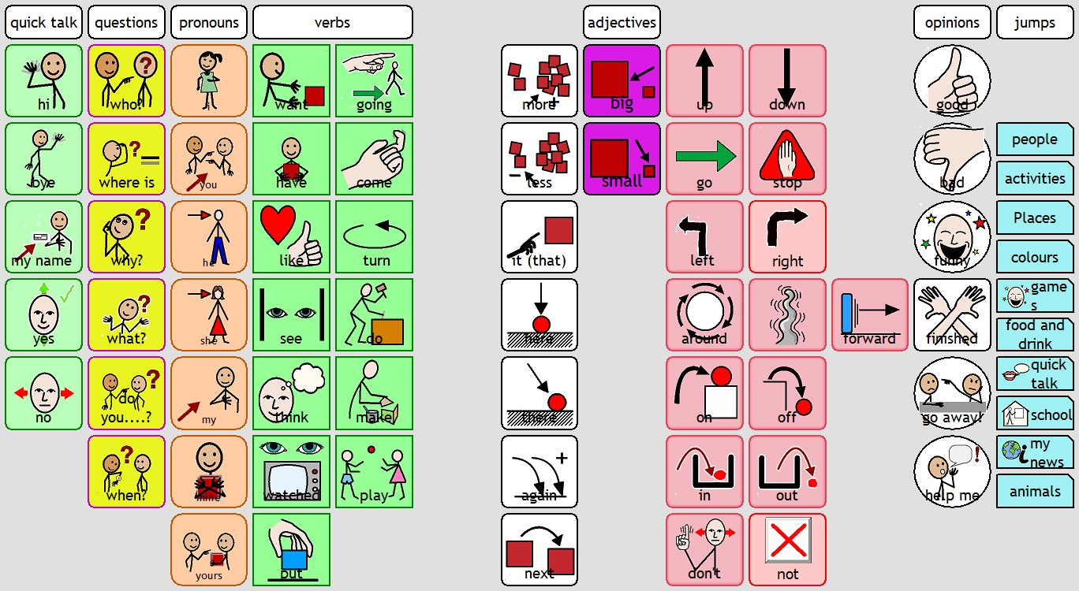

Figure 1 - Symbols currently used by Anna and Sarah

Anna also provided the work task list she uses to keep track of her progress with Sarah. She manually picks a symbol that represents the word, and arranges them in groups. She then encourages Sarah to use these core words to narrate her activity. She uses these words in different sentences and stories. She tries to encourage Anna to use these words in different scenarios, to show the diverse usage of the words. Anna keeps track of Sarah’s attempts, successes, the context of usage and words she prefers to use. This method although long and difficult, is at a heart the manual method that the project system is intended to automate. By offloading some of the manual elements, Sarah will hopefully be able to learn symbol meanings from the application.

### App Solutions

The Android market is currently overstocked with clunky and badly designed AAC symbol tools and language boards, which are offered as a speech aid to those who cannot speak. There are very few applications that aim to teach students symbol systems. There were however two system found worth mentioning.

#### Toddler Robot

On the Android market, there is a free applications called Toddler Robot. This application is aimed at very young children, and offers the user animations for a small selection of words, like objects and colours. The symbols the application use are not universally known but are only relevant to the application. In this sense they are not relevant to any AAC system and Toddler Robot is a local standalone system. The goal of the application is to animate words for the user and explain their meaning. However this system would not exactly complete the task that the project system will be designed to achieve, as it uses crude animations and unclear symbols. The element of having a library of the symbols, words and animations however is something that would fit well in this project (Russpuppy, 2015).

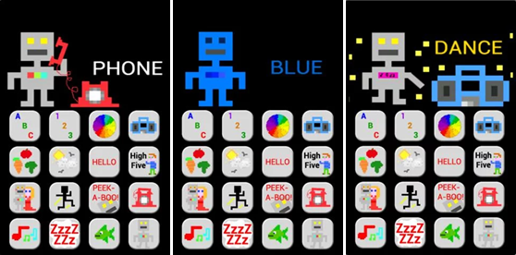

Figure 2 - Toddler Robot Android App

#### AtrikPix

AtrikPix is a symbol based learning app that can be found on the Apple Store. It presents a colourful interface and makes a game of matching symbols to words. This application is more advanced than Toddler Robot however, as it requires a more advanced base level of English. The symbols used here are however more universally understandable than that of Toddler Robot. By using a universal and well known symbol set, the application can lead to use of other symbol based applications. (Expressive Solutions, 2013).

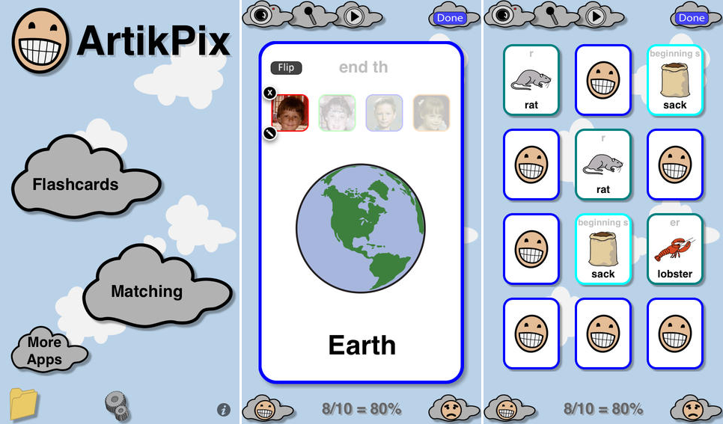

Figure 3 – AtrikPix

From looking at these two separate applications, potential for the project system can clearly be seen. Neither of the applications address the particular system goal or objective. From studying the manner in which these systems aim to teach users symbol systems, the project system should implement symbols known or at least familiar to the user. From the background research conducted, it is clear that the use of animations is a good way to show the meaning of the vocabulary being taught.

## Technologies researched

The technologies for this system were chosen based on which were most appropriate for the job, but also those which the developer would have confidence in being able to successfully use to complete the project. Those technologies unfamiliar to the developer, that have not used before would require self-teaching, and would need to be familiarised to a sufficient level for project completion.

### Mobile Platform

The main application of this project needs to be built for a tablet mobile platform. The system user already has experience using both IOS and Windows platforms, and therefore designing the system for tablet devices is a clear choice. This platform will require graphics and animation capabilities for the main application. It will also require the ability to connect to the server layer of the application. There are many options to consider in choosing what platform to use. These include cost effectiveness, difficulty of developing, licensing, etc. Popularity and market share is also an important factor. Below is a table of statistics that shows how Android has risen to dominate the global tablet market share. (Statsista, 2015)

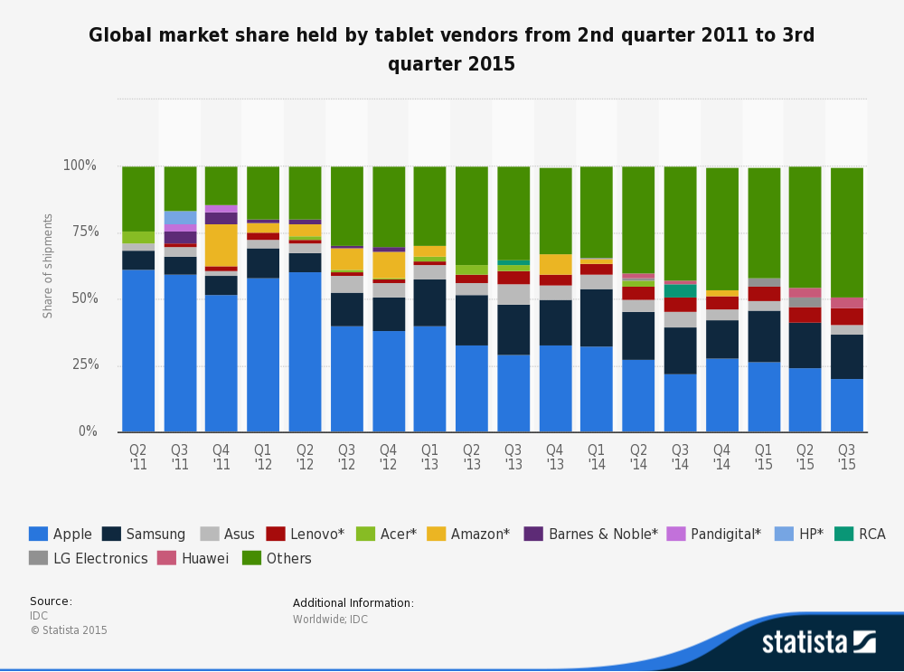

Figure 4 - http://www.statista.com/statistics/276635/market-share-held-by-tablet-vendors/

#### IOS

Firstly Apple IOS was researched and considered. Many would consider IOS to be the preferential platform to develop tablet based applications for. However, it was found that with IOS a license which costs $100 is required to publish developed applications (Monus et al., no date). It must also be noted that access to development on this platform is more difficult than others, as development for IOS is usually done on Macs in XCode. There are alternatives for Windows, but they lack the support and documentation required throughout the project development. Apps for IOS are generally written in Swift which the developer has never used before, and would require additional learning of another OOP language, which is not an established goal of this project.

#### Windows

With regards developing on the Windows tablet platform, it is clear that the lack of popularity of these devices in comparison to Android and Apple to be a significant factor. Windows were late to entering the mobile platform market in comparison to the others who dominate the market. (Rubens, 2014). As a result, it is more logical to develop the application for a system which is likely to have more potential users.

#### Android

As seen in Figure 3, Android is now the market leader platform for tablets. It dominates the market due to a number of factors, mainly being the cost effectiveness of devices. Googles Android is an open source operating system, meaning any manufacturer can use the operating system on their devices. As a result these devices come in various sizes and price ranges, and are made by a huge range of manufacturers (Ashokan, 2015). These are the main reasons Android has chosen as the platform to develop on.

It is also important to note that the developer already has access to Android hardware leading to easier and faster development. A first generation Google Nexus 7 tablet device will be used for developing purposes, which is a typical low to mid-range Android tablet. The project developer also has experience developing on Android from previous college assignments in other modules. In the past the developer has found developing on Android the platform to be difficult but rewarding. It has been established as the appropriate choice for the project system.

### Web Application

The project system will also require a web interface. This interface will connect to the database, and allow the user account to be logged in. Once they have logged in, they will have access to view the app user’s progress. These will be presented in the form of figures and graphs, and will give the web end user a good idea of how the app user is progressing. It will highlight areas that they excel, as well as areas they are struggling with.

### Client

The client side of this application will allow the supervisor to help the user with manual methods of teaching in the relevant section. This web interface will require the use of HTML and CSS, and some sort of JavaScript library to develop a rich web application. The two potential researched web languages are jQuery and AngularJS.

#### jQuery

jQuery is an open source JavaScript based framework that builds upon JavaScript, and allows greater manipulation of DOM elements. It also has many other useful features. It can also be used for event handling and animation, which may be useful for developing the projects web application. (Larson, 2012). Another potential reason to use jQuery, is that the developer also has experience using it from the Rich Web Applications module.

#### AngularJS

This is another JavaScript based framework has risen in popularity over recent years. It is now considered one of the best to use, as it can achieve everything that jQuery can, and much more. These additional features include RESTful API compatibility and form validation. It also supports the use of MVC(Model View Controller) pattern in development. This allows the presentation, logic and data layers to remain independent of each other, and is considered to be good coding practice. (Wilken, Puigcerber, and Erickson, no date). Having recently used AngularJS, the developer has found it to be quite a substantial and useful framework. As a result, AngularJS will likely be used for developing the systems web application.

### Server

For the server side of the application, the Android application and the web application need to successfully access and connect to the database. This will require the use of a language or technology to handle database requests. For this many languages could be used, but the options have been narrowed down to two of the most popular choices, with these being either Node.js or PHP.

#### Node.js

Node is a Google owned JavaScript library primarily used for handling client side requests for connected databases. Node also pays close attention to the Model View Controller pattern, and allows the user to keep these layers separate on the server. Node is relatively new but is quickly rising in popularity. It has many benefits over other server technologies, and when used correctly can result in a faster more efficient system. (Wayner, InfoWorld, and 12, 2015) Having never used Node.js, and judging by its seemingly steep learning curve, the developer will likely use an alternative like PHP.

#### PHP

PHP is an older language that serves the same purpose as Node.js, to handle the client side requests for a database. It is quite minimal in implementation, and allows developers to quickly code with ease without the need for other tools. It is also quite a good match for SQL languages like MySQL, which will likely be used. PHP has been around for years, and is still quite popular today. It has a large community and many resources available, making it an attractive choice for this project system. (Krill, 2014). The developer has some relevant experience of using PHP on the server layer from second year modules, and as a result of this and other reasons, it will be used. However due to the increasing popularity of Node.js, implementing it as an alternative to PHP will be considered, to see if it will improve the system.

### Database

The project will also require a database to store all of the user information, and potentially links for the symbols and animations. For the system being designed MySQL will likely be used. Before choosing this, the various options were weighed up and considered. Potential hosts and cloud service providers should also be considered, as they may not support the chosen database language.

#### NoSQL

It was first researched whether a relational or NoSQL database would be better suited for the project system. NoSQL generally allows data to be stored in documents, graphs, key values or columnars. They are good for performance and scalability, allowing a business to potentially grow rapidly and more easily. The way in which NoSQL can store its data differently, means it can be quite useful for arbitrary situations. (Coyle et al., 2014). However, the project system does not require these different ways of storing data. Having no experience with NoSQL until very recently was also an important factor in deciding whether or not to use NoSQL for this project.

#### SQL

Due to past experience with SQL, and the simplicity of the early concept data model, it was clear that SQL would be more than sufficient. For SQL, the many different flavours were researched, including Oracle, Microsoft SQL Server, PostgreSQL and MySQL. Oracle is quite a complex database system, and allows some features that others do not have. MySQL offers a much lighter experience, and is open source (ITX Design, no date). Due to its popularity and expansive resources and documentation, it seems MySQL would be the best option for the project system. It also works well with PHP as a server language, which may be used in the project system. The developer has experience with Oracle and MySQL, and having used both, MySQL would likely be a better choice.

### Web Services

For the system a cloud hosting of the database will be required. There are many options out there, but two of the more prominent service providers that stood out are Google Cloud Computing and Amazon AWS. Both have free plans but required careful consideration, as the database storage is an important element in the system (M, 2015).

#### Google Cloud Computing

Google Cloud Computing offer a number of cloud services, one of them being a managed MySQL service. They also provide a free starter package that allows $300 worth of cloud services to be used for the first 60 days, but after that required payment of some form. Google also provides good security and replication of data automatically (Google, no date) Having had complications in the past with Google APIs in Google App Engine, and cloud problems, the developer was hesitant to use them. As a result, Amazon AWS was investigated as a potential alternative.

#### Amazon AWS

Amazon AWS is one of the most popular choices for cloud services in the world. They provide the biggest range of services, from Networking and Storage, to Deployment and Database services. Googles free plan was not long enough for the project requirements, but luckily it was found that Amazon offers a much more substantial free hosting plan. This plan is for one year and offers 100GB of database storage and low tier access speeds for free, which is more than enough for the project requirements (Colangelo, 2014). Having also used Amazon Glacier for long term storage during industrial placement in 2015, Amazon web services have been found to be quite intuitive. Therefore, Amazon RDS on the Amazon AWS web services is easily the best option to choose.

### Data Visualisation

The supervisor element of the application, will require them being able to analyse the students’ progress. For representing the data to the user on the web application, it is likely that a data visualisation framework or tool will be needed. This element of the project is not as urgent as others, and thus it has not been researched it as thoroughly. There are many frameworks and tools available including D3.js, Chart.js Google Charts, Flot and more (Rahman, 2015). The tool required does not need many comprehensive features, just a means of displaying progress of the user.

#### D3.js

D3 is an open source chart, graph and visualisation tool built with JavaScript. It is a very comprehensive data visualisation framework. It allows the developer to attach data to a Document Object Model, which can be used to then generate tables or charts. It allows charts to be interactive and animated, however it does not come with a chart library. Instead all charts must be generated manually using the tools provided. (Bostock, no date) This framework would allow the charts to be tailored exactly to a chosen design, but requires more work and time than other charting tools and frameworks.

#### Chart.js

Chart.js is similar to D3.js but much slimmer. It is another open source JavaScript chart library. It allows the user to create visual charts from data using HTML5, which can be styled using CSS3. Charts generated with this library are simple, responsive and dependency free. This chart library also supports older browsers by use of polyfills. (Downie, 2015) This chart rendering tool will likely be easier to use than D3 and will provide enough of the required elements for this project. However, if the requirements of the project change, and extra features that D3 provides are required, this will implement that instead.

### Animation Technologies

For creating the animations and gaming elements of the application, a graphics library will need to be used. This will need to be flexible and integrate well with the applications purpose. To accomplish this, either Unity or OpenGL will be used.

#### Unity

## Unity engine is a comprehensive 2D game engine written in C# or JavaScript. It allows games to be created in a complex 2D or 3D engine, and is virtually limited when it comes to possibilities. Having used it before, using this engine would be quite easy for the developer. However, it may not interact easily with the other architectural layers in the system. (Unity - Game Engine, no date)

#### OpenGL

#### Androids OpenGL ES library allows 2D and 3D graphics to be rendered. This would integrate well with the Android base application, and all the connected layers. It would allow the use of animations and interactive games, but comes at a price of being more complex than Unity3D. The project system will likely make use of Androids OpenGL library, unless its implementation proves to be more complex than it is worth. (Android, no date)

## Other relevant research done

### Interview/Contact

Throughout the research phase of this project, there has been direct communication with Anna, the parent of a girl who would benefit greatly from the project. She has also studied child mental health and has relevant qualifications regarding the area. Therefore constructive feedback and responses to the ideas has been received, and the project has been tailored and adjusted appropriately. Throughout the course of the project, Anna will be consulted with to ensure project focus, and hopefully there will be an opportunity to have her and her daughter test the system.

From contact with Anna, she was able to give advice on some features and elements that would be good to implement. These include a strong cause and effect element for the user. This would be implemented by rewarding the user on successful interactivity, with a round of applause or cheering for example. She also mentioned that audio enforcement of the word in each section would be beneficial, to have the user become familiar with the sound of the word. Anna also provided the symbols that her daughter currently uses for AAC systems, which is a perfect starting point for symbols to use in the system. These were from a combination of SymbolStix (n2y, no date) and Widgit Symbols (Widgit Software, no date). She also provided a work list for her core vocabulary, which can be used as a guide for the vocabulary of the system to implement teaching of.

### Other students doing community projects

Email correspondence has been made between the students doing the communities projects. At a less busy time of the year, potentially next semester, a meeting will be organised where the students can share progress and pool resources and ideas. This will give the students an opportunity to develop more substantial projects, and to also allow the projects to potentially work together to solve their target problems more effectively. This will be taking place at some point in late January.

## Resultant findings/requirements

For example, a list of requirements for your solution – based on your research and analysis  
  
Based on research and analysis it has been found that a huge element of the project will be tailoring the system to the specific user group. This will involve following strict heuristics and user elements, and paying close attention to the user’s needs. In the research stages of this project, elicitation has been completed with a potential client of the software, in order to establish early on in the project stages what the requirements are. Based on these early requirement stages it was clear that there would need to be two main interfaces in the system.

### Requirements Doc

Android tablet application: This would be for the student to use, and would allow interactive completion of tasks that help the user develop their understanding of vocabulary by means of symbols.

Website application: This would be for the student’s supervisor to access. Here they could view the students’ progress, and find where the student may be struggling to learn vocabulary.

|  |  |  |
| --- | --- | --- |
| Name | Description | Priority |
| Android App System |  |  |
| User Login | On first use, the user should be logged in by their supervisor, after this it will automatically be logged in. | HIGH |
| Vocab Learning Game | This game will challenge the student to choose the correct symbol from a list for a given animation. | HIGH |
| Interactive Symbol Game | This game will follow the vocab learning, and will allow the student to use the symbols learned to control. | HIGH |
| Word Library | This will allow the user to view the library of all animations in the games, and will be categorised. | HIGH |
| Web App System |  |  |
| User Login | Have the supervisor log in to the system so they can access their web application. | HIGH |
| View student progress | Show the supervisor the students’ progress with graphs and charts, and where they are excelling and struggling. | HIGH |
| View student info | Allow the supervisor to view any additional information about the student. | MEDIUM |
| View app documentation | Allow the supervisor to view documentation on the apps functionality, and see instructions and help. | MEDIUM |
| Configure settings | Configure any potential system settings. | MEDIUM |
| Reset progress | Allow the supervisor to reset the students’ progress. | MEDIUM |
| Upload symbols | Allow the user to upload their own symbols to the system, which animations could then be created for. | LOW |
| General System Reqs. |  |  |
| Store user login online | Login information stored online in database, universally usable for both the Android and Web apps. | HIGH |
| Store symbols online | Links for the symbols should be stored online, allowing updated ones to be pushed by the application. | LOW |
| Store animations online | Links for the animations should be stored online, allowing updated ones to be pushed by the application. | LOW |

Anna will be contacted when required, to ensure that the project continues to follow the combined envisioned end product. Anna and her daughter will also be requested to test the system at certain points in the project cycle, including the end, the project’s success or failure can be determined. This will involve the completion of test cases.

## Bibliography (research sources)

### Background Research

American Speech-Language-Hearing Association (2014) Communication Bill of Rights. Available at: https://aaclanguagelab.com/files/communicationbillofrights.pdf (Accessed: 24 November 2015).

Baker, B. R. (2009) MinspeakTM History. Available at: http://www.minspeak.com/HistoryofMinspeak.php#.VlRNyXbhCUk (Accessed: 24 November 2015).

Bates, L. (2013) ‘5 Real Benefits of Using Animation in the Classroom’, Tools, 6 December. Available at: http://www.fractuslearning.com/2013/12/06/animation-in-the-classroom/ (Accessed: 16 November 2015).

Dyslexia Association of Ireland (no date) General Information about Dyslexia. Available at: http://www.dyslexia.ie/information/general-information-about-dyslexia/definitions/ (Accessed: 21 November 2015).

Dyspraxia Association of Ireland (2015) How to Recognise Dyspraxia | Dyspraxia association of Ireland. Available at: http://www.dyspraxia.ie/whatisdyspraxia_recognise (Accessed: 24 November 2015).

Expressive Solutions, E. S. (2013) ArtikPix on the App store. Available at: https://itunes.apple.com/us/app/artikpix/id383022107?mt=8&ign-mpt=uo%3D8 (Accessed: 24 November 2015).

Foundation for People with Learning Disabilities (no date) Communicating with and for people with learning disabilities. Available at: http://www.learningdisabilities.org.uk/help-information/learning-disability-a-z/c/communication/ (Accessed: 15 November 2015).

Johnson, D. J. (2015) Helping young children with learning disabilities at home | LD topics. Available at: http://www.ldonline.org/article/5880/ (Accessed: 7 December 2015).

Kulman, R., Watkins, L. and Carlson, A. (2012) Video games and learning disabilities. Available at: http://learningworksforkids.com/2012/07/why-video-games-are-good-for-kids-with-learning-disabilities/ (Accessed: 24 November 2015).

Le Normand, M.-T., Vaivre-Douret, L., Payan, C. and Cohen, H. (2000) ‘Neuromotor development and language processing in developmental Dyspraxia: A follow-up case study’, Journal of Clinical and Experimental Neuropsychology, 22(3), pp. 408–417. doi: 10.1076/1380-3395(200006)22:3;1-v;ft408.

Makaton (2015) About Makaton. Available at: http://www.makaton.org/aboutMakaton/ (Accessed: 1 December 2015).

Molnar, M. and Sebastian-Galles, N. (2014) ‘The roots of language learning: Infant language acquisition’, Language Learning, 64(s2), pp. 1–5. doi: 10.1111/lang.12073.

Newhall, P. W. (2012) Language-based learning disability: What to know. Available at: http://www.ldonline.org/article/56113/ (Accessed: 24 November 2015).

Nielsen, J. (1995) 10 Heuristics for user interface design: Article by Jakob Nielsen. Available at: http://www.nngroup.com/articles/ten-usability-heuristics/ (Accessed: 7 December 2015).

Patino, E. (2014) Understanding Dyspraxia. Available at: https://www.understood.org/en/learning-attention-issues/child-learning-disabilities/dyspraxia/understanding-dyspraxia (Accessed: 24 November 2015).

Prentke Romich Company (2008) ‘What’s Important in AAC?’, (January), .

Prentke Romich Company (no date) Core Vocabulary Studies and Core Word Activities. Available at: http://www.patinsproject.com/trainop_files/BethA1.pdf (Accessed: 24 November 2015).

Prentke Romich Company (no date) Free Resources - Teaching Resources. Available at: https://aaclanguagelab.com/resources/free (Accessed: 3 November 2015).

Prentke Romich Company (no date) LAMP Low Tech Board. Available at: https://aaclanguagelab.com/files/lamplowtechbackup.pdf (Accessed: 24 November 2015).

Prentke Romich Company (no date) PRC Unity Low Tech Board. Available at: https://aaclanguagelab.com/files/prcunitylowtechboard.pdf (Accessed: 24 November 2015).

ReadingByPhonics (no date) How to teach a 5 year old to read, write, and spell. Available at: http://www.readingbyphonics.com/early-start/5-year-old-read-write-spell.html#.VmTWa3bhCUk (Accessed: 7 December 2015).

Rowland, C. and Schweigert, P. (2000) Tangible Symbol Systems. Available at: https://www.osepideasthatwork.org/toolkit/instpract_tan_sym.asp (Accessed: 24 November 2015).

Russpuppy (2015) Toddler robot – Android Apps on Google play. Available at: https://play.google.com/store/apps/details?id=russh.toddler.robot (Accessed: 24 November 2015).

Saffran, J. (2014) ‘Sounds and meanings working together: Word learning as a collaborative effort’, Language Learning, 64(s2), pp. 106–120. doi: 10.1111/lang.12057.

Statistics Canada (2006) ‘Participation and Activity Limitation Survey’. .

Uttal, D. H. and DeLoache, J. S. (2006) Learning From Symbolic Objects - Observer Vol. 19, No.5. Available at: http://www.psychologicalscience.org/index.php/publications/observer/2006/may-06/learning-from-symbolic-objects.html (Accessed: 10 November 2015).

VanTatenhove (2005) Common words - the center for AAC and autism. Available at: http://www.aacandautism.com/common-words (Accessed: 29 October 2015).

Vinson, K. (no date) Core Vocabulary. Available at: http://www4.esc13.net/uploads/low_incidence/docs/BTH2013/Friday/Vinson_CoreVocabulary.pdf (Accessed: 9 November 2015).

Widgit Software (no date) Widgit Symbols. Available at: https://www.widgit.com/symbols/about_symbols/widgit_symbols.htm (Accessed: 18 November 2015).

n2y (no date) SymbolStix. Available at: https://www.n2y.com/products/symbolstix/ (Accessed: 24 November 2015).

### Technologies Researched

Android (no date) OpenGL ES. Available at: http://developer.android.com/guide/topics/graphics/opengl.html#manifest (Accessed: 7 December 2015).

Ashokan, A. (2015) Android is a better platform than iOS, know why?. Available at: http://gadgetsngaming.com/2015/08/04/android-is-a-better-platform-than-ios-know-why/ (Accessed: 1 December 2015).

Bostock, M. (no date) D3.js - data-driven documents. Available at: http://d3js.org/ (Accessed: 1 December 2015).

Colangelo, A. (2014) ‘Google cloud vs AWS: A comparison - cloud academy Blog’, Amazon Web Services, 30 October. Available at: http://cloudacademy.com/blog/google-cloud-vs-aws-a-comparison/ (Accessed: 3 December 2015).

Coyle, P., McNulty, E., Hannah, Poughia, E. and Krishnakumar, A. (2014) SQL vs. NoSQL- what you need to know. Available at: http://dataconomy.com/sql-vs-nosql-need-know/ (Accessed: 1 December 2015).

Downie, N. (2015) Chart.js. Available at: http://www.chartjs.org/ (Accessed: 30 November 2015).

Google (no date) Google cloud computing, hosting services & cloud support. Available at: https://cloud.google.com/ (Accessed: 8 November 2015).

ITX Design (no date) MySQL vs oracle. Available at: https://itxdesign.com/mysql-vs-oracle/ (Accessed: 1 December 2015).

Krill, P. (2014) Why developers love and hate PHP. Available at: http://www.infoworld.com/article/2852329/php/reasons-for-developers-to-love-hate-php.html (Accessed: 1 December 2015).

Larson, R. (2012) JQuery: The good, the bad & the ugly. Available at: http://www.webdesignerdepot.com/2012/09/jquery-the-good-the-bad-and-the-ugly/ (Accessed: 1 December 2015).

M, N. (2015) Amazon AWS vs Google cloud platform vs Microsoft azure: Which public cloud is best for you?. Available at: http://dazeinfo.com/2015/05/22/amazon-aws-google-cloud-microsoft-azure/ (Accessed: 1 December 2015).

Monus, A., Rocheleau, J., Ranjit, P. and Agus (no date) Beginner’s guide to iOS development: The interface – part I. Available at: http://www.hongkiat.com/blog/ios-development-guide-part1/ (Accessed: 1 December 2015).

Rahman, S. F. (2015) The 15 best JavaScript charting libraries. Available at: http://www.sitepoint.com/15-best-javascript-charting-libraries/ (Accessed: 1 December 2015).

Rubens, P. (2014) Is windows 8 development worth the trouble?. Available at: http://www.cio.com/article/2377123/windows-8/is-windows-8-development-worth-the-trouble-.html (Accessed: 1 December 2015).

Statsista (2015) Global market share held by tablet vendors from 2nd quarter 2011 to 3rd quarter 2015. Available at: http://www.statista.com/statistics/276635/market-share-held-by-tablet-vendors/ (Accessed: 1 December 2015).

Wayner, P., InfoWorld, P. W. F. and 12, J. (2015) PHP vs. Node.js: An epic battle for developer mind share. Available at: http://www.infoworld.com/article/2866712/php/php-vs-node-js-an-epic-battle-for-developer-mind-share.html (Accessed: 1 December 2015).

Wilken, J., Puigcerber, P. V. and Erickson, K. (no date) JQuery vs. AngularJS: A comparison and migration Walkthrough. Available at: https://www.airpair.com/angularjs/posts/jquery-angularjs-comparison-migration-walkthrough (Accessed: 1 December 2015).

Unity - Game Engine (no date) Available at: https://unity3d.com/unity (Accessed: 7 December 2015).

# Analysis: Describe clearly what your solution will do

The solution to this problem is broken down into two main client applications. The main user of the system, called the student (Sarah), will be using an Android tablet application. The secondary user, called the supervisor (Anna), will use the web application. These two applications operate independently but are connected via the same information.

### Student Tablet Application

The solution is going to approach this subject in a fun and educational matter. On first use, the student user will need to be logged in by the supervisor. After this the user will remain logged in for future use.

Here the student will be helped by teaching them the meaning of specific symbols, so they can make use of AAC systems. Therefore for the application will use symbol sets, which are already used by these AAC systems, and establish their meanings with animations and interactive game elements. The student will then have the option of selecting to play the vocabulary games, or view the vocabulary library.

The game will involve the student seeing an animation. The animation will represent a relevant word and hearing the word for the sound pronounced, followed by a relevant noise. This would be followed by the student being shown two symbols, and having to choose and touch the correct symbol. Upon selecting the correct symbol, the screen will have stars or confetti appear and an applause to let the user know they picked the correct symbol. If they pick the wrong symbol the application will flag this and this will be stored. For example, an animation could be a car driving. The two symbols could be a symbol for driving, and a symbol for sleeping.

After completing several of these rounds, the user will be given an interactive game to play using the symbols learned. This interactive game could be a car driving game, which would be controlled using left and right direction symbols. The game would also be tailored to the specific user, so they would be driving somewhere where a reward would be. These elements of the game will likely be adjusted with further requirements reviews later in the project.

The user will also have the option of viewing symbols in the library. First they will have to choose a category represented by a symbol. These symbol categories will include feelings, verbs, greetings, locations, movement and questions. Once a category is chosen, they will be able to view animations for all of the words in that category. Both of these user functions are integral to addressing one of the main objectives.

### Supervisor Web Application

Another important aspect of the system being developed, is a way for the user’s supervisor to view this individual user’s progress. The solution for this aspect of the system involves the development of a web interface application, which accesses the user’s data. Therefore this system will include a login, using the same credentials as being used on the Android application.

Once the user has been logged in, they have the option to displays graphs and information on where their student needs improving, or where they are excelling. This will help the supervisor to help the user with manual training on specific sets of symbols. Feedback from this system is vital to satisfying one of the other core objectives.

The supervisor will also be able to view additional information on the student, as well as user documentation and help for the Android application. There will be an area to allow the user to configure any potential settings, which are yet to be established and decided.

Another potential aspect of the web application would be to allow the supervisor to upload their own symbols. By doing this, a notification would be sent to allow the admin of the system to create and upload animations for these symbols. In doing this, the symbols would need to be stored online. This is a low priority requirement, and will be implemented if there is time.

### Summary

The main goal of the project is to teach the specific user the meaning of symbols, in a fun and interactive manor. To ensure that this goal is accurate enough, S.M.A.R.T. goal management is used to elaborate. To ensure that this goal is achieved, regular contact will be made with Anna, who has provided huge help in the research stages. This goal is both attainable and realistic in its achievability, in that it is possible to develop a system as described in the solution. The developer has the necessary experience and resources available that allow this goal to be achieved.

# Approach and Methodology

For this project, the Agile project development framework is being used. This project development framework is focused on the core of solving a problem and satisfying the customer. This methodology was chosen because of its popular and widespread use in industry, and its attention to customer and client needs being a priority of this project. Agile based methodologies are typically aimed at teams of individuals, so may not seem appropriate. However, an adapted approach is being used here. An adapted Scrum methodology is going to be used for this project.

### Scrum

Scrum involves a team of people working in iterations, where they establish goals and work rapidly to complete these goals. These rapid bursts of work are called sprints. Scrum also involves teams being split into roles, and the frequent contact between team-members. However, with this being a solo project, this is where it must be adapted.

The adapted version of Scrum being used on this project will involve the developer taking on all the roles in the project. The project will be done using iterative development of features in small sprints, and repeated analysis of requirements throughout the project lifecycle. This regular revision of requirements is necessary to ensure the final product is catered accurately to the customer’s needs. In this case Anna will be the customer, who can with the help of her daughter, give regular feedback on the direction of the project.

Throughout the early stages of the project, and due to its user oriented design, repeated requirements and design phases were conducted. This involved a large research phase, followed by a requirements phase, followed by a high level design phase. However, as a result of the importance of the user driven design elements of this system, the requirements section and design were conducted simultaneously for a long period of time. Throughout these stages, Anna was contacted and she gave valuable input into how she felt the system would best function. This was the most efficient way to achieve a solid design in the system, and to ensure that the design is an effective starting point for the development of the project.

Throughout the rest of the project, the development is being conducted in sprints of two weeks. Each of these begins with a short low level design phase, and aims to implement particular features. If time runs short, there are multiple features that have been marked as low priority from the requirements section. These include storing the symbols and animations in a linked database, allowing them to be updated and pushed to users, and also allowing the supervisor user to upload symbols themselves. These may require a considerable additional amount of work that could delay the projects final delivery, and as a result will be considered low priority.

# Design

## Technical architecture diagram:

### System Architecture

Architectural design models are integral to showing how an applications layers are separated. There are not many different architectural models that would be suitable for the project. As a result the Client Server Database 3 tier model is being used. This model is a fundamental networking model that has represented applications since the early World Wide Web.

This project is going to follow a Client Server Database model. The Android tablet application will represent one of the systems clients. The Web application represent the other potential client side of the application. The server will be running PHP in order to handle client requests from the two potential applications. These requests will then be processed and communicated to the server. The database will be a MySQL database running on Amazon RDS, as part of Amazon AWS. This database will store the user’s registration information, as well as the student user’s progress in the application.

## 

Figure 5- System Architectural Model

### Model View Controller

MVC (Model View Controller) is an important architectural pattern used in modern software development. This pattern is focused on Client user interfaces, and keeping their relevant layers separated. The MVC pattern

The Android platform in its core design, follows the principals of MVC. The view is the presentation element of the model, in this case handled by the XML. The model is the data that will be accessed from the database, in this case from SQL queries. The controller is the main logic of the application and allows the handling of events and activities, and in this case will be in Java.

## 

Figure 6- Model View Controller

For our web application, we will also be trying to keep the MVC pattern in use. The AngularJS framework is known for its support of the use of the MVC pattern. It allows the user to create a hierarchy of folders, which separates the model view and controller layers, keeping them independent.

### Nielsen’s Heuristics

Following Nielsen’s Heuristics closely is a vital part of this project. Nielsen’s Heuristics are a vital part of any interface design, however for this project system the specific user is at the core of the system design. (Nielsen, 1995)

## Other design documents

### Use Cases

There are two use case diagrams that represent the two users in the project system. These are the student User, and the supervisor User:

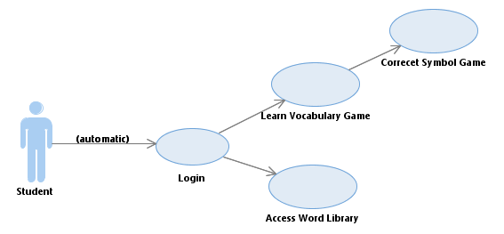

Figure 7- Student Use Case

The Student is the primary user. This user is typically a person with a learning disability, who wishes to learn core vocabulary with the tablet application. The system will initially require a log in at the beginning (and registration if not already registered). If the user has logged in before, this will be remembered, and the user can simply run the application. They will then have the option of either learning vocabulary through the game, or accessing the word library.

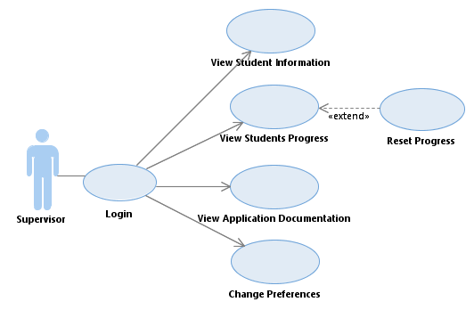

Figure 8- Supervisor Use Case

The supervisor user is typically the student user’s parent, guardian, therapist or guide for the application activities. They will be able to log in with the same credentials used on the app, and from there they can view the student’s information, the application document, change preferences and view the students’ progress. This progress will be displayed as graphs and charts that show where the student is struggling or excelling. This gives the supervisor a good indication of where to manually tutor the student, and help them.

### Storyboards

The storyboarding is used to describe a user’s step by step action. The focus user of this application system is the student user. Therefore the storyboard will only be done for this user. There are two main use cases for the student user which will be represented on the storyboards. These are playing the vocabulary games, and accessing the library of symbols and animations.

A hugely important factor in designing these storyboards is that they have the minimum steps necessary for our particular user to complete the use cases. In the design of these storyboards, the system needed to follow Nielsen’s Heuristics. Therefore, the systems main menu is very simple and minimal in design. The use of bright colours and animations result in the system to be aesthetically pleasing and fun looking.

The system also uses symbols for all of the icons. These symbols will come from the user’s already existing library of symbols, which hopefully they understand. This will be verified and established during test phases. There are also navigation buttons represented by universally known back and home buttons, which are implemented in most user system. This gives the user the option to backtrack through screens.

|  |  |
| --- | --- |
| 1. | 2. |
| 3. | Game playing storyboard 1. The user starts the application and is given the choice of going to the vocab game, or the library (after supervisor logs them in, only needs to be done once).  2. When choosing the vocab game, they are brought to the game screen, this will allow them to play the symbol animation game.  3. Then upon completing some of these rounds, the user will be brought to an interactive game that uses these symbols. Upon completion, the game returns to the menu screen. |
| 4. | 5. |
| 6. | Using library storbyoard 1. The user from the main menu can also select the library.  4. When clicking the library symbol, this brings the user to categories of symbols. Here the student or supervisor can choose a category.  5. When clicking the category symbol, this brings the user to all the symbols in that category.  6. Here the student or supervisor can select a symbol and view the animation for this. |

# Prototyping and Development

These phases mark the beginning of creating the envisioned project idea. These phases will continue through the remainder of the project timeline.

### Prototyping

Prototyping began with doing mock up screens of how the systems interface would be presented to the two users. This was then storyboarded in the previous sessions.

Then a more substantial prototyping tool was used to further expand on these storyboarded screens. From this I developed an interactive prototype to demonstrate how the screens will function on the application.

The second stages of prototyping involved testing various technologies independently. This was followed by testing their connectivity. After some experimentation with Android, Angular JS, MySQL and PHP, development began.

### Development

Development began with setting up the required development environments for the technologies being used. Firstly, Android Studio was downloaded along with the most recent versions of the java JDK and JREs. The workspace was created in a project folder, which was then added to a GitHub repository. This will ensure that the project files are version controlled, and backed up. This same system was set up on the development laptop and desktop.

The next important stage that was setting up a live database on Amazon AWS. This was not very complex as there was only the lowest spec database available. Once this was set up, an instance of the database could be created easily.

Then development was commenced by creating the Login and Registration screens for the Android application. These are key for identifying the user, and allowing them access to their own progress on the web application. This was firstly done by creating a java class file for each Android screen. For the moment these just included a main screen, a login screen and a registration screen. Each of these implements the OnClickListener which allows the buttons in the system to respond to input. Each of these Android screens was designed in the xml with a crude basic starting design.

Then a basic server was created using PHP. This would interact with the Android application, and allow the user to accept requests for the username and password information. Once it accepts these, it would pass them to the MySQL server and verify if they are correct, and if so will authenticate the users.

For the purpose of testing the early development of this system, the database was run locally using Apache with XAMPP. Once a successful log in system was functional, the next phase was to have the system function with a live database and server. This is a phase that is currently being developed, and is not yet demonstrable. If the demo system becomes live and functional, it will be made available for the interim presentation.

# Testing

The testing phases of this project will involve multiple sections and approaches. At the early stages, the only testing being completed for the system is done locally and manually. Towards the latter stages of the project, different types of testing will need to be performed. This will include both Black Box and White Box tests. Testing in the application will also need to be broken down into multiple sections and stages.

#### Blackbox Testing

Usability testing, also known as black box testing, is the primary testing that will drive the development of this system. This is because the system is user design focused, and must be tailored for the specific user’s needs. This will involve the testing of buttons, consistent navigation, and content verification on both the Android app and the web app. In turn for this section, it would also be ideal to deploy the application and have Anna and her daughter test the application.

Getting a user from the target user group, such as Anna and her daughter Sarah, to test the application would be hugely beneficial to determining the project success. If possible, they will be contacted at prototype production stages, and be asked to complete testing for the system. This testing will involve following given test cases with steps, in which Anna can help Sarah to complete. The systems success in this blackbox testing will be mainly judged by how user friendly and effective the system is. These test cases will be designed and evaluated during each blackbox stage, as the system could change in the meantime.

#### Whitebox Testing

Functionality testing, also known as whitebox testing, will also need to be performed on both the android and web system. For the Android application, JUnit tests will be written. This will involve testing the applications functions and ensuring that no errors occur. Qunit will also likely be used to test the web applications functionality. Having never used these tools before, they will need to be learned in the process of the testing phase.

Interface testing will be another important element of testing in the application. This will involve verifying that the information shared between the application layers stays consistent. This data is stored on the database, and should always be consistent with the user which is logged in. Without this consistency, the application will not perform successfully.

Compatibility testing will also be something to verify in the projects development stages. This will primarily involve testing the Android application across multiple tablet devices. It will also involve testing the web application across multiple browsers to ensure it functions accordingly.

Performance testing is another important area to test in the system. Here it will be vital to ensure that the server can handle multiple requests from the applications in short succession. It will also be important to ensure that the application executes without performance issues.

Security testing will also be important elements to test in the system. Storing user information comes with a responsibility for confidentiality and secure storage of the information. The application should also prevent SQL injection and alteration of the user’s data. However in this system, an attack like this is unlikely.

# Issues and risks

There are many potential risks and issues that may be faced throughout the project lifecycle. One obvious risk is that the project may not be completed on time. This could lead to greatly impeding the overall success of the project. As a contingency, the plan is to tackle elements of this project iteratively using the Agile Scrum methodology. This will involve developing individual functions of the project separately one at a time. It is also important to note that the project requirements have been given priority levels. Those which are of a low priority will be left till then end, and if time is running out, will be omitted from the final project submission. This helps to ensure that the core aspects of the project, the high priority requirements, are met and satisfied.

Development has begun with the login for the Android application, and developing a server layer that handles database requests from the app. The application will be progressively built in iterations, getting one function working at a time, starting with the more important functions. With the Android application being a greater focus of the application, it will require greater attention in the earlier stages of development.

Another potential risk in this project is losing project files by deletion, or by a hard drive failure. To counteract this issue, the application is being developed with the use of GitHub. GitHub is version control and backup software that allows the user to rollback to previous versions of projects. Therefore if the development system is lost to a hard disk failure, the project is stored on GitHub servers, and development can be continued on another system.

It is also important to note that using GitHub allows the project to be developed across systems. This is useful since the developer can use the desktop or laptop for development. These are both identical in setup with regards operating systems and environments meaning cross development works without issues. It is also important to note that having two computers provides a contingency plan for if one suffers a hardware failure. This should allow the continuation of development without much interruption.

It is important to acknowledge that language learning disabilities and the areas surrounding the project, such as symbols systems, are not somewhere the developer has a strong background or any experience in. The use of symbols or animations that are unfamiliar and meaningless to the user, will render the system useless. This is definitely a potential risk in the project, as it could affect the overall direction and final deliverables. Without having experience prior to the research phases in the project, mistakes and assumptions could be made. Hence as part of the methodology being used, requirements will be addressed and adjusted throughout this project, by means of contacting Anna as an acting client. This should help to maintain the projects direction user oriented design focus.

# Plan and future work

The key deliverables for the future work are as follows:

* A fully functioning Android tablet app that logs a student in, and allows them to partake in games and activities to improve their vocabulary. These activities will need to be interactive and be rewarding and enjoyable for the user.
* A website application that allows the students supervisor to log in and view the students’ progress. This data will be represented on charts and graphs, and will show areas where the student needs improving and where they are doing well. This will allow the supervisor to offer focused help to areas the student is struggling with.
  + There will also be user documentation on the website, in order to aid users.
* A well-documented final report of the project from research, to design and implementation. This report will also focus largely on the overall success of the project.

In order to achieve these goals, deadlines have been set in the project, which should allow room for possible delays in work completed. The main focus will be delivering the Android app in a polished and clean manner, so this deadline will come first. Secondly will be the web application, which should not require the same amount of development time as the Android application.

### Gantt chart

For the proposed project plan, a Gantt chart is being used to plan the stages and manage time and date deadlines.

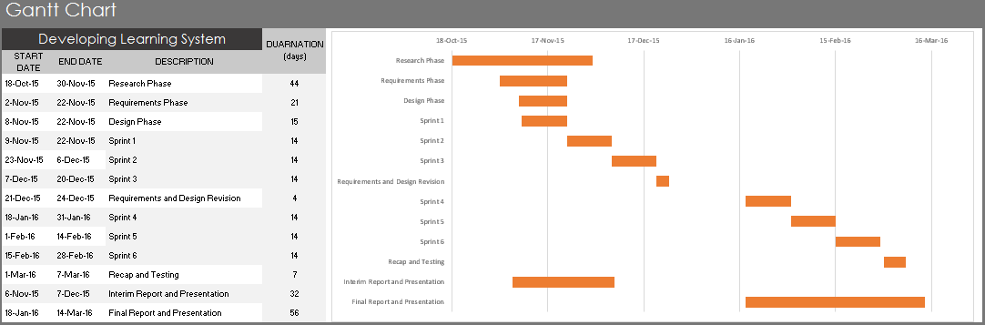

|  |  |
| --- | --- |
| Research Phase | - Researched background of learning disabilities etc.  - Investigated current market, similar apps  - Technology to use, compare to others, critical analysis  - Data analysis tech, what can be used |
| Note: | The requirements phase and design phase were first completed in sequence, but were then revised accordingly. This was repeated several times early in the project. |
| Requirements Phase | - User requirements established  - Features of the application |
| Design Phase | - Technology being used, justification of choice  - Use case and other UML diagrams  - Layers, connectivity, etc.  - Design database |
| Note: | Each sprint phase involves a brief design phase, development, and ends with some functionality testing. If the last Sprint has any uncompleted tasks, these are done at the start. Time allowance for delays has been incorporated, by setting an early project deadline. |
| Sprint 1 | - Android Registration and Login  - Android Main Screens  - Develop logic of main application, use gifs or static images |
| Sprint 2 | - Database design and look at implementation  - Sort out data storage of users details when they register,  - Allow users to log in using these stored details in the app and interface |
| Sprint 3 | - Basic Web Interface that allows log in to database  - Implement log in and registration on both Android and web application |
| Requirements and Revision | - Assess correct direction for application by revising requirements  - Check for major bugs, test functionality |
| Sprint 4 | - Use animation software to create html5 videos or gifs,  - Or use OpenGL and or Unity, or use basic animations based on basic android java code  - Create basic and small word library, 30 words |
| Sprint 5 | - Implement game logic and progress storage in database  - Implement cosmetic and design features and tidy up app |
| Sprint 6 | - Develop data graphing an charting section  - Style and design web interface |
| Recap and testing | - Recap on objectives and goals, and assess  - Check functionality and assess  - Search for security flaws and loopholes  - Give to user for testing for real feedback |
| Interim Report and Presentation | - Collect and document Research, Planning, Design  - Development so far etc.,  - 20ish pages, include diagrams and charts and references  - Slideshow Presentation preparation |
| Final Report and Presentation | - Similar to interim  - Contain all information, research, steps (design, research, all of development etc.) |

Due to the complex early stages of this project so far, the early development stages have been pushed back. However, the project plan allows for contingency catch up periods, and as a result I will catch up to the plan and attempt to regain focus on the target project finalisation period.

# Conclusions

So far this project has brought completely unfamiliar topics into the light of the developer, and has brought them out of their comfort zone. It is a topic with which they had no previous experience. As a result, they have developed a far greater understanding of dyspraxia, dyslexia, learning disabilities, and the complexity of teaching children using symbol systems. Many children suffer from learning disabilities, and would benefit from the project system, which has become a strong motivator for the developer. There are solutions out there, but they require a more manual approach to teaching.

The proposed system is plausible in both design and execution. However, whether it will address the target problem effectively remains to be seen during the testing phases. From research conducted, it appears the system will likely address the problem, but its success will depend on a well-designed and user focused system. By helping the target user to understand, they will hopefully be able to make use of AAC systems and improve communication skills.

In order to achieve the main goal, the three core objectives will need to complete. The student must be taught vocabulary in a fun and interactive way, the system must have a user driven design at its core, and the user’s progress must be tracked and visible for the supervisor. Hopefully the project will progress accordingly over the coming weeks, and it is hoped that the established goal will be achieved.