SMPTE ST 2110-21:201y

WD Standard

Professional Media Over IP Networks:

Timing Model for Uncompressed Active Video

Page 1 of 10 pages

32NF60-WD-ST-2110-21-SVIP_UCV_Timing-2017-01-05.docx

Warning

This document is an unpublished, confidential work under development and shall not be referred to as a SMPTE Standard, Recommended Practice, or Engineering Guideline. It is distributed for review and comment; distribution does not constitute publication. Recipients of this document are strongly encouraged to submit, with their comments, notification of any relevant patent rights of which they are aware and to provide supporting documentation.

Table of Contents

1 Scope 2

2 Conformance Notation 3

3 Normative References 3

4 Terms and Definitions 4

5 Packet Transmission Characteristics 5

5.1 Packet Transmission Timing Model 5

5.2 Last Allowed Transmission (LAT) Specification 6

5.3 Transmission Traffic Shape Model 8

6 Compliance Definitions 9

6.1 VRXfull 9

6.2 Senders 9

6.3 Receivers 9

Annex A Notes Regarding Buffer Capacity in Network Switches (Informative) 10

Foreword

SMPTE (the Society of Motion Picture and Television Engineers) is an internationally-recognized standards developing organization. Headquartered and incorporated in the United States of America, SMPTE has members in over 80 countries on six continents. SMPTE’s Engineering Documents, including Standards, Recommended Practices, and Engineering Guidelines, are prepared by SMPTE’s Technology Committees. Participation in these Committees is open to all with a bona fide interest in their work. SMPTE cooperates closely with other standards-developing organizations, including ISO, IEC and ITU.

SMPTE Engineering Documents are drafted in accordance with the rules given in its Standards Operations Manual. This SMPTE Engineering Document was prepared by Technology Committee 32NF.

Intellectual Property

At the time of publication no notice had been received by SMPTE claiming patent rights essential to the implementation of this Engineering Document. However, attention is drawn to the possibility that some of the elements of this document may be the subject of patent rights. SMPTE shall not be held responsible for identifying any or all such patent rights.

Introduction

This section is entirely informative and does not form an integral part of this Engineering Document.

The capability and capacity of IP networking equipment has improved steadily, enabling the use of IP switching and routing technology to transport and switch video, audio, and metadata essence within television facilities. Existing standards such as SMPTE ST 2022-6 have gained some amount of use in this application, but there was a desire in the industry to switch different essence elements separately.

This family of SMPTE engineering documents builds on the work of Video Services Forum (VSF) Technical Recommendations TR03 and TR04, documenting a system for transporting various essence streams over IP networks, capturing the timing relationships between those streams. The system is designed to be extensible to a variety of essence types .

Part 10 covers the system as a whole, the timing model, and common requirements across all essence types. Other documents will cover specific media essence formats. Part 20 documents the transport of uncompressed active video in such systems, using an RTP format based on IETF RFC 4175.

Part 21 (this part) specifies the timing model for senders and receivers of SMPTE ST 2110-20 streams.

# Scope

This standard specifies timing model for senders of SMPTE ST 2110-20 streams, and defines the sender and receiver parametric characteristics used to signal the timing properties of such streams.

# Conformance Notation

Normative text is text that describes elements of the design that are indispensable or contains the conformance language keywords: "shall", "should", or "may". Informative text is text that is potentially helpful to the user, but not indispensable, and can be removed, changed, or added editorially without affecting interoperability. Informative text does not contain any conformance keywords.

All text in this document is, by default, normative, except: the Introduction, any section explicitly labeled as "Informative" or individual paragraphs that start with "Note:”

The keywords "shall" and "shall not" indicate requirements strictly to be followed in order to conform to the document and from which no deviation is permitted.

The keywords, "should" and "should not" indicate that, among several possibilities, one is recommended as particularly suitable, without mentioning or excluding others; or that a certain course of action is preferred but not necessarily required; or that (in the negative form) a certain possibility or course of action is deprecated but not prohibited.

The keywords "may" and "need not" indicate courses of action permissible within the limits of the document.

The keyword “reserved” indicates a provision that is not defined at this time, shall not be used, and may be defined in the future. The keyword “forbidden” indicates “reserved” and in addition indicates that the provision will never be defined in the future.

A conformant implementation according to this document is one that includes all mandatory provisions ("shall") and, if implemented, all recommended provisions ("should") as described. A conformant implementation need not implement optional provisions ("may") and need not implement them as described.

Unless otherwise specified, the order of precedence of the types of normative information in this document shall be as follows: Normative prose shall be the authoritative definition; Tables shall be next; then formal languages; then figures; and then any other language forms.

# Normative References

The following standards contain provisions which, through reference in this text, constitute provisions of this engineering document. At the time of publication, the editions indicated were valid. All standards are subject to revision, and parties to agreements based on this engineering document are encouraged to investigate the possibility of applying the most recent edition of the standards indicated below.

SMPTE ST 2110-10:201y “Professional Media over IP Networks: System Timing and Definitions”

SMPTE ST 2110-20:201y “Professional Media over IP Networks: Uncompressed Active Video”

# Terms and Definitions

For the purposes of this document, the terms and definitions of SMPTE ST 2110-10 and SMPTE ST 2110-20 apply.

# Packet Transmission Characteristics

This section specifies the transmission characteristics of streams as they leave the transmission interface of the Sender, and defines parameters which a receiver must declare in order for system designers to assess suitability of a given receiver.

## Packet Transmission Timing Model

Figure -- Packet Transmission Timing Model

The following parameters are used in the transmission model shown in Figure 1. The model defines a Latest Allowed Transmission (LAT) instant for each packet within the frame of a SMPTE ST2110-20 video stream, relative to the Video Transmission Datum.

PFRAME is the time period of one frame of video at the prevailing frame rate (in seconds)

NPACKETS is the number of packets per frame of video (depends on mapping details)

IPS is the time between the transmissions of the first octets of adjacent packets if the packets are transmitted in a perfectly linear manner throughout the entire Pframe interval (in seconds)

LPS is the time between the transmissions of the first octets of adjacent packets when each packet is transmitted at the Last Allowed Transmission (LAT) instant

TLP0 is the LAT instant of the first packet of the frame. TLP0 is coincident with the Video Transmission Datum

TLPJ is the LAT instant for packet j, relative to the Video Transmission Datum

TF1LE is the time between the Video Transmission Datum and the LAT instant of the last packet of the first field, for interlaced systems

TF2LS is the time between the Video Transmission Datum and the LAT instant of the first packet of the second field, for interlaced systems

TFLE is the time between the Video Transmission Datum and the LAT instant of the last packet of the frame

IPS shall be the time between packets, if the packets were spaced perfectly linearly throughout the frame period.

IPS = [ PFRAME / NPACKETS ]

## Last Allowed Transmission (LAT) Specification

The Last Allowed Transmission (LAT) values TLP0 through TLPNPACKETS-1 define the latest transmission time allowed for a given packet. These TLPJ time instant values are defined relative to the Video Transmission Datum of the frame.

The Video Transmission Datum shall be the frame alignment point defined in SMPTE 2059-1 for the prevailing frame rate, with reference to the timing source specified by the sender, optionally offset by a value TXOFF. A positive value of TXOFF indicates that the Video Transmission Datum comes after the frame alignment point.

Senders using a non-zero value of TXOFF, shall signal the value of TXOFF with a Media Type Parameter “TXOFF” of the prevailing transmission offset value, in microseconds, expressed as a decimal value.

The LAT instant of the first packet of the frame, TLP0, shall be coincident with the Video Transmission Datum.

Note: The profile of the LAT values is loosely derived from the timing of the historical SDI signal.

### Last Allowed Transmission (LAT) – Progressive Images

For the case of progressively scanned images, the LAT values TLPJ shall be defined as follows:

TFLE = PFRAME * (1080/1125)

LPS = TFLE / NPACKETS

TLPJ = J * LPS

Note: this LAT model defines an inter-frame gap of 0.04 * PFRAME for all progressive formats, including 720p, 2160p, and 4320p.

### Last Allowed Transmission (LAT) – Interlaced Images

For the case of interlaced images, the LAT values depend on the interlace standard in use. The LAT values TLPJ for interlaced images shall be defined as follows:

TF1LE = (PFRAME/NTOTAL) * NF1LE

TF2LS = (PFRAME/NTOTAL) * NF2LS

TFLE = (PFRAME/NTOTAL) * NFLE

LPS = (TF1LE + TFLE – TF2LS) / NPACKETS

TLPJ = J * LPS [for values of J from 0 to (NPACKETS/2)-1]

TLPJ = TF2LS + (J - (NPACKETS/2)) * LPS [for values of J from NPACKETS/2 to NPACKETS-1]

Table – Field offset values for interlaced systems

|  |  |  |  |  |
| --- | --- | --- | --- | --- |
| System | NTOTAL | NF1LE | NF2LS | NFLE |
| 480i | 525 | 240 | 263 | 503 |
| 576i | 625 | 288 | 313 | 601 |
| 1080i | 1125 | 540 | 563 | 1103 |

## Transmission Traffic Shape Model

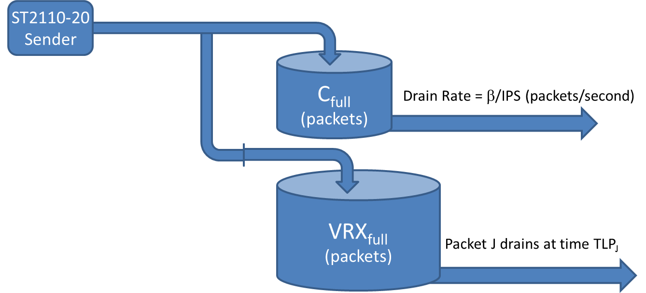Senders shall ensure that their sequence of actual transmission instants passes the dual-leaky-bucket model described in this section, and that neither bucket overflows at any time.

Figure – Dual Leaky Bucket Transmission Traffic Shape Model

Cfull == INT( 1 / (24000 * IPS)) (units of packets)

           

IPS and TLPJ as defined in section 5.1.

VRXfull is defined in section 5.3.

Packets from the sender simultaneously enter both buckets at the instant they are emitted from the sender. The “Cfull” bucket drains a packet every /IPS seconds, if a packet is available. The sender shall never overflow this bucket. Background on the value for Cfull can be found in Annex A.

The “VRXfull” bucket drains packet J at the Last Allowed Transmission (LAT) instant TLPJ. The sender shall ensure that this bucket does not overflow, and the sender shall ensure that packet J is available in the bucket no later than time instant TLPJ.

All senders under this standard shall comply with this dual-leaky-bucket transmission traffic shape model at all times. The model is tested at the output of the Sender, prior to any network delivery impairments.

# Compliance Definitions

## VRXfull

In order to constrain the traffic shape and characterize the streams, a virtual receiver buffer model is used. VRXfull is the parameter of this model, and part of the dual-leaky-bucket model in section 5.3. VRXfull is the capacity of the virtual receiver’s buffer, and it constrains the number of outstanding packets between the sender’s emission time and the virtual receiver’s drain time TLPJ.

## Senders

Senders shall comply with the model in section 5.3, and shall signal compliance with a Media Type Parameter “TP” of value “2110TPA”.

The model defines the latest instant a Sender is allowed to send each packet. Senders are allowed to send packets earlier than the LAT instant, but must maintain compliance with the model. The VRXfull parameter of the model constrains how much data a sender can transmit early – how far ahead (how early) a sender can transmit packets.

Senders shall signal the minimum value of VRXfull required by their output characteristic with a Media Type Parameter “VRXFULL” expressed as a decimal value number of packets.

Sender devices shall be clear in their product specifications in regards to their VRXfull and TXOFF requirements.

## Receivers

Receiver devices shall be clear in their product specifications in regards to the maximum value of VRXfull (in packets) which the receiver can tolerate, as well as any constraints on values of TXOFF.

Note: Practical Receivers will typically have additional buffering beyond VRXFULL in order to provide tolerance for network-induced jitter, transmission latency, and 2022-7 hitless merge re-alignment.

1. Notes Regarding Buffer Capacity in Network Switches (Informative)

Network Switches available in the marketplace today contain buffer memory which is used to queue packets waiting to egress the switch on a given interface. Switch architectures vary significantly across the industry, and the amount of memory available to queue packets for a given egress interface is different in different switches. Typically the presence of more memory for packet queuing is a feature associated with the more expensive switches within the Commercial Off The Shelf (COTS) marketplace.

The value of Cfull in the transmission packet model of section 5.3 scales with the nominal rate of the stream.

RPNOMINAL = 1/IPS (packets per second)

RNOMINAL = (8*1500) / IPS (bits per second)

While implementations within COTS switches vary significantly, a typical open-market switch ASIC has about 10000 packets of buffering, shared amongst 3.2 Tbits/sec of egress ports. Assuming 90% utilization on the egress ports ( = 1.1) and standard-sized (1500 octet) packets, this equates to 3.5 packets per gigabit of stream.

For a stream of rate RNOMINAL, the proportional share of the shared buffer capacity would be:

C = INT( 3.5 * RNOMINAL / 1,000,000,000 ) (packets)

C = INT( 3.5 * 8 * 1500 / (IPS * 1000000000) )

C = INT( 1 / (IPS * (1000000000/(3.5 * 8 * 1500))) )

C = INT( 1 / (IPS * 24000) ) with some rounding (packets)

The values above are based on specific commonly available implementations of switching ASICs as of the time of this writing, which are typically found in the trade. Switches with substantially more buffer memory are available. This analysis also assumes that there is no “statistical” favorability – specifically it plans the buffer capacity for the case in which all of the streams going through a switch have bursts which simultaneously hit the buffer, such that each stream utilizes its share of the buffer capacity at the same time. This analysis further assumes that all of the egress ports of the switch are fully utilized.