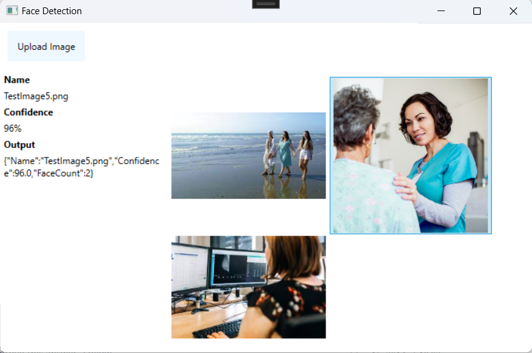

**My Solution**

A WPF .NET project that follows an MVVM architecture to decouple the UI logic from the business logic. I have an ObservableCollection of objects I created (ImageModel) that is bound to the panel on the right so when any changes are detected in the collection it will update the UI.

When an image is uploaded it will create a new object which uses the Google.Cloud.Vision.V1 library to get the result of any faces being detected in the image. Depending on the confidence returned through the Vision API it can do different actions. Now, the only thing the solution will do is print out a JSON of the object to the panel on the left if the confidence level is at least 80% including how many faces were detected.

**What would I do if I had more time?**

Error handling (try catches, using statements)

Improve look of UI (Especially around display of images)

Create reusable User Controls

Allow user to download the JSON to own device

Drag/Drop for uploading images, and processing of multiple images at same time

**Test Results**

