Kiera Wheatley Portfolio

Website showcasing the coursework in computer science and web design by Kiera Wheatley.

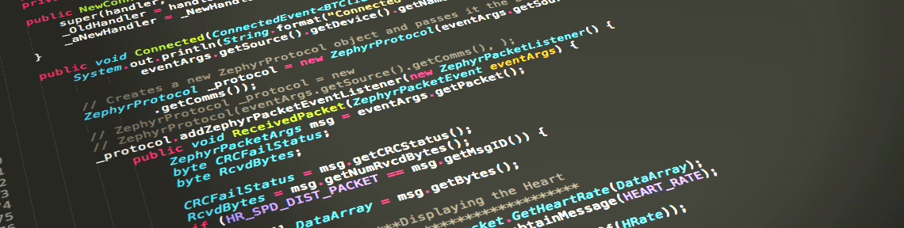

Kierawheatley.com will focus on sharing programs written in C++ 11 by Kiera Wheatley. The website will serve as a display of her prowess in problem solving and formulating appropriate algorithms. The primary agenda for this website is to draw in employers as well as bring in or secure offers for potential jobs in the computing industry.

Personas Comps

 1.<http://www.adhamdannaway.com/>

Student: Can access website

for C++ references and

examples.

2.<http://codersblock.com/>

3.<http://www.codercowboy.com/about/#portfolio>



Employer: Website serves as

tool to see perspective

employee’s talent with coding.