I found during this first class that I am more interested in this class now then I was when I signed up. I signed up for this class in order to get a jump for when I transfer to a larger university. Now, I am interested in learning about programming because it is learning a new language. I think that out of this class I will learn different uses for computers than just writing papers would.

GIT is a software used for programming. It allows a person to look at the changes that have been made to a program and even go back to them. This is especially important because a user doesn’t have to worry about going through a whole program to find a program, as long as they can go back to a spot where they saved the program. Where they last saved is preferred to have a working program with no problems, so that they don’t have to search the whole program to find where the problem in the program was.

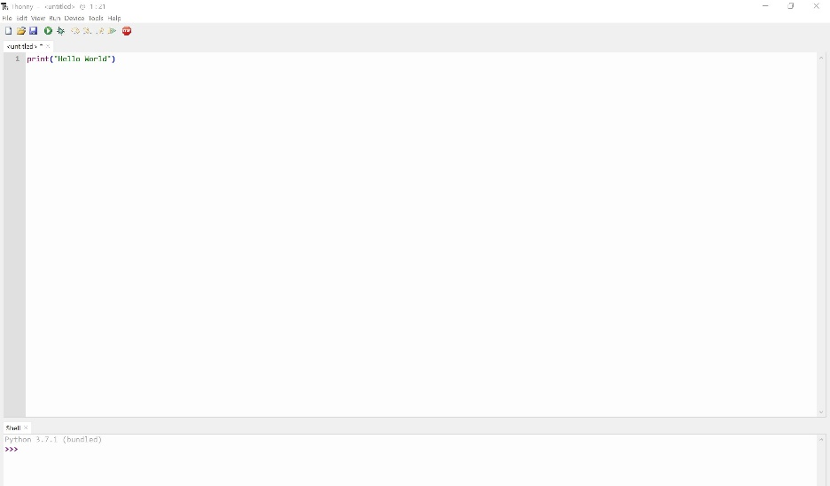“Hello World” Snip: